Academic Performance of Engineering Students
Case Study Report, MSSP 607 Assignment 1

Tianyi Tan
MSSP + DA, School of Social Policy & Practice, University of Pennsylvania
Date of submission: 30 September 2026

Executive Summary
This report examines the course dataset of 12,411 engineering students in Colombia. It links high-school Saber 11 results with final-year university Saber Pro results (De La Hoz). I compare parental education, socioeconomic stratum, gender, and engineering programs to answer the four assignment questions.
Family background is associated with large raw score gaps. Stratum 6 averages 29.2 points more than Stratum 1, and Model A gives an 18.3-point contrast between two university-educated parents and two parents with primary education or less. These gaps become much smaller after including other characteristics and the student's high-school average. The raw male advantage is 2.4 points, but the final regression gives a small female advantage of 0.78 points. English shows the largest standardized stratum gap at both assessments. Program comparisons also change after accounting for prior scores.
I suggest trying entry assessments, English support, and writing workshops in selected programs. These would be small pilots to evaluate, since the dataset does not show whether they would work or how much they would cost. Individual needs should guide access to support.

Introduction

Background and current situation
ICFES administers Saber 11 at the end of secondary school and Saber Pro near the end of university. The OECD review describes inequalities in Colombia's education system (OECD). Having linked results makes it possible to compare university outcomes while accounting for prior scores. Shavelson et al. discuss this approach in Colombia. Such comparisons still leave out factors that may affect both program choice and later performance.
For this case study, the Department of Education asks for a summary of student outcomes and recommendations for different engineering programs. I use the data to identify patterns and possible areas for support.

The data
The teacher's workbook is based on De La Hoz (2020), with further description in Delahoz-Dominguez et al. (2020). It has 12,411 records and 44 usable columns after removing one empty column. The five general subjects at each assessment have values from 0 to 100; the global score (G_SC) and engineering-project module use a 0–300 scale. Scores from different tests do not measure identical skills. Social variables include gender, parental education, stratum, SISBEN, and school type. Men account for 59% of records, Strata 2 and 3 for 65%, and students not classified by SISBEN for 61%.
The accompanying notebook reads the teacher's workbook and runs in Python. It accepts file uploads in Google Colab and saves the tables and figures in results/. Appendix C gives the data preparation and methods.

Key Issues, Goals and Problems
The main questions are how much scores differ by family background and gender, and what the program results suggest about student support. I compare raw gaps with adjusted gaps and examine subjects separately. This helps distinguish broad patterns from conclusions the data cannot support.

Decision Criteria
I focus on recommendations that follow from the results and could be tried within engineering programs. Students should be selected through assessments of their own needs. Any pilot would need an evaluation of participation, learning, retention, and costs before expansion.

Assumptions
- The data are observational. A score difference between groups does not show that a background characteristic caused that difference.
- The sample includes students with linked test results who reached the final university year. Students who left earlier are not represented, which limits generalization.
- The two tests use different instruments. I use z-scores to compare relative positions within the sample, rather than subtracting raw scores to estimate learning gains.
- The labels 0 and “Not sure” are separate from “Ninguno” (none). SISBEN is a classification and does not record grant receipt.
- Average program residuals compare observed scores with predictions based on high-school scores. They leave out other differences between students and universities, so I do not treat them as teaching effects.
- The statistical tests assume independent records. Regression standard errors do not adjust for students attending the same university. The dataset also has no intervention or cost information.

Data Analysis
I calculate numerical summaries by category and 95% confidence intervals for group means. ANOVA and eta squared describe group differences, and Tukey's test compares all 15 pairs of strata. For gender, I use Welch's t-test and Cohen's d. Three regressions use the same 11,488 complete records, adding controls in stages. Table 3 shows their main coefficients, and Appendix Table B6 gives uncertainty estimates for Model C. The notebook produces all tables and figures used here.

Question 1: parental education
Students with more educated parents generally have higher global scores (Figure 2; Appendix Table B1). The mean for fathers with postgraduate education is 177.0, compared with 155.2 for completed primary schooling. The corresponding mother means are 175.6 and 155.3. The postgraduate-versus-secondary gaps are 18.20 points for fathers and 17.17 for mothers. Eta squared is .077 for fathers and .075 for mothers, meaning that each set of categories describes about 8% of unadjusted score variation. These shares overlap. In Model A, the combined contrast between two university-educated parents and two parents with primary education or less is 18.3 points, or 0.79 SD.
Adding stratum, gender, school type, and internet reduces the university-versus-primary coefficients from 9.8 to 4.7 points for mothers and from 8.5 to 3.1 for fathers (Table 3). Adding the Saber 11 average reduces them further to +0.71 and −0.13. Both 95% confidence intervals include zero (Appendix Table B6). The raw parental gap is therefore much smaller after accounting for prior performance in this model. This does not prove that all background disadvantages occur before university or that parental education has no causal effect.

Question 2: socioeconomic stratum
Stratum 6 has the highest mean global score, 181.51, while Stratum 1 averages 152.35. The gap is 29.16 points. The group means increase across Strata 1–6 (Figure 1), and eta squared is .103. All 15 Tukey pairwise comparisons are significant at the .05 level under the test's common-variance assumption (Appendix Table B2).
Table 1. Global score and selected domains by socioeconomic stratum
Stratum | n | Mean G_SC | 95 % CI low | 95 % CI high | English S11 | English Pro | Quant. reas. Pro | z Saber 11 | z G_SC
Stratum 1 | 1,709 | 152.4 | 151.3 | 153.4 | 53.4 | 50.9 | 70.5 | -0.49 | -0.45
Stratum 2 | 4,029 | 158.2 | 157.5 | 158.9 | 57.2 | 60.9 | 74.6 | -0.25 | -0.20
Stratum 3 | 4,045 | 163.8 | 163.1 | 164.5 | 62.4 | 70.6 | 78.3 | +0.04 | +0.05
Stratum 4 | 1,578 | 172.0 | 170.9 | 173.1 | 69.8 | 80.1 | 83.2 | +0.47 | +0.40
Stratum 5 | 633 | 177.4 | 175.7 | 179.1 | 77.0 | 87.0 | 86.7 | +0.81 | +0.64
Stratum 6 | 403 | 181.5 | 179.4 | 183.7 | 82.4 | 92.5 | 88.4 | +1.05 | +0.81
Source: author's analysis of De La Hoz (2020) data.
English has the largest standardized Stratum 6–1 gap at both assessments: d = 2.74 in Saber 11 and 1.73 in Saber Pro. Written communication has the smallest gap among the Saber Pro subjects (d = 0.56), compared with 0.76 for quantitative reasoning. The stratum gap is about 1.5 SD on the high-school average and 1.3 SD on the university global score (Table 1). This describes a smaller difference in relative positions within the sample, not a measured learning gain. In Model C, the Stratum 6–1 coefficient is +0.37 points, and its 95% interval includes zero.

Question 3: gender
Men average 163.69 on the global assessment and women average 161.28. The 2.41-point gap has a 95% confidence interval of 1.59–3.23. It is statistically significant, but Cohen's d is only 0.105, and the distributions overlap substantially (Figure 3). The pattern varies by subject: men score higher in quantitative reasoning (d = 0.42), while women score higher in written communication (d = −0.16). The other three Saber Pro differences are smaller than 0.07 SD (Table 2; Figure 5).
Table 2. Mean scores by gender and domain (d > 0 means men score higher)
Domain | Women | Men | Men − Women | Cohen's d
Mathematics (Saber 11) | 61.9 | 66.0 | 4.0 | +0.34
Critical reading (Saber 11) | 60.9 | 60.7 | -0.2 | -0.02
Citizenship (Saber 11) | 60.0 | 61.2 | 1.3 | +0.12
Biology (Saber 11) | 62.3 | 65.1 | 2.8 | +0.26
English (Saber 11) | 61.5 | 62.0 | 0.6 | +0.04
Quantitative reasoning (Pro) | 71.9 | 81.2 | 9.3 | +0.42
Critical reading (Pro) | 61.3 | 62.8 | 1.4 | +0.05
Citizenship (Pro) | 58.6 | 59.6 | 1.0 | +0.04
English (Pro) | 66.5 | 68.2 | 1.6 | +0.06
Written communication (Pro) | 56.6 | 51.7 | -4.9 | -0.16
Global score | 161.3 | 163.7 | 2.4 | +0.10
Source: author's analysis of De La Hoz (2020) data.
The adjusted male–female coefficient changes from +2.08 in Model B to −0.78 when the high-school average is added in Model C (Table 3). The final estimate gives a small female advantage, with a 95% interval of −1.32 to −0.24 and p = .005. Thus, the gap reverses in this model rather than becoming zero. Female representation is also uneven: about 12% in mechanical, 20% in electronic, and 22% in electric engineering, compared with 52% in industrial and 55% in chemical engineering. In mechanical engineering, women have the higher raw global mean (167.5 versus 165.9). These group results do not determine an individual student's ability.
Table 3. Regression coefficients for the global score (points) as controls are added
Model | R² | Mother: university+ vs primary or less | Father: university+ vs primary or less | Stratum 6 vs Stratum 1 | Men vs women
A: parental education only | 0.08 | 9.8 | 8.5
B: + stratum, gender, school sector, internet | 0.14 | 4.7 | 3.1 | 18.4 | 2.1
C: + own Saber 11 average | 0.61 | 0.7 | -0.1 | 0.4 | -0.8
Note: all models use the same 11,488 complete records. Blank cells indicate that the predictor is absent. Reference groups are primary schooling or less, Stratum 1 and female. Model C also includes school sector and home internet. Appendix Table B6 gives uncertainty for selected Model C coefficients. Source: author's analysis of De La Hoz (2020) data.

Question 4: programs and other findings
The high-school average correlates r = .78 with G_SC. A regression using all five high-school subjects explains about 61% of global-score variation. Chemical engineering has the highest raw mean among the six larger programs (176.7) and the highest mean residual (+3.3 points). Electric engineering's residual is +1.0. Electronic and mechanical engineering have above-average raw scores but residual means of −0.9 and −1.2. Industrial engineering has the lowest raw mean, yet its residual is only −0.5; civil engineering is +0.2 (Table 4). This comparison shows why prior scores matter when discussing program results. It cannot establish which program teaches best.
Table 4. Programs with at least 100 students and their adjusted descriptive comparisons
Program | n | Saber 11 average at entry | Mean G_SC | Raw gap vs overall mean | Mean residual after Saber 11
Chemical Engineering | 1,000 | 68.0 | 176.7 | 14.0 | 3.3
Electric Engineering | 278 | 68.0 | 174.0 | 11.3 | 1.0
Civil Engineering | 3,320 | 61.4 | 161.1 | -1.6 | 0.2
Industrial Engineering | 5,318 | 60.5 | 159.0 | -3.7 | -0.5
Electronic Engineering | 849 | 65.1 | 166.9 | 4.2 | -0.9
Mechanical Engineering | 1,135 | 64.8 | 166.1 | 3.3 | -1.2
Source: author's analysis of De La Hoz (2020) data.
Other raw gaps follow a similar pattern. Students not classified by SISBEN average 167.5, compared with 152.7 in Level 1. Private-school graduates average 168.2 versus 156.5 for public-school graduates, and students with home internet average 164.9 versus 154.6 without it (Appendix Table B3). These differences are unadjusted. Written communication has the lowest numerical mean among the five general Saber Pro subjects (53.7), although subject means do not indicate equivalent proficiency. Keeping one record per repeated university-test code changes the main gaps by less than 0.04 point (Appendix Table B4).

Preferred Alternative
One option is to focus on final-year test preparation. Another is to identify learning needs when students enter university and offer support earlier. Program averages could also be reported with information on students' prior scores, rather than used as simple rankings.
I would start with a small entry-support pilot and report outcomes with that context. Prior scores are strongly associated with later results, and English gaps and program writing scores suggest specific areas to examine. The analysis does not show that early support would be more effective or cheaper than final-year support, so this is a proposal to test.

Justification, Predicted Outcomes and Recommendations
- Use entry assessments to identify students who need help. Stratum, school type, and access information could guide outreach, while students from any background could participate when their assessments show a need.
- Try English support for students with low diagnostic scores. The large English gaps between strata give a reason to examine this subject, but do not tell us which type of course would work best.
- Try writing workshops in mechanical, electronic, and civil engineering, where writing means are 50.5, 51.2, and 51.3. Industrial engineering is another useful setting because it has the largest sample (5,318 records; writing mean 54.1). Electric engineering could be included based on student needs. Chemical engineering's higher writing mean (64.0) gives a reason to look at its writing activities, without assuming those activities caused the difference.
- Report raw program means with sample sizes and comparisons that account for high-school scores. Shavelson et al. discuss the difficulties of measuring higher-education value added. More student and institutional information would be needed before using these residuals for decisions about program quality.
- Look more closely at the low female shares in mechanical, electronic, and electric engineering. The dataset cannot explain why those shares differ. Writing and quantitative support should depend on individual needs, rather than assumptions about gender.
- Evaluate a small pilot before expanding it. Track participation, learning outcomes, retention, and costs, using a comparison group where possible.
I would not predict a specific score improvement from these results. The data show where gaps exist, but contain no evidence about the effects of the proposed support. An evaluation would be needed to find out whether students benefit.

Conclusion
The strongest pattern is the association between family background and raw scores. Those gaps become much smaller after accounting for prior performance. The gender gap is small and changes direction in the final regression. English differences and program writing results suggest areas for support, while the adjusted program comparisons show the importance of context. I would use these findings to design a small pilot and learn from its results, without treating them as proof of teaching quality or intervention effects.

References
Cohen, Jacob. Statistical Power Analysis for the Behavioral Sciences. 2nd ed., Lawrence Erlbaum Associates, 1988.
De La Hoz, Enrique. "Data of Academic Performance Evolution for Engineering Students." Mendeley Data, V1, 2020, doi:10.17632/83tcx8psxv.1.
Delahoz-Dominguez, Enrique, Rohemi Zuluaga, and Tomas Fontalvo-Herrera. "Dataset of Academic Performance Evolution for Engineering Students." Data in Brief, vol. 30, 2020, article 105537, doi:10.1016/j.dib.2020.105537.
McKinney, Wes. "Data Structures for Statistical Computing in Python." Proceedings of the 9th Python in Science Conference, 2010, pp. 56–61.
OECD. Education in Colombia. Reviews of National Policies for Education, OECD Publishing, 2016, doi:10.1787/9789264250604-en.
Seabold, Skipper, and Josef Perktold. "Statsmodels: Econometric and Statistical Modeling with Python." Proceedings of the 9th Python in Science Conference, 2010, pp. 92–96.
Shavelson, Richard J., et al. "On the Practices and Challenges of Measuring Higher Education Value Added: The Case of Colombia." Assessment & Evaluation in Higher Education, vol. 41, no. 5, 2016, pp. 695–720.
Tables were calculated in Python, and figures were made with matplotlib.

Appendix A: Figures
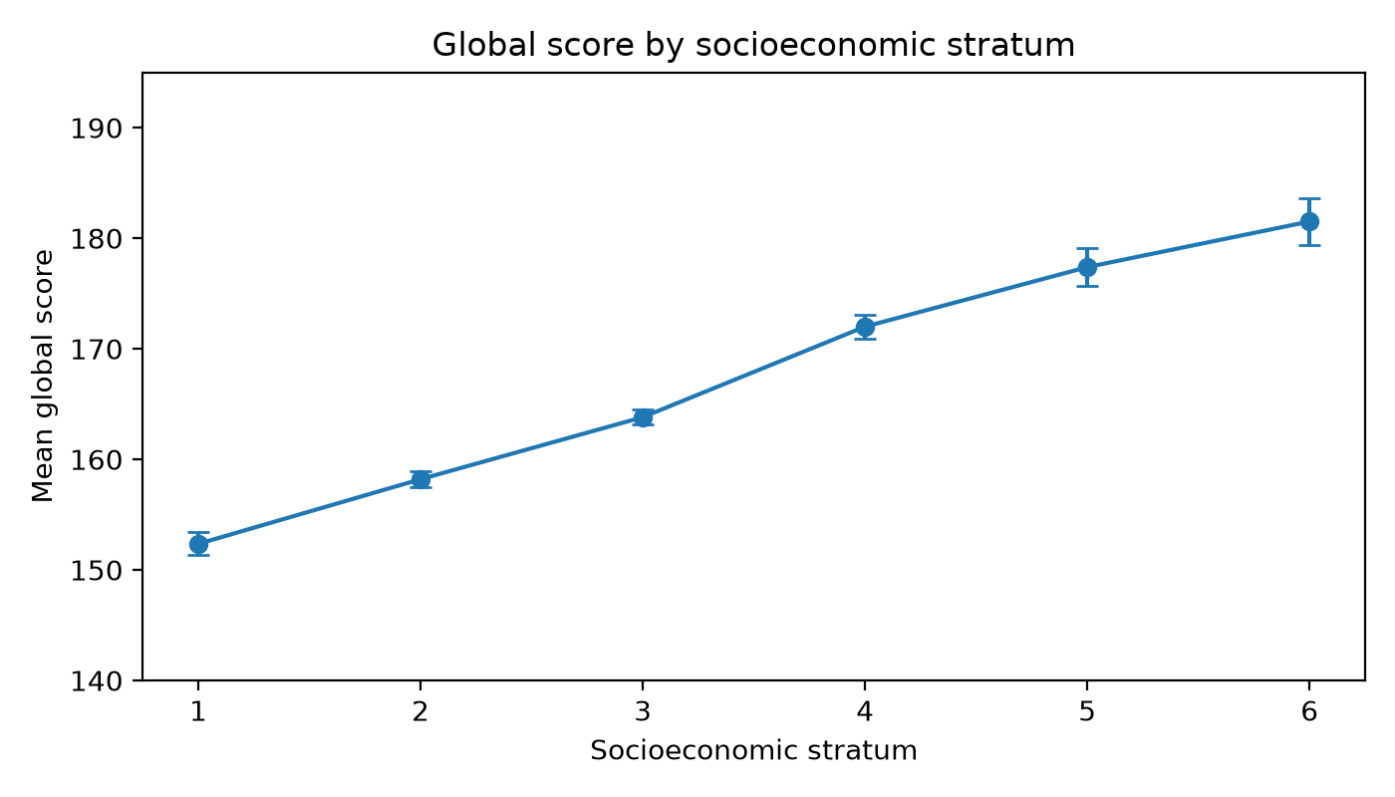
Figure 1. Mean global score by socioeconomic stratum with 95 % confidence intervals. Source: author's analysis of De La Hoz (2020).
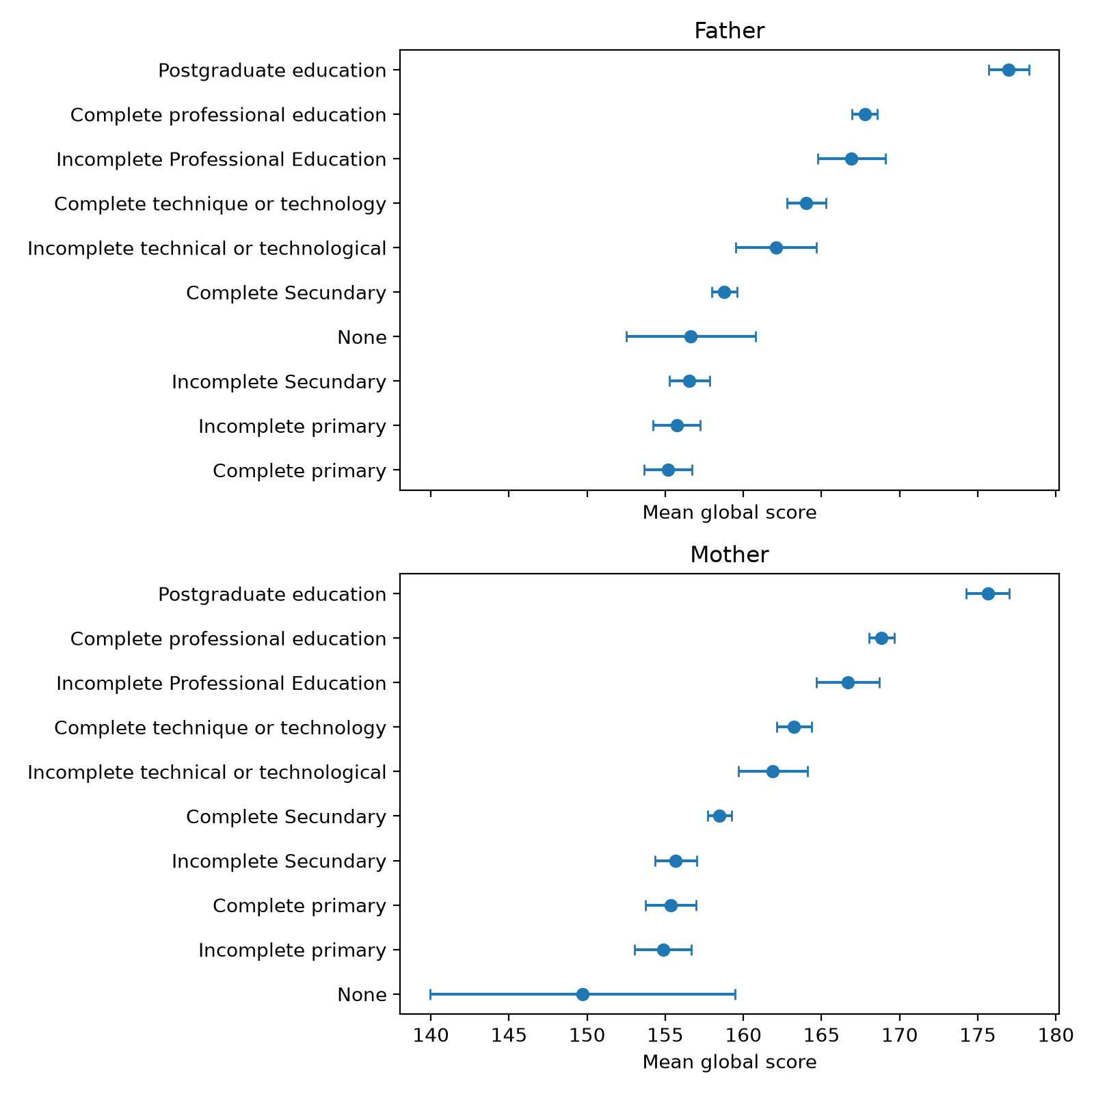
Figure 2. Mean global score by father's and mother's education with 95 % confidence intervals (undocumented 0 and "Not sure" categories omitted). Source: author's analysis of De La Hoz (2020).
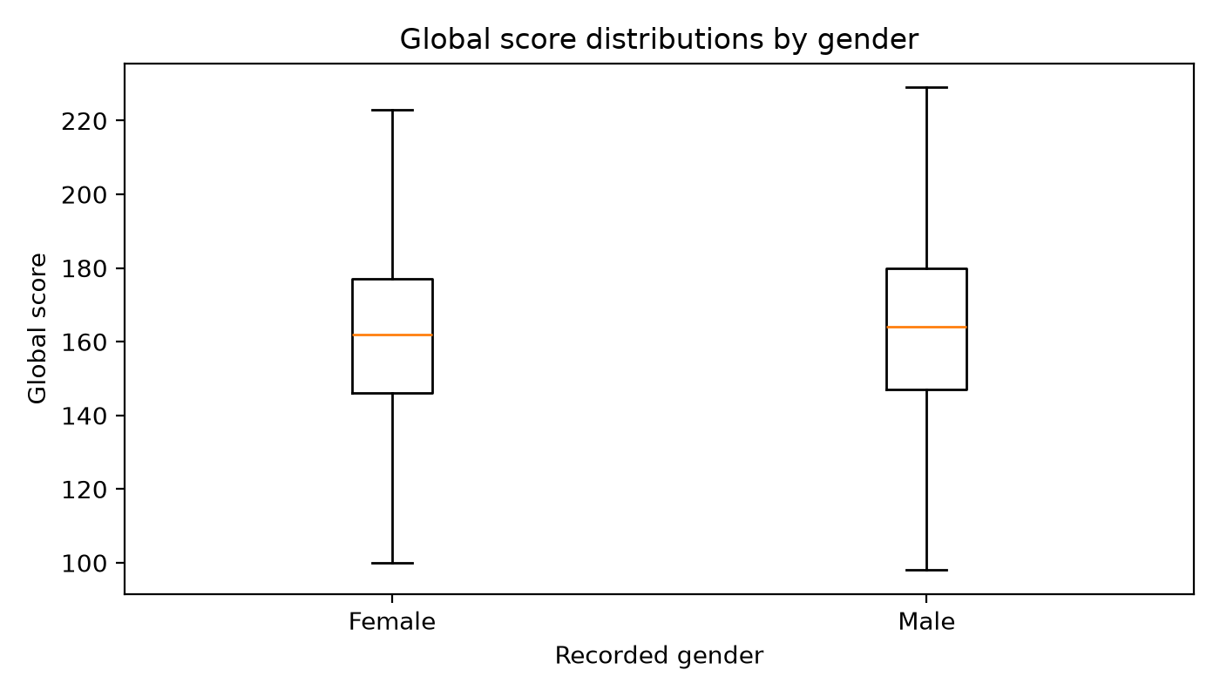
Figure 3. Distribution of the global score by gender (outliers hidden). Source: author's analysis of De La Hoz (2020).
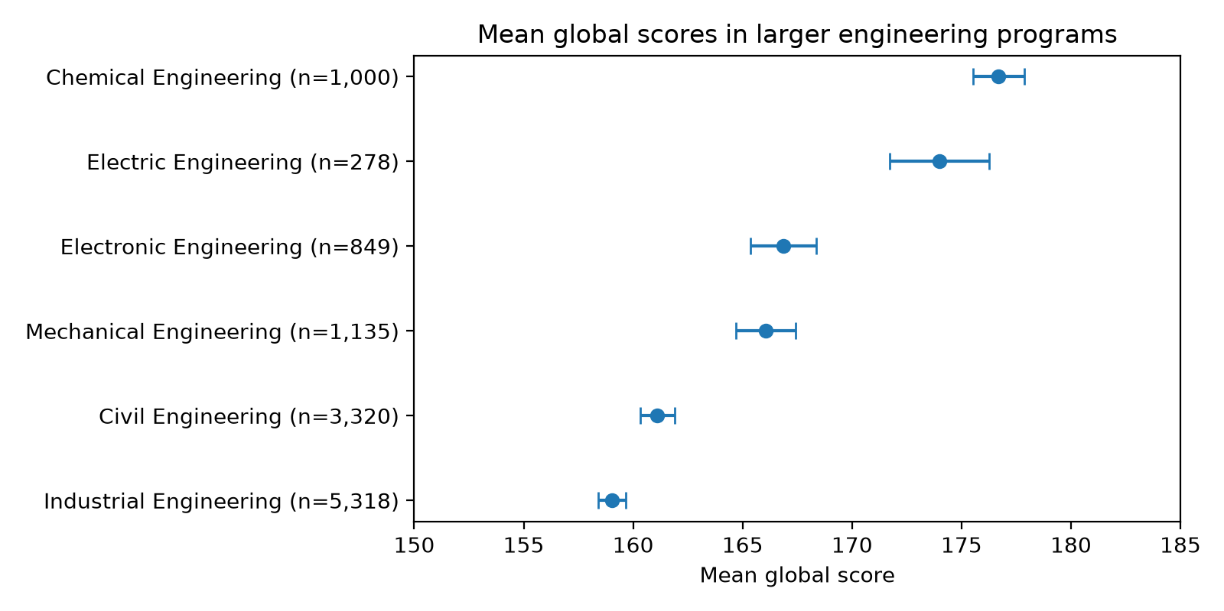
Figure 4. Mean global score in programs with at least 100 students, with 95 % confidence intervals. Source: author's analysis of De La Hoz (2020).
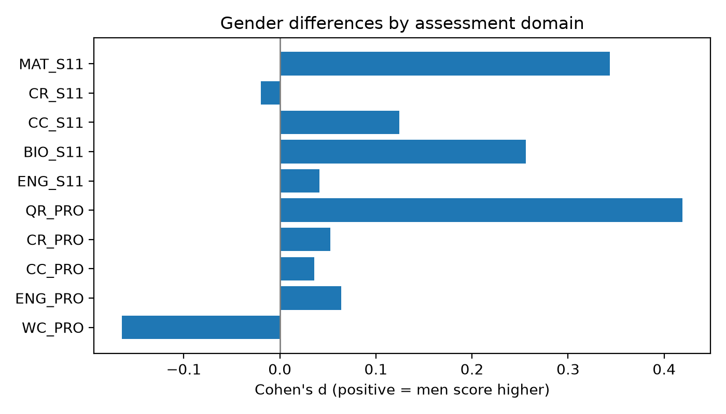
Figure 5. Gender gap by assessment domain, Cohen's d (positive values mean men score higher). Source: author's analysis of De La Hoz (2020).

Appendix B: Supplementary tables
Table B1. Global score by parental education (all recorded categories, sorted by mean)
Parent: level | n | Mean G_SC | 95 % CI low | 95 % CI high
Father: 0 | 391 | 155.1 | 153.1 | 157.1
Father: Complete primary | 824 | 155.2 | 153.7 | 156.7
Father: Incomplete primary | 735 | 155.7 | 154.2 | 157.2
Father: Incomplete Secundary | 1,091 | 156.5 | 155.2 | 157.8
Father: None (Ninguno) | 123 | 156.6 | 152.5 | 160.8
Father: Complete Secundary | 2,843 | 158.8 | 158.0 | 159.6
Father: Not sure | 407 | 160.3 | 158.1 | 162.5
Father: Incomplete technical or technological | 277 | 162.1 | 159.5 | 164.7
Father: Complete technique or technology | 1,194 | 164.0 | 162.8 | 165.3
Father: Incomplete Professional Education | 425 | 166.9 | 164.8 | 169.1
Father: Complete professional education | 3,016 | 167.8 | 166.9 | 168.6
Father: Postgraduate education | 1,085 | 177.0 | 175.7 | 178.3
Mother: None (Ninguno) | 34 | 149.7 | 140.0 | 159.5
Mother: Incomplete primary | 541 | 154.9 | 153.0 | 156.7
Mother: 0 | 388 | 154.9 | 152.9 | 156.9
Mother: Complete primary | 713 | 155.3 | 153.7 | 157.0
Mother: Incomplete Secundary | 1,056 | 155.7 | 154.3 | 157.0
Mother: Complete Secundary | 3,106 | 158.5 | 157.7 | 159.2
Mother: Not sure | 179 | 159.4 | 155.7 | 163.2
Mother: Incomplete technical or technological | 341 | 161.9 | 159.7 | 164.1
Mother: Complete technique or technology | 1,495 | 163.2 | 162.1 | 164.4
Mother: Incomplete Professional Education | 502 | 166.7 | 164.7 | 168.7
Mother: Complete professional education | 3,059 | 168.8 | 168.0 | 169.7
Mother: Postgraduate education | 997 | 175.6 | 174.3 | 177.0
Source: author's analysis of De La Hoz (2020) data.
Table B2. Tukey HSD pairwise comparisons of the global score across strata
Pair | Mean difference | Adjusted p | CI lower | CI upper
Stratum 1 vs Stratum 2 | 5.85 | < .001 | 4.05 | 7.65
Stratum 1 vs Stratum 3 | 11.46 | < .001 | 9.66 | 13.26
Stratum 1 vs Stratum 4 | 19.65 | < .001 | 17.47 | 21.83
Stratum 1 vs Stratum 5 | 25.03 | < .001 | 22.13 | 27.94
Stratum 1 vs Stratum 6 | 29.16 | < .001 | 25.70 | 32.61
Stratum 2 vs Stratum 3 | 5.62 | < .001 | 4.23 | 7.00
Stratum 2 vs Stratum 4 | 13.80 | < .001 | 11.95 | 15.66
Stratum 2 vs Stratum 5 | 19.19 | < .001 | 16.52 | 21.86
Stratum 2 vs Stratum 6 | 23.31 | < .001 | 20.05 | 26.57
Stratum 3 vs Stratum 4 | 8.19 | < .001 | 6.34 | 10.04
Stratum 3 vs Stratum 5 | 13.57 | < .001 | 10.91 | 16.24
Stratum 3 vs Stratum 6 | 17.70 | < .001 | 14.44 | 20.95
Stratum 4 vs Stratum 5 | 5.38 | < .001 | 2.45 | 8.32
Stratum 4 vs Stratum 6 | 9.51 | < .001 | 6.03 | 12.99
Stratum 5 vs Stratum 6 | 4.12 | 0.04 | 0.15 | 8.10
Source: author's analysis of De La Hoz (2020) data.
Table B3. Global score by SISBEN classification, high-school sector and home internet
Group | n | Mean G_SC | 95 % CI low | 95 % CI high
SISBEN: 0 | 21 | 158.6 | 149.5 | 167.8
SISBEN: Classified at another SISBEN level | 96 | 166.1 | 161.5 | 170.6
SISBEN: It is not classified by the SISBEN | 7,534 | 167.5 | 167.0 | 168.0
SISBEN: Level 1 | 2,057 | 152.7 | 151.7 | 153.6
SISBEN: Level 2 | 2,120 | 155.9 | 154.9 | 156.8
SISBEN: Level 3 | 583 | 161.0 | 159.2 | 162.8
High school: Private | 6,565 | 168.2 | 167.7 | 168.8
High school: Public | 5,846 | 156.5 | 156.0 | 157.1
Home internet: No | 2,659 | 154.6 | 153.8 | 155.5
Home internet: Yes | 9,752 | 164.9 | 164.5 | 165.4
Source: author's analysis of De La Hoz (2020) data.
Table B4. Sensitivity of headline gaps to repeated Saber Pro codes
Records used | n | Stratum 6 − 1 | Men − women | Father: postgrad − secondary | Mother: postgrad − secondary
All supplied records | 12,411 | 29.16 | 2.41 | 18.20 | 17.17
One record per professional code | 12,395 | 29.12 | 2.39 | 18.19 | 17.19
Source: author's analysis of De La Hoz (2020) data.
Table B5. One-way ANOVA of the global score across parental-education levels and strata (0 and "Not sure" excluded)
Grouping | n | Groups | ANOVA F | p | η²
EDU_FATHER | 11,613 | 10 | 107.3 | < 0.001 | 0.077
EDU_MOTHER | 11,844 | 10 | 106.7 | < 0.001 | 0.075
STRATUM | 12,397 | 6 | 286.1 | < 0.001 | 0.103
Source: author's analysis of De La Hoz (2020) data.
Table B6. Selected Model C coefficients with 95% confidence intervals
Comparison | Coefficient | 95% CI low | 95% CI high | p
Mother university+ vs primary or less | 0.71 | -0.48 | 1.90 | .241
Father university+ vs primary or less | -0.13 | -1.20 | 0.95 | .820
Stratum 6 vs Stratum 1 | 0.37 | -1.45 | 2.18 | .692
Male vs female | -0.78 | -1.32 | -0.24 | .005
Note: n = 11,488. Model C includes both parental-education groups, stratum, gender, school sector, internet and the Saber 11 average. Conventional OLS errors are not adjusted for university clustering. Source: author's analysis of De La Hoz (2020) data.

Appendix C: Data preparation and methods
- I use the teacher's data_academic_performance.xlsx and its SABER11_SABERPRO worksheet (12,411 records). I remove one empty column and trim spaces from labels. Sixteen university-test codes repeat beyond the first occurrence. Table B4 compares the full data with one record per code.
- Descriptive tables keep 0, “Not sure,” and “Ninguno” separate. Unknown parental labels and stratum 0 are excluded from the relevant statistical tests. Regressions group parental education into primary or less, secondary, technical or some college, and university degree or more.
- The Saber 11 average is the mean of its five subjects. I standardize this average and G_SC using their sample means and standard deviations. Program residuals come from a regression of G_SC on the five high-school subjects.
- Methods include 95% t intervals, ANOVA, eta squared, Tukey HSD, Welch's t-test, Cohen's d, and OLS regression. The three background regressions use the same 11,488 complete records. Their errors are not adjusted for university clustering.
- The notebook uses Python with pandas, NumPy, SciPy, statsmodels, and matplotlib. It accepts the teacher's workbook in Colab or locally and saves tables and figures in results/. The assignment also requires saving the notebook and data in the MSSP607 GitHub repository and sharing access with the instructor and TAs.

Appendix D: Acknowledgement of assistance
I used AI tools for grammar and sentence checks, as well as formatting revisions.

