Adventure Works Internet Sales
and Growth Strategy
Case Study Report Assignment 2
Tianyi Tan
MSSP 6070
3 November 2026

Executive Summary
Adventure Works should test bicycle offers to existing U.S. customers and optional accessory bundles. Internet sales total $29.36 million; bicycles contribute 96.5% at an average selling price of $1,862.42. U.S. customers spend less per person than Australian customers, providing a useful testing opportunity. Homeowners spend 8.7% more per customer on average, but the gap varies by country. Campaigns should be judged on additional contribution after costs, using a control group.

Introduction
Leadership wants to understand internet sales and identify growth opportunities. I analyze the course CSV from Microsoft’s AdventureWorks sample data: 60,398 order lines, 27,659 orders, and 18,484 customers in six country regions. Records cover 29 December 2010 to 28 January 2014. The data are fictional, so findings describe this sample rather than a real company (Microsoft; Microsoft Corporation).

Body

Key Issues Goals and Problems
The main questions are where revenue comes from, how customer groups differ, and which opportunities justify a small business test.

Decision Criteria
I prioritize a large revenue base, evidence from purchase history, and measurable additional contribution after product, delivery, and marketing costs.

Assumptions
Sales use SalesAmount before tax and freight. Identical recorded prices across countries support a common reporting basis, but the CSV does not verify currency conversion. Monetary values are treated as comparable recorded dollars. Categories are derived from names: 130 product names correspond to 158 product keys. Customer summaries count each buyer once. Growth comparisons use complete years 2011–2013; 2010 and 2014 are partial. Customer attributes are snapshots, and purchase histories differ in length.

Data Analysis

Sales by Year and Country Region
Sales fell from $7.08 million in 2011 to $5.84 million in 2012, then rose 179.9% to $16.35 million in 2013. The 2012 decline occurred in the United States (−41.5%), Canada (−46.2%), and Australia (−17.0%); the European regions grew. Every region grew in 2013. The United States contributes 32.0% of total revenue and Australia 30.9%. Tables A1–A2 show every country and year, including partial periods.

Income and Gender by Country Region
Australian customers average about $64,000 in yearly income, compared with $36,000 among French customers. Within each region, mean income differs by less than $2,000 between recorded genders, and counts are close to balanced. Table C1 reports minimums, maximums, means, and sample standard deviations. Gender is categorical, so Table C2 reports counts and percentages. Similar income does not establish similar product preferences.

Product Categories and Average Selling Price
Bikes generate $28.32 million, or 96.5% of revenue. Dividing this by 15,205 units gives an average selling price of $1,862.42. Road bikes contribute 49.5% of all sales, mountain bikes 33.9%, and touring bikes 13.1%. Accessories generate only 2.4% of revenue, but their product gross margin is 62.6%, compared with 40.6% for bikes and 40.1% for clothing. These margins exclude other operating costs (Table B1; Figure B1).

Home Ownership and Sales
Homeowners are 67.6% of customers and contribute 69.4% of sales. Their mean cumulative spending is $1,630.57 versus $1,500.05 for non-homeowners, an 8.7% gap. The gap is small in the United States (−1.5%) and Australia (+1.4%), but larger in France (+66.8%) and Germany (+42.0%). It also reverses within the $70,000–$90,000 income band. Category revenue shares are nearly identical. These descriptive checks do not establish a causal effect of home ownership (Tables D1–D2).

Customer Purchase Patterns
U.S. buyers spend $1,201 per person across the observed period, versus $2,523 in Australia. Bike-buyer shares are 45.6% and 60.0%, respectively; Canada and France have lower shares than the United States. The spending gap remains in a 2013-only comparison. Overall, 84.1% of bike buyers also purchase other categories, averaging $44.68 in non-bike sales per bike buyer (Table E1; Figure E1).

Preferred Alternative with Rationale
I recommend growing purchases among existing customers before committing to new markets. The U.S. customer base is large and includes 4,250 buyers with no observed bike purchase. This supports a test, although the data cannot reveal their intent or offline purchases. Cross-buying research also supports targeting offers using purchase history, without establishing an expected response here (Kumar et al.).

Recommendations and Expected Outcomes
First, run a 90-day test of bike offers to eligible U.S. customers. Randomly assign customers to an offer or control group. Second, separately test optional accessory bundles with relevant bike purchases. Measure additional purchases, revenue, discounts, delivery costs, returns, and campaign costs against the control. Keep the Road-150 Red and Mountain-200 models visible in recommendations; together they represent 45.9% of historical revenue.
For scale, 100 genuinely additional bike purchases at the historical average price and margin would yield about $186,242 in revenue and $75,671 in product gross profit before extra costs. This is an illustration, not a forecast or marketing budget. A later second-bike test should use the 4,128 customers with exactly one observed bike purchase, rather than all 9,132 bike buyers.

Conclusion
Bicycles are the revenue priority, with accessories offering a smaller complementary opportunity. Test purchase-based offers and expand only when additional contribution is positive. Missing traffic, campaign costs, and offline purchases prevent reliable conversion or return-on-marketing estimates. The fictional data support a learning exercise; no conclusions about real business outcomes are valid.

Appendix A Annual Sales by Country Region
Table A1
Complete-year sales and total observed sales in recorded dollars
Region | 2011 | 2012 | 2013 | All periods
Australia | 2,563,732.25 | 2,128,407.46 | 4,339,443.38 | 9,061,000.58
Canada | 571,571.80 | 307,604.52 | 1,085,632.65 | 1,977,844.86
France | 410,845.33 | 648,065.54 | 1,578,511.80 | 2,644,017.71
Germany | 520,500.16 | 608,657.98 | 1,761,876.36 | 2,894,312.34
United Kingdom | 550,591.22 | 712,700.96 | 2,124,007.29 | 3,391,712.21
United States | 2,458,285.17 | 1,437,048.73 | 5,462,078.86 | 9,389,789.51
Total | 7,075,525.93 | 5,842,485.20 | 16,351,550.34 | 29,358,677.22
All periods includes 29 Dec. 2010–28 Jan. 2014. Amounts are shown to two decimal places; rounding may affect displayed totals. Source: Author’s calculations from InternetSales.csv (Microsoft Corporation).
Table A2
Country sales in the two partial years in recorded dollars
Region | 2010 partial | 2014 partial
Australia | 20,909.78 | 8,507.72
Canada | 3,578.27 | 9,457.62
France | 3,399.99 | 3,195.06
Germany | 0.00 | 3,277.83
United Kingdom | 699.10 | 3,713.64
United States | 14,833.90 | 17,542.85
Total | 43,421.04 | 45,694.72
2010 covers 29–31 December; 2014 covers 1–28 January. These are not full-year totals. Zero means no recorded sales. Source: Author’s calculations from InternetSales.csv (Microsoft Corporation).

Appendix B Sales by Product Category
Table B1
Sales by year and derived product category in recorded dollars
Year | Bikes | Accessories | Clothing | Total
2010* | 43,421.04 | 0.00 | 0.00 | 43,421.04
2011 | 7,075,525.93 | 0.00 | 0.00 | 7,075,525.93
2012 | 5,839,695.33 | 2,147.08 | 642.79 | 5,842,485.20
2013 | 15,359,502.36 | 668,241.53 | 323,806.45 | 16,351,550.34
2014* | 0.00 | 30,371.35 | 15,323.37 | 45,694.72
* Partial year. Total category sales are $28.32 million for bikes, $0.70 million for accessories, and $0.34 million for clothing. Product gross margin equals sales less recorded product cost, divided by sales. Source: Author’s calculations from InternetSales.csv (Microsoft Corporation).
Figure B1. Internet sales in complete calendar years by derived category
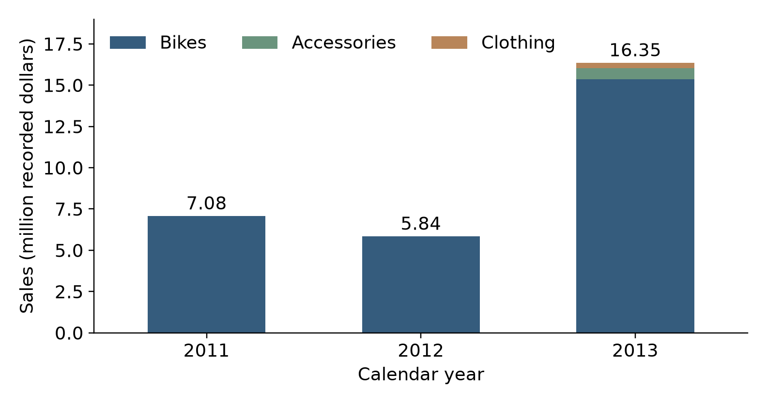
Source: Author’s calculations from InternetSales.csv (Microsoft Corporation).

Appendix C Income and Gender
Table C1
Yearly income by country region and gender among unique customers
Region | Gender | n | Mean | Min | Max | SD
Australia | F | 1,777 | 65,284 | 10,000 | 160,000 | 31,164
Australia | M | 1,814 | 63,412 | 10,000 | 170,000 | 32,451
Canada | F | 767 | 56,506 | 10,000 | 170,000 | 19,182
Canada | M | 804 | 57,799 | 10,000 | 170,000 | 21,215
France | F | 893 | 35,342 | 10,000 | 110,000 | 26,916
France | M | 917 | 36,172 | 10,000 | 110,000 | 27,633
Germany | F | 874 | 43,810 | 10,000 | 130,000 | 35,716
Germany | M | 906 | 42,108 | 10,000 | 130,000 | 35,277
UK | F | 934 | 52,184 | 10,000 | 170,000 | 48,288
UK | M | 979 | 52,155 | 10,000 | 170,000 | 48,593
US | F | 3,888 | 63,277 | 10,000 | 170,000 | 25,167
US | M | 3,931 | 63,953 | 10,000 | 170,000 | 26,228
Income is in recorded dollars. SD is the sample standard deviation. F = female; M = male, as recorded. UK = United Kingdom; US = United States. Each customer appears once. Source: Author’s calculations from InternetSales.csv (Microsoft Corporation).
Table C2
Gender counts and percentages within each country region
Region | Female n | Female % | Male n | Male %
Australia | 1,777 | 49.5% | 1,814 | 50.5%
Canada | 767 | 48.8% | 804 | 51.2%
France | 893 | 49.3% | 917 | 50.7%
Germany | 874 | 49.1% | 906 | 50.9%
UK | 934 | 48.8% | 979 | 51.2%
US | 3,888 | 49.7% | 3,931 | 50.3%
Percentages use the unique customers in each region as the denominator. Gender is categorical; numerical minimums, maximums, and standard deviations are not reported. Source: Author’s calculations from InternetSales.csv (Microsoft Corporation).

Appendix D Home Ownership Comparisons
Table D1
Observed sales and purchases by home ownership
Measure | Non-homeowner | Homeowner
Unique customers | 5,982 | 12,502
Share of customers | 32.4% | 67.6%
Total sales | $8,973,327.42 | $20,385,349.80
Mean sales per customer | $1,500.05 | $1,630.57
Median sales per customer | $209.96 | $342.00
Unique orders | 8,601 | 19,058
Average order value | $1,043.29 | $1,069.65
Bike buyers | 48.9% | 49.7%
Sales per customer are cumulative over the observed period. A bike buyer has at least one recorded bike purchase. HouseOwnerFlag is 0 for non-homeowners and 1 for homeowners. Source: Author’s calculations from InternetSales.csv (Microsoft Corporation).
Table D2
Mean cumulative sales per customer within each country region
Region | Non-owner | Owner | Gap
Australia | 2,501 | 2,536 | +1.4%
Canada | 1,142 | 1,316 | +15.2%
France | 1,019 | 1,699 | +66.8%
Germany | 1,272 | 1,807 | +42.0%
United Kingdom | 1,466 | 1,929 | +31.5%
United States | 1,214 | 1,196 | -1.5%
Amounts are in recorded dollars. Gap = (owner mean ÷ non-owner mean − 1) × 100. These separate group comparisons do not establish causation or jointly control other differences. Source: Author’s calculations from InternetSales.csv (Microsoft Corporation).

Appendix E Customer Patterns for Strategy
Table E1
Customers and cumulative spending over the observed period
Region | Customers | Sales per buyer | Bike buyers
Australia | 3,591 | 2,523 | 60.0%
Canada | 1,571 | 1,259 | 41.8%
France | 1,810 | 1,461 | 45.1%
Germany | 1,780 | 1,626 | 50.8%
United Kingdom | 1,913 | 1,773 | 53.9%
United States | 7,819 | 1,201 | 45.6%
Sales per buyer are in recorded dollars. Bike buyers are a share of observed customers, not a website conversion rate. Different customer histories limit cumulative comparisons. Source: Author’s calculations from InternetSales.csv (Microsoft Corporation).
Figure E1. Sales per active buyer in the common calendar year 2013
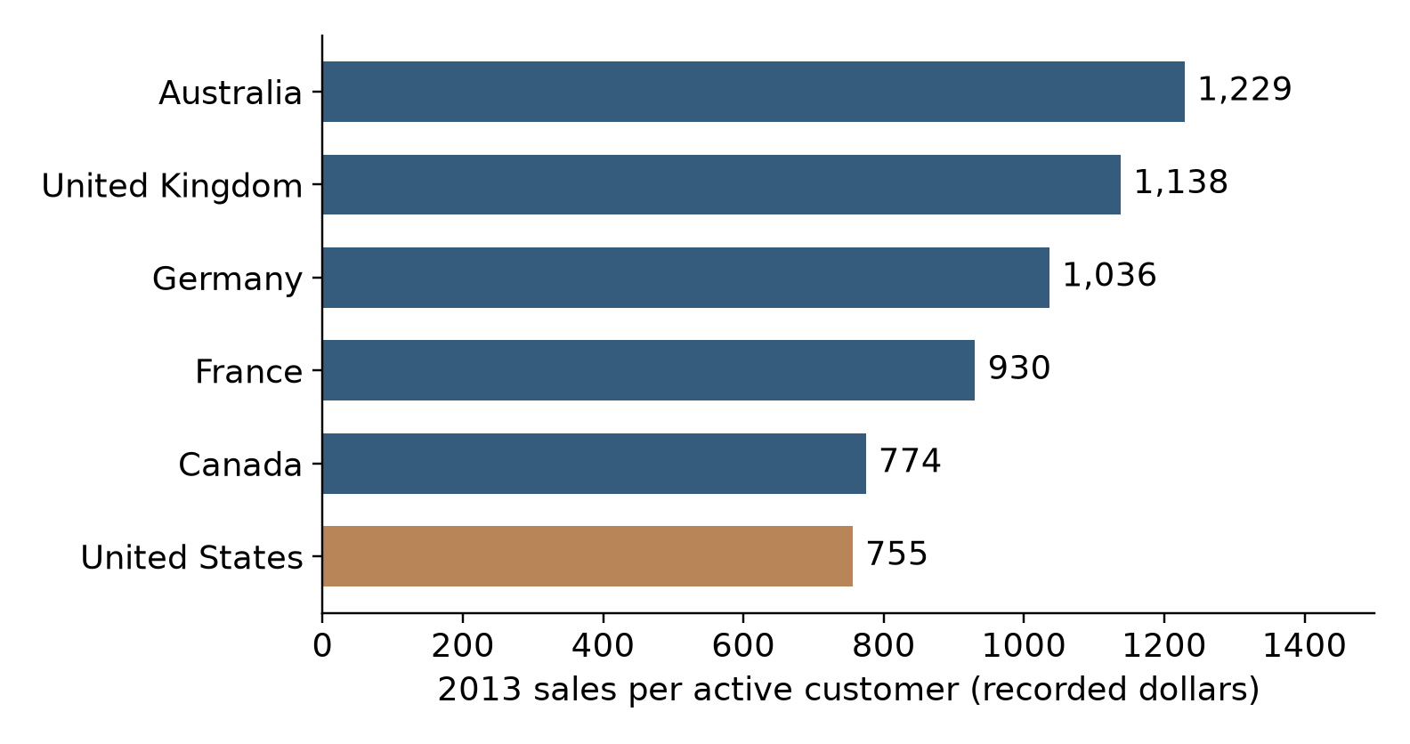
Source: Author’s calculations from InternetSales.csv (Microsoft Corporation).
An active buyer placed at least one order in 2013. The U.S.–Australia spending gap persists within one calendar year; product mix and customer tenure can still differ.

AI Assistance
AI-assisted tools, including AI Chat and Claude, were used to support code inspection, debugging, and error correction. All modifications were reviewed and verified by the authors.

References
“Case Study Report Format Guideline.” MSSP 6070, University of Pennsylvania, course handout.
Kumar, V., Morris George, and Joseph Pancras. “Cross-Buying in Retailing: Drivers and Consequences.” Journal of Retailing, vol. 84, no. 1, 2008, pp. 15–27. https://doi.org/10.1016/j.jretai.2008.01.007.
Microsoft. “AdventureWorks Sample Databases.” Microsoft Learn, https://learn.microsoft.com/en-us/sql/samples/adventureworks-install-configure. Accessed 3 Nov. 2026.
Microsoft Corporation. InternetSales.csv. Adventure Works Internet Sales Dataset, MSSP 6070, University of Pennsylvania, course-provided CSV.

