Summary of TerraBio eDNA Results for ininvertebrates

Karen Dyson

8/19/2021

## Biodiversity Results for the 2g Invertebrate dataset

Overall, we detected a total of 2.672142^{6} reads, describing a total of 1012 MOTU representing 85 unique Family groups.

TerraBio’s biodiversity indicators break down into two main components: those describing *key species* and those describing the entire community of insects/mammals detected.

## Key species indicators

### Key species present in our sample

We found a total of 57 key invertebrate species in our intervention and counterfactual sample (Table 1). A total of 59 key species were found in our forest sample.

Table X: Key invertebrate species found in the TerraBio pilot in cocoa and pasture fields, along with those found in the three forest plots.

|  |  |  |  |  |  |  |  |
| --- | --- | --- | --- | --- | --- | --- | --- |
| Species ID | Species Name | Cocoa Mean Abund. | Cocoa Std. Deviation | Pasture Mean Abund. | Pasture Std. Deviation | Forest Mean Abund. | Forest Std.Deviation |
| GSFX_000018855 | Genus_Anochetus | NA | NA | NA | NA | NA | NA |
| GSFX_000070935 | Camponotus_atriceps | NA | NA | NA | NA | 2.6667 | 4.62 |
| GSFX_000006496 | Crematogaster_abstinens | NA | NA | 5.5294 | 22.80 | NA | NA |
| GSFX_000025659 | Genus_Crematogaster | NA | NA | 5.5882 | 23.04 | NA | NA |
| GSFX_000024804 | Genus_Crematogaster | NA | NA | 4.8235 | 19.89 | NA | NA |
| GSFX_000003319 | Family_Formicidae | 0.1111 | 0.47 | NA | NA | NA | NA |
| GSFX_000015393 | Family_Formicidae | NA | NA | 1.8824 | 5.64 | NA | NA |
| GSFX_000111271 | Family_Formicidae | NA | NA | NA | NA | NA | NA |
| GSFX_000024386 | Genus_Labidus | 3.5000 | 14.85 | NA | NA | NA | NA |
| GSFX_000140355 | Odontomachus_haematodus | NA | NA | 0.5294 | 2.18 | NA | NA |
| GSFX_000023408 | Genus_Solenopsis | 4.3889 | 18.62 | NA | NA | NA | NA |
| GSFX_000030731 | Solenopsis_geminata | NA | NA | 8.1176 | 30.05 | NA | NA |
| GSFX_000003667 | Solenopsis_sp._PJGM-2017 | NA | NA | 47.1765 | 173.38 | NA | NA |
| GSFX_000036089 | Solenopsis_sp._TD01 | 0.5000 | 2.12 | NA | NA | NA | NA |
| GSFX_000001185 | Genus_Tranopelta | NA | NA | NA | NA | NA | NA |
| GSFX_000101160 | Genus_Wasmannia | 0.5556 | 2.36 | NA | NA | NA | NA |
| GSFX_000001677 | Family_Ichneumonidae | NA | NA | 0.1176 | 0.49 | NA | NA |
| GSFX_000000692 | Order_Hymenoptera | 2.2778 | 6.13 | 67.5882 | 109.01 | NA | NA |
| GSFX_000002340 | Order_Hymenoptera | 23.5000 | 99.70 | NA | NA | NA | NA |
| GSFX_000007998 | Order_Hymenoptera | NA | NA | NA | NA | NA | NA |
| GSFX_000012560 | Order_Hymenoptera | NA | NA | 6.2941 | 25.95 | NA | NA |
| GSFX_000024545 | Order_Hymenoptera | NA | NA | NA | NA | NA | NA |
| GSFX_000059427 | Order_Hymenoptera | 0.7222 | 3.06 | NA | NA | NA | NA |
| GSFX_000152465 | Order_Hymenoptera | NA | NA | NA | NA | NA | NA |
| GSFX_000262621 | Order_Hymenoptera | 0.1111 | 0.47 | NA | NA | NA | NA |
| GSFX_000538595 | Order_Hymenoptera | NA | NA | NA | NA | NA | NA |
| GSFX_000018397 | Family_Platygastridae | 14.5556 | 61.75 | NA | NA | NA | NA |
| ZSFX_000024451 | Genus_Coleophora | NA | NA | 0.7059 | 2.91 | NA | NA |
| ZSFX_000000041 | Genus_Argyria | NA | NA | 88.8824 | 365.44 | NA | NA |
| ZSFX_000000266 | Genus_Hileithia | 490.9444 | 2082.90 | NA | NA | NA | NA |
| ZSFX_000179323 | Genus_Family_Erebidae | NA | NA | 0.1176 | 0.49 | NA | NA |
| ZSFX_000003583 | Genus_Heliura | NA | NA | 3.0588 | 12.61 | NA | NA |
| ZSFX_000042116 | Family_Geometridae | NA | NA | 0.2941 | 1.21 | NA | NA |
| ZSFX_000014990 | Genus_Pararguda | NA | NA | 0.6471 | 2.67 | NA | NA |
| GSFX_000030775 | Noctua_pronuba | NA | NA | NA | NA | NA | NA |
| ZSFX_000000207 | Noctua_sp._BIOUG24176-E11 | NA | NA | NA | NA | NA | NA |
| ZSFX_000000027 | Hermeuptychia_hermes | NA | NA | 683.4706 | 2818.02 | NA | NA |
| ZSFX_000008591 | Order_Lepidoptera | NA | NA | 0.5882 | 2.43 | NA | NA |
| ZSFX_000068815 | Order_Lepidoptera | 0.3889 | 1.65 | NA | NA | NA | NA |
| ZSFX_000103197 | Order_Lepidoptera | NA | NA | 0.1176 | 0.49 | NA | NA |
| ZSFX_000175427 | Order_Lepidoptera | NA | NA | 0.1176 | 0.49 | NA | NA |
| ZSFX_000076948 | Family_Saturniidae | NA | NA | 0.3529 | 1.46 | NA | NA |
| ZSFX_000042792 | Family_Saturniidae | NA | NA | 0.2353 | 0.97 | NA | NA |
| ZSFX_000136238 | Family_Saturniidae | NA | NA | 0.1176 | 0.49 | NA | NA |
| ZSFX_000014244 | Genus_Hylesia | NA | NA | 3.2353 | 13.34 | NA | NA |
| ZSFX_000023852 | Genus_Hylesia | NA | NA | 0.5294 | 2.18 | NA | NA |
| ZSFX_000045112 | Genus_Hylesia | NA | NA | 0.5294 | 2.18 | NA | NA |
| ZSFX_000111310 | Genus_Hylesia | NA | NA | 0.5294 | 2.18 | NA | NA |
| ZSFX_000083985 | Genus_Hylesia | NA | NA | 0.4706 | 1.94 | NA | NA |
| ZSFX_000055745 | Genus_Hylesia | NA | NA | 0.4118 | 1.70 | NA | NA |
| ZSFX_000091642 | Genus_Hylesia | NA | NA | 0.4118 | 1.70 | NA | NA |
| ZSFX_000018650 | Genus_Hylesia | NA | NA | 0.3529 | 1.46 | NA | NA |
| ZSFX_000039101 | Genus_Hylesia | NA | NA | 0.2941 | 1.21 | NA | NA |
| ZSFX_000106935 | Genus_Hylesia | NA | NA | 0.1765 | 0.73 | NA | NA |
| ZSFX_000178638 | Genus_Hylesia | NA | NA | 0.1765 | 0.73 | NA | NA |
| ZSFX_000157580 | Genus_Hylesia | NA | NA | 0.1176 | 0.49 | NA | NA |
| ZSFX_000000211 | Hylesia_sp._BOLD:AAA3015 | NA | NA | 1251.5882 | 5160.43 | NA | NA |
| ZSFX_000001943 | Hylesia_sp._BOLD:AAA3015 | NA | NA | 3.9412 | 16.25 | NA | NA |
| ZSFX_000014485 | Hylesia_sp._BOLD:AAA3015 | NA | NA | 1.4706 | 6.06 | NA | NA |
| ZSFX_000056875 | Hylesia_sp._BOLD:AAA3015 | NA | NA | 1.2353 | 5.09 | NA | NA |
| ZSFX_000143082 | Hylesia_sp._BOLD:AAA3015 | NA | NA | 0.7647 | 3.15 | NA | NA |
| ZSFX_000017894 | Hylesia_sp._BOLD:AAA3015 | NA | NA | NA | NA | NA | NA |
| ZSFX_000002007 | Hylesia_sp._BOLD:AAA3015 | NA | NA | 0.2353 | 0.97 | NA | NA |
| ZSFX_000070758 | Hylesia_sp._BOLD:AAA3015 | NA | NA | 0.1765 | 0.73 | NA | NA |
| ZSFX_000060695 | Hylesia_sp._BOLD:AAA3015 | NA | NA | 0.1176 | 0.49 | NA | NA |
| ZSFX_000182526 | Hylesia_sp._BOLD:AAA3015 | NA | NA | 0.1176 | 0.49 | NA | NA |
| GSFX_000005554 | Genus_Clepsis | NA | NA | 4.1765 | 17.22 | NA | NA |
| ZSFX_000133918 | Family_Tortricidae | 0.1667 | 0.71 | NA | NA | NA | NA |
| ZSFX_000033830 | Family_Tortricidae | 0.1667 | 0.71 | NA | NA | NA | NA |

### Biodiversity Indicator 4 (ABF-KPI-6): Number of keystone/priority species due to intervention.

We found 13 species present in cocoa fields (intervention) that were not present in pasture (counterfactual). These are largely Hymenoptera detected with the Gillet primers. Additionally, we found 44 species present in pasture not present in cocoa fields. These are largely Lepidoptera (mostly moths) detected with the Zeale primers. 1 species were present in both cocoa and pasture fields, while we did not detect 11 species in either location. 1 key species were only found in forests.

We tested to see if any of the key species are associated with (indicative of) either cocoa fields or pasture and the ecological conditions found there (Bakker, 2008; De Caceres et al., 2012; Table 2). Only one indicator species was found for pastures (GSFX_000000692; Order Hymenoptera); the sparsity is likely due to the dataset sparsity as this OTU was the only one found on more than a few plots.

### Question 1.8: Does the number (richness) or abundance of key species change over time compared to the counterfactual?

As this pilot only included one time period, we compared the intervention to the counterfactual for this one time period. The number (richness) and abundance of key species for each plot and field is shown in Table X. Notably, there were many more key species found in the invertebrate dataset than the vertebrate dataset.

Table X: Richness and abundance of key species and all species of invertebrates found in the TerraBio pilot in cocoa and pasture fields.

|  |  |  |  |  |  |  |
| --- | --- | --- | --- | --- | --- | --- |
| Plot | Field ID | Field Type | Mean Species Richn. | Mean Species Abund. | All Species Richn. | All Species Abund. |
| SFX204-07C-01 | SFX204-07C | COCOA | 0 | 0 | 57 | 122003 |
| SFX204-07C-02 | SFX204-07C | COCOA | 1 | 3 | 108 | 257986 |
| SFX204-07C-03 | SFX204-07C | COCOA | 3 | 687 | 25 | 71438 |
| SFX217-03C-01 | SFX217-03C | COCOA | 1 | 63 | 55 | 93522 |
| SFX217-03C-02 | SFX217-03C | COCOA | 1 | 13 | 39 | 22759 |
| SFX217-03C-03 | SFX217-03C | COCOA | 2 | 14 | 24 | 3603 |
| SFX217-03C-04 | SFX217-03C | COCOA | 5 | 8859 | 91 | 91677 |
| SFX225-08C-01 | SFX225-08C | COCOA | 0 | 0 | 14 | 88038 |
| SFX225-08C-03 | SFX225-08C | COCOA | 0 | 0 | 25 | 98758 |
| SFX225-08C-04 | SFX225-08C | COCOA | 0 | 0 | 10 | 31556 |
| SFX188-05C-01 | SFX188-05C | COCOA | 0 | 0 | 40 | 37696 |
| SFX188-05C-02 | SFX188-05C | COCOA | 1 | 10 | 56 | 80470 |
| SFX188-05C-03 | SFX188-05C | COCOA | 1 | 79 | 18 | 27834 |
| SFX188-05C-04 | SFX188-05C | COCOA | 1 | 24 | 17 | 2077 |
| SFX006-02C-01 | SFX006-02C | COCOA | 1 | 2 | 8 | 5147 |
| SFX006-02C-02 | SFX006-02C | COCOA | 0 | 0 | 7 | 34382 |
| SFX006-02C-03 | SFX006-02C | COCOA | 0 | 0 | 10 | 6801 |
| SFX006-02C-04 | SFX006-02C | COCOA | 0 | 0 | 25 | 129940 |
| SFX237-04P-03 | SFX237-04P | PASTURE | 1 | 354 | 13 | 1117 |
| SFX237-04P-04 | SFX237-04P | PASTURE | 3 | 1581 | 5 | 1807 |
| SFX051-02P-01 | SFX051-02P | PASTURE | 3 | 11644 | 35 | 24289 |
| SFX051-02P-02 | SFX051-02P | PASTURE | 1 | 298 | 35 | 90563 |
| SFX051-02P-03 | SFX051-02P | PASTURE | 2 | 157 | 49 | 318418 |
| SFX026-01P-01 | SFX026-01P | PASTURE | 2 | 20 | 32 | 5408 |
| SFX026-01P-03 | SFX026-01P | PASTURE | 2 | 245 | 152 | 138670 |
| SFX026-01P-04 | SFX026-01P | PASTURE | 1 | 6 | 56 | 16557 |
| SFX128-07P-02 | SFX128-07P | PASTURE | 0 | 0 | 11 | 863 |
| SFX128-07P-03 | SFX128-07P | PASTURE | 1 | 4 | 10 | 9798 |
| SFX128-07P-04 | SFX128-07P | PASTURE | 0 | 0 | 13 | 4710 |
| SFX184-03P-01 | SFX184-03P | PASTURE | 1 | 88 | 41 | 51302 |
| SFX184-03P-03 | SFX184-03P | PASTURE | 3 | 145 | 29 | 27824 |
| SFX184-03P-02 | SFX184-03P | PASTURE | 6 | 301 | 81 | 63783 |
| SFX184-03P-04 | SFX184-03P | PASTURE | 0 | 0 | 58 | 163058 |
| SFX237-04P-01 | SFX237-04P | PASTURE | 34 | 22495 | 62 | 39449 |
| SFX237-04P-02 | SFX237-04P | PASTURE | 2 | 18 | 71 | 210027 |

When comparing key species richness between cocoa fields (intervention) and pasture (counterfactuals), we found that there was no significant difference in key species richness (Pr(>Chisq) = 0.1552; Fig. X). Note that there is one plot (SFX237-04P-01) with very high key species richness.

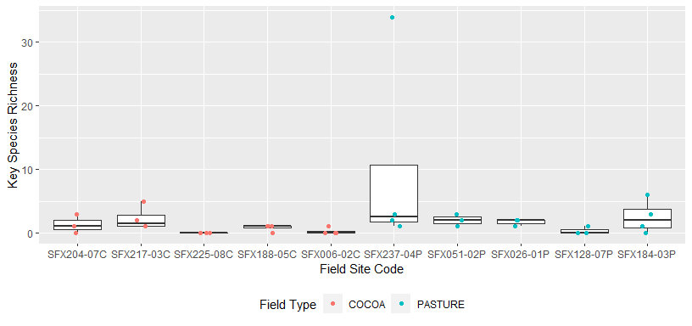

Figure X: Key species richness by field site.

When comparing key species abundance between cocoa fields (intervention) and pasture (counterfactuals), We found that there was also no significant difference in key species abundance (Pr(>Chisq) = 0.2649; Fig. X).

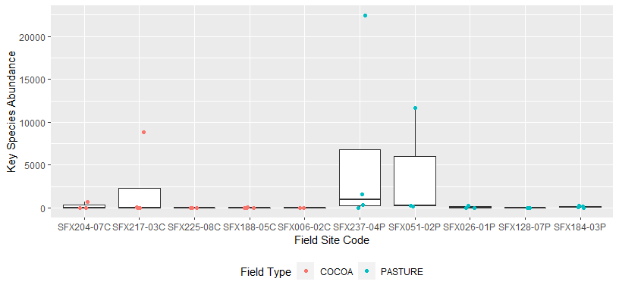

Figure X: Key species abundance (reads) by field site. Relative abundance is measured using the number of reads.

## General species richness, abundance, and diversity questions

In addition to examining key species, or species of particular importance, we also examined the community composition of mammal populations found on cocoa fields (intervention) and pastures (counterfactual).

### Question 1.5 & Biodiversity Indicator 6: Does species richness change over time compared to the counterfactual?

The mean species richness in cocoa fields was 34.9444444 species (SD = 28.7677765), while on pastures mean species richness was 44.2941176 (SD = 35.9492085). The number and abundance for all species for each plot and field is shown in Table 4.

Table 4: Richness and abundance of key species found in the TerraBio pilot in cocoa and pasture fields.

|  |  |  |  |  |
| --- | --- | --- | --- | --- |
| Plot | Field | Field Type | All Species Richn. | All Species Abund. |
| SFX204-07C-01 | SFX204-07C | COCOA | 57 | 122003 |
| SFX204-07C-02 | SFX204-07C | COCOA | 108 | 257986 |
| SFX204-07C-03 | SFX204-07C | COCOA | 25 | 71438 |
| SFX217-03C-01 | SFX217-03C | COCOA | 55 | 93522 |
| SFX217-03C-02 | SFX217-03C | COCOA | 39 | 22759 |
| SFX217-03C-03 | SFX217-03C | COCOA | 24 | 3603 |
| SFX217-03C-04 | SFX217-03C | COCOA | 91 | 91677 |
| SFX225-08C-01 | SFX225-08C | COCOA | 14 | 88038 |
| SFX225-08C-03 | SFX225-08C | COCOA | 25 | 98758 |
| SFX225-08C-04 | SFX225-08C | COCOA | 10 | 31556 |
| SFX188-05C-01 | SFX188-05C | COCOA | 40 | 37696 |
| SFX188-05C-02 | SFX188-05C | COCOA | 56 | 80470 |
| SFX188-05C-03 | SFX188-05C | COCOA | 18 | 27834 |
| SFX188-05C-04 | SFX188-05C | COCOA | 17 | 2077 |
| SFX006-02C-01 | SFX006-02C | COCOA | 8 | 5147 |
| SFX006-02C-02 | SFX006-02C | COCOA | 7 | 34382 |
| SFX006-02C-03 | SFX006-02C | COCOA | 10 | 6801 |
| SFX006-02C-04 | SFX006-02C | COCOA | 25 | 129940 |
| SFX237-04P-03 | SFX237-04P | PASTURE | 13 | 1117 |
| SFX237-04P-04 | SFX237-04P | PASTURE | 5 | 1807 |
| SFX051-02P-01 | SFX051-02P | PASTURE | 35 | 24289 |
| SFX051-02P-02 | SFX051-02P | PASTURE | 35 | 90563 |
| SFX051-02P-03 | SFX051-02P | PASTURE | 49 | 318418 |
| SFX026-01P-01 | SFX026-01P | PASTURE | 32 | 5408 |
| SFX026-01P-03 | SFX026-01P | PASTURE | 152 | 138670 |
| SFX026-01P-04 | SFX026-01P | PASTURE | 56 | 16557 |
| SFX128-07P-02 | SFX128-07P | PASTURE | 11 | 863 |
| SFX128-07P-03 | SFX128-07P | PASTURE | 10 | 9798 |
| SFX128-07P-04 | SFX128-07P | PASTURE | 13 | 4710 |
| SFX184-03P-01 | SFX184-03P | PASTURE | 41 | 51302 |
| SFX184-03P-03 | SFX184-03P | PASTURE | 29 | 27824 |
| SFX184-03P-02 | SFX184-03P | PASTURE | 81 | 63783 |
| SFX184-03P-04 | SFX184-03P | PASTURE | 58 | 163058 |
| SFX237-04P-01 | SFX237-04P | PASTURE | 62 | 39449 |
| SFX237-04P-02 | SFX237-04P | PASTURE | 71 | 210027 |

When comparing total species richness between cocoa fields (intervention) and pasture (counterfactuals), we found there was no significant difference in OTU richness (Pr(>Chisq) = 0.529; Fig. X).

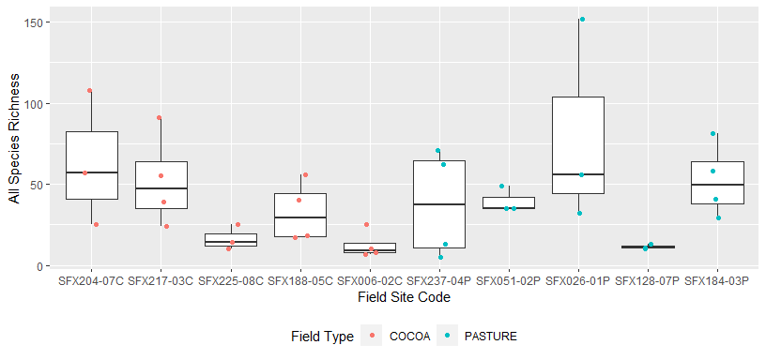

Figure 3: Total species richness by field site.

### Question 1.6: Does relative abundance of species change over time compared to counterfactual?

When comparing total species abundance between cocoa fields (intervention) and pasture (counterfactuals), we found that they was similarly no significant difference between the field types (Pr(>Chisq) = 0.9676; Fig. X).

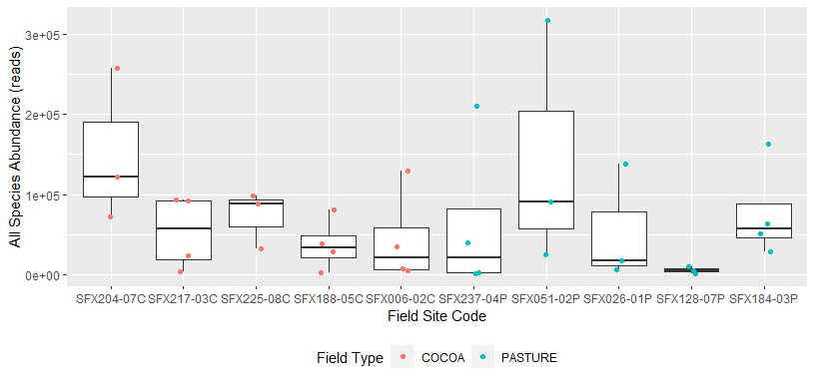

Figure 4: Total species abundance (reads) by field site. Relative abundance is measured using the number of reads.

### Question 1.7: Are there changes in Shannon’s diversity index (and others) over time compared to the counterfactual? & Biodiversity Indicator 7: Change in biodiversity indices due to interventions.

Results from calculating multiple diversity indices/metrics for each site are shown in Table 5. Overall alpha diversity was 39.5, gamma diversity was 1012, and beta diversity was 25.6202532.

Table 5: Diversity indices found in the TerraBio pilot in cocoa and pasture fields.

|  |  |  |  |  |  |  |
| --- | --- | --- | --- | --- | --- | --- |
| Plot | Shannon | Simpson | Pielou | Effective Sp. Richn. | Absolute Dominance | Relative Dominance |
| SFX004-01F-03 | 0.0743 | 0.0184 | 0.0252 | 1.0771 | 72295 | 0.0271 |
| SFX004-01F-04 | 0.4067 | 0.1492 | 0.1196 | 1.5018 | 123987 | 0.0464 |
| SFX004-01F-99 | 1.2905 | 0.5148 | 0.3038 | 3.6346 | 61889 | 0.0232 |
| SFX006-02C-01 | 0.6474 | 0.3100 | 0.3114 | 1.9106 | 4234 | 0.0016 |
| SFX006-02C-02 | 0.2910 | 0.1312 | 0.1496 | 1.3378 | 31979 | 0.0120 |
| SFX006-02C-03 | 1.4067 | 0.7245 | 0.6109 | 4.0823 | 2157 | 0.0008 |
| SFX006-02C-04 | 0.0990 | 0.0284 | 0.0308 | 1.1041 | 128075 | 0.0479 |
| SFX026-01P-01 | 1.7978 | 0.7557 | 0.5187 | 6.0366 | 2048 | 0.0008 |
| SFX026-01P-03 | 1.3624 | 0.6102 | 0.2712 | 3.9056 | 71435 | 0.0267 |
| SFX026-01P-04 | 1.5470 | 0.6052 | 0.3843 | 4.6975 | 9987 | 0.0037 |
| SFX051-02P-01 | 1.9960 | 0.7389 | 0.5614 | 7.3595 | 11619 | 0.0043 |
| SFX051-02P-02 | 0.9191 | 0.4238 | 0.2585 | 2.5070 | 67318 | 0.0252 |
| SFX051-02P-03 | 0.0718 | 0.0200 | 0.0184 | 1.0744 | 315213 | 0.1180 |
| SFX128-07P-02 | 1.5008 | 0.6803 | 0.6259 | 4.4851 | 436 | 0.0002 |
| SFX128-07P-03 | 0.7899 | 0.4266 | 0.3431 | 2.2032 | 7096 | 0.0027 |
| SFX128-07P-04 | 1.2565 | 0.6068 | 0.4899 | 3.5131 | 2571 | 0.0010 |
| SFX184-03P-01 | 1.2235 | 0.6509 | 0.3295 | 3.3992 | 20914 | 0.0078 |
| SFX184-03P-02 | 0.9982 | 0.4477 | 0.2272 | 2.7134 | 46087 | 0.0172 |
| SFX184-03P-03 | 0.9938 | 0.3965 | 0.2951 | 2.7016 | 21379 | 0.0080 |
| SFX184-03P-04 | 0.5679 | 0.2211 | 0.1399 | 1.7645 | 143404 | 0.0537 |
| SFX188-05C-01 | 0.9905 | 0.4618 | 0.2685 | 2.6927 | 26394 | 0.0099 |
| SFX188-05C-02 | 1.0766 | 0.4470 | 0.2674 | 2.9346 | 58784 | 0.0220 |
| SFX188-05C-03 | 0.5780 | 0.2451 | 0.2000 | 1.7825 | 24050 | 0.0090 |
| SFX188-05C-04 | 1.6143 | 0.6957 | 0.5698 | 5.0243 | 1021 | 0.0004 |
| SFX204-07C-01 | 1.2104 | 0.5133 | 0.2994 | 3.3547 | 81768 | 0.0306 |
| SFX204-07C-02 | 0.5605 | 0.1794 | 0.1197 | 1.7515 | 233531 | 0.0874 |
| SFX204-07C-03 | 0.8639 | 0.4668 | 0.2684 | 2.3725 | 48464 | 0.0181 |
| SFX217-03C-01 | 1.4638 | 0.6847 | 0.3653 | 4.3225 | 39128 | 0.0146 |
| SFX217-03C-02 | 1.7284 | 0.6951 | 0.4718 | 5.6314 | 11076 | 0.0041 |
| SFX217-03C-03 | 1.8784 | 0.7740 | 0.5911 | 6.5431 | 1424 | 0.0005 |
| SFX217-03C-04 | 1.8612 | 0.7683 | 0.4126 | 6.4314 | 35758 | 0.0134 |
| SFX225-08C-01 | 0.0828 | 0.0249 | 0.0314 | 1.0863 | 86934 | 0.0325 |
| SFX225-08C-03 | 0.0555 | 0.0141 | 0.0173 | 1.0571 | 98058 | 0.0367 |
| SFX225-08C-04 | 0.1331 | 0.0413 | 0.0578 | 1.1423 | 30896 | 0.0116 |
| SFX237-04P-01 | 1.3762 | 0.6423 | 0.3334 | 3.9597 | 21277 | 0.0080 |
| SFX237-04P-02 | 0.7592 | 0.4366 | 0.1781 | 2.1366 | 146296 | 0.0547 |
| SFX237-04P-03 | 1.8029 | 0.7901 | 0.7029 | 6.0669 | 354 | 0.0001 |
| SFX237-04P-04 | 0.6339 | 0.2949 | 0.3939 | 1.8850 | 1507 | 0.0006 |

When comparing diversity indicies between cocoa fields (intervention) and pasture (counterfactuals), we found that there were no significant differences for Shannon Diversity (Pr(>Chisq) = 0.3462; Fig. X) or for Effective Species Richness (Pr(>Chisq) = 0.4579; Fig. X).

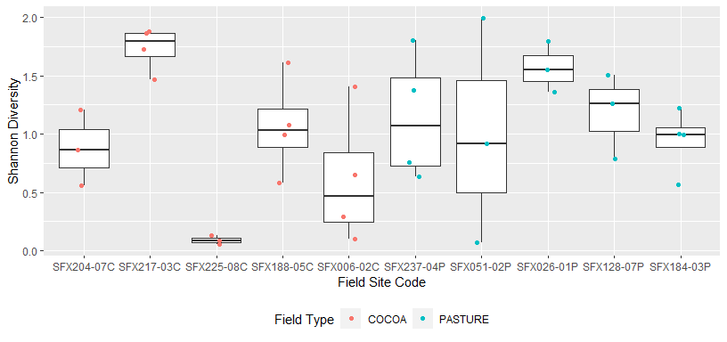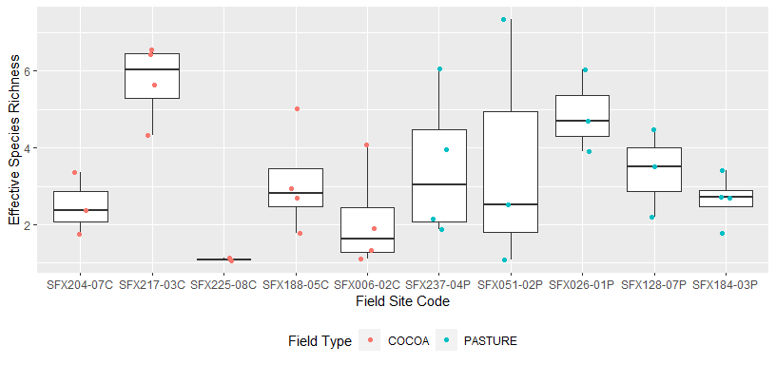

# References

De Cáceres, M., Legendre, P., Wiser, S.K. and Brotons, L. 2012. Using species combinations in indicator analyses. Methods in Ecology and Evolution 3(6): 973-982.

Bakker, J.D., 2008. Increasing the utility of indicator species analysis. Journal of Applied Ecology, 45(6), pp.1829-1835.