Olympic Weightlifting  
Competition Management System

v2.16.0

OWLCMS Installation Guide (Windows)

Jean-François Lamy

lamyjeanfrancois@gmail.com

# About this guide

This guide describes the installation procedure for the Olympic Weightlifting Competition Management System for the Windows operating system[1]. The procedures described here have been tested under Windows 7 and Windows 8.

# Pre-requisites

* **You must have Administrator rights on the computer**. This is normally the case for a personal laptop.
* **You need a version of Java**. Most computers have Java installed. If not,
  + Download and execute the installer for Java 7 from <http://java.com/download>
  + Make sure to UNCHECK the checkboxes related to the “Ask” toolbar and search engine – you do NOT want them.
  + Do NOT execute the “Check Java Version” check; you should IGNORE all the errors about the Java plug-in – you do NOT need the Java plug-in for running the system – you can just close the browser window.
* **You need a recent Internet Browser**: Chrome is the recommended choice. The system is also known to work well under Firefox. Recent versions of Internet Explorer (version 9 and newer) also appear to work well.

# Downloading the installation files

The most current Windows installer is accessible as a big green button on the page <https://sourceforge.net/projects/owlcms2/>

* **Download the installer:** Click on the big green button

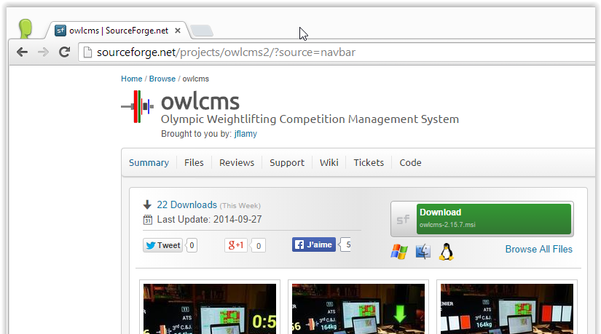

Release notes are visible at the bottom of the “Files” section of the Web site, and are also included in the installation package.

# Installing the System

* **Start the program:** After the download completes, start the installation process. You will be prompted to authorize the installer with a prompt similar to the following. For Windows 8, you will get a prompt telling you that the program is potentially dangerous; select the “Run Anyway” option.  
  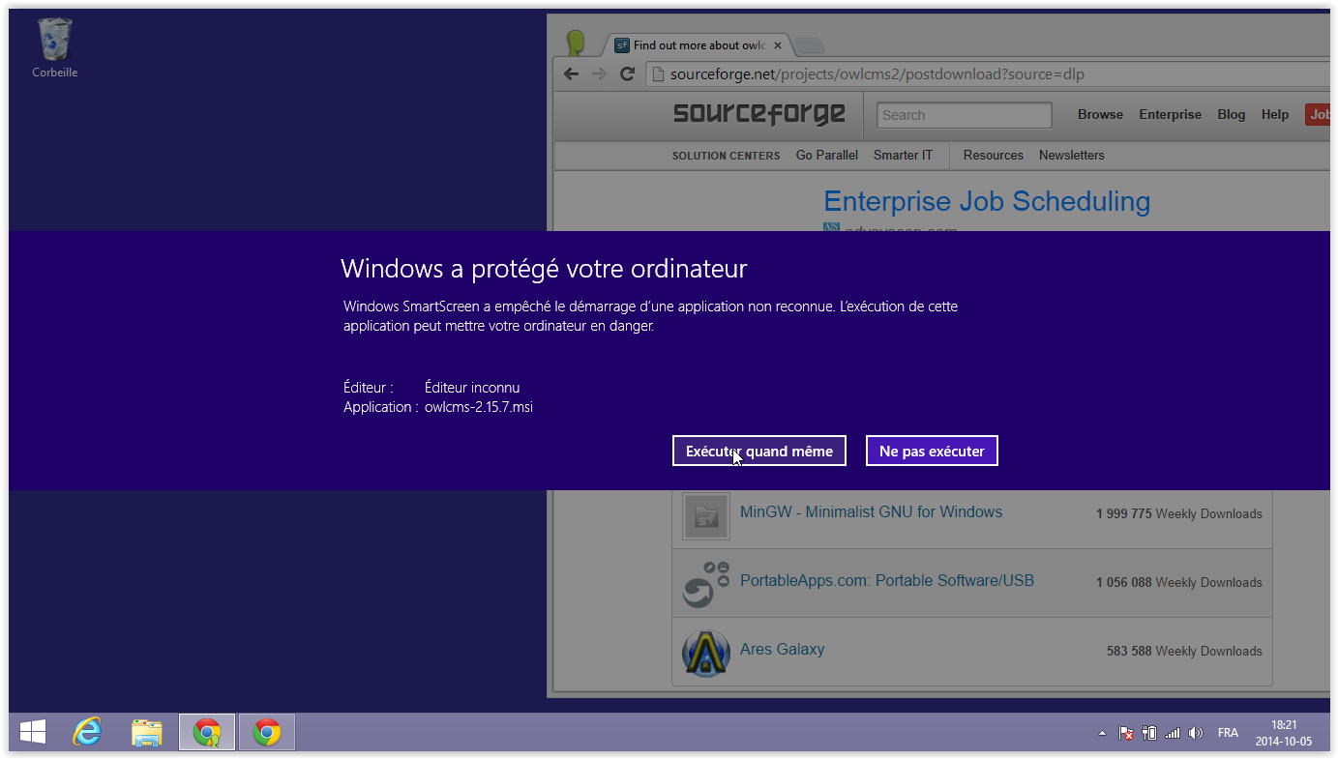
* **Click to run the installer:** You will then get to select the language under which you want to run the installer, and then the actual installer will start. Keep using the “Next >” button until you reach the final screen.

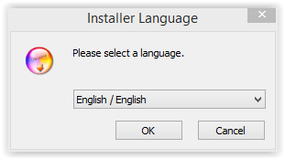. 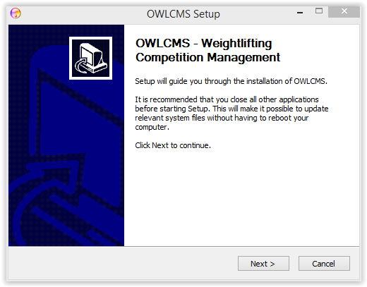

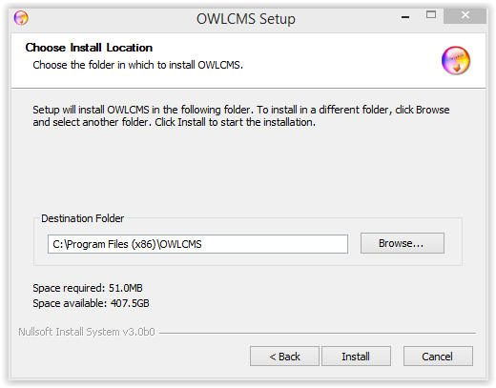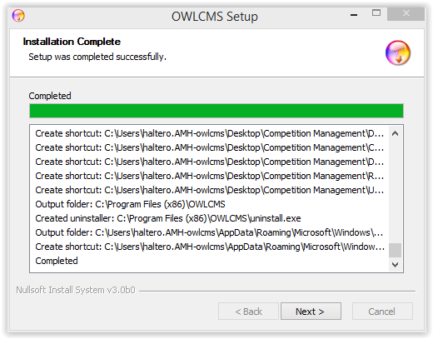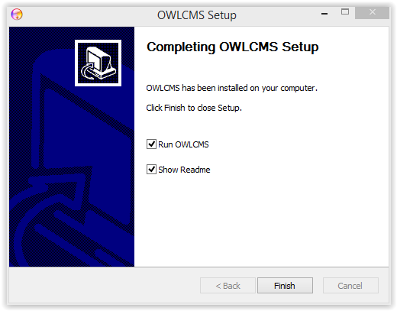  
.Once you hit “Finish” the system will start.

* **Accept Firewall adjustments:** On the first attempt to run the application, the Windows firewall will detect that OWLCMS wants to accept network connections. It will prompt you to authorize this. **Accept the suggested changes**.
* **Check correct installation:** An icon which looks like weightlifting plates on a bar will be shown at the bottom of the screen. A black window filled with technical messages will show up. 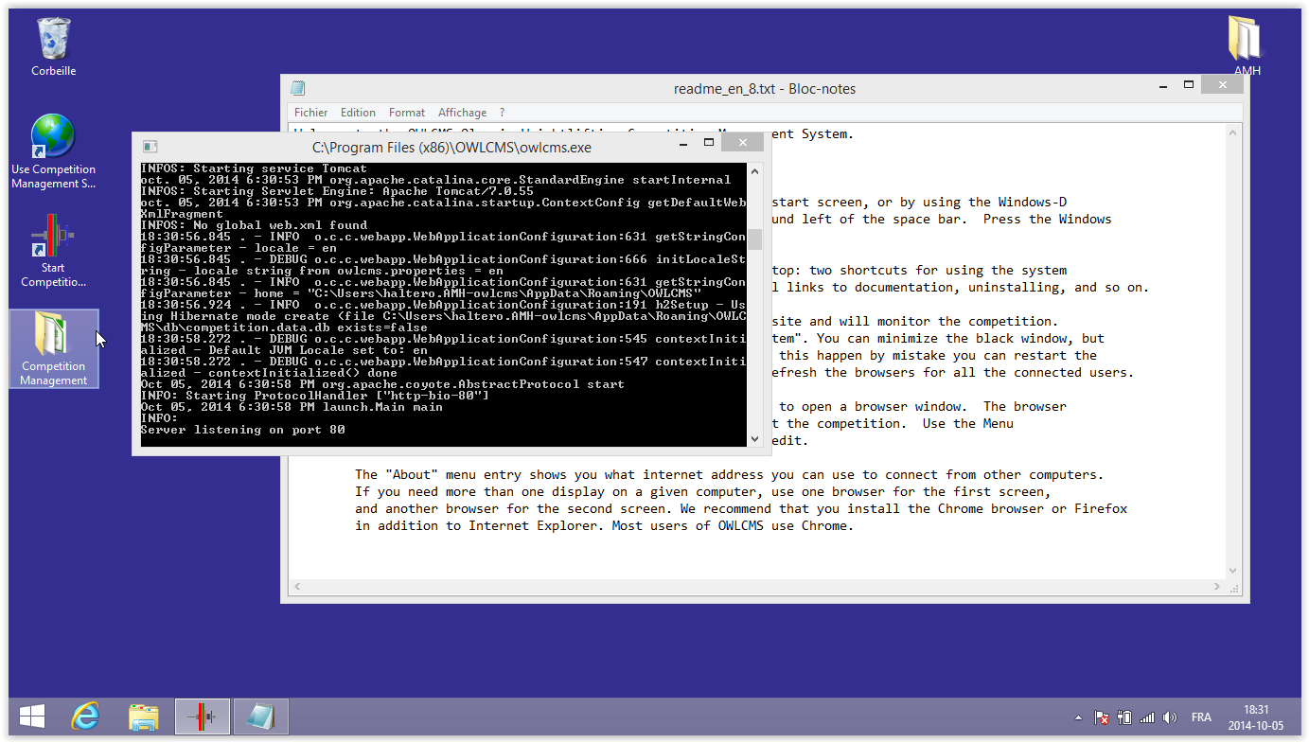

# Accessing shortcuts, data files, documentation and configuration

## Finding the Desktop

On Windows 7, you are automatically sent to the Desktop.

On Windows 8, you need to click on the Desktop tile on the Start Screen. Look for a tile called Desktop.

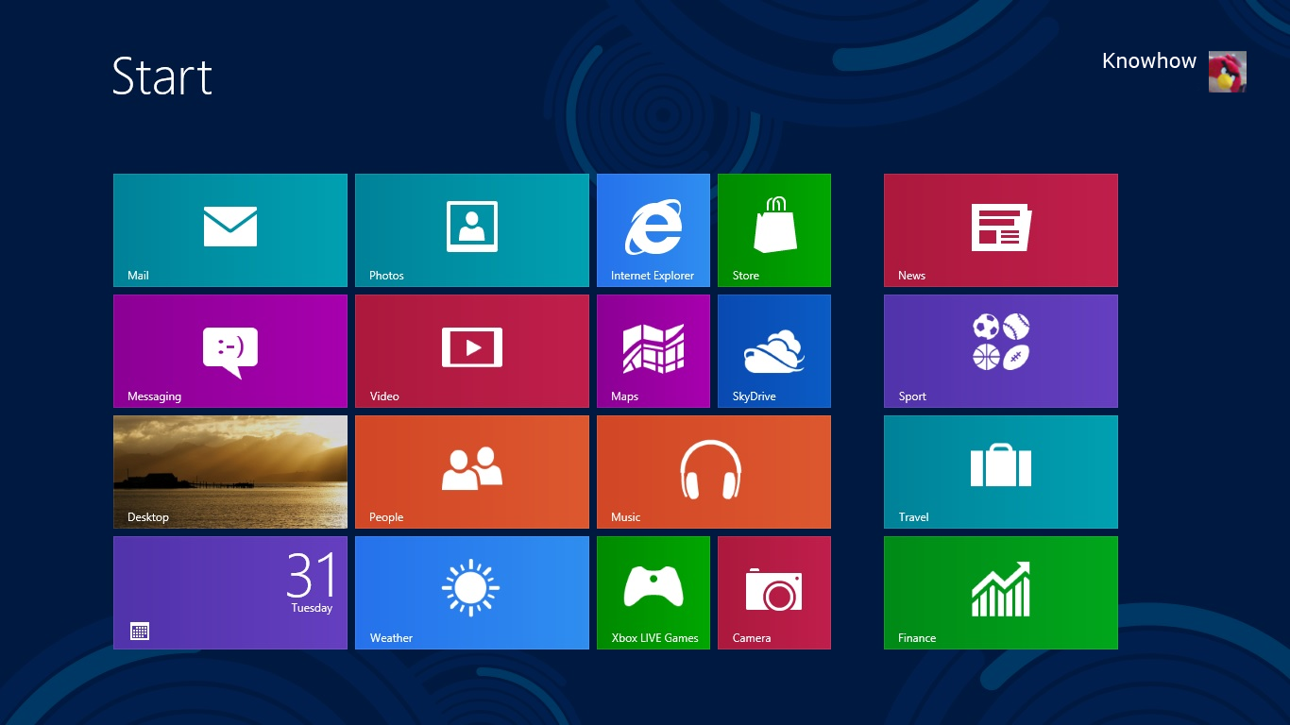

## Desktop shortcuts

* **There should now be 3 new items on the screen:**
* One to start the OWLCMS system (the black window) again – it looks like a set of bumper plates.
* One to start a web browser session to connect to OWLCMS, which looks like a browser icon (a sphere in the next image
* A folder that contains links to documentation and other items (uninstall, etc.)

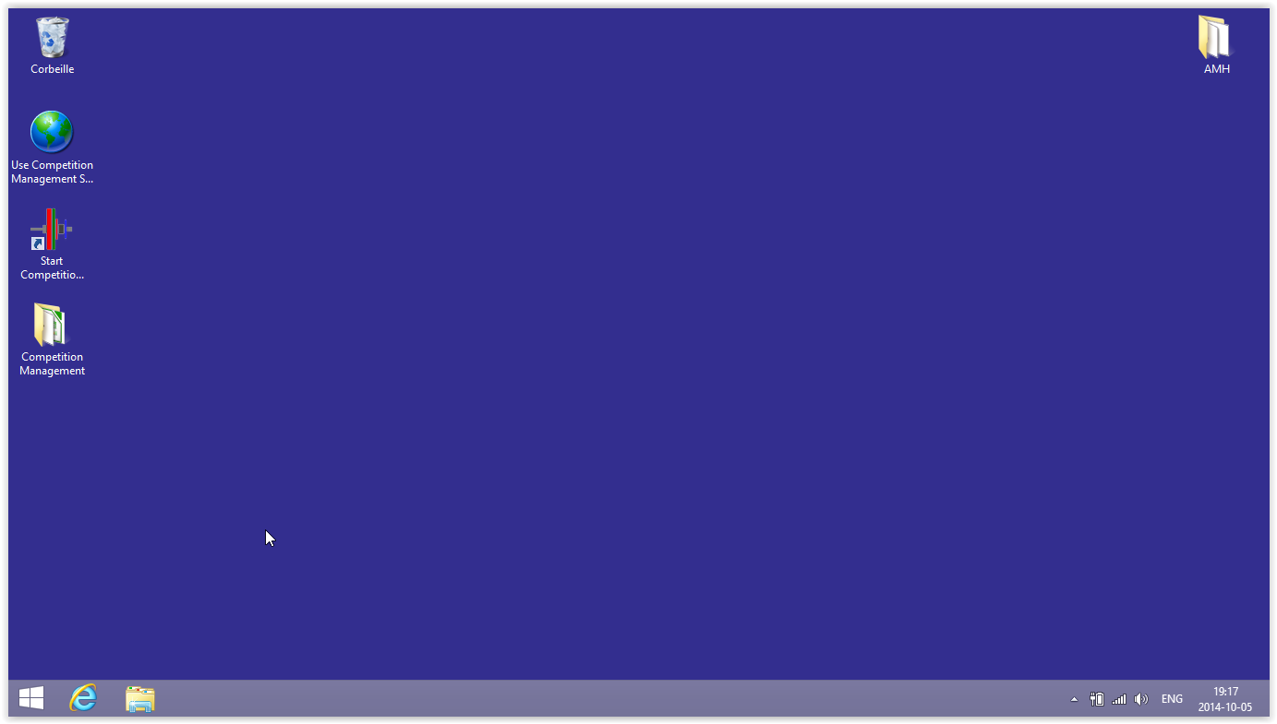

* The folder contains additional links to documentation, configuration, templates, etc.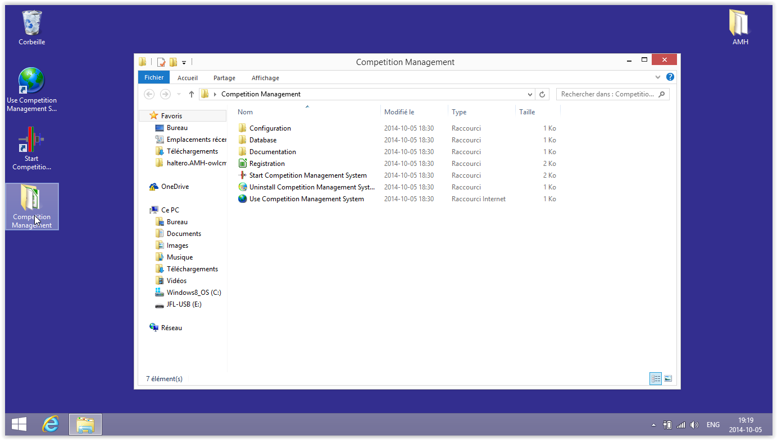

# Using the system

## Using the system from the main laptop

* **Access the competition management application from the main laptop:** Double click the shortcut named “Competition App”. You should see something similar to the following (using your own default browser).

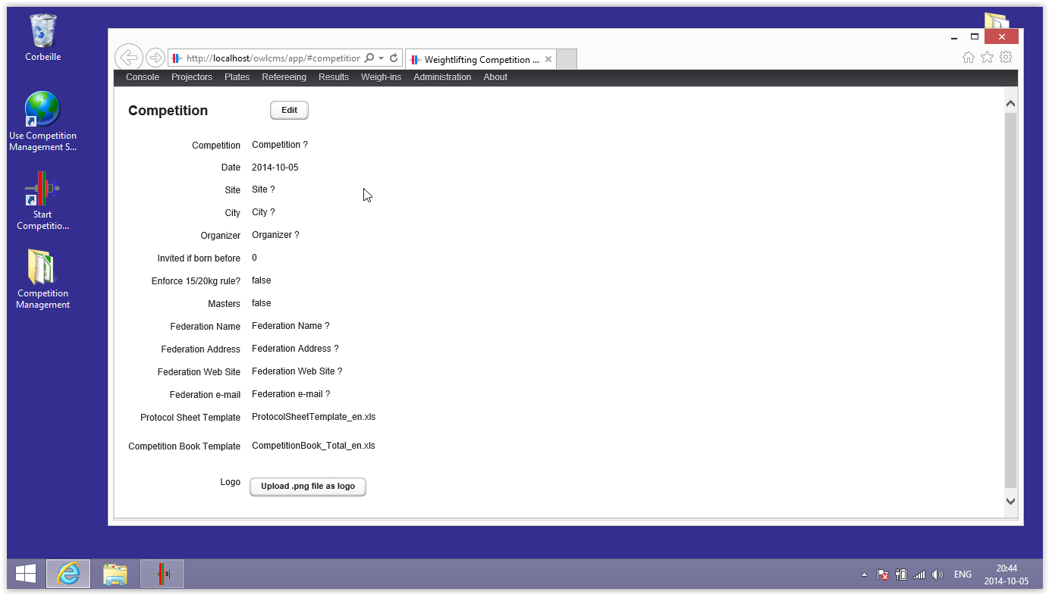

## Using the system from another laptop

In order to run several displays or projectors, you will need other laptops or TV boxes or tablets. They will need to connect to the main laptop, exactly as if the main laptop was a Web site on the Internet.

In order to do this, you will need to enter a URL in the browser of the other devices.

* **To find the address of the main laptop** go to the “About” menu in the application.You will see a list of one or more URLs starting with http://. The system attempts to show connections in the preferred order (wired connections are preferred to wireless connections), so you should try them in the order given.  
  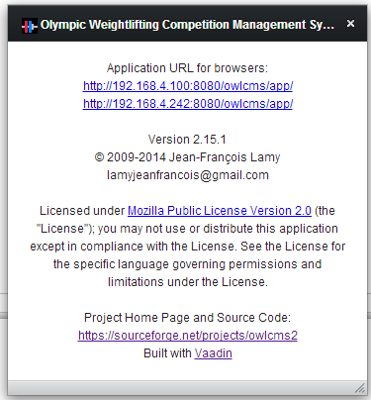
* **For laptops and TV boxes, enter the URL.** Try the addresses in the order given, so  
  http://192.168.4.100:8080/owlcms/app/  
  would be your first choice. You should then follow the instructions in the Competition Set-up Guide and the Announcer Quick Start Guide to get going.
* **For tablets and mobile phones:** for these devices, a subset of the application features, notably refereeing displays and timekeeping displays are available. The URL is similar to that for the application, you need to replace “/app/” with “/m/#mobileHome” as in the following example – of course, you must use the actual IP address for your laptop)  
  http://192.168.4.100:8080/owlcms/m/#mobileHome

# Stopping the system

The system runs in a so-called “console” window (the black window that started at the end of the install). The window will normally become hidden by other windows (as exemplified in the previous screen shot). When the system is run subsequently, the console is started “minimized”, meaning that it will show up only in the task bar at the bottom of the screen.

* **Locate the icon for the competition system in the task bar:** The icon is a square with colored lifting plates (similar to the following – the actual look may differ)

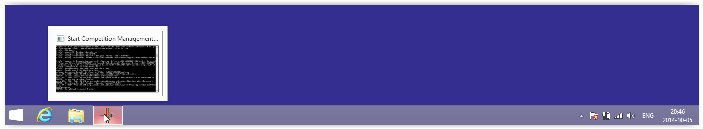

* **Close the console window:** There are two ways to do this
  1. Right-click on the icon and use the “close window” option
  2. Click on the icon, which will bring the black console to the forefront. Use the regular “close” button at the top right  
     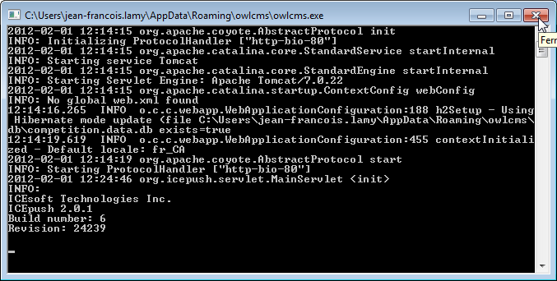

# Customizing

The configuration file is located in the standard Windows “AppData” directory, which is normally hidden. You may use the procedure in section 5 to locate the shortcut to the Configuration files.

## Overriding program locations

The program shortcuts use -Dowlcms.dir=*programLocation* and -Dowlcms.home=*dataFileLocation* options to indicate where the program executables and the program data files are located. You can change the shortcuts to refer another location.[2]

Alternately, you can define the OWLCMS_DIR and OWLCMS_HOME environment variables on your Windows machine. These variables, if defined, take precedence.

## Changing configuration options

The configuration file is found under owlcms.home and is called owlcms.properties, and contains the following values:

|  |  |
| --- | --- |
| owlcms.locale=en_US | Set this to your own locale; this will take precedence over OWLCMS_LOCALE environment variable |
| owlcms.useRegistrationCategory=false | Set to true to use the athlete's registration category instead of the dynamically computed one. This is useful if you create additional categories for juniors (as an example) and end up having several categories for the same bodyweight. |
| owlcms.useBirthYear=false | Set to true to use birth year instead of full YYYY-MM-dd as required by IWF rules. |
| owlcms.useBrowserLanguage=true | Set to true to have different browsers use different languages according to user preferences instead of owlcms.locale True is useful when different screens need to be in different languages (such as English and the local language). Set to false so all browsers use the same language, ignoring the settings for each browser. |
| owlcms.dbPath=db/competition | If given as an absolute path, it is used as the database location).  If given as a relative path, is searched under OWLCMS_HOME; if not found, is also sought under WEB-INF/classes in the web application directory. |
| owlcms.host=80 | Stand-alone windows launcher only: if you get messages about port 80 being in use, you can change this to 8080 for example. You then need to adjust your browser shortcuts accordingly (adding :8080 after the Internet host name) |

# Uninstalling

* **Stop the system**
* **Copy the data files:**  If you need them, usethe “Configuration” entry in the “Competition Management” folder on the desktop to get to the directory that contains the configuration and data files.

If files are removed, the system will recreate new ones when it is started.

* **Perform the uninstall:** Locate the Uninstall shortcut in the “Competition Management” folder, or alternately, use the Control Panel to uninstall

1. The system is also available as a Linux tar, and as a platform-neutral Java WAR archive. These two formats are targeted at advanced users and information technology professionals. For repeated use on large competitions, the WAR format using a full-capability web server program such as Tomcat is recommended. Contact the author for more information.
2. If running a Tomcat server, you may want to define owlcms.home in the “catalina.properties” file. You would then copy the owlcms.properties, db and templates files from the WEB-INF/classes directory to that new location. You would then edit owlcms.properties as described in this section.