1. **Association rules mining**

Based on my ANU ID u5326448,

* 1. Database:

|  |  |  |
| --- | --- | --- |
| Trans id | Item-set |  |
| t1 | a, b, e ,f |  |
| t2 | a, b, c, e ,f |  |
| t3 | b, c ,e |  |
| t4 | a, b, c, e ,f |  |
| t5 | b, c ,e |  |
| t6 | c, d, e |  |
| t7 | b, c ,f |  |
| t8 | a, b, d, f | [digit for ANU ID：4] |
| t9 | c, d, e | [digit for ANU ID：4] |
| t10 | a, b, c | [digit for ANU ID：8] |

* 1. Large 2 item-sets:

|  |  |
| --- | --- |
| Item-set | Count |
| a, b | 5 |
| a, c | 3 |
| a, e | 3 |
| a, f | 4 |
| b, c | 6 |
| b, e | 5 |
| b, f | 5 |
| c, e | 6 |
| c, f | 3 |
| e, f | 3 |

* 1. Large 3 item-sets:

|  |  |
| --- | --- |
| Item-set | Count |
| a, b, c | 3 |
| a, b, e | 3 |
| a, b, f | 4 |
| a, e, f | 3 |
| b, c, e | 3 |
| b, c, f | 3 |
| b, e, f | 3 |

* 1. Candidate 4 item-sets:

|  |  |
| --- | --- |
| Item-set |  |
| a, b, e, f |  |
| a, b, c, e <- Prunned | in Apriori prune step |

Some length 3 item-sets included in {a, b, c, e} are not in Large 3 item-sets, for example, {a, c, e} is not in L3. Thus, {a, b, c, e} need to be pruned.

Large 4 item-sets:

|  |  |
| --- | --- |
| Item-set | Count |
| a, b, e, f | 3 |

* 1. Frequent rules of length 3 from first two large 3 item-sets:

|  |  |  |  |
| --- | --- | --- | --- |
| Rule | Support | Confidence | Lift |
| (a, b) -> c | 30 | 60 | 0.75 |
| (a, c) -> b | 30 | 100 | 1.25 |
| (b, c) -> a | 30 | 50 | 1.00 |
| (a, b) -> e | 40 | 60 | 0.85 |
| (a, e) -> b | 40 | 100 | 1.25 |
| (b,e) -> a | 40 | 60 | 1.20 |

1. **Characteristics of clustering algorithms**
2. AGNES

(1). Arbitrary shape.

(2). Input final stop numbers of clusters *k*

(3). Time complexity is at least $Ο(n^{2}\log{n})$, n is the number of data points. No

object function may be minimized directly.

1. CLARA

(1). Connectivity models (data point with linking).

(2). *K* samples and applies PAM on each sample.

(3). Efficiency based on the size of samples. A good sample based clustering

might not necessarily represent a good clustering of the whole data set if the sample is biased.

1. DBSCAN

(1). Arbitrary shape.

(2). $ε$ (eps) and the minimum number of points.

(3). It is not entirely deterministic. It is difficult to choose a distance threshold $ε$ if the scale and data are not well understood.

1. *k*-means

(1). Spherical shape.

(2). Input numbers of clusters *k*

(3). It may have problems when the data contains outliers. It also has problems when clusters are of differing size and densities.

1. **Classifier accuracy measures**
2. Uni ID: 5326448

TP = 53264

FP = 26448

TN = 326448

FN = 532

1. Confusion matrix:

|  |  |  |  |
| --- | --- | --- | --- |
|  | Pred Pos | Pred Neg |  |
| True Pos | 53264 | 532 |  |
| True Neg | 26448 | 326448 | Total: 406692 |

1. Normalised confusion matrix:

|  |  |  |
| --- | --- | --- |
|  | Pred Pos | Pred Neg |
| True Pos | 0.13097 | 0.00131 |
| True Neg | 0.06503 | 0.80269 |

1. Accuracy = (true_pos + true_neg) / (all_class_pos + all_class_neg)

= (53264 + 326448) / (53264 + 26448 + 326448 + 532)

= 93.37%

Error rate = 1 – Accuracy = 1 – 93.37% = 6.63%

1. and (5)

Specificity = true_neg / all_true_neg = 326448 / (26448 + 326448) = 92.51%

Precision = true_pos / (true_pos + false_pos)

= 53264 / (53264 + 26448) = 66.82%

Recall = true_pos / all_true_pos = 53264 / (53264 + 532) = 99.01%

F-measure = 2 * Precision * Recall / (Precision + Recall)

= 2 * 66.82% * 99.01% / (66.82% + 99.01%)

= 79.79% (Wikipedia, 2016)

1. Balanced Classification Rate = 1/2(Specificity + Recall)

= 1/2(92.51% + 99.01%) = 95.76%

Since True_pos << True_neg, thus we consider that harmonic mean of precision and recall would be more accurate. I choose F-measure as measurement. F1-score is 79.79%, so I think this classification problem is balanced.

1. **Decision tree classification**
2. Gender = Male, Age = Young, it is true positive and class= Pre_Neg, thus the record is a false negative.
3. Gender = Male, Age = Old, Has_car = No, it is true positive and class= Pre_Neg, thus the record is a false negative.
4. Gender = Female, Student = No, it is true negative and class= Pre_Neg, thus the record is a true negative.
5. Gender = Female, Student = Yes, Employed = Yes, it is true negative and class= Pre_Pos, thus the record is a false positive .
6. **Data mining project**

Data set: <http://archive.ics.uci.edu/ml/machine-learning-databases/forest-fires/>

|  |  |  |  |  |  |  |
| --- | --- | --- | --- | --- | --- | --- |
| Variable | Data Type | Comment | Maximum | Minimum | Mean | Median |
| X | Numeric | 9 | 9.000 | 1.000 | 4.598 | 4.000 |
| Y | Numeric | 7 | 9.000 | 2.000 | 4.244 | 4.000 |
| month | Categoric | 12 | August | June | / | / |
| day | Categoric | 7 | Sunday | Wednesday | / | / |
| Temp | Numeric | 192 | 33.30 | 2.20 | 18.81 | 19.30 |
| RH | Numeric | 75 | 100.0 | 15.0 | 44.5 | 42.0 |
| Wind | Numeric | 21 | 9.400 | 0.900 | 3.963 | 4.000 |
| Rain | Numeric | 7 | 1.40000 | 0.00000 | 0.00831 | 0.00000 |
| area | Numeric | 251 | 746.28 | 0.00 | 10.94 | 0.00 |

When we choose rain and area:

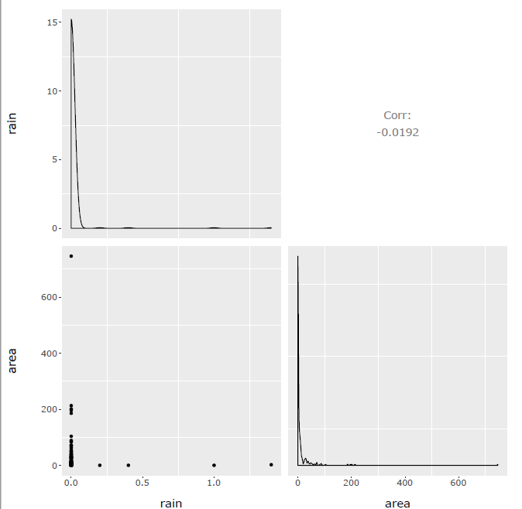

When we choose wind and area:

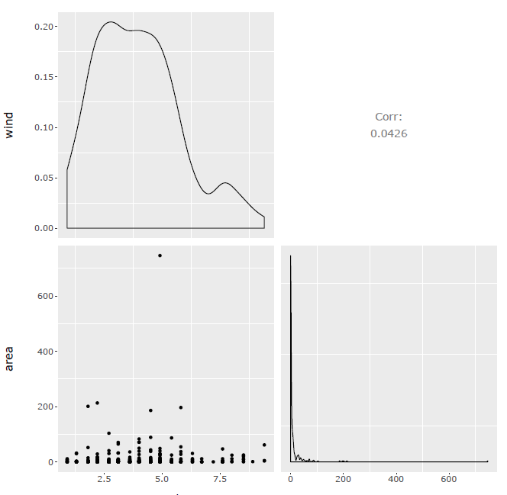

When we choose rain, area and month together:

