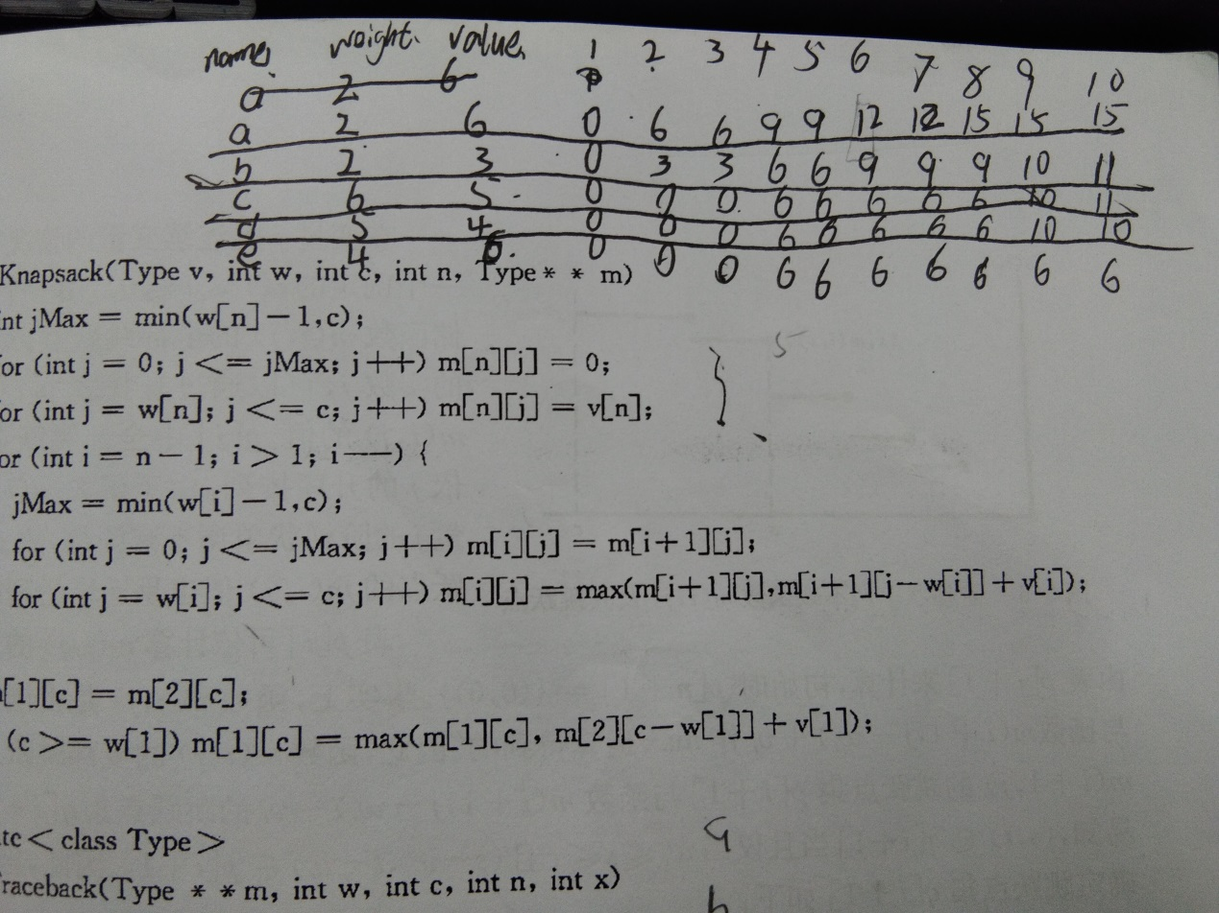

**package** com.whj.bag;

**import** java.util.Scanner;

**public** **class** Bag {

**public** **static** **void** main(String[] args) {

Scanner sca = **new** Scanner(System.***in***);

System.***out***.println("请输入物品的个数:");

**int** n = sca.nextInt();

System.***out***.println("请输入背包的重量:");

**int** c = sca.nextInt();

**int** m[][] = **new** **int**[n+1][c+1];

**int** w[] = **new** **int**[n+1];

**int** v[] = **new** **int**[n+1];

**int** x[] = **new** **int**[n+1];

w[0] = 0;

v[0] = 0;

System.***out***.println("请输入每件物品的重量及价值:");

**for**(**int** i=1;i<=n;i++) {

w[i]= sca.nextInt();

v[i]= sca.nextInt();

}

*Knapsack*(v,w,c,n,m);

*Trackback*(m,w,c,n,x);

System.***out***.println(m[1][c]);

System.***out***.println("物品的装入情况如下:");

**for**(**int** i=1;i<=n;i++)

{

**if**(x[i] == 1)

System.***out***.println(i+"号物品被装入");

}

}

**public** **static** **void** Knapsack(**int** v[],**int** w[], **int** c,**int** n,**int** m[][]) {

**int** jMax = (w[n]-1)<c ? (w[n]-1) : c;

**for**(**int** j=0;j<=jMax;j++) m[n][j] = 0;

**for**(**int** j=w[n];j<=c;j++) m[n][j] = v[n];

**for**(**int** i=n-1;i>1;i--){

jMax = (w[i]-1)<c ? (w[i]-1) : c;

**for**(**int** j=0;j<=jMax;j++)

m[i][j] = m[i+1][j];

**for**(**int** j=w[i];j<=c;j++)

m[i][j] = m[i+1][j]<(m[i+1][j-w[i]]+v[i]) ? (m[i+1][j-w[i]]+v[i]) : m[i+1][j];

}

m[1][c] = m[2][c];

**if**(c>=w[1])

m[1][c] = m[1][c]<(m[2][c-w[1]]+v[1]) ? (m[2][c-w[1]]+v[1]) : m[1][c];

}

**static** **void** Trackback(**int** m[][],**int** w[],**int** c,**int** n,**int** x[]){

**for**(**int** i=1;i<n;i++) {

**if**(m[i][c]==m[i+1][c]) x[i] = 0;

**else** {

x[i] =1;

c-= w[i];

}

x[n] = (m[n][c]!=0) ? 1: 0;

}

}

}