**ELEC352 - Task 3 - Part B**

|  |  |
| --- | --- |
| **Group number:** | |
| **PM:Zekun Li** | **Secretary:Yuhao Zhu** |

1. Please calculate your answers on paper then enter your **Depreciation Value** in the box below.

***Residual value after 3.5 years: £54331.63***

In this part, the depreciation of some instruments will be calculated. The costs of buying them are included in the prime cost of this project and they are part of the direct materials [1].

Table 1: Cost of Equipment for Different Projects

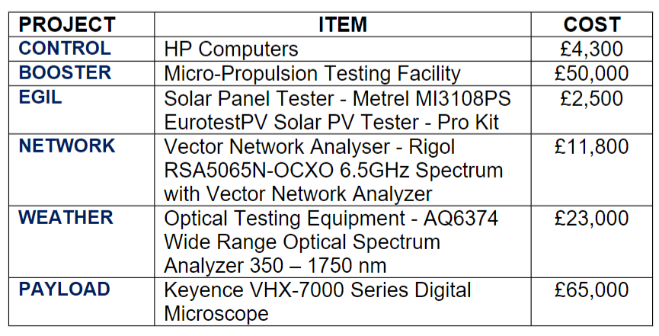

Due to daily use, age, and obsolescence (from technology or market changes), there are wear and tear, consumption, or other loss of value of fixed assets, and depreciation is a financial measure of these losses [2].

To calculate the depreciation of the equipment, the time-based reducing balance method (diminishing balance method) is used [3]. This method calculates the depreciation by multiplying depreciation rate to the book value of the asset this year, as a consequence of which, the value of depreciation decreases year by year as the book value decreases [].

According to the information given by the question, the depreciation rates of these instruments are the same – 5% per year.

For our payload system project, the cost of Keyence VHX-7000 Series Digital Microscope is taken into consideration:

$$\begin{aligned}v1=65000\#\end{aligned}$$

Depreciation of the first year:

$$\begin{aligned}d1=v1∗depreciation rate=65000∗5\%=3250\#\end{aligned}$$

Value at the end of the first year:

$$\begin{aligned}v2=v1−d1=65000−3250=61750\#\end{aligned}$$

Depreciation of the second year:

$$\begin{aligned}d2=v2∗depreciation rate=61750∗5\%=3087.5\#\end{aligned}$$

Value at the end of the second year:

$$\begin{aligned}v3=v2−d2=61750−3087.5=58662.5\#\end{aligned}$$

Depreciation of the third year:

$$\begin{aligned}d3=v3∗depreciation rate=58662.5∗5\%=2933.125≈2933.13\#\end{aligned}$$

Value at the end of the third year:

$$\begin{aligned}v4=v3−d3=58663.5−2933.13=55729.37\#\end{aligned}$$

Depreciation of the last half year:

$$\begin{aligned}d4=v4∗\frac{depreciation rate}{2}=55729.37∗5\%÷2=1393.23425≈1393.24\#\end{aligned}$$

Value at the end of the third year:

$$\begin{aligned}v_{residual}=v4−d4=55729.37−1393.24=54336.13\#\end{aligned}$$

As a result, the residual value after 3.5 years is: £54336.13

1. Please complete the table below

|  |  |  |
| --- | --- | --- |
| **Absorption base** | **OAR** | **Unit Cost** |
| ***Labour Hours*** | 6.897 £/h | $$£12601.85$$ |
| ***% on wages*** | 43.96%. | $$£8812.24$$ |
| ***% on prime cost*** | 21.28%. | $$£10682.95$$ |
| ***Machine hours*** | 6.897 £/h |  |

* 1. **Cost organization analysis**

In the cost organization, there is a cost centre, which is a department for the calculations of the operating cost [4]. The cost centre can be divided into two centres, which are factory (production cost centre), and Head office (non-production cost centre). The function of the factory is to manage the prime cost, which is the direct cost of producing a cost unit [5] and the production overheads, which are the indirect cost of the product manufacture [5]. The function of the Head office is to manage the cost related to the general overheads, such as Human resource and marketing.

In this project, the cost centre is widgets pay load system, the prime cost is given in the project, which are wages, and material, and the production overhead is also given in the project, which are labour hours, and machine hours. The general overhead is not given. Fig. 1 shows the cost organization of this project.

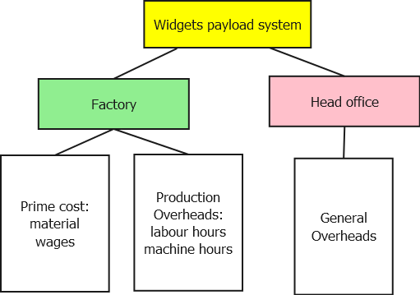

Figure 1 The cost organization of the payload system

* 1. **How to calculate Overhead Absorption Rate**

To work out the Overhead Absorption Rate, what should be done is that divide the overhead cost by the number of units which are going to be produced. For the payload system, both the total cost, either time or money, of the units and the total overhead for period are shown in Table 1 [6].

Table 1 The cost of all the units and total overhead for period

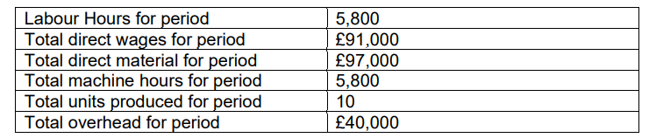

The formula of calculating Overhead Absorption Rate (OAR), which indicates the fraction of the production overheads allocated to each cost unit, is shown below.

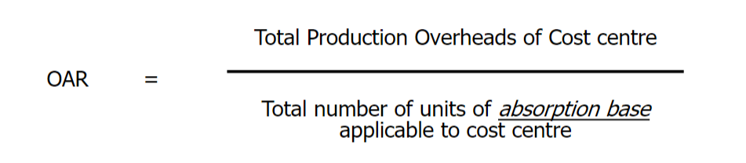

There are three essential steps for **overhead absorption**. These are:

* Determination of absorption bases, which includes labor hours, wages cost, prime cost, and machine hours.
* Working out the overhead absorption rate by using different formulas.
* Application of overhead to products at this worked-out rate to select the most suitable model.

The calculations of OAR based on different bases are demonstrated below.

**2.2.1The Overhead Absorption Rate based on the Labour Hours**

The calculation of overhead absorption may be carried out when a product which is labour intensive is under manufacturing (therefore costly in labour). Within the calculation, the overhead absorption rate is calculated by dividing the expected overhead attributable to the production by the appropriate number of direct labour hours. To find the direct labour hour rate, the following calculation is performed [6].

$$\begin{aligned}Direct labour hour rate=\frac{Overhead for the specific period}{Direct labour hours for the same period}\#\end{aligned}$$

Substitute the data shown in table 1 into the formula shown above, the calculation is shown below.

$$\begin{aligned}Overhead Absorption Rate=\frac{£40,000}{5800}=6.897£/h\#\end{aligned}$$

Hence, the OAR of the labour hours is close to 6.897 £/h.

**2.2.2 The Overhead Absorption Rate based on the percentage of wages**

The method calculates the overhead absorption rate by giving the overhead expense that needs to be absorbed as a percentage of the cost of direct labour for the same period [6]. The calculation of the absorbed overhead can be represented as:

$$\begin{aligned}Overhead absorption rate\left(\%\right)=\frac{Actual overhead costs}{Actual cost of wages to produce the product}×100\%\end{aligned}$$

Substitute the data shown in table 1 into the formula shown above, the calculation is shown below.

$$\begin{aligned}Overhead absorption rate\left(\%\right)=\frac{£40,000}{£91,000}×100\%=43.96\%\#\end{aligned}$$

Hence, the OAR of the percentage on wages is close to 43.96%.

**2.2.3 The Overhead Absorption Rate based on the percentage of prime cost**

Under the condition that both the materials used and the labour (i.e., the wages) it takes to produce the product jointly led to factory overheads, the total cost of both material and labour should be accounted for when calculating the overhead absorption rate of the percentage on prime cost [6]. The percentage of prime costs finds the overhead absorption rate by dividing the total overhead by the total prime cost, which is shown below.

$$\begin{aligned}Overhead absorption rate=\frac{Budgeted or actual overhead}{Prime cost}×100\%\#\end{aligned}$$

Substitute the data shown in table 1 into the formula shown above, the calculation is shown below.

$$\begin{aligned}Overhead absorption rate=\frac{£40,000 }{\left(£91,000 +£97,000 \right)}×100\%=21.28\%\#\end{aligned}$$

Hence, the OAR of the percentage on prime cost is close to 21.28%.

**2.2.4 The Overhead Absorption Rate based on the Machine Hours**

The calculation of overheads is carried out when the machinery is predominantly used to manufacture a product. To work out the overheads, the expenses that are incurred from running the machine should be calculated. This will include things like the machine’s depreciation, how much power it uses, how much the insurance costs, and how much maintenance is needed [6]. To calculate the machine hour rate, the calculation shown below should be performed.

$$\begin{aligned}Machine hour rate=\frac{Estimated production overhead during specific time period}{Machine hours during that time period}\#\end{aligned}$$

Substitute the data shown in table 1 into the formula shown above, the calculation is shown below.

$$\begin{aligned}Machine hour rate=\frac{£40,000 }{5,800}=6.897£/h\#\end{aligned}$$

Hence, the OAR of the machine hours is close to 6.897 £/h.

* 1. **How to calculate the unit cost**

A unit cost is defined that the total expenditure incurred by a company to produce, store, and sell one unit of a particular product or service [7], which can be calculated by the formula:

$$Unit cost=Prime cost+share of total overhead cost$$

Where the prime cost is the total direct cost of producing a cost unit, and the total overhead cost is the indirect cost of producing a cost unit.

A cost unit has been produced in the above cost centre with following record:

Table 2 A cost unit has been produced in the above cost centre

The OAR has been calculated and recorded in table 3. According to Table 2, the prime costs are the costs of the direct material and direct wages, which can be calculated by

$$\begin{aligned}Prime cost=Direct Material cost+Direct Wages cost=£8800+£8.5=£8808.5\#\end{aligned}$$

The share of total overhead cost of labour hours, wages, prime cost, and machine hours can be calculated by

$$OverHead\left(labour hour\right)=Direct Material cost∗OAR\left(labour hour\right)=550∗6.897£/h=£3793.35$$

$$OverHead\left(wages\right)=Direct Wages cost∗OAR\left(wages\right)=£8.5∗43.96\%=£3.74$$

$$OverHead\left(prime cost\right)=\left(Direct Material cost+Direct Wages cost\right)∗OAR\left(labour hour\right)=\left(£8800+£8.5\right)∗21.28\%=£1874.45$$

$$OverHead\left(machine hours\right)=Machine cost∗OAR\left(Machine hour\right)=85∗6.897£/h=£586.25$$

Thus, the unit cost of labour hours, wages, prime cost, and machine hours can be calculated by

$$Unit cost \left(labour hour\right)=Prime cost+OverHead\left(labour hour\right)=£8808.5+£3793.35=£12601.85$$

$$Unit cost \left(wages\right)=Prime cost+OverHead\left(wages\right)=£8808.5+£3.74=£8812.24$$

$$Unit cost \left(prime cost\right)=Prime cost+OverHead\left(prime cost\right)=£8808.5+£1874.45=£10682.95$$

$$Unit cost \left(machine hour\right)=Prime cost+OverHead\left(machine hour\right)=£8808.5+£586.25=£9394.75$$

3.In no more than **200 words** explain which of the four possible Overhead Absorption Rates is most appropriate for your project and why.

The most appropriate overhead absorption rate for the payload system is the OAR whose absorption base is the percentage of prime cost. Since the materials cost (£9400), including mass spectrum cost, telescopic observation system cost and neutral materials detection cost, constitute a significant proportion of the total cost, and the prices of materials don’t fluctuate, although the wages are low, which are £9. The reason why OAR whose base is the percentage on wage is not suitable is that the wages are too low and the reason for not choosing OAR based on machine hours as the most appropriate OAR is that the machine hours spent in this project is only 22 hours which verifies that this project has less work performed with the help of machines. For the OAR whose absorption base is labor hours, although the direct labor hours for this project is 280 hours, which is very long, and the unit cost of it is £12601.85 which is the highest price of the four absorption bases, the reason why not choose it is that this project is not a labor-intensive industry in which manual labor is a dominant factor in production. (194 words)

**References:**

1. J. Team, “Your Guide to Depreciation”, December 8, 2021, [Online]. Available: <https://jupiter.money/resources/guide-to-depreciation/>
2. Xero, “What is Depreciation”, [Online]. Available: <https://jupiter.money/resources/guide-to-depreciation/>
3. T. Nomisma, “The ‘reducing balance method’ of depreciation: how it shows an asset’s declining value”, September 16, 2020, [Online]. Available: <https://www.nomisma.co.uk/2020/09/16/the-reducing-balance-method-of-depreciation-how-it-shows-an-assets-declining-value-2/>
4. A. Tuovila, “Cost Center Definition: How It Works and Example”, June 28, 2020, [Online]. Available: <https://www.nomisma.co.uk/2020/09/16/the-reducing-balance-method-of-depreciation-how-it-shows-an-assets-declining-value-2/>
5. W. Kenton, “What Is Prime Cost? Definition, Formula, Calculation, and Purpose”, April 30, 2021, [Online]. Available: <https://www.investopedia.com/terms/p/prime-cost.asp>

[6] T. Tamplin, “Overhead absorption”, September 17, 2021, [Online]. Available: <https://www.investopedia.com/terms/p/prime-cost.asp>

[7] J. Young, “Unit Cost: What It Is, 2 Types, and Examples”, March 25, 2021, [Online]. Available: <https://www.investopedia.com/terms/u/unitcost.asp>

Appendix-Meeting Agendas and Minutes

Agenda 1:

*Project Management Module*

Group 28 Virtual Project Management Committee

There will be a meeting of the above committee at 11:00 on 24/11/2022.

### Agenda

1. Apologies *[the secretary should indicate which members have apologised in advance for their absence]*
2. Approval of minutes of the previous meeting *[members should agree that the minutes are a true record of the last meeting, and if necessary modify them to make this so]*
3. Matters arising *[check if all the tasks go smoothly]*
4. Review of progress on current tasks *[members who were allocated tasks should report on their progress]*
5. Break task 3B to detailed parts *[discuss how to split the task and document the discussion results]*
6. Assign the parts to different team members and let them analyse and calculate the cost in this project *[the tasks and the responsible team member must be recorded*
7. *in the minutes]*
8. Confirm the next Chairperson/Project Manager and Secretary.  *[Refer to table that was drawn up in the first meeting]*
9. Agree the date, time and place for the next meeting
10. Any Other Business *[there should not normally be any other business, since items for discussion should have been put on the agenda previously]*

Meeting 1:

*Project Management Module*

Group 28 Virtual Project Management Committee

|  |
| --- |
| **Minutes of the meeting on the 24/11/2022** |

|  |  |  |  |
| --- | --- | --- | --- |
| **Group Name/Number:** | **Group 28** | **Meeting Date and time:** | **24/11/2022** |
| **Meeting Topic:** | **Weekly Review Meeting** | **Location:** | **ETC** |

|  |  |
| --- | --- |
| **Attendees:** | (Project Manager) Zekun Li |
|  | (Secretary) Yuhao Zhu |
|  | Zhiyu Zhu |
|  | Tiankuo Jiao |
|  | Shiyan Wang |
| **Apologies:** | N/A |
| **Absences:** | N/A |

1. Approval of minutes of the previous meeting *[members should agree that the minutes are a true record of the last meeting, and if necessary modify them to make this so]*

Everyone checked and agreed the minutes.

1. Matters arising *[check if all the tasks go smoothly]*

According to the previous meeting, members should finish reading lecture 6 and 7, however this task has not been completed yet, and this task is added to this meeting

1. Review of progress on current tasks *[members who were allocated tasks should report on their progress]*

Everyone has finished their assigned tasks on time.

1. Break task 3B to detailed parts *[discuss how to split the task and document the discussion results]*

In the meeting, team members have discussed and divided the task to 4 parts: calculating and analysing depreciation, calculating and analysing OAR, calculating and analysing unit cost and final discussion.

1. Assign the parts to different team members and let them analyse and calculate the cost in this project *[the tasks and the responsible team member must be recorded in the minutes]*

S.Wang is responsible for writing the depreciation part.

Z.Li is responsible for writing the OAR part.

Y.Zhu is responsible for writing the unit cost part.

1. Confirm the next Chairperson/Project Manager and Secretary.  *[Refer to table that was drawn up in the first meeting]*

Project Manager: Zekun Li

Secretary: Yuhao Zhu

1. Agree the date, time and place for the next meeting

11:00 ETC, 1/12/2022

1. Any Other Business *[there should not normally be any other business, since items for discussion should have been put on the agenda previously]*

N/A

|  |  |  |
| --- | --- | --- |
| ACTIONS SUMMARY – For review at next meeting | | |
| Future agreed Actions | **Initials** | **Due date** |
| 1. Calculating and analysing depreciation | **SW** | **1/12/22** |
| 1. Calculating and analysing OAR | **ZL** | **1/12/22** |
| 1. Calculating and analysing unit cost | **YZ** | **1/12/22** |
| 1. Write up minutes | **YZ** | **30/11/22** |
| 1. Write agenda for next meeting | **YZ** | **30/11/22** |

Agenda2:

*Project Management Module*

Group 28 Virtual Project Management Committee

There will be a meeting of the above committee at 11:00 on 1/12/2022.

### Agenda

1. Apologies *[the secretary should indicate which members have apologised in advance for their absence]*
2. Approval of minutes of the previous meeting *[members should agree that the minutes are a true record of the last meeting, and if necessary modify them to make this so]*
3. Matters arising *[check if all the tasks go smoothly]*
4. Review of progress on current tasks *[members who were allocated tasks should report on their progress]*
5. Discuss whether there are places needed to be modified in the calculations and analysis *[check if there is any mistake]*
6. Team members express their opinions on the discussion part and assign a team member to document the discussion. *[the tasks and the responsible team member must be recorded in the minutes]*
7. Confirm the next Chairperson/Project Manager and Secretary.  *[Refer to table that was drawn up in the first meeting]*
8. Agree the date, time and place for the next meeting
9. Any Other Business *[there should not normally be any other business, since items for discussion should have been put on the agenda previously]*

Meeting 2:

*Project Management Module*

Group 28 Virtual Project Management Committee

|  |
| --- |
| **Minutes of the meeting on the 1/12/2022** |

|  |  |  |  |
| --- | --- | --- | --- |
| **Group Name/Number:** | **Group 28** | **Meeting Date and time:** | **1/12/2022** |
| **Meeting Topic:** | **Weekly Review Meeting** | **Location:** | **ETC** |

|  |  |
| --- | --- |
| **Attendees:** | (Project Manager) Zekun Li |
|  | (Secretary) Yuhao Zhu |
|  | Zhiyu Zhu |
|  | Tiankuo Jiao |
|  | Shiyan Wang |
| **Apologies:** | N/A |
| **Absences:** | N/A |

1. Approval of minutes of the previous meeting *[members should agree that the minutes are a true record of the last meeting, and if necessary modify them to make this so]*

Everyone checked and agreed the minutes.

1. Matters arising *[check if all the tasks go smoothly]*

Some team members cannot fully understand the concept of OAR.

1. Review of progress on current tasks *[members who were allocated tasks should report on their progress]*

Z.Li needs 2 extra days to finish writing the OAR part.

The others have finished their tasks.

1. Discuss whether there are places needed to be modified in the calculations and analysis *[check if there is any mistake]*

S.Wang has add all the system cost together to calculate the depreciation. However, only the cost of payload should be taken into consideration.

1. Team members express their opinions on the discussion part and assign a team member to document the discussion. *[the tasks and the responsible team member must be recorded in the minutes]*

Members discussed which of the four possible Overhead Absorption Rates is most appropriate for your project and why.

Z.Zhu is responsible for writing the discussion part.

1. Confirm the next Chairperson/Project Manager and Secretary.  *[Refer to table that was drawn up in the first meeting]*

This is the last meeting of this project, so there is no more project manager and secretary.

1. Agree the date, time and place for the next meeting

This is the last meeting of this project.

1. Any Other Business *[there should not normally be any other business, since items for discussion should have been put on the agenda previously]*

N/A

|  |  |  |
| --- | --- | --- |
| ACTIONS SUMMARY – For review at next meeting | | |
| Future agreed Actions | **Initials** | **Due date** |
| 1. Modify the depreciation part | **SW** | **2/12/22** |
| 1. Calculating and analysing OAR | **ZL** | **3/12/22** |
| 1. Write up minutes | **YZ** | **4/12/22** |
| 1. Write up the discussion | **ZZ** | **4/12/22** |