

Department of Electrical and Electronic Engineering

MEC102 Electromagnetism and Electromechanics

Lab 1： Electrostatic Field Plotting

Name : Tiankuo.Jiao
Student ID : 1929098
Lab’s date: 23/03/2021
Group member: Yukai.Lei

Catalogue

Abstract 3
1.Introduction 4
1.1 Electric and electrostatic fields 4
1.2 The experiment method 4
1.3 The experiment content 5
2.Aims and Objectives 6
3.Experiment procedure 6
3.1 Experimental Instruments 6
3.2 Basic process 6
3.2.1 Electric field between parallel plates 6
3.2.2 The electric field between coaxial cylinder electrodes 7
4.Results 8
4.1 Electrostatic field between parallel plates 8
4.1.1 Theoretical analysis 8
4.1.2 Experimental results 9
4.2 Coaxial charged cylindrical field 13
4.2.1 Theoretical analysis 13
4.2.2 Experimental results 14
5.Error analysis and Discussion 16
5.1 Error calculation and analysis 16
5.2 Summary of the errors in the experiment 18
6.Conclusions 18
6.1 For electric field of parallel plate 18
6.1.1 The electric field between two parallel plates 18
6.1.2 The electric field outside the parallel plates 19
6.1.3 Error summary 19
6.2 For a coaxial charged cylindrical field 19
6.2.1 Experiment summary 19
6.2.2 Error summary 19
7.References 20
8.Appendix 20
8.1 Answer the Pre-lab Questions 20
8.1.1 Pre-lab Question 1 20
8.1.2 Pre-lab Question 2 21
8.1.3 Pre-lab Question 3 22
8.2 Experiment data 23
8.2.1 Measurement data of parallel plate experiment 24
8.2.2 Concentric cylinders experimental measurement data 24

Abstract

The main content of the experiment is to draw the electric field of parallel plate and concentric or coaxial cylinder .

For the electric field of the parallel plates, the electric field between the parallel plates and the electric field outside the parallel plates were done. By looking for the same potential points (5V, 4V, 2V, 1V), we draw the equipotential lines for certain potentials. At the same time, we get the approximate electric field lines between the parallel plates by making the tangent lines at the appropriate positions. For the electric field outside the parallel plate, the distribution of the potential is not the same as in the parallel plate because of the boundary effect. On the basis of drawing the electric field, we also conducted error analysis according to our experimental data. After analysis, our results were within the allowable range of experimental error, and the experiment was successful. Finally, we have summarized the causes of the errors. We will try to reduce the errors in the next experiment.

For the electric field between concentric or coaxial cylinder, the equipotential lines of some potential are also drawn by looking for the same potential(5V、4V、2.5V、1V). The electric field lines of the concentric or coaxial cylinder are obtained by making tangents at appropriate locations. After drawing the experimental diagram, we also compared the experimental data with the calculated theoretical value. We found that the potential (5V) produced the bigger error which was near the center of part.We also summed up the cause of the error. All the other potential points are within acceptable error limits. Meanwhile, we analyze the error of the electric field between the coaxial cylindrical electrodes and summarize the causes of the error.

In the Appendix section, we answered pre-lab questions, and in this part, each question was answered in detail.

- Introduction

1.1 Electric and electrostatic fields

An electric field is an area of space around a charged particle or object in which an electric charge feels a force.The electric field is a vector and can be thought of as an arrow pointing towards or away from the charge.The electrostatic field exists in the area around a charged object.After the static equilibrium is established, the charge reaches equilibrium very quickly because the force of the electric field is very strong. The mathematical method of electrostatics allows us to calculate the distribution of electric fields and potentials from the known structures of charges, conductors, and insulators.

1.2 The experiment method

The experiments of parallel plate and concentric or coaxial cylinder electrode were carried out by THME-3 electrostatic field tracer. We use water as a dielectric because water has a very uniform conductivity ,which is also in good contact with the electrodes. We should fill a small amount of water in an electrolytic cell to simulate the distribution of electric fields in a two-dimensional plane.At the same time, we should pay attention to the horizontal placement of the experimental bench.

1.3 The experiment content

In the first experiment, we carried out the experiment of parallel plates. After electrifying, we found the points with the potential of 1, 2, 4 and 5 volt respectively, and recorded the positions of these points. After drawing, we analyzed the position of the same potential point, and compared with the theoretical value, so as to get the characteristics of the potential between parallel plates. At the same time, after drawing the electric potential points, we also draw the electric field lines and the equipotential lines of part of the electric potential.

In the second experiment, we studied the electric field distribution between concentric or coaxial cylinder electrodes. As in the parallel plates experiment, we found the potential points of 5, 4, 2.5 and 1 Volt in the quarter circle, respectively. Because of the symmetry of the circle, we deduced the distribution of the entire electric field. At the same time, after drawing the electric potential points, we also draw the electric field lines and the equipotential lines of part of the electric potential. The experiment was successful.

Aims and Objectives
We need to carry out experiments on the parallel plate electrostatic field and electrostatic field between concentric or coaxial cylinder electrodes, mastering the electric field distribution in these two cases, and draw the electric field lines and equipotential lines.
At the same time, we recognize that the charge is the source and sink of the electric field lines and that the electric field is the (negative) gradient of the potential.Moreover, the correctness of the experimental results is verified by the formula.
Finally,we calculated the error in each experiment and analyzed the cause of the error.

- Experiment procedure

3.1 Experimental Instruments

THME-3 type electrostatic field tracer, probe, circular metal electrode, cylindrical metal electrode, white paper

3.2 Basic process

3.2.1 Electric field between parallel plates

1. Put a small amount of clean water in the sink
2. Adjust sink to level
3. Put the two parallel plates in the appropriate position of the sink and press them with the conductive connecting rod (we chose to put the two parallel plates at the position of 5).
4. Connect the power supply of the experiment box to the two electrodes of the water tank, apply 8V voltage to the electrodes, and adjust the output frequency to 200Hz
5. Select the voltage as 1, 2, 4 and 5V, and find more than 6 corresponding points for each voltage value on the coordinate board

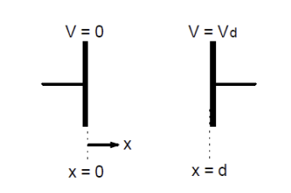

Figure 1: Schematic diagram of parallel plates [1]

3.2.2 The electric field between coaxial cylinder electrodes

1. Place the cylindrical electrode on the center of the coordinate plate of the sink, and the ring electrode on the circumference of the sink, and hold them down with the conductive rod
2. Put a small amount of clean water in the sink
3. Adjust the device to level
4. Apply 8V voltage to the electrode through two terminals on the water tank, and adjust the output frequency to 200Hz
5. Select the voltage as 1V, 2.5V, 4V and 5V, and find more than 6 corresponding points on the quarter circle of the coordinate plate
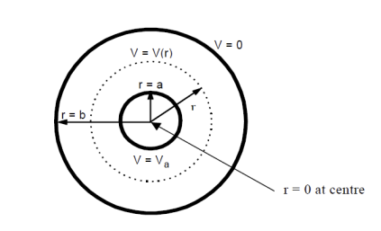

Figure 2: Schematic diagram of electric field between long straight coaxial cylindrical electrodes [1]

Note:

1. Clean the sink coordinate plate and electrode before the experiment

2. The water tank should be kept level throughout the experiment

- Try to make the probe perpendicular to the water surface when measuring

Results

4.1 Electrostatic field between parallel plates

4.1.1 Theoretical analysis

Due to the electric field between the parallel plates:

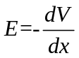 (1)

Integrating (1), we can get:
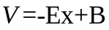 (2)

Where B is a constant.
If we assume that at x is equal to 0, the potential of one of the parallel plates is 0.
From (2), we know that:
B=0 (3)
Substituting (3) into (2), we can get:

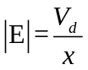 (4)
If we know that the distance between the parallel plates is d
Then:
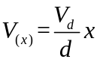 (5)

4.1.2 Experimental results

For Electric field between two parallel plates

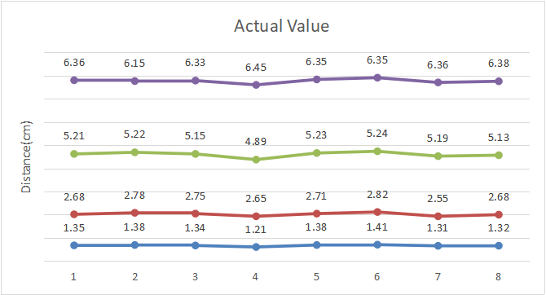
Figure 3：The potential between the parallel plates (the data in the chart is the distance from this point to the point where the potential is zero)

Where, the purple line represents the distance from the potential to 0 when the potential is 5V, the green line represents the distance from the potential to 0 when the potential is 4V, the red line represents the distance from the potential to 0 when the potential is 2V, and the blue line represents the distance from the potential to 0 when the potential is 1V.
 | 1V | 2V | 4V | 5V
Average value(cm) | 1.3375 | 2.7025 | 5.1575 | 6.3413
Theoretical value(cm) | 1.25 | 2.5 | 5 | 6.25

Table 1 : Mean values and theoretical values of experimental points
In Table 1, it can be found that within the error allowable range, the distance between points with the same potential and points with the potential 0 is basically the same. Meanwhile, by observing the table, we found that within the error allowable range, the error between the mean value of the experimental data and the theoretical value of each potential was small.The specific reasons for the errors and the error analysis will be discussed in the following sections.

For Parallel off-board experiments

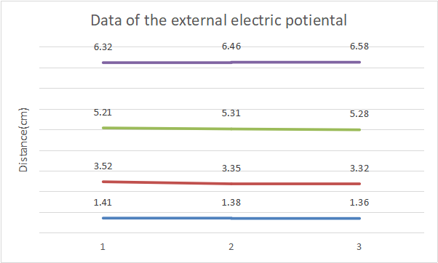

Figure 4: 5V, 4V, 2V, 1V experimental diagram outside parallel plate

The experimental points outside the parallel plate are relatively dense.After excluding the error factor, the data outside the parallel plate are different from the experimental data inside the parallel plate, indicating that the electric field outside the parallel plate is non-uniform. Due to the boundary effect, only the electric field inside the parallel plate is uniformly distributed.

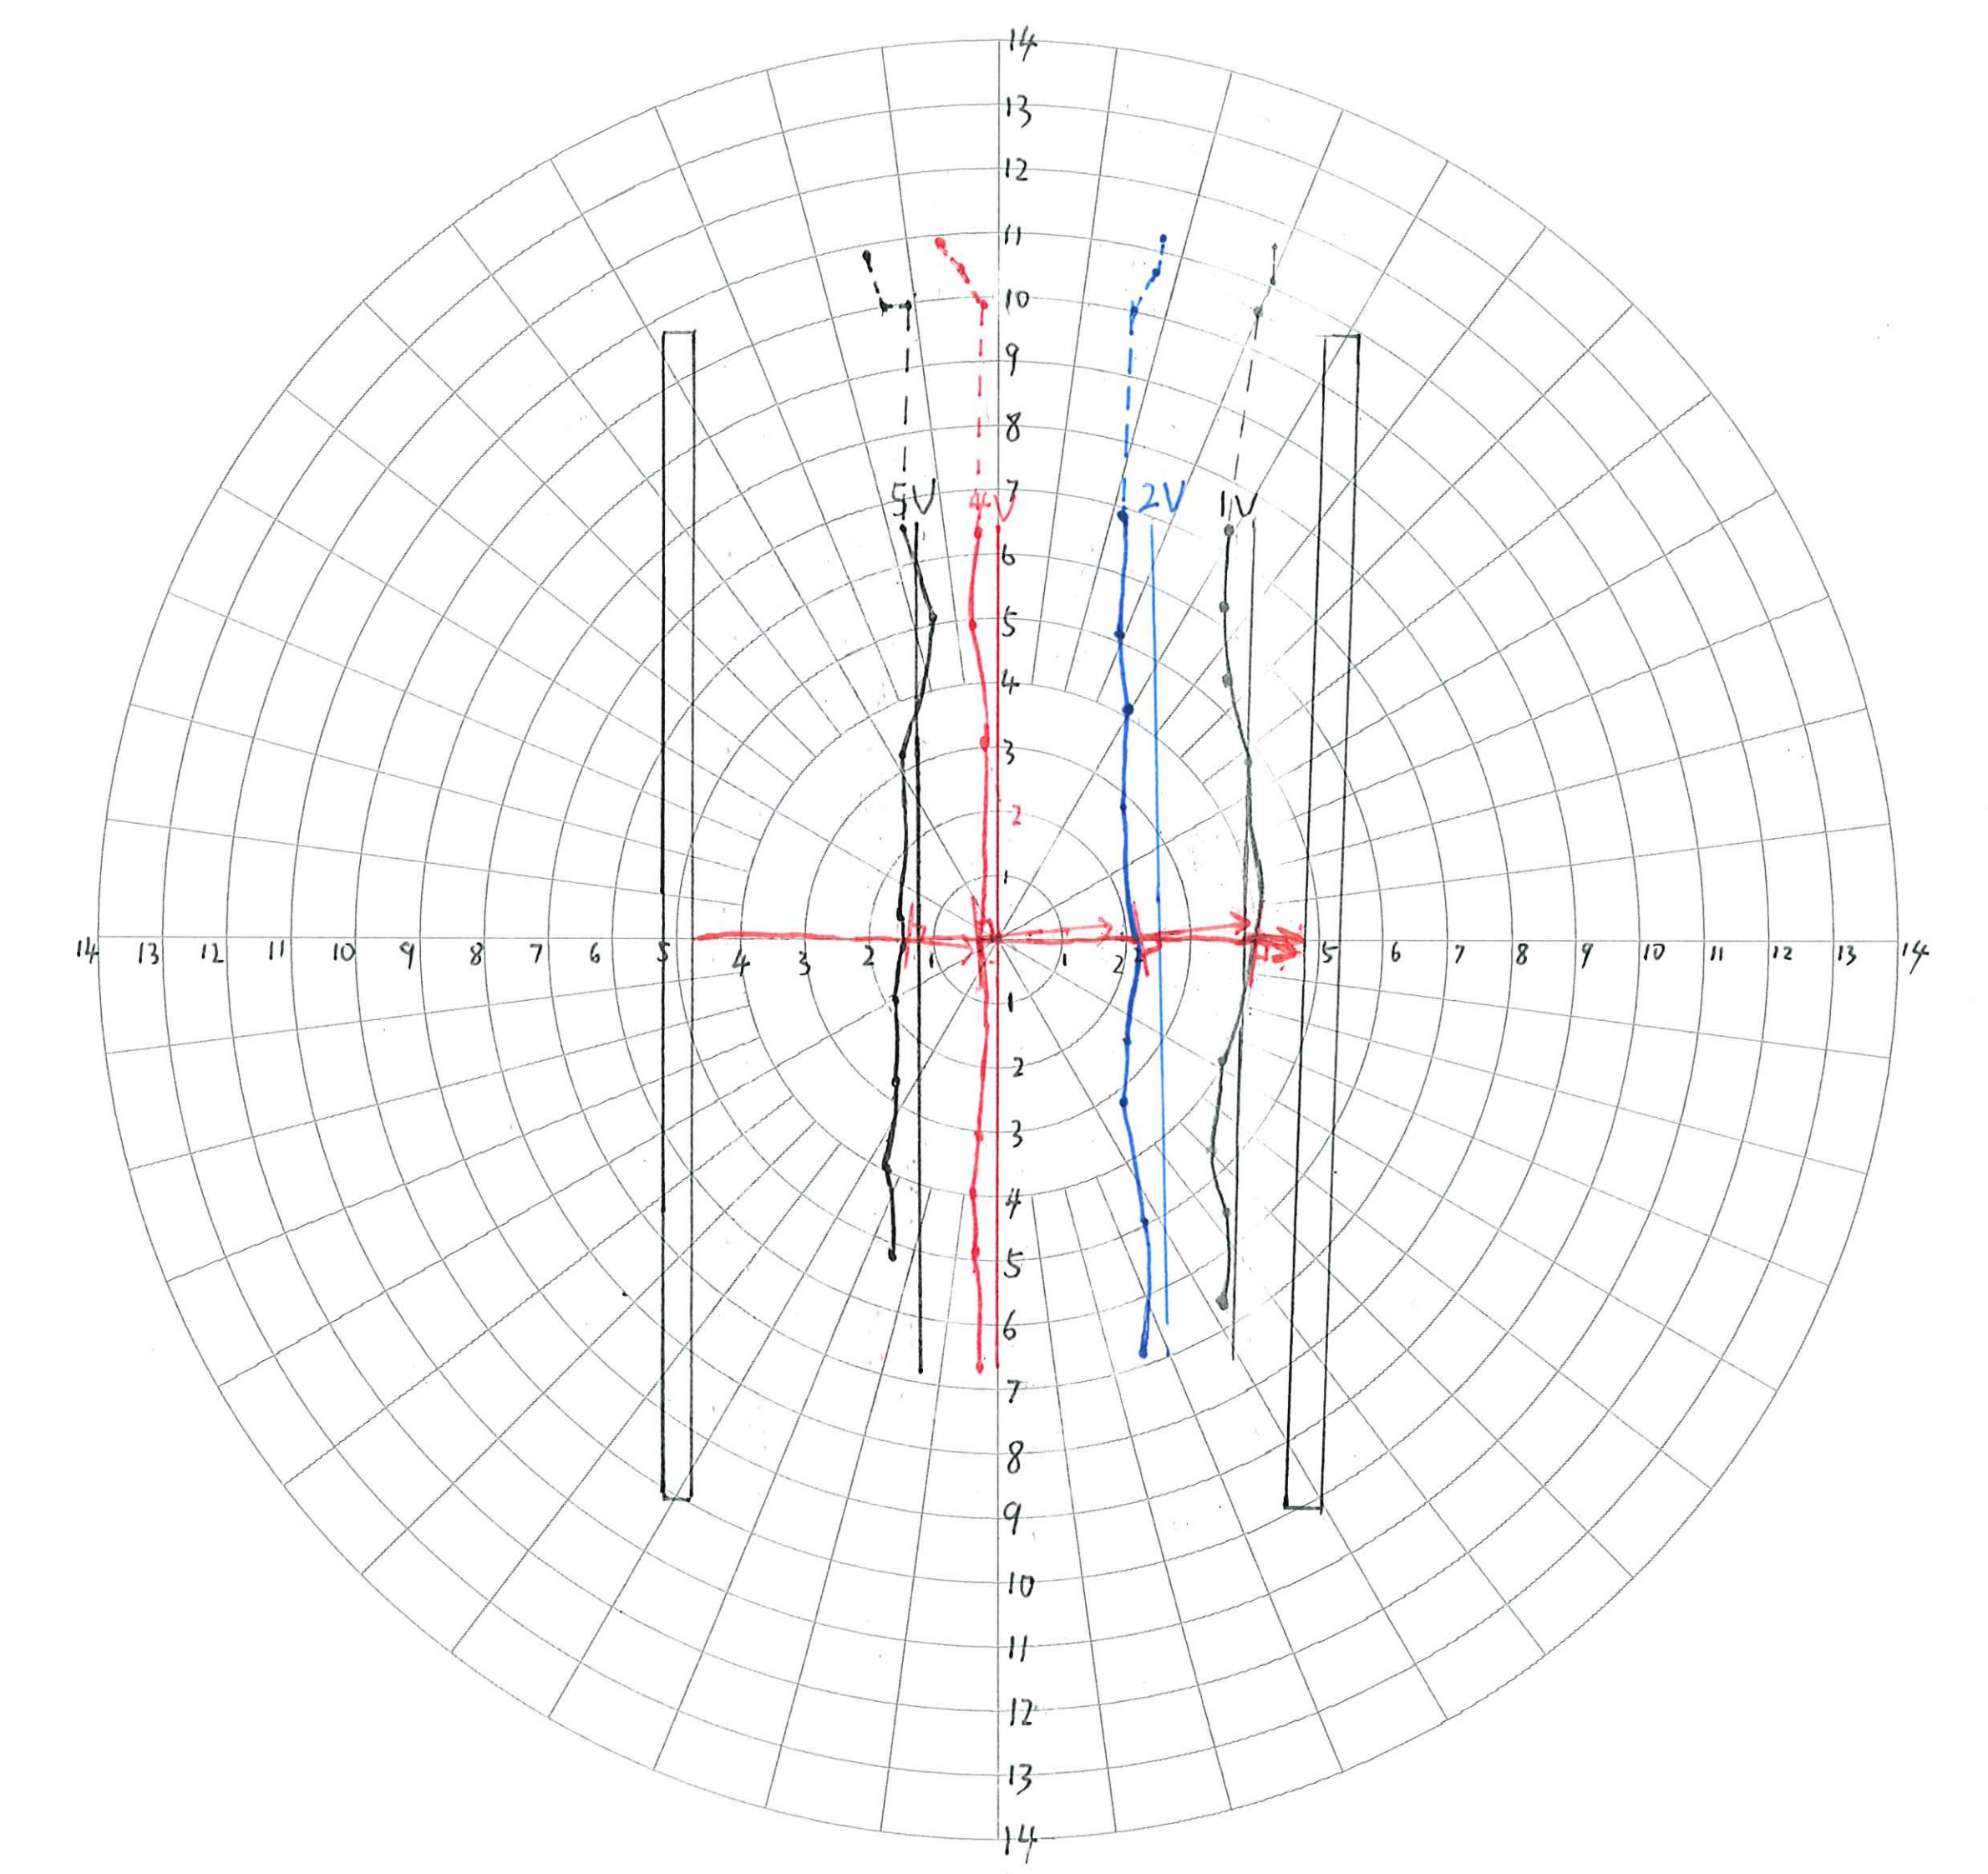

Figure 5 ：Experiment diagram between parallel plates

Through the image, we can find:
The same potential points are basically arranged vertically, and the potential decreases from left to right, and the potential decreases from 8V parallel plate to 0V parallel plate. And through data analysis, the reduction of potential is uniform. We have connected the points with the same potential and obtained the similar equipotential lines between the parallel plates, and by drawing the tangent lines, we have also drawn the field lines of the electric fields of the parallel plates.Because the center line is the most accurate, let's take the center line as the field line.
Outside the parallel plate, the same potential points do not appear vertical arrangement. Because of boundary effect, the field will incline to the direction of the parallel plate.

4.2 Coaxial charged cylindrical field

4.2.1 Theoretical analysis

We first assume that is infinitely long cylinder, inner and outer radius r = a and r = b respectively, and the total charge at the enclosed is Q

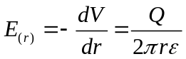 (1)

According to Gauss's theorem, we assume r is the distance between any point on the cylinder and the axis, if the potential of the outer cylinder is 0, then the potential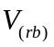 of the inner cylinder is the potential difference between the two cylinders.

We can get：
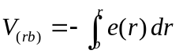 (2)

Substituting (1) into (2), we can get:

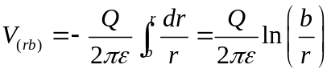 (3)
If we assume that 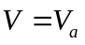 at the centre situated at R = A.

Then:

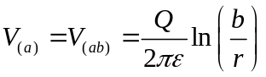 (4)

Substituting (4) into (3), we can get:
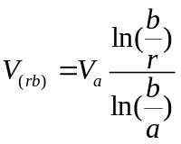 (5)
4.2.2 Experimental results
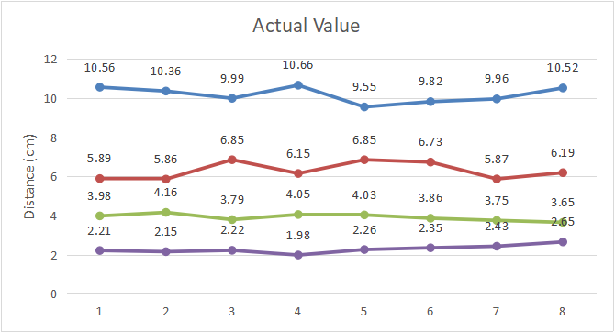

Figure 6：Electric potential diagram of coaxial charged cylinder field of 1V, 2.5V, 4V and 5V
In the chart, the blue line represents the distance from the 1V potential point to the center point, the red line represents the distance from the 2.5V potential point to the center point, the green line represents the distance from the 4V potential point to the center point, and the purple line represents the distance from the 5V potential point to the center point.

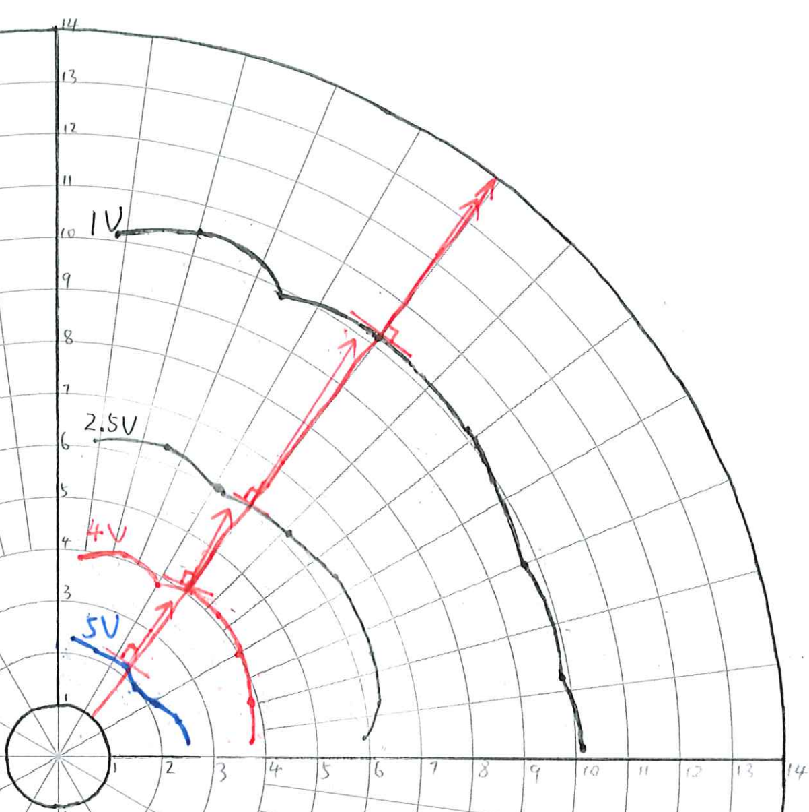

Figure 7:Experimental diagram of a quarter circle

From the experimental results, we can find that within the error allowable range, the distance between the points with the same potential and the center point is similar, and there is no big error. At the same time, we found that the point with higher potential is closer to the center point. Since we are only measuring in one quarter of the circle, we can infer the distribution of the potential in the rest of the circle from the symmetry.In addition, we have tangent lines at the appropriate places on each of the equipotential lines. Through the tangent lines, we have also made a electric field line on a Coaxial charged cylindrical field.

 | 1V | 2.5V | 4V | 5V
Average value(cm) | 10.178 | 6.299 | 3.909 | 2.2813
Theoretical value(cm) | 10.07 | 6.14 | 3.74 | 2.69

Table 2 : Actual mean values and theoretical values of experimental points
From the table, we can find that the difference between the actual average value and the theoretical value is not very big. In addition, we found that the closer to the center point, the greater the error between the potential and the theoretical value. After our comparison, the average error between the theoretical value and the experimental value is within the acceptable range, the experiment is successful.

5.Error analysis and Discussion

5.1 Error calculation and analysis

For electric field of parallel plate

According to the formula:

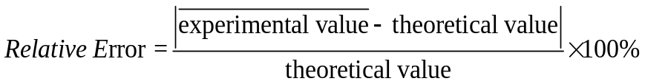
1V: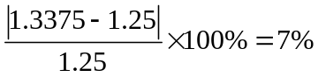
2V：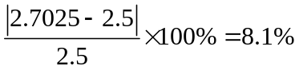
4V：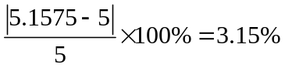
5V: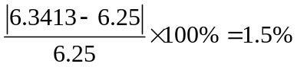

According to the above errors, we analyzed the possible causes:

- The experimental tank is not kept horizontal and has a certain inclination.

2. There are some impurities in the water in the experimental tank and the electrical conductivity is not uniform

3. When measuring, the probe is not measured vertically

4.Error in reading: Since the measurement is carried out on coordinate paper, it is difficult to accurately record the experimental points of each time, which will cause errors

For a coaxial charged cylindrical field

According to the formula:

We calculated the relative error of each potential as: 1V: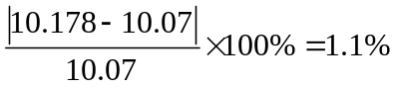
2.5V: 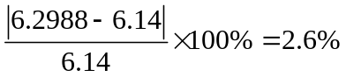
4V: 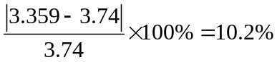
5V: 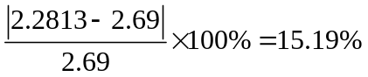

According to the above error, we can find that the error gradually increases with the increase of electric potential, which may be because:

- Too close to the center, every small movement will produce a large potential change

- The experimental tank is not kept level and has a certain tilt, resulting in different electrical conductivity of water

- Probe is not measured vertically during measurement

4. It is difficult to find the exact corresponding potential point, so we can only find the most suitable one near it

5.Error occurred when memorizing coordinates, so it is difficult to accurately record

5.2 Summary of the errors in the experiment

In this experiment, THME-3 electrostatic field tracer is used to describe the electrostatic field. Because it is not a precise measuring instrument, it is inevitable to produce some errors. After our analysis, the errors of the two experiments are within the acceptable range. At the same time, we find out the reason of the error by comparing the theoretical value with the experimental value. According to the coordinate paper of the experiment, we have drawn the general electric field line diagram and the equipotential lines. In the next experiment, the above errors should be minimized as far as possible.

6.Conclusions

6.1 For electric field of parallel plate

6.1.1 The electric field between two parallel plates

We first calculate the theoretical value(distance) from the center point of 1V, 2V, 4V and 5V potentials according to the formula. Then, we compare the experimental data with the theoretical value, and find that the error between the two values is within the acceptable range. On the coordinate board, we also drew the equipotential lines and electric field line. Moreover, we found that the electric field always points from the high potential to the low potential. At the same time, we also consider that the electric field of the parallel plates is uniform.

6.1.2 The electric field outside the parallel plates

We also carried out experiments outside the parallel plate, and found that the electric field outside the parallel plate did not satisfy the electric field formula, and the distribution was not uniform.

6.1.3 Error summary

On the basis of the experiment, we also analyzed the reasons for the error of the data, which mainly included: impurities in the water, no vertical measurement of the probe, and so on. In the next measurement, we should try to minimize the error. All in all, the experiment was successful.

6.2 For a coaxial charged cylindrical field

6.2.1 Experiment summary

We know that the electric field around a charged body is distributed in three dimensions, and if the electric field has symmetry, we can use the electric field in two dimensions to infer the electric field in three dimensions. In this experiment, we select the 1/4 part of the coordinate circle. By conducting experiments in this part, we can predict the distribution of the electric field in the whole two-dimensional plane, and then predict the distribution of the electric field in the three-dimensional space. In addition, we draw the equipotential lines and electric field lines according to the experimental data of the coordinate plate. According to the experimental data, we found that the distribution of the electric field on the coaxial charged cylinder was not uniform, and the closer to the center point, the denser the electric field lines were.

6.2.2 Error summary

At the same time, error analysis was carried out on the measured data and it was found that the error was within the acceptable range, although the error may be too big when measuring 5V potential. We have analyzed the causes of errors, and in the following experiments, we should try to avoid the generation of errors.

- References

[1] Department of Electrical and Electronic Engineering, “MEC102 Lab1 Electrostatic Field Plotting”, [Online]. Available:https://learningmall.xjtlu.edu.cn/pluginfile.php/104202/mod_resource/content/1/MEC102_Lab1_Instruction.pdf
[2] Ellingson, S. W., “Electric Flux Density ”, [Online].Available: https://eng.libretexts.org/@go/page/3905

8.Appendix

8.1 Answer the Pre-lab Questions

8.1.1 Can you think of other fields of force that you have encountered in your science studies?

First of all, We consider that the property that objects with certain properties can exert a force on similar objects which are not in contact with in a certain region of space is called fields of force. Fields of force is a region of space throughout which the force produced by an agent or several agents, such as an electric charge, is operative.
In physics, a field of force is a physical quantity with space-time as its variable. Fields of force can be divided into scalar field, vector field and tensor field. In our daily life, we have come into contact with electric field, gravitational field, electromagnetic field and temperature field. The gravitational field is a vector field: three quantities are required to indicate the value of each of the gravitational fields in space-time, which are the vector components of the gravitational field at each point. In the gravitational field the ratio of the gravitational potential energy of an object to its mass can be defined as the gravitational potential. However,the temperature field is a scalar field.

8.1.2 In terms of the information already cited in the introduction, why is it the negative and not the positive of the gradient of potential that is involved here?

We know that the electrical potential difference 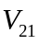 measured over a path  is given by:
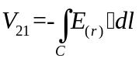 (1)

We begin by identifying the contribution of an infinitesimal length of the integral to the total integral in Equation (1). At point r, this is:

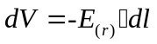 (2)

In Cartesian coordinates,
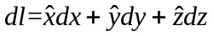 (3)
Consider 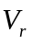：
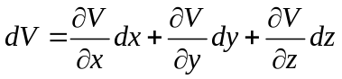 (4)
Note that 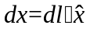 and so on for dy and dz. Making these substitutions into the above equation, we obtain:
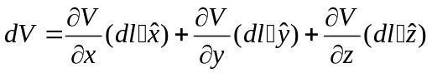 (5)
Therefore:
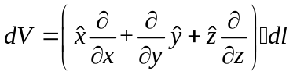 (6)

Comparing the above equation to Equation (2) , we find:
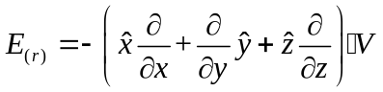 (7)

Combined with the gradient operator "∇"

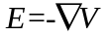 (8)

According to Equation 8，we express the electric field as the negative gradient of potential.

8.1.3 What are the units of electric flux density and electric field? What is the relationship between them?

First, electric flux density, assigned the symbol D, is an alternative to electric field intensity (E) as a way to quantify an electric field [2].

Usually we think thatthe electric flux density:
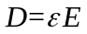 (1)
Which has units of C/m2, is a description of the electric field in terms of flux, as opposed to force or change in electric potential. In Equation (1), is the permittivity of the medium (material) where we are measuring the fields.

If we change a way of expression:

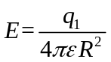 (2)
Then:
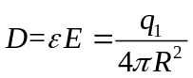 (3)

As can be seen from Equation (3), the electric flux density is very similar to the electric field, but independent of the material we are measuring (that is, it is independent of the permittivity).

8.2 Experiment data

8.2.1 Measurement data of parallel plate experiment

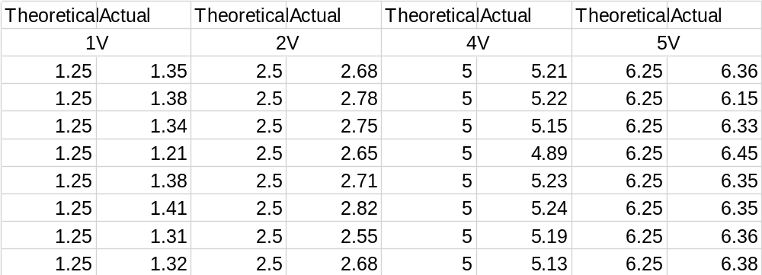
Table 3 :The electric field between the parallel plates

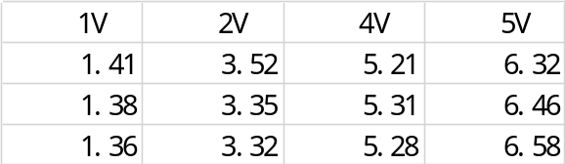
Table 4: The electric field outside the parallel plate

8.2.2 Concentric cylinders experimental measurement data

