

Department of Electrical and Electronic Engineering

MEC102 Electromagnetism and Electromechanics

Lab 2：Single-phase Transformers

Name : Tiankuo.Jiao
Student ID : 1929098
Lab partner：Jiang.Zhuoyuan Jiang.Zilin
Lab group: 3
Date of experiment: May 4, 15:00-18:00

1 Abstract

In this experiment, we conduct the no-load and short-circuit tests of single-phase transformers respectively. After connecting the circuit, we measure the different parameters of the two circuits and record the experimental results in two experimental tables. Finally, we calculate the values of 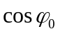 and 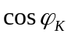 according to the data recorded in the experimental tables.
For no-load experiment, we draw three curves of the following functions and analyze the trend of each curve. Three functions with different parameters :
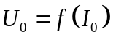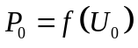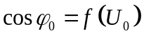
In the discussion section, we calculate the values of the transformation ratio, the relevant parameters of the no-load circuit: Excitation resistance, Excitation impedance, Excitation reactance. According to the results, we draw the equivalent circuit of the no-load circuit and fill in relevant data.
For short-circuit experiment, we draw three curves of the following functions and analyze and explain the reasons for the trend of each curve. Three functions with different parameters :
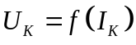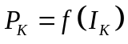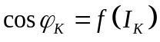

In the discussion section, we calculate the values of the transformation ratio, the relevant parameters of short-circuit: Excitation resistance, Excitation impedance, Excitation reactance. In addition, we also calculate equivalent parameters at the LV side. Finally, we calculated the short-circuit loss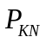 according to the obtained data.
According to the experimental requirements, we then draw the equivalent circuit of the short circuit and fill in part of the data. After adding the data of no-load experiment, we draw the whole equivalent circuit.

Catalogue

1.Abstract ii
2.Introduction iii
2.1 Definition of Single-phase transformer 1
2.2 Methods and objectives of the experiment 1
3.Experiment procedure 3
3.1 Experimental Instruments 3
3.2 The experimental process 3
3.2.1 No load test 3
3.2.2 Short-circuit test 4
3.3 Cautions during the experiment 6
4.Results 6
4.1 Table of data 6
4.2 Graphs of data(No load test) 7
4.3 Graphs of data (Short circuit test) 9
4.4 Comments on graphs and results 11
5.Discussion and Error analysis 12
5.1 Transformation ratio calculation 12
5.2 Relevant parameters of no load circuit 13
5.2.1 Excitation resistance 13
5.2.2 Excitation impedance 13
5.2.3 Excitation reactance 13
5.2.4 The equivalent circuit 14
5.3 Relevant parameters of short circuit 15
5.3.1 Transformation ratio calculation 15
5.3.2 Excitation resistance 16
5.3.3 Excitation impedance 16
5.3.4 Excitation reactance 16
5.3.5 Equivalent parameters at the LV side 16
5.3.6 Short-circuit loss 17
5.3.7 The equivalent circuit 18
6. Conclusion 19
6.1 No load test 19
6.2 Short circuit test 20
7.References 21

- Introduction

2.1 Definition of Single-phase transformer
A Single-phase transformer is an electrical device that receives single-phase AC power supply and outputs single-phase AC. [1] The strength of the magnetic field generated in the core depends on the number of turns in the winding and the magnitude of the current. Magnetic flux and electric current are proportional to each other. Moreover, the single-phase transformer works on the principle of Faraday' s Law of Electromagnetic Induction.

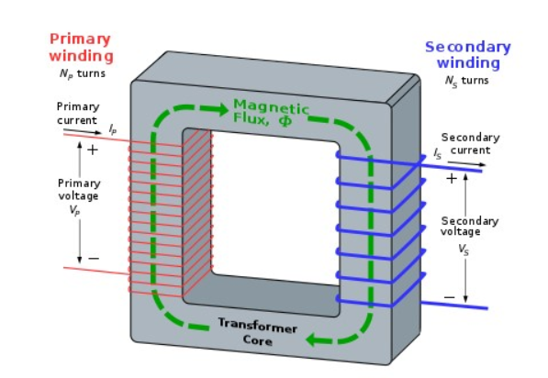

Figure 1: Transformer Core [1]

2.2 Methods and objectives of the experiment
The transformation ratio and parameters of the Single-phase transformer were measured by no-load and short-circuit experiments. In the experiment, we should connect the no-load and short-circuit circuits correctly according to the schematic diagram. In order to reduce the error, within the measuring range of the instruments, we make the ammeter and power meter in series, the voltmeter in parallel according to the experimental requirements.

In the no-load experiment, we should measure the no-load characteristics of the Single-phase transformer:

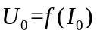,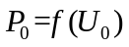,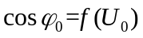

In the short-circuit experiment, we should measure the short-circuit characteristics of Single-phase transformer:

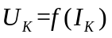,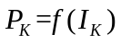,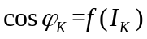

In the two experiments, the power measured in the no-load test is iron consumption, and the power measured in the short-circuit test is copper consumption.

After calculating the relevant data in the two experiments, we drew the equivalent circuit diagram and filled the calculated data into the equivalent circuit diagram.

3.Experiment procedure

3.1 Experimental Instruments

Module | Name | Quantity
D33 | AC digital/analog Voltmeter | 1
D32 | AC digital/analog Ammeter | 1
D34-3 | Intelligent 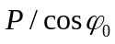 meter | 1
DJ11 | Shell-type transformer | 1
D42 | Adjustable resistor | 1

3.2 The experimental process

3.2.1 No load test
For no-load experiment, the experimental circuit diagram is shown in Figure 2:
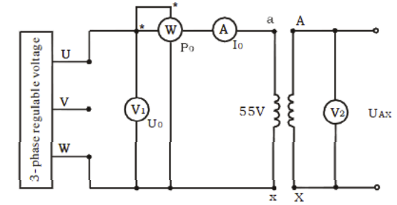
Figure 2：No load test circuit[2]

In the experiment, we choose DT40 three-phase group transformer. One group is selected in the experiment, and its parameters are as follows:

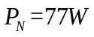
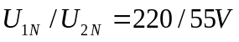
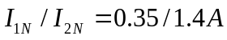

We must first connect each instrument correctly according to the schematic diagram. Next, we also need to select the appropriate range for all the meters.

Then, we need to turn the control knob of auto-transformer counterclockwise (CCW) to the end, and then set the output voltage to 0V. Next, turn on the switch, select the appropriate voltage from the range of 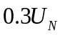-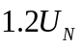, and measure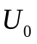,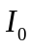,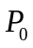,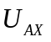 one by one.

We need to ensure that 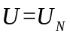 is measured. At the end of the test, we must turn off the main power and remove all circuits.

3.2.2 Short-circuit test
For short circuit test: the experimental circuit diagram is shown in Figure 3

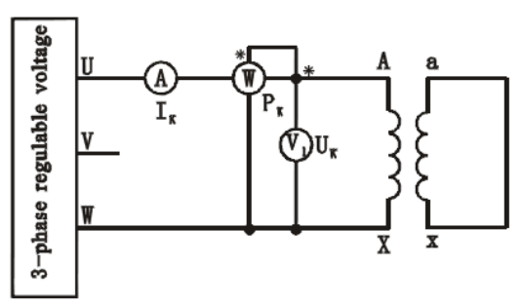
Figure 3：Short circuit test [2]

We must first connect each instrument correctly according to the schematic diagram. Next, we also need to select the appropriate range for all the meters.

Then, we need to turn the control knob of autotransformer counterclockwise (CCW) to the end, and then set the output voltage to 0V. Next, turn on the switch, select the appropriate voltage from the range of 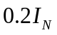-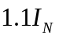, and measure,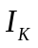,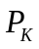 one by one. Importantly, we need to do the experiment in the range of requirement, and finally, we need to calculate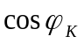. Moreover, we complete the remaining data of the equivalent circuit according to the calculated data. Finally, we need to press the Stop button at the end of the experiment, turn off the main power supply and remove the circuit.

It should be noted that if we would like to avoid excessive short-circuit current, the experiment will be carried out under the condition of low voltage. The power supply voltage should be added to the high-voltage winding, and the low-voltage winding should be short-connected.

3.3 Cautions during the experiment
(1) Don't touch live circuits.
(2)The power supply must be cut off when we connect or disconnect the wires.
(3) We can only turn on the power with the permission of the teacher. In case of failure, we should turn off the power immediately to prevent any danger.
(4) check the power meter and ammeter before connecting the power supply to avoid short circuit fault.
(5) The main power switch should be operated under the permission of the instructor

4.Results

4.1 Table of data
In order to facilitate the analysis and processing of the data, we recorded both the experimental data and the calculated data in the table.
Table 1:No Load Test
No. | Measured data |  |  |  | Calculated data
No. | 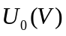 | 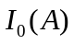 | 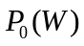 | 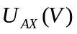
1 | 66 | 0.118 | 2.1 | 275 | 0.27
2 | 62.1 | 0.103 | 1.8 | 252 | 0.281
3 | 59.5 | 0.079 | 1.5 | 239 | 0.319
4 | 55 | 0.048 | 1.3 | 214 | 0.492
5 | 50.6 | 0.036 | 1.1 | 195 | 0.604
6 | 45.8 | 0.031 | 0.9 | 178 | 0.634
7 | 40.1 | 0.026 | 0.7 | 157 | 0.671
8 | 32.7 | 0.021 | 0.6 | 138 | 1
9 | 25 | 0.016 | 0.4 | 105 | 1
10 | 16.5 | 0.01 | 0.3 | 61 | 1

Table 2:Short Circuit Test
No. | Measured data |  |  |  | Calculated data
No. | 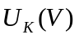 | 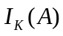 | 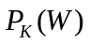 | 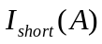
1 | 2.2 | 0.07 | 0.1 | 0.23 | 0.649
2 | 3.4 | 0.13 | 0.3 | 0.42 | 0.679
3 | 4.9 | 0.15 | 0.7 | 0.65 | 0.952
4 | 6.5 | 0.19 | 1.2 | 0.78 | 0.972
5 | 8.1 | 0.24 | 1.9 | 1.05 | 0.977
6 | 10.4 | 0.29 | 2.9 | 1.22 | 0.962
7 | 11.6 | 0.35 | 3.9 | 1.27 | 0.952
8 | 12.7 | 0.385 | 4.7 | 1.51 | 0.961

4.2 Graphs of data(No load test)

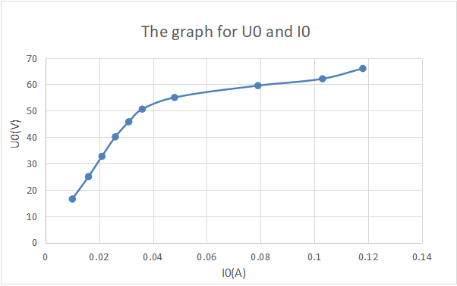
Figure 4：The graph for and

Through observation, we found that in the no-load circuit experiment, with the continuous increase of , the increase of gradually became slow. And the growth is not linear. This may be due to the influence of the original magnetic leakage, resulting in the curve change is not linear. When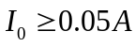, the overall curve is much flatter.
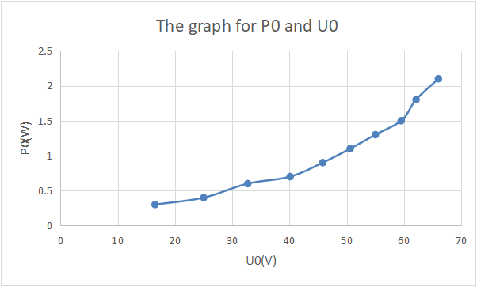
Figure 5：The graph for and
Through observation, we found that with the continuous increase of , also basically increased. From the graph, we can see that the trend of and grows in square.

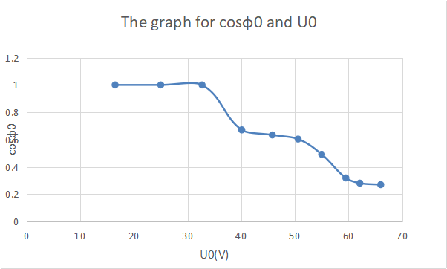
Figure 6：The graph for 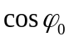 and

From the figure, we can see that in the case of 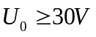, the value of gradually decreases with the continuous increase of . Since the of the last three groups of data we measured was all greater than 1, we took 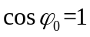 for calculation. In addition, although the experimental data has a little error, the error is within the allowable range.

4.3 Graphs of data (Short circuit test)
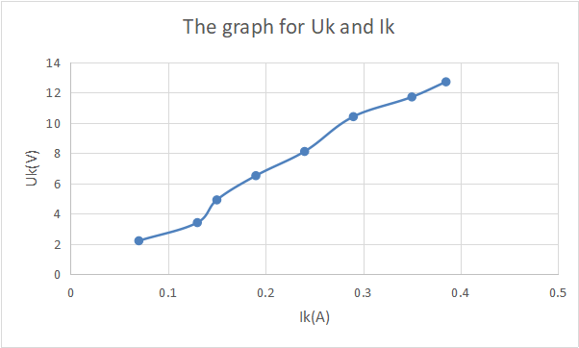
Figure 7: The graph for and

Through the experimental data, we found that the overall curve showed an upward trend, and with the constant increase of , also increased. And the growth trend shows a linear relationship. This may be because the magnetic flux leakage in the short-circuit experiment is not saturated, and the short-circuit impedance 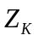can be regarded as a constant value. Therefore, the short-circuit voltage has a linear relationship with the current.

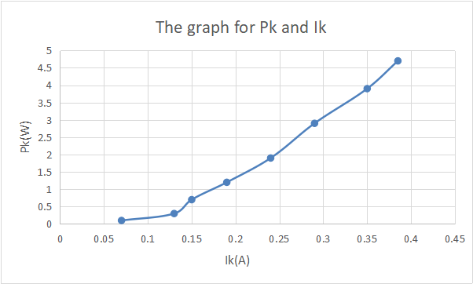
Figure 8: The graph for and
It is observed that is also increasing with the continuous increase of , but the increasing relationship is exponential. Because 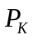 is proportional to 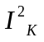, the curve grows exponentially.

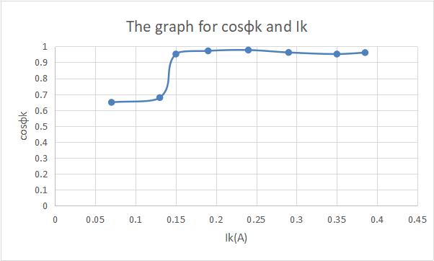
Figure 9: The graph for 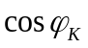 and

According to the figure, in the case of 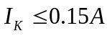, the value of is about 0.65. In the case of 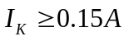, the value of is about 0.95, which is close to 1. This phenomenon is because when the circuit is short, the resistance of the load is basically unchanged which means the power factor is unchanged.

4.4 Comments on graphs and results

To no-load and short-circuit experiments, we fill in the data in the table and draw the curve according to the data.

For no-load tests, we have drawn the following function graph:

For the characteristics of each image, we have made a summary at the bottom of each figure. rises in two stages. The first stage is fast and the second stage is slow. The function graph of has been rising slowly. showed a downward trend.

For short circuit tests, we have drawn the following function graph:

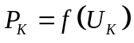

For the characteristics of each image, we have made a summary at the bottom of the figure. The graph of shows a linear upward trend. The graph of firstly goes up slowly and then faster. The function graph of is divided into two parts. When 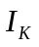 is small, is relatively small. When is large, is relatively large, which is approximately equal to 1.

5.Discussion and Error analysis

5.1 Transformation ratio calculation
From theoretical analysis 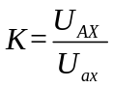

K for each experiment is as follows:

Table 1: The K for each experiment
No. | Ratios
1 | 4.17
2 | 4.06
3 | 4.02
4 | 3.89
5 | 3.85
6 | 3.89
7 | 3.92
8 | 4.22
9 | 4.22
10 | 3.7
Average Value | 3.992

Through the calculation, we find the real value of the transformation ratio is 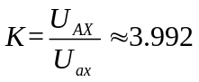.
From the theoretical values: 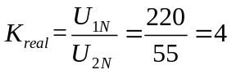.
Error analysis：

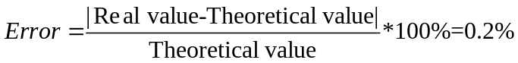 (1)

Through error analysis, we find that the error of the experiment is 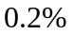, and the value is small within the allowable range. The experiment is successful.

5.2 Relevant parameters of no load circuit

5.2.1 Excitation resistance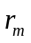

From the data we recorded, we can know: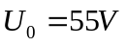 、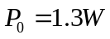、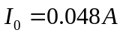

According to the formula：

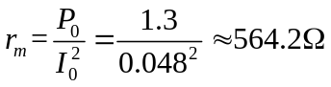
Therefore ，the value of Excitation resistance is 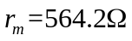

5.2.2 Excitation impedance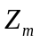
From the first set of data, we know that 、
According to the formula:
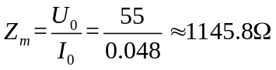
Therefore，the value of Excitation impedance is 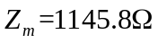

5.2.3 Excitation reactance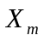
From the previous results 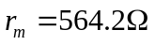、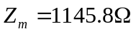

According to the formula：

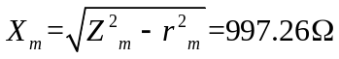
Therefore, the value of excitation reactance is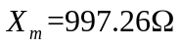
5.2.4 The equivalent circuit

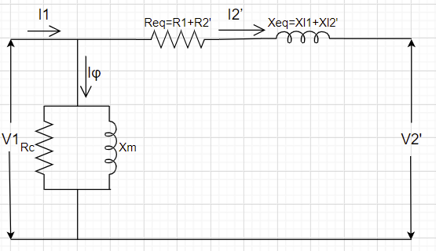
Figure 10: The equivalent circuit of no load test

If we fill the and into the circuit, we can get:

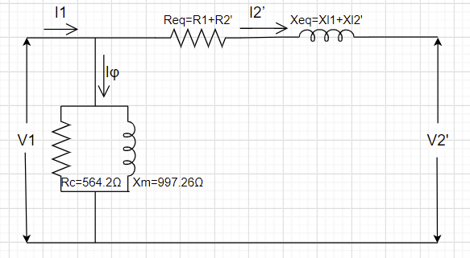
Figure 11: The equivalent circuit of no load test

From what we learned in class, we know 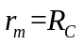, so we substitute to 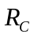.
In addition, we have calculated the value of . Therefore, we can substitute into the circuit to obtain the current equivalent circuit diagram. In addition, we will calculate the data which has not been filled in in the short-circuit experiment.

5.3 Relevant parameters of short circuit

5.3.1 Transformation ratio calculation
According to the formula 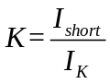
K of each group of data is as follows:

Table 2: The K for each experiment
No. | Ratios
1 | 3.29
2 | 3.23
3 | 4.33
4 | 6.31
5 | 4.38
6 | 4.21
7 | 3.63
8 | 3.92
Average Value | 4.16

Through calculation, we found that the actual value of the Transformation ratio is:

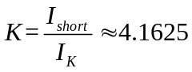
The theoretical value of K is：
.
Error analysis：

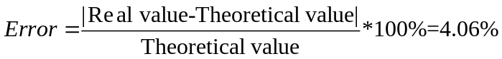 (1)

Through error analysis, we found that the error of the experiment is 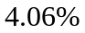, and the error is small which is within the allowable range. That means that the experiment is successful.

5.3.2 Excitation resistance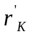
When 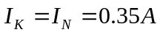, we know that 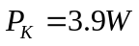,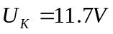
According to the formula：

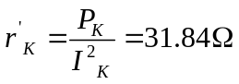

Therefore ，the value of Excitation resistance is 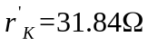

5.3.3 Excitation impedance 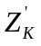
When , we know that
According to the formula：

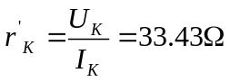

Therefore, the value of Excitation impedance is 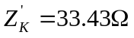

5.3.4 Excitation reactance 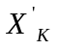
We know that ,
According to the formula：

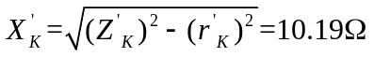

Therefore, the value of Excitation reactance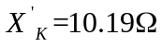

5.3.5 Equivalent parameters at the LV side
We know that 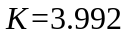

Therefore, Excitation resistance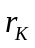:
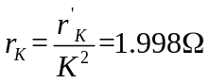

Excitation impedance 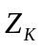:
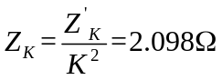
Excitation reactance 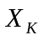:
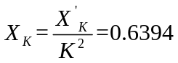

5.3.6 Short-circuit loss 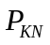
We know that:
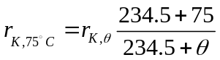 (1)

Where, 234.5 is the coefficient of copper conductor.

In addition, we measured the indoor temperature during the experiment, and the temperature was 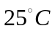
Therefore, when the temperature is ,

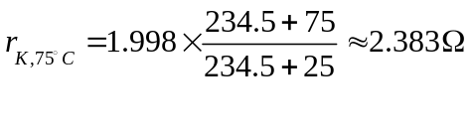
Therefore, according to the formula when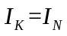,we can get:

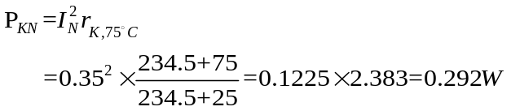
Therefore, the value of is 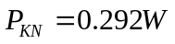

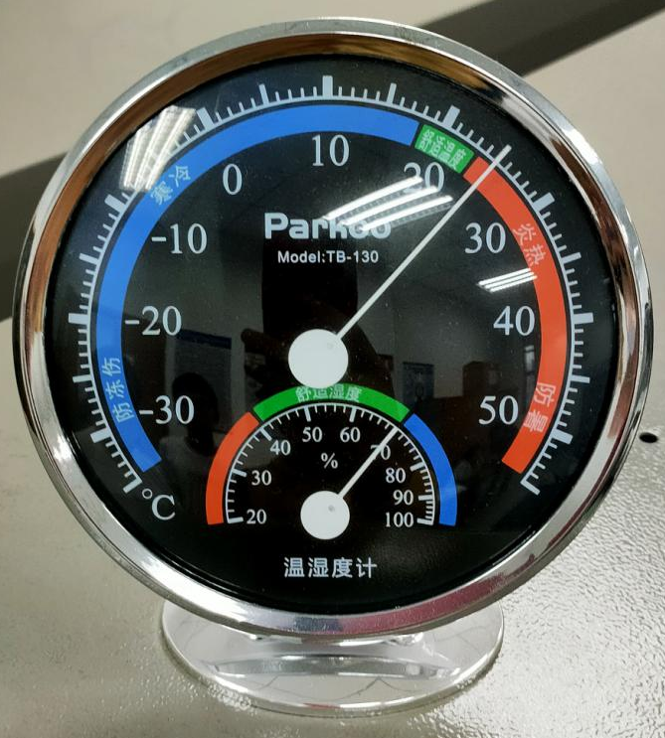
Figure 12:The temperature is

5.3.7 The equivalent circuit
Based on the knowledge learned in class, I draw the equivalent circuit of the short test. The equivalent circuit is shown as follows:

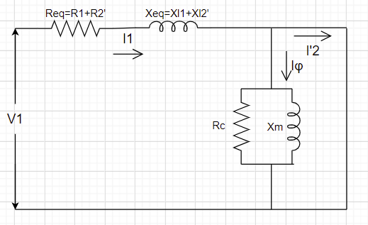
Figure 13: The equivalent circuit about short-circuit

If we substitute the data of and into the equivalent circuit, we can get:
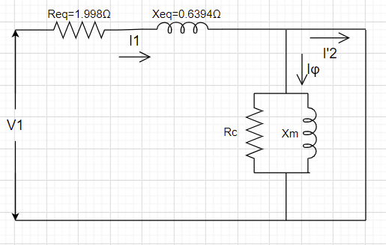
Figure 14：The equivalent circuit with the value of 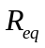 and 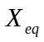

Through the open circuit experiment and short circuit experiment, we integrate the data obtained from the two experiments together to obtain the total equivalent circuit:

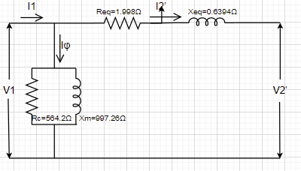
Figure 15：The equivalent circuit

6. Conclusion

6.1 No load test
In the experiment, we measured the values of 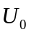,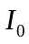,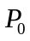,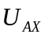, and then calculate the value of . In addition, we plot the following functions and analyze the trend.
We found that for no-load characteristic curve, when increases, also increases, but the growth does not show a linear relationship. This may be due to the influence of the original magnetic leakage, resulting in its change trend is not linear.
For ，whenincreases，will increase, too. The growth trend of the two is close to the square relationship.
For , when increases, will decrease. Because the value of in the last three experiments is larger than 1, we consider the value of is 1.
Next, we first calculate the transformation ratio K, which is 3.992, approximately equal to 4. Then, we calculate Excitation resistance, Excitation impedance, Excitation reactance for the open circuit. From the calculated data, we draw the equivalent circuit of the no-load circuit test.

6.2 Short circuit test
In the experiment, we measured the values of ,,,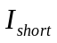, and then calculate the value of . In addition, we plot the following functions and analyze the trend.
We found that for no-load characteristic curve, when increases, also increases, and its growth shows a linear relationship. This may be because the magnetic flux leakage in the short-circuit experiment is not saturated, and the short-circuit impedance can be regarded as a constant value, so the short-circuit voltage has a linear relationship with the current.
For ，when increases，will increase, too. The growth trend of the two is close to the index relationship. Because is proportional to , the curve will grow exponentially.

For , the value of is nearly constant as increases. This phenomenon was because when we did the short circuit experiment, the resistance of the load was basically unchanged, which means the power factor was unchanged.

Next, we calculate the transformation ratio K. The value of K is 4.16, which is about 4. Then, we calculate the Excitation resistance, Excitation impedance, Excitation reactance for the short circuit. And under the condition of the LV side, the Equivalent parameters are calculated. From the calculated data, we draw the equivalent circuit of the no-load circuit test. Finally, the whole equivalent circuit is drawn according to the calculated results.

7.References

- Electronics projects focus, “What is a Single Phase Transformer: Construction and Its Working”, [Online].
Available:https://www.elprocus.com/what-is-a-single-phase-transformer-construction-and-its-working/

[2] Department of Electrical and Electronic Engineering, “ Lab 2 Single-phase Transformers”, [Online].Available: https://www.learningmall.cn/pluginfile.php/135163/mod_resource/content/1/MEC102_Lab2_Single-phase-transformer_Instructions.pdf

