Section A (55 marks)

Question 1 — Geometric Sequences [5]
(a)
Common ratio
$$r=\frac{-16}{32}=-\frac{1}{2}$$
[A1]

(b)
Use the geometric term formula
$$u_{n}=ar^{n-1}$$
[M1]
Substitute $a=32,r=-\frac{1}{2}$
$$u_{6}=32{\left( − \frac{1}{2}\right)}^{5}$$
[A1]
$$u_{6}=-1$$
[A1]
FT allowed from incorrect $r$.

(c)
Since
$$∣r∣<1$$
the infinite sum exists.
[M1]
Use
$$S_{∞}=\frac{a}{1-r}$$
Substitute $a=32,r=-\frac{1}{2}$
$$S_{∞}=\frac{32}{1+\frac{1}{2}}$$
[A1]
$$S_{∞}=\frac{64}{3}$$
[A1]
FT allowed from incorrect $r$.

Question 2 — Logarithmic Equations [5]
Combine logarithms
$${log⁡}_{6}x+{log⁡}_{6}(x-5)={log⁡}_{6}[x(x-5)]$$
[M1]
Hence
$$x(x-5)=36$$
[A1]
Expand
$$x^{2}-5x-36=0$$
[M1]
Solve
$$x=9\text{or}x=-4$$
[A1]
Domain restriction
$$x>5$$
Therefore
$$x=9$$
[R1]

Question 3 — Quadratic Functions [6]
(a)
Intercepts obtained from
$$(x+1)(x-6)=0$$
[M1]
$$x=-1,x=6$$
[A1]
Intercepts
$$\left(-1,0),(6,0\right)$$

(b)
Expand
$$\left(x+1)(x-6\right)$$
[M1]
$$x^{2}-5x-6$$
[A1]
Thus
$$b=-5$$
[A1]
$$c=-6$$
[A1]
FT allowed from incorrect factors.

Question 4 — Partial Fractions [6]
(a)
Write
$$\frac{1}{x(x-1)}=\frac{A}{x}+\frac{B}{x-1}$$
[M1]
Multiply by denominator
$$1=A(x-1)+Bx$$
[M1]
Equating coefficients
$$A=-1,B=1$$
[A1]

(b)
Recognise telescoping sum, any one term correctly expanded using the formula below
$$\frac{1}{n(n+1)}=\frac{1}{n}-\frac{1}{n+1}$$
[M1]
Simplify to
$$1-\frac{1}{100}$$
[M1]
Evaluate
[A1]
$$\frac{99}{100}$$

Question 5 — Area of Triangle [6]
Area of triangle $ABC$: $\frac{1}{2}AB ∙BC∙\sin{2θ}=\frac{1}{2}∙2\sqrt{7}∙x∙\sin{2θ}=3$[M1]
Applying the Pythagorean identity $\sin^{2}{θ}+\cos^{2}{θ}=1$, or draw an acute triangle, [M1]
using $\sin{θ}=\frac{3}{4}$, $cos θ=\frac{\sqrt{7}}{4}$[A1]
Use double angle formula and substitute the value of $\sin{θ}=\frac{3}{4}$, $cos θ=\frac{\sqrt{7}}{4}$:
$\sin{2θ}=2\sin{θ}\cos{θ}=\frac{3\sqrt{7}}{8}$[M1A1]
Final answer: $x=\frac{8}{7}$[A1]

Question 6 — Cubic with Arithmetic Roots [7]
(a)
Using the sum of roots of formula
$$\text{Sum of roots}=\frac{144}{32}=\frac{9}{2}$$
[A1]

(b)
Sum of roots
$$3a=\frac{9}{2}$$
[M1]
$$a=\frac{3}{2}$$
[A1]
Applying the product of roots formula:
$$\left(a-d\right)a\left(a+d\right)=\frac{105}{32}$$
[M1]
Substitute the value of $a$ and solve for $d$
[M1]
$$d^{2}=\frac{1}{16}$$
Roots
$$\frac{5}{4}, \frac{3}{2}, \frac{7}{4}$$
[A1] [A1]
FT allowed from incorrect $a$.

Question 7 — Trigonometry [8]
(a)
$$\left(1 + \sqrt{3})^{2}\right. \\ =4+2\sqrt{3}$$
[A1]

(b)
Use compound angle identity
$$cos⁡({75}^{∘})=cos⁡(30+45)$$
[M1]
$$=cos⁡30cos⁡45-sin⁡30sin⁡45$$
[M1]
Substitute exact values
$$\frac{\sqrt{6}-\sqrt{2}}{4}$$
[A1]

Apply cosine rule: $AB^{2}=AC^{2}+BC^{2}-2×AC ×BC×cos 75°$ [M1]
$AB^{2}=4+2\sqrt{3}$; [M1]
$AB=1+\sqrt{3}$[M1A1]
Q8: Permutations [5 marks]
- (a) $2!×3!×2!=24$[A1]
- (b) $4!×2!=48$[A1]
- (c) $3!×2!=12$[A1]
- (d) $5!-48=72$ or $3!×{}_{2}^{4}P=72$[M1A1]
Q9: Inverse Trigonometric Functions [6 marks]
- (a) stretch, scale factor $\frac{1}{2}$, [A1]
translation $\left(\begin{matrix}\frac{3}{2} \\ \frac{3π}{4}\end{matrix}\right)$, [M1A1]
- or
translation $\left({3 \atop 0}\right)$, stretch scale factor $\frac{1}{2}$, translation $\left({0 \atop \frac{3π}{4}}\right)$[A1A1A1]
- (b) use compound angle identities for tangent, $tan⁡(α-β)=\frac{p-q}{1+pq}$ [M1]
Correct simplification to the RHS [M1A1]

SECTION B (55 marks)
Q10: Venn Diagrams [16 marks]
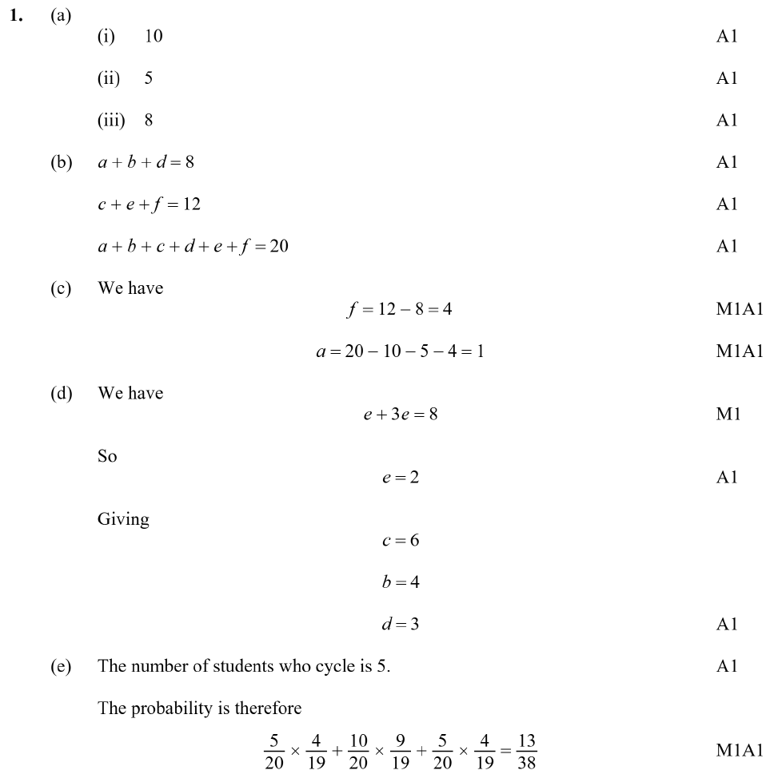

Q11: Rational Functions [18 marks]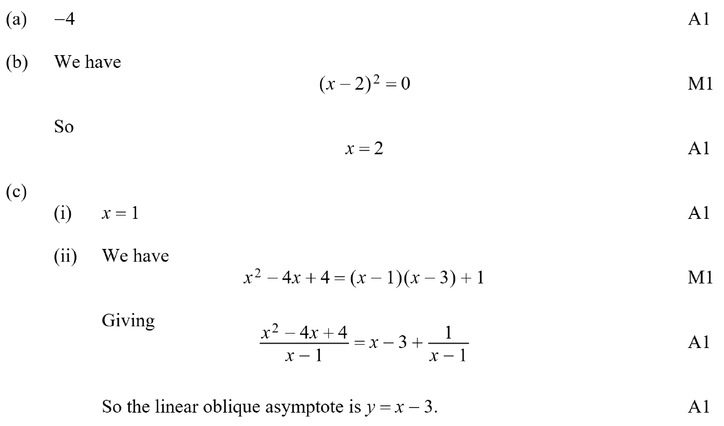 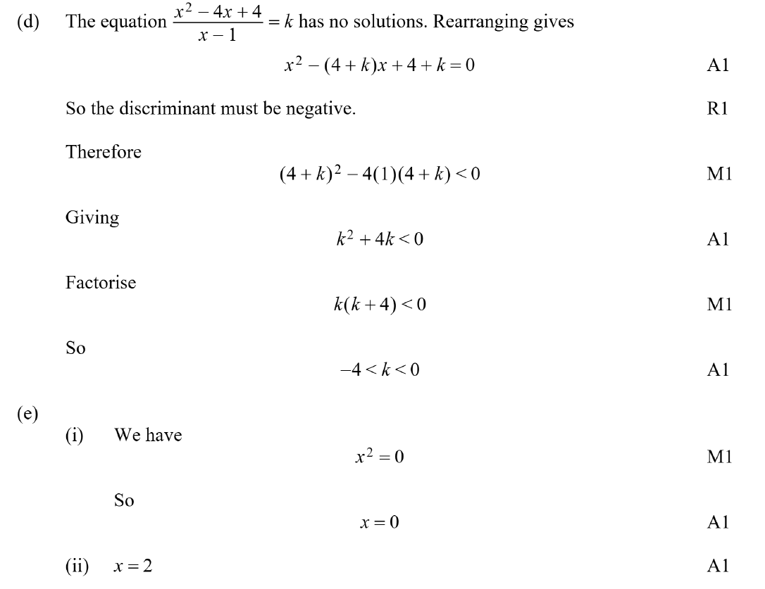
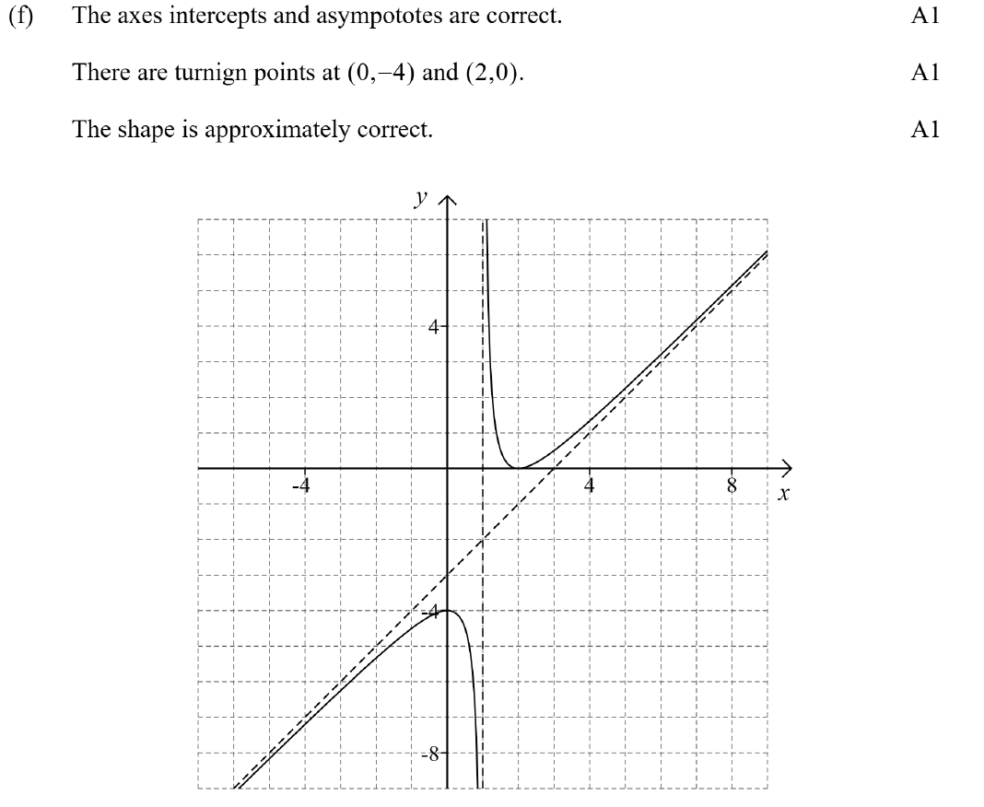

Q12: Trigonometric Identities [22 marks]
- (a) use compound angle identities:
$\cos{3θ}=\cos\left(2θ+θ\right)$[M1]
$=\cos{(2θ)}\cos{θ}-\sin{2θ}\sin{θ}$ [A1]
Apply double angle identities for sine and cosine:
$=\left(2\cos^{2}{θ}-1\right)\cos{θ}-2(1-\cos^{2}{θ})cos⁡θ$ [M1]
Correction simplification to the RHS [A1]
$4{cos⁡}^{3}θ-3cos⁡θ$[AG]
- (b) $f(cos⁡k)=0$ verified [M1A1]
- (c) (i) sum of roots formula: $αβ=\frac{\cos{3k}}{4\cos{k}}=\frac{4\cos^{3}{k}-3\cos{k}{}}{4\cos{k}}=\frac{4\cos^{2}{k}-3}{4}$ [M1A1];
  - use of $α+β+\cos{k}=0⇒β=-α-cos⁡k$[M1AG]
- (d) correct substitution of results from part (c) and simplify:
$α^{2}+αcos⁡k+{cos⁡}^{2}k-\frac{3}{4}=0$[M1M1AG]
- (e) use quadratic formula and Pythagorean identity $\sin^{2}{k}+\cos^{2}{k}=1$:
$α=\frac{-\cos{k}±\sqrt{\cos^{2}{k}-4\left(\cos^{2}{k}-\frac{3}{4}\right)}}{2}$ [M1A1]
$α=\frac{-cos⁡k+\sqrt{3}sin⁡k}{2}$; $β=\frac{-cos⁡k-\sqrt{3}sin⁡k}{2}$[A1A1]
- (f) when anyone of $α=β$, $α=\cos{k}$ or $β=\cos{k}$ is seen anywhere [M1]
when $α=β$:
$\frac{-cos⁡k+\sqrt{3}sin⁡k}{2}=\frac{-\cos{k}-\sqrt{3}sin⁡k}{2}$ [M1]
Simplifies to $2\sqrt{3}\sin{k}=0$ [M1]
Hence $k=0, π, 2π$ [A1]

when $α=\cos{k}$:
$\frac{-cos⁡k+\sqrt{3}sin⁡k}{2}=\cos{k}$
Simplifies to $\tan{k}=\sqrt{3}$ [M1]
Hence $k=\frac{π}{3},\frac{4π}{3}$ [A1]

when $β=\cos{k}$:
$\frac{-\cos{k}-\sqrt{3}sin⁡k}{2}=\cos{k}$
Simplifies to $\tan{k}=-\sqrt{3}$
Hence $k=\frac{2π}{3},\frac{5π}{3}$ [A1]

