Paper 2 — Section A — Question 1 (GDC allowed) $\left[8\right]$
Let
$$f(x)=x^{2}arcsin⁡(x),-1≤x≤1.$$

(a) Sketch the graph of $y=f(x)$. $\left[3\right]$
Key facts (expected on sketch):
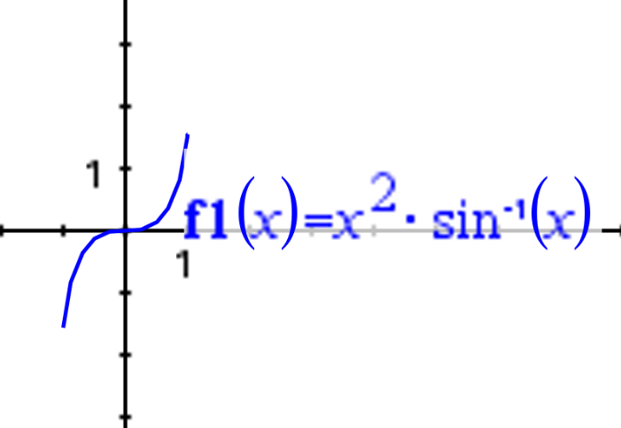
- $arcsin⁡(x)$is odd and $x^{2}$is even $⇒f(x)$is odd:
$$f(-x)=-f(x)$$
(origin symmetry).
- Intercept: $f(0)=0⇒(0,0)$.
- Endpoints:
$$f(1)=1⋅arcsin⁡(1)=\frac{π}{2},f(-1)=1⋅arcsin⁡(-1)=-\frac{π}{2}.$$
- $f$is increasing on $\left[0 , 1\right]$(hence decreasing on $\left[-1,0\right]$by odd symmetry), so the graph rises smoothly from $\left(0 , 0\right)$to $\left(1 , π/2\right)$, and mirrors through the origin to $\left(-1,-π/2\right)$.

Marks
- A1 Correct intercept and odd symmetry shown (passes through $\left(0 , 0\right)$and has origin symmetry).
- A1 Correct endpoint values shown/indicated: $\left(-1,-π/2\right)$and $\left(1 , π/2\right)$.
- A1 Correct overall shape/monotonicity: decreasing on $\left[-1,0\right]$, increasing on $\left[0 , 1\right]$, with a smooth curve joining key points.
Notes
- A sketch need not be to scale, but must show correct symmetry, correct endpoints, and correct trend.
- Do not accept a graph that is even / symmetric about the $y$-axis.

(b) Write down the range of $f$. $\left[2\right]$
From (a), the minimum occurs at $x=-1$and the maximum at $x=1$:
$$f(-1)=-\frac{π}{2},f(1)=\frac{π}{2}.$$
Hence the range is
$$-\frac{π}{2}≤f(x)≤\frac{π}{2}.$$
Marks
- M1 Identifies correct extrema on the domain (e.g. by monotonicity, or GDC evidence) leading to endpoint extrema.
- A1 Correct range $\left[-\frac{π}{2}, \frac{π}{2}\right]$.
Note: Accept equivalent inequality notation.

(c) Solve the inequality $∣x^{2}arcsin⁡(x)∣>0.5$. $\left[3\right]$
Since $f$is odd, $∣f(x)∣>0.5$is symmetric about the origin. Solve for $x≥0$:
$$x^{2}arcsin⁡(x)>0.5,0≤x≤1.$$
Using a GDC to solve
$$x^{2}arcsin⁡(x)=0.5$$
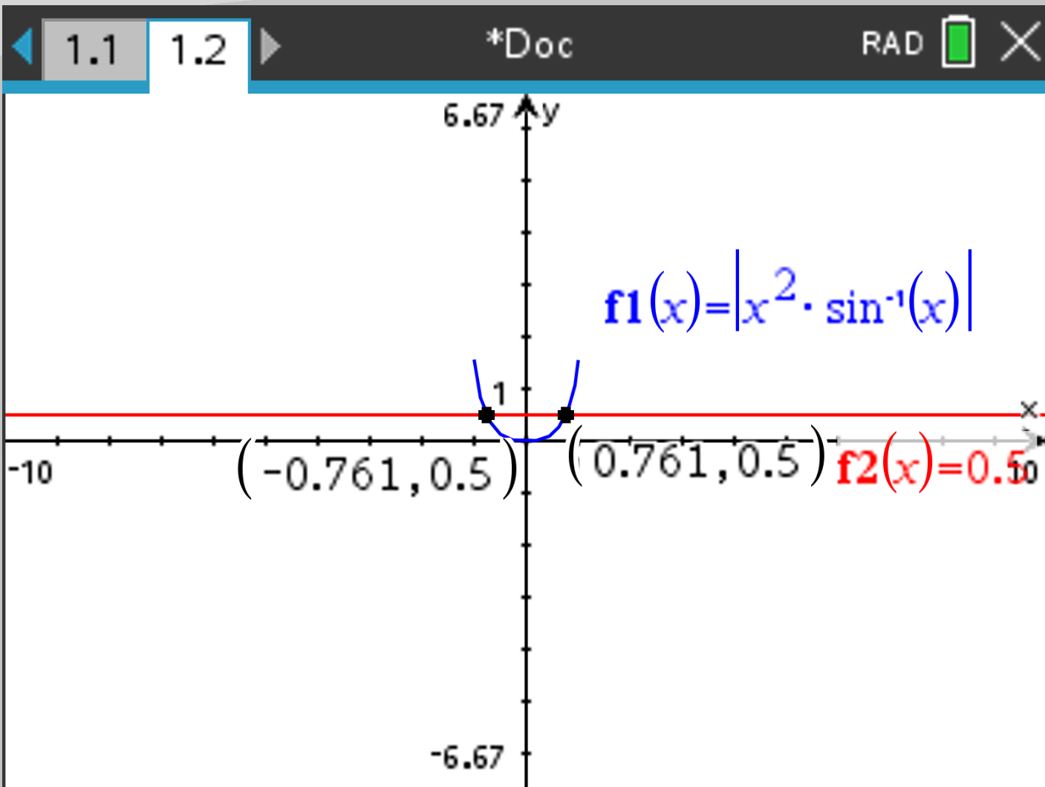
gives
$$x≈0.7606128429…≈0.761 (\text{3 s.f.})$$
Therefore,
$$x∈(0.7606…,1]\text{ for the positive branch,}$$
and by symmetry,
$$x∈[-1,-0.7606…)\text{ for the negative branch.}$$
Final answer (3 s.f.):
$$x∈[-1,-0.761) ∪ (0.761,1].$$
Marks
- M1 Solves $x^{2}arcsin⁡(x)=0.5$(GDC intersection / root find) and obtains the correct critical value $x≈0.7606$.
- M1 Uses absolute value and symmetry (or correct sign reasoning) to form two solution intervals.
- A1 Correct final solution set, with correct strict inequality (endpoints at $±0.7606…$excluded; $±1$included).
Notes
- Accept answers to 3 s.f. (as per paper instructions), i.e. $0.761$.
- Do not accept inclusion of $x=±0.761$(since the inequality is strict $>$).
Paper 2 — Section A — Question 2 (GDC allowed) $\left[6\right]$
Given two events $A$and $B$such that
$$P(A)=3k,P(B)=k,P(A∩B)=\frac{k^{2}}{2},P(A∪B)=0.78.$$

(a) Find the value of $k$. $\left[3\right]$
Use the union formula:
$$P(A∪B)=P(A)+P(B)-P(A∩B).$$
Substitute the given expressions:
$$0.78=3k+k-\frac{k^{2}}{2} \\ 0.78=4k-\frac{k^{2}}{2} \\ k^{2}-8k+1.56=0$$
Solve (quadratic formula or GDC):
$$k=\frac{8±\sqrt{64-6.24}}{2}=\frac{8±\sqrt{57.76}}{2} \\ k=\frac{8±7.6}{2}⇒k=7.8\text{ or }0.2$$
Since $P(B)=k≤1$, only
$$\boxed{k=0.2}$$
is valid.
Marks
- M1 Uses $P(A∪B)=P(A)+P(B)-P(A∩B)$.
- M1 Forms and solves a correct quadratic in $k$(algebraic or GDC).
- A1 Selects the valid solution $k=0.2$.
Notes
- The extraneous root $k=7.8$must be rejected using probability constraints.
- Correct rounding is not required here; exact decimals acceptable.

(b) Find $P(A^{'}∩B)$. $\left[3\right]$
$$P(A^{'}∩B)=P(B)-P(A∩B)$$
Substitute $k=0.2$:
$$P(A^{'}∩B)=0.2-\frac{\left(0.2)^{2}\right.}{2}=0.2-0.02=0.18 \\ \boxed{P(A^{'}∩B)=0.18}$$
Marks
- M1 Uses $P(A^{'}∩B)=P(B)-P(A∩B)$.
- A1 Correct substitution of $k=0.2$.
- A1 Correct final probability $0.18$.
Notes
- Alternative valid method using Venn diagrams is acceptable.
- Answers must be numerical;
- Using probability for independent events will receive 0 mark
Question 3 (Maximum mark: 6)
Circle centre $O$, radius $8$cm, $∠A\hat{O}B=1.4$radians.
(a) Find the length of the minor arc $AB$. $\left[3\right]$
Arc length:
$$s=rθ=8(1.4)=11.2\text{ cm}$$
M1 Uses $s=rθ$.
A1 Substitutes $r=8, θ=1.4$.
A1 $s=11.2$cm. (Correct answer with unit) is needed for A1.

(b) Find the area of the shaded region. $\left[3\right]$
The shaded region is the sector $AOB$(minor sector).
$$\text{Area}=\frac{1}{2}r^{2}θ=\frac{1}{2}(8^{2})(1.4)=\frac{1}{2}(64)(1.4)=44.8{\text{ cm}}^{2}$$
M1 Uses $\text{Area}=\frac{1}{2}r^{2}θ$.
A1 Correct substitution.
A1 $44.8{\text{ cm}}^{2}$.

Question 4 (Maximum mark: 6)
$$m(t)=120e^{-0.000121t}$$
$m(t)$in nanograms, $t$in years.
(a) Write down the initial mass. $\left[1\right]$
$$m(0)=120e^{0}=120$$
A1 $120$ng.
Note: Unit for this question is not considered when awarding the final A1.

(b) Find the mass after $20000$years. $\left[2\right]$
$$m(20000)=120e^{-0.000121(20000)}=120e^{-2.42}≈10.6706$$
M1 Substitutes $t=20000$correctly.
A1 $m(20000)≈10.7$ng (answer must be kept to 3 s.f. for this A1 to be awarded).
GDC: Award M1 for correct calculator evaluation setup.

(c) Smallest number of complete years for more than half to decay. $\left[3\right]$
“More than half decayed” $⇒$remaining mass $<60$ng:
$$120e^{-0.000121t}<60⇒e^{-0.000121t}<\frac{1}{2} \\ -0.000121t<ln⁡\left(\frac{1}{2}\right)=-ln⁡2⇒t>\frac{\ln{2}}{0.000121}≈5728.49$$
Smallest complete number of years:
$$t=5729$$
M1 Sets up inequality $120e^{-0.000121t}<60$.
M1 Solves to $t>\frac{\ln{2}}{0.000121}$(or equivalent).
A1 $5729$years. (Do NOT accept 5728, 5728.5)
Note: Must round up (strict inequality + “complete years”).

Question 5 (Maximum mark: 8)
Bearings: $B$is $70$km from $A$on bearing ${130}^{∘}$.
$C$is $40$km from $B$on bearing ${75}^{∘}$.
(a) Find the distance from $A$to $C$. $\left[2\right]$
Using coordinates or cosine rule after forming included angle.
Result:
$$AC≈98.5\text{ km}$$
M1 Correct method (coordinate/bearing components or cosine rule with correct included angle).
A1 $AC≈98.5$km (accept answers kept to more than 3 s.f. if the candidate was already penalized in question 4).
Allow FT for part (B) and (c).
Special Case: award MRM0A1 for students who misread BC as 10km, the graph is a bit unclear, although the information was also given in the question. The answer will be 76.2km.
If student used 10 instead 40km for BC, the answer to part (b) is 124$°$, the answer to (c) is 287km.

(b) Find the bearing of $C$from $A$. $\left[3\right]$
Using components (east/north) or a correct triangle + trig method (GDC).
$$\text{Bearing}≈{110.58}^{∘}≈{111}^{∘}$$
M1 Forms correct direction from $A$to $C$(components or angle reasoning).
M1 Correct use of ${tan⁡}^{-1}$/ GDC to obtain direction angle.
A1 Bearing $≈{111}^{∘}$(nearest degree).
Notes
- Accept ${110.6}^{∘}$(to 1 d.p.) or ${111}^{∘}$(nearest degree), depending on candidate rounding.
- Bearing must be three-figure if rounded to nearest degree: ${111}^{∘}$.

(c) Find the area of triangle $ABC$. $\left[3\right]$
Using
$$\text{Area}=\frac{1}{2}AB⋅BC⋅sin⁡(∠ABC)$$
or coordinate determinant method (GDC acceptable).
Result:
$$\text{Area}≈1.15×{10}^{3}{\text{ km}}^{2} (≈1150{\text{ km}}^{2})$$
M1 Correct area method selected.
M1 Correct substitution (including correct included angle).
A1 $\text{Area}≈1.15×{10}^{3}{\text{ km}}^{2}$(3 s.f.). (Accept 1146.8 also. Missing units is not penalized in this question again if the candidate was already penalized in question 4)

Question 6 (Maximum mark: 5)
$$f(x)=0.2e^{x+2}-4,-3≤x≤2$$
(a) Sketch the graph of $y=f(x)$. $\left[3\right]$
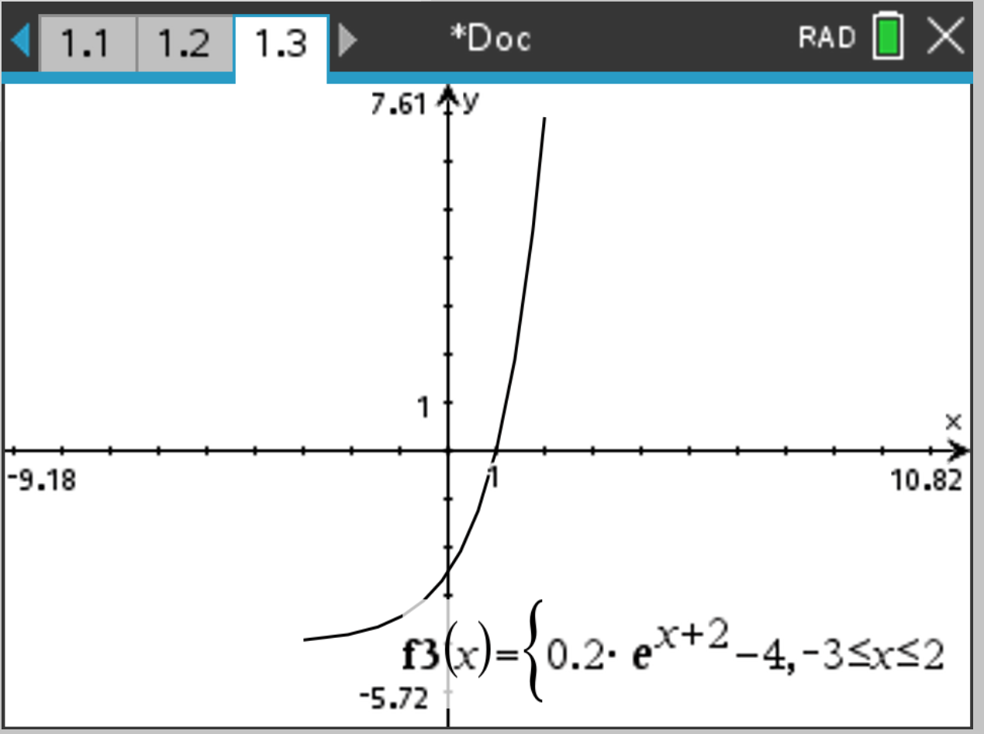
Key features:
- Exponential increasing function.
- Horizontal asymptote $y=-4$.
- Endpoints on domain:
$$f(-3)=0.2e^{-1}-4≈-3.93,f(2)=0.2e^{4}-4≈6.92$$
- Crosses $x$-axis once near $x≈0.996$.
A1 Correct horizontal asymptote $y=-4$.
A1 Correct general exponential shape/increasing and appropriate positioning on the given domain.
A1 Includes at least two correct reference points (e.g. endpoints and/or intercepts) consistent with the function.
Notes
- A GDC-generated sketch is acceptable if correctly transferred to the grid.
- Penalise if the curve is decreasing or asymptote is incorrect.

(b) Find the coordinates of (i) the $x$-intercept, (ii) the $y$-intercept. $\left[2\right]$
(i) $x$-intercept:
$$0.2e^{x+2}-4=0⇒e^{x+2}=20⇒x=ln⁡20-2≈0.9957$$
So $\left(0.996 , 0\right)$(3 s.f.).
(ii) $y$-intercept:
$$f(0)=0.2e^{2}-4≈-2.522$$
So $\left(0,-2.52\right)$(3 s.f.).
A1 Correct $x$-intercept $\left(0.996 , 0\right)$.
A1 Correct $y$-intercept $\left(0,-2.52\right)$.
GDC: Accept solutions from solver/graph with appropriate rounding.

Question 7 (Maximum mark: 6)
$$f(x)=2^{x}-\frac{1}{2^{x}},x∈R \\ g(x)=\frac{x-1}{x^{2}-2x-3},x∈R, x≠-1, x≠3$$
(a) Show that $f$is an odd function. $\left[2\right]$
$$f(-x)=2^{-x}-\frac{1}{2^{-x}}=2^{-x}-2^{x}=-(2^{x}-2^{-x})=-f(x)$$
M1 Substitutes $-x$correctly and simplifies or correct sketch of graph
A1 Concludes $f(-x)=-f(x)$, or it is rotational symmetry about the origin, hence $f$is odd.

(b) Solve the inequality $f(x)≥g(x)$. $\left[4\right]$
Let
$$h(x)=f(x)-g(x)=2^{x}-2^{-x}-\frac{x-1}{\left(x-3)(x+1\right)}.$$
Use GDC to find intersections $h(x)=0$(with domain restrictions $x≠-1,3$).
Solutions (to 3 s.f.):
$$x≈-1.27,x≈0.178$$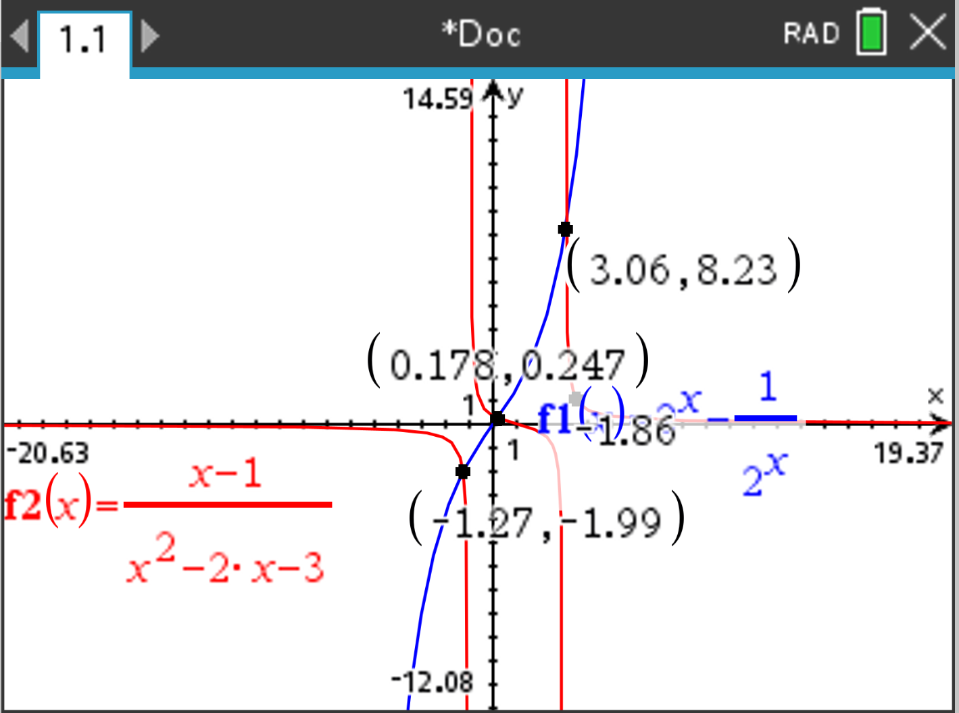
Sign analysis (GDC table/graph):
- $h(x)≥0$on $[-1.27,-1)$
- $h(x)≥0$on $[0.178,3)$
- $h(x)≥0$on $\left(3 , ∞\right)$
Hence:
$$\boxed{x∈[-1.27,-1) ∪ [0.178,3) ∪ (3,∞)}$$
M1 Sets up inequality as $h(x)=f(x)-g(x)≥0$with correct domain restrictions.
M1 Uses GDC to obtain correct boundary values (intersections) $≈-1.27, 0.178$.
M1 Correct sign/interval reasoning (e.g. test points or GDC inequality solver output).
A1 Correct final solution set with exclusions $x≠-1,3$and correct inclusive/exclusive endpoints.
Notes
- Endpoints at $-1.27$and $0.178$are included (≥).
- $x=-1$and $x=3$must be excluded (undefined $g$).
- Accept equivalent interval notation.

Question 8 (Maximum mark: 11)
$$g(x)=arccos⁡\left(\frac{x^{2}-1}{x^{2}+1}\right),x≥0$$
(a) Find the range of $g$. $\left[2\right]$
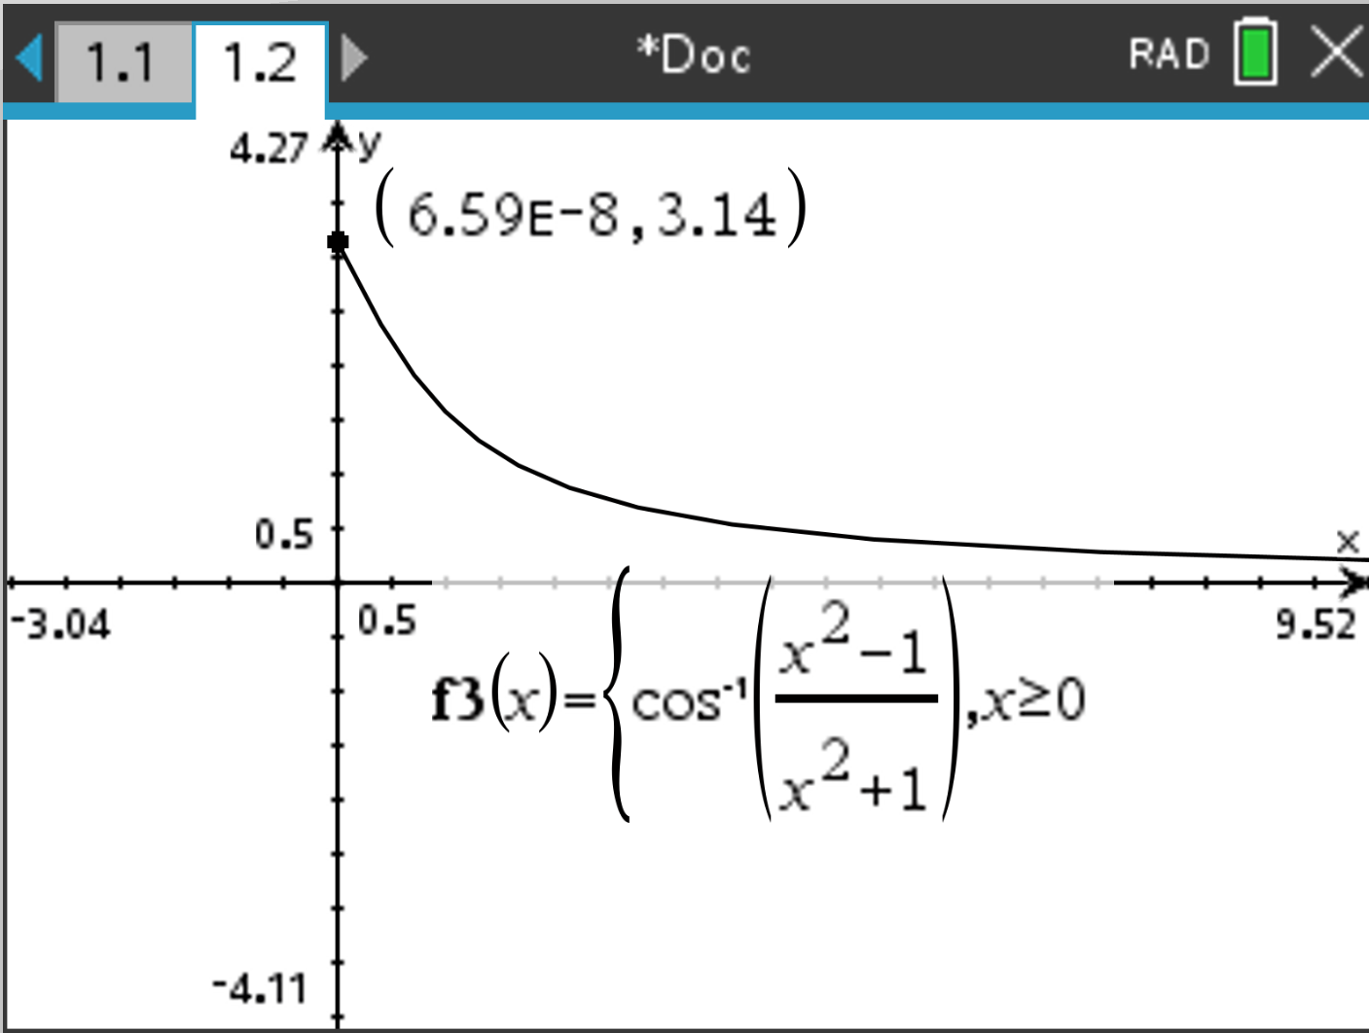
Let
$$u(x)=\frac{x^{2}-1}{x^{2}+1}.$$
For $x≥0$: $u(0)=-1$and $u(x)→1$as $x→∞$, with $u(x)<1$for all finite $x$.
Thus $\left.u∈[-1,1\right)$.
Since $arccos⁡$maps $\left[-1,1]→[0,π\right]$, we get:
$$g(0)=arccos⁡(-1)=π,g(x)→0^{+}\text{ as }x→∞$$
So the range is
$$\boxed{0<g(x)≤π.}$$
M1 Correct endpoint/limit behaviour ($x=0$ gives $π$, and limit as $x→∞$gives $0$).
A1 Correct range $0<g(x)≤π$.

(b) Find an expression for $g^{-1}(x)$. $\left[4\right]$
Let $y=g(x)$:
$$y=arccos⁡\left(\frac{x^{2}-1}{x^{2}+1}\right)⇒cos⁡y=\frac{x^{2}-1}{x^{2}+1}.$$
Solve for $x$:
$$cos⁡y(x^{2}+1)=x^{2}-1⇒(cos⁡y-1)x^{2}=-(1+cos⁡y) \\ x^{2}=\frac{1+cos⁡y}{1-cos⁡y}.$$
Using identities $1+cos⁡y=2{cos⁡}^{2}\frac{y}{2}, 1-cos⁡y=2{sin⁡}^{2}\frac{y}{2}$:
$$x^{2}={cot⁡}^{2}\left(\frac{y}{2}\right)⇒x=cot⁡\left(\frac{y}{2}\right)(\text{since }x≥0).$$
Therefore
$$\boxed{g^{-1}(y)=cot⁡\left(\frac{y}{2}\right)}.$$
Equivalently, using variable $x$:
$$\boxed{g^{-1}(x)=cot⁡\left(\frac{x}{2}\right)}.$$accept $g^{-1}\left(x\right)=\sqrt{\frac{1+cos⁡y}{1-cos⁡y}.}$ Or other equivalent form also.
M1 Takes cosine and rearranges to isolate $x^{2}$.
M1 Obtains $x^{2}=\frac{1+cos⁡y}{1-cos⁡y}$.
A1 Simplifies to $x=cot⁡\left(\frac{y}{2}\right)$.
A1 Correctly selects the positive root using $x≥0$.

(c) State the domain of $g^{-1}(x)$. $\left[1\right]$
Domain of inverse = range of $g$:
$$\boxed{0<x≤π.}$$
A1 Correct domain.
Allow FT for their answer to part (a).

(d) Sketch the graph of $y=g^{-1}(x)$, indicating asymptotes and intercepts. $\left[4\right]$
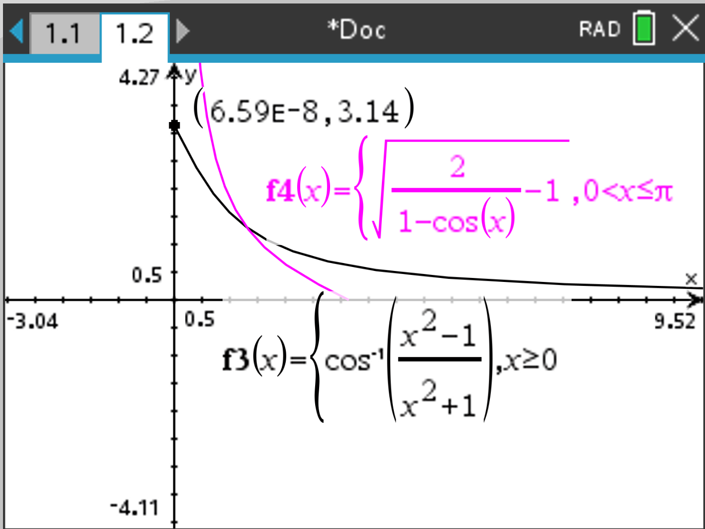
From (b),
$$y=g^{-1}(x)=cot⁡\left(\frac{x}{2}\right),0<x≤π.$$
- As $x→0^{+}$, $cot⁡(x/2)→+∞$
$⇒$vertical asymptote:
$$\boxed{x=0}$$
- At $x=π$,
$$y=cot⁡\left(\frac{π}{2}\right)=0⇒x\text{-intercept }\boxed{\left(π , 0\right)}.$$
- No $y$-intercept (since $x=0$is not in the domain).
- Curve is decreasing on $(0,π]$, from $+∞$down to $0$.
A1 Correct asymptote $x=0$.
A1 Correct intercept $\left(π , 0\right)$.
A1 Correct overall shape (decreasing, tends to $+∞$as $x→0^{+}$).
A1 Correct domain shown on sketch (only $0<x≤π$) and no $y$-intercept.
Paper 2 — Question 9 Markscheme (GDC allowed) $\left[17\right]$
Cumulative frequency curve for $n=80$drivers.
(Answers read from a graph should be accepted within a reasonable tolerance consistent with the printed scale.)

(a) Number of drivers who travelled between 3200 km and 5000 km $\left[2\right]$
Read from the cumulative frequency curve:
- $\text{CF at }3200≈47$ ($±3)$
- $\text{CF at }5000≈76$ ($±3)$
Number between $3200$and $5000$:
$$76-47=29$$
M1 Reads (or attempts to read) cumulative frequencies at 3200 and 5000 from the curve.
A1 Correct subtraction to give $\boxed{29 (±5)}$drivers.
Accept: typically $24$–$34$, depending on accurate reading.

(b) Use the curve to find: median, lower quartile, upper quartile $\left[3\right]$
For $n=80$:
- Lower quartile $Q_{1}$at CF $=\frac{80}{4}=20$
- Median $Q_{2}$at CF $=\frac{80}{2}=40$
- Upper quartile $Q_{3}$at CF $=\frac{3×80}{4}=60$
Read corresponding distances from the curve:
$$Q_{2}≈3000\text{ km},Q_{1}≈2500\text{ km},Q_{3}≈3600\text{ km}$$
A1 Median $≈3000$km (from CF $=40$).
A1 Lower quartile $≈2500$km (from CF $=20$).
A1 Upper quartile $≈3600$km (from CF $=60$).
Acceptable ranges (typical):
- $Q_{1}$: $2400$–$2600$ km
- Median: $2900$–$3100$ km
- $Q_{3}$: $3500$–$3700$ km

(c) Hence, find the interquartile range $\left[1\right]$
$$\text{IQR}=Q_{3}-Q_{1}≈3600-2500=1100\text{ km (approx.)}$$
A1 $\boxed{\text{IQR}≈1100\text{ km}}$(FT from part (b)).

(d) Percentage of drivers who travelled a distance greater than the upper quartile $\left[1\right]$
Upper quartile is the 75th percentile, so the proportion above it is $25\%$.
A1 $\boxed{25\%}$

(e) Number of drivers who travelled $≤2750$km $\left[1\right]$
Read CF at $2750$km:
$$\text{CF}(2750)≈28$$
A1 $\boxed{28}$drivers.
Accept: typically $26$–$30$.

(f) 11 drivers travelled more than $m$km. Find $m$. $\left[2\right]$
“11 travelled more than $m$” means $80-11=69$travelled $≤m$.
So $m$is the distance at cumulative frequency $69$.
From the curve:
$$m≈4100\text{ km}$$
M1 Uses CF $=69$(or equivalent reasoning).
A1 Reads $m≈4100$km from the curve.
Acceptable range (typical): $3900$–$4300$ km.

(g) Box-and-whisker diagram on graph paper, scale $2\text{ cm}:1000\text{ km}\left[4\right]$
Given:
- Minimum $=500$km
- Maximum $=6000$km
From part (b):
- $Q_{1}≈2500$km
- Median $≈3000$km
- $Q_{3}≈3600$km
Expected five-number summary (approx.):
$$\left(500 , 2500 , 3000 , 3600 , 6000\right)$$
Marking (graphical):
- A1 Whiskers correctly placed at $\boxed{500}$km and $\boxed{6000}$km.
- A1 Box correctly drawn from $\boxed{Q_{1}}$to $\boxed{Q_{3}}$using consistent scale.
- A1 Median line correctly placed at $\boxed{Q_{2}}$.
- A1 Diagram uses the stated scale and is clearly labelled/accurately positioned.
Notes
- Award follow-through for quartiles if candidate’s $Q_{1},Q_{2},Q_{3}$are consistent with their (b).
- If the diagram is not on graph paper (as instructed in the question), apply your school policy; the paper states it would score 0 for this part.

Summary of key numerical answers (guide)
- (a) $28$
- (b) $Q_{1}≈2500$, median $≈3000$, $Q_{3}≈3600$(km)
- (c) IQR $≈1100$km
- (d) $25\%$
- (e) $28$
- (f) $m≈4100$km
- (g) min 500, $Q_{1}≈2500$, median $≈3000$, $Q_{3}≈3600$, max 6000
Paper 2 — Question 10 Markscheme (GDC allowed) $\left[17\right]$
Loan principal $L=480 000$. Term $10$years, compounded monthly. Monthly payment $p$is made after interest is added each month.
Let
$$k=1+\frac{r}{1200}.$$

(a) Scenario 1: $p=5000\left[6\right]$
(a)(i) Number of payments over 10 years $\left[1\right]$
$$n=10×12=120$$
A1 $n=120$.

(a)(ii) Show that $96k^{120}=\frac{k^{120}-1}{k-1}\left[2\right]$
For an amortized loan (interest first, then payment), the balance after $n$payments is
$$B_{n}=Lk^{n}-p\left(\frac{k^{n}-1}{k-1}\right).$$
Here $n=120$, and the loan is fully repaid, so $B_{120}=0$:
$$0=480000 k^{120}-5000\left(\frac{k^{120}-1}{k-1}\right).$$
Divide by $5000$:
$$0=96k^{120}-\frac{k^{120}-1}{k-1}⇒96k^{120}=\frac{k^{120}-1}{k-1}.$$
Or by balance remaining for each month:
$480000\left(1+\frac{r}{12}\right)-p$ after the 1st month
$480000{\left(1+\frac{r}{12}\right)}^{2}-\left(1+\frac{r}{12}\right)p-p$ after the 2nd month
$480000{\left(1+\frac{r}{12}\right)}^{3}-{\left(1+\frac{r}{12}\right)}^{2}p-\left(1+\frac{r}{12}\right)p-p$ after the 3rd month…
M1 Uses a correct loan recurrence/standard formula leading to $0=Lk^{120}-p\left(\frac{k^{120}-1}{k-1}\right)$.
A1 Correctly simplifies to $96k^{120}=\frac{k^{120}-1}{k-1}$.
Note: Accept derivation by geometric series from repeated substitution.

(a)(iii) Hence, or otherwise, find $r$. $\left[3\right]$
Solve (using GDC) the equation
$$96k^{120}=\frac{k^{120}-1}{k-1},k>1.$$
GDC gives
$$k≈1.00384118265.$$
Or use the finance solver on GDC gives
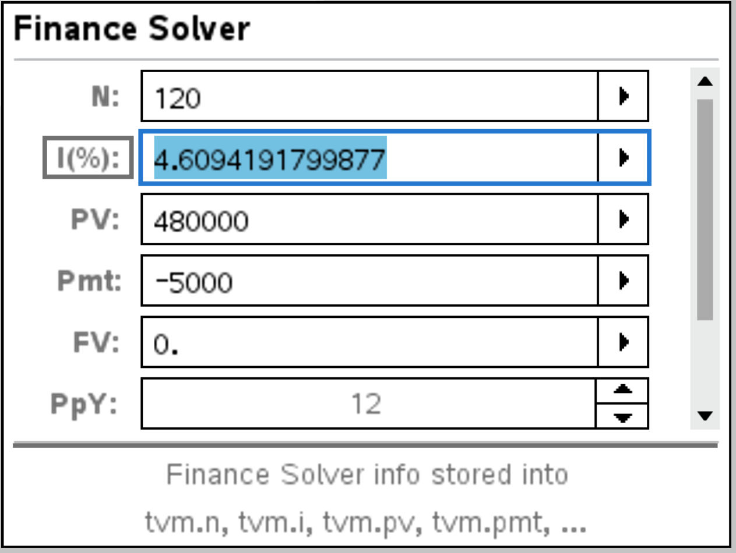
Then
$$r=1200(k-1)≈1200(0.00384118265)=4.60941918≈4.61. \\ \boxed{r≈4.61\%\text{ p.a.}}$$
M1 Solves the equation for $k$using a correct numerical method (GDC).
M1 Converts correctly using $r=1200(k-1)$.
A1 $r≈4.61\%$(to 3 s.f. acceptable).
Notes
- Reject extraneous $k≤1$(would imply $r≤0$, not consistent with a standard loan context).
- Accept $r=4.609\%$etc.

(b) Scenario 2: same $p$and $r$as (a), pays for 7 years 4 months then final payment $\left[3\right]$
(b)(i) Number of monthly payments before the final payment $\left[1\right]$
$$7\text{ years }4\text{ months}=7×12+4=88\text{ payments}.$$
A1 $88$.

(b)(ii) Final payment (to clear remaining balance) to 4 s.f. $\left[2\right]$
Balance after $88$payments:
$$B_{88}=480000 k^{88}-5000\left(\frac{k^{88}-1}{k-1}\right).$$
Using $k≈1.00384118265$,
$$B_{88}≈150286.3.$$

Or use the finance solver on GDC gives
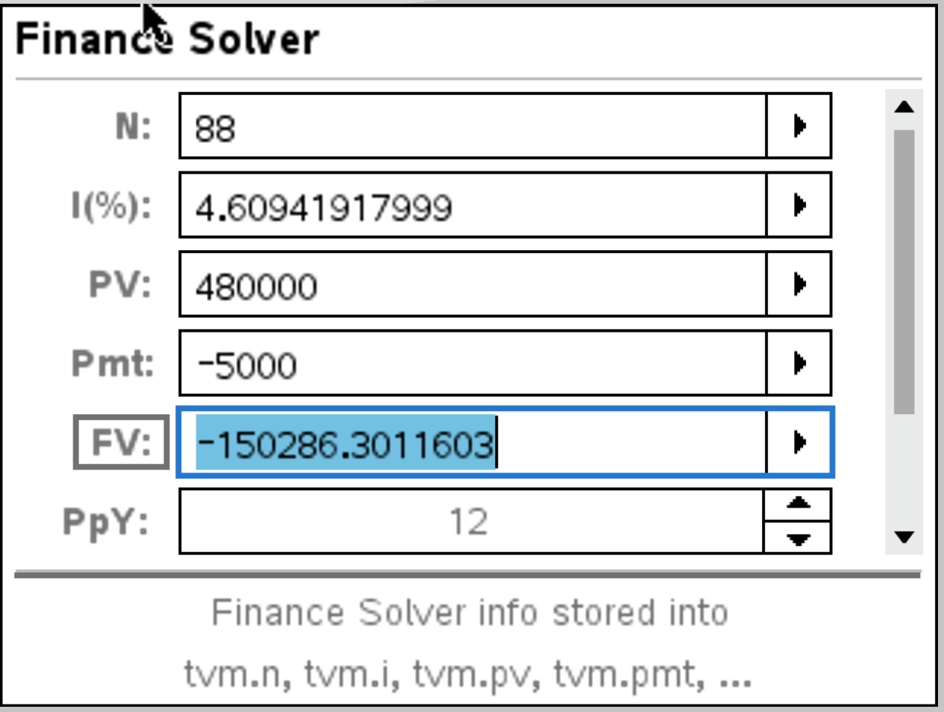
One more month of interest is added before the final payment, so final payment
$$F=B_{88}k≈150286.3\left(1.00384118265\right)≈150863.6 \\ \boxed{F≈1.509×{10}^{5}\text{ dollars}≈150900}\left(4\text{ s.f.}\right)$$Allow answer that did not consider the one last month of interest added, which yields:
$$\boxed{F≈1.503×{10}^{5}\text{ dollars}≈150300}(4\text{ s.f.})$$
M1 Uses correct remaining-balance method after 88 payments (GDC acceptable).
A1 Correct final payment after adding one month of interest, $F=B_{88}k$ or $F=B_{88}$, to be awarded the final A1, the candidate must have kept their answers to 4 s.f.
Notes
- FT allowed from candidate’s $k$in part (a).
- Accept answers in the range consistent with rounding/solver precision.

(c) Scenario 3: pays $p$for 5 years, then $2p$for remaining 5 years $\left[8\right]$
Total months: 60 months at $p$, then 60 months at $2p$.
After first 60 payments, balance:
$$B_{60}=480000 k^{60}-p\left(\frac{k^{60}-1}{k-1}\right).$$
After next 60 payments of $2p$, final balance is zero:
$$0=B_{60}k^{60}-2p\left(\frac{k^{60}-1}{k-1}\right).$$
Substitute $B_{60}$:
$$0=\left(480000 k^{60} − pA\right)k^{60}-2pA=480000 k^{120}-pA(k^{60}+2)$$
where $A=\frac{k^{60}-1}{k-1}$.
Hence
$$p=\frac{480000 k^{120}}{A(k^{60}+2)}.$$
Using $k≈1.00384118265$:
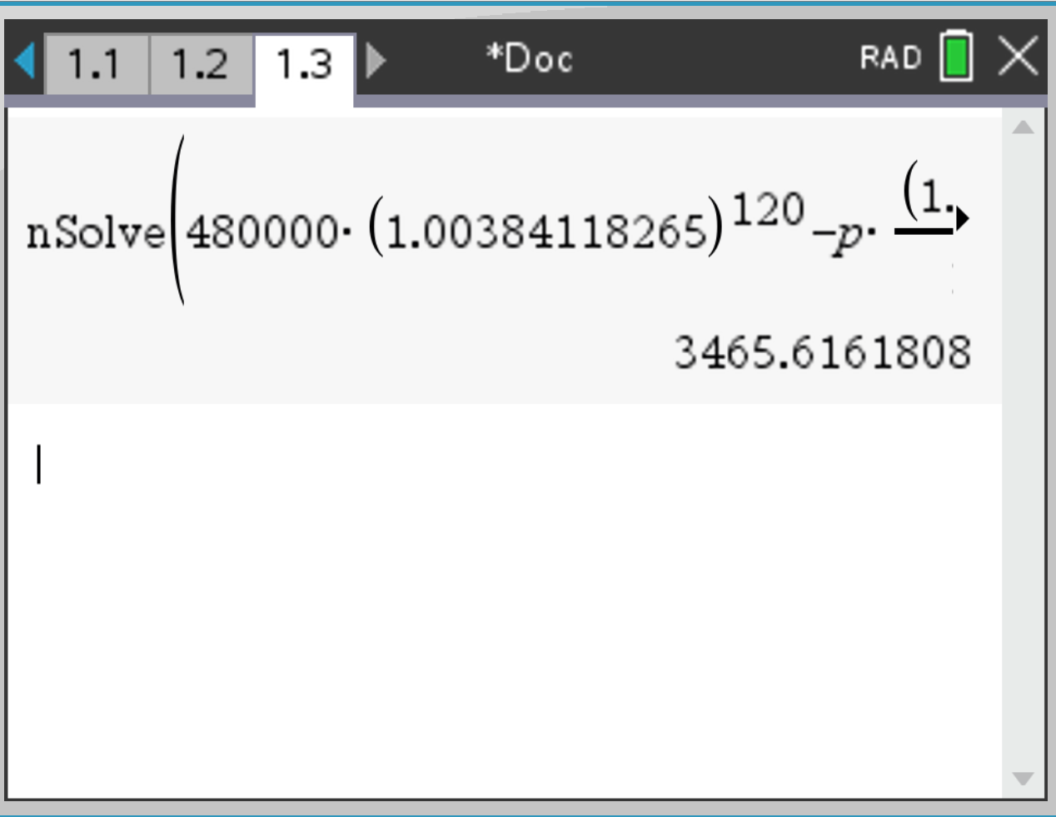
$$p≈3465.616 ⇒ \boxed{p≈3466}.$$
Mark allocation
- M1 Correct expression for $B_{60}$.
- M1 Correct second-stage equation $0=B_{60}k^{60}-2pA$(or equivalent).
- M1 Correct elimination to an equation in $p$only.
- M1 Correct formula for $p$(as above) or equivalent.
- A1 Correct numerical evaluation of $p$.
- A1 $p≈3466$dollars (nearest dollar).
- A1 Correct handling of $k$from part (a) (FT allowed).
- A1 Final answer stated clearly with correct rounding.
Notes
- GDC use is expected for evaluating the expression.
- FT allowed from a candidate’s value of $k$from (a)(iii), provided their method is consistent.

Final answers (for reference)
- (a)(i) $120$
- (a)(iii) $r≈4.61\%$
- (b)(i) $88$
- (b)(ii) Final payment $≈150900$ or 150300 Allow FT.
- (c) $p≈3466$
Paper 2 — Question 11 Markscheme (GDC allowed) $\left[23\right]$
Model:
$$H(t)=asin⁡(b(t-c))+d,a>0, b>0, c>0,$$
where $t$is hours after midnight.
Given:
- First high tide at $t=4.5$(04:30)
- Next high tide 12 hours later $⇒$period $T=12$
- Heights fluctuate between 2.2 m and 6.8 m (1 d.p.)

(a) Show that $b=\frac{π}{6}$. $\left[1\right]$
Period of $sin⁡(b(t-c))$is $\frac{2π}{b}$.
Given $T=12$:
$$\frac{2π}{b}=12 ⇒ b=\frac{2π}{12}=\frac{π}{6}.$$
A1 Correctly obtains $b=\frac{π}{6}$.

(b) Find $a$. $\left[2\right]$
Amplitude:
$$a=\frac{\text{max}-\text{min}}{2}=\frac{6.8-2.2}{2}=2.3.$$
M1 Uses amplitude $=\frac{\text{max}-\text{min}}{2}$.
A1 $a=2.3$.

(c) Find $d$. $\left[2\right]$
Midline:
$$d=\frac{\text{max}+\text{min}}{2}=\frac{6.8+2.2}{2}=4.5.$$
M1 Uses midline $=\frac{\text{max}+\text{min}}{2}$.
A1 $d=4.5$.

(d) Find the smallest possible value of $c$. $\left[3\right]$
High tide (maximum) occurs when:
$$sin⁡(b(t-c))=1 ⇒ b(t-c)=\frac{π}{2}+2πn.$$
At the first high tide $t=4.5$, with $b=\frac{π}{6}$:
$$\frac{π}{6}(4.5-c)=\frac{π}{2}+2πn \\ 4.5-c=3+12n⇒c=1.5-12n.$$
With $c>0$, the smallest possible is when $n=0$:
$$c=1.5.$$
M1 Uses the maximum condition $b(t-c)=\frac{π}{2}+2πn$.
M1 Substitutes $t=4.5$, $b=\frac{π}{6}$and solves for $c$.
A1 Smallest positive $c=1.5$(hours).

(e) Find the height of the water at 12:00. $\left[2\right]$
At 12:00, $t=12$:
$$H(12)=2.3sin⁡ \text{⁣}\left(\frac{π}{6}(12-1.5)\right)+4.5=2.3sin⁡ \text{⁣}\left(\frac{10.5π}{6}\right)+4.5 \\ = 2.3sin⁡ \text{⁣}\left(\frac{7π}{4}\right)+4.5=2.3\left( − \frac{\sqrt{2}}{2}\right)+4.5≈2.8737. \\ \boxed{H(12)≈2.87\text{ m}}(\text{to }\text{3 }\text{s.f}\text{.})$$
M1 Correct substitution $t=12$into the model (FT from earlier parts).
A1 $H(12)≈2.87$m (3 s.f.).
GDC: May be used to evaluate $H(12)$.

(g) Determine the number of hours, over a 24-hour period, for which the tide is higher than 5 m. $\left[3\right]$
Solve:
$$H(t)>5 ⇒ 2.3sin⁡(b(t-c))+4.5>5 \\ sin⁡(b(t-c))>\frac{0.5}{2.3}=0.217391…$$
Let $θ=b(t-c)$. Over one cycle ($0≤θ<2π$):
$$sin⁡θ>0.217391…$$
This holds for
$$α<θ<π-α,α=arcsin⁡(0.217391…)≈0.219\text{ rad}.$$
Interval length:
$$(π-α)-α=π-2α≈2.703\text{ rad}.$$
Fraction of one cycle:
$$\frac{π-2α}{2π}≈0.4303.$$
One cycle lasts 12 hours, so time per cycle:
$$0.4303×12≈5.16\text{ h}.$$
Over 24 hours (two cycles):
$$2×5.16≈10.3\text{ h}. \\ \boxed{\text{About }10.3\text{ hours}}$$
M1 Sets up inequality leading to $sin⁡(b(t-c))>\frac{0.5}{2.3}$.
M1 Uses inverse sine / GDC to obtain the correct interval in one cycle (or equivalent graph/inequality solver).
A1 Correct total duration over 24 h $≈10.3$hours.
Notes
- Allow FT for their values of $a, b$ and $c$.
- Full credit if obtained via GDC graph + “measure”/intersection time differences, provided the method is clear.

(h) Folkestone has the same sinusoidal pattern, but high and low tides occur 50 minutes earlier. Give a suitable model. $\left[2\right]$
50 minutes $=\frac{50}{60}=\frac{5}{6}$hours earlier $⇒$translate left by $\frac{5}{6}$.
A suitable model:
$$H_{F}(t)=asin⁡(b(t-(c-\frac{5}{6})))+d$$
or equivalently
$$\boxed{H_{F}(t)=asin⁡(b(t-c+\frac{5}{6}))+d.}$$
M1 Recognises earlier tides $⇒$horizontal translation left by $\frac{5}{6}$hour.
A1 Correct translated model.

(j) Rewriting and interpreting the model $\left[4\right]$
Given
$$H(t)=asin⁡(bt)cos⁡(bc)-acos⁡(bt)sin⁡(bc)+d.$$
(j)(i) Show this is equivalent to $H(t)=asin⁡(b(t-c))+d$. $\left[2\right]$
Use $sin⁡(X-Y)=sin⁡Xcos⁡Y-cos⁡Xsin⁡Y$with $X=bt, Y=bc$:
$$sin⁡(bt-bc)=sin⁡(bt)cos⁡(bc)-cos⁡(bt)sin⁡(bc).$$
Hence
$$H(t)=asin⁡(bt-bc)+d=asin⁡(b(t-c))+d.$$
M1 Uses the identity $sin⁡(X-Y)=sin⁡Xcos⁡Y-cos⁡Xsin⁡Y$.
A1 Correctly rewrites to $asin⁡(b(t-c))+d$.
(j)(ii) Explain the significance of $a$and $c$. $\left[2\right]$
- $a$is the amplitude: maximum deviation from the mean water level $d$.
- $c$is the horizontal translation / phase shift (in hours): the time shift of the cycle; specifically $t=c$gives $H(t)=d$(midline crossing), and it determines when highs/lows occur.
A1 Correct interpretation of $a$(amplitude).
A1 Correct interpretation of $c$(time/phase shift).

(k) Let $K(t)=[H(t)-d]^{2}$. Show $K(t)=A-Bcos⁡(2b(t-c))$and find $A,B$. $\left[4\right]$
$$H(t)-d=asin⁡(b(t-c))⇒K(t)=a^{2}{sin⁡}^{2}(b(t-c)).$$
Use ${sin⁡}^{2}x=\frac{1-cos⁡2x}{2}$:
$$K(t)=a^{2}⋅\frac{1-cos⁡(2b(t-c))}{2}=\frac{a^{2}}{2}-\frac{a^{2}}{2}cos⁡(2b(t-c)).$$
So
$$\boxed{A=\frac{a^{2}}{2},B=\frac{a^{2}}{2}.}$$
M1 Writes $K(t)=a^{2}{sin⁡}^{2}(b(t-c))$.
M1 Uses ${sin⁡}^{2}x=\frac{1-cos⁡2x}{2}$(or equivalent).
A1 Obtains the required form $A-Bcos⁡(2b(t-c))$.
A1 Correct constants $A=\frac{a^{2}}{2}, B=\frac{a^{2}}{2}$.

Final answers (for reference)
- (a) $b=\frac{π}{6}$
- (b) $a=2.3$
- (c) $d=4.5$
- (d) $c=1.5$
- (e) $H(12)≈2.87$m
- (g) $≈10.3$hours
- (h) $H_{F}(t)=asin⁡(b(t-c+\frac{5}{6}))+d$
- (k) $A=B=\frac{a^{2}}{2}$

