Paper 3 [55 marks]
1. 24N.3.AHL.TZ0.2
A polynomial is said to be palindromic if the sequence of its coefficients remains the same in reverse. This question asks you to investigate some properties and solutions of palindromic polynomial equations.
In parts (a) and (b), consider quadratic equations of the form $ax^{2}+bx+a=0$, where $a≠0$.
The sequence of coefficients, $\left\{a, b, a\right\}$, remains the same in reverse.
The following table shows three palindromic quadratic equations and their sequence of coefficients.
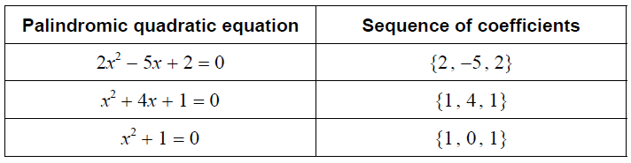
The quadratic equation $2x^{2}-5x+2=0$ has roots $2$ and $\frac{1}{2}$.
These roots form a “reciprocal pair”, since one root is the reciprocal of the other.
(a.i)
Determine the roots of $x^{2}+4x+1=0$.
Give these roots in the form $s±\sqrt{t}$, where $s∈Z$ and $t∈Z^{+}$.
[3]
Markscheme
attempts to solve (M1) EITHER $x=\frac{-4±\sqrt{4^{2}-4\left(1\right)\left(1\right)}}{2}$
OR ${\left(x+2\right)}^{2}-3 \left(=0\right)$
OR $\left(x+2+\sqrt{3}\right)\left(x+2-\sqrt{3}\right) \left(=0\right)$
THEN $x=-2±\sqrt{3}$ A1A1 Note: Award A1 for $-2+\sqrt{3}$ and A1 for $-2-\sqrt{3}$.
[3 marks]

(a.ii)
Hence, or otherwise, show that these roots form a reciprocal pair.
[2]
Markscheme
METHOD 1 attempts to find their $\frac{1}{-2-\sqrt{3}}×\frac{-2+\sqrt{3}}{-2+\sqrt{3}}$ (M1) Note: Only award (M1) if the roots are in the form $s±\sqrt{t}$. $=\frac{-2+\sqrt{3}}{{\left(-2\right)}^{2}-{\left(\sqrt{3}\right)}^{2}}$ and ${\left(-2\right)}^{2}-{\left(\sqrt{3}\right)}^{2}=1$ A1 hence the roots form a reciprocal pair AG Note: Award as above for attempting to show that $\frac{1}{-2+\sqrt{3}}=-2-\sqrt{3}$. METHOD 2 considers the product of their roots (M1) Note: Only award (M1) if the roots are in the form $s±\sqrt{t}$. $\left(-2+\sqrt{3}\right)\left(-2-\sqrt{3}\right)=1$ A1 hence the roots form a reciprocal pair AG METHOD 3 considers $\frac{c}{a} \left(=\frac{1}{1}\right)$ (M1) the product of roots is $1$ A1 hence the roots form a reciprocal pair AG
[2 marks]

Let $p\left(x\right)=ax^{2}+bx+a$, where $a≠0$.
(b)
Verify that $p\left(x\right)=x^{2}p\left(\frac{1}{x}\right)$ where $x≠0$.
[2]
Markscheme
$p\left(\frac{1}{x}\right)=\frac{a}{x^{2}}+\frac{b}{x}+a$ (A1) $x^{2}p\left(\frac{1}{x}\right)=x^{2}\left(\frac{a}{x^{2}}+\frac{b}{x}+a\right)$ A1 $=ax^{2}+bx+a$ $=p\left(x\right)$ AG Note: Award as above for showing that $\frac{p\left(x\right)}{x^{2}}=p\left(\frac{1}{x}\right)=\frac{a}{x^{2}}+\frac{b}{x}+a$.
[2 marks]

In parts (d) and (e), you may assume the result that a polynomial, $p\left(x\right)$, of degree $n$ is palindromic if and only if $p\left(x\right)=x^{n}p\left(\frac{1}{x}\right)$.
(c)
Use $p\left(x\right)=x^{n}p\left(\frac{1}{x}\right)$ to show that if $α≠0$ is a root of $p\left(x\right)=0$, then $\frac{1}{α}$ is also a root.
[2]
Markscheme
METHOD 1 $\left.p\left(α\right)=0⇒α^{n}p\left(\frac{1}{α}\right)=0\right.$ A1
EITHER $α^{n}≠0$ (as $α≠0$) $\left.⇒p\left(\frac{1}{α}\right)=0\right.$ R1
OR $α≠0$ (hence $α^{n}≠0$) $\left.⇒p\left(\frac{1}{α}\right)=0\right.$ R1
THEN
so $\frac{1}{α}$ is also a root AG Note: The R1 is dependent on the A1. METHOD 2 $p\left(\frac{1}{α}\right)={\left(\frac{1}{α}\right)}^{n} p\left(\frac{\frac{1}{1}}{α}\right)$ $p\left(\frac{1}{α}\right)={\left(\frac{1}{α}\right)}^{n} p\left(α\right)$ A1 for $α≠0$ (seen anywhere), $\left.p\left(α\right)=0⇒{\left(\frac{1}{α}\right)}^{n} p\left(α\right)=0\right.$ and so $p\left(\frac{1}{α}\right)=0$ R1 so $\frac{1}{α}$ is also a root AG Note: The R1 is dependent on the A1.
[2 marks]

Let $f\left(x\right)=p\left(x\right)q\left(x\right)$, where $p$ and $q$ are palindromic polynomials of degree $n$ and $m$ respectively.
(d)
Show that $f$ is a palindromic polynomial.
[4]
Markscheme
METHOD 1 $p\left(x\right)=x^{n}p\left(\frac{1}{x}\right)$ $q\left(x\right)=x^{m}q\left(\frac{1}{x}\right)$ (A1) attempts to substitute for $p\left(x\right)$ and $q\left(x\right)$ into $f\left(x\right)=p\left(x\right)q\left(x\right)$ (M1) $f\left(x\right)=x^{n}p\left(\frac{1}{x}\right)x^{m}q\left(\frac{1}{x}\right) \left(=x^{n+m}p\left(\frac{1}{x}\right)q\left(\frac{1}{x}\right)\right)$ A1 $=x^{n+m}f\left(\frac{1}{x}\right)$ (and $n+m$ is the degree of $f$) A1 hence $f$ is a palindromic polynomial. AG METHOD 2 $p\left(\frac{1}{x}\right)=\frac{p\left(x\right)}{x^{n}}$ $q\left(\frac{1}{x}\right)=\frac{q\left(x\right)}{x^{m}}$ (A1) attempts to substitute for $p\left(\frac{1}{x}\right)$ and $q\left(\frac{1}{x}\right)$ into $f\left(\frac{1}{x}\right)=p\left(\frac{1}{x}\right)q\left(\frac{1}{x}\right)$ (M1) $f\left(\frac{1}{x}\right)=\frac{p\left(x\right)}{x^{n}}\frac{q\left(x\right)}{x^{m}} \left(=\frac{p\left(x\right)q\left(x\right)}{x^{n+m}}\right)$ A1 $x^{n+m}f\left(\frac{1}{x}\right)=p\left(x\right)q\left(x\right)$ and $f\left(x\right)=p\left(x\right)q\left(x\right)$ (and $n+m$ is the degree of $f$) A1 hence $f$ is a palindromic polynomial. AG METHOD 3 for example, $p\left(x\right)=a_{n}x^{n}+a_{n-1}x^{n-1}+...+a_{n-1}x+a_{n}$ AND $q\left(x\right)=b_{m}x^{m}+b_{m-1}x^{m-1}+...+b_{m-1}x+b_{m}$ A1 attempts to multiple out their $p\left(x\right)q\left(x\right)$ (M1) Note: Only award (M1) for polynomials of degree $n$ and $m$ respectively with different corresponding coefficients. $p\left(x\right)q\left(x\right)=a_{n}b_{m}x^{m+n}+\left(a_{n-1}b_{m}+a_{n}b_{m-1}\right)x^{m+n-1}+...+\left(a_{n-1}b_{m}+a_{n}b_{m-1}\right)x+a_{n}b_{m}$ A1A1 Note: Award A1 for the first and second terms and A1 for the penultimate and last terms. hence $f$ is a palindromic polynomial AG
[4 marks]

Consider the palindromic polynomial $f\left(x\right)=x^{4}+2x^{3}-x^{2}+2x+1$.
This polynomial can be expressed in the form
$f\left(x\right)=\left(x^{2}+ux+1\right)\left(x^{2}+vx+1\right)$, where $u$, $v∈Z$ and $u<v$.
(e)
By forming and solving an appropriate system of equations in $u$ and $v$, determine the value of $u$ and the value of $v$.
[6]
Markscheme
METHOD 1 attempts to expand the product of two quadratic factors (M1)
EITHER $x^{4}+ux^{3}+vx^{3}+uvx^{2}+2x^{2}+ux+vx+1$ (A1)
OR $x^{4}+\left(u+v\right)x^{3}+\left(uv+2\right)x^{2}+\left(u+v\right)x+1$ (A1)
THEN equates coefficients and forms a system of two equations in $u$ and $v$ (M1) $u+v=2$ and $uv+2=-1 \left(uv=-3\right)$ A1 attempts to solve their system of two equations (M1) $u=-1, v=3$ OR $\left(f\left(x\right)=\right) \left(x^{2}-x+1\right)\left(x^{2}+3x+1\right)$ A1 Note: Candidates must attempt to form and solve a system of equations in $u$ and $v$. Hence, award no marks for working backwards from either decimal or exact values of roots given by a GDC. Award A0 for $u=-1, v=3$ and $u=3, v=-1$ both specified. METHOD 2 attempts to divide one of $\left(x^{2}+ux+1\right)$ or $\left(x^{2}+vx+1\right)$ into $f\left(x\right)$ (M1)
EITHER for example, the quotient is $x^{2}+\left(2-u\right)x+u^{2}-2u-2$ A1 sets their quotient equal to $x^{2}+vx+1$ (M1) $x^{2}+\left(2-u\right)x+u^{2}-2u-2=x^{2}+vx+1$ $u^{2}-2u-2=1$ and $2-u=v$ A1 attempts to solve their equations for $u$ and then $v$ (or vice versa) (M1)
OR for example, the remainder is $u\left(-u^{2}+2u+3\right)x+\left(-u^{2}+2u+3\right)$ A1 sets their remainder equal to zero (M1) attempts to solve for $u$(or $v$) (M1) $u=-1,3$ and $u+v=2$ A1
THEN $u=-1, v=3$ OR $\left(f\left(x\right)=\right) \left(x^{2}-x+1\right)\left(x^{2}+3x+1\right)$ A1 Note: Award A0 for $u=-1, v=3$ and $u=3, v=-1$ both specified. METHOD 3 considers $f\left(1\right)$, for example (M1) $\left(u+2\right)\left(v+2\right)=5$ A1 considers $f\left(2\right)$, for example (M1) $\left(2u+5\right)\left(2v+5\right)=33$ A1 attempts to solve their system of two equations (M1) $u=-1, v=3$ OR $\left(f\left(x\right)=\right) \left(x^{2}-x+1\right)\left(x^{2}+3x+1\right)$ A1 Note: Award A0 for $u=-1, v=3$ and $u=3, v=-1$ both specified.
[6 marks]

(f)
Hence, find all the real roots of $x^{4}+2x^{3}-x^{2}+2x+1=0$.
[3]
Markscheme
attempts to solve $x^{4}+2x^{3}-x^{2}+2x+1=0$ (M1)

Note: Award (M1) for attempting to solve one of their quadratic equations or sketch of graph.

$-\frac{3}{2}±\frac{\sqrt{5}}{2}$ A1A1

Note: Award A1 for $-\frac{3}{2}+\frac{\sqrt{5}}{2}$ and A1 for $-\frac{3}{2}-\frac{\sqrt{5}}{2}$.
[3 marks]

Consider the palindromic polynomial equation
$x^{n}+a_{1}x^{n-1}+a_{2}x^{n-2}+...+a_{2}x^{2}+a_{1}x+1=0$, where $n$ is odd.
(g)
Show that $-1$ is always a root of this equation.
[4]
Markscheme
METHOD 1 consider $p\left(x\right)=x^{n}+a_{1}x^{n-1}+a_{2}x^{n-2}+...+a_{2}x^{2}+a_{1}x+a_{0} \left(=0\right)$ attempts to find $p\left(-1\right)$ (M1) $p\left(-1\right)={\left(-1\right)}^{n}+a_{1}{\left(-1\right)}^{n-1}+a_{2}{\left(-1\right)}^{n-2}+...+a_{2}{\left(-1\right)}^{2}+a_{1}\left(-1\right)+1$ (A1) $=\left(-1\right)+a_{1}-a_{2}+...+a_{2}-a_{1}+1$ A1 (since $n$ is odd), $p\left(x\right)$ has
EITHER $n+1$ terms so all terms cancel giving $p\left(-1\right)=0$ R1
OR an even number of terms so all terms cancel giving $p\left(-1\right)=0$ R1
THEN hence $-1$ is always a root AG METHOD 2 considers the product of roots of a polynomial equation of degree $n$ (M1) $\frac{{\left(-1\right)}^{n}a_{0}}{a_{n}}$ product of roots is ${\left(-1\right)}^{n}$ (seen anywhere) A1 (for $n$ odd) there are $\frac{n-1}{2}$ reciprocal pairs of roots A1 product of each reciprocal pair is $1$ and ${\left(-1\right)}^{n}=-1$ (since $n$ is odd) R1 hence $-1$ is always a root AG METHOD 3 consider $p\left(x\right)=x^{n}+a_{1}x^{n-1}+a_{2}x^{n-2}+...+a_{2}x^{2}+a_{1}x+a_{0} \left(=0\right)$ considers $p\left(x\right)=x^{n}p\left(\frac{1}{x}\right)$ with $x=-1$ (M1) $p\left(-1\right)={\left(-1\right)}^{n}p\left(-1\right)$ A1 $p\left(-1\right)=-p\left(-1\right) \left(2p\left(-1\right)=0\right)$ (since $n$ is odd) A1 hence $p\left(-1\right)=0$ R1 hence $-1$ is always a root AG
[4 marks]

© International Baccalaureate Organization, 2025

Q2. Maximum marks: 25 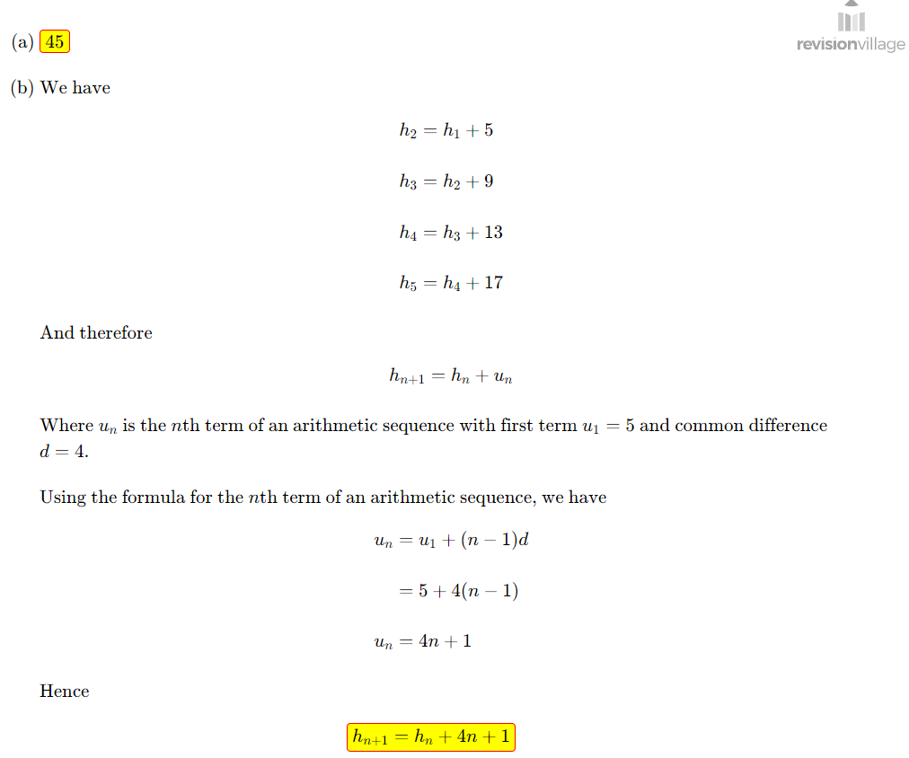 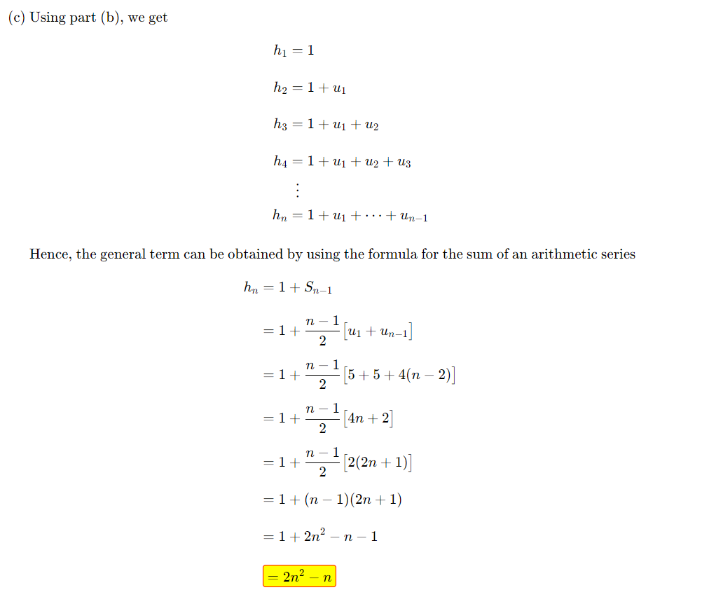 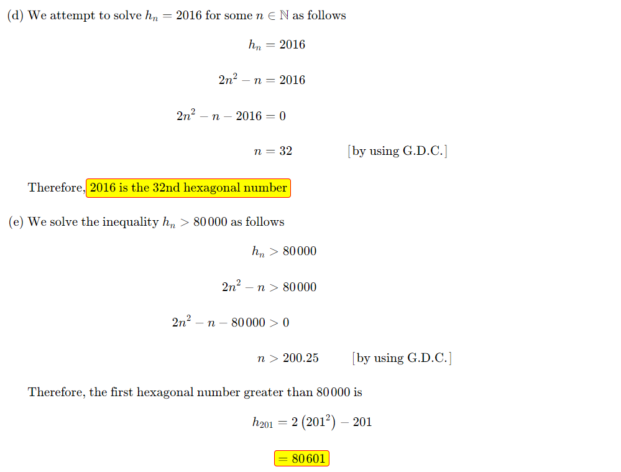 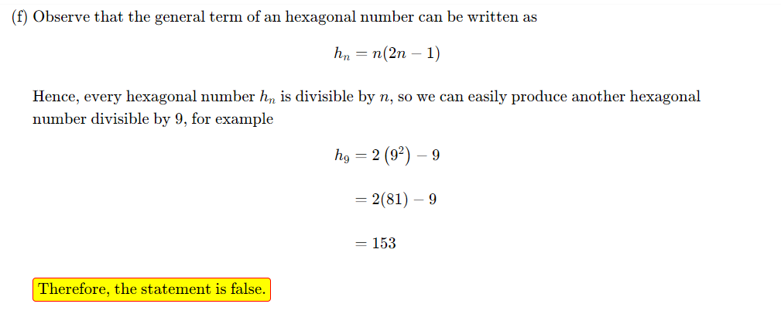

(g) [4]

M1A1
Recognises that changing $h_{1}$shifts the sequence by a constant, or correctly evaluates the general term using summation:
$$h_{n}=m+\sum_{k=1}^{n-1}{(4k+1).}$$

M1A1
Correctly used sum of AP formula to simplify to obtain
$$h_{n}=2n^{2}-n+(m-1).$$
(Any equivalent correct form earns full credit.)

(h)(i) $\left[2\right]$
M1
Uses $h_{n}=2n^{2}-n=n(2n-1)$and a parity argument.
A1
Expected observation: $2n-1$is always odd.

R1
Correctly concludes:
- If $n$is even, then $h_{n}=n(2n-1)$is even.
- If $n$is odd, then $n$is odd and $2n-1$is odd, so $h_{n}$is odd.
Hence $h_{n}$is even if $n$is even.
(Equivalent reasoning using $h_{n}=n(2n-1)≡n(mod2)$is acceptable.)

(h)(ii) $\left[2\right]$
M1
Sets up divisibility-by-4 analysis correctly. For example:
- Let $n=2k$(since from (i), only even $n$can give multiples of 4), then
$$h_{n}=h_{2k}=2(2k)^{2}-2k=8k^{2}-2k=2k(4k-1).$$
Notes that $4k-1$is odd.
A1
Concludes that $h_{2k}$is divisible by 4 if $2k$is divisible by 4, i.e. $k$is even.
So $n=2k$with $k$even $⇒n$is a multiple of 4.
Final answer:
$$\boxed{h_{n}\text{ is divisible by }4 ⟺ n≡0(mod4).}$$
(Equivalent: $n=4m$ for some $m∈N$.)

