A Monte Carlo Approach for L Intersection Crossing Path Optimization

Tian Yu

Contents

Introduction 1

Theoretical Background 1

Greedy Strategy 1

Lazy Strategy 2

Methodology 3

Results 4

Expected Value and Optimal Strategy 4

Characterization of PMF and PDF for Both Strategies 7

Histogram Breakdown of Waiting Times 8

Conclusion 9

Addendum 9

# Introduction

Most of us have had to cross an intersection in their lives. If you are like me and have too much time on your hands, you may try to optimize your route when walking as a pedestrian. In this respect, the need to wait at intersections is a significant time sink, which provides a challenge to be optimized.

In this paper, we will be determining the minimal time path given the following intersection scenario. You are initially walking down a North/South street, on the west side of the street. You have an upcoming four-way intersection that needs to be crossed in both directions. You are given the opportunity to cross the street immediately now, or you may wait to arrive at the four-way intersection and cross both directions when you arrive. This reflects the real-world case of when a closer intersection allows for East/West crossing, a pedestrian crossing exists, or a jaywalking opportunity presents itself before the eventual four way intersection.

This setup also requires some assumptions. You are assumed to be walking at a constant speed, and all roads are assumed to have constant width. We also assume that you are able start crossing as long as relevant the light remains green, but there is also a 6 second window after each light switches from green to red in which both lights remain red, followed by the alternate light switching from red to green. 6 seconds was chosen to be in line with the standards of Toronto traffic lights and will be referred to as the “dead time”. The dead time can also be increased to represent the time in which the light only has a small amount of time before changing to red, and thus crossing is not allowed even though the light is green.

Given this formulation, we need to find the situations in which crossing immediately is preferable to crossing both ways at the intersection. These options will be referred to as the “Greedy” and “Lazy” crossing methods respectively. Furthermore, we would like to determine this for most reasonable combinations of “on” times for both lights. The North/South convention will be used in this report for consistency, although due to symmetry clearly other orientations exists.

# Theoretical Background

## Greedy Strategy

We first propose a model for the greedy strategy, which is slightly simpler, and then extend it to the lazy strategy.

If the dead time is ignored, we can modal this problem as a joint distribution of a binomial probability mass function (PMF) and a uniform probability distribution function (PDF). The binomial function describes the probability of arriving at the intersection and being able to cross immediately or needing to wait for the light to change. If you need to wait for the light, the probability distribution of the waiting time is distributed uniformly, as you are equally likely to arrive at any point in the light’s “off” cycle. We can write these probability functions as follows:

$$P\left(x=A\right)=p (1)$$

$$f\left(x∈(A,B)\right)=\left(1-p\right)\left(\frac{1}{B-A}\right) (2)$$

Where x is the time required to cross, p is the ratio of time (and thus probability) when you can cross north/south immediately, A is the minimum amount of time crossing assuming no waits at any lights, and B is the maximum possible time for crossing. The equations for these times are presented below. Outside of the range $A≤x<B$ the probability is 0.

$$A=C+2CT (3)$$

$$B=C+2CT+EWL (4)$$

Where CT is cross time, EWL is the time in which the East/West light is on (the time in which North/South is off), and C is an arbitrary constant that represents the time taken initially to walk to the four way intersection.

Given this formulation, we can determine the expected value as follows:

$$E\left(x\right)=Ap+\int_{A}^{B}{x\left(1-p\right)\left(\frac{1}{B-A}\right)dx}$$

$$E\left(x\right)=Ap+\begin{matrix}B \\ | \\ A\end{matrix}\frac{1}{2}x^{2}\left(1-p\right)\left(\frac{1}{B-A}\right)$$

$$E\left(x\right)=Ap+\frac{1}{2}\left(1-p\right)\left(\frac{B^{2}-A^{2}}{B-A}\right), B>A≥0 (5)$$

We can also calculate the variance, but I hate that math so it is left as an exercise for the reader.

## Lazy Strategy

There are more possible cases that can be observed when arriving at the intersection from the lazy strategy. For each of these cases, we take the probability of arriving at the intersection in each case as the active time of that case per cycle divided by the total “cycle time” for the intersection. As the intersection changes on a cyclic basis, we can thus constrain ourselves to consideration over a single cycle.

We can observe four states that can occur from the lazy strategy. The first is if you arrive in the range of when the North/South light first switches on, to the end of the duration of the north south light (NSL) minus CT. In this case, you will cross the North/South light immediately and then will need to wait for the East/West light to change. After crossing North/South, you will then need to wait for the East/West light to change, which is uniformly distributed according to the following distribution.

$$f\left(x∈(A,B_{2})\right)=\frac{1}{NSL-CT}$$

We note that the fastest time to cross, A, is the same as before, but the slowest time to cross, $B_{2}$, is defined as:

$$B_{2}=C+2CT+\left(NSL-CT\right)$$

$$B_{2}=C+CT+NSL (6)$$

Which describes the time needed to walk across both intersections, added to the maximum time spent waiting for the East/West light to change. A and $B_{2}$ can be used to obtain the unform PDF.

If you arrive at the intersection after the North/South light has already been on on for NSL-CT amount of time, but before the East/West light turns on, you will be able to cross both ways immediately. The probability of this is as follows:

$$P\left(x=A\right)=\frac{CT}{TT}$$

As the timespan in which this case occurs is of length CT.

There are two more cases that symmetric to those described above, but when you cross the other way first. Therefore, we can use the same formulation but with a slight change of variables. Note that we define the max crossing time in this case as:

$B_{3}=C+CT+EWL$ (7)

Therefore, we have the following final probabilities for each crossing time. Equation 8 is obtained simply by adding both cases when crossing immediately is possible, which is allowed since both cases are completely exclusive. Equations 9 and 10 are obtained by multiplying the previously derived PDF functions with the fraction of time they are on to obtain the final distributions.

$$P\left(x=A\right)=\frac{2CT}{TT} (8)$$

$$f\left(x∈(A,B_{2})\right)=\frac{NSL-CT}{TT}\frac{1}{NSL-CT}=\frac{1}{TT} (9)$$

$$f\left(x∈(A,B_{3})\right)=\frac{EWL-CT}{TT}\frac{1}{EWL-CT}=\frac{1}{TT} (10)$$

The expected value over the entire distribution is:

$$E\left(x\right)=\frac{1}{TT}\left(\frac{B_{2}^{2}-A^{2}}{2}+\frac{B_{3}^{2}-A^{2}}{2}+2A*CT\right) (11)$$

# Methodology

The Monte Carlo Method employed to validate our theoretical results is fairly simple. We first setup the problem for the desired parameters. Walking speed is set as 2m/s and the crossing width is set to be 20m to obtain a CT of 10s. We also set 6 seconds as the dead time between light changes. Once these are assigned, we iterate through a grid of on times for both the North/South and East/West lights, with the minimum time being 10s, the maximum time being 240s (or 4 minutes), and an increment between time samples of 5 seconds.

For time setup, we then perform the Monte Carlo sampling. 10,000 samples were used which were able to provide consistent results without undue computational strain. For each sample, a random number is drawn from [0,1). These numbers are used to determine the state the sample corresponds to. We do this by corresponding the randomly drawn number to a linear mapping of the entire cycle of all intersection states to the range [0, 1). In other words, the samples correspond to a random instantiation of the four-way intersection to some point in its cycle, which represents the state of the intersection at the point in time you arrive at the first light. The random number also determines the exact time in the respective state the sample corresponds to, for example, arriving at the North/South light 1 second after it turns red vs 1.5 seconds after it turns red.

Once the samples are drawn, the path time for each sample is then computed. This was done simply by summing the crossing times and waiting times for each sample, depending on the state and exact time represented by the sample. These times are then saved, and the aggregated results are presented in the following section. Furthermore, a breakdown of waiting times at each intersection is also presented at the end of the results section, to provide additional insight on the paths taken when employing either strategy.

Finally, binomial probability and uniform distribution ranges are calculated using the time results as well. Binomial probability of immediately crossing is determined by calculating the ratio of minimum crossing time samples to all samples. The uniform distribution range is determined by subtracting the maximum crossing time from the minimum time from the respective strategy.

# Results

## Expected Value and Optimal Strategy

Figure 1 below shows the results obtained from theoretical reasoning presented in this paper. Figure 1a displays the difference in EV between method A (lazy) and method B (greedy). As we can see, the greedy strategy is only disadvantageous when the time in which you are able to cross east/west is much higher than the time allowed to cross north/south.

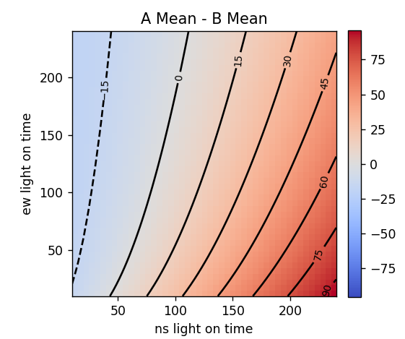

Figure 1a: Difference in Mean Times for Both Crossing Methods

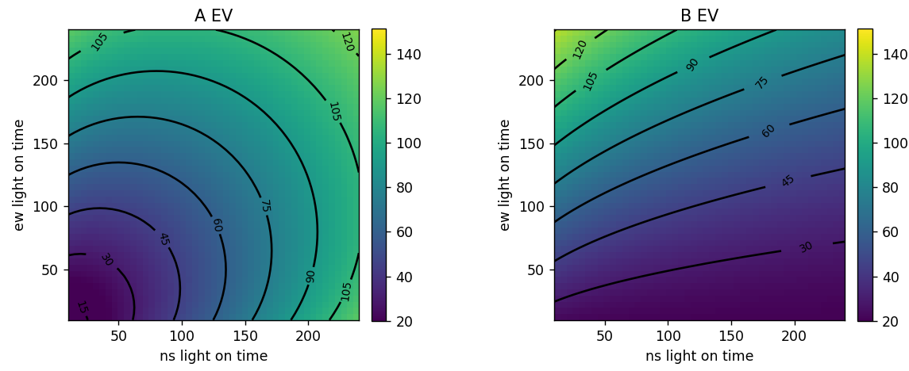

Figures 1b, c: Expected Value Surface for Both Methods

To validate the theory suggested by this paper, we present the results of the Monte Carlo method below in figure 2. Although there are some differences, likely attributed to the inclusion of the “dead time” in which crossing is not allowed for 6 seconds between light changes, the expected value graph follow closely in line with our theoretical expectations.

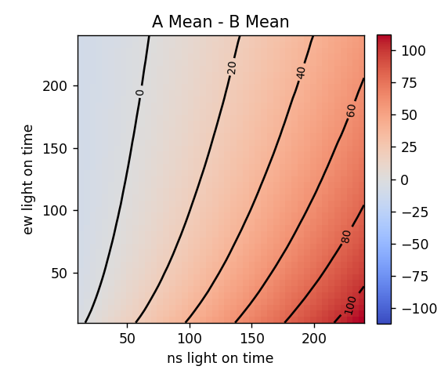

Figure 2a: Difference in Mean Using Monte Carlo Simulation

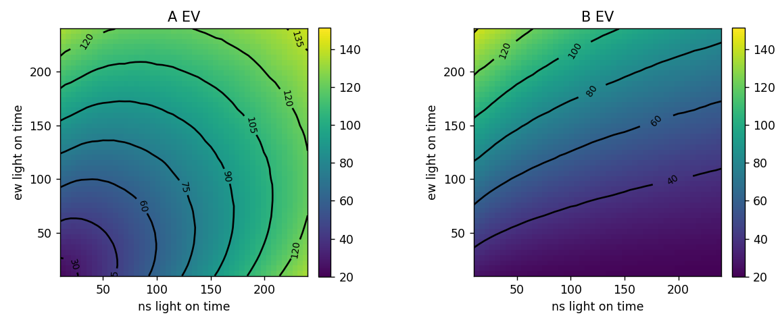

Figures 2b, c: Expected Values for Both Methods Using Monte Carlo Simulation

As can be seen in the above figures, the simulation presents very similar results to that of the theoretical derivations. It can be noticed that the expected values for crossing, especially in method A where two crosses at the light are required, is larger for the simulation. This can be attributed to the addition of dead time, which affects method A more as more crossings at the intersection are required.

In addition to the previous note that the greedy strategy is optimal in all cases except those where crossing east/west is much easier than crossing north/south, we also consider the individual expected value plots for both strategies. For strategy A, a symmetric plot is observed which aligns with observations, as the crossing of north/south and east/west in this case are interchangeable. For strategy B, the expected value increases only as the east/west crossing availability increases relative to the north/south crossing availability. This makes sense as by increasing the proportion of time available to cross east/west, we reduce the proportion of time available to cross north/south and therefore increase the average wait time of strategy B, which only crosses north/south at the intersection.

## Characterization of PMF and PDF for Both Strategies

Finally, we can also use the simulation to characterize both crossing methods as we have done earlier, in the form of a binomial distribution determining whether you are able to cross instantly, combined with a uniform distribution of waiting time given an inability to cross instantly. These plots are shown as figures 3 and 4:

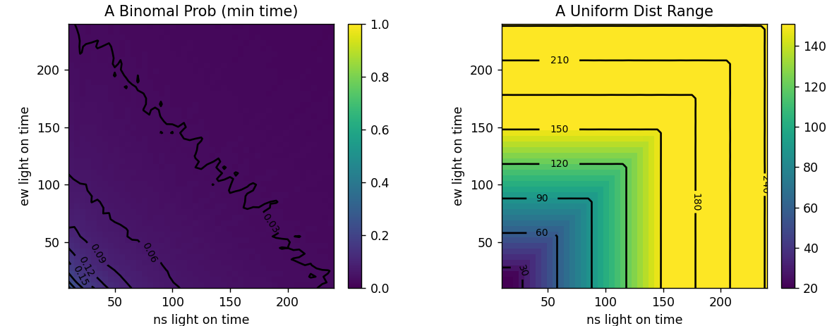Figures 3a, b: Binomial Probability and Uniform Distribution for Method A

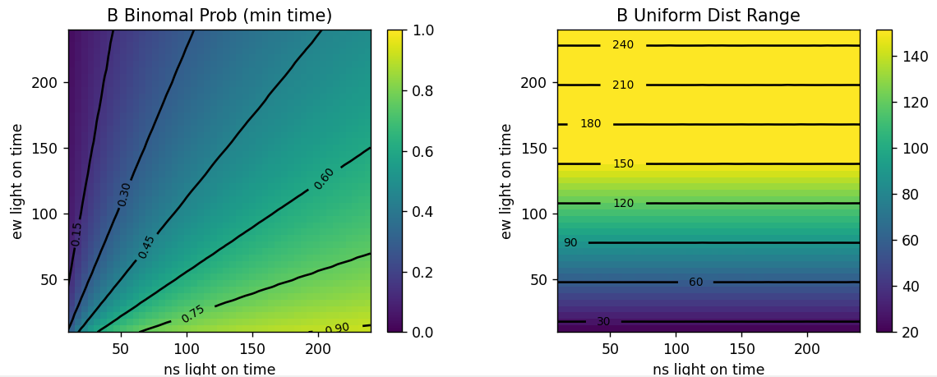

Figures 4a, b: Binomial Probability and Uniform Distribution for Method B

The binomial probability plot, figure 3 a, for the lazy strategy (A) describes the probability at the second crossing that you will be able to cross immediately, without waiting for the light to change at all. The uniform probability plot, figure 3b, for the lazy strategy describes the difference between the absolute longest and shortest times for crossing the intersection both ways. As we can see, the lazy strategy results in very few instances of being able to cross immediately at the second intersection. We note that the contour lines do not look smooth as the values are close to zero and thus suffer from the variance of Monte C+C+arlo sampling. In terms of the uniform distribution, we also observe a symmetric increase in its distribution range as both the N/S and E/W active times increase which makes sense as there should not be a bias in crossing either direction first.

For the greedy strategy (B), the binomial plot describes the probability of crossing the N/S intersection immediately. We see that this probability is much higher than that for the lazy strategy, with a uniform increase in the radial clockwise direction. This makes sense as the percentage of time in which you are able to cross N/S increases uniformly with a radial relationship that has boundaries at 0 and 1. In terms of the uniform distribution, we see only an increase as the E/W lights on time, which corresponds to more time in which you cannot cross N/S. Furthermore, we notice that the uniform distribution range is slightly higher than that of strategy A, which makes sense as the worst case in the greedy strategy is waiting for the entire duration of the light, while with the lazy strategy some time is saved by the initial road crossing.

## Histogram Breakdown of Waiting Times

The following figures are histograms of travel times for each sample, for both strategy A (lazy) and B (greedy). The figures in blue represent the time spent waiting at each corner of the intersection (Northwest, Northeast, Southwest), and the figure in green represents the distribution of final travel times, including crossing times. Samples were taken for both intersection on times being set to 30s.

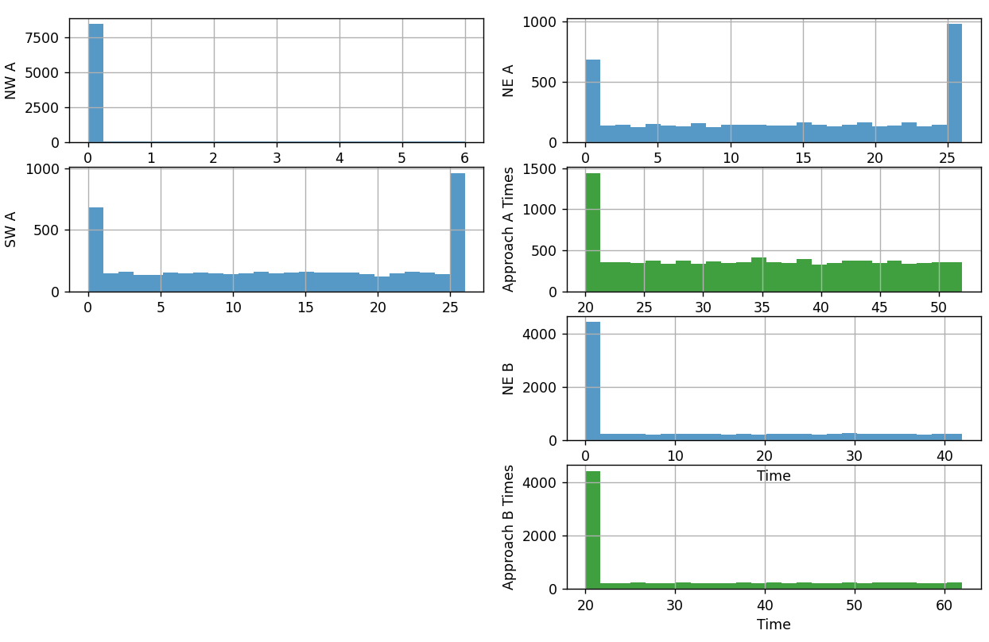

Figure 5: Histogram of Waiting Times at Each Intersection Corner and Total Times

From figure 5, we can notice a couple of key points. At the Northwest corner, the majority of samples are able to pass right through. However, about 25% of the samples in this case need to wait, due to arriving during the dead time. This distribution is shown in more detail in figure 6 below. These dead time samples also correspond to the spikes at 25s in both the NW and SW intersection wait times, as arriving during dead time means waiting for the longest possible time at the following intersection. However, the uniform initial dead time distribution added to the single secondary waiting time results in a uniform distribution that simply extends the uniform range for the total travel time for strategy A. We also notice that strategy A contains far fewer samples that travel the shortest time, 20s in this case, as compared with strategy B, while strategy B has a larger range of times. This corresponds to the results produced earlier.

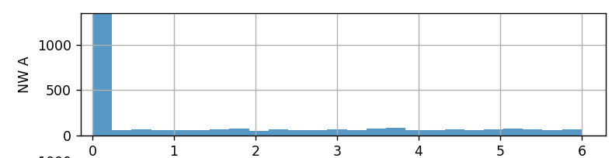

Figure 6: Zoomed in Histogram for Northwest Corner With Lazy Strategy

# Conclusion

In conclusion, we have determined in this paper a method to optimally cross both directions of a two-way intersection. Provided some general assumptions. We have determined that in the general case, crossing “greedily” is ideal and can reduce wait times reliably by around 10%. We have also identified exceptions where crossing “lazily” is preferred if the intersection that is being skipped in the greedy case has a much higher available crossing time than the alternative intersection, or if a smaller maximum waiting time is desired. Finally, we have introduced an analytical model by combining a binomial and uniform probability distribution and have validated that it is acceptable through a monte carlo simulation.

The research in this paper can be further extended beyond a single crossing to a generalized grid with random waiting times. This could be used to help optimize traffic routes in cities, or to settle further drunk arguments when walking home from the bar. The robustness of the monte carlo method also allows for changes in road widths, dead times, and variable walking speeds to be introduced as well, which provide the basis for further exploration.

# Addendum

From recent testing, we have noticed a problem in the initial formulation of our problem. When the waiting times at both lights are not equal, the final distribution of times appears to contain two different uniform distributions rather than a single uniform distribution. For the North/South intersection being on for 30s and the East/West intersection being on for 60s, the following histogram is observed:

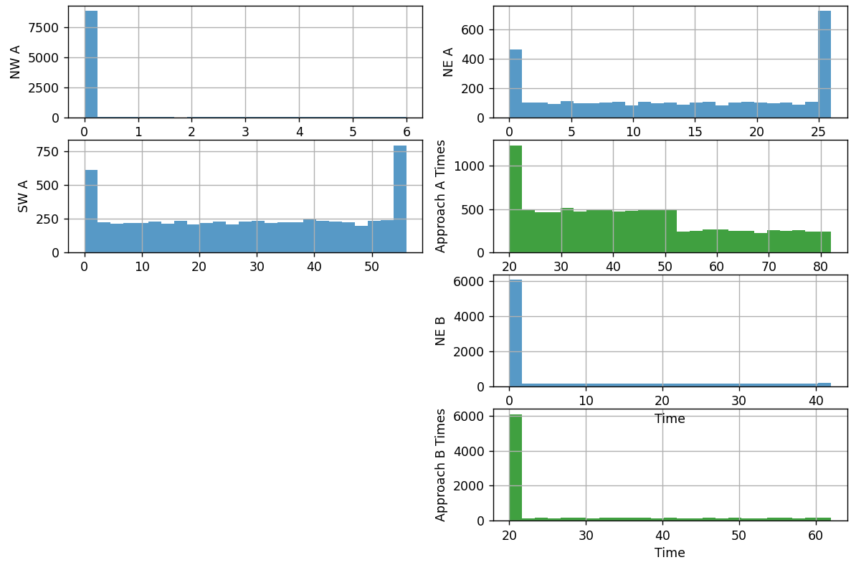

Figure 7: Histogram for Unequal Light Times

Clearly for strategy A, for times above the minimum, two different uniform distributions can be observed. This behavior needs to be investigated further, and modifications will need to be made to the analytical results to account for this. We note that these modifications may not affect the expected value however, as the derived results still align with the simulations. Therefore, it could be possible that the two uniform distributions have a joint expected value equal to the initially assumed single uniform distribution in the analytical solution.