Cross-Dataset Conformal Coverage Audit of Parkinson’s Disease Typing Classifiers Under Deployment Shift
Authors: Taylor [Given name, Family name]¹
¹ [Department, Institution, City, Country]
Corresponding author: [Given name, Family name]; e-mail: [to be completed]
ORCID: [16-digit iD to be completed]

Abstract
Conformal prediction (CP) provides distribution-free prediction sets with guaranteed marginal coverage under exchangeability. In keystroke-based Parkinson’s disease (PD) detection, cross-dataset deployment degrades discrimination, but whether empirical coverage retains its nominal target under deployment had not been audited. Under a pre-registered protocol, we audited split-CP coverage (α = 0.10; logistic-regression reference model) under cross-dataset deployment across four public keystroke datasets (cohort: 475 subjects). The primary family covered three confirmatory transfer directions with Holm correction; coverage conditional on PD versus healthy-control (HC) class was a pre-specified failure-mode diagnostic; recovery (target-domain calibration budgets) and attribution (prevalence-resampling and label-flip stress tests) were pre-registered secondary analyses. All three primary directions were Incompatible (family-controlled) — pre-registered statistical incompatibility with the nominal 0.90 level, a statistical rather than clinical determination: Tappy→MIT 0.598 [95% confidence interval (CI) 0.483–0.704], MIT→Tappy 0.850 [0.788–0.899], clinical-pool→self-report 0.732 [0.684–0.777]. Marginal totals concealed class asymmetry (PD-conditional coverage 0.214 in Tappy→MIT; HC 1.000). Coverage behavior differed between the two evaluated predictive models: the LightGBM comparator, despite lower discrimination, showed class-conditional coverage of 0.925–1.000 across the three primary directions. In these cohorts, target recalibration reached the 0.80 audit threshold with confidence-interval support using 9 and 18 target labels; in Tappy→MIT it did not within a 30% budget, and label-free weighting attained nominal coverage only by abstaining on 86–100% of subjects. Prevalence re-matching and label corruption did not reproduce the observed phenotype. Discrimination and coverage behave as distinct reliability dimensions under deployment shift; deployment reporting should include coverage audits and class-conditional diagnostics alongside the area under the receiver operating characteristic curve (AUC).
Keywords: conformal prediction · Parkinson’s disease · keystroke dynamics · coverage audit · cross-dataset deployment · clinical decision support

Introduction
Keystroke dynamics have been proposed as a scalable digital-biomarker candidate for Parkinson’s disease (PD) screening, and public datasets have supported a decade of classifier development [1–3] evaluated almost exclusively by discrimination — typically the area under the receiver operating characteristic curve (AUC) under cross-dataset transfer, where degradation is well documented [4]. A deployed screening system must deliver a second property: calibrated uncertainty. Coverage is the promised rate at which the system’s prediction sets contain the true diagnosis. When coverage fails, the system is miscalibrated — and it is least trustworthy precisely when it emits a single confident wrong label, the one outcome a triage workflow cannot afford. Conformal prediction (CP) promises such calibration: under exchangeability, split CP covers the true label with probability at least 1−α regardless of the underlying model [5,6]. Deployment across datasets breaks exchangeability; theory characterizes how coverage degrades beyond exchangeability [7–10], while empirical audits in deployed clinical workflows remain sparse [17–19]. To our knowledge, no prior study has systematically audited conformal prediction coverage across publicly available Parkinson’s keystroke datasets under cross-dataset deployment.
This audit asks whether discrimination degradation and coverage degradation exhibit non-identical patterns across deployment shifts (pre-registered hypothesis H1). We addressed three questions: (RQ1) Does marginal conformal coverage remain statistically compatible with the nominal 0.90 level under cross-dataset deployment? (RQ2) Are coverage degradation and discrimination degradation coupled across transfer directions and predictive models? (RQ3) Can target recalibration, or controlled prevalence and label-shift interventions, restore or explain the observed coverage phenotype? The audit evaluates research-grade classifiers on public datasets; it establishes no clinical screening validity, and the models studied are not validated screening devices. We report the work as a deployment-reliability audit rather than a failure claim: the pre-registered verdict vocabulary asserts statistical compatibility with a pre-specified operational audit threshold, not clinical failure, and primary outcomes were not conditioned on observing degradation.
The study contributes: (i) a pre-registered, embargoed systematic audit of CP coverage across four public PD keystroke datasets, with a fixed cohort — the confirmatory family comprised three pre-specified primary transfer directions, and all 12 ordered transfer directions were examined descriptively; (ii) a coverage–discrimination decoupling map across all 12 ordered transfer directions and two predictive models; (iii) in-the-wild quantification of heterogeneous label sources (clinical vs self-report) on coverage, with controlled-shift stress tests; and (iv) an open audit toolkit (three-tier feature system, coverage-restoration unit tests including an independent oracle for weighted CP, pre-registered protocol, and an illustrative coverage-to-workflow mapping: singleton = auto-pass, doubleton = manual review, full set = system rejection).

Methods

Study Design and Ethical Approval
This audit is a retrospective, pre-registered analysis of exclusively de-identified public datasets released for research use; no new human data were collected and no intervention occurred. The analysis plan was pre-registered on the Open Science Framework (registration https://osf.io/j9fvx, 26 September 2026; frozen plan v1, tag v1.0-prereg) before any cross-dataset coverage was computed, under a 2-year embargo; reviewers can be granted view-only access during peer review.

Data Sources and Cohorts
Four public datasets were used: MIT-CSXPD (clinical gold standard), Tappy Keplar (self-report, bring-your-own-device), TyPD (clinical, i-PROGNOSIS), and Online English (OE; self-report, web-based). Cleaning rules were pre-registered and label-blind (seven steps; session validity ≥ 100 digraphs; person eligibility ≥ 300 valid digraphs). The frozen cohort comprised 475 subjects (PD 270 / healthy-control (HC) 205): MIT 82 (42/40), Tappy 173 (133/40), TyPD 27 (12/15), and Online English 193 (83/110) (Table 1). PD status was defined by clinical diagnosis fields (MIT, TyPD) or self-report fields (Tappy, OE). Three Tappy participants reporting tremor without PD diagnosis were excluded from the primary analysis; dual re-inclusion is reported as sensitivity.

Features and Models
Person-level features aggregate all valid digraphs of a person (one subject = one conformal observation). Three pre-registered tiers — L1: hold/latency/flight distribution summaries (15 features, all datasets); L2: hand-conditional summaries (MIT/Tappy/OE); L3: digraph-transition features (MIT/OE) — with the transfer tier fixed at the minimum of the chain’s dataset caps and recorded as an audit covariate. The effective primary reference model was ℓ2-regularized logistic regression (amendment CHG-P1: the pre-registered LightGBM failed a pre-declared in-domain gate in three documented runs and is reported as comparator with shallow-tree settings). All hyperparameters were fixed before target data were accessed; target datasets were never used for model selection.

Conformal Procedures
Split CP used the least-ambiguous classification (LAC) score, s(x,y) = 1 − p̂(y|x), with a single pooled calibration quantile targeting marginal 1−α coverage, computed on a stratified 30% source calibration split (single confirmatory seed = 1, the first registered seed; 50-seed summaries are descriptive). The conformal threshold was the k-th smallest calibration score, where k = ⌈(n_cal + 1)(1−α)⌉ and n_cal is the calibration-split size; a candidate label was included when its LAC score did not exceed this threshold. When k > n_cal, the resulting prediction set was the full label set. Class-conditional coverage was evaluated only as a diagnostic and was not used in calibration. Elements per procedure — predictor: source-trained classifier; score: LAC; calibration: the above split and quantile; guarantee target: marginal 1−α coverage on the target cohort. Pre-specified remediation arms: target-domain recalibration at 0/5/10/20/30% labeled budgets (class-stratified single draw; test on the complement); weighted CP under estimated density ratios (domain-classifier odds, pooled 99th-percentile (p99) truncation; Tibshirani et al. eq. (8) direct form [7], verified against an independent oracle; guarantee target: covariate-shift-weighted marginal 1−α — noting that truncation voids the formal guarantee, so this arm is reported as a practical intervention); and protocol-conditional recalibration (guarantee target: protocol-group-conditional 1−α). The split-CP implementation matches the MAPIE 1.5.0 reference implementation [15] pointwise (1800/1800) and passes 18 synthetic tests.

Outcomes and Audit Verdicts
All inferential analyses were performed at the person level: sessions and digraphs were aggregated within participant before conformal evaluation, so no participant contributed more than one target-level coverage observation. The pre-registered primary family was three high-power directions × α = 0.10 × marginal coverage — Tappy→MIT, MIT→Tappy, and clinical-pool (MIT+TyPD) → self-report (Tappy+OE) — with one-sided binomial tests (H0: true coverage ≥ 0.90) and Holm correction at family-wise 0.10 (confirmatory inference). The descriptive audit matrix covers all 12 ordered dataset pairs; TyPD and OE enter the confirmatory family only through the pooled clinical-source and self-report-target direction, respectively. Operationally, each direction also receives an audit label from the unadjusted 95% Clopper–Pearson interval (CI) against the pre-specified operational audit threshold of 0.80 (Compatible: lower bound ≥ 0.80; Incompatible: upper bound < 0.90; else Undetermined; Incompatible priority in the overlap). The 0.80 threshold has no clinical-safety interpretation. For the primary directions the two procedures agree in this data set; the alignment of the audit-label rule with the pre-registered “Holm-adjusted CI” wording is recorded as an amendment in the protocol change log. PD/HC class-conditional coverage was a pre-specified safety diagnostic with exact Clopper–Pearson intervals. Even in-domain, split CP guarantees only marginal — not class-conditional — coverage; under joint covariate and label shift, class-conditional coverage may further be unidentifiable without target labels, which is why it is measured. All class-conditional, subgroup, and comparator analyses are descriptive and unadjusted. All analyses were performed in Python 3.12.10 using pandas 3.0.6, NumPy 2.5.3, SciPy 1.18.1, scikit-learn 1.9.1, LightGBM 4.7.0, and MAPIE 1.5.0 (versions pinned in the repository’s requirements.txt).

Recovery and Attribution Analyses
The pre-registered recovery-cost table crossed {naive CP, target recalibration (5/10/20/30%), weighted CP, protocol-conditional recalibration} with {target labels used, coverage, PD coverage, mean set size, singleton rate, rejection rate}. Attribution stress tests: (A) synthetic dose–response — donor-class person-level label flips at 10/20/30% in three flip directions, compared with the dispersive-noise theory of Einbinder et al. [9] via the exact calibration-side stochastic-dominance condition; (B) a three-arm real-transfer test — prevalence re-matching to 74% by resampling, prevalence-preserving two-way label flips, and their combination — against pre-specified practical-equivalence tolerances (±5 percentage points coverage; ±0.3 mean set size, corresponding to 30% of the binary set-size range); (C) black-box shift estimation (BBSE) [16], which estimates target prevalence from a source-trained classifier’s class-conditional confusion matrix under the label-shift assumption P(x|y) unchanged — validated on constructed label shift and applied descriptively to real pairs. Following the frozen wording template, these tests ask whether the manipulations are sufficient to reproduce the observed patterns; no causal identification is claimed.

Reporting Standards
We report with reference to the TRIPOD+AI statement [14] where applicable; the completed checklist accompanies the submission as supplementary material.

Results

Cross-Dataset Coverage Audit
Every primary direction fell statistically short of the nominal level under family-wise control (Table 2, Fig. 1): Tappy→MIT 0.598 [0.483, 0.704] (Holm q = 1.2×10⁻¹²), MIT→Tappy 0.850 [0.788, 0.899] (q = 0.023), clinical-pool→self-report 0.732 [0.684, 0.777] (q = 2.5×10⁻¹⁹). Prediction sets were short (mean sizes 1.11–1.53; singleton rates 0.47–0.89), indicating that the observed coverage deficits were not primarily due to uniformly uninformative full-set predictions. The singleton rate is the fraction of subjects receiving a single-class prediction set — the system’s committed diagnosis. The LightGBM comparator covered 0.963–0.988 in the same directions (mean set sizes 1.92–1.97; singleton rates 0.03–0.08); its higher coverage was accompanied by substantially larger prediction sets and far fewer singleton predictions.

Class-Conditional Coverage Asymmetry
In Tappy→MIT, PD-conditional coverage was 0.214 [0.103, 0.368] (n = 42) while HC coverage was 1.000 (n = 40): 33 of 42 PD participants (78.6%) received prediction sets excluding their true label (Fig. 2). With 34 of the 42 PD participants receiving singleton sets (PD singleton rate 0.810) and only 9 PD participants covered, at least 25 of the 33 misses were single-class sets — which, in a binary problem, necessarily contained only the non-PD label. These misses would therefore have propagated as false reassurance if the illustrative singleton-as-auto-pass mapping were applied. The under-served class flipped with target prevalence: HC-conditional coverage was the deficient one in the two PD-heavy targets (0.700 in MIT→Tappy; 0.627 in clinical→self-report). The comparator score was near-uniform across classes (0.925–1.000). These are measured, unadjusted diagnostics, not guarantees.

Coverage–Discrimination Decoupling
Across all 12 transfer directions, discrimination and coverage moved asynchronously in both predictive models (Fig. 3). The comparator’s mean coverage exceeded the reference’s in 11 of 12 directions despite lower AUC in all 12; reference-model directions spanning AUC 0.55–0.81 showed coverage from 0.58 to 0.91. Per the pre-registered H1 plan this is a descriptive cross-direction characterization (no significance testing across 12 non-independent directions); the pattern is the paper’s central object. The full 12-direction AUC matrix is shown in Fig. 7; coverage matrices are provided in the supplement.

Target Recalibration and Recovery Cost
Target recalibration with 9 labels reached the pre-specified 0.80 operational audit threshold with CI support in MIT→Tappy (0.982 [0.947, 0.996]; Fig. 4); 18 labels reached it for clinical→self-report (0.876 [0.837, 0.909], whose CI lower bound remained below the nominal 0.90 level). Tappy→MIT was different: at the first non-degenerate budget (16 labels) the point estimate crossed 0.80 (0.833), but the CI lower bound never reached 0.80 within a 30% budget (25 labels; 0.877 [0.763, 0.949]), and the PD-conditional residual persisted (0.759 vs HC 1.000) — pooled recalibration repairs the marginal quantile, not class-conditional miscalibration. These budgets are observed sufficiencies in these cohorts, not general sample-size requirements. The protocol-conditional arm, evaluated on the two-protocol merged target, did not clear the threshold at the 5% budget (0.836 [0.793, 0.874]), a different estimand from the pooled quantile. Label-free density-ratio weighting attained nominal coverage (0.918–1.000) only by abstaining on 86–100% of subjects: coverage without utility (Fig. 5). Fewer than 9 target labels yield degenerate full-set calibration sets at α = 0.10.

Stress Tests of Alternative Shift Explanations
Synthetic dose–response on the clinical source reproduced the form of class-conditional collapse — the HC→PD flip pinned PD-conditional coverage at 1.000 while HC-conditional coverage fell monotonically to 0.425 — and the dispersive-noise dominance condition held at the process level in 9/9 theory-aligned cells. In the three-arm test, none of prevalence re-matching, prevalence-preserving corruption, or their combination reproduced the observed MIT→Tappy phenotype within the pre-specified tolerances — every arm missed both tolerances, two by overshooting into extreme asymmetry (HC coverage 0.025 and 0.000) absent from the real data (Fig. 6). BBSE, validated as unbiased with nominal interval coverage on constructed label shift, degenerated on exactly the worst direction (Tappy→MIT, estimated PD prevalence 0.000): its label-shift assumption is least plausible exactly there, so the estimate is reported as an assumption-violation diagnostic, not a prevalence estimate. The deployed coverage phenotype was not reproduced by prevalence re-matching or label corruption alone at the pre-specified doses in this direction; other forms of distribution shift, including covariate and conditional shift, remain possible explanations (no causal identification claimed).

Robustness and Subgroup Analyses
Under the pre-registered confirmatory pipeline (single seed = 1), no pre-registered sensitivity analysis flipped the primary verdicts: α = 0.20 (0.522–0.705); dual re-inclusion of the three tremor-only participants (largest shift +0.073); quarter-level session re-aggregation (identical results); stratification by feature tier (no monotone gradient). The MIT→Tappy verdict sits close to the decision boundary (CI upper bound 0.8994), and its per-seed split distribution (mean 0.853 ± 0.058) implies that individual splits can fall in the Undetermined band; the 50-seed sensitivity distribution lay below the nominal 0.90 level in its center and in the majority of individual splits, and the pre-registered power analysis is provided in the supplement. Sex-stratified coverage (computable only for Tappy-origin targets) showed an 8.7 pp male deficit in MIT→Tappy; MIT and OE publish no demographic fields, which is reported as a limitation rather than imputed.

Discussion
Under cross-dataset deployment of PD typing classifiers, empirical conformal coverage behaved as a reliability dimension distinct from discrimination. In directions where discrimination looked acceptable, coverage was statistically incompatible with the nominal level under family-wise control; where discrimination looked poor, coverage remained compatible — a pattern consistent with a coverage–efficiency trade-off for the comparator’s near-full sets. Acceptable marginal totals concealed class-conditional collapse, and recovery costs differed widely across directions. None of the tested prevalence and label-noise mechanisms alone reproduced the observed phenotype. AUC-only evaluation therefore measures discrimination but not the reliability of prediction-set coverage under deployment shift.

Coverage Auditing as Deployment Governance
Operationally, these results indicate that a deployment could pass an AUC acceptance test yet — if singleton sets were operationalized as auto-pass decisions — route most positive patients through that pathway, which is why coverage auditing should be considered a component of a deployment acceptance framework rather than a post-hoc evaluation alone. Four operational recommendations follow: (i) treat the pre-registered verdict vocabulary as a candidate deployment-audit gate, to be validated prospectively before operational use (Undetermined/Incompatible findings should trigger additional validation or remediation before operational use), and schedule periodic re-audits with re-triggering on upstream device or population changes; (ii) budget a small, class-stratified standing calibration set per deployment site — in these cohorts, observed recovery budgets were 9–18 labels where the score survives; where recovery was not achieved within the evaluated calibration budget, deployment would require additional validation or an alternative uncertainty-management strategy; (iii) treat class-conditional audit results as a candidate gating condition before permitting any auto-pass workflow — if singleton sets were operationalized as auto-pass decisions, 78.6% of PD participants in Tappy→MIT would have been incorrectly routed through that pathway; at the observed mean set sizes (1.11–1.53) every prediction set contained one or two labels, so the doubleton (manual-review) fraction under the illustrative mapping is 11–53% of subjects, a modest cost against the failure mode; (iv) regard typing-based PD triage as one component of a health-information system referral pathway, not a standalone diagnostic.

Relation to Prior Work
Coverage audits of CP under shift exist outside medicine — at scale in computer vision [20] and as a natural-experiment diagnosis in clinical prediction [21] — and clinical conformal studies have begun reporting coverage under transport: a sepsis mortality predictor externally validated from MIMIC to eICU [17], subgroup coverage auditing under temporal shift [19], and class-conditional coverage imbalance in LLM-based mortality prediction [18], the last paralleling the class asymmetry measured here. PD digital phenotyping has used CP for medication-need intervals [11] and reliable longitudinal assessment on real-world digital neurologic signatures [12] — in-domain. Relative to these, this audit adds a pre-registered verdict protocol, class-conditional failure-mode diagnostics, and recovery-cost quantification in a keystroke modality where uncertainty has been unexamined. Our results do not contradict CP theory; they measure what the theory predicts at the boundary of its assumptions, on data a deployment would actually meet.

Limitations
- (1) Self-report labels qualify the estimand on self-report targets; random flips are not structured mislabeling, and reproduction claims are limited to “sufficient to reproduce” at the pre-specified doses in one direction. (2) The effective reference model is logistic regression; the originally planned LightGBM failed a pre-specified in-domain performance criterion (three pre-declared attempts), the amendment was finalized before cross-dataset coverage was computed, and the comparator is reported throughout. (3) Model-dependent coverage behavior is established descriptively across two predictive models and 12 non-independent directions; two models demonstrate that coverage failure is not intrinsic to the task, not a general law of model space. (4) MIT and OE publish no sex/age fields, limiting subgroup audits; MIT’s control group is female-biased (~17 pp) per the literature. (5) Class-conditional coverage is measured, not guaranteed, even in-domain. (6) OE retains 0.27% duplicate rows by pre-registered decision; the merged source pool statement concerns label quality, not distribution exchangeability, and no leave-one-source-out sensitivity was run. (7) Weighted CP has no third-party library cross-check; p99 truncation voids its formal guarantee; correctness of the untruncated form rests on an independent oracle, and its practical failure (abstention) is reported as an outcome. (8) The primary confirmatory analysis used a single pre-registered calibration split; repeated-seed analyses were sensitivity analyses and do not replace it. The decision boundary is sensitive to the calibration-set realization, particularly for MIT→Tappy (CI upper bound 0.8994), and the finite target cohorts limit per-class precision (PD-conditional n = 42 in Tappy→MIT).

Conclusion
Discrimination metrics and empirical coverage behave as distinct reliability dimensions under deployment shift. Health systems deploying keystroke-based screening should treat coverage auditing — marginal and class-conditional, per target cohort — as a standing requirement alongside discrimination evaluation, budget for small per-site calibration sets, and evaluate candidate models’ coverage behavior as part of model selection.
Supplementary Information The TRIPOD+AI checklist, the full 12-direction AUC and coverage matrices, per-seed split distributions, the pre-registered power analysis, and subgroup tables are provided in the supplementary material.
Author Contributions [CRediT roles to be completed: conceptualization, methodology, software, investigation, writing — to be assigned by the author.]
Funding [No funding was received for this study / to be completed by the author.]
Data Availability All four datasets are publicly available from their original distributors: MIT-CSXPD via PhysioNet (nqmitcsxpd 1.0.0, https://physionet.org/content/nqmitcsxpd/1.0.0/) [1]; Tappy Keplar via PhysioNet (tappy 1.0.0, https://physionet.org/content/tappy/1.0.0/); TyPD/i-PROGNOSIS DS2.5 via Zenodo (record 2571623, https://zenodo.org/records/2571623); Online English via OSF (project ew34b, https://osf.io/ew34b/). No dataset is redistributed. The fixed cohort construction with step-by-step inclusion/exclusion counts is released with the code in the public archive below.
Code Availability The full pipeline, unit-test suite, figure/table generation scripts, and frozen result tables are publicly available at https://github.com/Tiannn0512/typing-pd-conformal-audit (public timestamp archive; frozen result tag results-frozen-v1). [A citable Zenodo DOI will be added; repository DOI to be completed.]
Declarations
Ethics Approval This study used exclusively de-identified, publicly available datasets (MIT-CSXPD, Tappy Keplar, TyPD/i-PROGNOSIS, Online English) released for research use; no new human data were collected and no intervention occurred. [Final ethics/exemption wording to be confirmed against the author’s institutional policy before submission.]
Consent to Participate Not applicable: no individual participant data were newly collected; all datasets are public research releases with their own consent frameworks.
Consent for Publication Not applicable: the manuscript contains no identifiable individual data.
Clinical Trial Number Not applicable.
Competing Interests The author declares no competing interests. [To be confirmed.]

References
- Giancardo L, Cisco G, Sánchez-Ferro A, et al (2016) Computer keyboard interaction as an indicator of early Parkinson’s disease. Sci Rep 6:34468. https://doi.org/10.1038/srep34468
- Arroyo-Gallego T, Ledesma-Carbayo MJ, Sánchez-Ferro A, et al (2017) Detection of motor impairment in Parkinson’s disease via mobile touchscreen typing. IEEE Trans Biomed Eng 64(9):1994–2002. https://doi.org/10.1109/TBME.2017.2664802
- Tripathi S, Arroyo-Gallego T, Giancardo L (2023) Keystroke-dynamics for Parkinson’s disease signs detection in an at-home uncontrolled population. IEEE Trans Biomed Eng 70:182–192. https://doi.org/10.1109/TBME.2022.3187309
- Francesconi A, Cappetta D, Rebecchi F, Soda P, Guarrasi V (2026) Cross-dataset multivariate time-series model for Parkinson’s diagnosis via keyboard dynamics. Commun Comput Inf Sci:61–74. https://doi.org/10.1007/978-3-032-17216-7_6
- Vovk V, Gammerman A, Shafer G (2005) Algorithmic learning in a random world. Springer, New York
- Angelopoulos AN, Bates S (2023) Conformal prediction: a gentle introduction. Found Trends Mach Learn 16:494–591. https://doi.org/10.1561/2200000101
- Tibshirani RJ, Foygel Barber R, Candès E, Ramdas A (2019) Conformal prediction under covariate shift. In: NeurIPS 32
- Barber RF, Candès E, Ramdas A, Tibshirani RJ (2023) Conformal prediction beyond exchangeability. Ann Stat 51:816–845. https://doi.org/10.1214/23-AOS2276
- Einbinder B-S, Feldman S, Bates S, Angelopoulos AN, Gendler A, Romano Y (2024) Label noise robustness of conformal prediction. J Mach Learn Res 25(328):1–66
- Han W, et al (2026) The label complexity of class-conditional coverage under distribution shift. arXiv:2607.18088. https://arxiv.org/abs/2607.18088
- Diaz-Rincon A, Liang M, Ramirez-Zamora A, Shickel B (2025) Uncertainty-aware prediction of Parkinson’s disease medication needs: a two-stage conformal prediction approach. In: Proceedings of the 10th Machine Learning for Healthcare Conference, PMLR 298. https://proceedings.mlr.press/v298/diaz-rincon25a.html
- Wei W, Gao R, Yao S, et al (2026) SGC-RML: a reliable and interpretable longitudinal assessment for PD in real-world DNS. arXiv:2605.08302. https://arxiv.org/abs/2605.08302
- Tuwani R, Beam AL (2023) Safe and reliable transport of prediction models to new healthcare settings without the need to collect new labeled data. medRxiv. https://doi.org/10.1101/2023.12.13.23299899 [preprint; no published version located as of 2026-09-27 — re-verify before submission]
- Collins GS, Moons KGM, Dhiman P, et al (2024) TRIPOD+AI statement: updated guidance for reporting clinical prediction models that use regression or machine learning methods. BMJ 385:e078378. https://doi.org/10.1136/bmj-2023-078378
- Taquet V, Blot V, Morzadec T, Lacombe L, Brunel N (2022) MAPIE: an open-source library for distribution-free uncertainty quantification. arXiv:2207.12274. https://arxiv.org/abs/2207.12274
- Lipton ZC, Wang Y-X, Smola A (2018) Detecting and correcting for label shift with black box predictors. In: ICML 35
- Yang M, Chen H, Hu W, Mischi M, et al (2024) Development and validation of an interpretable conformal predictor to predict sepsis mortality risk: retrospective cohort study. J Med Internet Res 26:e50369. https://doi.org/10.2196/50369
- Shah-Mohammadi F, Millar A, Facelli JC, Gouripeddi R (2026) Understanding uncertainty in large language model predictions of early death in critically ill patients: a conformal prediction approach. JAMIA Open 9(3):ooag108. https://doi.org/10.1093/jamiaopen/ooag108
- Kwon H, Kim DJ (2026) Conformal selective prediction with cost aware deferral for safe clinical triage under distribution shift. Sci Rep 16:10016. https://doi.org/10.1038/s41598-026-40637-w
- Kasa KW, Taylor GW (2023) Empirically validating conformal prediction on modern vision architectures under distribution shift and long-tailed data. ICML 2023 Workshop on Structured Probabilistic Inference and Generative Modeling (SPIGM). arXiv:2307.01088
- Lee C (2026) Diagnosing conformal prediction failures under distribution shift: a COVID-19 case study. In: UAI 2026, PMLR 337:3453–3476. arXiv:2601.00908

Tables
Table 1. Cohort composition (subjects; PD/HC). The three confirmatory transfer directions and the manner in which each dataset enters them (directly or via the merged pools) are specified in Methods.
Dataset | Labels | Subjects | PD | HC
MIT-CSXPD | Clinical | 82 | 42 | 40
Tappy Keplar | Self-report | 173 | 133 | 40
TyPD (i-PROGNOSIS) | Clinical | 27 | 12 | 15
Online English | Self-report | 193 | 83 | 110
Total |  | 475 | 270 | 205
Table 2. Primary family (α = 0.10, split CP, confirmatory seed = 1). Verdicts under family-wise Holm correction (H0: true coverage ≥ 0.90). LR = logistic-regression primary reference; LGBM = LightGBM comparator (not in the test family).
Direction | Model | K/n | Coverage [95% CI] | Holm q | Verdict
Tappy→MIT | LR | 49/82 | 0.598 [0.483, 0.704] | 1.2×10⁻¹² | Incompatible
Tappy→MIT | LGBM | 79/82 | 0.963 [0.897, 0.992] | — | —
MIT→Tappy | LR | 147/173 | 0.850 [0.788, 0.899] | 0.023 | Incompatible
MIT→Tappy | LGBM | 171/173 | 0.988 [0.959, 0.999] | — | —
Clinical→Self-report | LR | 268/366 | 0.732 [0.684, 0.777] | 2.5×10⁻¹⁹ | Incompatible
Clinical→Self-report | LGBM | 354/366 | 0.967 [0.943, 0.983] | — | —

Figures
Fig. 1 Primary-family coverage on target cohorts (Clopper–Pearson 95% CI). Dashed line = nominal 0.90; dotted = pre-specified operational audit threshold 0.80. LR = primary reference; LGBM = comparator
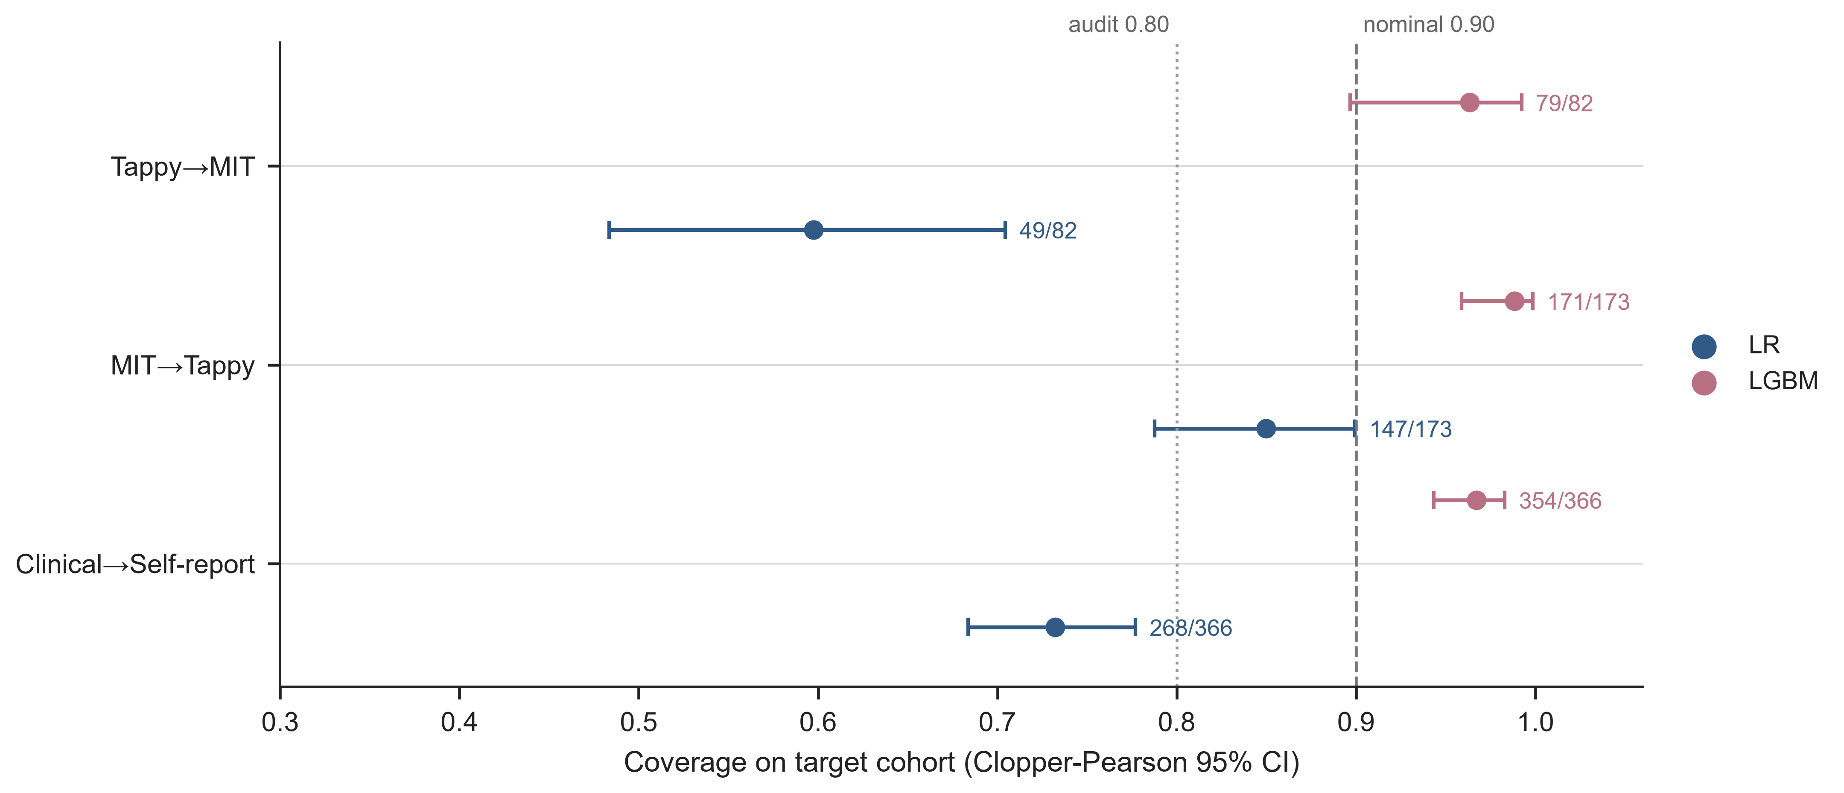

Fig1
Fig. 2 PD/HC class-conditional coverage (measured, unadjusted failure-mode diagnostic — not a guarantee). Left = LR; right = LGBM. Squares = PD; circles = HC; annotations give per-class n
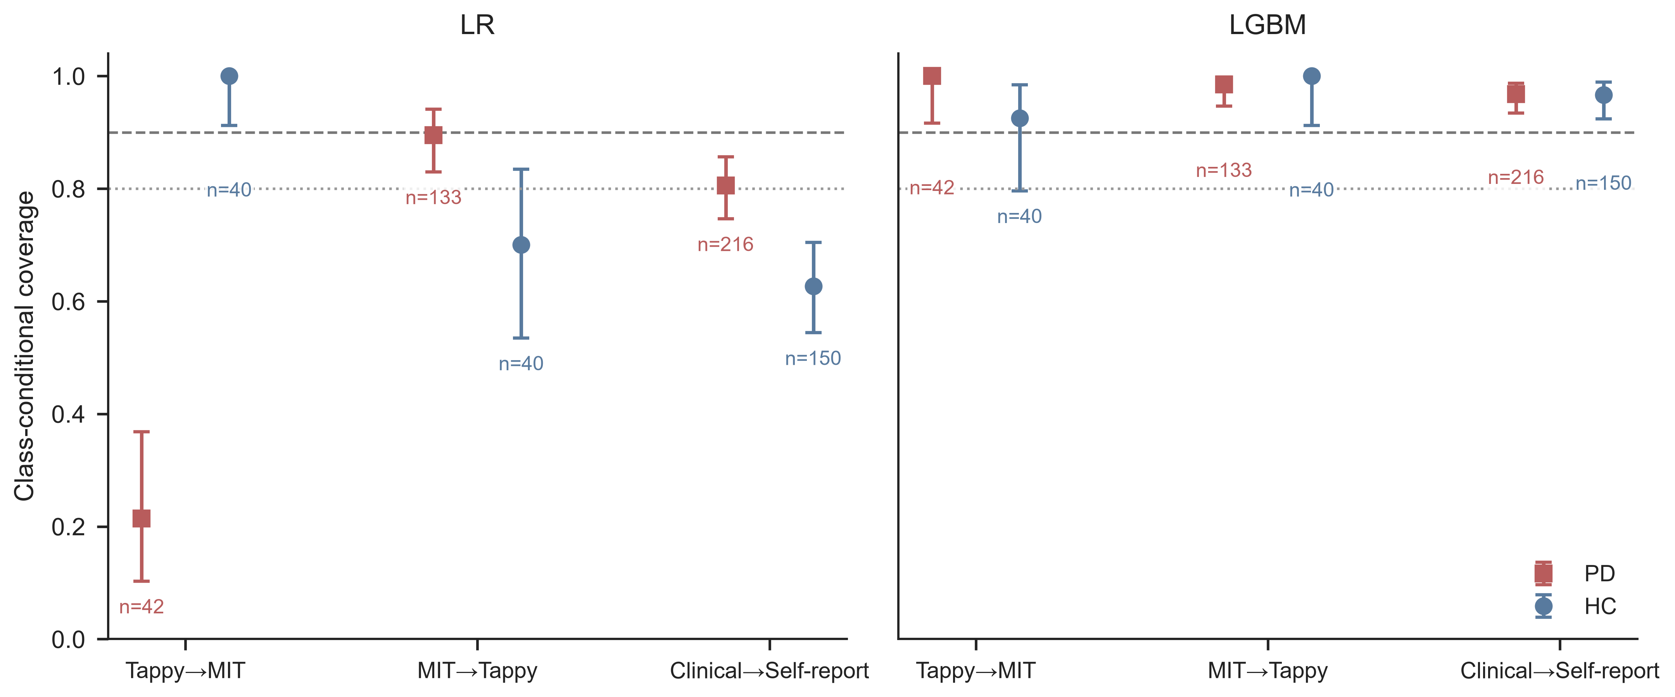

Fig2
Fig. 3 Decoupling map: ΔAUC vs Δcoverage (50-seed means; 12 non-independent directions — descriptive, no correlation test). Left = LR; right = LGBM. Labels: dataset initials T = Tappy, M = MIT, Y = TyPD, O = Online English; arrow = transfer direction
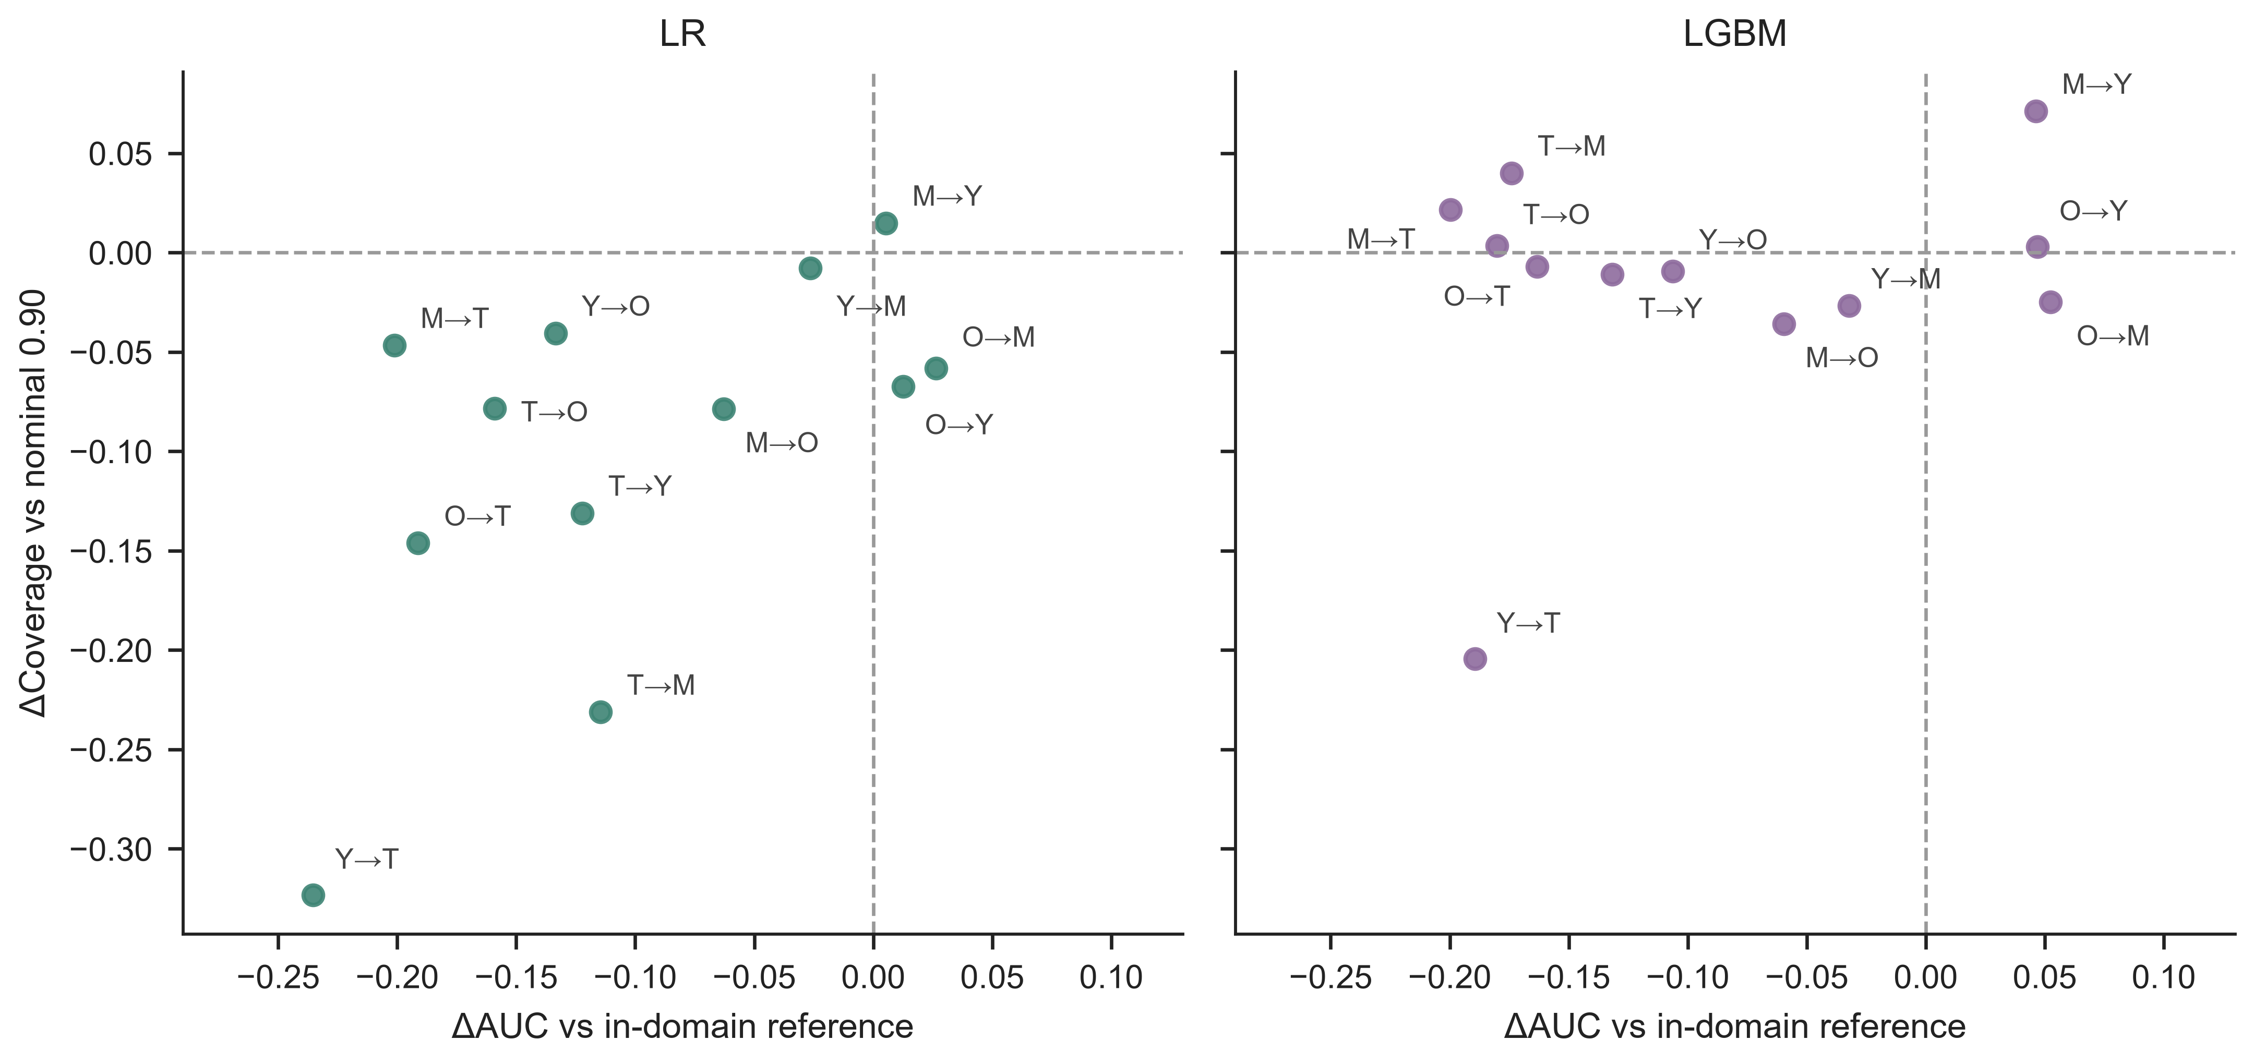

Fig3
Fig. 4 Recovery-cost curves. Open markers = degenerate full-set calibration (m<9); stars = weighted CP at 0 labels (rejection 0.86–1.00): coverage without utility. Non-monotonic segments reflect single-draw sampling noise. Audit 0.80 = pre-specified operational audit threshold. The Tappy→MIT and MIT→Tappy weighted-CP stars coincide at (0 labels, coverage 1.00) and are offset horizontally for visibility.
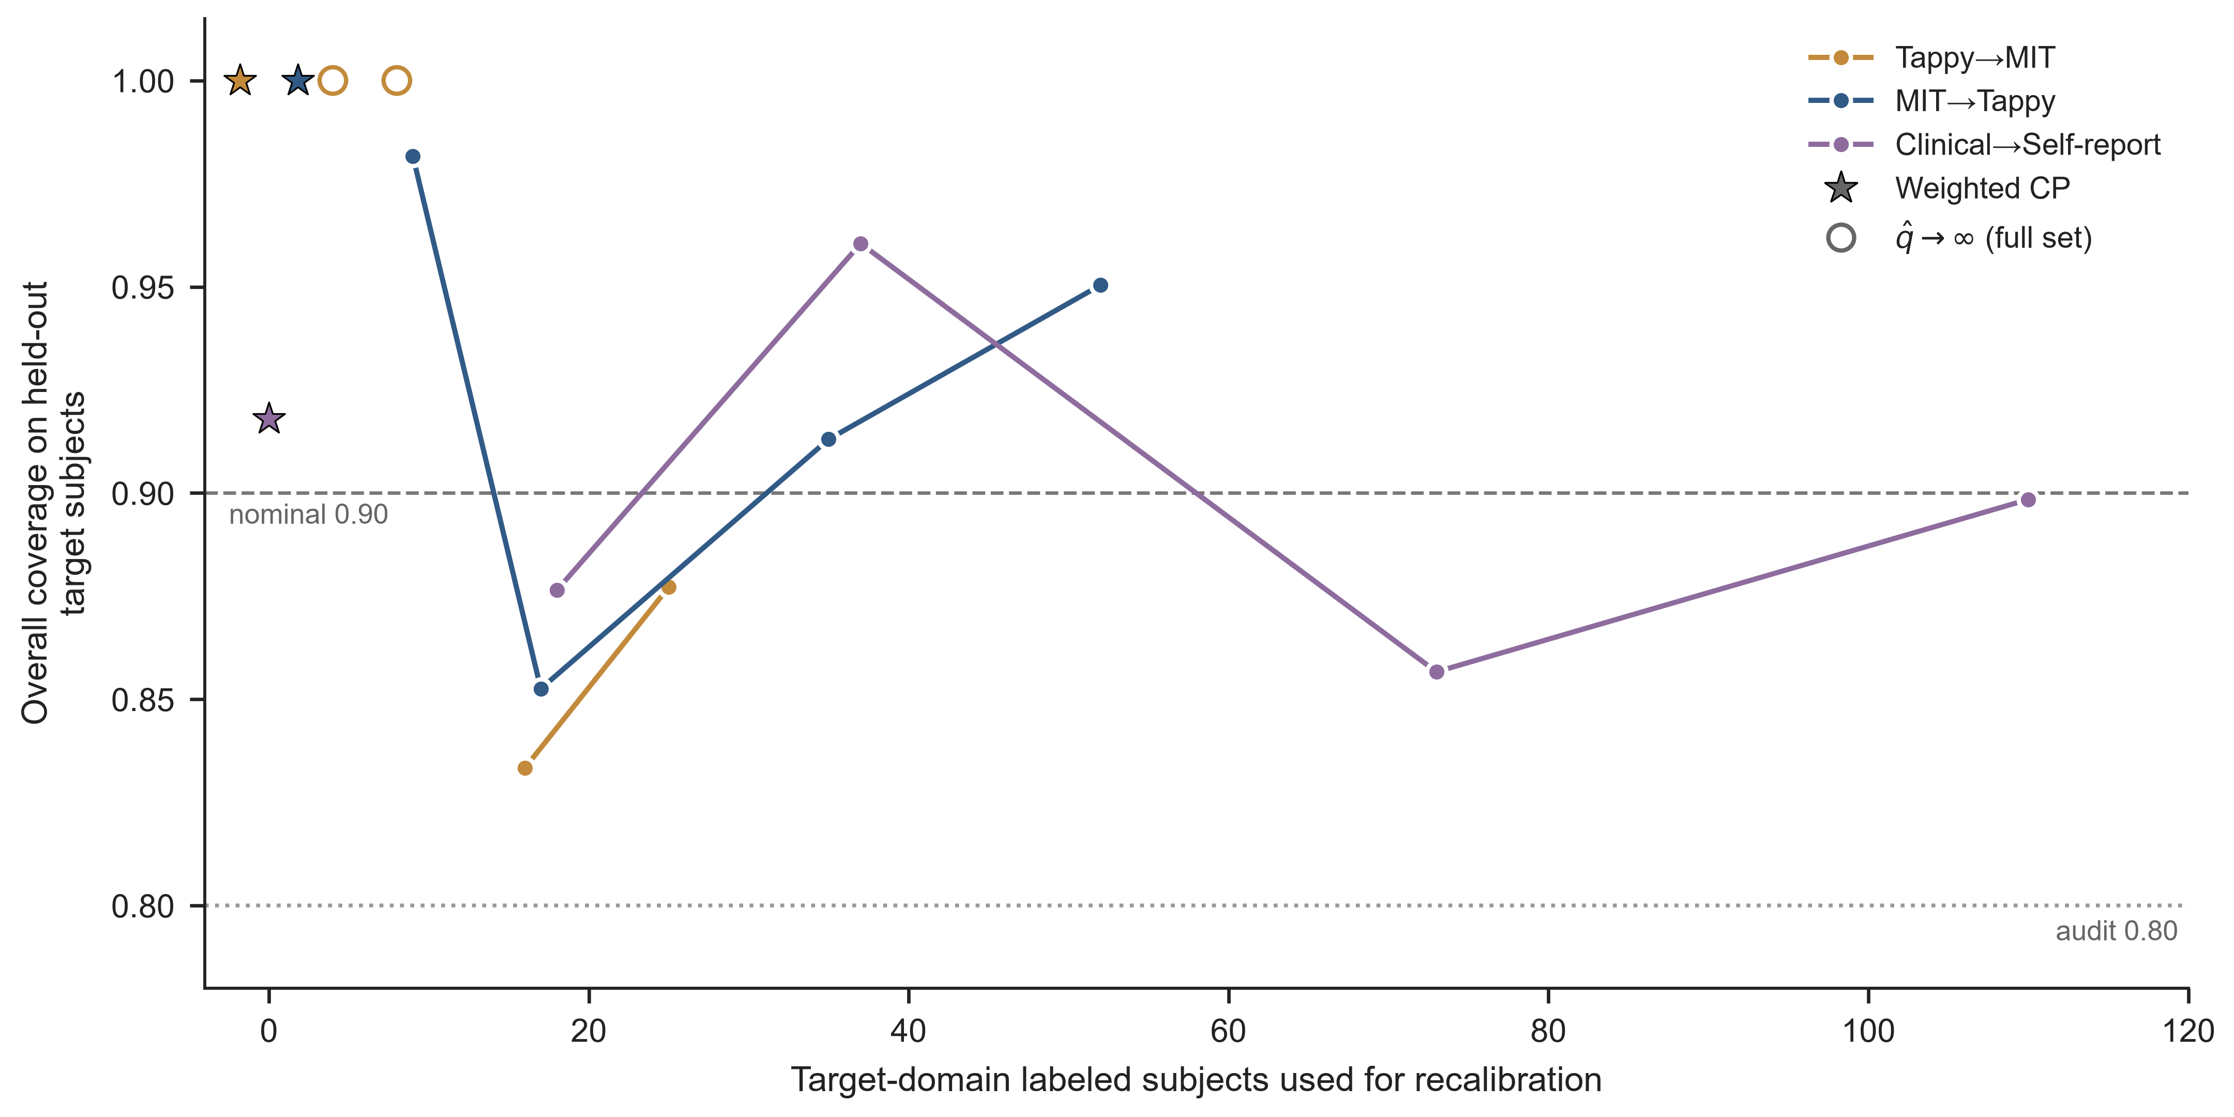

Fig4
Fig. 5 Coverage–abstention trade-off under label-free density-ratio weighting (0 target labels), three primary directions. Left: overall coverage on held-out target subjects (dashed = nominal 0.90; dotted = pre-specified operational audit threshold 0.80). Right: rejection (abstention) rate — the fraction of subjects whose prediction set is the full label set, i.e., no usable ranking
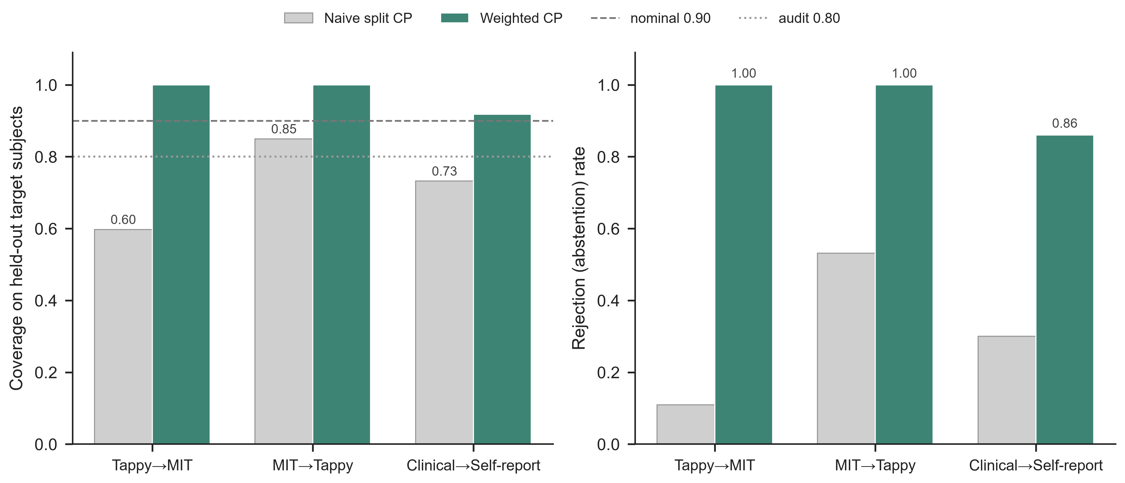

Fig5
Fig. 6 Controlled stress tests, Tappy→MIT direction. A: calibration-only synthetic label-flip dose–response on the clinical source (theory-aligned). B: train+calibration label flips (deployment scope). C: three-arm real-transfer test — PD/HC-conditional coverage for the observed phenotype vs prevalence re-matching (pool level), prevalence-preserving flips and their combination (train+calibration scope). Shaded bands indicate the pre-specified ±5 percentage-point practical-equivalence tolerance around the observed phenotype; they are not confidence intervals
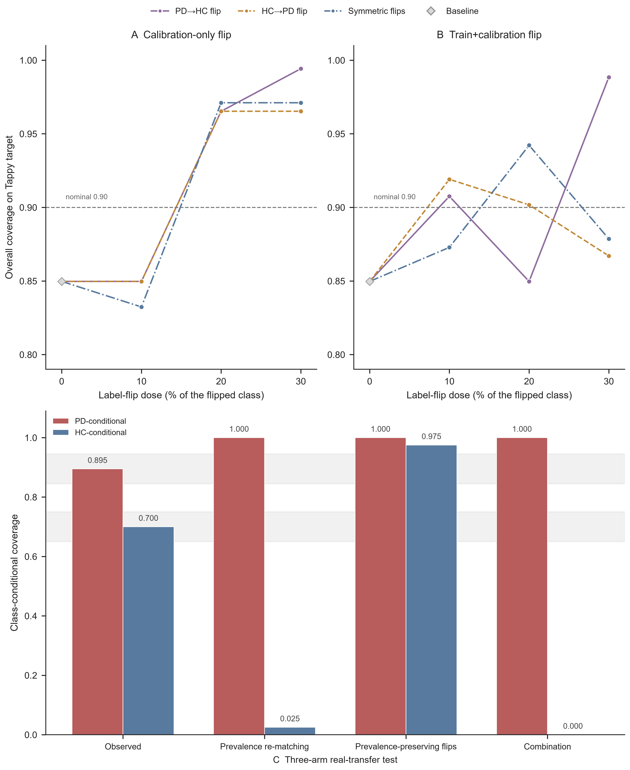

Fig6
Fig. 7 Twelve-direction transfer heatmap of mean test AUC (50 seeds), primary reference model. Rows = source dataset, columns = target dataset; the diagonal (in-domain) is not evaluated. Cell values are point estimates; the diverging colour scale spans 0.4–1.0
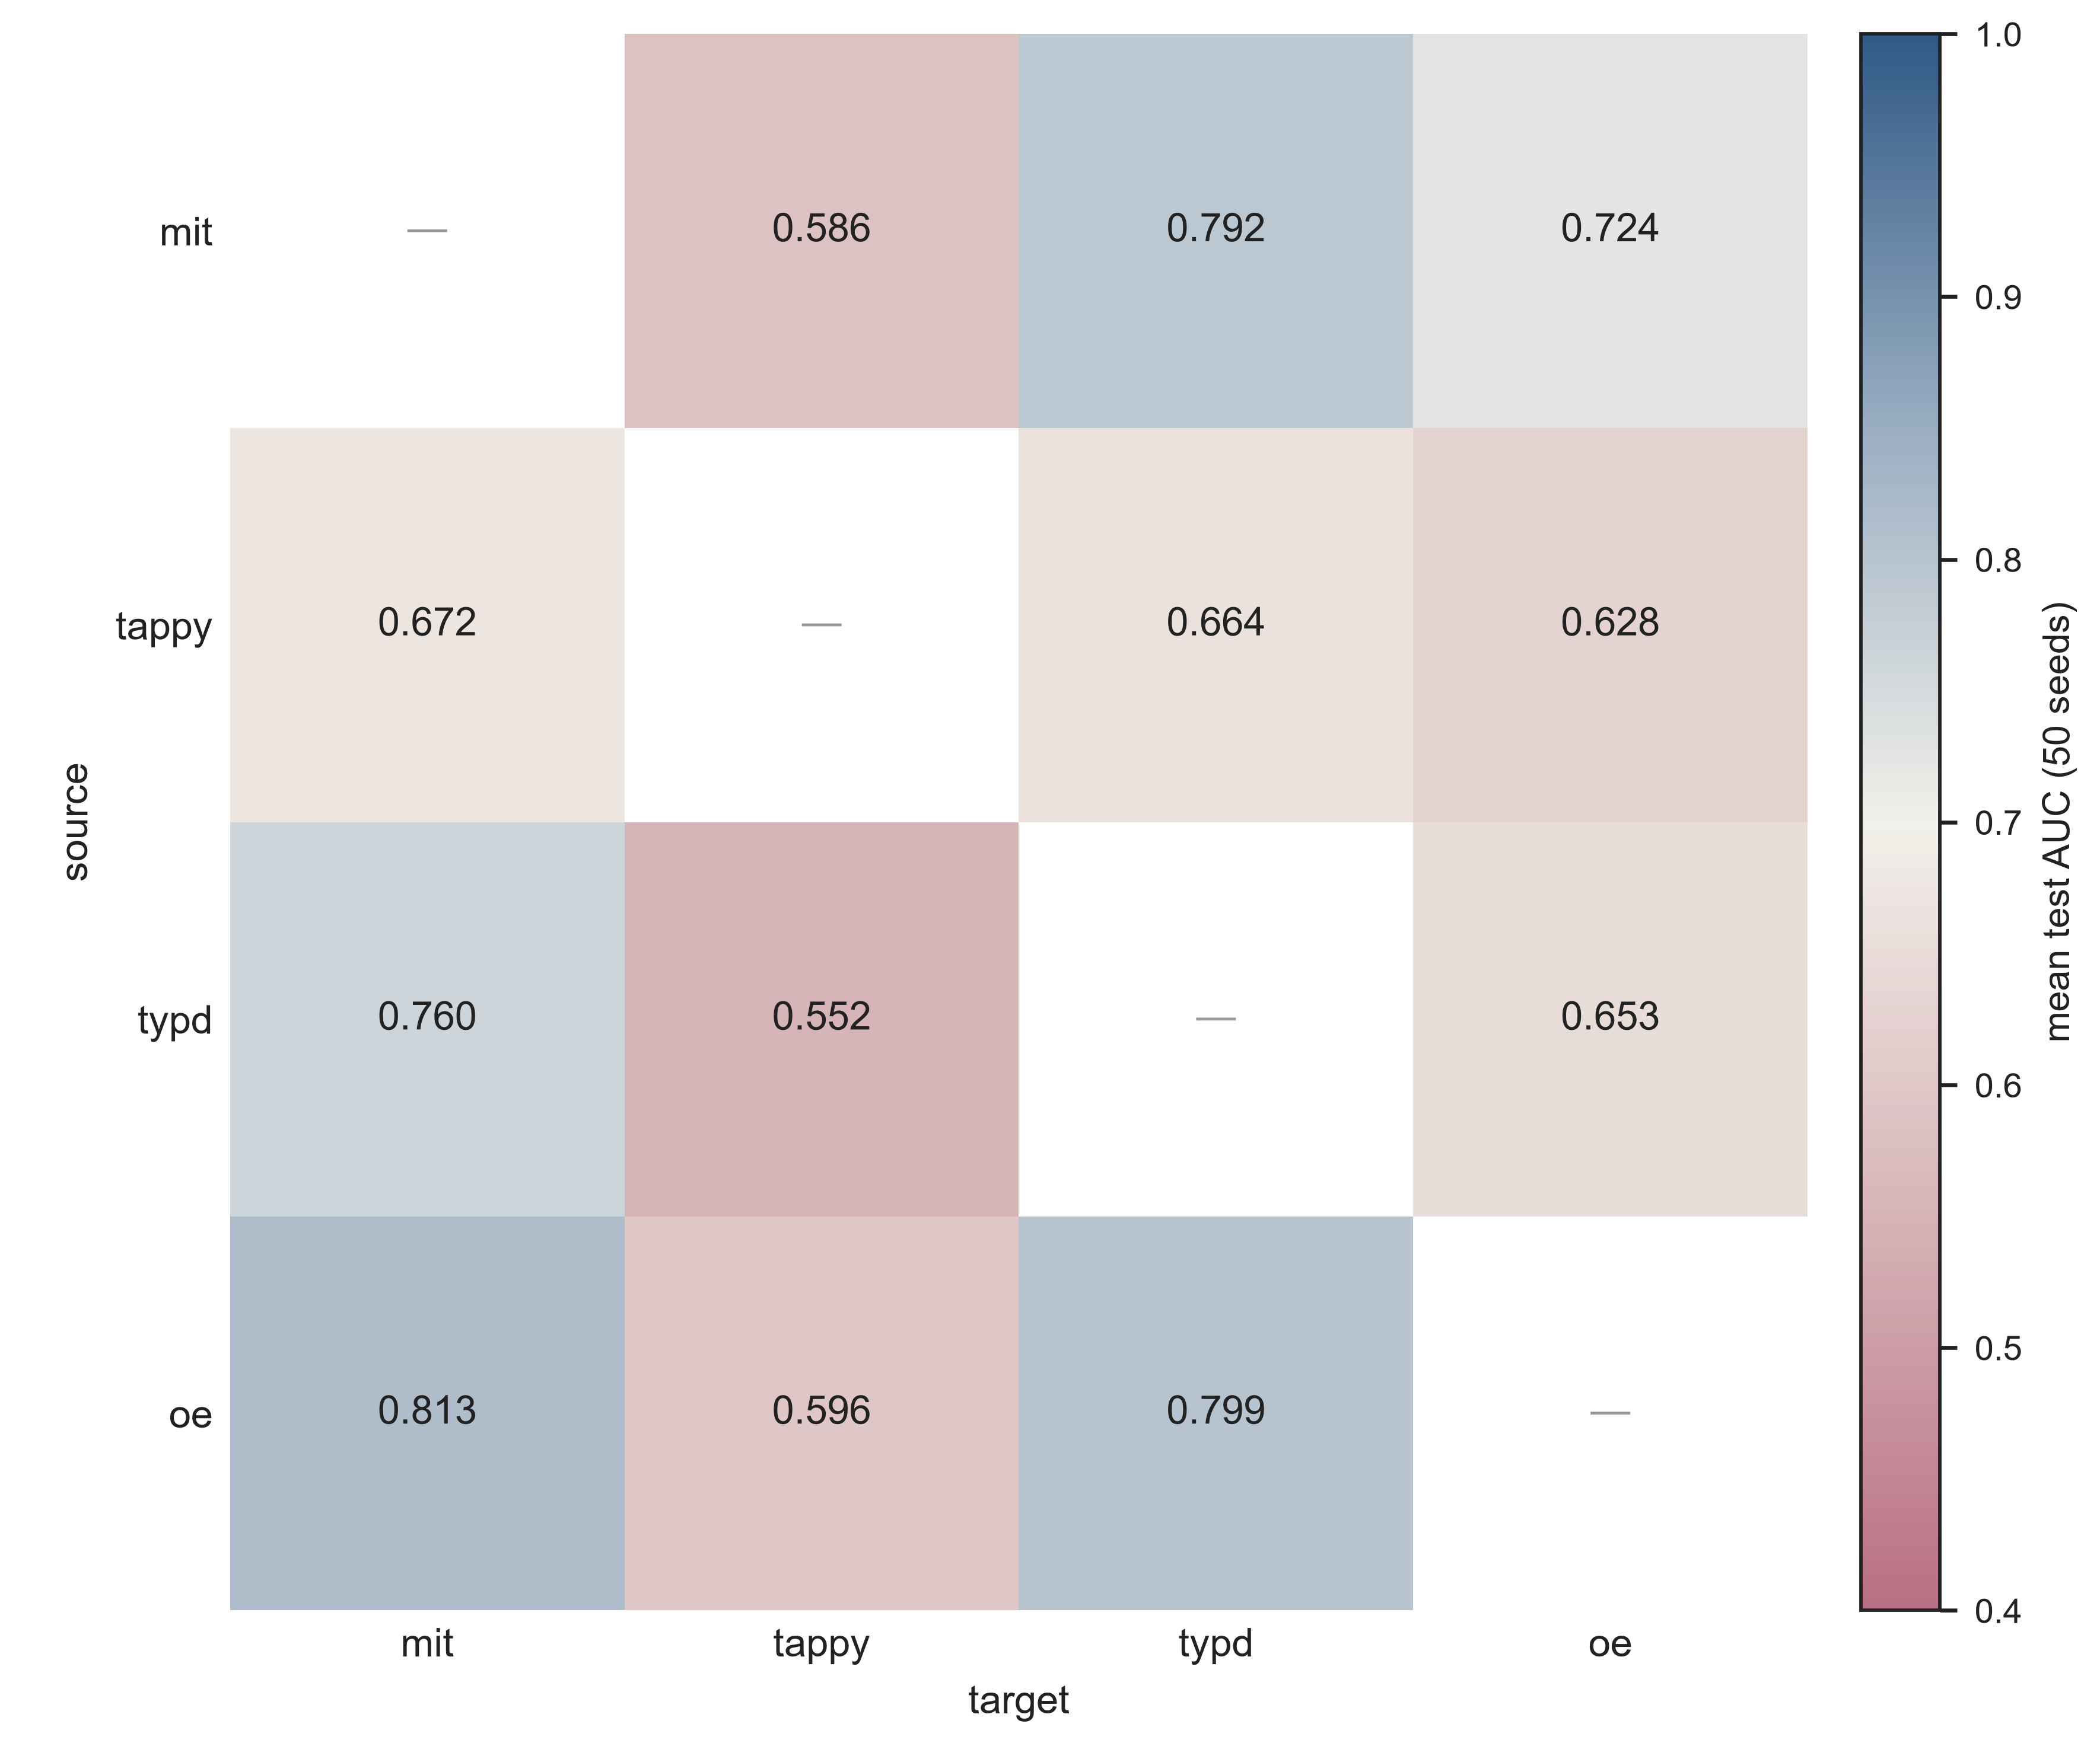

Fig7

