Youth Female Unemployment

Student ID: 21408041

Name: JIANG TIANQI

In the recent years, the issue about gender equality is getting more and more attention. One demonstration of gender equality is the equal employment opportunities between male and female. The report will use the data about the youth female unemployment published by World Bank to analyze the change of the youth female employment from 2015 to 2019.

Four main discussions:

* The whole trend of youth female unemployment from 2015 to 2019 around the world
* Which countries performed best in decreasing the rate? Which countries performed worst?
* **Trend of supranational organizations**
* Trend of income groups

**The Whole Trend around the World**



According to the description of data about data, the mean of rate over the 5 years keeps decreasing slowly from 19.603 % in 2015 to 18.593% in 2019. In addition, the median range varies from 16.436 % (2015) to 15.41 % (2019), which presents that in the majority of countries, the youth female unemployment rate has decreased.

Through the swarm plot over the 5 years, the rate of most countries is below 20%.

**Top 10 Performing Countries and Bottom 10 Performing Countrie**

The below bar plot shows the net change about rates over 5 year periods (2015-2019) for all the countries. The more negative, the more decrease in the rate, which means the country performed better. In contrast, the more positive, the worse the country performed. Therefore, there are more countries performing well.

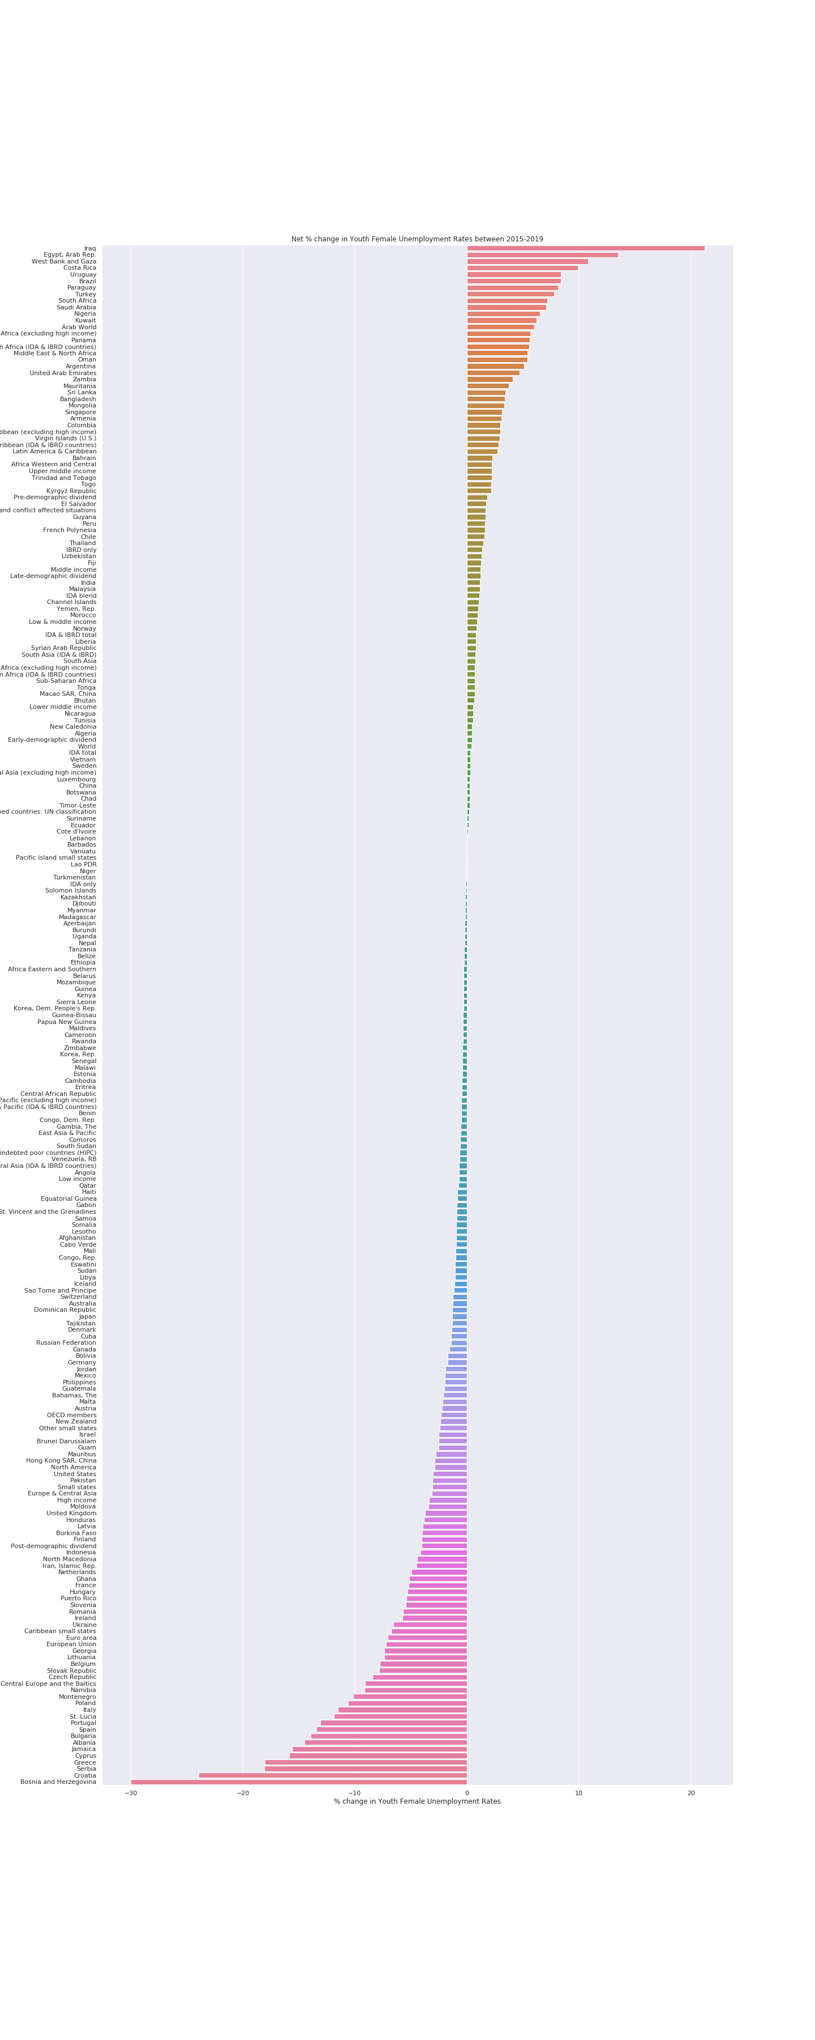

The second bar plot suggests that top 10 countries which improve most successfully and bottom 10 countries who fail to dealing with the problem.

On the left of the horizontal bar, top 5 countries are Bosnia and Herzegovina, Croatia, Serbia, Greece and Cyprus. It suggests that most of top countries are in Europe, especially in the south and southeast of Europe, as Bosnia and Herzegovina being the best having a negative number of -30.2%.

On the right, bottom 10 countries with the worst performance are most located in Middle East, Africa and South America. Especially, Iraq (from 41.37% to 62.61%), West Bank and Gaza (from 55.99% to 66.79%) and South Africa (from 55.06% to 62.23%), Saudi Arabia (from 57.26% to 64.35%) with high rates over the 5 years.

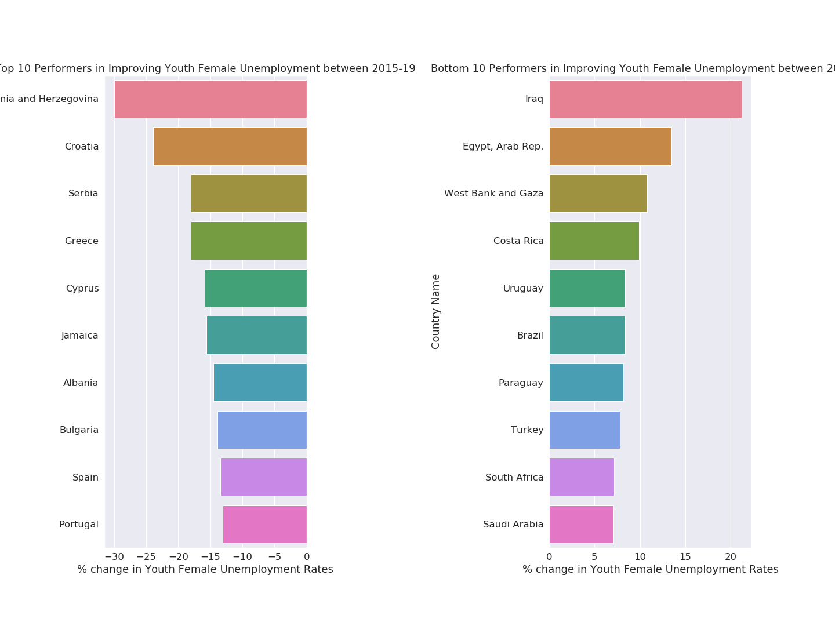

However, through the heat map, we can find that it cannot prove that the overall situation of youth female employment in top performed countries is good or other countries perform badly. For example, although Bosnia and Herzegovina has a highest negative number with -30.2%, the unemployment of youth female is still higher (from 67.58% in 2015 to 37.56% in 2019) than most of countries.

**Trend of Supranational Organizations**

The linear plot displays the trends in different groups. It shows that North America, East Asia & Pacific, Sub-Saharan Africa and OECD members have lower rate than the average world rate. The rate of Arab World and Middle East & North Africa is far higher than the average and keeps increasing.

**Trend of Income Groups**

The second linear plot analyzes the trend based on income levels. It presents that Lower middle income, Middle income countries have higher rates compared with the average. The rate of Upper middle income countries keeps increasing, which should be concerned. The rate of High income keeps decreasing over the 5 years.

**Conclusion**

With the almost unchanged rate (decrease 1.01%) over the 5 years, the problem would be existed for the long term. The southern European countries perform best on improving the youth female unemployment. In contrast, the countries in Middle East, Africa and South America perform worst. The Lower middle and Middle income countries need to provide more opportunities for female. The world organizations and the governments should continue exploring the solution to decrease the youth female unemployment and provide an equal employment market for male and female.