

COMP 353

Main Project Report

Group Members

Mathieu Dumais-Savard 6095275Justin Torres 9356592Ramez Debbas 9103910Han Gao 40053734

Table of Contents

Introduction 2

E/R Model 3

E/R Model to Relation 3

Convert to 3NF: 4

SQL Statements 4

User Interface and PHP 11

Contributions of Each Team Member 16

## Introduction

The purpose of this project is to design a web-based database of a company management system using MySQL and PHP to set relations in between different components such as Employees, Department and projects, and keep track of the performances.

In progress of building the system, an E/R relationship model is presented to explain relationship of entities. To enhance the system performance in long run, we decomposed the relations into 3NF. Constraints during creating system are listed to better understand the inner system structure. A brief introduction on our user interface is provided to help users getting on to it. Test data and some example queries are provided.

## E/R Model

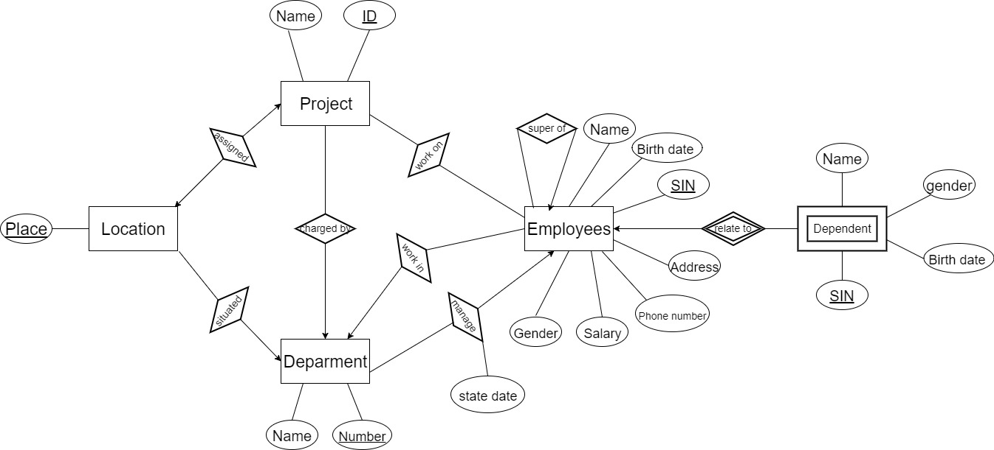

A department may have several locations, so the relationship between department and location is one to many.

A department is in charge of a number of projects,

a single location assigned to each project

Each employee is assigned to one department but he/she may work on different projects in the company,

We would like to keep track of the hours an employee worked on each project as well as the direct supervisor of each employee (who is another employee).

For insurance and benefits reasons, the database should also record and keep track of information about employees’ dependents.

Since both department and project have location, we upgrade it to an entity, and created relation between location and department/project.

## E/R Model to Relation

Employees(SIN, Name, birthDate, address, gender, phoneNumber, salary)

SuperviseOf(SIN, Name, birthDate, address, gender, phoneNumber, salary)

Dependent(DSIN, ESIN, dependentName, dBirthDate, dGender)

Department(DNumber, DName)

Project(PID, PName)

Location(place)

assigned(PID, place)

situated(place, DNumber)

chargedBy(PID, DNumber)

workOn(PID, ESIN, hours)

workIn(ESIN, DNumber)

manage(DNumber, ESIN, StartDate)

## Convert to 3NF:

For all tuples with single key, they are already in 3NF, so no need to convert.

For table workOn, (PID, ESIN) -> hours, 3NF

For table Dependent,

(DSIN, ESIN) -> dependentName , 3NF

(DSIN, ESIN) -> dependentBirthday, 3NF

(DSIN, ESIN) -> dependentGender, 3NF

So all relations are in 3NF

No trivial dependencies found

## SQL Statements

1. List of tables and constraints

CREATE TABLE Employees(

SIN INTEGER(40) NOT NULL PRIMARY KEY,

Name VARCHAR(40) NOT NULL ,

birthDate DATE NOT NULL ,

address VARCHAR(60),

gender ENUM('M', 'F') DEFAULT 'F',

phoneNumber BIGINT,

salary DOUBLE UNSIGNED DEFAULT 0

);

We picked SIN as primary key for employee, used enum to make sure gender is either male or female.

CREATE TABLE SuperviseOf(

EmployeeSIN INTEGER(40) NOT NULL PRIMARY KEY ,

SupervisorSIN INTEGER(40) NOT NULL,

FOREIGN KEY (EmployeeSIN) REFERENCES Employees(SIN),

FOREIGN KEY (SupervisorSIN) REFERENCES Employees(SIN)

);

Set foreign keys EmployeeSIN and supervisorSIN

CREATE TABLE Dependent(

DependentSIN INTEGER(40) NOT NULL,

ESIN INTEGER(40) NOT NULL,

FOREIGN KEY(ESIN) REFERENCES EMPLOYEES(SIN),

dependentName VARCHAR(40) NOT NULL,

dBirthDate DATE,

dGender ENUM('M', 'F') DEFAULT 'F',

PRIMARY KEY(DependentSIN, ESIN)

);

Primary key is the pair (DependentSIN, ESIN), since Dependent is a weak entity;

CREATE TABLE Department(

DepartmentNumber INTEGER(40) NOT NULL PRIMARY KEY,

DepartmentName VARCHAR(40) NOT NULL UNIQUE

);

Used UNIQUE to make department name unique

CREATE TABLE Project(

PID INTEGER(40) NOT NULL PRIMARY KEY,

PName VARCHAR(40) NOT NULL UNIQUE

);

CREATE TABLE Location(

place VARCHAR(40) NOT NULL PRIMARY KEY

);

CREATE TABLE assigned(

PID INTEGER(40) NOT NULL PRIMARY KEY,

place VARCHAR(40),

FOREIGN KEY (PID) REFERENCES Project(PID),

FOREIGN KEY (place) REFERENCES Location(place)

);

CREATE TABLE situated(

place VARCHAR(40) NOT NULL PRIMARY KEY ,

DepartmentNumber INTEGER(40) NOT NULL,

FOREIGN KEY (place) REFERENCES Location(place),

FOREIGN KEY (DepartmentNumber) REFERENCES Department(DepartmentNumber)

);

CREATE TABLE changedBy (

PID INTEGER(40) NOT NULL PRIMARY KEY ,

DNumber INTEGER(40) NOT NULL ,

FOREIGN KEY (PID) REFERENCES Project (PID),

FOREIGN KEY (DNumber) REFERENCES Department (DepartmentNumber)

);

CREATE TABLE workOn(

PID INTEGER(40) NOT NULL ,

SIN INTEGER(40) NOT NULL ,

hours DOUBLE,

PRIMARY KEY (PID, SIN),

FOREIGN KEY (PID) REFERENCES Project(PID),

FOREIGN KEY (SIN) REFERENCES Employees(SIN)

);

CREATE TABLE workIn(

SIN INTEGER(40) NOT NULL PRIMARY KEY ,

DNumber INTEGER(40) NOT NULL ,

FOREIGN KEY (SIN) REFERENCES Employees(SIN),

FOREIGN KEY (DNumber) REFERENCES Department(DepartmentNumber)

);

CREATE TABLE manage(

DNumber INTEGER(40) PRIMARY KEY,

SIN INTEGER(40),

StartDate DATE,

FOREIGN KEY (DNumber) REFERENCES Department(DepartmentNumber),

FOREIGN KEY (SIN) REFERENCES Employees(SIN)

);

One to many relation, so pick department number as primary key

CREATE TABLE related(

DependentSIN INTEGER(40) NOT NULL ,

SIN INTEGER(40) NOT NULL ,

FOREIGN KEY (SIN) REFERENCES Employees(SIN)

);

1. **Sample Test Data**

INSERT INTO Employees VALUE (1,'jason','1991-04-22','188 boul de L\'Assomption, QC', 'M', 5149926186, 3199.4237);

INSERT INTO Employees VALUE (2,'Fatimah', '1991-04-12', '20 Maple Avenue San Pedro, QC', 'M', 5149926186, 3129.4237);

INSERT INTO Employees VALUE (3,'Chanel', '1992-06-22', '7 W. Adams Lane San Jose, QC', 'F', 5149926186, 4999.4237);

INSERT INTO Employees VALUE (4,'Dayna', '1995-05-12', '188 boul de L\'Assomption, QC', 'F', 5149926186, 2999.4237);

INSERT INTO Employees VALUE (5,'Sue', '1994-09-22', '601 Sherwood Ave, QC', 'F', 5149926186, 1929.4237);

INSERT INTO Employees VALUE (6,'Kennedy', '1993-04-22', '1 East Bayberry Street, QC', 'F', 5149926186, 2999.4237);

INSERT INTO Employees VALUE (7,'Isabel', '1996-04-22', '241 Indian Spring St, QC', 'M', 5149926186, 2999.4237);

INSERT INTO Employees VALUE (8,'Nico', '1995-12-22', '25 Fairview Dr. Los Angeles, QC', 'M', 5149926186, 2349.4237);

INSERT INTO Employees VALUE (9,'Lottie', '1995-08-22', '737 Hill Field Street, QC', 'F', 5149926186, 2789.4237);

INSERT INTO Employees VALUE (10,'Roxanne', '1997-01-22', '23 boul de L\'Assomption, QC', 'M', 5149926186, 2991.4237);

INSERT INTO Employees VALUE (11,'Marilyn','1990-04-23','188 boul de L\'Assomption, QC', 'F', 5149926186, 3299.4237);

INSERT INTO Employees VALUE (12,'Judy', '1995-04-12', '12 S. Sulphur Springs St, QC', 'M', 5149926186, 2999.4237);

INSERT INTO Employees VALUE (13,'Camilla', '1996-06-22', '33 Addison Street, QC', 'M', 5149926186, 2999.4237);

INSERT INTO Employees VALUE (14,'Hiba', '1990-05-12', '282 Hawthorne Street, QC', 'F', 5149926186, 2999.4237);

INSERT INTO Employees VALUE (15,'Kathy ', '1992-09-22', '8 SE. Washington St, QC', 'F', 5149926186, 2999.4237);

INSERT INTO Employees VALUE (16,'Jamie', '1993-04-22', '9877 Washington Dr, QC', 'F', 5149926186, 2999.4237);

INSERT INTO Employees VALUE (17,'Michal ', '1996-02-12', '13 Vermont Dr.Sacramento, QC', 'F', 5149926186, 2999.4237);

INSERT INTO Employees VALUE (18,'Agnes ', '1995-12-22', '148 boul de Shadow, QC', 'M', 5149926186, 2999.4237);

INSERT INTO Employees VALUE (19,'Cindy', '1995-08-22', '112 boul de Shadow, QC', 'M', 5149926186, 2999.4237);

INSERT INTO Employees VALUE (20,'Robbie', '1997-01-22', '188 boul de Boston, QC', 'M', 5149926186, 2999.4237);

INSERT INTO Employees VALUE (21,'Phillip','1991-04-22','188 boul de L\'Assomption, QC', 'M', 5149926186, 2999.4237);

INSERT INTO Employees VALUE (22,'Tommy ', '1991-04-12', '18 boul de Assomon, QC', 'F', 5149926186, 2999.4237);

INSERT INTO Employees VALUE (23,'Iestyn', '1992-06-22', '7755 Shadow Brook Ave, QC', 'F', 5149926186, 2999.4237);

INSERT INTO Employees VALUE (24,'Phillip', '1995-05-12', '188 boul de Asso, QC', 'F', 5149926186, 2999.4237);

INSERT INTO Employees VALUE (25,'Krish', '1994-09-22', '181 boul de Assomption, QC', 'M', 5149926186, 2999.4237);

INSERT INTO Employees VALUE (26,'Harlow', '1993-04-22', '991 Tarkiln Hill Ave, QC', 'M', 5149926186, 2999.4237);

INSERT INTO Employees VALUE (27,'Everly', '1996-04-22', '182 boul de L\'Assomption, QC', 'M', 5149926186, 2999.4237);

INSERT INTO Employees VALUE (28,'Georgie', '1995-12-22', '49 Ridgewood Ave, QC', 'F', 5149926186, 2999.4237);

INSERT INTO Employees VALUE (29,'Emmanuel', '1995-08-22', '9089 Constitution Court, QC', 'F', 5149926186, 2999.4237);

INSERT INTO Employees VALUE (30,'Max', '1997-01-22', '389 Gainsway Stree, QC', 'M', 5149926186, 2999.4237);

INSERT INTO Department VALUE (1, 'gaming');

INSERT INTO Department VALUE (2, 'web');

INSERT INTO Department VALUE (3, 'application');

INSERT INTO Location VALUE ('H building');

INSERT INTO Location VALUE ('EV building');

INSERT INTO Location VALUE ('S building');

INSERT INTO Project VALUE (1, 'x');

INSERT INTO Project VALUE (2, 't');

INSERT INTO Project VALUE (3, 'website');

INSERT INTO Dependent VALUE (1, 'tem', '1993-03-23', 'F');

INSERT INTO Dependent VALUE (2, 'tem', '1993-03-23', 'F');

INSERT INTO Dependent VALUE (3, 'tem', '1993-03-23', 'F');

INSERT INTO Dependent VALUE (4, 'tem', '1993-03-23', 'F');

INSERT INTO Dependent VALUE (5, 'tem', '1993-03-23', 'F');

INSERT INTO Dependent VALUE (6, 'tem', '1993-03-23', 'F');

INSERT INTO Dependent VALUE (7, 'tem', '1993-03-23', 'F');

INSERT INTO Dependent VALUE (8, 'tem', '1993-03-23', 'F');

INSERT INTO Dependent VALUE (9, 'tem', '1993-03-23', 'F');

INSERT INTO Dependent VALUE (10, 'tem', '1993-03-23', 'F');

INSERT INTO related VALUE (1, 1);

INSERT INTO related VALUE (2, 2);

INSERT INTO related VALUE (3, 3);

INSERT INTO related VALUE (4, 4);

INSERT INTO related VALUE (5, 5);

INSERT INTO related VALUE (6, 6);

INSERT INTO related VALUE (7, 7);

INSERT INTO related VALUE (8, 8);

INSERT INTO related VALUE (9, 9);

INSERT INTO related VALUE (10,10);

INSERT INTO related VALUE (1,10);

SELECT DependentSIN

FROM related

WHERE SIN=10;

INSERT INTO SuperviseOf VALUE (10,1);

INSERT INTO SuperviseOf VALUE (9, 1);

INSERT INTO SuperviseOf VALUE (8, 2);

INSERT INTO SuperviseOf VALUE (7, 1);

INSERT INTO SuperviseOf VALUE (6, 1);

INSERT INTO SuperviseOf VALUE (5, 2);

INSERT INTO SuperviseOf VALUE (4, 1);

INSERT INTO SuperviseOf VALUE (3, 2);

SELECT SupervisorSIN

FROM SuperviseOf

WHERE EmployeeSIN=4;

SELECT EmployeeSIN

FROM SuperviseOf

WHERE SupervisorSIN=1;

INSERT INTO workOn VALUE (1,1,20);

INSERT INTO workOn VALUE (1,4,20);

INSERT INTO workOn VALUE (1,7,20);

INSERT INTO workOn VALUE (1,3,20);

INSERT INTO workOn VALUE (2,2,12);

INSERT INTO workOn VALUE (2,6,20);

INSERT INTO workOn VALUE (3,5,20);

INSERT INTO workOn VALUE (3,8,20);

INSERT INTO workOn VALUE (3,9,20);

INSERT INTO workOn VALUE (3,10,20);

SELECT SIN

FROM workOn

WHERE PID = 3;

INSERT INTO assigned VALUE (1, '101');

INSERT INTO assigned VALUE (2, '101');

INSERT INTO situated VALUE ('101', 1);

INSERT INTO situated VALUE ('102', 1);

INSERT INTO changedBy VALUE (1, 1);

INSERT INTO changedBy VALUE (2, 1);

INSERT INTO changedBy VALUE (3, 2);

INSERT INTO workIn VALUE (1, 1);

INSERT INTO workIn VALUE (2, 2);

INSERT INTO workIn VALUE (4, 1);

INSERT INTO workIn VALUE (6,1);

SELECT EmployeeSIN

FROM SuperviseOf

WHERE SupervisorSIN=1;

INSERT INTO manage VALUE (1,1,'2014-02-23');

INSERT INTO manage VALUE (2,2,'2014-02-23');

## User Interface and PHP

There are 7 PHP files in this project which are query.php, logIn.php, main.php, check.php, update.php, insert.php, and delete.php.

The logIn.php is used for login the website and database, the username and password is the same as login in to the database. If login success, the webpage will jump to main.php.

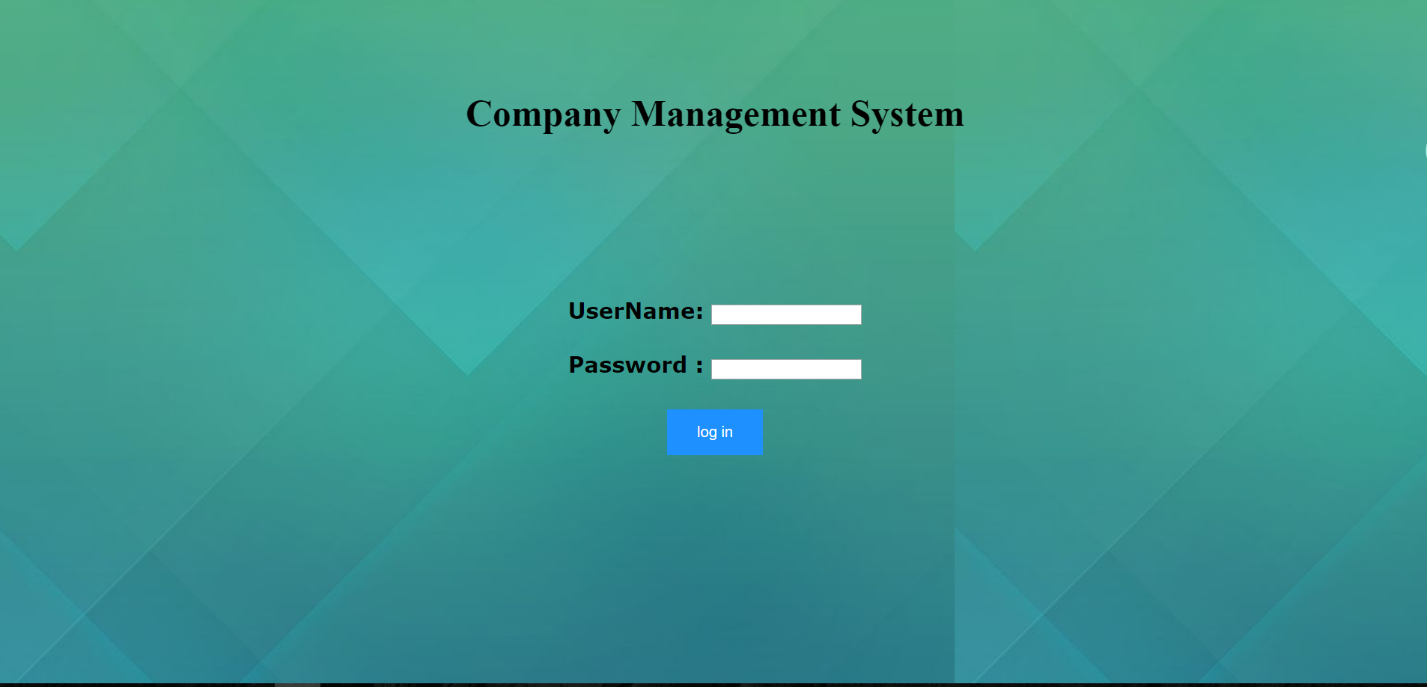

The main.php is the home page of this project. The function of this page is used for user select the function which they want to use. There are four function buttons on this page which is Search, Modify, Add, and Delete. Each buttons will jump to corresponding page. The Search button correspond to check.php, the Modify button correspond to update.php, the Add button correspond to insert.php, and the Delete correspond to Delete,php.

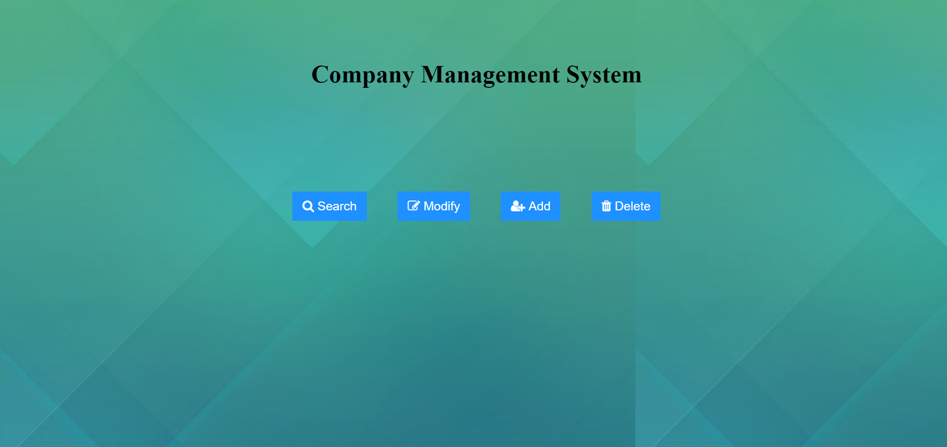

The check.php is used for search the data of the database. The Home button is used for return to Main.php. User can use From to select which part of data they want to search, and the Select1 and Select2 are used for selecting the data which user want to be show. (If use want to show all the information, just select From and select the option All in Select1.

The query.php is not offer to normal user. It is offer for Database administrator. It is design for database maintaining. The administrator can key in every query.

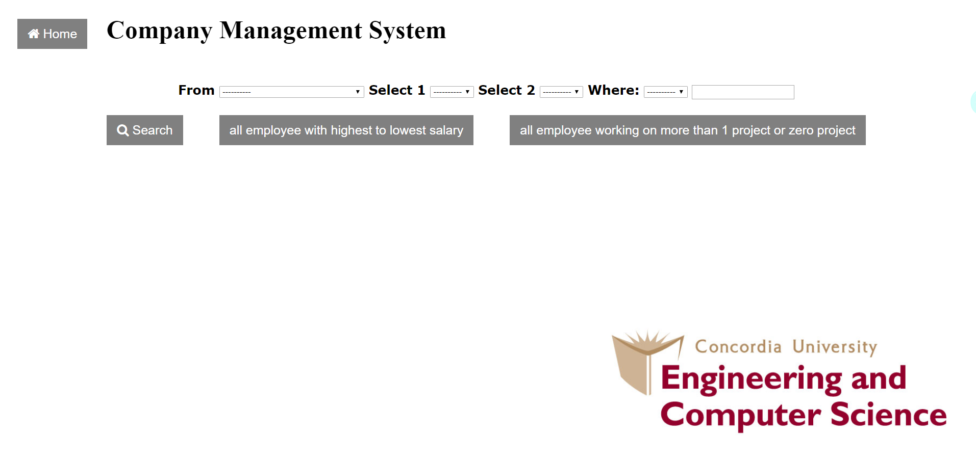

Search button used for submit the form, and the result will be return after click the Search button.

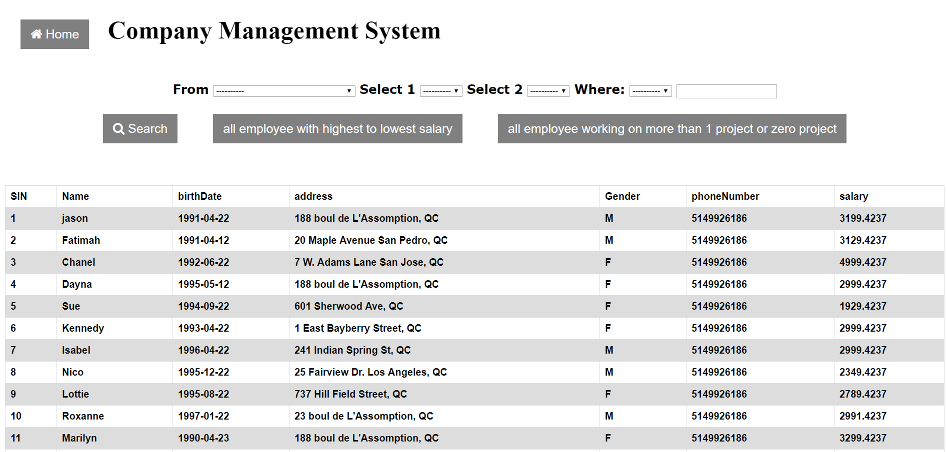

The all employee with highest to lowest salary button is used for return the data of employee with highest to lowest salary.

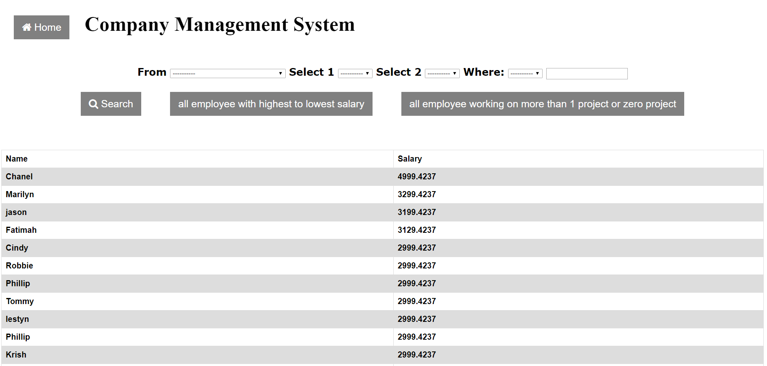

The all employee working on more than 1 project or zero project button is used for return the data of employee working on more than 1 project or zero project.

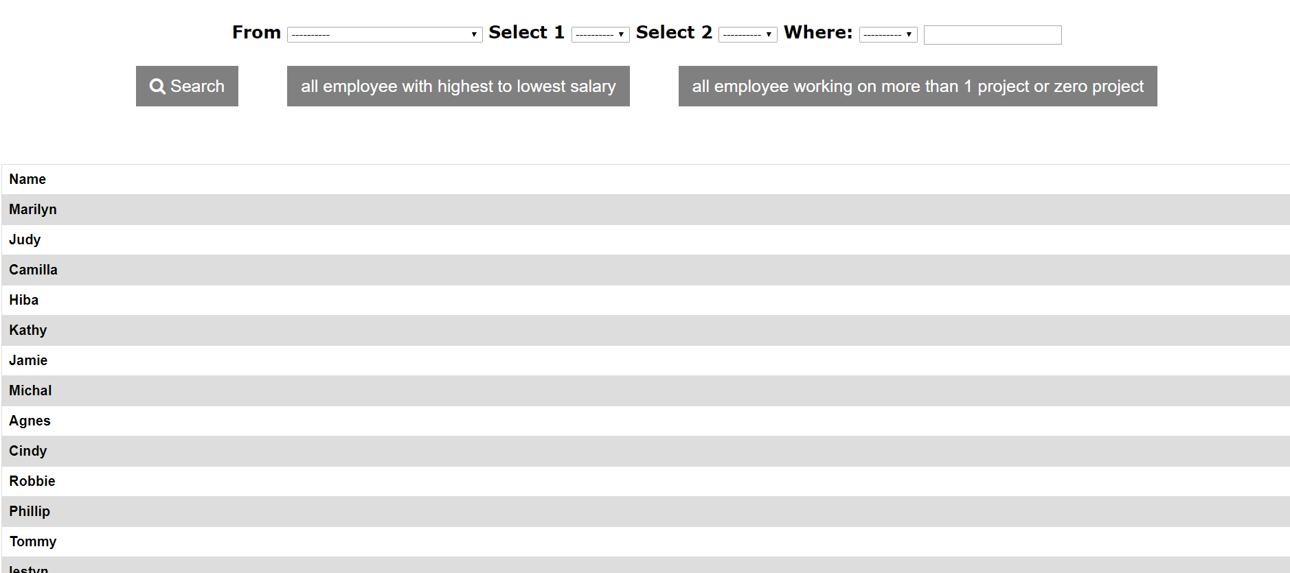

The update.php is used for update or modify the data which exist in the database. The function of the Home button as same as check.php. The Update is used for select which part of data user want to modify. And user can key in the new data in New Data section. They also need give the condition of the old data in Where area.

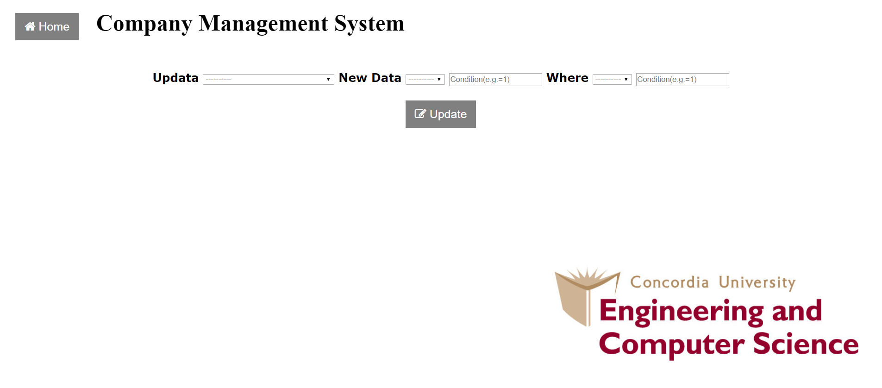

The insert.php is used for add data into the database. The function of the Home button as same as check.php. First of all, the user need select the table which they want to add data in. After that the text area will appear, user must fill out all of them, and click Add button. If the command is successful executed, the “insert success” will appear, otherwise, the “insert unsuccessful” will appear.

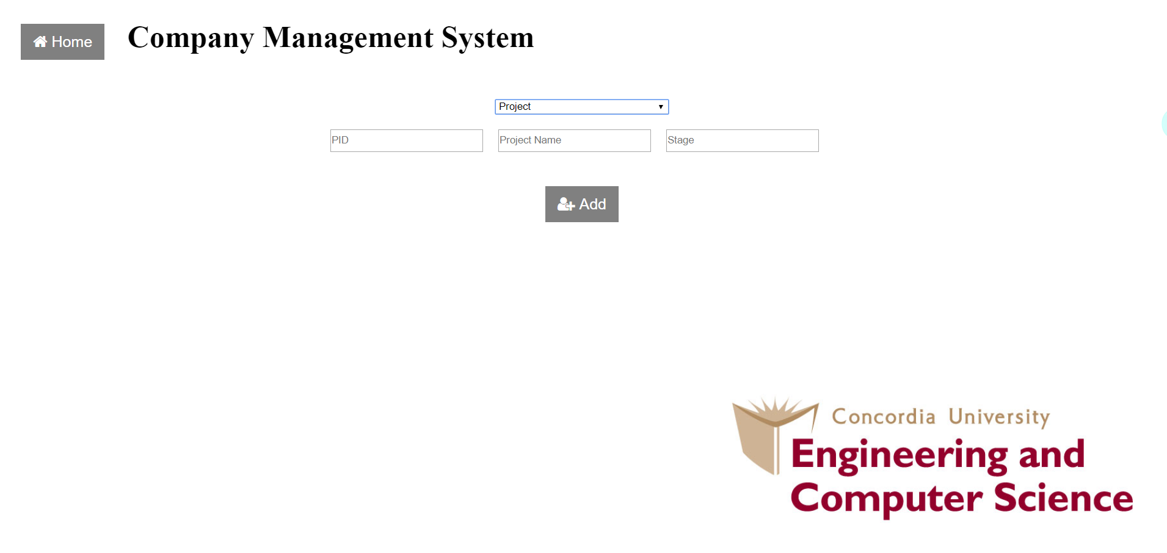

The Delete.php is used for delete data of database. The function of the Home button as same as check.php. First of all, user need select Delete From which will determine which table user will modify. After that, user can key in the information of the data which user want to delete. If the command is successful executed, the “Delete success” will appear, otherwise, the “Delete unsuccessful” will appear.

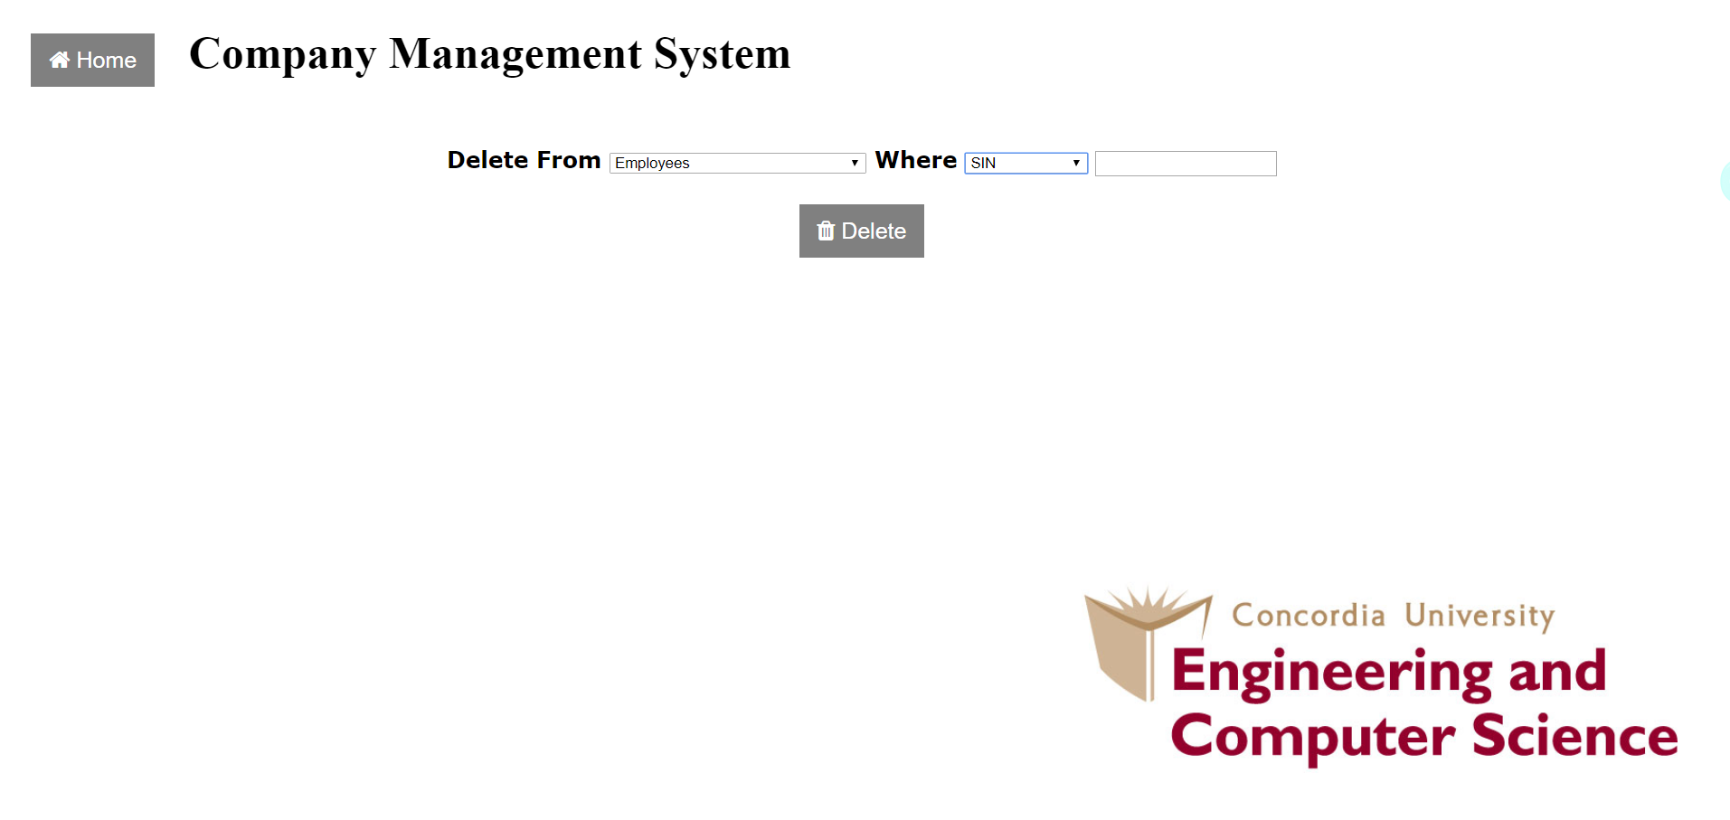

## Contributions of Each Team Member

每个人都干了啥

Tiantian

E/R Model, convert to relation schema, convert to 3NF, php function check, report

Han Gao:

E/R Model, convert to relation schema, html and css, php test, report.