**TWITTER API TEST**

Twcao

(project2.phase 1)

**Step1:**

Set all the keys properly. To use twitter apis, one has to first create an project in twitter developer portal and get the four keys we need to use all the apis.

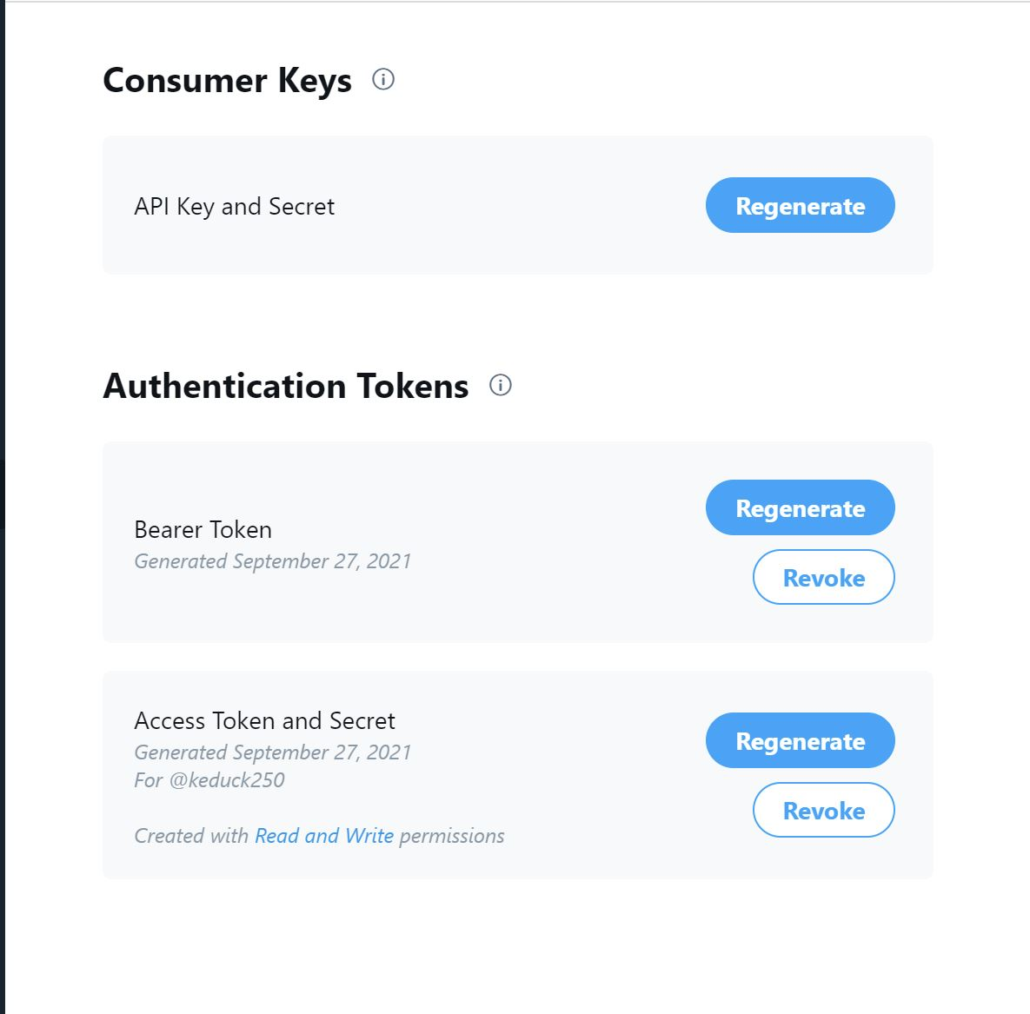

Also, remember to enable both read and write in your project so as to use both ‘GET’ and ‘POST’ methods.

**Step 2:**

Create an python file to store all the keys. Then create a python file to run your main function and use the following code to build authentication.

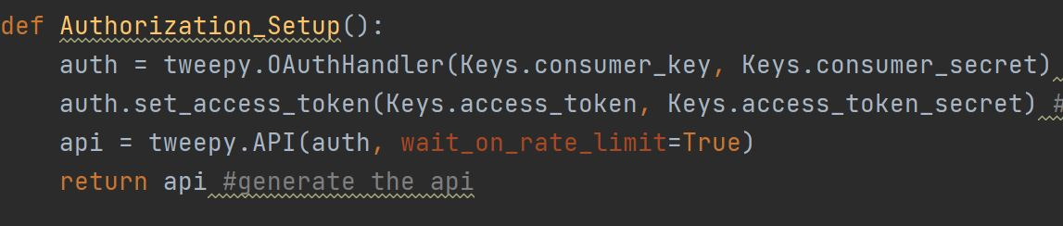

**Step 3:**

Now preparations are all down, we can create functions to test our apis. Here I implements the following apis:

1. GET_My_Home_tweets:

This function use **home_timeline()** to list all the tweets sent by me.

Parameters:

|  |  |  |  |  |
| --- | --- | --- | --- | --- |
| Name | Required | Description | Default Value | Example |
| count | optional | Specifies the number of records to retrieve. Must be less than or equal to 200. Defaults to 20. The value of count is best thought of as a limit to the number of tweets to return because suspended or deleted content is removed after the count has been applied. |  | *5* |
| since_id | optional | Returns results with an ID greater than (that is, more recent than) the specified ID. There are limits to the number of Tweets which can be accessed through the API. If the limit of Tweets has occured since the since_id, the since_id will be forced to the oldest ID available. |  | *12345* |
| max_id | optional | Returns results with an ID less than (that is, older than) or equal to the specified ID. |  | *54321* |
| trim_user | optional | When set to either *true* , *t* or *1* , each Tweet returned in a timeline will include a user object including only the status authors numerical ID. Omit this parameter to receive the complete user object. |  | *true* |
| exclude_replies | optional | This parameter will prevent replies from appearing in the returned timeline. Using *exclude_replies* with the *count* parameter will mean you will receive up-to count Tweets — this is because the *count* parameter retrieves that many Tweets before filtering out retweets and replies. |  | *true* |
| include_entities | optional | The *entities* node will not be included when set to *false*. |  | *false* |

1. GET_Help_languages:

This function use **supported_languages()** to list all the languages supported by Twitter.

Parameters:

No parameters.

1. GET_User_Timeline:

This function use **user_timeline()** to list a certain number of tweets sent by a certain user.

Parameters:

|  |  |  |  |  |
| --- | --- | --- | --- | --- |
| Name | Required | Description | Default Value | Example |
| user_id | optional | The ID of the user for whom to return results. |  | *12345* |
| screen_name | optional | The screen name of the user for whom to return results. |  | *noradio* |
| since_id | optional | Returns results with an ID greater than (that is, more recent than) the specified ID. There are limits to the number of Tweets that can be accessed through the API. If the limit of Tweets has occured since the since_id, the since_id will be forced to the oldest ID available. |  | *12345* |
| count | optional | Specifies the number of Tweets to try and retrieve, up to a maximum of 200 per distinct request. The value of *count* is best thought of as a limit to the number of Tweets to return because suspended or deleted content is removed after the count has been applied. We include retweets in the count, even if *include_rts* is not supplied. It is recommended you always send *include_rts=1* when using this API method. |  |  |
| max_id | optional | Returns results with an ID less than (that is, older than) or equal to the specified ID. |  | *54321* |
| trim_user | optional | When set to either *true* , *t* or *1* , each Tweet returned in a timeline will include a user object including only the status authors numerical ID. Omit this parameter to receive the complete user object. |  | *true* |
| exclude_replies | optional | This parameter will prevent replies from appearing in the returned timeline. Using *exclude_replies* with the *count* parameter will mean you will receive up-to count tweets — this is because the *count* parameter retrieves that many Tweets before filtering out retweets and replies. |  | *true* |
| include_rts | optional | When set to *false* , the timeline will strip any native retweets (though they will still count toward both the maximal length of the timeline and the slice selected by the count parameter). Note: If you're using the trim_user parameter in conjunction with include_rts, the retweets will still contain a full user object. |  | *false* |

1. GET_Followers:

This function use **get_follower_ids()** to list followers of an user.

Parameters:

| **Name** | **Required** | **Description** | **Default Value** | **Example** |
| --- | --- | --- | --- | --- |
| user_id | optional | The ID of the user for whom to return results. |  | 12345 |
| screen_name | optional | The screen name of the user for whom to return results. |  | noradio |
| cursor | semi-optional | Causes the list of connections to be broken into pages of no more than 5000 IDs at a time. The number of IDs returned is not guaranteed to be 5000 as suspended users are filtered out after connections are queried. If no cursor is provided, a value of -1 will be assumed, which is the first "page."  The response from the API will include a previous_cursor and next_cursor to allow paging back and forth. See [Using cursors to navigate collections](https://developer.twitter.com/en/docs/basics/cursoring) for more information. | -1 | 12893764510938 |
| stringify_ids | optional | Some programming environments will not consume Twitter IDs due to their size. Provide this option to have IDs returned as strings instead. More about [Twitter IDs](https://developer.twitter.com/en/docs/basics/twitter-ids). | false | true |
| count | optional | Specifies the number of IDs attempt retrieval of, up to a maximum of 5,000 per distinct request. The value of count is best thought of as a limit to the number of results to return. When using the count parameter with this method, it is wise to use a consistent count value across all requests to the same user's collection. Usage of this parameter is encouraged in environments where all 5,000 IDs constitutes too large of a response. |  | 2048 |

1. GET_Search_Tweets:

This function use **search_tweets()** to search tweets by content.

Parameters:

| **Name** | **Required** | **Description** | **Default Value** | **Example** |
| --- | --- | --- | --- | --- |
| q | required | A UTF-8, URL-encoded search query of 500 characters maximum, including operators. Queries may additionally be limited by complexity. |  | @noradio |
| geocode | optional | Returns tweets by users located within a given radius of the given latitude/longitude. The location is preferentially taking from the Geotagging API, but will fall back to their Twitter profile. The parameter value is specified by " latitude,longitude,radius ", where radius units must be specified as either " mi " (miles) or " km " (kilometers). Note that you cannot use the near operator via the API to geocode arbitrary locations; however you can use this geocode parameter to search near geocodes directly. A maximum of 1,000 distinct "sub-regions" will be considered when using the radius modifier. |  | 37.781157 -122.398720 1mi |
| lang | optional | Restricts tweets to the given language, given by an [ISO 639-1](http://en.wikipedia.org/wiki/List_of_ISO_639-1_codes) code. Language detection is best-effort. |  | eu |
| locale | optional | Specify the language of the query you are sending (only ja is currently effective). This is intended for language-specific consumers and the default should work in the majority of cases. |  | ja |
| result_type | optional | Optional. Specifies what type of search results you would prefer to receive. The current default is "mixed." Valid values include:  * mixed : Include both popular and real time results in the response.  * recent : return only the most recent results in the response  * popular : return only the most popular results in the response. |  | mixed recent popular |
| count | optional | The number of tweets to return per page, up to a maximum of 100. Defaults to 15. This was formerly the "rpp" parameter in the old Search API. |  | 100 |
| until | optional | Returns tweets created before the given date. Date should be formatted as YYYY-MM-DD. Keep in mind that the search index has a 7-day limit. In other words, no tweets will be found for a date older than one week. |  | 2015-07-19 |
| since_id | optional | Returns results with an ID greater than (that is, more recent than) the specified ID. There are limits to the number of Tweets which can be accessed through the API. If the limit of Tweets has occured since the since_id, the since_id will be forced to the oldest ID available. |  | 12345 |
| max_id | optional | Returns results with an ID less than (that is, older than) or equal to the specified ID. |  | 54321 |
| include_entities | optional | The entities node will not be included when set to false. |  | false |

**References:**

1. [tweepy.API — Twitter API v1.1 Reference — tweepy 4.0.0 documentation](https://docs.tweepy.org/en/stable/api.html#tweepy.API.get_direct_messages)
2. [EC601/TweetAPI.py at master · NiantongDong/EC601 (github.com)](https://github.com/NiantongDong/EC601/blob/master/Project%202/TweetAPI.py)