**GOOGLE NLP APPLICATION**

Twcao

(project2.phase 3)

steps to test:

**0 make sure you have implemented the following modules:** pip install beautifulsoup4 pip install lxml pip install html5lib also need these modules: json pandas.

1 please download all files in the dictory and place them in correct folders.

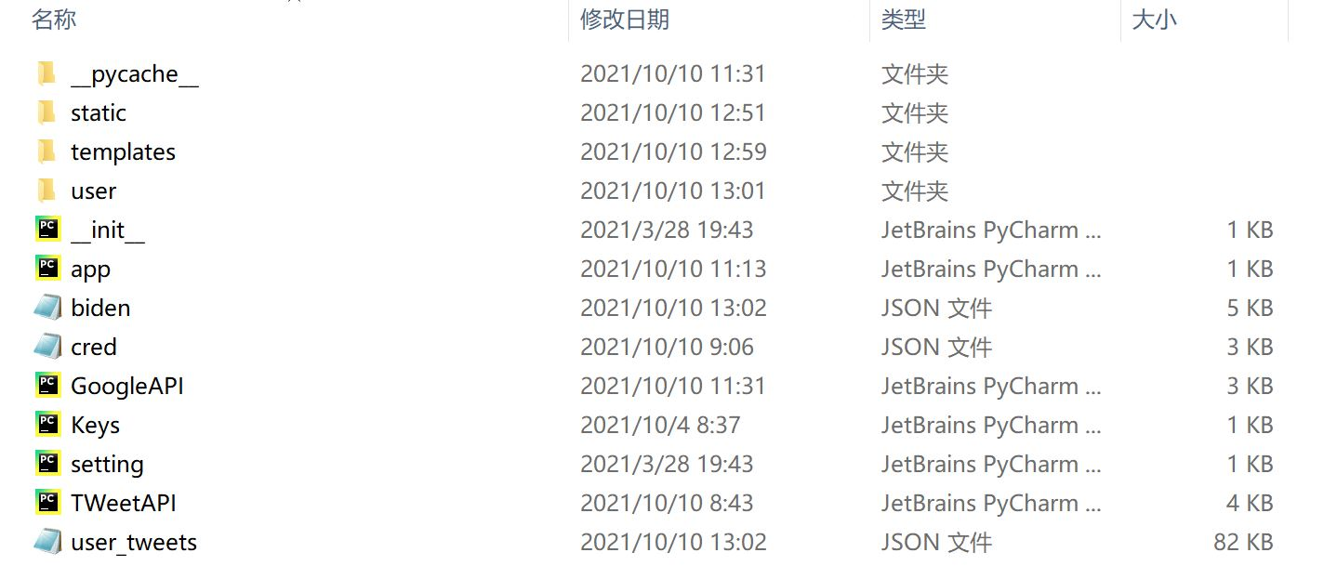

app.py is where everything starts, run that file can start our project.

user_tweets stores the tweet I fetch from a user.

biden.json is where I store the sentiment analyze of user’s tweets

cred.json is the credential for Google Cloud.

Google API.py is the result of phase 2.

Keys.py is the crentential for tweepy.

TWeetAPI.py is the result of phase 1.

Folder templates: where I stores my html page

Folder user: where I store view.py, the main program that controls

operations on html page.

**2 open and run app.py**

**3 copy the link http://127.0.0.1:8083/**

Display of my website:

This is the homepage of my site

We enter the username in row1 and the number of tweets we want to fetch on row2.

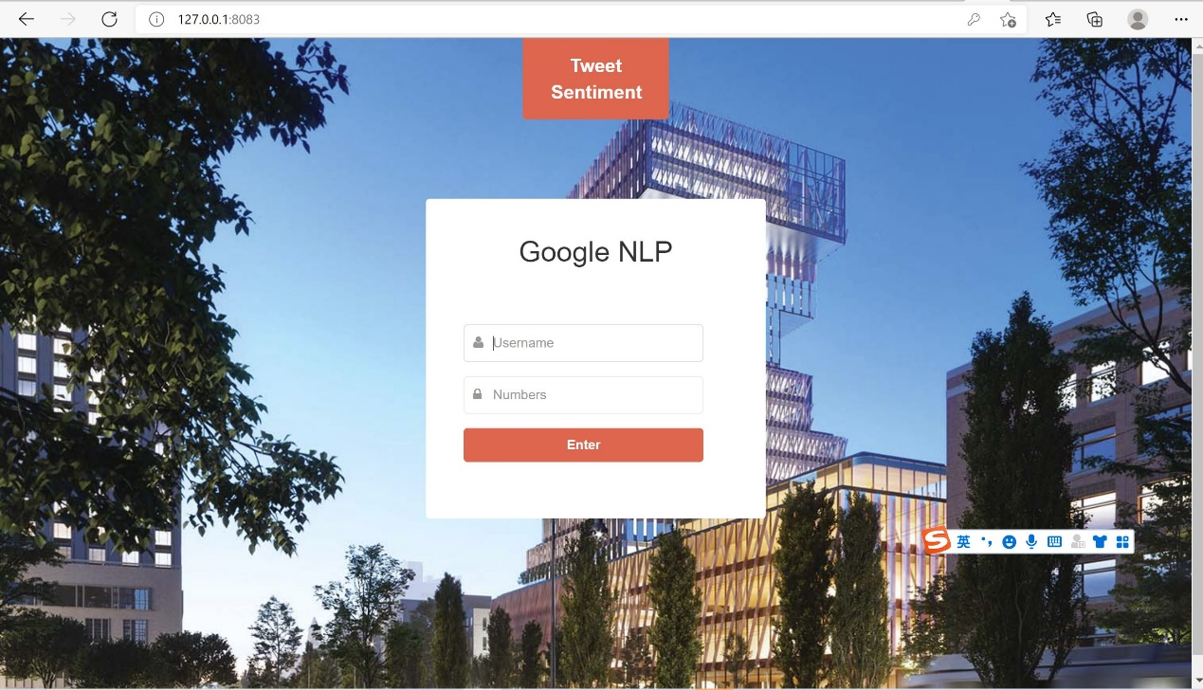

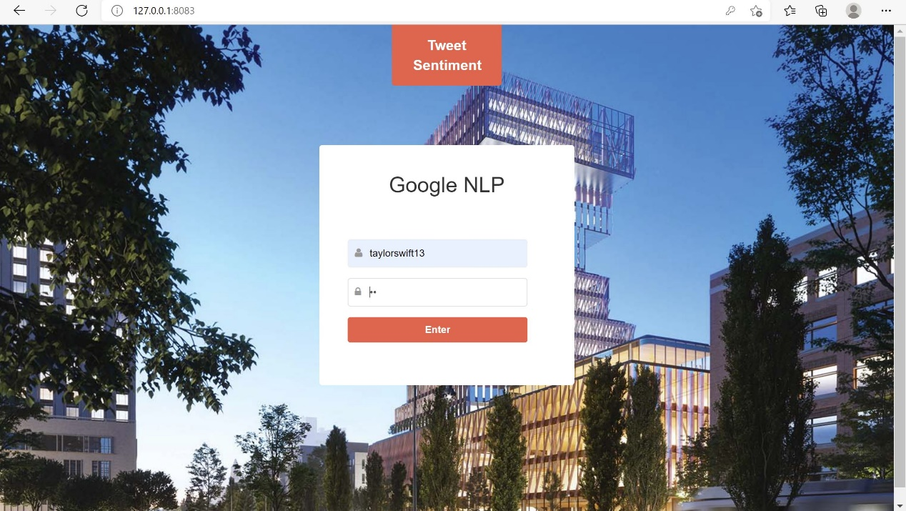

By click enter we will be redirect to a page where we can see all the

results and the sentiment of them.

Also the button on the bottom allows us to return to homepage.

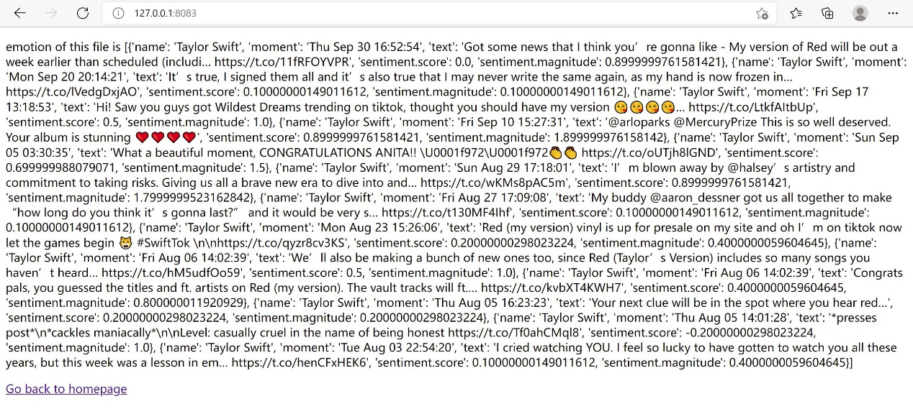

**References:**

[Natural Language client libraries  |  Cloud Natural Language API (google.com)](https://cloud.google.com/natural-language/docs/reference/libraries#cloud-console)