2025-2026-2.17学生选课
学生与课程之间为多对多的关系，一名学生可以选择多门课程，一门课程可以被多名学生选择。在关系型数据库设计规范下，应该要设计一张中间表来保存多对多的关系。

1.选课功能
在Trae对话框中发送命令：在学生应用下创建学生选课功能，在学生列表选择一个学生后，然后为他分配课程。
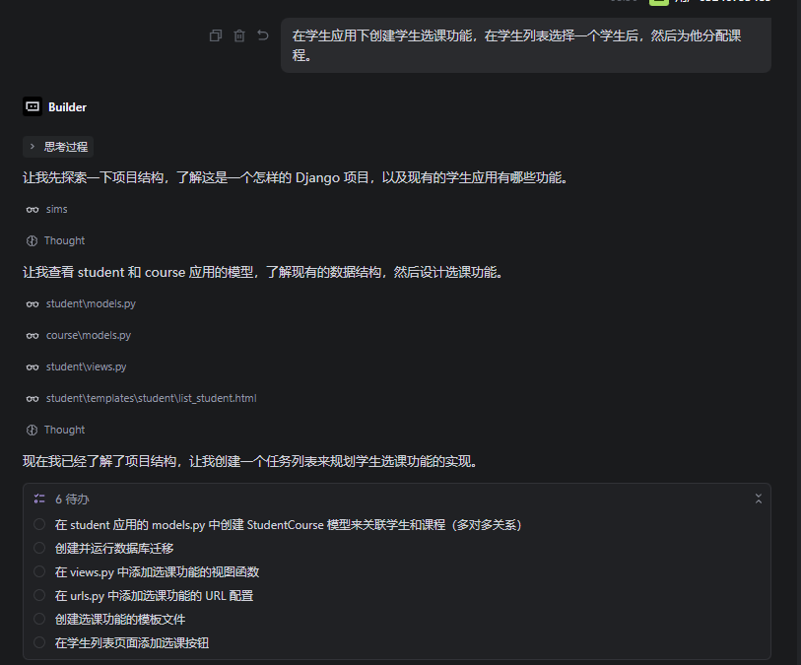
Trae会自动完成以上的步骤。具体如下：

（1）多对多模型
在学生的模型中增加了一列，表明与课程之间为多对多的关系。(第18行代码）
from django.db import models
class Student(models.Model):
student_id = models.CharField(max_length=20, unique=True, verbose_name='学号')
name = models.CharField(max_length=50, verbose_name='姓名')
birthday = models.DateField(verbose_name='生日')
GENDER_CHOICES = (
('male', '男'),
('female', '女'),
)
gender = models.CharField(max_length=10, choices=GENDER_CHOICES, verbose_name='性别')
phone = models.CharField(max_length=20, verbose_name='电话')
email = models.EmailField(verbose_name='邮箱')
address = models.CharField(max_length=200, verbose_name='家庭地址')
avatar = models.ImageField(upload_to='avatars/', verbose_name='头像', blank=True, null=True)
class_field = models.ForeignKey('classes.Class', on_delete=models.SET_NULL, verbose_name='班级', blank=True, null=True, related_name='students')
courses = models.ManyToManyField('course.Course', verbose_name='所选课程', blank=True, related_name='students')
class Meta:
verbose_name = '学生'
verbose_name_plural = '学生'
def __str__(self):
return f'{self.student_id} - {self.name}'

（2）数据库迁移
多对多的关系需要创建一张中间表保存记录，涉及数据库表的创建，需要执行数据库迁移命令。
Django数据库迁移分两步，一是生成迁移文件，二是执行迁移命令。
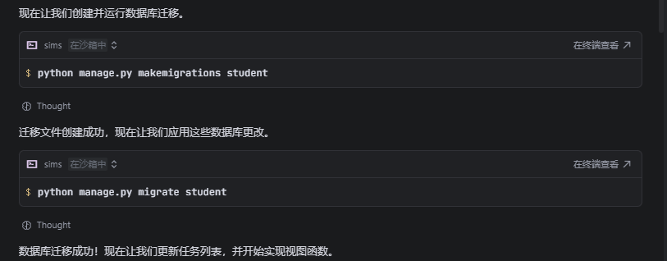

a.生成迁移文件
python manage.py makemigrations student

b.执行迁移
python manage.py migrate student

（3）视图函数
在学生视图文件中增加视频函数（def enroll_course(request, pk)）处理选课业务逻辑。
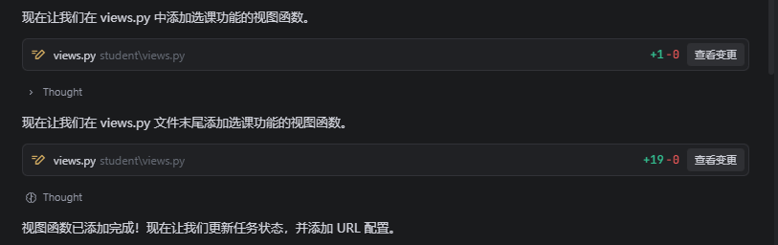
新增视频函数def enroll_course(request, pk)后，学生视图文件如下：
from django.shortcuts import render, redirect, get_object_or_404
from django.core.paginator import Paginator
from .forms import StudentForm
from .models import Student
from classes.models import Class
from course.models import Course
def list_student(request):
# 获取查询参数
student_id = request.GET.get('student_id', '')
name = request.GET.get('name', '')
phone = request.GET.get('phone', '')
gender = request.GET.get('gender', '')
class_field = request.GET.get('class_field', '')
# 构建查询
students = Student.objects.all()
# 按学号、姓名、电话进行模糊查询
if student_id:
students = students.filter(student_id__icontains=student_id)
if name:
students = students.filter(name__icontains=name)
if phone:
students = students.filter(phone__icontains=phone)
# 按性别进行精确查询
if gender:
students = students.filter(gender=gender)
# 按班级进行精确查询
if class_field:
students = students.filter(class_field_id=class_field)
paginator = Paginator(students, 3)
page_number = request.GET.get('page')
page_obj = paginator.get_page(page_number)
# 获取所有班级用于下拉选择
classes = Class.objects.all()
# 传递查询参数给模板
context = {
'page_obj': page_obj,
'student_id': student_id,
'name': name,
'phone': phone,
'gender': gender,
'class_field': class_field,
'classes': classes
}
return render(request, 'student/list_student.html', context)
def add_student(request):
if request.method == 'POST':
form = StudentForm(request.POST, request.FILES)
if form.is_valid():
form.save()
return redirect('student:add_student')
else:
form = StudentForm()
return render(request, 'student/add_student.html', {'form': form})
def edit_student(request, pk):
student = get_object_or_404(Student, pk=pk)
if request.method == 'POST':
form = StudentForm(request.POST, request.FILES, instance=student)
if form.is_valid():
form.save()
return redirect('student:list_student')
else:
form = StudentForm(instance=student)
return render(request, 'student/edit_student.html', {'form': form})
def delete_student(request, pk):
student = get_object_or_404(Student, pk=pk)
if request.method == 'POST':
student.delete()
return redirect('student:list_student')
return render(request, 'student/delete_student.html', {'student': student})
def home(request):
return render(request, 'home.html')
def enroll_course(request, pk):
student = get_object_or_404(Student, pk=pk)
all_courses = Course.objects.all()
enrolled_courses = student.courses.all()
if request.method == 'POST':
course_ids = request.POST.getlist('courses')
student.courses.set(course_ids)
student.save()
return redirect('student:list_student')
context = {
'student': student,
'all_courses': all_courses,
'enrolled_courses': enrolled_courses
}
return render(request, 'student/enroll_course.html', context)

（4）配置路由
将选课的视图函数配置到路由文件中。
from django.urls import path
from . import views
app_name = 'student'
urlpatterns = [
path('list/', views.list_student, name='list_student'),
path('add/', views.add_student, name='add_student'),
path('edit/<int:pk>/', views.edit_student, name='edit_student'),
path('delete/<int:pk>/', views.delete_student, name='delete_student'),
path('enroll/<int:pk>/', views.enroll_course, name='enroll_course'),
]

（5）模板文件
为选课功能生成模板文件enroll_course.html。
<!DOCTYPE html>
<html lang="zh-CN">
<head>
<meta charset="UTF-8">
<meta name="viewport" content="width=device-width, initial-scale=1.0">
<title>学生选课</title>
<link href="https://fastly.jsdelivr.net/npm/bootstrap@5.3.0/dist/css/bootstrap.min.css" rel="stylesheet">
</head>
<body>
<div class="container mt-5">
<h1 class="text-center mb-4">为学生选课</h1>
<div class="card mb-4">
<div class="card-header">
<h5 class="mb-0">学生信息</h5>
</div>
<div class="card-body">
<p><strong>学号：</strong>{{ student.student_id }}</p>
<p><strong>姓名：</strong>{{ student.name }}</p>
<p><strong>班级：</strong>{{ student.class_field.name|default:"未分配" }}</p>
</div>
</div>
<div class="row justify-content-center">
<div class="col-md-8">
<form method="post" class="border p-4 rounded bg-light">
{% csrf_token %}
<div class="mb-3">
<label class="form-label"><strong>选择课程</strong></label>
<div class="row">
{% for course in all_courses %}
<div class="col-md-6">
<div class="form-check">
<input class="form-check-input" type="checkbox" name="courses" value="{{ course.pk }}" id="course_{{ course.pk }}" {% if course in enrolled_courses %}checked{% endif %}>
<label class="form-check-label" for="course_{{ course.pk }}">
{{ course.name }} - {{ course.credits }}学分
</label>
</div>
</div>
{% empty %}
<div class="col-12">
<p class="text-muted">暂无课程可供选择</p>
</div>
{% endfor %}
</div>
</div>
<div class="d-flex gap-2">
<button type="submit" class="btn btn-primary">保存选课</button>
<a href="{% url 'student:list_student' %}" class="btn btn-secondary">返回学生列表</a>
</div>
</form>
</div>
</div>
</div>
<script src="https://fastly.jsdelivr.net/npm/bootstrap@5.3.0/dist/js/bootstrap.bundle.min.js"></script>
</body>
</html>

（6）选课功能按钮
在学生列表中添加选课按钮。
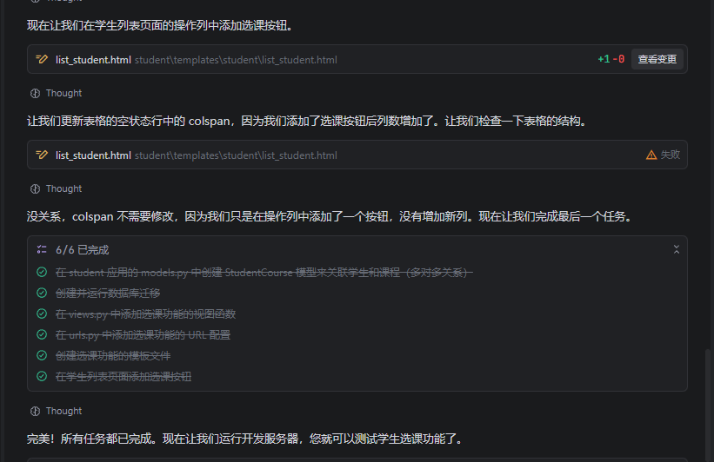
对应要修改学生列表的代码，在列表增加按钮，并传递参数。添加选课按钮后，学生列表页面代码如下：
<!DOCTYPE html>
<html lang="zh-CN">
<head>
<meta charset="UTF-8">
<meta name="viewport" content="width=device-width, initial-scale=1.0">
<title>学生列表</title>
<link href="https://fastly.jsdelivr.net/npm/bootstrap@5.3.0/dist/css/bootstrap.min.css" rel="stylesheet">
</head>
<body>
<div class="container mt-5">
<h1 class="text-center mb-4">学生列表</h1>
<!-- 查询表单 -->
<form method="get" class="mb-4">
<div class="row g-3">
<div class="col-md-3">
<label for="student_id" class="form-label">学号</label>
<input type="text" id="student_id" name="student_id" class="form-control" value="{{ student_id }}" placeholder="请输入学号">
</div>
<div class="col-md-3">
<label for="name" class="form-label">姓名</label>
<input type="text" id="name" name="name" class="form-control" value="{{ name }}" placeholder="请输入姓名">
</div>
<div class="col-md-3">
<label for="phone" class="form-label">电话</label>
<input type="text" id="phone" name="phone" class="form-control" value="{{ phone }}" placeholder="请输入电话">
</div>
<div class="col-md-3">
<label for="gender" class="form-label">性别</label>
<select id="gender" name="gender" class="form-select">
<option value="" {% if gender == '' %}selected{% endif %}>全部</option>
<option value="male" {% if gender == 'male' %}selected{% endif %}>男</option>
<option value="female" {% if gender == 'female' %}selected{% endif %}>女</option>
</select>
</div>
<div class="col-md-3">
<label for="class_field" class="form-label">班级</label>
<select id="class_field" name="class_field" class="form-select">
<option value="" {% if class_field == '' %}selected{% endif %}>全部</option>
{% for cls in classes %}
<option value="{{ cls.pk }}" {% if class_field == cls.pk|stringformat:"i" %}selected{% endif %}>{{ cls.name }}</option>
{% endfor %}
</select>
</div>
</div>
<div class="mt-3">
<button type="submit" class="btn btn-primary">查询</button>
<a href="{% url 'student:list_student' %}" class="btn btn-secondary">重置</a>
<a href="{% url 'student:add_student' %}" class="btn btn-success">添加学生</a>
</div>
</form>
<div class="table-responsive">
<table class="table table-striped table-hover table-bordered">
<thead class="table-dark">
<tr>
<th>学号</th>
<th>头像</th>
<th>姓名</th>
<th>生日</th>
<th>性别</th>
<th>班级</th>
<th>电话</th>
<th>邮箱</th>
<th>家庭地址</th>
<th>操作</th>
</tr>
</thead>
<tbody>
{% for student in page_obj %}
<tr>
<td>{{ student.student_id }}</td>
<td>
{% if student.avatar %}
<img src="{{ MEDIA_URL }}{{ student.avatar.url }}" alt="头像" class="img-thumbnail" style="width: 50px; height: 50px;">
{% else %}
<span class="text-muted">无</span>
{% endif %}
</td>
<td>{{ student.name }}</td>
<td>{{ student.birthday }}</td>
<td>{{ student.get_gender_display }}</td>
<td>{{ student.class_field.name|default:"未分配" }}</td>
<td>{{ student.phone }}</td>
<td>{{ student.email }}</td>
<td>{{ student.address }}</td>
<td>
<a href="{% url 'student:enroll_course' student.pk %}" class="btn btn-sm btn-info">选课</a>
<a href="{% url 'student:edit_student' student.pk %}" class="btn btn-sm btn-warning">编辑</a>
<a href="{% url 'student:delete_student' student.pk %}" class="btn btn-sm btn-danger">删除</a>
</td>
</tr>
{% empty %}
<tr>
<td colspan="10" class="text-center">暂无学生记录</td>
</tr>
{% endfor %}
</tbody>
</table>
</div>
{% if page_obj.has_other_pages %}
<nav aria-label="Page navigation">
<ul class="pagination justify-content-center">
{% if page_obj.has_previous %}
<li class="page-item">
<a class="page-link" href="?page={{ page_obj.previous_page_number }}{% if student_id %}&student_id={{ student_id }}{% endif %}{% if name %}&name={{ name }}{% endif %}{% if phone %}&phone={{ phone }}{% endif %}{% if gender %}&gender={{ gender }}{% endif %}{% if class_field %}&class_field={{ class_field }}{% endif %}">上一页</a>
</li>
{% else %}
<li class="page-item disabled">
<span class="page-link">上一页</span>
</li>
{% endif %}
{% for num in page_obj.paginator.page_range %}
{% if page_obj.number == num %}
<li class="page-item active">
<span class="page-link">{{ num }}</span>
</li>
{% else %}
<li class="page-item">
<a class="page-link" href="?page={{ num }}{% if student_id %}&student_id={{ student_id }}{% endif %}{% if name %}&name={{ name }}{% endif %}{% if phone %}&phone={{ phone }}{% endif %}{% if gender %}&gender={{ gender }}{% endif %}{% if class_field %}&class_field={{ class_field }}{% endif %}">{{ num }}</a>
</li>
{% endif %}
{% endfor %}
{% if page_obj.has_next %}
<li class="page-item">
<a class="page-link" href="?page={{ page_obj.next_page_number }}{% if student_id %}&student_id={{ student_id }}{% endif %}{% if name %}&name={{ name }}{% endif %}{% if phone %}&phone={{ phone }}{% endif %}{% if gender %}&gender={{ gender }}{% endif %}{% if class_field %}&class_field={{ class_field }}{% endif %}">下一页</a>
</li>
{% else %}
<li class="page-item disabled">
<span class="page-link">下一页</span>
</li>
{% endif %}
<li class="page-item disabled">
<span class="page-link">第 {{ page_obj.number }} / {{ page_obj.paginator.num_pages }} 页</span>
</li>
</ul>
</nav>
{% endif %}
</div>
<script src="https://fastly.jsdelivr.net/npm/bootstrap@5.3.0/dist/js/bootstrap.bundle.min.js"></script>
</body>
</html>

2.功能测试
进入学生列表界面。
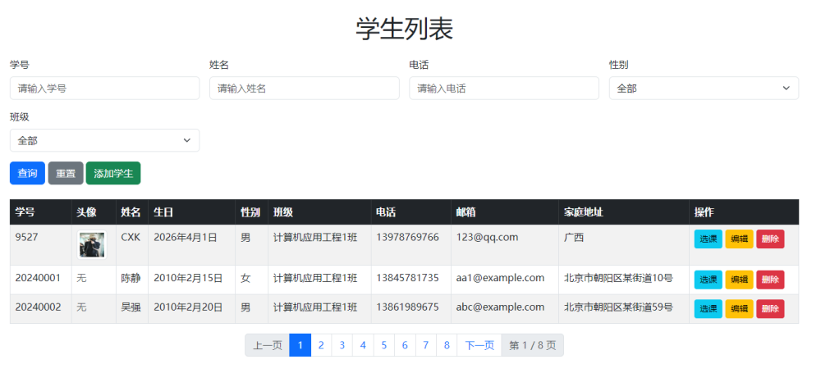
测试选课功能。
