2025-2026-2.15创建课程应用

1.创建课程应用
为项目增加课程管理功能，从模块化开发的角度出发点，应该把课程管理定位为一个应用。在Trae工具发送命令：创建课程应用，应用名称为course.
或者手动创建课程应用，在项目的目录下执行命令：
python manage.py startapp course
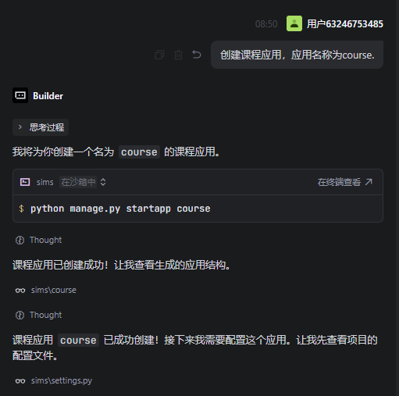
工具会自动执行以下步骤
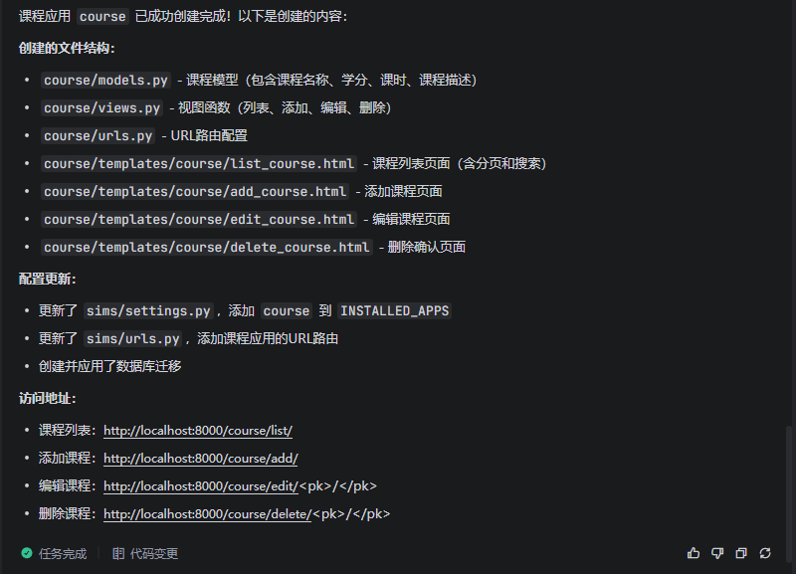
具体的每一个步骤为：

(1)修改settings.py文件
将 course 应用添加到 settings.py文件的INSTALLED_APPS 中。
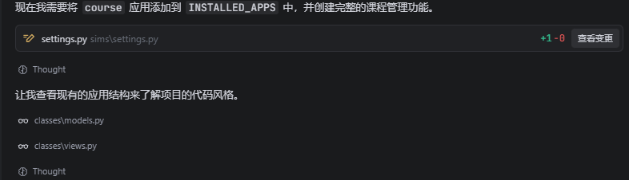
INSTALLED_APPS = [
'django.contrib.admin', # Django后台管理系统
'django.contrib.auth', # 认证系统
'django.contrib.contenttypes', # 内容类型框架
'django.contrib.sessions', # 会话管理
'django.contrib.messages', # 消息系统
'django.contrib.staticfiles', # 静态文件管理
'student', # 自定义学生应用
'classes', # 班级应用
'course', # 课程应用
]

(2)创建课程模型
创建课程的模型models.py，后续再会将模型转换成数据库表。

from django.db import models
class Course(models.Model):
name = models.CharField(max_length=100, verbose_name='课程名称')
credits = models.IntegerField(verbose_name='学分')
hours = models.IntegerField(verbose_name='课时')
description = models.TextField(blank=True, null=True, verbose_name='课程描述')
class Meta:
db_table = 'courses'
verbose_name = '课程'
verbose_name_plural = '课程'
def __str__(self):
return self.name

(3)创建课程应用的视图文件
在课程应用下创建视图文件views.py，里面是视图函数，负责处理业务逻辑，如增加、修改、删除等。

from django.shortcuts import render, redirect, get_object_or_404
from django.core.paginator import Paginator
from .models import Course
def list_course(request):
name = request.GET.get('name', '')
courses = Course.objects.all()
if name:
courses = courses.filter(name__icontains=name)
paginator = Paginator(courses, 3)
page_number = request.GET.get('page')
page_obj = paginator.get_page(page_number)
context = {
'page_obj': page_obj,
'name': name
}
return render(request, 'course/list_course.html', context)
def add_course(request):
if request.method == 'POST':
name = request.POST.get('name')
credits = request.POST.get('credits')
hours = request.POST.get('hours')
description = request.POST.get('description')
Course.objects.create(name=name, credits=credits, hours=hours, description=description)
return redirect('course:list_course')
return render(request, 'course/add_course.html')
def edit_course(request, pk):
course_obj = get_object_or_404(Course, pk=pk)
if request.method == 'POST':
course_obj.name = request.POST.get('name')
course_obj.credits = request.POST.get('credits')
course_obj.hours = request.POST.get('hours')
course_obj.description = request.POST.get('description')
course_obj.save()
return redirect('course:list_course')
return render(request, 'course/edit_course.html', {'course': course_obj, 'pk': pk})
def delete_course(request, pk):
course_obj = get_object_or_404(Course, pk=pk)
if request.method == 'POST':
course_obj.delete()
return redirect('course:list_course')
return render(request, 'course/delete_course.html', {'course': course_obj, 'pk': pk})

(4)创建课程应用的URL配置文件

这一步需要完成两个操作，一个是应用本身的路由文件（course/urls.py），另一个是将应用的路由文件添加到项目的路由文件（sims/urls.py）中。

a.应用本身的路由文件
from django.urls import path
from . import views
app_name = 'course'
urlpatterns = [
path('list/', views.list_course, name='list_course'),
path('add/', views.add_course, name='add_course'),
path('edit/<int:pk>/', views.edit_course, name='edit_course'),
path('delete/<int:pk>/', views.delete_course, name='delete_course'),
]

b.项目的路由文件
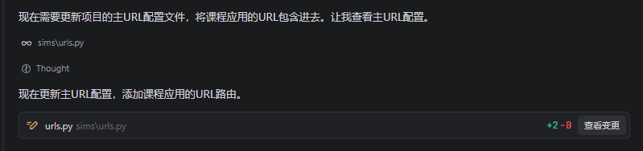
将应用的路由文件添加到项目的路由文件（sims/urls.py）中。
"""
URL configuration for sims project.
The `urlpatterns` list routes URLs to views. For more information please see:
https://docs.djangoproject.com/en/5.2/topics/http/urls/
Examples:
Function views
1. Add an import: from my_app import views
2. Add a URL to urlpatterns: path('', views.home, name='home')
Class-based views
1. Add an import: from other_app.views import Home
2. Add a URL to urlpatterns: path('', Home.as_view(), name='home')
Including another URLconf
1. Import the include() function: from django.urls import include, path
2. Add a URL to urlpatterns: path('blog/', include('blog.urls'))
"""
# 导入必要的模块
from django.contrib import admin
from django.urls import path, include
from django.conf import settings
from django.conf.urls.static import static
from student import views
# URL 路由配置列表
urlpatterns = [
# 管理后台 URL
path('admin/', admin.site.urls),
# 默认首页 - 显示学生列表
path('', views.list_student, name='home'),
# 学生应用的 URL 路由
path('student/', include('student.urls')),
# 班级应用的 URL 路由
path('classes/', include('classes.urls')),
# 课程应用的 URL 路由
path('course/', include('course.urls')),
] + static(settings.MEDIA_URL, document_root=settings.MEDIA_ROOT) # 静态媒体文件 URL 配置

(5)创建模板文件
工具会在应用下的templates文件夹下创建增加、修改、删除、列表的模板文件。
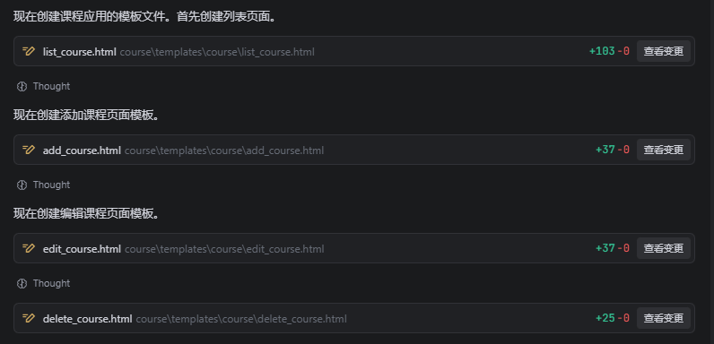

a.添加页面add_course.html
<!DOCTYPE html>
<html lang="zh-CN">
<head>
<meta charset="UTF-8">
<meta name="viewport" content="width=device-width, initial-scale=1.0">
<title>添加课程</title>
<link href="https://fastly.jsdelivr.net/npm/bootstrap@5.3.0/dist/css/bootstrap.min.css" rel="stylesheet">
</head>
<body>
<div class="container mt-5">
<h1 class="text-center mb-4">添加课程</h1>
<form method="post">
{% csrf_token %}
<div class="mb-3">
<label for="name" class="form-label">课程名称</label>
<input type="text" class="form-control" id="name" name="name" required>
</div>
<div class="mb-3">
<label for="credits" class="form-label">学分</label>
<input type="number" class="form-control" id="credits" name="credits" required>
</div>
<div class="mb-3">
<label for="hours" class="form-label">课时</label>
<input type="number" class="form-control" id="hours" name="hours" required>
</div>
<div class="mb-3">
<label for="description" class="form-label">课程描述</label>
<textarea class="form-control" id="description" name="description" rows="3"></textarea>
</div>
<button type="submit" class="btn btn-success">添加</button>
<a href="{% url 'course:list_course' %}" class="btn btn-secondary">返回</a>
</form>
</div>
<script src="https://fastly.jsdelivr.net/npm/bootstrap@5.3.0/dist/js/bootstrap.bundle.min.js"></script>
</body>
</html>

b.删除页面delete_course.html
<!DOCTYPE html>
<html lang="zh-CN">
<head>
<meta charset="UTF-8">
<meta name="viewport" content="width=device-width, initial-scale=1.0">
<title>删除课程</title>
<link href="https://fastly.jsdelivr.net/npm/bootstrap@5.3.0/dist/css/bootstrap.min.css" rel="stylesheet">
</head>
<body>
<div class="container mt-5">
<h1 class="text-center mb-4">删除课程</h1>
<div class="alert alert-danger" role="alert">
<p>确定要删除课程 "<strong>{{ course.name }}</strong>" 吗？</p>
<p class="small">此操作不可撤销！</p>
</div>
<form method="post">
{% csrf_token %}
<button type="submit" class="btn btn-danger">确认删除</button>
<a href="{% url 'course:list_course' %}" class="btn btn-secondary">取消</a>
</form>
</div>
<script src="https://fastly.jsdelivr.net/npm/bootstrap@5.3.0/dist/js/bootstrap.bundle.min.js"></script>
</body>
</html>

c.编辑页面edit_course.html
<!DOCTYPE html>
<html lang="zh-CN">
<head>
<meta charset="UTF-8">
<meta name="viewport" content="width=device-width, initial-scale=1.0">
<title>编辑课程</title>
<link href="https://fastly.jsdelivr.net/npm/bootstrap@5.3.0/dist/css/bootstrap.min.css" rel="stylesheet">
</head>
<body>
<div class="container mt-5">
<h1 class="text-center mb-4">编辑课程</h1>
<form method="post">
{% csrf_token %}
<div class="mb-3">
<label for="name" class="form-label">课程名称</label>
<input type="text" class="form-control" id="name" name="name" value="{{ course.name }}" required>
</div>
<div class="mb-3">
<label for="credits" class="form-label">学分</label>
<input type="number" class="form-control" id="credits" name="credits" value="{{ course.credits }}" required>
</div>
<div class="mb-3">
<label for="hours" class="form-label">课时</label>
<input type="number" class="form-control" id="hours" name="hours" value="{{ course.hours }}" required>
</div>
<div class="mb-3">
<label for="description" class="form-label">课程描述</label>
<textarea class="form-control" id="description" name="description" rows="3">{{ course.description }}</textarea>
</div>
<button type="submit" class="btn btn-success">保存</button>
<a href="{% url 'course:list_course' %}" class="btn btn-secondary">返回</a>
</form>
</div>
<script src="https://fastly.jsdelivr.net/npm/bootstrap@5.3.0/dist/js/bootstrap.bundle.min.js"></script>
</body>
</html>

d.列表页面list_course.html（含分页功能）
<!DOCTYPE html>
<html lang="zh-CN">
<head>
<meta charset="UTF-8">
<meta name="viewport" content="width=device-width, initial-scale=1.0">
<title>课程列表</title>
<link href="https://fastly.jsdelivr.net/npm/bootstrap@5.3.0/dist/css/bootstrap.min.css" rel="stylesheet">
</head>
<body>
<div class="container mt-5">
<h1 class="text-center mb-4">课程列表</h1>
<form method="get" class="mb-4">
<div class="row g-3">
<div class="col-md-6">
<label for="name" class="form-label">课程名称</label>
<input type="text" id="name" name="name" class="form-control" value="{{ name }}" placeholder="请输入课程名称">
</div>
</div>
<div class="mt-3">
<button type="submit" class="btn btn-primary">查询</button>
<a href="{% url 'course:list_course' %}" class="btn btn-secondary">重置</a>
<a href="{% url 'course:add_course' %}" class="btn btn-success">添加课程</a>
</div>
</form>
<div class="table-responsive">
<table class="table table-striped table-hover table-bordered">
<thead class="table-dark">
<tr>
<th>ID</th>
<th>课程名称</th>
<th>学分</th>
<th>课时</th>
<th>课程描述</th>
<th>操作</th>
</tr>
</thead>
<tbody>
{% for course in page_obj %}
<tr>
<td>{{ course.id }}</td>
<td>{{ course.name }}</td>
<td>{{ course.credits }}</td>
<td>{{ course.hours }}</td>
<td>{{ course.description|truncatechars:50 }}</td>
<td>
<a href="{% url 'course:edit_course' course.pk %}" class="btn btn-sm btn-warning">编辑</a>
<a href="{% url 'course:delete_course' course.pk %}" class="btn btn-sm btn-danger">删除</a>
</td>
</tr>
{% empty %}
<tr>
<td colspan="6" class="text-center">暂无课程记录</td>
</tr>
{% endfor %}
</tbody>
</table>
</div>
{% if page_obj.has_other_pages %}
<nav aria-label="Page navigation">
<ul class="pagination justify-content-center">
{% if page_obj.has_previous %}
<li class="page-item">
<a class="page-link" href="?page={{ page_obj.previous_page_number }}{% if name %}&name={{ name }}{% endif %}">上一页</a>
</li>
{% else %}
<li class="page-item disabled">
<span class="page-link">上一页</span>
</li>
{% endif %}
{% for num in page_obj.paginator.page_range %}
{% if page_obj.number == num %}
<li class="page-item active">
<span class="page-link">{{ num }}</span>
</li>
{% else %}
<li class="page-item">
<a class="page-link" href="?page={{ num }}{% if name %}&name={{ name }}{% endif %}"{{ num }}</a>
</li>
{% endif %}
{% endfor %}
{% if page_obj.has_next %}
<li class="page-item">
<a class="page-link" href="?page={{ page_obj.next_page_number }}{% if name %}&name={{ name }}{% endif %}">下一页</a>
</li>
{% else %}
<li class="page-item disabled">
<span class="page-link">下一页</span>
</li>
{% endif %}
<li class="page-item disabled">
<span class="page-link">第 {{ page_obj.number }} / {{ page_obj.paginator.num_pages }} 页</span>
</li>
</ul>
</nav>
{% endif %}
</div>
<script src="https://fastly.jsdelivr.net/npm/bootstrap@5.3.0/dist/js/bootstrap.bundle.min.js"></script>
</body>
</html>

(6)数据库迁移
每次有模型的改动都要进行数据库迁移，否则修改的模型不会变更到数据库表中。
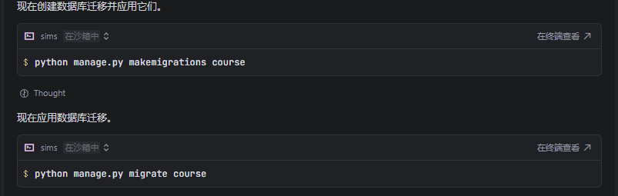

2.测试功能
参考班级应用的代码代码部分。

