**HW8**

Tianyang Chen

N1307278

[tc2820@nyu.edu](mailto:tc2820@nyu.edu)

**Lab 4: ICMP Pinger Lab**

**Code:**

from socket import *

import os

import sys

import struct

import time

import select

import binascii

ICMP_ECHO_REQUEST = 8

def checksum(string):

csum = 0

countTo = (len(string) // 2) * 2

count = 0

while count < countTo:

thisVal = ord(string[count + 1]) * 256 + ord(string[count])

csum = csum + thisVal

csum = csum & 0xffffffff

count = count + 2

if countTo < len(string):

csum = csum + ord(string[len(string) - 1])

csum = csum & 0xffffffff

csum = (csum >> 16) + (csum & 0xffff)

csum = csum + (csum >> 16)

answer = ~csum

answer = answer & 0xffff

answer = answer >> 8 | (answer << 8 & 0xff00)

return answer

def receiveOnePing(mySocket, ID, timeout, destAddr):

timeLeft = timeout

while 1:

startedSelect = time.time()

whatReady = select.select([mySocket], [], [], timeLeft)

howLongInSelect = (time.time() - startedSelect)

if whatReady[0] == []: # Timeout

return "Request timed out."

timeReceived = time.time()

recPacket, addr = mySocket.recvfrom(1024)

icmpHeader = recPacket[20:28]

icmpType, code, mychecksum, packetID, sequence = struct.unpack("bbHHh", icmpHeader)

if type != 8 and packetID == ID:

bytesInDouble = struct.calcsize("d")

timeSent = struct.unpack("d", recPacket[28:28 + bytesInDouble])[0]

return timeReceived - timeSent

timeLeft = timeLeft - howLongInSelect

if timeLeft <= 0:

return "Request timed out."

def sendOnePing(mySocket, destAddr, ID):

# Header is type (8), code (8), checksum (16), id (16), sequence (16)

myChecksum = 0

# Make a dummy header with a 0 checksum

# struct -- Interpret strings as packed binary data

header = struct.pack("bbHHh", ICMP_ECHO_REQUEST, 0, myChecksum, ID, 1)

data = struct.pack("d", time.time())

# Calculate the checksum on the data and the dummy header.

myChecksum = checksum(str(header + data))

# Get the right checksum, and put in the header

if sys.platform == 'darwin':

# Convert 16-bit integers from host to network byte order

myChecksum = htons(myChecksum) & 0xffff

else:

myChecksum = htons(myChecksum)

header = struct.pack("bbHHh", ICMP_ECHO_REQUEST, 0, myChecksum, ID, 1)

packet = header + data

mySocket.sendto(packet, (destAddr, 1)) # AF_INET address must be tuple, not str

# Both LISTS and TUPLES consist of a number of objects

# which can be referenced by their position number within the object.

def doOnePing(destAddr, timeout):

icmp = getprotobyname("icmp")

# SOCK_RAW is a powerful socket type. For more details: http://sockraw.org/papers/sock_raw

mySocket = socket(AF_INET, SOCK_RAW, icmp)

myID = os.getpid() & 0xFFFF # Return the current process i

sendOnePing(mySocket, destAddr, myID)

delay = receiveOnePing(mySocket, myID, timeout, destAddr)

mySocket.close()

return delay

def ping(host, timeout=1):

# timeout=1 means: If one second goes by without a reply from the server,

# the client assumes that either the client's ping or the server's pong is lost

dest = gethostbyname(host)

print("Pinging " + dest + " using Python:")

print("")

# Send ping requests to a server separated by approximately one second

while 1:

delay = doOnePing(dest, timeout)

print(delay)

time.sleep(1) # one second

return delay

# ping("127.0.0.1")

# ping("www.google.com")

# ping("www.poly.edu")

# ping("www.baidu.com")

**Results:**

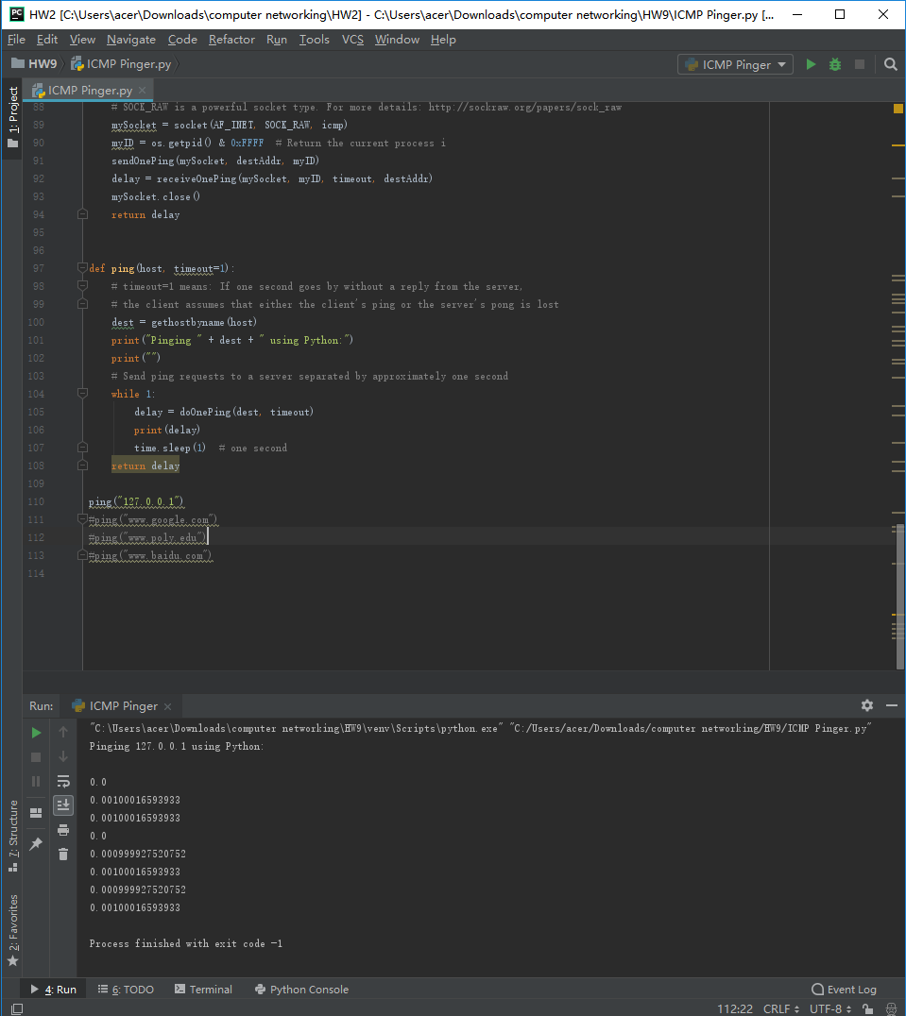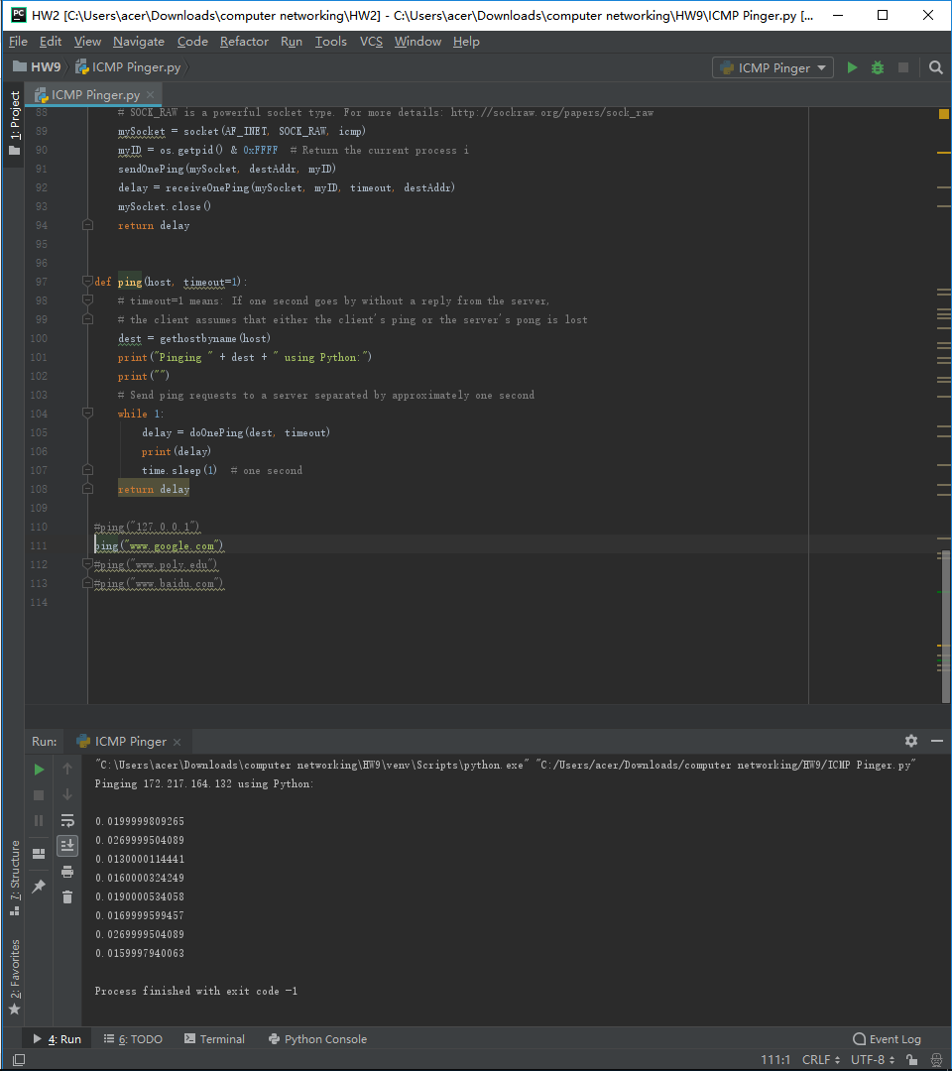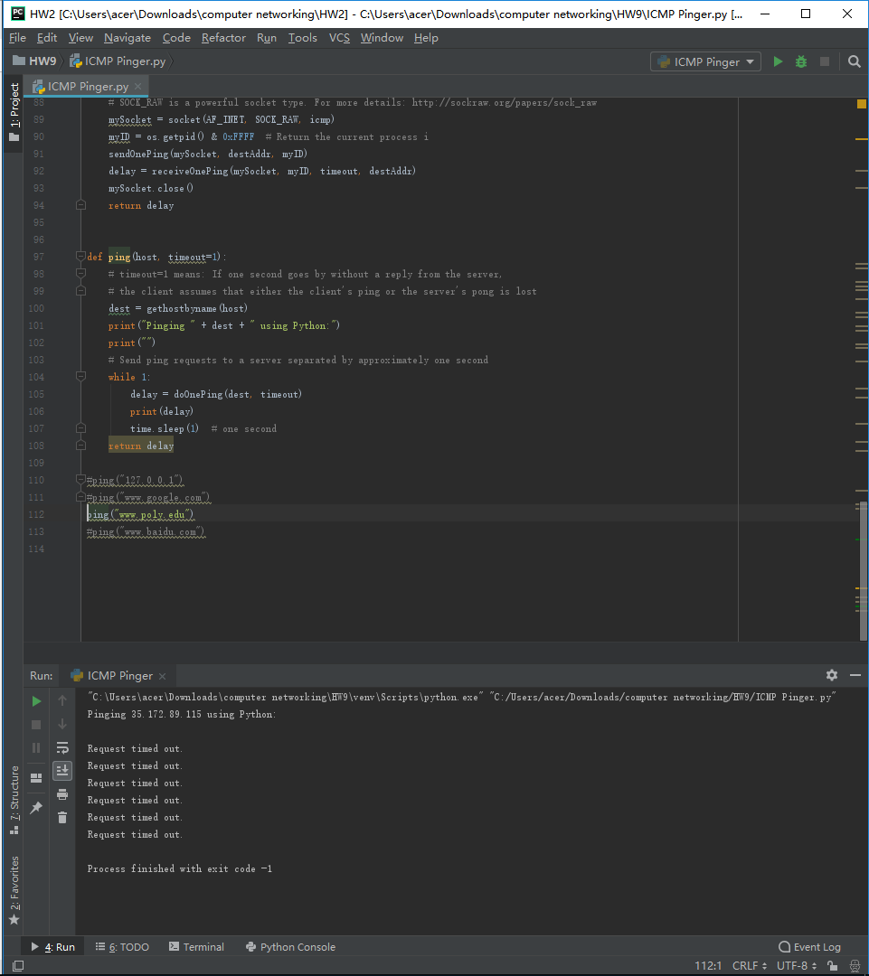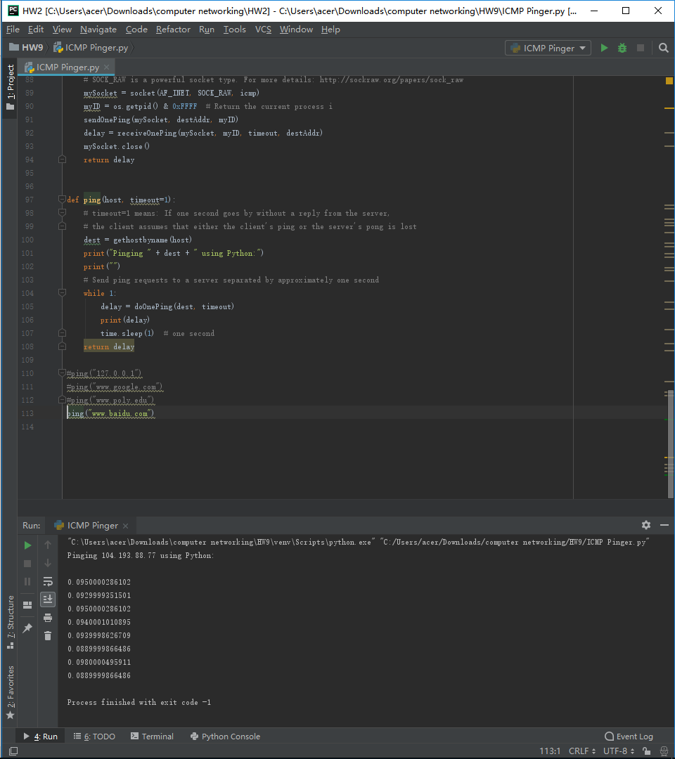

**ICMP Traceroute Lab**

**Code:**

from socket import *

import os

import sys

import struct

import time

import select

import binascii

ICMP_ECHO_REQUEST = 8

MAX_HOPS = 30

TIMEOUT = 2.0

TRIES = 2

# The packet that we shall send to each router along the path is the ICMP echo

# request packet, which is exactly what we had used in the ICMP ping exercise.

# We shall use the same packet that we built in the Ping exercise

def checksum(string):

# In this function we make the checksum of our packet

# hint: see icmpPing lab

csum = 0

countTo = (len(string) // 2) * 2

count = 0

while count < countTo:

thisVal = ord(string[count + 1]) * 256 + ord(string[count])

csum = csum + thisVal

csum = csum & 0xffffffff

count = count + 2

if countTo < len(string):

csum = csum + ord(string[len(string) - 1])

csum = csum & 0xffffffff

csum = (csum >> 16) + (csum & 0xffff)

csum = csum + (csum >> 16)

answer = ~csum

answer = answer & 0xffff

answer = answer >> 8 | (answer << 8 & 0xff00)

return answer

def build_packet():

# Header is type (8), code (8), checksum (16), id (16), sequence (16)

myChecksum = 0

myID = os.getpid() & 0xFFFF # Return the current process i

# Make a dummy header with a 0 checksum

# struct -- Interpret strings as packed binary data

header = struct.pack("bbHHh", ICMP_ECHO_REQUEST, 0, myChecksum, myID, 1)

data = struct.pack("d", time.time())

# Calculate the checksum on the data and the dummy header.

myChecksum = checksum(str(header + data))

# Get the right checksum, and put in the header

if sys.platform == 'darwin':

# Convert 16-bit integers from host to network byte order

myChecksum = htons(myChecksum) & 0xffff

else:

myChecksum = htons(myChecksum)

header = struct.pack("bbHHh", ICMP_ECHO_REQUEST, 0, myChecksum, myID, 1)

packet = header + data

return packet

def get_route(hostname):

timeLeft = TIMEOUT

for ttl in range(1, MAX_HOPS):

for tries in range(TRIES):

destAddr = gethostbyname(hostname)

# Fill in start

# Make a raw socket named mySocket

icmp = getprotobyname("icmp")

# SOCK_RAW is a powerful socket type. For more details: http://sockraw.org/papers/sock_raw

mySocket = socket(AF_INET, SOCK_RAW, icmp)

# Fill in end

mySocket.setsockopt(IPPROTO_IP, IP_TTL, struct.pack('I', ttl))

mySocket.settimeout(TIMEOUT)

try:

d = build_packet()

mySocket.sendto(d, (destAddr, 0))

t = time.time()

startedSelect = time.time()

whatReady = select.select([mySocket], [], [], timeLeft)

howLongInSelect = (time.time() - startedSelect)

if whatReady[0] == []: # Timeout

print(" * * * Request timed out.")

recvPacket, addr = mySocket.recvfrom(1024)

timeReceived = time.time()

timeLeft = timeLeft - howLongInSelect

if timeLeft <= 0:

print(" * * * Request timed out.")

except timeout:

continue

else:

# Fill in start

# Fetch the icmp type from the IP packet

icmpHeader = recvPacket[20:28]

types, code, mychecksum, packetID, sequence = struct.unpack("bbHHh", icmpHeader)

# Fill in end

if types == 11:

# bytes = struct.calcsize("d")

# timeSent = struct.unpack("d", recvPacket[28:28 + bytes])[0]

print(" %d rtt=%.0f ms %s" % (ttl, (timeReceived - t) * 1000, addr[0]))

elif types == 3:

# bytes = struct.calcsize("d")

# timeSent = struct.unpack("d", recvPacket[28:28 + bytes])[0]

print(" %d rtt=%.0f ms %s" % (ttl, (timeReceived - t) * 1000, addr[0]))

elif types == 0:

bytes = struct.calcsize("d")

timeSent = struct.unpack("d", recvPacket[28:28 + bytes])[0]

print(" %d rtt=%.0f ms %s" % (ttl, (timeReceived - timeSent) * 1000, addr[0]))

return

else:

print("error")

break

finally:

mySocket.close()

# get_route("127.0.0.1")

# get_route("www.google.com")

# get_route("www.poly.edu")

# get_route("www.baidu.com")

**Results:**

