Contents

Blog 1

Service landing page and Documentation landing page. 1

Service- 1

Documentation – 1

Navigation 2

CDN MVP talk missing under CDN category 3

概览 4

CDN概览 4

功能介绍 4

快速上手 5

入门教程 5

操作指南/功能使用 5

进阶学习 6

常见问题 6

资料中心 6

定价信息 6

# Blog

Blog has brief introduction of CDN and all new services/announcements.

## Service landing page and Documentation landing page.

### Service-

Use current page

navigation to documentation

### Documentation –

<http://www.windowsazure.cn/documentation/services/cdn/>

服务更新-

Should sync with what’s new, no pricing change

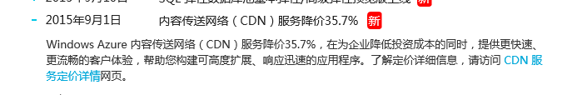

## Navigation

When you select one sub-category, it should still remain at the Documentation section and should be able to see the navigation panel.

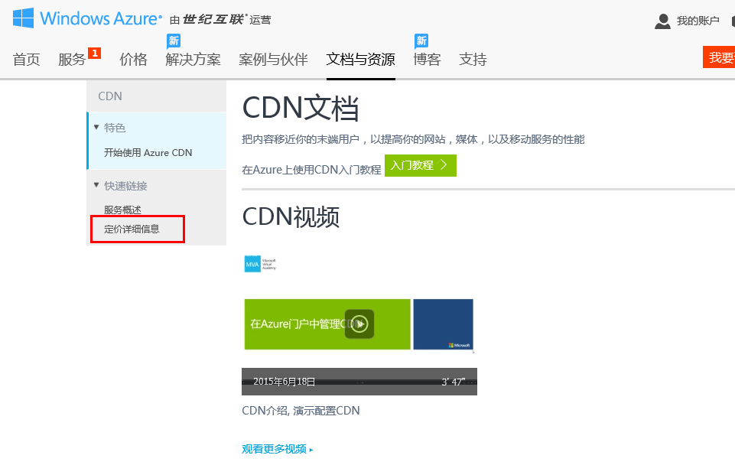

## CDN MVP talk missing under CDN category

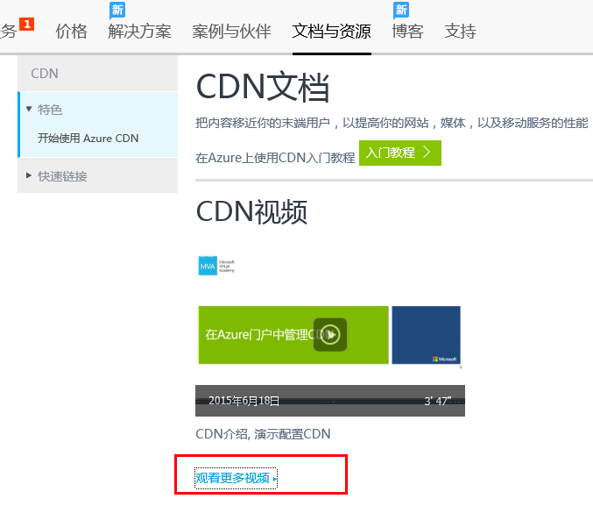

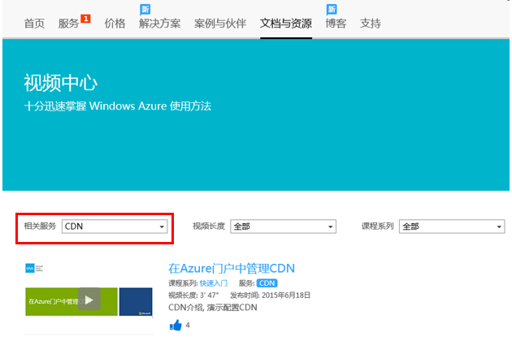

CDN MVP Talk is not under CDN category.

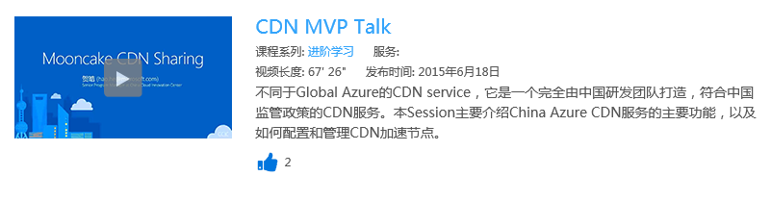

## 概览

### CDN概览

Use content under Azure management portal->CDN->overview

Windows Azure 内容传送网络 (CDN) 通过遍布在中国大陆的众多物理节点上缓存Azure平台上的Storage Blob，Cloud Service和WebSites的静态内容，为开发人员提供一个传送高带宽内容的解决方案。目前本CDN服务也同时支持没有部署在Azure平台上的源站。

### 功能介绍

Tecent:

<http://www.qcloud.com/product/cdn.html#advantage>

UCloud:

<https://www.ucloud.cn/site/product/ucdn.html>

Ali:

<http://www.aliyun.com/product/cdn/?spm=5176.383338.1906226.8.d1AHwf>

## 快速上手

### 入门教程

在Azure上使用CDN入门教程

<http://www.windowsazure.cn/documentation/articles/cdn-how-to-use/>

Use video under CDN documentation ->开始使用Azure CDN

<http://www.windowsazure.cn/documentation/services/cdn/>

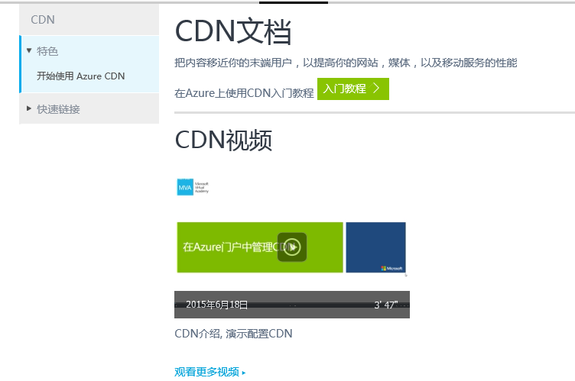

## 操作指南/功能使用

Common scenario- technical documentation

Use User-guidance on Azure management portal

<https://cdnportal.windowsazure.cn/>

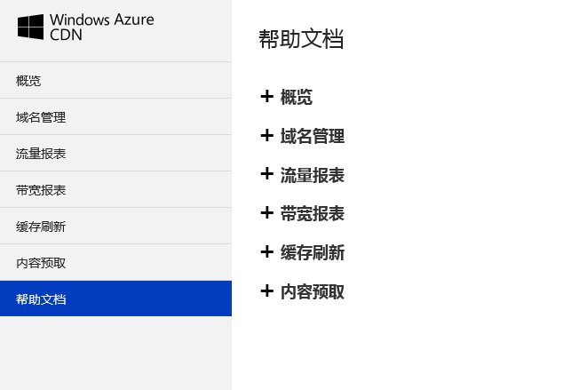

## 进阶学习

Typical CRIs

## 常见问题

FAQ

## 资料中心

### 定价信息

http://www.windowsazure.cn/home/features/caching#price