PulseAlloc

Personalised Adaptive Allocation and Sentiment-Enhanced Portfolio Strategy

Student ID: z5347273
Course: FINS3645
Submission Date: 14 August 2026

GitHub repo: https://github.com/TianyiZhang-yuan/z5347273_projectB

Streamlit app: https://z5347273projectb-eyhflcl9j8pzdkftdabgeq.streamlit.app/

Table of Contents
1. Portfolio Baseline
1.1 Fund Construction and Out-of-Sample Backtesting
1.2 Cross-Fund Baseline Performance
1.3 Baseline Sharpe Ratio Comparison
1.4 Combined Fund Growth of $1
1.5 Combined Portfolio Allocation Over Time
1.6 Baseline Drawdown and Downside Risk
1.7 Latest Target Holdings
1.8 Limitation
2. Portfolio Innovation: Personalised Adaptive Stock–Crypto Allocation
2.1 Risk Signal and Personalised Allocation Design
2.2 Fixed vs Adaptive Results
2.3 Personalisation Evidence
2.4 Robustness, Implementation Trade-offs and Conclusion
3. Sentiment Index and Baseline Fusion
3.1 Standalone Sector Sentiment Index
3.2 Basic Sentiment Fusion Baseline
4. Sentiment Innovation
4.1 Tail-Risk-Aware Final Strategy
4.2 Final Performance and Robustness
5. App and Investor Journey
6. Recommendations
6.1 Move from Profile-Based to Investor-Specific Personalisation
6.2 Distinguish Temporary Risk Shocks from Persistent Risk Deterioration
6.3 Add Forward-Looking Explainability
Appendix
Tables and Figures

1. Portfolio Baseline

1.1 Fund Construction and Out-of-Sample Backtesting
The baseline includes three investment universes: Equity, Crypto, and Combined Equity–Crypto. Four portfolio methods are applied to each universe: Equal Weight, Minimum Variance, Maximum Sharpe, and Minimum CVaR, producing 12 baseline funds. Equal Weight provides a simple benchmark, while the other methods focus on different risk–return objectives. The Combined funds are especially important because they provide the direct baseline for the later stock–Crypto allocation innovation.
All optimised funds are long-only, with weights summing to one and consistent portfolio constraints across comparable funds. Performance is evaluated using a walk-forward out-of-sample backtest. A 252-trading-day estimation window is used and portfolios are rebalanced monthly. The first live portfolio weights become effective on 4 January 2021, and the out-of-sample period continues to the end of 2023. Each rebalance uses only information available before the effective date, which prevents look-ahead bias. A zero risk-free rate is used for the Sharpe ratio. Baseline results are reported before transaction costs, while trading costs are tested later in the innovation analysis.

1.2 Cross-Fund Baseline Performance
The 12 baseline funds are compared in Table 1 by their annualised return, annualised volatility, Sharpe ratio and maximum drawdown. These results reveal clear differences between the asset classes and between the portfolio methods.
Crypto returned a lot more and was riskier. For instance, while Crypto Minimum Variance had the best Sharpe ratio of all the Crypto funds (0.861), its annualised volatility was 78.68% and its worst drawdown was −74.18%. This does not imply that a higher risk-adjusted return necessarily equates to a lower absolute risk.
There was far less volatility in equity funds. The annualised return of Equity Equal Weight was 12.64% and the volatility was 16.12%, with a Sharpe ratio of 0.784. Equity Minimum Variance further lowered the volatility to 12.69% with an annualised return of 5.44%. This indicates that there is a clear trade-off between return and risk, and not one approach dominating across all measures.
1.3 Baseline Sharpe Ratio Comparison
Figure 1 compares the Sharpe ratios of the 12 baseline funds. Crypto Minimum Variance had the highest Sharpe ratio. Its Sharpe ratio was 0.86. Equity Equal Weight had a Sharpe ratio of 0.78. It performed best among the Equity funds. Combined Maximum Sharpe had the highest Sharpe ratio among the Combined funds. Its Sharpe ratio was 0.72. Combined Equal Weight had a Sharpe ratio of 0.70. The results show clear differences across the portfolio methods. The methods produced different levels of risk-adjusted performance..
1.4 Combined Fund Growth of $1
Figure 2 shows the Growth of $1 for the four Combined funds during the out-of-sample period. Maximum Sharpe reached the highest final value at about $1.59. Equal Weight reached about $1.52. Minimum Variance reached about $1.17. Minimum CVaR reached about $1.09.
The differences were apparent during the Crypto market peak in November 2021. They again became clear in the November 2022 FTX collapse. Maximum Sharpe and Equal Weight had a better performance in the strong market conditions for Crypto.
They also fell more when market conditions became worse. Minimum Variance and Minimum CVaR moved more steadily. Their optimisation methods focused more on risk control.
1.5 Combined Portfolio Allocation Over Time
The figure shows a clear risk–return trade-off. Higher Crypto exposure can increase growth potential. Higher Crypto exposure can also increase sensitivity to market stress. PulseAlloc investors should not choose a fund only for its highest final value. Investors should consider their own risk-return preferences. They should also consider the level of downside protection.
The performance differences between the four Combined funds are explained in Figure 3. Equal Weight held approximately 16.7% in Crypto. All assets received equal weights. Maximum Sharpe also maintained a meaningful Crypto allocation. The weight of Crypto changed over time. This increased the fund's exposure to Crypto growth. It also increased sensitivity to Crypto market movements.
But Minimum Variance used a different approach. It allocated very little to Crypto. The average Crypto weight was approximately 0.6%. The approach was to reduce the overall volatility of the portfolio. It therefore gave more weight to lower-risk equity assets. Minimum CVaR was also highly defensive. It limited exposure to assets with greater extreme downside risk.
The different optimisation methods are illustrated in Figure 3. A different balance between Equity and Crypto was achieved with each method. The various growth paths are also explained in Figure 2. Maximum Sharpe retained more Crypto in the portfolio. Equal Weight also retained more Crypto. These funds saw stronger growth. Minimum Variance kept less Crypto. Minimum CVaR also kept less Crypto. The performance of these funds was more stable.
1.6 Baseline Drawdown and Downside Risk
Figure 4 shows the downside risk of the different funds. The losses of the crypto funds were much deeper. Their maximum drawdowns ranged from −74% to −82%. The maximum drawdowns were smaller in equity funds. Their maximum drawdowns were approximately between −15% and −23%.
Clear difference was evident in the Combined funds too. Combined Equal Weight had the greatest drawdown. It has a maximum drawdown of −27.87%. Combined Minimum Variance had a significantly lower drawdown. The maximum drawdown it recorded was −15.45%. This indicates that there was an added downside risk from Crypto exposure. A small allocation to Crypto may make a portfolio more sensitive to market stress.
There are also distinct variations among the different portfolio methods in the baseline. Maximum Sharpe allocated more weight to Crypto. Equal Weight also allocated more weight to Crypto. Both these methods have produced stronger growth. Minimum Variance had lower Crypto exposure. Minimum CVaR also had lower Crypto exposure. Both of these strategies were more defensive.
1.7 Latest Target Holdings
Table 2 reports the latest target holdings for all 12 baseline funds. The final rebalance date was 1 December 2023. The holdings were different across the methods. Equal Weight remained broadly diversified. Minimum Variance was more defensive. Minimum CVaR was also more defensive. Maximum Sharpe was more concentrated. It also retained more Crypto exposure in the Combined fund.
1.8 Limitation
However, each optimiser still follows a fixed objective. The stock–Crypto allocation does not directly respond to Crypto downside risk. It also does not directly respond to different investor preferences. A Conservative investor may receive the same rule. A Growth investor may also receive the same rule under the same method. This limitation motivates the Personalised Adaptive Stock–Crypto Allocation. The new approach adds investor profiles and changing Crypto risk to the allocation decision.

2. Portfolio Innovation: Personalised Adaptive Stock–Crypto Allocation
The baseline showed that standard portfolio methods produced very different stock–Crypto exposures, but these allocations were still driven mainly by fixed optimisation objectives. They did not directly respond to changing Crypto downside risk or investor risk preferences. To address this limitation, the project developed a Personalised Adaptive Stock–Crypto Allocation framework. Its purpose is to adjust Crypto exposure when downside risk changes and provide different risk levels for different investors.

2.1 Risk Signal and Personalised Allocation Design
Crypto downside risk was measured using a market-level index of the 10 equally weighted Crypto assets. A 60-day rolling realised 90% CVaR was calculated because CVaR focuses on losses in the worst part of the return distribution and is therefore suitable for measuring severe Crypto downside risk.
The measure was converted into a 0–100 Risk Score using its expanding historical percentile, based only on information available at each decision date. A higher score indicates that current downside risk is high relative to its historical level.
In table 3. The Risk Score was mapped into target Crypto budgets for three investor profiles. As risk increased, Crypto exposure fell, while Growth investors consistently maintained higher exposure than Balanced and Conservative investors. The Crypto budget was treated as a target allocation, allowing the investor profile to directly determine the intended stock–Crypto mix.
There were 2 smoothing rules to reduce sudden transitions. The first rule did not consider adjustments of less than 1 percentage point. The second rule was that only a maximum of 5 percentage points of a Crypto Budget can be changed each month.
The portfolio consisted of a two-sleeve structure. Equity and Crypto were allocated based on the personalised budget. 95% Minimum-CVaR chose the securities in each sleeve. This is to separate the risk preference of the investors from the selection of securities.

As seen in Figure 5, the budgets for the Conservative, Balanced and Growth Crypto profiles varied with the market risk while keeping the desired order. Smoothing also helped to reduce sudden shifts, particularly for the Growth profile.
2.2 Fixed vs Adaptive Results

The evidence in this section demonstrates the differences between Fixed and Adaptive results and the evidence of personalisation. All Adaptive funds were compared to a Fixed version, with 10%, 20% and 30% Crypto for the Conservative, Balanced and Growth profiles respectively. Other portfolio parameters remained constant, to isolate the impact of the adaptive allocation rule. For all profiles, Adaptive funds achieved lower volatility, smaller maximum drawdowns, less negative realised 95% CVaR, and better worst 10-day returns. The greatest risk reduction was for the Growth profile, which had a higher Fixed Crypto allocation, thereby increasing its downside risk.
Adaptive funds also had lower annualised returns and Sharpe ratios though. The innovation thus enhanced protection against downside risk, at the cost of some return that would have been available from keeping a higher Crypto exposure.
The result was consistent across different risk measures as seen in Figure 6, which indicates an improvement in volatility, maximum drawdown and CVaR across all three profiles.
2.3 Personalisation Evidence
Conservative, Balanced and Growth average Adaptive Crypto Budgets were around 6.03%, 14.16% and 22.37%, respectively. This is in line with the greater Crypto exposure and higher realised risk of higher-risk profiles, which suggests that the profiles represent genuinely different investment choices.
2.4 Robustness, Implementation Trade-offs and Conclusion
The tests were conducted with 10 basis points × portfolio turnover as the transaction cost. Adaptive funds tended to come with slightly higher costs in general as their target allocations varied according to market risk, but the downside-risk improvements were still maintained after costs.
Also, an unsmoothed Raw Adaptive strategy was compared with smoothing. It cut down on abrupt allocation changes and also decreased turnover for Balanced and Growth, but failed to enhance net performance and marginally increased the turnover of Conservative. It was thus not so much about higher returns but more about the benefit of greater implementation stability.
The framework is still subject to limitations. The 2020–2023 sample includes unusual Crypto market conditions, the Risk Score depends on historical CVaR, and the transaction-cost model is simplified.
Overall, the framework responded to changing Crypto downside risk, created meaningful differences across investor profiles, and improved downside-risk measures after transaction costs. Its main value is therefore personalised risk control rather than return maximisation.

3. Sentiment Index and Baseline Fusion

3.1 Standalone Sector Sentiment Index
News sentiment was measured with a finance-oriented VADER model. The model used the supplied equity headlines. The original headline structure was mostly preserved. Capitalisation was retained. Punctuation was also retained. VADER uses these features to measure sentiment strength and context. Stemming was not applied. Lemmatisation was not applied. Stopword removal was not applied. This approach keeps the sentiment measure close to the information that an investor would actually see in a headline.
The sentiment index was built in two stages. The model gave each headline a compound sentiment score. The scores were then averaged for each stock on each trading day. This created a ticker-day sentiment measure. Second, the ticker-day scores were equally weighted across stocks in the same sector. This created the daily sector sentiment index. This method prevents stocks with more headlines from having more influence on sector sentiment. Ticker-days with no news received a sentiment value of zero. This rule keeps a complete stock-by-trading-day panel. It does not mean that no news is always economically neutral.
The timing design also prevented look-ahead bias. Headlines from non-trading days were moved to the next equity trading day. The sentiment signal was then lagged by one trading day. A portfolio decision on day t could only use sentiment from day t-1 or earlier. For example, a weekend headline moved to Monday. It could first affect portfolio weights on Tuesday. This rule prevents the model from using information too early.
Figure 7 shows the daily sector sentiment index from 2020 to 2023. It also shows the 30-trading-day rolling mean. Daily sentiment is noisy. It changes often. The 30-day average shows the longer-term pattern more clearly. Sentiment changed more sharply in early 2020. Most sectors stayed slightly positive later in the sample. Energy became more positive during parts of 2022. Real Estate also became more positive during parts of 2022. Technology was more stable. Healthcare was also more stable. Average sentiment was positive across all ten sectors. Healthcare had a high average sentiment. It was about 0.065. Technology had a similar average. It was also about 0.065. Materials had the lowest average sentiment. It was about 0.032. The results changed over time. The sectors also showed different sentiment levels. They also show clear differences across sectors. A single market-wide measure may hide these sector differences.

3.2 Basic Sentiment Fusion Baseline
The first fusion experiment tested whether news sentiment could add value to the Equity Minimum-Variance portfolio. The Minimum-Variance strategy was used as the no-sentiment benchmark. Lagged ticker-level sentiment was used in the analysis. It was converted into a 60-trading-day rolling z-score. This made sentiment comparable over time:

$$z_{\left\{i,t\right\}}=\backslash frac\left\{s_{\left\{i,t-1\right\}}-μ_{\left\{i,t-1\right\}}^{\left\{60\right\}}\right\}\left\{σ_{\left\{i,t-1\right\}}^{\left\{60\right\}}\right\}$$
The z-score measures whether current sentiment is unusually positive or negative relative to the stock’s own recent history, rather than relying on the absolute VADER score.
A simple sentiment tilt was then applied to the base portfolio weights:
$${\tilde{w}}_{\left\{i,t\right\}}=w_{\left\{i,t\right\}\left(1+λz_{\left\{i,t\right\}}\right)}^{\left\{base\right\}}$$

Three specifications were compared. λ = 0 kept the Minimum-Variance portfolio unchanged. λ = +1 created a momentum tilt. It increased the weight of stocks with positive sentiment. λ = −1 created a contrarian tilt. It increased the weight of stocks with negative sentiment.

Negative portfolio weights were set to zero. The portfolio weights were then rescaled. The total weight was set to one. The λ values were fixed before the test. They were not chosen based on performance. This kept the experiment simple. It was a sentiment-fusion baseline. It was not a tuned investment strategy.

The out-of-sample period covered 2021–2023. Sentiment did not always improve performance. The Base Minimum-Variance portfolio had an annualised return of 5.44%. Its volatility was 12.69%. Its Sharpe ratio was 0.429. Its maximum drawdown was −15.29%.

The Momentum Tilt performed worse. Its annualised return fell to 4.58%. Its Sharpe ratio fell to 0.344. Its volatility increased to 13.30%. Positive news did not always lead to better portfolio performance.

The Contrarian Tilt performed better. Its annualised return increased to 6.34%. Its Sharpe ratio increased to 0.477. Its volatility increased to 13.29%. Its maximum drawdown increased to −16.73%.

Figure 8 shows the cumulative wealth of the three strategies. The three strategies stayed close for most of the out-of-sample period. The Contrarian strategy finished ahead at the end of 2023. The baseline shows that sentiment may contain useful information. The result also depends on the direction of the tilt.

A fixed sentiment tilt has some limits. It does not separate stock-specific news from sector sentiment. It does not change the signal strength when market risk changes.

These limits support a more controlled sentiment-fusion design in the innovation section.

4 sentiment innovation

4.1 Tail-Risk-Aware Final Strategy
I started by taking each stock's sentiment score and adjusting it relative to its sector. This helped to remove broad sector sentiment. It also helped to focus the signal on stock-specific information. The initial fixed contrarian parameter did not perform well. I tried a range of values of λ with the data from 2021 to 2022. The λ with the strongest performance was chosen. This value was fixed prior to the 2023 holdout test.
The sector-relative signal improved the sentiment input, but the strategy could still use a strong sentiment tilt when downside risk was high. A tail-risk-aware control was therefore added. When downside risk became unusually high, the size of the sentiment adjustment was reduced. The aim was to keep useful sentiment information while limiting aggressive portfolio changes during riskier periods.
Figure 9 shows the improvement across the main stages of the strategy. The Base Minimum-Variance portfolio had a Sharpe ratio of 0.429. The Naive Contrarian Tilt increased it to 0.477. The Sector-Neutral Contrarian strategy increased it further to 0.562. The final tail-risk-aware strategy reached 0.609.
The improvement was not caused only by taking more risk. The Sector-Neutral strategy produced an annualised return of 7.30%, volatility of 13.00%, and a maximum drawdown of −13.71%. The final strategy increased annualised return to 7.92%. Volatility remained close to 13.00%, while maximum drawdown improved further to −12.73%. This is also better than the Naive Contrarian maximum drawdown of −16.73%. The results show that sector adjustment improved the original signal, while the final risk-control layer improved both
return and downside protection

4.2 Final Performance and Robustness
Figure 10 & table 4 compares the growth of $1 for the Base Minimum-Variance portfolio, the Naive Contrarian Tilt, and the final strategy over the full 2021–2023 out-of-sample period. The three strategies were close during some parts of the sample. The final strategy later moved ahead and finished with the highest cumulative value. This supports the Sharpe-ratio results and shows that the improvement also affected final investor wealth. Transaction costs were then added to test whether the result remained strong under more realistic conditions.
Figure 11 shows that higher trading costs reduced performance for all strategies. The final strategy’s Sharpe ratio fell from 0.609 at 0 bps to 0.575 at 10 bps, 0.524 at 25 bps, and 0.439 at 50 bps. However, the final strategy remained above both comparison strategies at every tested cost level. At 50 bps, the Base Minimum-Variance portfolio had a Sharpe ratio of 0.360, while the Naive Contrarian strategy had a Sharpe ratio of 0.310.strategies at every tested cost level.
Overall, the results show that sentiment worked better after the signal and risk controls were improved. Removing common sector sentiment gave a cleaner stock-level signal. The tail-risk layer also reduced downside loss while keeping the return improvement. However, the evidence is based on only the 2021–2023 out-of-sample period. Headline sentiment is also noisy, and trading costs reduce performance. The final strategy should therefore be viewed as an improved way to use sentiment, rather than evidence that sentiment will always improve future returns.

5. App and Investor Journey

PulseAlloc is designed for retail investors. It focuses on investors with exposure to both equities and Crypto. These investors may find fund comparison difficult. They may also struggle to understand their actual risk level. They may not know when market conditions support a portfolio change. PulseAlloc combines fund comparison, portfolio construction, adaptive risk control, sentiment analysis, and transaction-cost information in one process.

Consider an investor with a relatively Conservative preference. The journey starts in Explore Funds. The investor compares Combined Minimum Variance, Combined Maximum Sharpe, and Combined Minimum CVaR. Over the selected one-year period, Combined Minimum Variance has a 1.41% return. Its volatility is 10.66%. Its Sharpe ratio is 0.13. Its maximum drawdown is −10.03%. The app also shows Growth of $1. It also shows risk-return charts. This helps the investor avoid a return-only decision. The investor can judge the extra return. The investor can also judge the extra risk.

The investor then moves to Build Portfolio. In this example, three Equity funds receive equal weights. The portfolio has a 5.47% annualised return. Its volatility is 10.78%. Its Sharpe ratio is 0.51. Its maximum drawdown is −9.25%.

The user selects a Balanced profile. PulseAlloc identifies the portfolio as Conservative-leaning. This helps the investor compare the selected profile with the actual portfolio risk. It also shows a possible mismatch between the risk label and the real portfolio.

Next, Adaptive Allocation checks the Crypto exposure. The system uses downside risk to adjust the allocation. The Balanced profile starts with a 20% Crypto Budget. The selected date shows a Crypto Risk Score of 3.7/100. Downside risk is 3.27%. The risk scaler remains at 1.00×. The final Adaptive Crypto Target is 19.99%.

This result shows that the system does not always change the allocation. It avoids unnecessary trading during low-risk periods. Historical results also show a clear trade-off. Adaptive volatility falls from 20.62% to 17.47%. Maximum drawdown improves from −30.67% to −27.21%. Realised 95% CVaR improves from −3.07% to −2.56%. However, return also falls. The investor can clearly see the cost of downside protection.

Finally, Sentiment Signals provides more information for Equity decisions. For WMT, relative sentiment is +0.028. Signal strength is +0.7σ. Tail risk is low at the 4th percentile. The risk scaler is 1.23×. The final action is an Underweight of −15.5 percentage points.

The app shows sentiment information. It also shows tail risk. This helps the investor avoid a decision based only on positive news. The investor can check the signal strength. The investor can also check the risk level. These results help the investor judge the portfolio action.

The app also shows performance after transaction costs. At 25 bps, the Final Strategy has a Sharpe ratio of 0.524. Base Minimum Variance has a Sharpe ratio of 0.394. The Naive Sentiment Tilt has a Sharpe ratio of 0.393. This helps the investor check the value of the strategy after trading costs.

Overall, PulseAlloc helps the investor understand the main portfolio decisions. It shows suitable funds for different risk-return preferences. It shows the difference between the selected profile and the actual portfolio risk. It shows possible changes in Crypto exposure. It also shows the value of sentiment after risk controls and trading costs. The main value is simple. The investor can understand the trade-off before making a decision.

6 Recommendation

6.1Recommendation : Move from Profile-Based to Investor-Specific Personalisation

There are three profiles categorised by PulseAlloc users: Conservative, Balanced and Growth. Every profile has a particular Crypto Budget range. This already brings about meaningful differences in exposure. The average adaptive Crypto Budgets are approximately 6.03%, 14.16% and 22.37% for the three profiles. But, two investors with the same profile can have very different financial situations.

For instance, if two users both select Balanced then they are both placed in the same profile. An Investor A might be 25 years old, with a steady income, investing for 10 years and be willing to take a 20% loss for a period of time. Investor B might need the cash for a house deposit in 3 years and might only be prepared to lose a small amount. In the current design, the same Balanced Crypto range is used by both investors, although Investor B might require a significantly lower Crypto exposure.

In the future, it could gather additional information. This information could cover investment horizon. It could also cover loss tolerance. Liquidity requirements could be included. Investment experience could also be included. It could then establish a personal Crypto range initially. For instance, Investor A can get 12% to 20% and Investor B can get 5% to 10%. The Adaptive Risk Score could then make adjustments to the allocation within each personal range.

This would shift the personalisation away from group-based personalisation and towards investor-specific personalisation, and the allocation towards both market risk and the investor's own ability to take risk.

6.2 Recommendation : Distinguish Temporary Risk Shocks from Persistent Risk Deterioration

The current Adaptive Allocation reacts to the changes in the Crypto Risk Score. This helps the portfolio to respond to deteriorating risk; however, if the risk increases significantly, it could just be a short-term market event.

For instance, if the Crypto Risk Score is at 30 and there is some negative news, it may jump to 75. However, the market may stabilise rapidly. The score may then drop again. This may be just a temporary spike. This can generate unnecessary turnover and transaction costs if PulseAlloc reduces the exposure to Crypto immediately, and then increases it again shortly after. A better signal would be a Risk Score remaining above 70 for multiple periods and downside risk continuing to deteriorate. If so, a greater decrease in Crypto exposure would be more justified. An extension that could be made practical is to include a persistence check. It can take just one period for the Risk Score to trigger a small adjustment. A larger adjustment could require the Risk Score to remain high for several periods. The system could also confirm the change. It could use other risk indicators. These indicators may include rising volatility. They may also include a deeper drawdown.

This would help PulseAlloc separate temporary market noise from persistent risk deterioration. It could also reduce unnecessary trading. The system could still make a strong response when risk remains high.

6.3 Recommendation: Add Forward-Looking Explainability
PulseAlloc already explains the current portfolio decision. It uses the Crypto Risk Score. It shows downside risk. It shows Risk Trend. It shows the Risk Scaler. It also shows the final Adaptive Crypto Budget.
For the current Balanced profile, the Crypto Risk Score is 3.7/100. The Risk Scaler is 1.00×. The Crypto Budget stays close to 20%. The final value is 19.99%. This helps the investor understand the current allocation.
However, the app mainly explains one question:
“Why is my portfolio positioned this way today?”
The app could also explain another question:
“What would make my portfolio change next?”
For example, the app could add a section called “What could change my allocation?” The current Crypto allocation stays near 20%. Risk is low. A high Risk Score could reduce Crypto exposure. The score should stay high for several periods. A later fall in risk could increase Crypto exposure again. The allocation could move toward the upper part of the Balanced range.
The same idea could improve the Sentiment Signals page. WMT currently receives an Underweight of −15.5 percentage points. The app could explain possible changes to this action. Higher tail risk may change the action. A weaker relative sentiment signal may also change the action.
This would help investors understand the current decision. It would also help investors understand the next possible decision. The app could show the conditions for a future portfolio change. This would make PulseAlloc more transparent. It would also make the app easier to follow.
Overall, these three recommendations improve different parts of the product. The first recommendation improves personalisation. The second recommendation improves the identification of meaningful risk changes. The third recommendation improves the explanation of future portfolio actions. These changes could make PulseAlloc more personalised. They could also make it more stable. They could also make it more transparent.

Appendix:
Table 1 Cross-Fund Performance Metrics
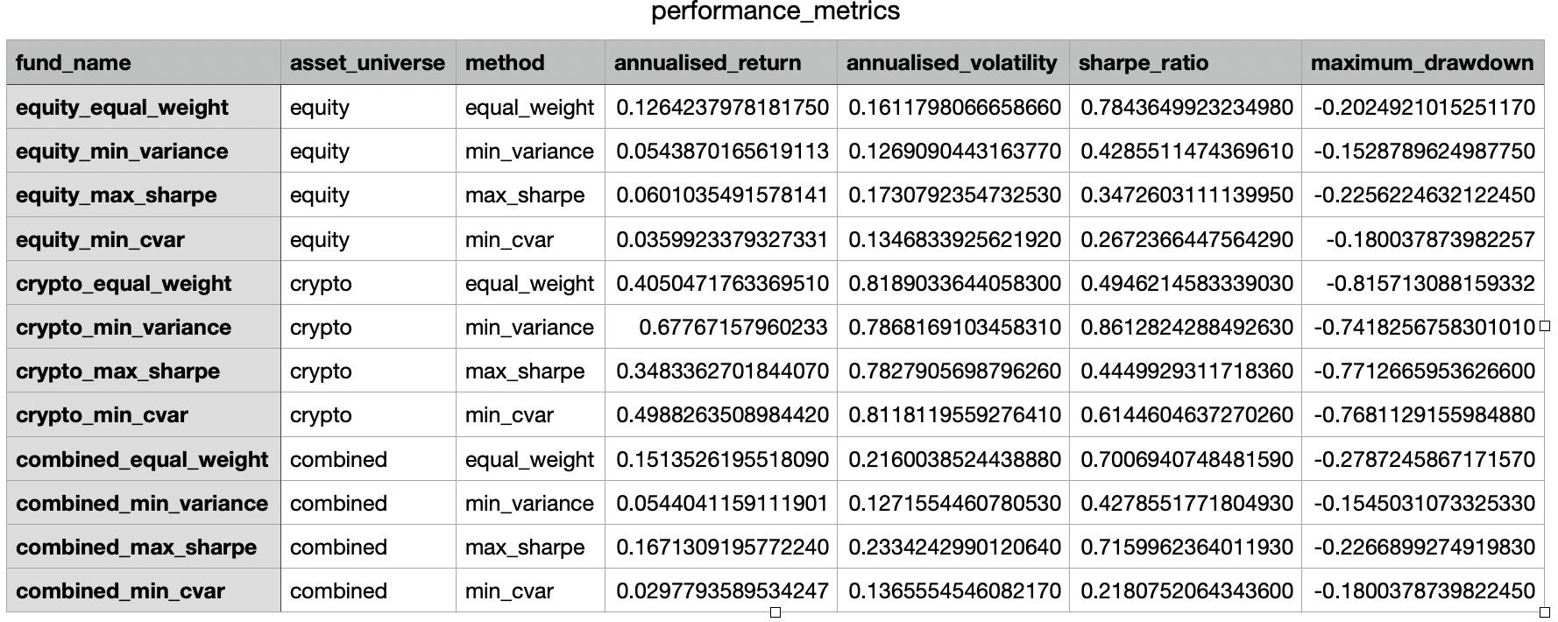
Figure 1 Baseline Fund Sharpe Ratio Comparison
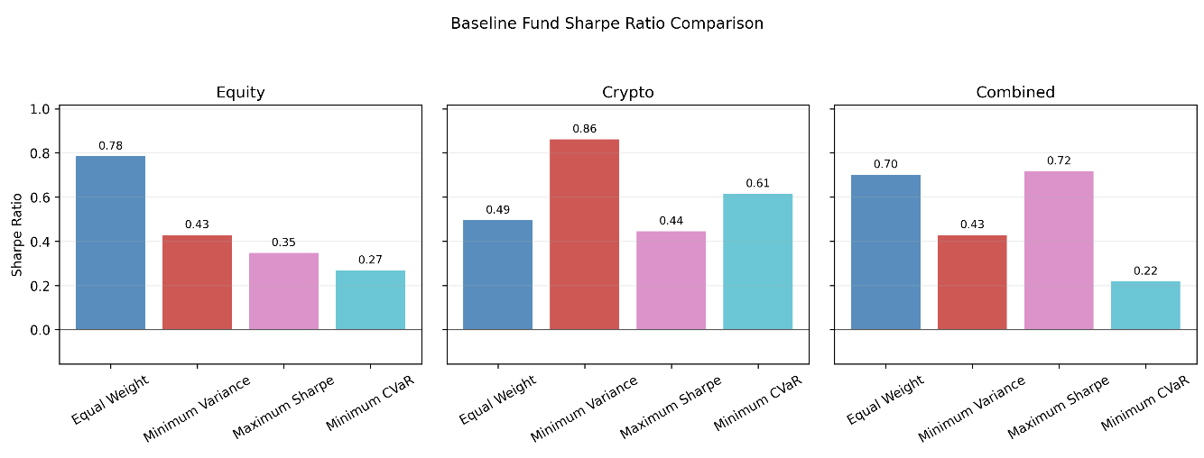
Figure 2 Combined Funds: Growth of $1

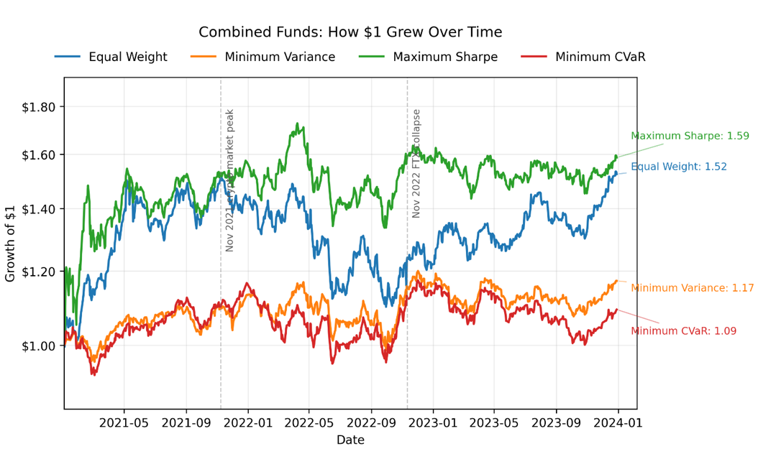

Figure 3 Combined Portfolio Allocation Over Time
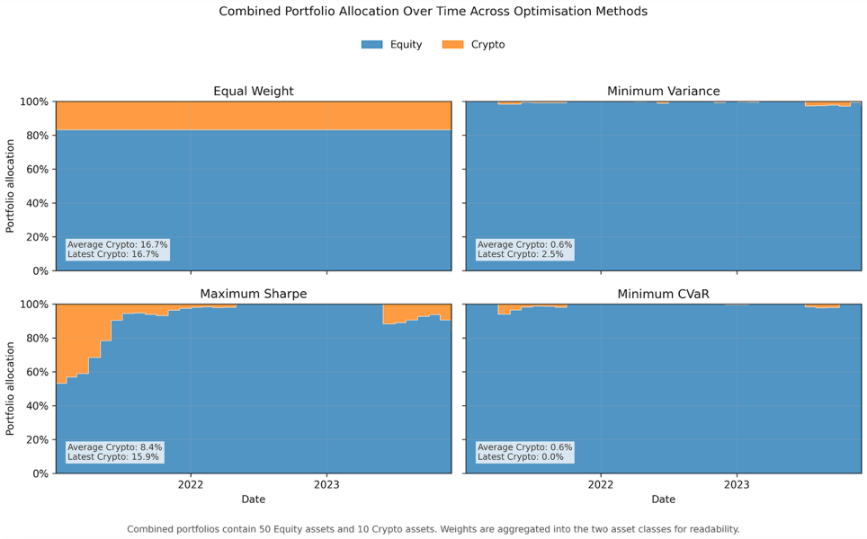
Figure 4 Baseline Drawdown and Downside Risk
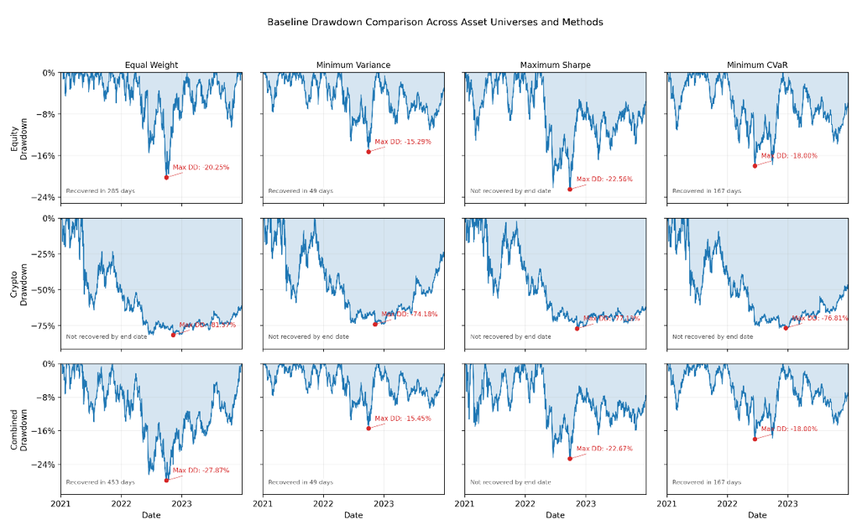

Table2 Latest holding 12 funds
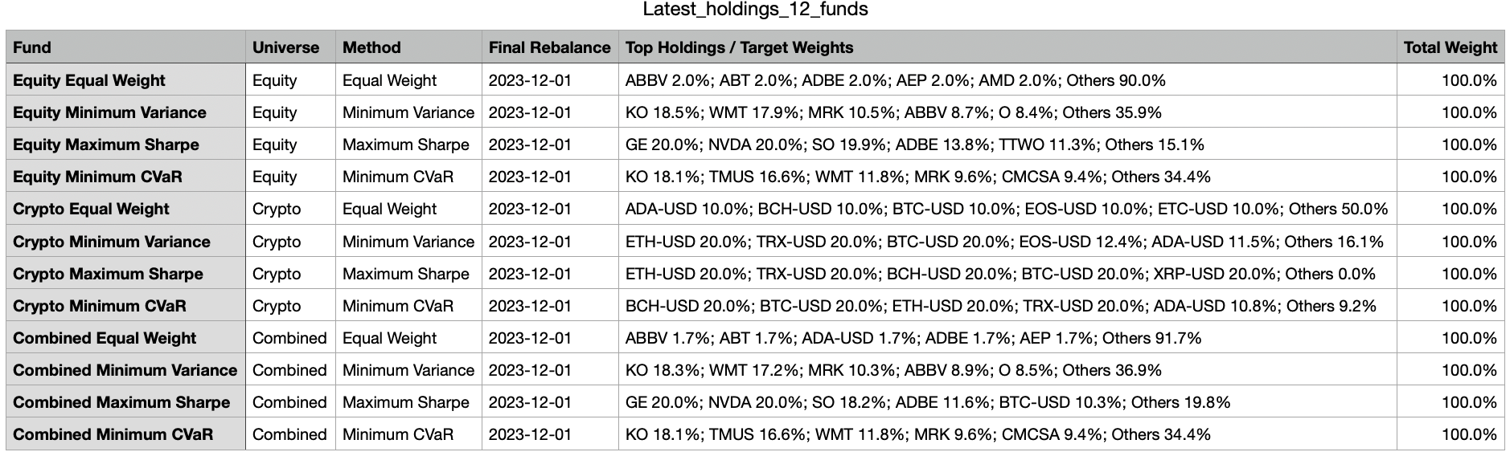

Risk Score | Conservative | Balanced | Growth
0 | 10% | 20% | 30%
100 | 0% | 5% | 10%
Table 3 Risk Score Mapping to Target Crypto Budgets

Figure 5 Crypto Budget Paths Across Investor Profiles

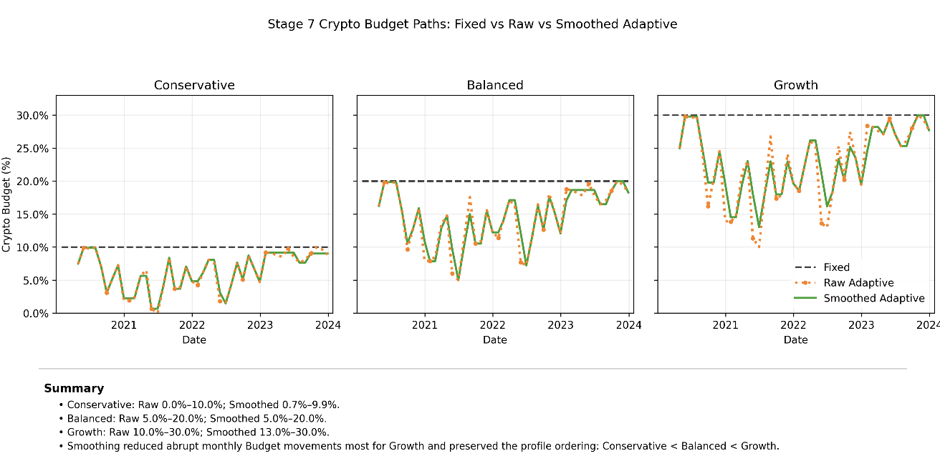

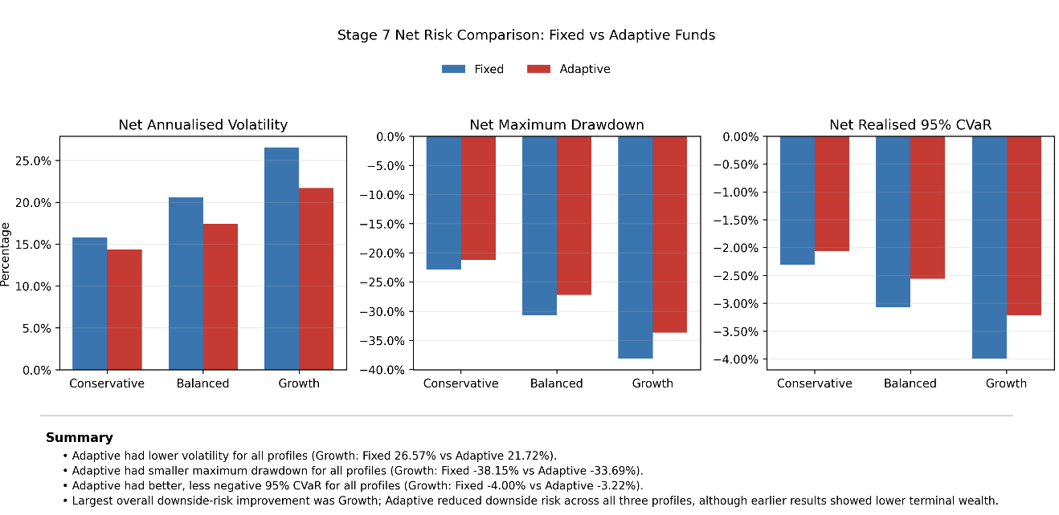
Figure 6 Net risk comparison

Figure 7 Standalone Sector Sentiment Index
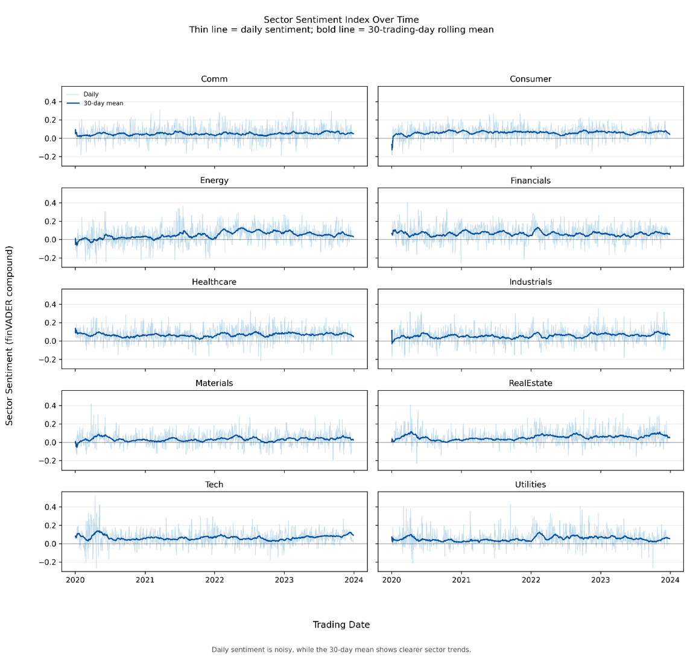

Figure 8 Basic Sentiment Fusion: Growth of $1

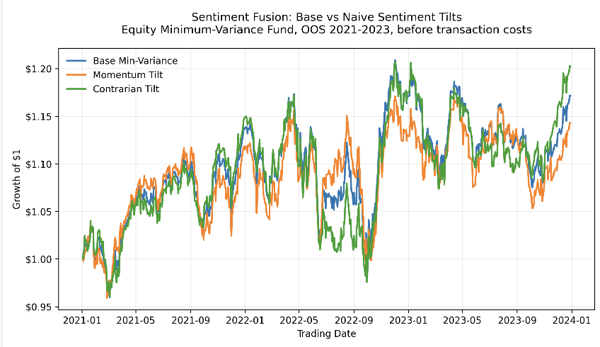

Figure 9 sentiment innovation progression
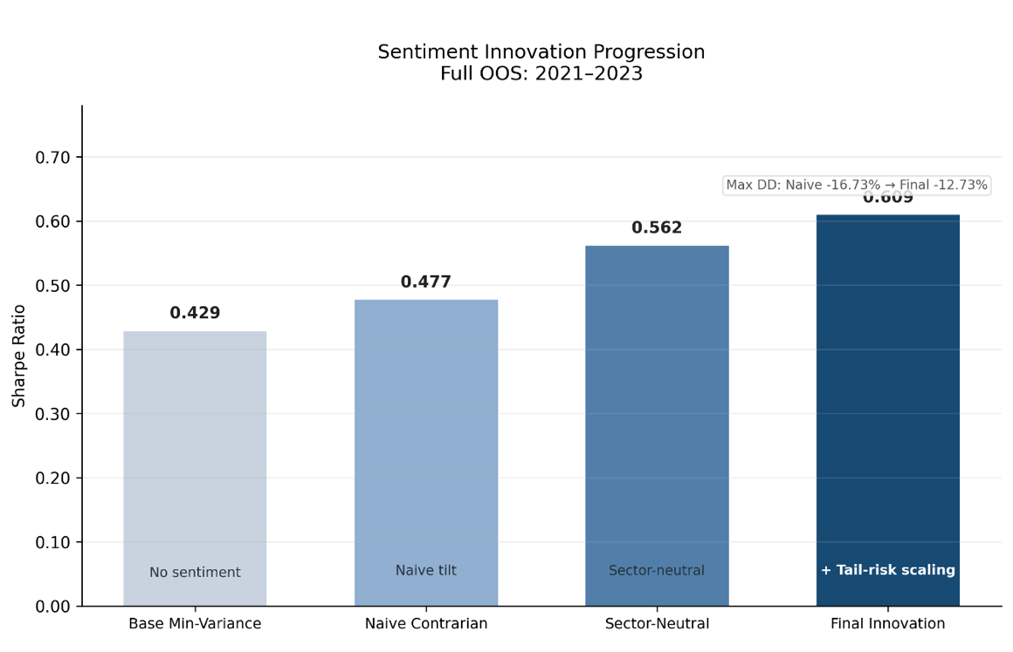

Figure 10 Performance and risk comparison
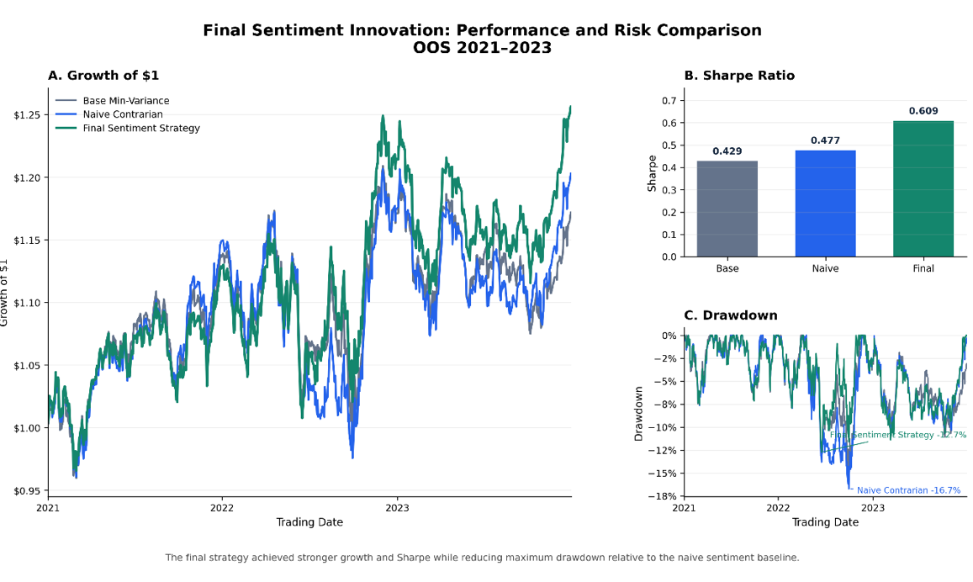
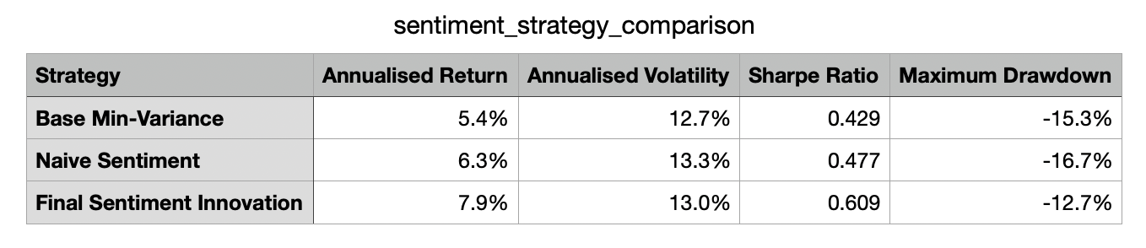
Table 4 sentient strategy comparison
Figure 11 cost sensitivity
