WeWork Enters into the Chinese Market

Tianyi Tong

International Business Management

Summer Quarter

October 20, 2016

Content:

Background of WeWork………………………………………………....P3

PEST Analysis of Chinese Market…………………………………….P4-5

SWOT Analysis …………………………………………………………….…P5-8

Five-force Porter analysis………………..................................P8-13

Ghemawat’s CAGE analysis…………………………………………….P13-16

Funding…………………………………………………………………………..P16-19

Team member………………………………………………………………..P19-20

Conclusion………………………………………………………………………P20

Background:

In the backdrop of sharing economy, myriads of Internet companies have sprung up like mushrooms by virtue of this prevailing concept at present such as Uber, Airbnb, Appearhere and so on. What I am thinking about in terms of implementing a business idea abroad is to introduce WeWork to China.

WeWork is a commercial real estate startup which brings the sharing economy into your workspace, which is focused on co-working office rental market. Founded in 2010 and headquartered in New York City, WeWork provides shared workspace, community and services for entrepreneurs, freelancers, startups and small businesses. It is a platform for creators and a place for people who are trying to bring something new to the world and hopefully find some support as well as make it easy for them to follow their passion and their dreams. Since its birth in February 2010, it has been quickly recognized by markets. Having had 54 co-working locations across the U.S., Canada, Australia, South Korea, Europe and Israel, WeWork expects to expand to every continent except Antarctica by 2017. China is definitely one of its most important target markets. Starting from this year, China’s first WeWork space office space has been launched in Shanghai.

WeWork designs and builds physical and virtual communities where entrepreneurs share space, facilities and office service as well as gain the opportunities to co-work and build business or individual relationship with one another, which may expose them to more good resources. Members of WeWork have access to health insurance, an internal social network, social events and workshops, and an annual summer retreat.

WeWork chooses to set up office points where are cheap to rent and redesigns them to make them stylish, customizable and with complete social function. Then WeWork leases these office areas to small businesses and entrepreneurs and provides them with no threshold co-working space at the same time. Those who rent office from WeWork don’t need any initial investment before they start their businesses. WeWork provides customers with both tangible and intangible products and services. Tangible products are offices, including security, reception, internet, printing and other services, which are also equipped with entertainment, bathroom and other amenities. In addition, there are also conference rooms which may hold large, medium and small meetings. When it comes to intangible products, firstly, WeWork provides a social platform. For instance, parties like “bagel” and “Mimosa” are regularly held to promote communications among entrepreneurs, between entrepreneurs and investors, entrepreneurs and technical and management personnel. WeWork members can promote their ideas in an informal presentation day and get free advice from external partners like Wieden + Kennedy advertising company, which are willing to serve them voluntarily. Secondly, WeWork also acts as an intermediary, providing a variety of services including medical, accounting, legal and cloud computing to its members. Thirdly, WeWork creates opportunities for cooperation. It builds a bridge of capital or business cooperation between entrepreneurs, entrepreneurs and investors, start-ups and established companies, which help entrepreneurs to find partners, customers and investors.

PEST Analysis

1. Political environment.

Chinese government has increased the intensity of supporting innovation and entrepreneurship. Since May 2013, the Chinese government has introduced more than 20 policy documents to support innovation and entrepreneurship. On the National People's Congress and Political Consultative Conference in 2015, Chinese Premier Li Keqiang proposed in his government work report that "public entrepreneurship and people’s innovation" should be forged into an important engine of China's economy. According to the statistics of National Development and Reform Commission, as of June 2015, the State Council departments and provinces (cities, districts) have introduced 1997 policies to support innovation and entrepreneurship, among which Beijing, Shanghai, Shenzhen, Guangzhou, Wuhan, Chengdu, Xi'an and other cities where innovation and entrepreneurship is relatively active have released 129 supporting policies. With the implementation of these policies, the environment for innovation and entrepreneurship in China has been significantly improved, the vitalization of innovation and entrepreneurship has been significantly enhanced and the demand for innovation and entrepreneurship has increased rapidly, which all create opportunities for the development of co-working space like WeWork.

1. Economic environment.

Since the global financial crisis in 2008, China's economic growth has continued to drop, but it began to stabilize in the fourth quarter of last year. The first half of this year saw a GDP growth of 6.7%, which continues to maintain high-speed growth. The growth rates of production, demand, prices, physical volume indicators are all commonly higher than expected. International Monetary Fund (IMF), World Bank and other international organizations have also raised expectations for Chinese economic growth. At present, the Chinese government implemented a proactive fiscal policy and prudent monetary policy. Usually, the stimulus of fiscal policy is greater than that of monetary policy. The short-term money market rates reached about 2.2%, in a relatively low level in history. The macroeconomic and financial environment with increasing positive factors is conducive to innovation and entrepreneurship development, which definitely provides a great opportunity for WeWork to expand Chinese market.

1. Social environment.

In an upcoming period, China will have a huge demand of employment. According to China's new urbanization plan, the urbanization rate will increase by 1% each year from 2014 to 2020, so there are nearly 7 million rural residents who will go to cities to seek employment. Meanwhile, there will be 7 million graduates to seek employment. The huge demand of employment is crying for a rapid development of the companies caring about innovation and entrepreneurship. The social atmosphere of "public entrepreneurship and people’s innovation" is becoming increasingly strong, which promotes an increasingly strong demand of co-working spaces, but the lack of effective supply still cannot meet the demand of innovation and entrepreneurship. Although there have been some companies which emulate WeWork, their operating model still lags behind.

1. Technical environment.

The technical conditions WeWork needs are mainly Internet-based service platform. China has the world's cutting-edge Internet technology and the popularity of Internet applications are in front of the world, which fully meet the needs for WeWork’s development in China.

SWOT Analysis of WeWork to enter into Chinese market

1. Strength (S)
2. Model strength.

The business model of WeWork is based on the concept of sharing economy. WeWork rents a batch of vacant office space resources, breaks the closed office space, then sublets them to small businesses and entrepreneurs in station units, provides operational services, and creates a flexible public office community for entrepreneurs to start up a business. At present, China’s major modes of office leasing are office buildings, incubators, and Regus which represents serviced offices and other models. In recent years, Makerspace, a business start-up service platform similar to WeWork, is on the rise in China. Compared with these models, WeWork has unique advantages.

Firstly, the rents are more affordable. Expensive rent of office space is always a “pain point” of individual entrepreneurs and start-ups, while the entry point of WeWork is to provide them with office space where the transportation is convenient, rent is affordable, and time is flexible. In China, the operating model of office building is "buying land, constructing and leasing". This model requires huge capital investment, long operating cycle, but has slow return of funds, resulting in high operating costs. However, WeWork doesn’t have this problem. It leases areas where rents are inexpensive then redesigns them, which needs much less investment than establishing new buildings. Serviced offices, represented by Regus, select high-end office buildings in urban core CBD as their regional network layout, the rental price of which is relatively high. WeWork adopts a "Whole Retail Rent" approach, which means it rents the space in batch but leases them separately and individually in order to get the margin in between. Therefore, it has price advantage over Regus and more flexibility than Regus.

Secondly, it’s more convenient to get resources. Start-up companies often have very limited resources, if they can communicate and collaborate with each other, the synergies arising from the integration of such resources will be much more efficient and convenient than that of each team looking for resources on their own. WeWork has a relatively complete social network for entrepreneurs, with tens of thousands of members. In addition to entrepreneurs and businesses working in WeWork, there are many people who care about entrepreneurship, including investors, government officials, and other persons responsible for multinational corporations, which are important resources entrepreneurs can use. In order to facilitate entrepreneurs to collaborate, WeWork regularly hold social events to encourage each team to crowdsource which means obtaining needed services, ideas, or content by soliciting contributions from a large group of people, especially from an online community. Moreover, they even write in some sharing behaviors to the lease in order to promote team interaction and resources sharing. This is not what the other models can compare. Thirdly, WeWork provides better value-added services. Most start-up companies in the early days, will be faced with many must-use but temporarily unable to self-supporting services. WeWork can act as intermediaries, through cooperation with professional service organizations to provide them with value-added services such as personnel, social security, legal, investment and financing docking, cloud services, project resources, product sales and so on.

1. Intangible asset strength.

Firstly, WeWork has a huge brand influence. Known as the originator of the global co-working space companies, WeWork is an industry leader in terms of brand value and influence. It was rated as the most innovative company of the year 2015 by "Fast Company" and ranked 13th on the list of Unicorn in "Fortune" published in 2016. On the ranking list of global startups’ market capitalization released by Dow Jones and “Wall Street Journal”, WeWork, Snapchat and Didi Kuaidi are tied for the sixth place globally with $16 billion.

Secondly, unique community culture is another strength. WeWork focus on nurturing community of creators and encouraging people to engage in the cause they love. Through the concept of "work hard and play hard", it has attracted a large number of entrepreneurs, entrepreneurial team and freelancers to enter WeWork, so that people from different industries, different companies can accompany and encourage each other. Therefore, WeWork has become a place where people never want to get off work. In China, although there are a large number of co-working office space, many are engaged in the work of the incubator and the majority of them did not establish a community and form their own community culture.

1. Human resources strength:

WeWork has staff with expertise in key areas, motivated and experienced employees and strong ability of organizational learning.

1. Organization system strength:

WeWork has high quality control system, perfect information management system, a loyal customer base and strong financing capability.

1. Weakness (W)
2. The mode of WeWork lacks barriers, which is easy to copy. On the one hand, in different regions, and even markets of different cultures, there is little difference among the demands for office facilities of different companies. On the other hand, WeWork mode does not have the core technical barriers. Therefore, this model is very easy to be copied by other companies. At present, there are already many similar companies emulating WeWork mode.
3. The community culture of WeWork is confronted with challenges. Cultivating community culture is one of the factors of the success of WeWork. In mainland China, startups are more willing to opt for an independent office than an open desk, even if they pay more for rent. The effect of contact and communication between the companies in the public office space will be greatly reduced. How to guide customers to voluntarily enter the social platform to take advantages of community culture is a new challenge to WeWork.
4. Opportunity (O)
5. The rise of free professional groups and mobile offices will promote the demand of the sharing of office. At present, the Chinese freelance group is not as large as that of the United States, but it is also in the process of rapid expansion. Meanwhile, there are more and more temporary project teams and long-term travel employees in large companies. The demand of mobile office grows rapidly. These factors will drive the growth of the demand of sharing office.
6. The demand of cross-regional office needs to be satisfied. In the network of WeWork, a member can not only use the office in public space in New York after paying a monthly fee, but he can also work in the local WeWork office when he travels to Chicago or even London. At present, the demand of Chinese mainland market for this service is very large, but cross-regional sharing office space market has not yet been developed. Similar companies have not yet provided such services, which gives WeWork very good opportunities.
7. There is a strong growth in market demand. In the next period, the Chinese government reinforce the support of innovation and entrepreneurship. The group focused on innovation and entrepreneurship will enter into a period of rapid development, which will directly promote the rapid growth of the demand of sharing office.
8. Threats (T)
9. The threat of competitors.

In recent years, China's urban makerspace is developing rapidly. The strength of the state-level technology business incubators increases rapidly. A new generation of the main force of makerspace develops with a strong momentum. In the future, the makerspace platform companies are likely to become a powerful competitor of WeWork.

1. The threat of price competition.

The pursuit of cheap and fine products is deeply ingrained in the mind of Chinese consumers, especially the entrepreneurs who are in shortage of funds are more price-sensitive. Currently, the price of station of Wework in Shanghai, China market is set relatively high, however, enterprises of Chinese mainland are often keen to fight a price war, which may bring some pressure on the WeWork.

1. The impact of the economic depression.

The global economy has great uncertainty in the future. Although China's economy is relatively stable, if the global economic situation deteriorated, it is bound to adversely affect the economy of China. Meanwhile, whether China's economy can maintain a trend of stable recovery in the long term also depends on whether the structural reform of the supply front can achieve the goal of increasing the quality and efficiency of supply system and providing a growth impetus for sustainable economic development. If the economic downturn cannot be radically reversed, entrepreneurs will raise their caution, thus decreasing the demand of setting up a business. The impact on WeWork is inevitable.

Five-force Porter analysis

1. Bargaining power of suppliers

The situation where there is oversupply and high vacancy rate in real estate market continues and the bargaining power of rental housing suppliers has weakened. According to the statistics of Ying Shi Group Research Center, “As of the end of 2015, the total stock of China's 20 largest city commercial property market has exceeded 100 million square meters, among which the total stock of Grade A office space reached 45.57 million square meters.” According to data from RET China Research Center for Commercial Real Estate, “As of December 2015, the average vacancy rate of office space in China had reached 18%, and the vacancy rate of commercial premises had been as high as 30%.” This year, the Chinese government promote the real estate market to intensify the liquidation of inventory so that supply-demand relationship has been improved, but it’s still not optimistic in the short term. According to the forecast of Ying Shi Group Research Center, “By 2018, among the 20 major cities in China, in addition to Shanghai and Beijing where the Grade A office space can maintain a basic balance between supply and demand, the other cities have the same problem of oversupply. The proportion of Grade A office distributed in the non-core business district will increase from 23% in 2015 to 33%, which means that the supply of low-cost office will increase significantly.

In recent years, China's downward economic pressure continues to increase, many small and medium enterprises have difficulties in production and operation. Some SMEs are even off production or half off production, thus a large number of idle factories can be rented. In consideration of the pressing needs of these enterprises to liven stock assets, the bargaining power of suppliers is not strong.

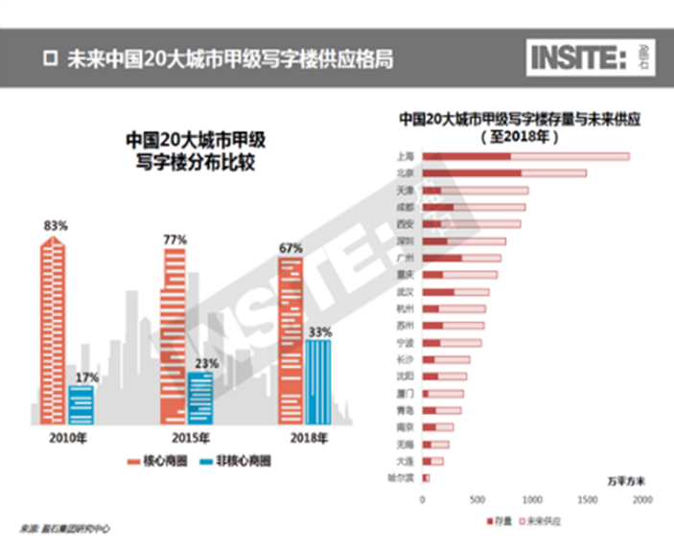

1. Bargaining power of buyers

Looking at the supply of joint offices, Deskmag, which specializes in tracking the trends of co-working office space, showed that there are about 5,900 joint offices worldwide at the end of 2014. According to WeWork's publicly available data, the number of joint office space in China has been more than 2,300, among which Beijing, Shanghai and Guangzhou have the most intensive co-working office space. The situation has developed so rapidly, mainly due to policy that Chinese government encourages innovation and entrepreneurship. After experiencing explosive growth, the development of maker space has shown signs of recession since 2016. According to the professional’s analysis, the underlying reason is that a large number of maker spaces are speculative and take advantage of good policy to activate the real estate inventory. In addition, the operation model of some maker spaces failed to meet the needs of entrepreneurs. In conclusion, the supply of China's co-working office space has grown too fast, which enhanced the buyer's bargaining power. However, WeWork’s brand influence and originality of operating model are strongly attractive to entrepreneurs and start-ups. Therefore, buyers who attach more importance to get access to better service value do not overly bargain.

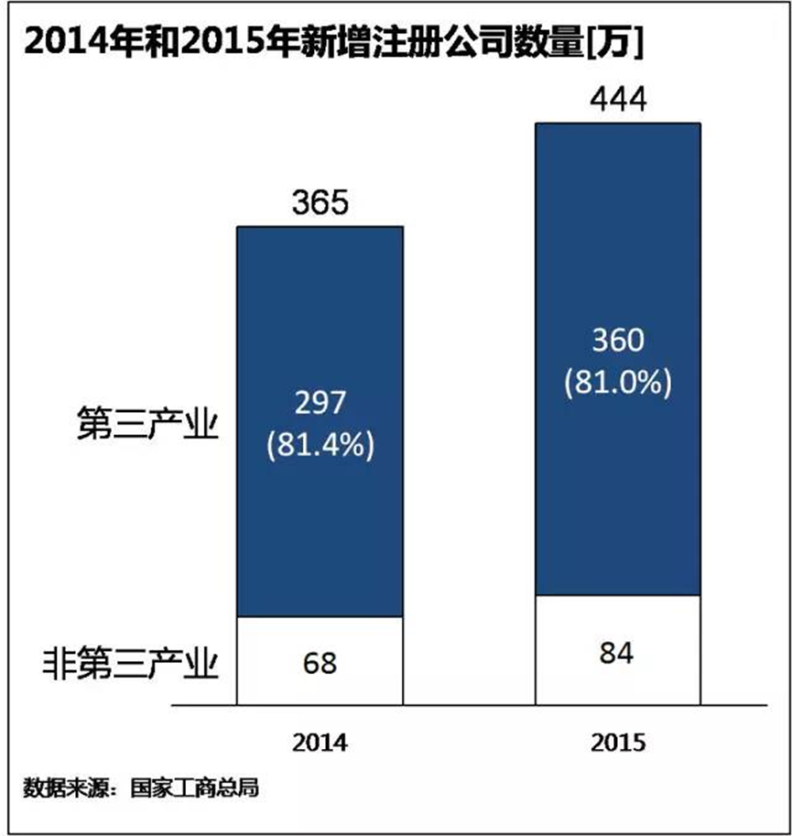

From the point of the needs of co-working office space, in recent years, the Chinese government has introduced policies in a row to encourage innovation and entrepreneurship to stimulate the enthusiasm of private investment and entrepreneurship, which has promoted the rapid growth of market players. The State Administration for Industry and Commerce released data that shows that in 2015 the number of new registered enterprises reached 4.4 million with an increase of 21.6% on year-on-year basis. The average daily new registration of 12,000 enterprises touched a record high, of which 3.6 million new registered enterprises were in the tertiary industry with a year-on-year increase of 24.5%, accounting for 81% of the total number of newly registered enterprises. Start-ups have strong demand for co-working office space with low rent, flexible lease, and the ability to promote communication between companies. In addition, China's freelance economy is still in its infancy compared with that of the developed countries. With the development of China's tertiary industry, maturity of mobile Internet technology and the change of people's attitudes, there will be more and more people who want to join the ranks of freelancers. According to "Freelancer Status Report in China in 2015” released by LinkedIn, the Chinese freelancers has been trending younger in age. Those after the birth of 1985 account for more than 60%. Those whose working life are less than 3 years account for more than 30%. There are an increasing number of young people in first-and-second-tier choosing to be freelancers. Top cities of the number of freelancers are Shanghai, Beijing, Guangzhou, Shenzhen, Chengdu, accounting for 26% of the whole country. To sum up, there is a huge potential of China's co-working office space market demand. In the long run, the buyer's bargaining power will tend to be weaken.

1. Threat of new entry

Brand influence:

WeWork is the originator of the global maker space so that its brand value and influence are in the leading position of the industry, while the brand building of similar companies in Chinese market is still in the initial stage.

Differentiation level:

Compared with other co-working office space model, WeWork is a typical sharing economic model, users can look for the required office space at any time through the wework supply and demand platform (web and APP). Wework introduced a large number of business service providers in the form of cooperation with them. Once users access platform, they can get access to all the resources on the platform. WeWork focuses on serving the start-ups, precisely introducing relevant service providers, which enables platform resources to have the incubator function to provide value to the target user. Besides, by setting up social platform, WeWork also promotes the teams in the maker space to communicate with each other, share resources, cooperate with each other and develop, forming an advantage of unique community culture. These features equip WeWork with a differentiated competitive advantage. At present, China's companies that are newly into co-working office market are mostly the imitators of WeWork. Although these companies invariably claim to become "China's WeWork", they are largely different from WeWork in terms of target groups, operating strategies and business models. They did not learn the essence of the WeWork model. They compete for the entry of high-quality start-ups and for the land and benefits from local governments with incubators, accelerators and Pioneer Park, which makes them fall into homogeneous competition. Therefore, these co-working office enterprises cannot pose a real threat on WeWork in the short term.

Economies of scale:

The core of sharing economy is the integration of fragmented resources. The larger the scale of sharing, the higher the overall efficiency, the lower the cost. At present, similar companies in Chinese market is still in the exploratory stage in the use of sharing economy model, while WeWork has formed a mature sharing economy model. The larger the scale, the more conducive to the boost of WeWork’s economic efficiency and competitiveness.

Technical barriers:

The technical support of sharing economy is mainly the Internet platform, however, Internet technology is open and shared, so there is no barrier.

1. Threat of substitution

WeWork provides primarily co-working office space for entrepreneurs and start-ups. At present, there are three main categories of maker space in the form of co-working office in China: the first one is the real estate enterprises that make transformation to become maker space such as Youke plant, SOHO3Q, Hongtai innovation; the second category is to put the entrepreneurial space as a supplement to the business sector such as the media, investment companies and large corporations; the third category is focused on doing co-working office space, supplemented by services for setting up a business, represented by Temple of Science and Technology, Unbounded Space, Cool Nest. These maker spaces are different forms of co-working office products, most of which currently earn rental income through the "bulk buying and retail selling" approach. If put aside policy support and government subsidies and other factors, the vast majority of them are at a loss. In the short term, these co-working office model cannot replace WeWork model.

1. Competitive rivalry

Scale competition:

In recent years, stimulated by the policy of the Chinese government to support innovation and entrepreneurship, co-working office space developed rapidly. It is shown in public information that there are 100 co-working office space nationwide in 2014 and then it reached 2300 in 2015. The industry competition is extremely fierce. China's co-working office market will enter the stage of industry reshuffle when investment will expand and the pace of mergers and acquisitions will accelerate. The operators with higher visibility such as WE +, SOHO 3Q, P2 and UR Work are constantly expanding. Among them, WE + plans to establish a layout of 200 spots in China in 2018. SOHO 3Q plans to reach the number of 100,000 workstations in 2017, UR Works plans to expand to 21 cities.

Price competition:

Currently, China's co-working office space market has serious problems of disorderly development, excessive development and oversupply. Plus, Chinese entrepreneurs and small businesses are highly sensitive to the price, hence the promotions of reducing price in the future industry are inevitable. Currently, the major challenge WeWork is confronted with is how to play the advantage of price competition model in the future, through realizing the maximum of the benefits of value-added services.

Service competition:

Although WeWork services have a unique competitive advantage in the Chinese market, there are some similar companies in the industry form a core competitiveness through innovative services. For example, Workingdom, founded in early 2016, target customers at the new generation of users, promote sharing and personalized services, provide a full range of personalized services from the physical terminals, service platforms, content production, resource integration, and stimulate users’ creativity and inspiration. Firstly, on the physical terminal, Workingdom covers the co-working office, mobile office, long-rent apartment and various ecological communities, etc. Unlike many co-working office space, Workingdom also tried to introduce virtual reality in the field of co-working office space, establish new residential office consumption environment. Secondly, on the service platform, Workingdom will establish consumption, finance, social, electronic business platforms which are based on enterprise SAAS service so as to meet the needs of target users. Thirdly, on content production, Workingdom will build growth college, copyright culture, growth media and growth fund platform and provide support and assistance for users and enterprises in different stages of growth. Currently, Workingdom has launched a series of space products: Workingdom TUBE sense experience sharing workspace, Workingdom CUBE intelligent experience sharing workspace, Workingdom HUB sharing ecological community. These products have been highly acknowledged by the market. For instance, the rate of signing lease contracts has reached up to 90% within one month since the opening of the co-working office space in Kaihong Square, Sichuan Road, Hongkou District, Shanghai office space, which indicates that the Workingdom model is more suitable for the current Chinese environment of innovative entrepreneurship. Therefore, it is imperative for WeWork to combine their own advantages with China's environment of innovative entrepreneurship to achieve localization development in respond to the innovation and competition of the service in the industry.

Ghemawat’s CAGE analysis

Professor Ghemawat of Harvard Business School noted that the relationship between any two countries is affected by the distance between the two countries. He summed up the distance as GAGE ​​framework. The feasibility analysis of WeWork’s investment into China by using the GAGE ​​framework is as follows:

1. Cultural distance

In terms of language, China and the United States use Chinese and English respectively. Not only language but also culture is hugely different from each other. In aspect to ethnic composition, the disparity between China and the U.S. is huge but more and more connections also come up. China is a country with 56 nationalities, among which the majority is the Han gentry, while the United States of America is a new nation formed by multi-national immigrants, among which the descendants of England, Ireland, Germany and Africa are in the majority. The number of foreigners living in the territory of China are also increasing. The UK HSBC Group announced the "Expat Explorer Report 2014" in October 2014. It shows that in the rank of "The most attractive country or region to foreigners for living", China ranked third overall, second only to Switzerland and Singapore. The US Census Bureau released data in 2015 which shows that the Chinese population has reached 4.52 million, the largest ethnic group Asian Americans in the United States, the second-largest ethnic minorities in the United States after Mexico and their overall level of education is significantly higher than that of the United States. The number of Chinese students studying in the United States continues to increase, reaching more than 300,000, becoming the highest on the globe. With regard to the values, China implements socialist system where the core values at the national level is to build a strong, prosperous, democratic, culturally advanced and harmonious country. The value orientation at social level is freedom, equality, justice, the rule of law. The United States implements the capitalist system where the core values ​​are freedom, democracy, equality, human rights and the rule of law. As for the character, Americans tend to show publicized temperament, so they prefer group work. In contrast, Chinese who are more quiet and passive prefer individual work. Americans love adventure and worship individual heroism, so "innovation" is a kind of nature of many Americans, while the Chinese people who received examination-oriented education regard innovation as danger. In the degree of opening up to the outside world, the United States is a country with a high degree of opening-up. The scale of foreign trade in the U.S. is the second largest in the world and there are a large number of multinational companies. The level of China’s opening to the outside world is constantly increasing. It is now the world's largest international trade country, but the opening-up mechanism lags some distance behind the international rules. President Xi Jinping stressed that China will unswervingly expand the scope of opening-up at the G20 summit in 2016.

1. Administrative distance

There are no colonial relations between China and the United States and they do not belong to the common regional trade union. They have different currency, political system and legal system. The United States is a country with market economy. Currently, more than 80 countries recognized China's market economy status, but European countries and the United States has not yet recognized. Both China and the United States are permanent members of the United Nations and are members of numerous international organizations. The United States has a relatively complete legal system, while China's legal system has been improved and the strategy of ruling the country by law has risen to an unprecedented height. Both China and the United States attach great importance to anti-corruption. Especially in recent years, the Chinese government has unprecedentedly established anti-corruption system and crack down on corruption with remarkable achievement. Both China and the United States have stable social order and political order.

1. Geographical distance

China and the United States are far apart. The straight line distance between Beijing, China and Washington DC, the United States is about 11,160 km. There is no common border between China and the U.S. Both China and the U.S. have a variety of climates from the frigid to the tropics, but China mainly has North-South differences in climate, while the U.S. mainly has differences between the East and the West; China is backed by Eurasia, facing the Pacific Ocean, forming a strong monsoon climate and four distinct seasons. North American continent is much smaller relative to the Eurasian continent, so it failed to form an obvious monsoon climate. The humid climate of U.S. is mainly affected by the Atlantic and Gulf of Mexico. The wind from Pacific Ocean is blocked by the Rocky Mountains, so it has little impact on the U.S.

1. Economic distance

From the point of income gap between consumers, the news released by the World Bank shows that the per capita GDP of the U.S. was $51248 in 2013, while China's per capita GDP was $6629. The per capita income of the U.S. is $43017 in 2014, while that of China is $7476. In terms of the difference of availability of resource and facility between China and the U.S.:

(1) The United States has high-quality human resources, while the total amount of human resources in China is large but the quality is relatively low.

(2) The U.S. has well-developed financial industry with a relatively sound financing system for start-ups. It has built investment mechanism for start-ups, which are based on the developed capital market, focus on private capital as the main force, regard private or independent venture capital companies as the main intermediary to ensure high profits. It’s pretty easy for entrepreneurs to have access to financing as long as they are creative enough. However, in China, it’s hard to get access to financing for SMEs including start-ups.

(3) Both China and the United States are abundant in natural resources, but the per capita possession of resources of the U.S. is much higher than that of China.

(4) Both China and the United States have relatively sound infrastructure, especially the logistics efficiency of China has been greatly improved due to large-scale construction of high-speed rail and expressway and the development of regional aviation.

According to Ghemawat's CAGE theory, trade intensity is inversely proportional to geographical distance. The trade volume of countries using common language is 42% higher than the two countries with different languages. The trade volume of two countries with colonial relations is 118% higher than the average. The difference in the degree of corruption and political stability also inhibits trade growth. The trade volume of countries bordering on each other is 125% higher than that of countries not neighboring on each other. And the per capita income disparities have a positive effect on trade intensity. The analysis above shows that the distance between China and the U.S. is very far in the four aspects above. However, it should be noted that the Chinese government has made great efforts to narrow the distance and reduce the sensitivity of distance, such as actively streamlining administration and delegating power to the lower levels, opening wider to the outside world, promoting Sino-US cultural exchanges and strengthening trade cooperation. These actions all made some positive results and promote the sustainable development of Sino-US trade. As for WeWork, not only should it seize the opportunities brought about by China's reform and opening-up, but also actively adapt to the Chinese market environment by combining its own advantages with the needs of the Chinese market. It’s necessary to reduce sensitivity to distance through the implementation of localization strategy so as to strengthen its adaptability to the market.

Funding

1. Cost of market research.

WeWork market distribution should give priority to cities with superior environment for innovative entrepreneurship. It is recommended that WeWork China should set up a professional team to make a deep market research into the top 20 cities based on the evaluation of China’s urban environment for innovative entrepreneurship published by Tsinghua University Institute of Innovation. According to the result of market research, WeWork can determine the layout of the city. Market research funds can first be budgeted by 50,000 yuan per city standard and the final cost should be determined by actual expenditure.

1. Labor costs.

Given the fact that WeWork has set up headquarters as well as operation and management team in Shanghai, China, the focus here is on the labor costs of the operation team in the proposed cities. Shanghai, for example, in accordance with the salary level of Shanghai in 2016, the average monthly salary of product manager is RMB 14,343 yuan; the average monthly salary of product manager of the intermediary service industry is RMB 21,963 yuan; the average monthly salary of sales manager is RMB 7619 yuan; the average monthly salary of sales manager of intermediary services industry is RMB 11,912 yuan; the average monthly salary of sales representative is RMB 5375 yuan; the average monthly salary of property management / business center sales representative is RMB 5841 yuan; the average monthly salary of web development engineers on the front-end is RMB 10,880 yuan. With reference to the criteria above, the labor cost of the urban operation and management team is as follows:

1. Cost of human resources in the operations teams of city branches

The wage of city manager refers to the average wage level of the product manager of the intermediary service industry. The annual salary is about RMB 260,000 yuan. The salary of business development manager refers to the average wage level of the sales manager in the intermediary service industry. The annual salary is about RMB 140,000 yuan. Assuming the sales department employs five salespeople, their wages refer to the average wage of property management or business center sales representative, so everyone’s annual salary is about RMB 70,000 yuan, amounting to RMB 350,000 yuan. The salary of the manager of the operation department shall be determined by the wage standard of the manager of the business development department, and the annual salary shall be about RMB 140,000 yuan. If two employees are recruited, the salary shall be determined by the salary standard of the sales department. The annual salary of every sales person shall be about RMB 70,000 yuan, a total of about RMB 310,000 yuan. The salary of network technology department staffs refers to the average wage of web development engineers. Assuming the network technology department employs two people, and the annual salary of each person is RMB 130,000 yuan, amounting to RMB 260,000 yuan. The labor costs of the operation team of the branch are approximately RMB 1.46 million yuan per year.

1. Labor costs of the operation team of branch stores set up by branch office in each city

Assuming that each branch store covers about 5,000 square meters with 1000 workstations, each equipped with an operation manager and five community managers. The salary of branch manager is determined by the wage standard of the manager of sales department and operation department of the branch office. The annual salary is about RMB 140,000 yuan. Assuming that 5 community managers are employed, given that community managers are the staffs at the frontline and their service quality and level is closely related to the brand image of WeWork, their salaries could be higher than that of sales department and operation department but lower than that of the branch store manager. It is suggested that the annual salary should be about 80,000 yuan per person, a total of 400,000 yuan. Assuming that each city opens five branch stores, the labor cost is about 2.7 million yuan per year.

Assuming that each city set up a branch office and five branch stores, the total labor costs are about 4.16 million yuan per year.

Assuming that at the same time of establishing Shanghai branch, we select Beijing, Guangzhou, Shenzhen, Hangzhou and other cities to set up branches. The formulation of wage standards of the operation team should refer to that of Shanghai and make some adjustments according to the wage difference compared with the per capita salary of Shanghai. Beijing's per capita salary is 8.27% higher than that of Shanghai, so the team's salary increases 8.27% on the basis of the Shanghai team's salary standard, totaling about 4.5 million yuan. Guangzhou's per capita salary is 32.5% lower than that of Shanghai, so the team's salary should be reduced by 32.5% based on the Shanghai team's wage standard, amounting to about 2.8 million yuan. The average salary per capita in Shenzhen is 22.6% lower than that in Shanghai. The salary of team members should be reduced by 22.6% on the basis of team salary standard in Shanghai, totaling about 3.22 million Yuan. Hangzhou's per capita wage is 18.3% lower than that of Shanghai, so the team wages in Hangzhou should be reduced by 18.3% on the basis of team salary standard in Shanghai, totaling about 3.4 million.

1. Cost of rent.

Assuming the opening of branches in Beijing, Guangzhou, Shenzhen, Hangzhou and other cities, the rental cost of each city will be calculated as follows according to the rent level of urban office buildings in China in the second quarter of 2016 (as is shown in the figure below)

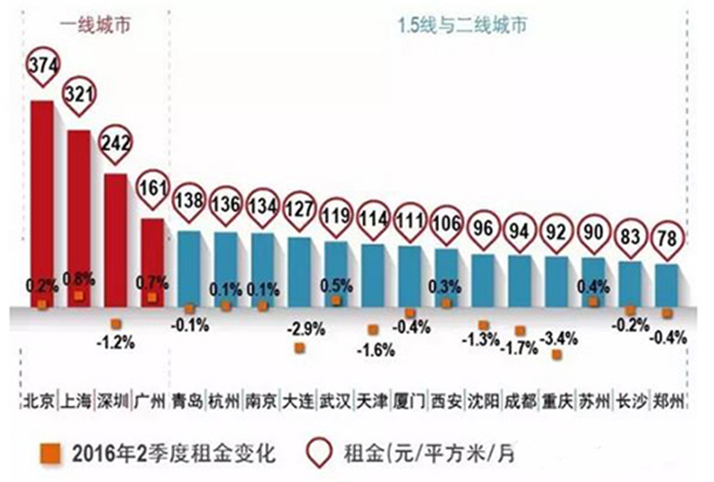

1. The average rent of Shanghai office building is 321 yuan per square meter per month. Hence the establishment of a 5000 square meters of the store requires a rent of 19.26 million yuan per year.
2. The average rent of Beijing office building is 374 yuan per square meter per month. Hence the establishment of a 5000 square meters of the store requires a rent of 22.44 million yuan per year.
3. The average rent of Guangzhou office building is 161 yuan per square meter per month. Hence the establishment of a 5000 square meters of the store requires a rent of 9.66 million yuan per year.
4. The average rent of Shenzhen office building is 242 yuan per square meter per month. Hence the establishment of a 5000 square meters of the store requires a rent of 14.52 million yuan per year.

The cost estimation above is based on the average rents of the office buildings in each city. If the branch is located in a non-core business district, the rental price will be lower if the vacant buildings and factories are selected.

Team member

At present, WeWork has set up branch office in Shanghai being the head office in China and set up the operation and management team. Next step is focused on the construction of the layout of operations team in each selected city. Suggestions are as follows:

Establish branch offices in the selected cities, then hire a person who has more than 3 years of experience of co-working office or operation and management experience of incubators, and who are familiar with the investment market as the city manager to take responsibility for the operation management and market development of WeWork in the city.

Establish a business development of each branch, then hire professionals who have a bachelor degree or above and have more than 3 years of experience of marketing strategy, brand promotion and user market promotion and other management experience as a manager and take responsibility for the overall investment strategy, formulation, organization and implementation of brand promotion program. Establish 5 sales and marketing positions, then hire people who have a bachelor degree or above and have experience of real estate and sales experience, strong capability of communication and coordination. Their main responsibilities are: understand customer demand of service information and effectively track them; skillfully use company products, answer customers’ questions; maintain customer relationships; take responsibility for the development and collection of the source of information of the provisions of the regional office; carry out market research into office leasing and mining potential market of customers; conduct on-site visits to the property with the intention of the trusteeship and sign a trusteeship contract with the property owners who meet the trusteeship requirements; support and manage project of regional sales.

Establish branch operation department, then select people who have a college degree or above and more than 3 years of business operations management experience as a manager who is responsible for the implementation of the company's business strategy and the operation management of WeWork co-working office space. Set up 2 positions of operation management and hire people who are familiar with O2O, social network, B2C business, online and offline business model to take responsibility for the supervision, assessment, analysis of the daily operation of the branch store and coordinate and deal with specific matters.

Establish branch network technology department. Establish 2 positions of network engineer who are responsible for the front-end and back-end development of the website, the overall website maintenance, modification, development and organization of document.

According to the market demand of the selected cities, establish appropriate number of co-working office space. Assuming that each branch store covers 5,000 square meters with 1000 workstations. Select and hire people who are familiar with O2O, social network, B2C business, online and offline business model as a manager who are responsible for the daily operation and management of branch stores. Establish 5 positions of community managers who not only have strong capability of communication and coordination but are also familiar with e-commerce, O2O, social networking, B2C business, online and offline business model to take responsibility for the specific service work of the branch store, contact the community members, and promote the communication and information docking between customers and communities.

Conclusion

SWOT analysis shows that WeWork co-working office products has an obvious competitive advantage in the Chinese market, especially its unique operating model and brand advantage, which constitutes a high barrier. PEST analysis shows that, WeWork co-working office products are in line with China's market demand for innovation and entrepreneurship, in particular, the Chinese government is increasingly support innovation and entrepreneurship. Besides, the vitality of folk innovation and entrepreneurship is becoming stronger, so the demand for co-working office products will continue to grow. The environment of developing co-working office space is friendly and suitable for WeWork. Porter's five-power analysis shows that China's real estate market has been over-developed and the vacancy rate of real estate including office buildings is very high, which is conducive to low-cost integration and use of these resources. China's rapid growth of entrepreneurial enterprises triggered an increase in the demand for co-working office space. In the short term, new entrants and substitutes of WeWork cannot pose a substantial threat, so WeWork can seize the initiative in the competition of the same industry. CAGE analysis shows that although the cultural distance, administrative distance, geographical distance and economic distance between China and the United States are far away, the Chinese government has taken positive measures to narrow the distance and reduce the distance sensitivity, which has promoted the Sino-US sustainable trade development, which provides a opportunity and a good environment for WeWork to enter the Chinese market. The cost analysis shows that the choice of first-tier cities, although the cost is relatively high in the near future, these cities have high-level of economic development, strong motive power of economic growth, high vitality of innovation and entrepreneurship of the demand for co-working office space. Hence they have huge market potential. Based on the analysis above, this business plan is very likely to achieve success.

Reference:

<http://www.askci.com/news/chanye/2016/01/26/14936c1gt_3.shtml>

<http://www.chyxx.com/industry/201608/443618.html>

<http://e.ent.163.com/docs/2/2016032111/BIM7EJ8H9001EJ8I.html>

<http://sanwen8.cn/p/2947yNu.html>

<http://wenku.baidu.com/link?url=VNKz6QTy7x__PD9mKvwSmzbgu33x7RW4275T0ySbjw7u46rEgSCoM-k-vfmqVu57DUVPTSxUeGqPB6nzt-ot7IjNU1S-Hwd0sJe7xhOG3Ty>

<http://salarycalculator.sinaapp.com/report/%E4%B8%8A%E6%B5%B7>

<http://news.chineseoffice.com.cn/html/2016-07/31088.html>