Optical networking preliminary report
  - Physical modelling resource allocation and reference parameter checks
Tianze Wang | tw609
Department of Engineering, University of Cambridge
Supervisor Seb Savory | 28 October 2026

Summary
The project has established a reference physical model alongside an exploratory resource-allocation prototype. Under the thesis reference parameters, an 800 km link gives an optimal per-channel power of -1.500 dBm, a maximum SNR of 18.009 dB and an ideal central-channel capacity of 384.319 Gbit/s. Numerical checks reproduce the reported SPM coherence exponent and support retaining linear XPM accumulation for this configuration. The earlier four-node network admits 3000 Gbit/s from four requests totalling 4000 Gbit/s under its separate 200 GBd exploratory parameters. Those network results have not yet been recomputed with the 32 GBd reference model. The completed checks establish numerical consistency within the GN assumptions; propagation and experimental validation remain outstanding.

1 Exploratory baseline parameters
Parameter | Value
Symbol rate and channel count | 200 GBd; 25 channels
Channel spacing and carrier frequency | 400 GHz; 193.5 THz
Span length and reference route | 80 km; 800 km or 10 spans
Fibre attenuation | 0.22 dB/km
Dispersion magnitude | 21.3 ps²/km
Nonlinearity coefficient | 1.3 W⁻¹ km⁻¹
Amplifier noise figure | 4.5 dB
SPM coherence exponent | ε = 0 in the baseline
FEC overhead | 20%

Powers refer to the total signal over both polarisations. All WDM channels share the same launch power. Sections 1 to 7 report the exploratory parameter set used for the initial physical and network experiments. Section 8 introduces the thesis reference parameters and the adopted physical-layer baseline.

2 Exploratory physical model and rate selection
The signal-to-noise ratio includes amplified spontaneous emission (ASE) and nonlinear interference (NLI). The latter is represented by self-phase modulation (SPM) and the summed cross-phase modulation (XPM) from other channels. The single-span coefficients use the closed-form expressions reproduced in [1, Eqs. 4.24 and 4.25]; the route model follows the structure of [1, Eq. 6.1].
$$P_{ASE} = N_{s}A_{span}, η\left(N_{s}\right) = {N_{s}}^{1+ε}X_{SPM} + N_{s}X_{XPM}$$
$$SNR\left(P, N_{s}\right) = \frac{P}{N_{s}A_{span} + η\left(N_{s}\right)P^{3}}, C = 2R_{s}\log_{2}\left(1 + SNR\right)$$
Here P is the common power per channel in watts, N_{s} is the number of spans, A_{span} is the ASE power added per span, and η has units W⁻². X_{SPM} and X_{XPM} are single-span coefficients, with X_{XPM} denoting the sum over interfering channels for the central channel. C is the ideal dual-polarisation Shannon capacity of that channel and R_{s} is the symbol rate.
The ASE expression follows the noise-figure convention in [1, Eq. 4.15], using the linear amplifier noise factor F, Planck constant h, carrier frequency ν, and amplifier gain G compensating one span of loss:
$$A_{span} = FhνR_{s}G$$
The baseline gives A_{span} = 4.159 μW, X_{SPM} = 18.228 W⁻² and X_{XPM} = 11.158 W⁻². For ten spans, total ASE is 41.588 μW and η = 293.860 W⁻².
Differentiating the SNR with respect to power gives the analytical optimum below. At this point, the NLI power equals half the ASE power. With ε = 0, both noise contributions scale linearly with N_{s}, so the optimum power is independent of route length under the homogeneous-span assumptions.
$$P_{opt} = {\left(\frac{N_{s}A_{span}}{2η\left(N_{s}\right)}\right)}^{\frac{1}{3}}$$
For connection admission, the SNR is mapped to a supported modulation format. The thresholds are taken from the pre-FEC BER = 0.015 column of [1, Table 4.2], corresponding to the assumed 20% FEC overhead. The selected format is the highest-rate format satisfying the required margin M.
$$R_{net} = \frac{R_{s}b_{DP}}{1 + o_{FEC}}, {SNR}_{dB} ≥ {SNR}_{req,dB} + M$$
The bit loading b_{DP} already includes both polarisations, and o_{FEC} = 0.20. The rate expression includes FEC overhead but no additional framing overhead. The formats most relevant to the reported cases are listed below; the implementation includes the wider table from PM-BPSK to PM-1024QAM.
Format | Required SNR in dB | Net rate in Gbit/s
PM-8QAM | 10.81 | 1000.0
PM-16QAM | 13.24 | 1333.3
PM-32QAM | 16.22 | 1666.7
PM-64QAM | 19.01 | 2000.0

These thresholds are assumptions of the present study. They are not universal specifications for practical transceivers.

3 Exploratory physical layer results
At low launch power, ASE dominates and increasing power improves SNR. At high power, the cubic NLI term dominates and SNR decreases. The ideal capacity therefore peaks at the same power as SNR. At fixed power, increasing distance increases accumulated noise and reduces capacity, as shown in Figure 1.
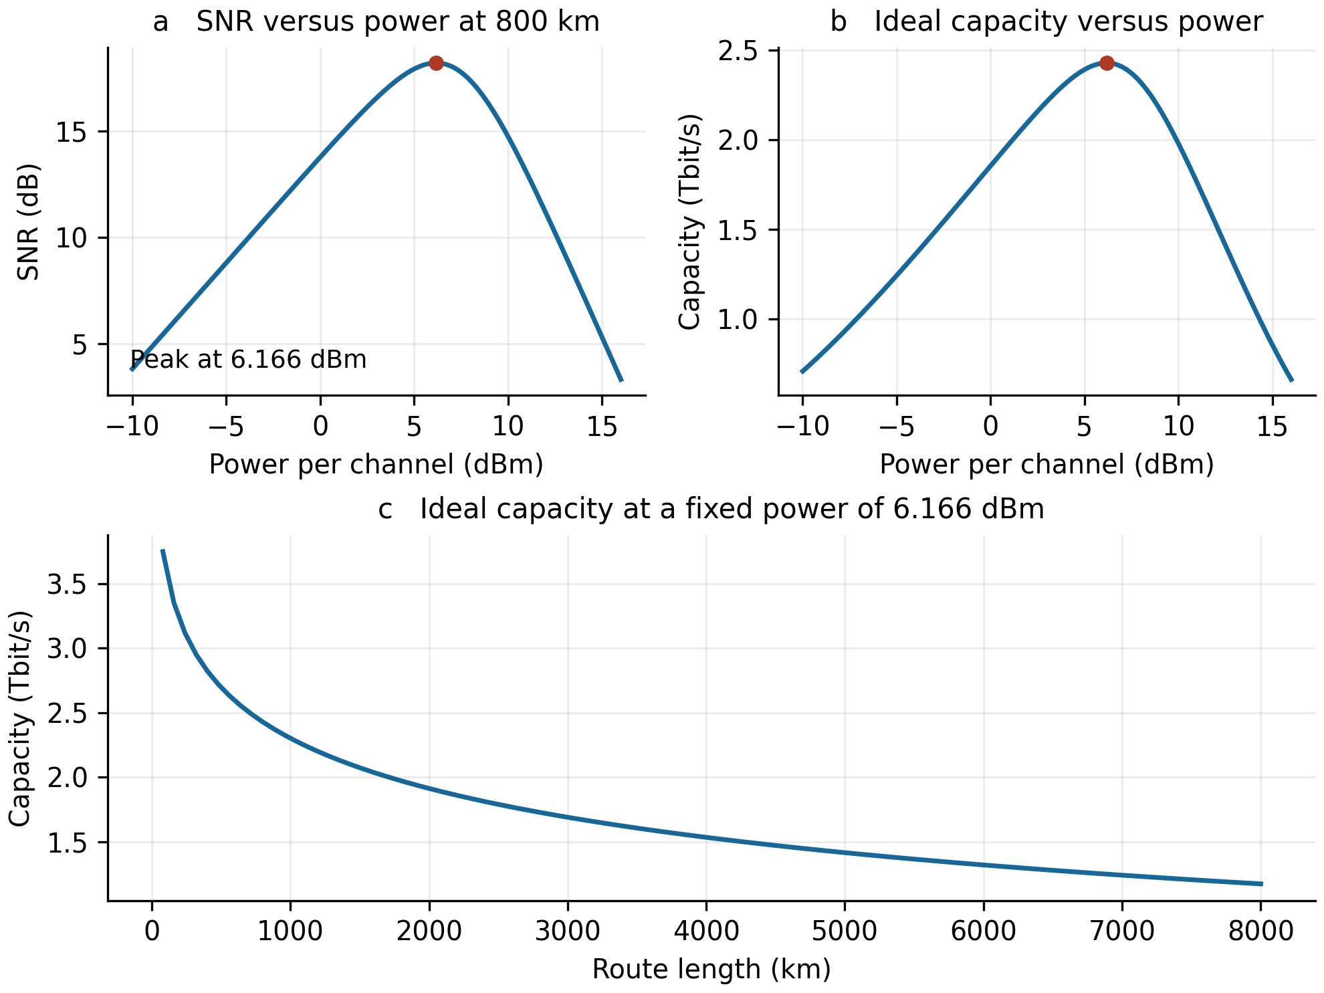
Figure 1. Central-channel SNR and ideal dual-polarisation capacity. Panels a and b use an 800 km route. Panel c holds power at 6.166 dBm while increasing the number of 80 km spans. All panels use the full-load baseline.
Length in km | SNR in dB | Ideal C in Tbit/s | Selected format | Net Gbit/s
800 | 18.215 | 2.429 | PM-32QAM | 1666.7
1600 | 15.205 | 2.038 | PM-16QAM | 1333.3
4000 | 11.226 | 1.534 | PM-8QAM | 1000.0

Doubling the span count reduces SNR by 3.010 dB in this baseline. The ideal capacity and modulation net rate quantify different quantities: the former is a continuous information-theoretic estimate, while the latter is restricted to the available modulation formats and the chosen FEC overhead.

4 Network model and optimisation
The test network contains four nodes and five undirected links. Figure 2 specifies link lengths and initial free wavelength identifiers. Opposite directions share the same resource state in this simplified model. Wavelengths not listed as free are unavailable to the test requests. Scenario B changes only the free set on A-C.
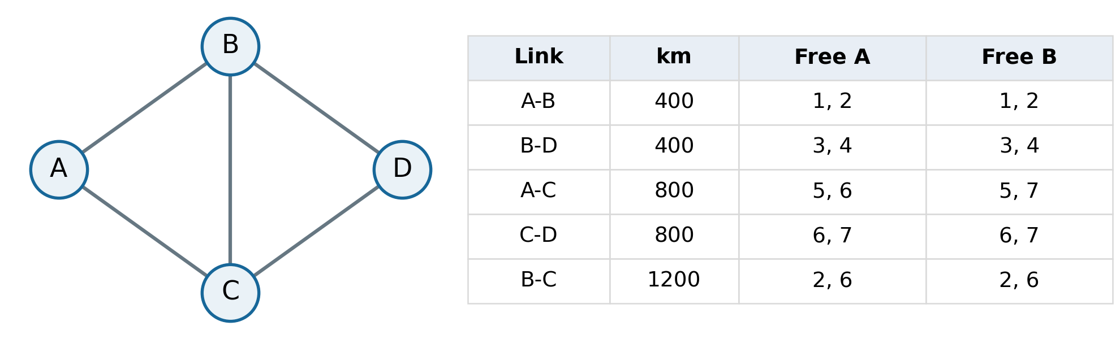
Figure 2. Illustrative topology and initial resources. Free A and Free B denote free wavelength identifiers in scenarios A and B. Node positions have no geographical meaning.
The ordered request list is C to D, A to D, B to D, and A to D, each demanding 1000 Gbit/s. A request must be carried by one lightpath, with one wavelength continuous along the entire route. There is no conversion, regeneration, grooming, splitting or departure. Accepted requests retain their resources for the rest of the experiment.
Up to K = 4 shortest simple paths are generated for each node pair. At fixed common power and required margin, routes are filtered by their supported net rate. Each remaining route and common free wavelength defines an allocation option. Physical feasibility uses the full-load central-channel SNR throughout, so it can be precomputed independently of which requests are admitted.
For request r with demand d_{r}, let Ω_{r} be its feasible options and let x_{ro} indicate selection of option o. The offline problem maximises admitted demand T, with at most one option per request and at most one use of each link-wavelength resource:
$$\max_{x} T = \sum_{r}{d_{r}\sum_{o∈Ωᵣ}{x_{ro}}}, x_{ro} ∈ \{0, 1\}$$
$$\sum_{o∈Ωᵣ}{x_{ro}} ≤ 1 ∀r$$
$$\sum_{r,o: (e,λ)∈o}{x_{ro}} ≤ 1 ∀(e, λ)$$
Initial resource availability and the SNR/rate conditions are already enforced when constructing Ω_{r}. A positive net-rate surplus is left unused, so the objective sums request demands rather than lightpath capacities. Background traffic is excluded from T.
Two solvers were implemented: exhaustive enumeration for the small example, and binary ILP using SciPy. Sequential heuristics inspect paths in distance order and select either the smallest or largest available wavelength identifier on the first feasible path. Each trial begins from a fresh copy of the initial resource state.

5 Allocation and launch power results
Both offline solvers admit three of the four requests, giving 3000 Gbit/s and a blocked fraction of 25% for this batch. The ILP has seven binary variables and ten constraints. The two A-to-D requests compete for a single feasible wavelength on A-C-D, limiting admission to one of them. Sequential results depend on the wavelength rule:
Scenario | Lowest identifier | Highest identifier | Offline optimum
A | 2000 Gbit/s | 3000 Gbit/s | 3000 Gbit/s
B | 3000 Gbit/s | 2000 Gbit/s | 3000 Gbit/s

In scenario A, admitting C-to-D on wavelength 6 removes the only A-to-D option; wavelength 7 preserves it. Scenario B reverses this preference. These constructed cases do not establish a general ranking of the rules. The offline benchmark knows all requests in advance, whereas the sequential policy processes them in order. In a separate two-request A-to-D check, K = 1 admitted no requests; K = 2, 3 and 4 each admitted one.
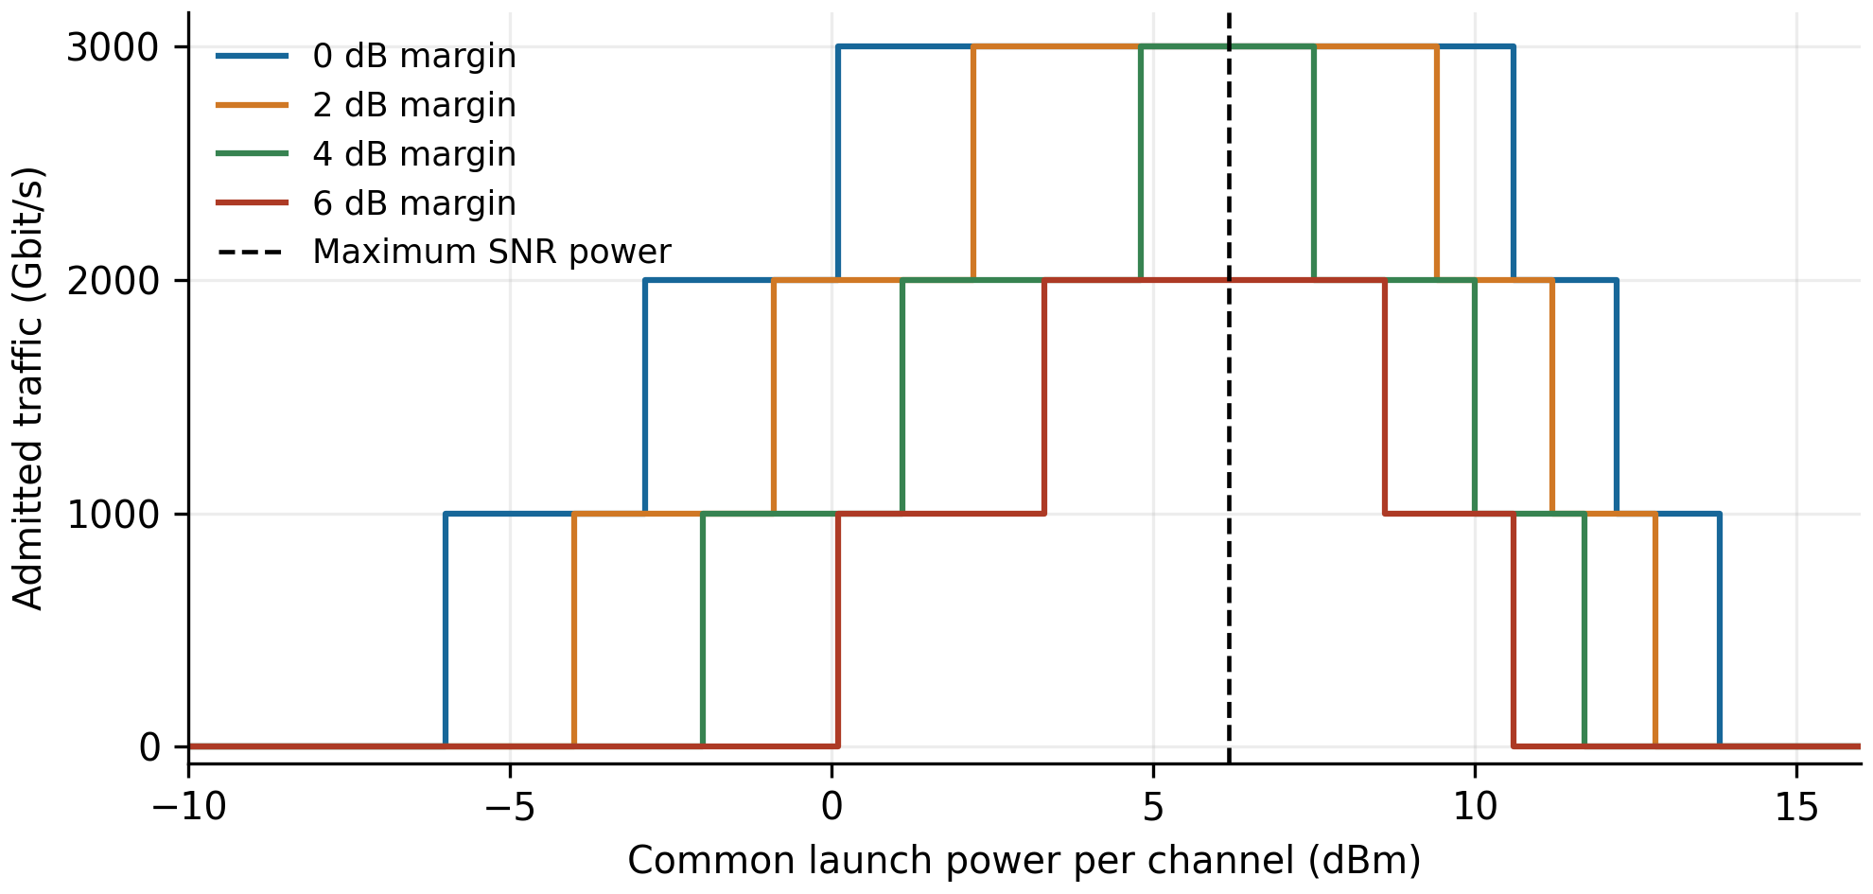
Figure 3. Optimal admitted traffic versus common launch power, with required SNR margins of 0, 2, 4 and 6 dB. The vertical line marks the power that maximises route SNR for the baseline.
Required margin | Maximum T in Gbit/s | Power samples giving 3000 Gbit/s
0 dB | 3000 | 0.1 to 10.5 dBm
2 dB | 3000 | 2.2 to 9.3 dBm
4 dB | 3000 | 4.8 to 7.4 dBm
6 dB | 2000 | Not achievable

Power was sampled from -10 to 16 dBm in 0.1 dB steps; the reported endpoints are sampled values. Discrete requests create broad throughput plateaus even though SNR has a distinct peak. A larger required margin narrows these feasible power ranges and can reduce the maximum admitted traffic.

6 Margin limit and distance sensitivity
To maintain 3000 Gbit/s in scenario A, one A-to-D request must use A-C-D. At the optimal common power, this 1600 km route reaches 15.205 dB. PM-8QAM is sufficient for its 1000 Gbit/s demand and requires 10.81 dB. The limiting common margin is therefore:
$$M_{max} = 15.205 - 10.81 = 4.395 dB$$
Using unrounded values, bisection with the ILP as a feasibility check agrees with the analytical boundary to within 10⁻⁴ dB. At 4.39 dB, 3000 Gbit/s remains feasible; at 4.40 dB, the optimum is 2000 Gbit/s. The route can downgrade from PM-16QAM to PM-8QAM to reserve more margin while still meeting demand. At 6 dB, both A-to-D requests are infeasible.
For the distance study, all link lengths are multiplied by a common factor a. The span length remains 80 km, and the common power, requests and initial wavelength availability are held fixed. With ε = 0:
$${SNR}_{r}\left(a\right) = \frac{{SNR}_{r}\left(1\right)}{a}, {SNR}_{r,dB}\left(a\right) = {SNR}_{r,dB}\left(1\right) - 10\log_{10}a$$
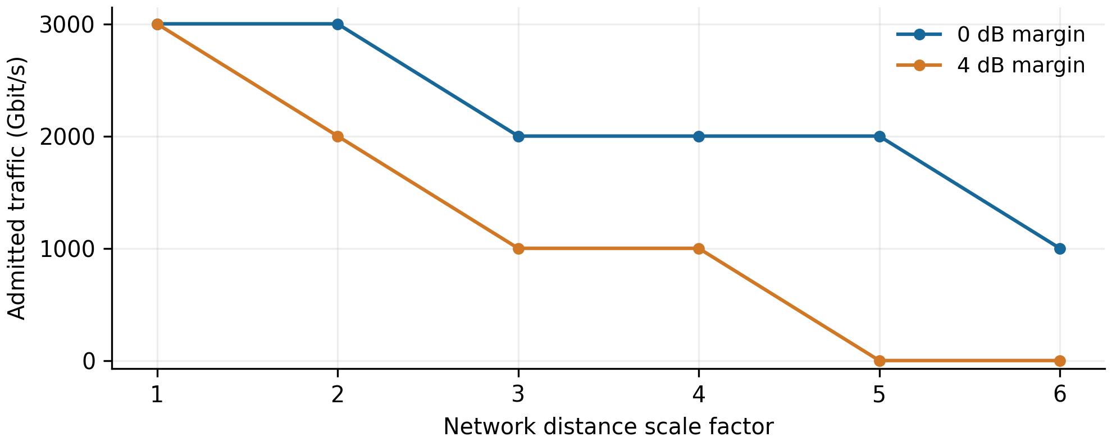
Figure 4. Admitted traffic versus network distance scale. Markers are the computed networks; connecting lines are guides rather than continuous interpolation of admission decisions.
Distance scale | A-C-D length in km | T at 0 dB margin | T at 4 dB margin
1 | 1600 | 3000 | 3000
2 | 3200 | 3000 | 2000
3 | 4800 | 2000 | 1000
4 | 6400 | 2000 | 1000
5 | 8000 | 2000 | 0
6 | 9600 | 1000 | 0

Traffic entries are in Gbit/s. Plateaus occur while the same requests remain admissible despite falling SNR. A zero entry means that none of the four test requests is admitted under the stated margin; previously occupied background resources are outside this metric.

7 Implementation and numerical checks
The original sequential teaching script has been refactored into physical_model.py, network_model.py and run_experiments.py. Physical parameters and resource states are passed explicitly. Distance scans create independent network instances, and importing a module does not execute earlier experiments. All links are checked to contain an integer number of complete spans.
Nine regression checks passed, covering physical reference values, candidate paths, sequential rules, ILP versus exhaustive search, power and margin boundaries, distance scaling, state isolation and demand-weighted allocation. Direct comparison with the original script matched all 1044 power/margin samples and all 12 distance/margin samples. Physical coefficients matched within a relative tolerance of 10⁻¹² [2]. These checks establish numerical consistency of the implementation, rather than independent validation of the physical model.
The automated checks ran on Linux with Python 3.12.14, NumPy 2.3.5, SciPy 1.17.0, NetworkX 3.7 and Matplotlib 3.10.8. The earlier step scripts were run on Windows Python 3.13; the earlier refactored network package has not yet been directly tested in that environment.

8 Reference parameter physical layer checks
Steps 26 to 30 separate parameter alignment, single-span approximation error and multi-span accumulation. They establish the reference physical layer adopted for subsequent work [3]. The exploratory network results in Sections 4 to 6 remain associated with the earlier parameter set.

Reference parameters
Parameter | Exploratory configuration | Adopted reference configuration
Symbol rate | 200 GBd | 32 GBd
Channel count | 25 | 80
Channel spacing | 400 GHz | 50 GHz
Amplifier noise figure | 4.5 dB | 5.0 dB
Adopted accumulation | Linear SPM and XPM | Coherent SPM and linear XPM

The reference values follow [1, Table 3.1, p. 40]. Both configurations use 80 km spans, 0.22 dB/km attenuation, |β₂| = 21.3 ps²/km, γ = 1.3 W⁻¹ km⁻¹ and a 193.5 THz carrier. Step 26 first retained closed-form coefficients and incoherent accumulation to isolate the parameter change. It gave 0.746598 μW ASE per span and, at 800 km, P_{opt} = -1.388514 dBm, SNR = 18.119704 dB and C = 386.643781 Gbit/s. Metre/kilometre equivalence, comb symmetry, the NLI/ASE ratio of one half at the optimum, and agreement between analytical and swept optimum powers were checked.

Single span integration
Step 27 evaluates the matched-filter integrals in [1, Eqs. 4.22 and 4.23] and compares them with the closed-form expressions in Eqs. 4.24 and 4.25. For rectangular spectra, the original triple integral reduces exactly to a weighted two-dimensional integral. Independent direct triple-integral checks for SPM and 50 GHz XPM agree with the reduced calculation.
The table reports coefficients in W⁻². Error is 10 log₁₀(closed form / numerical), so a positive value means the closed form overestimates the coefficient. The total uses the central channel (index 40), with 79 interferers: separations 50 to 1950 GHz occur twice each and 2000 GHz once.
Contribution | Closed form | Numerical integral | Error in dB
SPM | 208.666579 | 170.464462 | +0.878190
XPM at 50 GHz | 91.163434 | 80.973180 | +0.514795
XPM at 200 GHz | 22.318049 | 21.858283 | +0.090402
XPM at 400 GHz | 11.147121 | 11.176832 | -0.011560
XPM at 2000 GHz | 2.228662 | 2.288262 | -0.114615
Total single span η | 974.117136 | 911.801967 | +0.287107

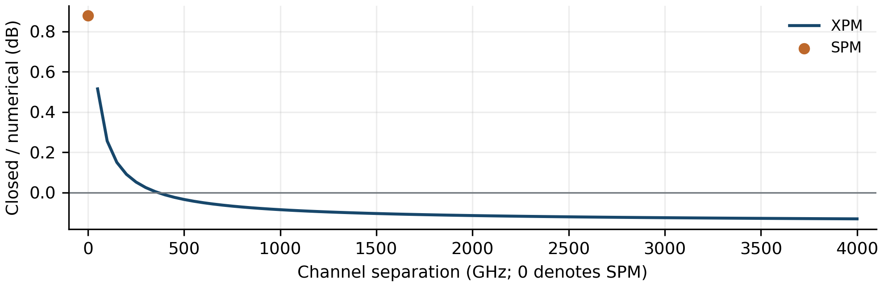
Figure 5. Single-span closed-form approximation error under the thesis reference parameters. The SPM point is separate from the XPM curve; the 4000 GHz range extends beyond the separations needed for the central channel of the 80-channel comb.
All 81 evaluated coefficients met a refinement criterion of two successive changes below 10⁻⁴ dB. Quadrature refinement is a numerical consistency check, not a rigorous error bound. The summed single-span XPM coefficient is 741.337505 W⁻². Keeping incoherent accumulation, the numerical coefficients give P_{opt} = -1.292812 dBm and SNR = 18.215406 dB at 800 km: a 0.095702 dB increase over the closed-form model when each uses its own optimum. This isolates the single-span approximation.

SPM coherence
Step 28 restores the phased-array factor from [1, Eq. 4.19] inside the SPM integral for 1 to 100 identical spans. The effective exponent is obtained from the integrated coefficients; it is not supplied as an input. Using the thesis definition at 100 spans gives:
$$ε_{100} = \frac{log\left(\frac{X_{SPM}\left(100\right)}{X_{SPM}\left(1\right)}\right)}{log 100} - 1 = 0.218566379$$
This rounds to the reported value 0.2186 [1, p. 68]. The effective exponent varies with distance (0.260351 at ten spans), so a fixed exponent is an approximation. The 100-span exponent gives a maximum absolute SPM coefficient error of 0.419225 dB over the checked 1 to 100 spans. This is an SPM coefficient error, not an SNR error. The adopted model retains the numerical coherent SPM integral.
With XPM still linear, the 800 km optimum changes from -1.292812 to -1.499563 dBm and maximum SNR changes from 18.215406 to 18.008655 dB. The optimum decreases further with distance, as shown in Figure 6a. Independent one- and two-dimensional SPM integrals agree at 1, 10 and 100 spans. The stable phased-array factor also agrees with explicit complex phasor sums.

XPM accumulation
Step 29 changes only XPM accumulation, retaining the same coherent SPM and ASE. It evaluates all 40 unique interferer separations at 1, 2, 5, 10, 20, 50 and 100 spans. At 100 spans, the nearest-neighbour XPM correction is 0.119041 dB, while the correction to the sum of all 79 XPM contributions is 0.038937 dB. After adding SPM and optimising power, the maximum SNR change is below 0.009 dB at every tested span count; its largest sampled value is 0.008124 dB at 50 spans.
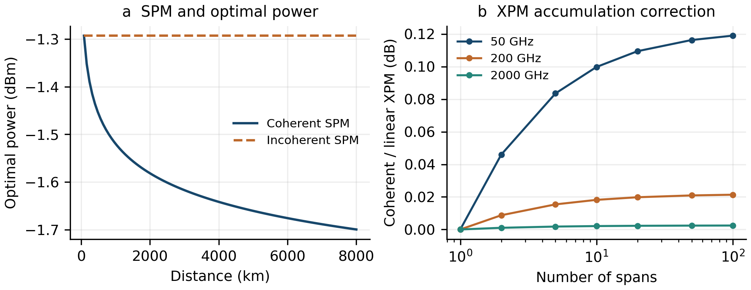
Figure 6. Multi-span checks. Panel a retains linear XPM in both models. Panel b shows individual XPM corrections; their effect on link SNR also depends on the other noise contributions. Both panels use identical contiguous spans.
A separate 500-span nearest-neighbour check gives 0.121540 dB, consistent with the thesis statement of less than 0.13 dB. Single-span agreement, independent multi-span two-dimensional integrals and shifted integration panels also pass. These results support retaining linear XPM for the checked configuration.

Unified reference physical model
Step 30 consolidates the adopted model in reference_physical_model.py. The SNR and ideal-capacity relations in Section 2 now use the following nonlinear coefficient, where the single-span XPM term is summed over all interferers:
$$η\left(N_{s}\right) = X_{SPM,coh}\left(N_{s}\right) + N_{s}X_{XPM,1}$$
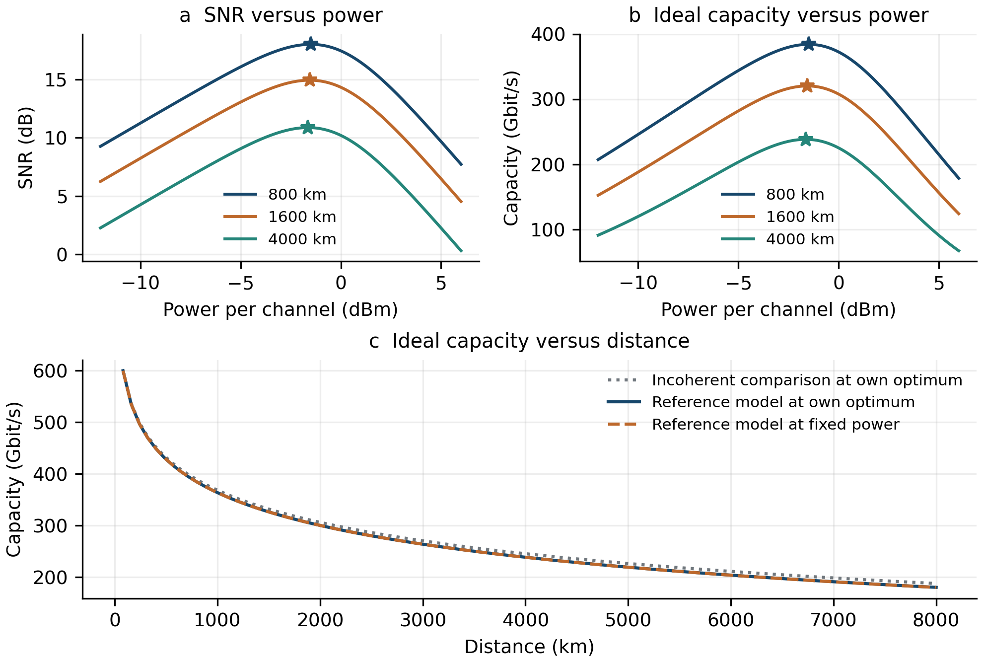
Figure 7. Recomputed reference-model relationships. Stars mark analytical optima. In panel c, fixed power is -1.499563 dBm, the 800 km optimum; it nearly coincides with the re-optimised reference curve. All capacities are ideal dual-polarisation values for one channel.
Distance  in km | Optimal power  in dBm | Maximum SNR  in dB | C at optimum  in Gbit/s | C at fixed P  in Gbit/s
800 | -1.499563 | 18.008655 | 384.319146 | 384.319146
1600 | -1.562049 | 14.935869 | 320.458340 | 320.439733
4000 | -1.641802 | 10.876716 | 238.495605 | 238.403074
8000 | -1.699729 | 7.808489 | 180.162524 | 179.991789

Across 80 to 8000 km, the largest gain from retuning power is 0.205514 Gbit/s, at 80 km. From 800 to 1600 km, each at its own optimum, SNR decreases by 3.072786 dB; the exact 3.010300 dB doubling rule belongs to the incoherent model. All 100 Step 28 operating points were reproduced, and four regression tests passed. Steps 26 to 30 were also run successfully on Windows Python 3.13, with matching output tables and figures.

9 Scope and limitations
The network allocation results concern a four-node network and a small fixed request batch. The measured blocked fractions are batch outcomes, not estimates of a steady-state blocking probability. No statistical ranking of heuristics or scalability claim is supported yet. The present ILP is exact within its precomputed candidate set and constraints.
The adopted reference model assumes identical contiguous spans, rectangular spectra, equal launch powers and full-load central-channel interference. Its SPM/XPM decomposition omits additional multi-channel mixing terms, occupancy-dependent NLI, Raman power transfer, wavelength-dependent gain and transceiver or ROADM filtering penalties. The numerical checks quantify selected approximations within this model. They do not establish agreement with split-step Fourier propagation or measured transmission performance. Their accuracy should not be assumed unchanged after altering the fibre, spectra, channel loading or add/drop pattern.

10 Proposed next phase
The reference-parameter numerical review is complete for the present scope. The next step is to connect reference_physical_model.py to the thesis modulation thresholds, FEC overhead and explicit SNR margins. Traffic demands must then be made consistent with 32 GBd before rerunning the network allocation experiments. For example, PM-32QAM at 32 GBd with 20% FEC overhead gives 266.7 Gbit/s before other framing overhead; the earlier 1000 Gbit/s single-lightpath requests therefore require a revised traffic or service model.
A larger topology and traffic model should be agreed with the supervisor. Algorithm comparisons should use identical input instances, varying demands and offered loads, and multiple random seeds, reporting admitted traffic, blocked demand and runtime. ILP can measure heuristic gaps on tractable instances. The next research question is which constraints cause those gaps and whether a targeted routing or wavelength-selection rule reduces them at lower computational cost. Individual channel-power optimisation and the later stages of the thesis workflow remain future work.

References
[1] D. J. Ives, Coherent Optical Fibre Networking in the Nonlinear Regime, PhD thesis, University College London, December 2015. Table 3.1, p. 40; Table 4.2, p. 60; Eq. 4.15, p. 62; Eqs. 4.18 to 4.23, pp. 63 to 65; Eqs. 4.24 to 4.25, p. 67; Eqs. 4.32 to 4.33, p. 68; Fig. 6.1 and Eq. 6.1, pp. 98 to 99.
[2] T. Wang, Optical networking exploratory code and numerical records, 28 October 2026: step25_traffic_vs_distance.py and optical_networking_refactored, including example_results and VALIDATION.json.
[3] T. Wang, Reference physical-layer checks and numerical records, 28 October 2026: Steps 26 to 30, their results_step26 to results_step30 outputs, and the reusable reference_physical_model.py module. The records include quadrature histories, independent integration checks and regression results.

