导师周报 Weekly research update · 2026 年 11 月 6 日 / 6 November 2026

光网络规模与非均匀流量实验
Network size and nonuniform traffic in an optical mesh
上周您建议我们先扩大网络，再研究非均匀流量。本周我们先用四节点案例检验物理模型，再转到 12 节点网络。均匀流量下，我们看到连续波长会限制接纳。流量集中到 F 后，瓶颈出现在 F 周围。引入混合速率后，即使接纳的连接变少，总业务量也可能增加。
Following your suggestion, we first checked the physical model on four nodes, then moved to a 12-node mesh. Under uniform traffic, wavelength continuity limited which requests we could serve. A traffic hotspot concentrated congestion around node F. With mixed rates, we could carry more traffic even while admitting fewer connections.

Step 31 四节点模型验证 Four node model check
我们把 32 GBd、80 信道的参考物理模型接入路由和波长分配。原案例使用 200 GBd，因此把单请求从 1000 按比例调到 160 Gbit/s，保留原有的 PM-8QAM 最低调制要求。四个请求合计 640 Gbit/s。
We connected the 32 GBd, 80-channel physical model to route and wavelength allocation. Scaling each demand from 1,000 to 160 Gbit/s in proportion to the change from 200 to 32 GBd preserved the minimum PM-8QAM requirement. The four requests offered 640 Gbit/s in total.
初始波长场景  Initial availability | 先选最小编号  Lowest first | 先选最大编号  Highest first | 穷举及 ILP  Exact methods
A | 320 | 480 | 480
B | 480 | 320 | 480
表中数值为接纳业务量（Gbit/s），公共发射功率约 −1.50 dBm，裕量为 0 dB。
Entries are admitted demand in Gbit/s at a common launch power of −1.50 dBm and zero SNR margin.
穷举和整数线性规划（ILP）都得到 480 Gbit/s，即接纳三个请求。改变初始空闲波长后，两种顺序规则的优劣互换。固定发射功率时，A–C–D 的 SNR 约为 14.935 dB，扣除 PM-8QAM 门限 10.81 dB 后，恰好解释了维持 480 Gbit/s 的最大裕量约 4.125 dB。
Exhaustive search and integer linear programming (ILP) both admitted three requests, or 480 Gbit/s. Changing initial wavelength availability reversed the ranking of the two sequential rules. At fixed power, the 14.935 dB SNR on A–C–D minus the 10.81 dB PM-8QAM threshold explains the measured margin limit of about 4.125 dB for carrying 480 Gbit/s.

Step 32 扩大到十二节点网络
Uniform traffic on the larger mesh
我们在 12 节点、17 条双向共享链路的合成网格上建立均匀流量基线。水平链路长 320 km，垂直链路长 480 km。每条链路开放 8 个波长，物理模型按 80 信道满载计算，预留 2 dB 裕量。节点数、请求及波长配置都随两个步骤而变，因此我们用 12 节点内部的负载对照解释结果。
We established a uniform baseline on a synthetic 12-node mesh with 17 links shared by both directions. Horizontal links span 320 km and vertical links 480 km. Each link offers eight wavelengths. The physical model assumes 80 loaded channels and a 2 dB margin. Because the two steps also differ in demands and resources, we compare loads within the 12-node mesh to interpret the results.
66 种节点对等概率抽样，每个请求 100 Gbit/s。SP-FF 尝试一条最短路径，KSP-FF 最多尝试四条。两者按顺序选择第一条可行路径上的最小公共空闲波长。离线 ILP 提前知道整批需求，在每个请求的四条候选路径内给出已证明的最优接纳业务量。
All 66 node pairs were equally likely, at 100 Gbit/s per request. SP-FF tried one shortest path and KSP-FF up to four. Both assigned the lowest common free wavelength on the first feasible path, in arrival order. Offline ILP knew the full batch and proved the maximum admitted traffic within the four candidates per request.
请求数  Requests | 总需求  Offered | SP-FF | KSP-FF | ILP
24 | 2,400 | 2,370 | 2,400 | 2,400
48 | 4,800 | 4,000 | 4,270 | 4,640
72 | 7,200 | 4,930 | 5,220 | 5,810
96 | 9,600 | 5,700 | 5,860 | 6,890
各业务量列单位均为 Gbit/s。接纳量为 10 个随机种子的均值；每批请求占用资源到批次结束。
Traffic is in Gbit/s. Admitted traffic is the mean across 10 seeds. Connections hold their wavelengths for the full batch.
在 96 个请求时，四条候选路径比一条平均多承载 160 Gbit/s，离线 ILP 又比 KSP-FF 多承载 1030 Gbit/s。48 请求、种子 0 的第 35 个请求说明了差异的来源。D→I 的四条路径都支持 160 Gbit/s，足以承载其 100 Gbit/s 需求。KSP-FF 找不到端到端公共波长，ILP 的整批分配让第一条路径可以全程使用波长 39。
At 96 requests, trying four paths carried 160 Gbit/s more on average than trying one. Offline planning added another 1,030 Gbit/s over KSP-FF. Request 35 in the 48-request batch with seed 0 shows one reason. All four D-to-I paths supported 160 Gbit/s, enough for its 100 Gbit/s demand. KSP-FF found no common free wavelength. The ILP allocation made wavelength 39 available along the first path.

热点流量使拥塞集中在 F 周围
Congestion around node F under hotspot traffic
我们保持每个请求 100 Gbit/s，把以 F 为端点的抽样概率从 11/66（16.67%）提高到 65%。每批 96 个请求仍合计 9600 Gbit/s。KSP-FF 的平均接纳量从 5860 降至 4880 Gbit/s，阻塞率从 38.96% 升至 49.17%，增加 10.21 个百分点。
We kept each request at 100 Gbit/s and raised the probability of an endpoint at F from 11/66 (16.67%) to 65%. Each batch of 96 still offered 9,600 Gbit/s. Mean KSP-FF admissions fell from 5,860 to 4,880 Gbit/s. Blocking rose from 38.96% to 49.17%, an increase of 10.21 percentage points.
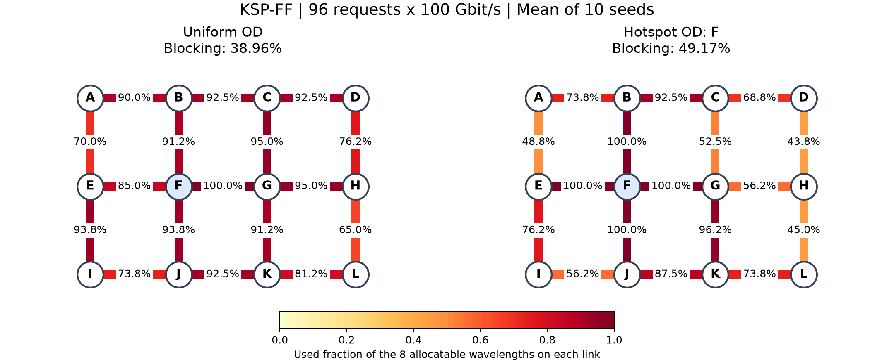
图中数字为链路波长占用率。左图为均匀流量，右图为 F 热点，均为 10 个种子的平均值。
Labels show mean wavelength utilisation over 10 seeds, with uniform traffic on the left and hotspot traffic on the right.
在全部 10 个热点批次中，KSP-FF 都用满了 F 相邻的四条链路，而外围 D–H 的平均占用率为 43.75%。F 周围共有 4 × 8 = 32 份链路波长资源。以 F 为端点的连接用一份，经过 F 的连接用两份。平均 63.8 个请求必须到达 F，即使其他地方都有空闲资源，这一限制也使每批平均至少被拒绝 31.8 个请求。
KSP-FF filled all four links adjacent to F in every hotspot batch, while mean utilisation on the outer D–H link was 43.75%. The four links supply 32 link–wavelength resources. A connection ending at F uses one and a connection passing through uses two. With 63.8 requests involving F on average, this local limit alone forced at least 31.8 rejections per batch on average.
例如种子 0 的 G→I 请求，KSP-FF 走 G–F–E–I，ILP 走 G–K–J–I。两条路径同为 1120 km，后者为必须到达 F 的请求腾出了两份资源。
For example, KSP-FF routed G to I via G–F–E–I in seed 0. ILP used G–K–J–I. Both paths were 1,120 km long, but the latter left two resources near F available for connections that needed them.

混合速率下的连接数和业务量
Connections served and traffic carried at mixed rates
在相同的节点对序列上，我们把 96 个请求分成 24 个 50、48 个 100、24 个 150 Gbit/s，总需求仍为 9600 Gbit/s。每个请求在所经链路上各占一个完整波长。ILP 最大化接纳的 Gbit/s，因此会重新选择接纳组合。
For the same sequence of node pairs, we assigned 24 requests at 50, 48 at 100 and 24 at 150 Gbit/s. Total demand was again 9,600 Gbit/s. Each connection occupies one wavelength on every link it uses. ILP maximises admitted Gbit/s, so changing the rates can change which requests it admits.
流量场景  Traffic | 接纳数  Admitted | 接纳业务量  Gbit/s | 请求阻塞率  By count | 业务阻塞率  By Gbit/s
均匀固定  Uniform fixed | 68.9 | 6,890 | 28.23% | 28.23%
均匀混合  Uniform mixed | 67.0 | 7,435 | 30.21% | 22.55%
热点固定  Hotspot fixed | 59.4 | 5,940 | 38.13% | 38.13%
热点混合  Hotspot mixed | 58.7 | 6,745 | 38.85% | 29.74%
ILP 在 96 请求下的 10 种子均值。请求阻塞率按拒绝的请求数计；业务阻塞率按拒绝的 Gbit/s 计。
ILP means across 10 seeds at 96 requests. Blocking is the share of offered requests or offered Gbit/s rejected.
热点组平均少接纳 0.7 个请求，却多承载 805 Gbit/s。种子 0 的混合速率方案接纳了 67 个请求，其中三档分别为 10、33、24 个，合计 7400 Gbit/s。96 个请求中有 29 个被拒绝（30.21%），9600 Gbit/s 中有 2200 Gbit/s 被拒绝（22.92%）。
Under hotspot traffic, ILP served 0.7 fewer connections on average but carried 805 Gbit/s more. In mixed-rate seed 0, it served 67 requests, admitting 10, 33 and 24 in the three rate classes for a total of 7,400 Gbit/s. It rejected 29 of 96 requests (30.21%) and 2,200 of 9,600 Gbit/s (22.92%).
因此我们同时报告两种阻塞率和分档接纳率。在热点混合场景的 10 个批次中，150 Gbit/s 请求接纳了 236/240（98.33%），50 Gbit/s 请求只接纳了 61/240（25.42%）。模型赋予高需求请求更大的目标权重，总业务量的改善伴随着明显的档间差异。
We therefore report both blocking measures and admission by rate. Across the 10 hotspot batches, ILP served 236 of 240 requests at 150 Gbit/s (98.33%) and 61 of 240 at 50 Gbit/s (25.42%). Maximising carried traffic gives more weight to larger demands, and the gains come with a marked difference in service between rate classes.

