Optical networking preliminary report
  - Phase one physical modelling and resource allocation
Tianze Wang | tw609
Department of Engineering, University of Cambridge
Supervisor Seb Savory | 28 October 2026

Summary
The first phase has established a reproducible Python baseline linking optical transmission quality to routing and wavelength allocation. For an 800 km reference link, the model gives an optimal common per-channel launch power of 6.166 dBm, a maximum SNR of 18.215 dB and an ideal central-channel capacity of 2.429 Tbit/s. In a four-node network, exhaustive search and a binary integer linear programme both admit 3000 Gbit/s from four requests totalling 4000 Gbit/s. Power, distance and SNR-margin studies show how physical feasibility changes this admitted traffic. These results provide a checked baseline for subsequent algorithm studies; validation against larger networks and more detailed physical models remains to be completed.

1 Baseline parameters
Parameter | Value
Symbol rate and channel count | 200 GBd; 25 channels
Channel spacing and carrier frequency | 400 GHz; 193.5 THz
Span length and reference route | 80 km; 800 km or 10 spans
Fibre attenuation | 0.22 dB/km
Dispersion magnitude | 21.3 ps²/km
Nonlinearity coefficient | 1.3 W⁻¹ km⁻¹
Amplifier noise figure | 4.5 dB
SPM coherence exponent | ε = 0 in the baseline
FEC overhead | 20%

Powers refer to the total signal over both polarisations. All WDM channels share the same launch power. The chosen parameters are a modelling baseline, rather than an exact match to every parameter used in the thesis.

2 Physical model and rate selection
The signal-to-noise ratio includes amplified spontaneous emission (ASE) and nonlinear interference (NLI). The latter is represented by self-phase modulation (SPM) and the summed cross-phase modulation (XPM) from other channels. The single-span coefficients use the closed-form expressions reproduced in [1, Eqs. 4.24 and 4.25]; the route model follows the structure of [1, Eq. 6.1].
$$P_{ASE} = N_{s}A_{span}, η\left(N_{s}\right) = {N_{s}}^{1+ε}X_{SPM} + N_{s}X_{XPM}$$
$$SNR\left(P, N_{s}\right) = \frac{P}{N_{s}A_{span} + η\left(N_{s}\right)P^{3}}, C = 2R_{s}\log_{2}\left(1 + SNR\right)$$
Here P is the common power per channel in watts, N_{s} is the number of spans, A_{span} is the ASE power added per span, and η has units W⁻². X_{SPM} and X_{XPM} are single-span coefficients, with X_{XPM} denoting the sum over interfering channels for the central channel. C is the ideal dual-polarisation Shannon capacity of that channel and R_{s} is the symbol rate.
The high-gain ASE approximation uses the linear amplifier noise factor F, Planck constant h, carrier frequency ν, and amplifier gain G compensating one span of loss:
$$A_{span} = FhνR_{s}G$$
The baseline gives A_{span} = 4.159 μW, X_{SPM} = 18.228 W⁻² and X_{XPM} = 11.158 W⁻². For ten spans, total ASE is 41.588 μW and η = 293.860 W⁻².
Differentiating the SNR with respect to power gives the analytical optimum below. At this point, the NLI power equals half the ASE power. With ε = 0, both noise contributions scale linearly with N_{s}, so the optimum power is independent of route length under the homogeneous-span assumptions.
$$P_{opt} = {\left(\frac{N_{s}A_{span}}{2η\left(N_{s}\right)}\right)}^{\frac{1}{3}}$$
For connection admission, the SNR is mapped to a supported modulation format. The thresholds are taken from the pre-FEC BER = 0.015 column of [1, Table 4.2], corresponding to the assumed 20% FEC overhead. The selected format is the highest-rate format satisfying the required margin M.
$$R_{net} = \frac{R_{s}b_{DP}}{1 + o_{FEC}}, {SNR}_{dB} ≥ {SNR}_{req,dB} + M$$
The bit loading b_{DP} already includes both polarisations, and o_{FEC} = 0.20. The rate expression includes FEC overhead but no additional framing overhead. The formats most relevant to the reported cases are listed below; the implementation includes the wider table from PM-BPSK to PM-1024QAM.
Format | Required SNR in dB | Net rate in Gbit/s
PM-8QAM | 10.81 | 1000.0
PM-16QAM | 13.24 | 1333.3
PM-32QAM | 16.22 | 1666.7
PM-64QAM | 19.01 | 2000.0

These thresholds are assumptions of the present study. They are not universal specifications for practical transceivers.

3 Physical layer results
At low launch power, ASE dominates and increasing power improves SNR. At high power, the cubic NLI term dominates and SNR decreases. The ideal capacity therefore peaks at the same power as SNR. At fixed power, increasing distance increases accumulated noise and reduces capacity, as shown in Figure 1.
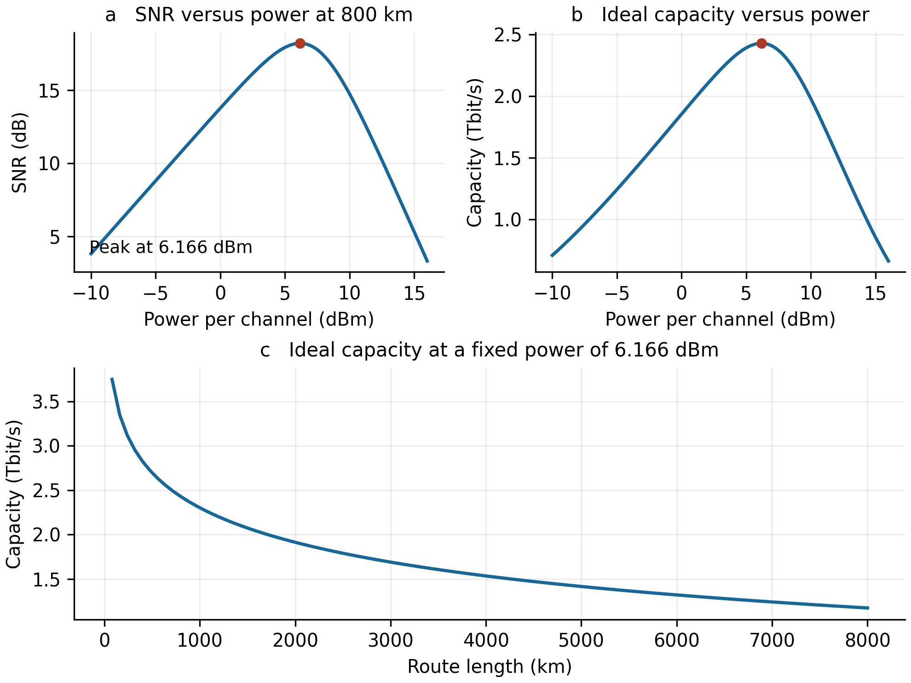
Figure 1. Central-channel SNR and ideal dual-polarisation capacity. Panels a and b use an 800 km route. Panel c holds power at 6.166 dBm while increasing the number of 80 km spans. All panels use the full-load baseline.
Length in km | SNR in dB | Ideal C in Tbit/s | Selected format | Net Gbit/s
800 | 18.215 | 2.429 | PM-32QAM | 1666.7
1600 | 15.205 | 2.038 | PM-16QAM | 1333.3
4000 | 11.226 | 1.534 | PM-8QAM | 1000.0

Doubling the span count reduces SNR by 3.010 dB in this baseline. The ideal capacity and modulation net rate quantify different quantities: the former is a continuous information-theoretic estimate, while the latter is restricted to the available modulation formats and the chosen FEC overhead.

4 Network model and optimisation
The test network contains four nodes and five undirected links. Figure 2 specifies link lengths and initial free wavelength identifiers. Opposite directions share the same resource state in this simplified model. Wavelengths not listed as free are unavailable to the test requests. Scenario B changes only the free set on A-C.
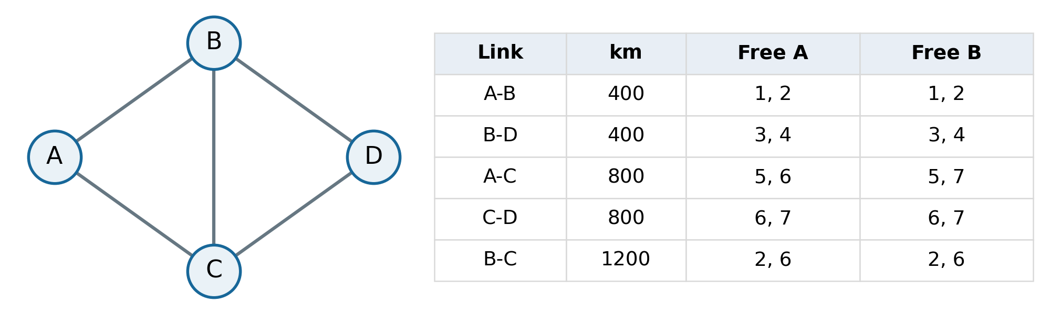
Figure 2. Illustrative topology and initial resources. Free A and Free B denote free wavelength identifiers in scenarios A and B. Node positions have no geographical meaning.
The ordered request list is C to D, A to D, B to D, and A to D, each demanding 1000 Gbit/s. A request must be carried by one lightpath, with one wavelength continuous along the entire route. There is no conversion, regeneration, grooming, splitting or departure. Accepted requests retain their resources for the rest of the experiment.
Up to K = 4 shortest simple paths are generated for each node pair. At fixed common power and required margin, routes are filtered by their supported net rate. Each remaining route and common free wavelength defines an allocation option. Physical feasibility uses the full-load central-channel SNR throughout, so it can be precomputed independently of which requests are admitted.
For request r with demand d_{r}, let Ω_{r} be its feasible options and let x_{ro} indicate selection of option o. The offline problem maximises admitted demand T, with at most one option per request and at most one use of each link-wavelength resource:
$$\max_{x} T = \sum_{r}{d_{r}\sum_{o∈Ωᵣ}{x_{ro}}}, x_{ro} ∈ \{0, 1\}$$
$$\sum_{o∈Ωᵣ}{x_{ro}} ≤ 1 ∀r$$
$$\sum_{r,o: (e,λ)∈o}{x_{ro}} ≤ 1 ∀(e, λ)$$
Initial resource availability and the SNR/rate conditions are already enforced when constructing Ω_{r}. A positive net-rate surplus is left unused, so the objective sums request demands rather than lightpath capacities. Background traffic is excluded from T.
Two solvers were implemented: exhaustive enumeration for the small example, and binary ILP using SciPy. Sequential heuristics inspect paths in distance order and select either the smallest or largest available wavelength identifier on the first feasible path. Each trial begins from a fresh copy of the initial resource state.

5 Allocation and launch power results
Both offline solvers admit three of the four requests, giving 3000 Gbit/s and a blocked fraction of 25% for this batch. The ILP has seven binary variables and ten constraints. The two A-to-D requests compete for a single feasible wavelength on A-C-D, limiting admission to one of them. Sequential results depend on the wavelength rule:
Scenario | Lowest identifier | Highest identifier | Offline optimum
A | 2000 Gbit/s | 3000 Gbit/s | 3000 Gbit/s
B | 3000 Gbit/s | 2000 Gbit/s | 3000 Gbit/s

In scenario A, admitting C-to-D on wavelength 6 removes the only A-to-D option; wavelength 7 preserves it. Scenario B reverses this preference. These constructed cases do not establish a general ranking of the rules. The offline benchmark knows all requests in advance, whereas the sequential policy processes them in order. In a separate two-request A-to-D check, K = 1 admitted no requests; K = 2, 3 and 4 each admitted one.
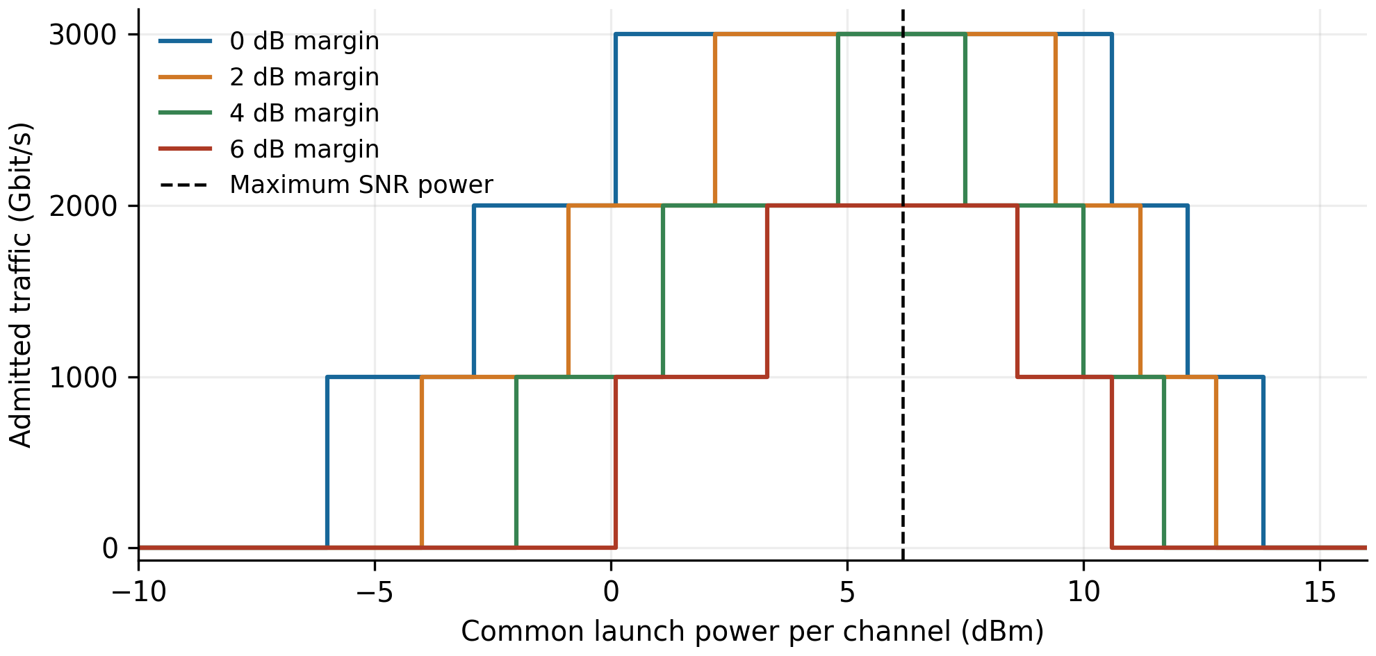
Figure 3. Optimal admitted traffic versus common launch power, with required SNR margins of 0, 2, 4 and 6 dB. The vertical line marks the power that maximises route SNR for the baseline.
Required margin | Maximum T in Gbit/s | Power samples giving 3000 Gbit/s
0 dB | 3000 | 0.1 to 10.5 dBm
2 dB | 3000 | 2.2 to 9.3 dBm
4 dB | 3000 | 4.8 to 7.4 dBm
6 dB | 2000 | Not achievable

Power was sampled from -10 to 16 dBm in 0.1 dB steps; the reported endpoints are sampled values. Discrete requests create broad throughput plateaus even though SNR has a distinct peak. A larger required margin narrows these feasible power ranges and can reduce the maximum admitted traffic.

6 Margin limit and distance sensitivity
To maintain 3000 Gbit/s in scenario A, one A-to-D request must use A-C-D. At the optimal common power, this 1600 km route reaches 15.205 dB. PM-8QAM is sufficient for its 1000 Gbit/s demand and requires 10.81 dB. The limiting common margin is therefore:
$$M_{max} = 15.205 - 10.81 = 4.395 dB$$
Using unrounded values, bisection with the ILP as a feasibility check agrees with the analytical boundary to within 10⁻⁴ dB. At 4.39 dB, 3000 Gbit/s remains feasible; at 4.40 dB, the optimum is 2000 Gbit/s. The route can downgrade from PM-16QAM to PM-8QAM to reserve more margin while still meeting demand. At 6 dB, both A-to-D requests are infeasible.
For the distance study, all link lengths are multiplied by a common factor a. The span length remains 80 km, and the common power, requests and initial wavelength availability are held fixed. With ε = 0:
$${SNR}_{r}\left(a\right) = \frac{{SNR}_{r}\left(1\right)}{a}, {SNR}_{r,dB}\left(a\right) = {SNR}_{r,dB}\left(1\right) - 10\log_{10}a$$
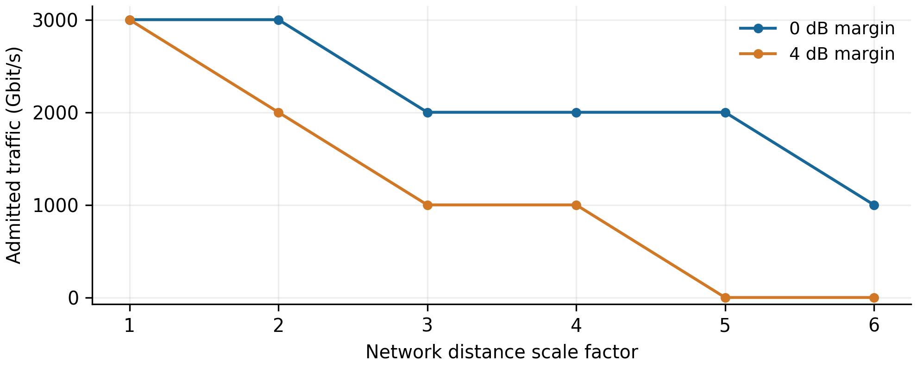
Figure 4. Admitted traffic versus network distance scale. Markers are the computed networks; connecting lines are guides rather than continuous interpolation of admission decisions.
Distance scale | A-C-D length in km | T at 0 dB margin | T at 4 dB margin
1 | 1600 | 3000 | 3000
2 | 3200 | 3000 | 2000
3 | 4800 | 2000 | 1000
4 | 6400 | 2000 | 1000
5 | 8000 | 2000 | 0
6 | 9600 | 1000 | 0

Traffic entries are in Gbit/s. Plateaus occur while the same requests remain admissible despite falling SNR. A zero entry means that none of the four test requests is admitted under the stated margin; previously occupied background resources are outside this metric.

7 Implementation and numerical checks
The original sequential teaching script has been refactored into physical_model.py, network_model.py and run_experiments.py. Physical parameters and resource states are passed explicitly. Distance scans create independent network instances, and importing a module does not execute earlier experiments. All links are checked to contain an integer number of complete spans.
Nine regression checks passed, covering physical reference values, candidate paths, sequential rules, ILP versus exhaustive search, power and margin boundaries, distance scaling, state isolation and demand-weighted allocation. Direct comparison with the original script matched all 1044 power/margin samples and all 12 distance/margin samples. Physical coefficients matched within a relative tolerance of 10⁻¹² [3]. These checks establish numerical consistency of the implementation, rather than independent validation of the physical model.
The automated checks ran on Linux with Python 3.12.14, NumPy 2.3.5, SciPy 1.17.0, NetworkX 3.7 and Matplotlib 3.10.8. The earlier step scripts were run on Windows Python 3.13; the refactored package has not yet been directly tested in that environment.

8 Scope and limitations
The results concern a four-node network and a small fixed request batch. The measured blocked fractions are batch outcomes, not estimates of a steady-state blocking probability. No statistical ranking of heuristics or scalability claim is supported yet. The present ILP is exact within its precomputed candidate set and constraints.
The physical model assumes identical spans, flat parameters, rectangular spectra and full-load central-channel interference. It omits occupancy-dependent NLI, wavelength-dependent gain and Raman power transfer, and additional transceiver or filtering penalties. The closed-form nonlinear coefficients have not been checked against a detailed propagation simulation in this project. Positive ε makes the optimum power depend on route length. Individual channel-power optimisation, spectral reassignment and the later stages of the thesis workflow remain outside the current implementation.

9 Proposed next phase
The next phase should first agree a parameter set, a larger topology and a traffic model with the supervisor. The existing baseline can then be extended to multiple source-destination pairs, varying demands and offered loads. Comparisons should use identical input instances across algorithms and multiple random seeds, reporting admitted traffic, blocked demand and runtime.
For instances small enough to solve exactly, ILP can quantify the gap to heuristic allocation. The next research question is which resource or physical constraints cause that gap, and whether a targeted routing or wavelength-selection rule reduces it at lower computational cost. Machine-learning methods can be considered once a clear decision task and reproducible non-learning baselines have been established.

