QRM II Graded Assignment (6)
  - Period 1, 2026
Fill in your group number and names here
13-10-2026

1 Introduction
This assignment is to be completed in groups of 4-5. Further, all students in your group need to be assigned to the same R tutorial group (Friday’s tutorial). You can sign yourself up for a group on Canvas. Please do so You can use the Discussion Board in Canvas if you do not have a group yet or if your group is incomplete.
The assignment has 5 parts, and each part corresponds to the course material of that week (with the exclusion of week 6, for which there is no R programming material).
You are supposed to hand in these assignments on Canvas at the following dates:
- Deadline 1 Sunday September 27th, at 23:59pm: you are supposed to hand in weeks 1, 2, and 3 of this assignment. This will determine 18% of your overall course grade
- Deadline 2 Sunday October 11th, at 23:59pm: you are supposed to hand in weeks 4, and 5 of this assignment. This will determine 12% of your overall course grade
The R tutorials (each Friday) will consist of two halves. During the first half, you will discuss the tutorial exercises. These can be downloaded separately from Canvas. During the second half, you can work on this graded assignment within your own group. The purpose is that you find out how to work with R for doing statistical analyses by yourself. The tutorial exercises are meant to teach you basic commands to get you started, but to answer the problem sets in this assignment, you might need to research your own solutions, and use functions and commands not described in the tutorial exercises. Learning how to solve your own research problems is integral part of learning R. When you and your group get stuck on how to approach an exercise, the hierarchy in finding your way is as follows:
- use the concepts from the tutorial exercises;
- use the cheat sheets available on Canvas;
- use Google, YouTube, StackOverflow, or another website;
- ask the teacher.
The use of generative AI is permitted and may result in a grade of 0. See the AI protocol in the course manual for details.
To answer the assignment, you can simply fill out this R markdown document. There are designated places which you can fill with R code. There are also designated spaces for you to answer each question. Often, the structure of an answer will be as follows. First, you type the R code in the designated box. This will show how you analyzed the data to get the answer to the question. Below the box for the R code, you will then summarize your answer to the question, i.e. what are the conclusions that you draw from the data analysis?
When handing in, you are supposed to submit this .Rmd file, and a knitted version of this document. You can knit this document to pdf, word, or html. Knitting to pdf requires you to have a .tex distribution installed on your computer. Knitting to Word requires you to have Word installed.
The exercises are designed such that you should be able to finish the majority of them during the tutorial each week. If you are not able to finish them fully during that time, you are expected to work on it in your own time using the computers on campus or your own device. It is best to meet as a group in-person when working together. If you want to work remotely, github is a good platform to guarantee smooth collaboration. Alternatively, you can email this .Rmd file back and forth to one another as a group, but this is not recommended as it is more cumbersome.
We encourage you to keep your code blocks, printing statements, and final answers, as short as possible. In any case, there is a page limit of 6 pages per week, which encompasses the total length of this document which consists of the questions, your coding lines, and your answers. When your answers to questions of the respective week exceed this page limit, they will not be graded, resulting in zero points.

2 Week 1
- Find the dataset “movies4.tsv” on Canvas. Describe your data set: How many observations does it have. How many variables are there? How many subjects? What consists of a subject?
#WRITE YOUR CODE HERE
library(dplyr)
##
## Attaching package: 'dplyr'
## The following objects are masked from 'package:stats':
##
## filter, lag
## The following objects are masked from 'package:base':
##
## intersect, setdiff, setequal, union
library(ggplot2)
library(moments)
## Warning: package 'moments' was built under R version 4.6.1
movies <- read.delim("movies4.tsv")
nrow(movies) * ncol(movies)
## [1] 15352
ncol(movies)
## [1] 19
Your Answer:
Write your response here.
The dataset contains 808 observations and 19 variables. There are 15352 subjects. Each subject represents one movie.
- Which of the following types of variables are present in your data set? (i) nominal; (ii) ordinal; (iii); continuous; (iv) discrete. If present, name one example of such a variable present in your data set.
#WRITE YOUR CODE HERE
str(movies)
## 'data.frame': 808 obs. of 19 variables:
## $ index : int 2256 2473 1514 1512 395 3156 4753 4590 1665 2714 ...
## $ budget : num 0.0 1.5e+07 3.2e+07 3.2e+07 8.5e+07 0.0 6.0e+04 0.0 0.0 1.4e+07 ...
## $ keywords : chr NA "barcelona spain menage a trois author" "gunslinger revenge prairie shootout pistol" "robbery double life dual identity small town indiana" ...
## $ original_language : chr "en" "en" "en" "en" ...
## $ title : chr "The Oogieloves in the Big Balloon Adventure" "Vicky Cristina Barcelona" "The Quick and the Dead" "A History of Violence" ...
## $ popularity : num 0.286 32.758 16.473 34.629 44.967 ...
## $ release_date : chr "2012-08-29" "2008-08-15" "1995-02-09" "2005-09-23" ...
## $ revenue : num 0.00 9.64e+07 1.86e+07 6.07e+07 1.94e+08 ...
## $ runtime : int 88 96 107 96 136 92 93 97 138 149 ...
## $ vote_average : num 2.2 6.7 6.3 6.9 6.7 7.1 5.1 5.6 6.7 6.1 ...
## $ vote_count : int 8 1020 427 832 1225 83 6 4 144 86 ...
## $ genre : chr "Family" "Drama" "Action" "Drama" ...
## $ release_year : int 2012 2008 1995 2005 2006 2011 2012 2004 2004 2011 ...
## $ release_month : int 8 8 2 9 12 8 10 9 9 9 ...
## $ release_day : int 29 15 9 23 8 4 13 23 3 30 ...
## $ first_actor : chr "Christopher Lloyd" "Scarlett Johansson" "Sharon Stone" "Viggo Mortensen" ...
## $ first_actor_gender : chr "male" "female" "female" "male" ...
## $ director_first_name: chr "Matthew" "Woody" "Sam" "David" ...
## $ director_gender : chr "male" "male" "male" "male" ...
Your Answer:
Write your response here.
The dataset contains nominal, continuous, and discrete variables. An example of a nominal variable is “genre”, since genres don’t have a natural order. An example of continuous variable is “revenue”. An example of a discrete variable is “vote_count”, since the number of votes can only take whole-number values. There is no ordinal variable in the dataset.
- A movie studio wants to know which types of movies give maximal revenue. Perform the following steps to provide the movie studio with an analysis which corresponds to their request:
- Summarize the variable revenue and report its mean, median, maximum, and minimum.
- Which movie has the highest revenue in your data set and how much is this revenue. Which movie has the lowest and how much is its revenue? If multiple movies have the exact same highest or lowest revenue, give only one example.
- Create a histogram of the variable revenue. Make sure it has an appropriate title, and appropriate titles and labels for the x- and y-axis. Describe the shape of the histogram. What does this tell you about the nature of making money in the movies industry?
- Add a new variable to your data set: the log of revenue. When creating this variable, what happens to movies for which revenue is zero? What then happens when you calculate the mean of log revenue?
- For movies that have a revenue of zero, replace log of revenue with “NA”. What is now the mean of log of revenue? Create a histogram for log revenue, again with an appropriate title, x- and y-axis labels. Describe the shape of this histogram.
- For the variables revenue and log of revenue calculate their skewness and kurtosis. How do these numbers relate to the shape of the histograms that you estimated under d.) and e.)?
For each step, you should provide first all the code you used to answer the question and then formulate an answer using full sentences.
Each week consists of 1, 2, or 3 subquestions. The total amount of points you can earn per week is 20 points.
Step a
#WRITE YOUR CODE HERE
summary(movies$revenue)
## Min. 1st Qu. Median Mean 3rd Qu. Max.
## 0.000e+00 0.000e+00 1.456e+07 8.273e+07 8.521e+07 1.520e+09
Your Answer:
Write your formulated response here. The mean revenue is approximately $82.73 million, while the median revenue is approximately $14.56 million. The minimum revenue is $0 and the maximum revenue is approximately $1.52 billion.
Step b
movies %>%
filter(revenue==max(revenue)) %>%
slice(1) %>%
select(title, revenue)
## title revenue
## 1 The Avengers 1519557910
movies %>%
filter(revenue==min(revenue)) %>%
slice(1) %>%
select(title, revenue)
## title revenue
## 1 The Oogieloves in the Big Balloon Adventure 0
Your Answer:
The movie with the highest revenue in the dataset is ‘The Avengers’ with a revenue of $1,519,557,910.00. The movie with the lowest revenue is ‘The Oogieloves in the Big Balloon Adventure’ which had no revenue at all.
Step c
ggplot(movies,aes(x = revenue)) +
geom_histogram(bins=30) +
labs(title = "revenue distribution of movies",
x = "Revenue",
y = "number of movies" )
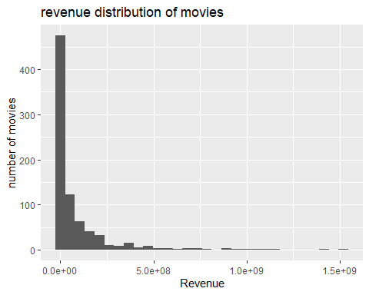
Your Answer:
The shape of the histogram is strongly right-skewed and only has a few outliers to the right. Which shows that most movies generated very little revenue or no revenue at all. The tail to the right represents the small number of movies that did generate a serious amount of revenue. In short, the histogram shows that making money in the movie industry is very difficult, but the few movies that did succeed were able to generate extremely high revenues.
Step d
movies <- mutate(movies, log_of_revenue = log(revenue))
mean(movies$log_of_revenue)
## [1] -Inf
Your Answer: The movies that have a revenue of zero all have a log revenue of minus infinity (-Inf). When the mean of the log value is calculated, the outcome will consequently also become minus infinity (-Inf).
Step e
movies$log_of_revenue[movies$log_of_revenue == -Inf] <- NA
mean(movies$log_of_revenue, na.rm = TRUE)
## [1] 17.27957
ggplot(movies,aes(x = log_of_revenue)) +
geom_histogram(bins=30) +
labs(title = "revenue distribution of movies",
x = "Log of revenue",
y = "number of movies" )
## Warning: Removed 257 rows containing non-finite outside the scale range
## (`stat_bin()`).
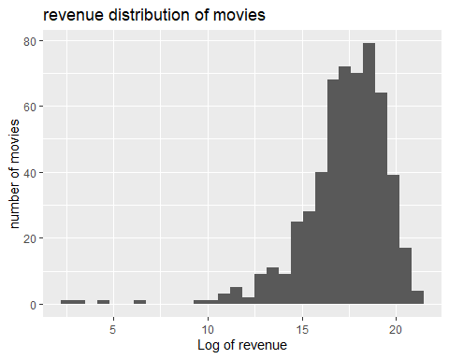
Your Answer: After replacing -Inf values with NA, the mean of log revenue becomes approximately 17.28. The shape of the histogram of log revenue is left skewed with a tail extending to the left.
Step f
skewness(movies$revenue, na.rm = TRUE)
## [1] 3.903008
kurtosis(movies$revenue, na.rm = TRUE)
## [1] 22.37797
skewness(movies$log_of_revenue, na.rm = TRUE)
## [1] -1.955152
kurtosis(movies$log_of_revenue, na.rm = TRUE)
## [1] 10.94619
Your Answer: the skewness of the revenue is approximately 3.90 and therefore greater then 0, this would give a skewness to the right which is in line with the result of question c. The corresponding kurtosis is relatively high, with a value of approximately 22.37, this shows that the data contains some extreme values, which was also concluded in answer c. the skewness of the log of revenue is negative, approximately -1.96 and therefore left skewed which is consistent with the result of question e. The corresponding kurtosis is also relatively high, although lower than without the log, with a value of approximately 10.95. This also shows the existence of some extreme values just as concluded in answer e.

3 Week 2
1 Is your dataset movies4.tsv the full population, or is it a sample of a larger population? If the latter, how would you describe the full population?
Your answer here: The movies4.tsv dataset is a sample of a larger population, rather than the full population. It contains 808 movies, while the broader population consists of many more movies. The full population can therefore be described as all movies from the population from which these 808 movies were selected.
Write your formulated response here.
2 For this question, you will assume that your data set is the full population.
- What is the mean of the variable vote_average in your data set?
- Create a new data set, called movies_sample. Make sure that it is a random sample of your data set of 25 movies. What is the mean of vote_average in this random sample? How does it compare to the mean of vote_average in 2a?
- In a for loop, create 100 different samples of 25 movies, as in b, and estimate the mean within each sample. Save the mean of each sample in a vector called sample_means. So the first position of the vector would have the mean of the first sample, the second position the mean of the second sample, etc. Print the start of this vector.
- Summarize and make a histogram of sample_means. What is the mean, standard deviation and shape of its distribution?
- Using the formulas of the Central Limit Theorem, give the distribution of the sample mean of vote_average in a sample of 25 movies from your population (including its expected value and standard deviation). How do these values compare to your answers at d.)?
Step a
mean(movies$vote_average, na.rm = TRUE)
## [1] 6.039356
Your Answer: The mean of vote_average in the full dataset is approximately 6.039.
Write your formulated response here.
Step b
set.seed(123)
movies_sample <- movies[sample(nrow(movies), 25), ]
mean(movies_sample$vote_average)
## [1] 6.016
Your Answer: The mean of vote_average in the random sample of 25 movies is 6.016. This is very close to the mean of the full dataset, which is approximately 6.039, although the sample mean is slightly lower.
Write your formulated response here.
Step c
sample_means <- numeric(100)
for(i in 1:100) {
movies_sample <- movies[sample(1:nrow(movies), 25), ]
sample_means[i] <- mean(movies_sample$vote_average)
}
print(sample_means[1:10])
## [1] 6.172 5.856 6.112 6.016 5.696 6.028 6.452 6.036 6.272 6.048
Your Answer:
Write your formulated response here.
Step d
hist(sample_means,
main = "Histogram of Sample Means",
xlab = "Sample Mean",
ylab = "Frequency",
breaks = 20)
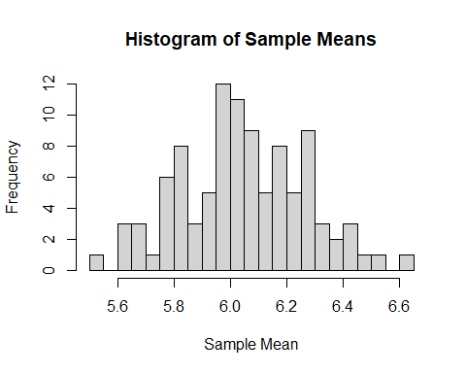
mean(sample_means)
## [1] 6.0452
sd(sample_means)
## [1] 0.2206887
Your Answer:
The sample means have a mean of 6.0452 and a standard deviation of 0.2207. The distribution is approximately normal as the histogram is bell-shaped around the center.
Step e
mean(movies$vote_average)
## [1] 6.039356
sd(movies$vote_average)
## [1] 1.184602
Your Answer:
According to the Central Limit Theorem, the distribution of the sample mean of vote_average for samples of 25 movies is approximately normally distributed with an expected value of 6.0394 and a standard deviation of 0.2369. In the simulation, the mean was 6.0452 and the standard deviation was 0.2207.The distribution is approximately normal. There are only a few small differences to the clt values due to the random sampling.
- Is there a variable in your data set which you would expect to follow a discrete uniform distribution? Explain, without looking at the data, why you expect this data to be discrete uniform. If the data would indeed follow a discrete uniform distribution, what would you expect the mean and standard deviation of this variable to be? Next, plot a histogram of the variable, and plot an appropriate discrete uniform distribution on top of this histogram. Comment whether the variable indeed follows this expected distribution. If the distribution deviates from the discrete uniform distribution, explain why this is the case.
Your Answer:
A variable in this data set that would be likely to follow a discrete uniform distribution is release_day. Without looking at the data there is no reason movie studios would favor releasing movies on a particular day of the month. Therefore, each day from 1 to 31 should be equally likely to occur, which means it follows a discrete uniform distribution.
Expected mean: mean = (1+31)/2=16
Expected standard deviation: std. deviation = SQRT(((31-1+1)^2 -1)/12)= 8.94
library(ggplot2)
# Load the data
df <- read.delim("movies4.tsv", sep = "\t", header = TRUE)
# Theoretical values for Discrete Uniform(1, 31)
n <- nrow(df)
expected_count <- n * (1/31)
theoretical_mean <- (1 + 31) / 2
theoretical_sd <- sqrt(((31 - 1 + 1)^2 - 1) / 12)
cat("Theoretical mean:", theoretical_mean, "\n")
## Theoretical mean: 16
cat("Theoretical SD:", theoretical_sd, "\n")
## Theoretical SD: 8.944272
cat("Observed mean:", mean(df$release_day), "\n")
## Observed mean: 15.33416
cat("Observed SD:", sd(df$release_day), "\n")
## Observed SD: 8.563328
# Plot histogram
ggplot(df, aes(x = release_day)) +
geom_histogram(binwidth = 1, boundary = 0.5, fill = "steelblue", color = "black") +
geom_hline(aes(yintercept = expected_count, linetype = "Expected count"),
color = "red", linewidth = 1) +
scale_x_continuous(breaks = seq(1, 31, by = 2)) +
scale_linetype_manual(name = "", values = "dashed") +
labs(
title = "Histogram of Release Day vs. Expected Discrete Uniform(1,31)",
x = "Release day of month",
y = "Frequency"
) +
theme_minimal() +
theme(legend.position = "top")
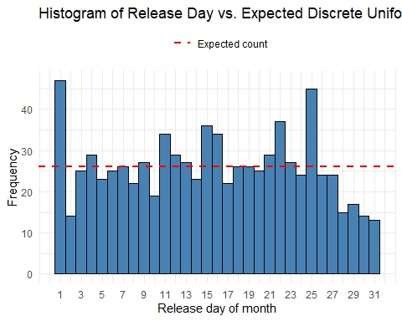
Your Answer:
The data show a mean of 15.33 and a standard deviation of 8.56 which is pretty close to the expected mean of 16 and standard deviation of 8.94. This makes it look like release_day follows a discrete uniform distribution, but when you take a closer look 2 main things stand out:
Day 1 and 25 stick out a lot. Day 1 is probably a regular default release date and day 25 lines up with christmas which is a big release period for movies. Studios are likely doing this on purpose to release films around these dates, so this isn’t random.
Also days 28 to 31 show up less often. This actually makes sense, because not every month has a 29th 30th or 31st. February usually stops at the 28th and a lot of other months don’t have a 31st. So no matter what movie studios do these days never appear as often as the earlier days.
So overall, release_days looked like a very good candidate for a discrete uniform distribution, but it turns out it isn’t really uniform.

4 Week 3
For the next part of the assignment, assume that the movies in your data frame are a random sample of a larger population of movies.
- Give a 90 percent confidence interval for the variable revenue. Interpret the result.
t.test(movies$revenue, conf.level = 0.9)
##
## One Sample t-test
##
## data: movies$revenue
## t = 13.628, df = 807, p-value < 2.2e-16
## alternative hypothesis: true mean is not equal to 0
## 90 percent confidence interval:
## 72731406 92724364
## sample estimates:
## mean of x
## 82727885
Your Answer:
The confidence interval= (72731406;92724364) This means that it is 90% certain that the true population mean revenue lies within this range. 2
- How many movies in your sample were directed by a male director? How many by a female director?
- Test the null hypothesis that the chance that a movie is being directed by a male or female director is equal. Clearly state your null hypothesis and alternative hypothesis, and your chosen significance level. Use an appropriate R function to test your hypothesis, and state your conclusion. Also give the p-value that corresponds to your test statistic.
- Recode revenue such that it is measured in millions of dollars. What is the variance of revenue for movies with a male director? What is the variance of revenue for movies with a female director?
- Assume that the variance of revenue for movies with a male director in your data is the same as the variance for movies with a male director in your population (that is, there is no sampling uncertainty in this estimate). Now, set up a hypothesis test to test for the null hypothesis that the variance of revenue for movies with a female director is equal to the variance for movies with a male director. Clearly state your null hypothesis and alternative hypothesis, and your chosen significance level. Calculate your test statistic and tell how your test statistic is distributed, and state your conclusion. Also give the p-value that corresponds to your test statistic.
step a
table(movies$director_gender)
##
## female male
## 80 685
Your Answer:
685 movies were directed by males and 80 movies were directed by females.
step b
movies$genderdum<-NA
movies$genderdum[movies$director_gender=="male"]<-1
movies$genderdum[movies$director_gender=="female"]<-0
binom.test(sum(movies$genderdum == 1, na.rm=TRUE), sum(!is.na(movies$genderdum)), p=0.5)
##
## Exact binomial test
##
## data: sum(movies$genderdum == 1, na.rm = TRUE) and sum(!is.na(movies$genderdum))
## number of successes = 685, number of trials = 765, p-value < 2.2e-16
## alternative hypothesis: true probability of success is not equal to 0.5
## 95 percent confidence interval:
## 0.8715412 0.9162048
## sample estimates:
## probability of success
## 0.8954248
Your Answer: Ho: p=0.5 , H1: p!=0.5 , a=0.05 Based on our binomial test we found that ou of 765 trials 685 where successful, the corresponding p-value was 2.2e-16, which is lower then 0.05. Therefore the null hypothesis is rejected.
step c
#WRITE YOUR CODE HERE
movies$revenue_millions <- movies$revenue / 1000000
var(movies$revenue_millions[movies$director_gender == "male"], na.rm = TRUE)
## [1] 31137.62
var(movies$revenue_millions[movies$director_gender == "female"], na.rm = TRUE)
## [1] 13224.54
Your Answer:
Write your formulated response here. After recoding revenue into millions of dollars, the variance of revenue for movies with a male director is approximately 31,137.62. For movies with a female director, the variance is approximately 13,224.54.
step d
#WRITE YOUR CODE HERE
male_var <- var(movies$revenue_millions[movies$director_gender == "male"], na.rm = TRUE)
female_var <- var(movies$revenue_millions[movies$director_gender == "female"], na.rm = TRUE)
n_female <- sum(movies$director_gender == "female", na.rm = TRUE)
test_stat <- (n_female - 1) * female_var / male_var
test_stat
## [1] 33.55229
p_value <- 2 * min(
pchisq(test_stat, df = n_female - 1),
1 - pchisq(test_stat, df = n_female - 1)
)
p_value
## [1] 3.226983e-06
Your Answer:
Write your formulated response here. We test the null hypothesis that the variance of revenue for movies with female directors is equal to the variance for movies with male directors. The alternative hypothesis is that the two variances are different. We use a significance level of 5%.
The test statistic is 33.55 and follows a chi-square distribution with 79 degrees of freedom under the null hypothesis. The p-value is approximately 0.00000323.
Since the p-value is smaller than 0.05, we reject the null hypothesis. We conclude that the variance of revenue for movies with female directors is significantly different from the variance for movies with male directors. The variance for movies with female directors is lower.
3
- Create a scatter plot with year on the x axis and mean of revenue within that year on the y-axis. Make sure it has an appropriate title, and appropriate titles and labels for the x- and y-axis. Is revenue of movies increasing or decreasing over time?
- Recreate the scatter plot with year on the x axis and mean_revenue on the y-axis, but now add bars around each point, indicating the 95% confidence interval.
- If you look closely at the resulting plot in b.), you will probably see that the confidence intervals in some years are wider than in other years. What are some possible reasons that a confidence interval in a given year can be wide? Can you verify this using your data?
step a
library(ggplot2)
ggplot(movies, aes(x = release_year, y = revenue)) +
stat_summary(fun = mean, geom = "point") +
labs(
title = "Mean Revenue by Year",
x = "Year",
y = "Mean Revenue"
)
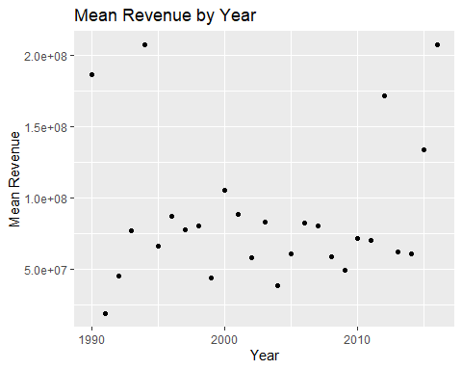
Your Answer:
The mean revenue does not appear to have increasing or decreasing trend over time. The revenue fluctuates year by year but based on the scatter plot we can’t assume that years have a linear relationship with revenue.
step b
library(ggplot2)
ggplot(movies, aes(x = release_year, y = revenue)) +
stat_summary(
fun = mean,
geom = "point"
) +
stat_summary(
fun.data = mean_cl_normal,
geom = "errorbar",
width = 0.2
) +
labs(
title = "Mean Revenue by Year with 95% Confidence Intervals",
x = "Year",
y = "Mean Revenue"
)
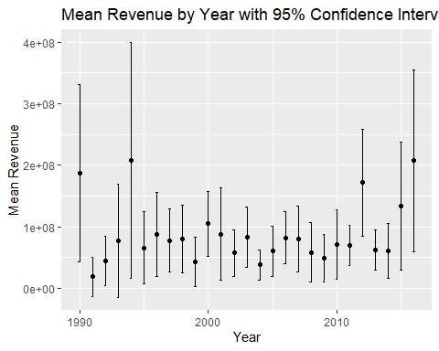
Your Answer:
Write your formulated response here.
step c
library(dplyr)
movies %>%
group_by(release_year) %>%
summarise(
n = n(),
mean_revenue = mean(revenue, na.rm = TRUE),
sd_revenue = sd(revenue, na.rm = TRUE)
)
## # A tibble: 27 × 4
## release_year n mean_revenue sd_revenue
## <int> <int> <dbl> <dbl>
## 1 1990 9 186877132. 187490969.
## 2 1991 6 18668724. 30641357.
## 3 1992 8 44841829. 48451860.
## 4 1993 12 77260396. 144924308.
## 5 1994 11 207613344. 285619241.
## 6 1995 14 65777270. 101531033.
## 7 1996 15 87280453. 122920163.
## 8 1997 18 77629423. 103445389.
## 9 1998 24 79988239. 130582852.
## 10 1999 37 43444845. 121310808.
## # ℹ 17 more rows
Your Answer There are two factors that can cause the confidence intervals to be wider in a given year: 1. If the individual revenues of the movies in a year differ more, the standard error of the mean increases. This creates a wider interval. 2. Fewer observations, a smaller sample size also increases the standard error.Therefore also creating a wider interval. We can verify this by calculating the number of observations and the standard deviation with the code above. If you compare these numbers with the with of the confidence intervals you can see that the years with smaller Number of observations and a larger standard deviation have wider intervals.

5 Week 4
- There is an argument going on in the movie studio. Bob claims that production budgets are getting out of hand, and that the studio should focus on making cheaper movies. Chantal disagrees. She tells Bob that ``Every dollar we spend on movie production is more than offset by the increase in movie revenue’’.
- Set up a regression model to test Chantal’s claim, and estimate it. That is, estimate:
$${\text{Revenue}}_{i}=β_{0}+β_{1}{\text{Budget}}_{i}+ε_{i}.$$
- Print a summary of your estimated model.
- What is the estimated value of $β_{1}$ and how do you interpet it?
- Test for the null hypothesis that $β_{1}≤1$. Report the p-value and state your conclusion.
- Next, estimate the model
$${\text{Log Revenue}}_{i}=β_{0}+β_{1}{\text{Log Budget}}_{i}+ε_{i}.$$
- When creating the variables Log Revenue and Log Budget, make sure that movies with a Revenue or Budget of zero are assigned the value “NA”. Print a summary of your estimated model.
- What is the estimated value of $β_{1}$ and how do you interpet it?
- Which model has better fit? The level-level model or the log-log model? Explain.
- Who do you think is correct? Bob or Chantal? What would you advise the movie studio to do?
step a
#WRITE YOUR CODE HERE
model1 <- lm(revenue ~ budget, data = movies)
summary(model1)
##
## Call:
## lm(formula = revenue ~ budget, data = movies)
##
## Residuals:
## Min 1Q Median 3Q Max
## -462638759 -35800260 8464473 11626239 835595485
##
## Coefficients:
## Estimate Std. Error t value Pr(>|t|)
## (Intercept) -1.163e+07 4.708e+06 -2.47 0.0137 *
## budget 3.162e+00 9.104e-02 34.73 <2e-16 ***
## ---
## Signif. codes: 0 '***' 0.001 '**' 0.01 '*' 0.05 '.' 0.1 ' ' 1
##
## Residual standard error: 109300000 on 806 degrees of freedom
## Multiple R-squared: 0.5994, Adjusted R-squared: 0.5989
## F-statistic: 1206 on 1 and 806 DF, p-value: < 2.2e-16
Your Answer:
The estimated regression model is:
Revenue = -11.63 million + 3.162 * Budget where both revenue and budget are measured in US dollars. step b
coef(model1)["budget"]
## budget
## 3.161767
Your Answer:
The estimated value of beta1 is approximately 3.162. This means that, on average a 1 US dollar increase in a movie’s budget is associated with an increase of approximately 3.16 US dollars in revenue.
step c
#WRITE YOUR CODE HERE
beta1 <- coef(model1)["budget"]
se_beta1 <- summary(model1)$coefficients["budget", "Std. Error"]
t_stat <- (beta1 - 1) / se_beta1
p_value <- pt(t_stat, df = df.residual(model1), lower.tail = FALSE)
t_stat
## budget
## 23.74518
p_value
## budget
## 3.277238e-95
Your Answer:
The null hypothesis is that beta1 is less than or equal to 1, while the alternative hypothesis is that beta1 is greater than 1. The test statistic is approximately 23.75 and the p-value is approximately 3.28e-95. Since the p-value is far below 0.05, we reject the null hypothesis. There is strong evidence that beta1 is greater than 1.
step d
#WRITE YOUR CODE HERE
movies$log_revenue <- ifelse(movies$revenue == 0, NA, log(movies$revenue))
movies$log_budget <- ifelse(movies$budget == 0, NA, log(movies$budget))
model2 <- lm(log_revenue ~ log_budget, data = movies)
summary(model2)
##
## Call:
## lm(formula = log_revenue ~ log_budget, data = movies)
##
## Residuals:
## Min 1Q Median 3Q Max
## -13.6073 -0.6971 0.2294 0.8698 3.8941
##
## Coefficients:
## Estimate Std. Error t value Pr(>|t|)
## (Intercept) -0.04588 0.77932 -0.059 0.953
## log_budget 1.02996 0.04573 22.523 <2e-16 ***
## ---
## Signif. codes: 0 '***' 0.001 '**' 0.01 '*' 0.05 '.' 0.1 ' ' 1
##
## Residual standard error: 1.495 on 517 degrees of freedom
## (289 observations deleted due to missingness)
## Multiple R-squared: 0.4953, Adjusted R-squared: 0.4943
## F-statistic: 507.3 on 1 and 517 DF, p-value: < 2.2e-16
Your Answer:
The estimated log-log regression model is:
Log Revenue = -0.0459 + 1.030 * Log Budget
Movies with a revenue or budget of zero were assigned NA before taking the logarithm. The full regression output is shown above.
step e
#WRITE YOUR CODE HERE
coef(model2)["log_budget"]
## log_budget
## 1.029956
Your Answer: The estimated value of beta1 is approximately 1.030. Since this is a log-log model, beta1 can be interpreted as an elasticity. A 1% increase in a movie’s budget is associated with an average increase of approximately 1.03% in revenue.
step f
#WRITE YOUR CODE HERE
summary(model1)$r.squared
## [1] 0.5994288
summary(model2)$r.squared
## [1] 0.4952515
Your Answer:
The level-level model has an R-squared of approximately 0.599, while the log-log model has an R-squared of approximately 0.495. However, these values are not directly comparable because the dependent variables differ and the models are estimated on different samples. Therefore, R-squared alone cannot determine which model has the better fit. The log-log model may still be preferable because it reduces the influence of extreme values and allows for a percentage interpretation.
step g
#WRITE YOUR CODE HERE
coef(model1)["budget"]
## budget
## 3.161767
coef(model2)["log_budget"]
## log_budget
## 1.029956
Your Answer:
The results provide more support for Chantal’s claim. In the level-level model, each additional dollar of budget is associated with approximately $3.16 of additional revenue, and this coefficient is significantly greater than 1. The log-log model shows a similar positive relationship: a 1% increase in budget is associated with approximately a 1.03% increase in revenue, although this elasticity is not significantly different from 1. However, these results show association rather than causality, and movie revenue does not directly represent studio profit because other costs and revenue sharing are not accounted for. Therefore, I would advise the studio not to simply focus on cheaper movies, but also not to increase budgets automatically.
2
- Make a scatterplot with log revenue on the y-axis, and log budget on the x-axis. Within the same scatterplot, draw a straight line which summarizes the association between the log of revenue and log of budget.
- Using the insights from the scatterplot, your linear model, and your data, find an example of a movie that vastly overperformed. That means, find a movie that had much more revenue than expected, given its budget. For this movie, report its log of revenue, its predicted log of revenue, and its residual.
step a
ggplot(movies, aes(x = log_budget, y = log_revenue)) +
geom_point() +
geom_smooth(method = "lm", se=FALSE, color = "red") +
labs(
title = "associaton log of budget and log of revenue ",
x = "Log of budget", y = "Log of revenue"
) +
theme_minimal()
## `geom_smooth()` using formula = 'y ~ x'
## Warning: Removed 289 rows containing non-finite outside the scale range
## (`stat_smooth()`).
## Warning: Removed 289 rows containing missing values or values outside the scale range
## (`geom_point()`).
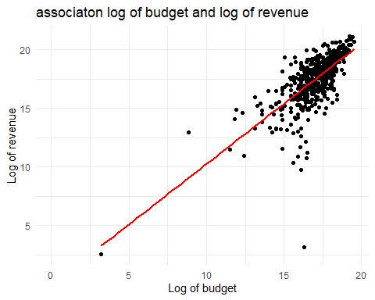
Your Answer:
The scatterplot shows the log of budget and the log of revenue. With a straight line that shows the association between the two.
step b
movies_check <- movies[!is.na(movies$log_revenue) & !is.na(movies$log_budget) &
movies$budget > 0 & movies$revenue > 4, ]
model2 <- lm(log_revenue ~ log_budget, data = movies_check)
i <- which.max(residuals(model2))
fitted(model2)[i]
## 627
## 15.47378
movies$log_of_revenue[627]
## [1] 19.36789
residuals(model2)[i]
## 627
## 3.894113
movies$title[627]
## [1] "The Full Monty"
Your Answer: A movie which highly over performed is The Full Monty. This movie has a log of revenue of 19.36789, a predicted log of revenue of 15.47378, and a residual of 3.894113.

6 Week 5
- Make a frequency table of the variable genre. Which are the three genres that occur the most?
- Create a new variable called genre2. Make sure that the three most popular genres remain the same, but that all the other genres get categorized into one genre called “Other”. Report a frequency table of this new variable genre2.
- Estimate an OLS model which has as dependent variable the log of revenue of a movie, and as independent variable the log of budget, a dummy for each level that genre2 can take, and the year of release. Show a summary of the resulting model and interpret each coefficient.
The movie studio that you work at is releasing a new movie in 2026. It will be a Drama movie with a budget of 20,000,0000. It will have a runtime of 120 minutes.
- Estimate a model that is able to predict the revenue of this movie. Give its predicted revenue and include a 90% prediction interval.
- Plot the residuals against various independent variables in the model. Do you find any evidence of heteroskedasticity?
- One executive at the studio wants to time the release of the movie to a specific month of the year such that they can maximize revenue. Another executive is of the opinion that the month in which the movie is released will not have a big impact on its revenue. Estimate a model that can test whether the month of release impacts the revenue of a movie. Use an appropriate hypothesis test to test whether month of release matters. What would you advise the movie studio regarding the timing of the release of the movie?
step a
table(movies$genre)
##
## Action Adventure Comedy Crime Documentary Drama
## 41 16 186 2 9 402
## Family Fiction Horror Music Romance Thriller
## 11 5 11 4 1 116
## Western
## 1
freq_genre <- table(movies$genre)
sort(freq_genre, decreasing = TRUE)[1:3]
##
## Drama Comedy Thriller
## 402 186 116
Your Answer:
The three movie genre that occur the most are Drama, Comedy and Thriller.
step b
library(tidyverse)
## ── Attaching core tidyverse packages ──────────────────────── tidyverse 2.0.0 ──
## ✔ forcats 1.0.1 ✔ stringr 1.6.0
## ✔ lubridate 1.9.5 ✔ tibble 3.3.1
## ✔ purrr 1.2.2 ✔ tidyr 1.3.2
## ✔ readr 2.2.0
## ── Conflicts ────────────────────────────────────────── tidyverse_conflicts() ──
## ✖ dplyr::filter() masks stats::filter()
## ✖ dplyr::lag() masks stats::lag()
## ℹ Use the conflicted package (<http://conflicted.r-lib.org/>) to force all conflicts to become errors
freq_genre <- table(movies$genre)
top_genres <- names(sort(freq_genre, decreasing = TRUE)[1:3])
movies <- movies %>%
mutate(
genre2 = if_else(genre %in% top_genres, genre, "other"),
genre2 = as.factor(genre2)
)
freq_table_genre2 <- table(movies$genre2)
print(freq_table_genre2)
##
## Comedy Drama other Thriller
## 186 402 104 116
Your Answer:
Write your formulated response here.
step c
library(tidyverse)
movies_clean <- movies %>%
filter(revenue > 0, budget > 0) %>%
drop_na(revenue, budget, genre2, release_year)
model <- lm(log(revenue) ~ log(budget) + genre2 + release_year, data = movies_clean)
summary(model)
##
## Call:
## lm(formula = log(revenue) ~ log(budget) + genre2 + release_year,
## data = movies_clean)
##
## Residuals:
## Min 1Q Median 3Q Max
## -13.5777 -0.6653 0.2248 0.8514 3.8557
##
## Coefficients:
## Estimate Std. Error t value Pr(>|t|)
## (Intercept) 9.097982 19.628713 0.464 0.64320
## log(budget) 1.001004 0.047074 21.264 < 2e-16 ***
## genre2Drama -0.472877 0.162469 -2.911 0.00376 **
## genre2other -0.014269 0.223589 -0.064 0.94914
## genre2Thriller -0.321644 0.200858 -1.601 0.10991
## release_year -0.004184 0.009789 -0.427 0.66926
## ---
## Signif. codes: 0 '***' 0.001 '**' 0.01 '*' 0.05 '.' 0.1 ' ' 1
##
## Residual standard error: 1.486 on 513 degrees of freedom
## Multiple R-squared: 0.5053, Adjusted R-squared: 0.5005
## F-statistic: 104.8 on 5 and 513 DF, p-value: < 2.2e-16
Your Answer:
Coefficient Interpretations Guide When you run summary(model), you will get coefficients that are interpreted as follows: Intercept (β_0): The expected value of log⁡(“revenue” ) when log⁡(“budget” )=0 (i.e., budget = 1), release year is 0 (or baseline depending on scaling), and the movie belongs to the reference category of genre2 (the omitted category in the dummy set). log⁡(“budget” ) Coefficient (β_1): Since both revenue and budget are log-transformed (a log-log model), this coefficient represents an elasticity. Interpretation: A 1% increase in a movie’s budget is associated with an average β_1% change in its revenue, holding genre and release year constant. genre2 Dummy Coefficients: Each coefficient for a specific genre level represents the difference in expected log revenue between that genre and the baseline (reference) genre, holding budget and year constant. Interpretation: Compared to the reference genre, movies in this specific genre have an expected log revenue that is higher (if positive) or lower (if negative) by β units, controlling for budget and year. (To convert log differences roughly to percentage differences for small coefficients, you can use 100×(exp⁡(β)-1)). year Coefficient (β_y): Interpretation: Holding budget and genre constant, an increase of one release year is associated with an average change of β_y units in the log of revenue per year (representing a temporal trend in box office earnings).
step d
model_d <- lm(log(revenue) ~ log(budget) + genre2 + release_year + runtime,
data = movies_clean)
summary(model_d)
##
## Call:
## lm(formula = log(revenue) ~ log(budget) + genre2 + release_year +
## runtime, data = movies_clean)
##
## Residuals:
## Min 1Q Median 3Q Max
## -13.6049 -0.6515 0.2440 0.8519 3.8637
##
## Coefficients:
## Estimate Std. Error t value Pr(>|t|)
## (Intercept) 8.636671 19.665452 0.439 0.66072
## log(budget) 0.992461 0.050191 19.774 < 2e-16 ***
## genre2Drama -0.508235 0.177688 -2.860 0.00441 **
## genre2other -0.023597 0.224552 -0.105 0.91635
## genre2Thriller -0.337773 0.203648 -1.659 0.09781 .
## release_year -0.003975 0.009805 -0.405 0.68534
## runtime 0.001899 0.003850 0.493 0.62201
## ---
## Signif. codes: 0 '***' 0.001 '**' 0.01 '*' 0.05 '.' 0.1 ' ' 1
##
## Residual standard error: 1.487 on 512 degrees of freedom
## Multiple R-squared: 0.5056, Adjusted R-squared: 0.4998
## F-statistic: 87.26 on 6 and 512 DF, p-value: < 2.2e-16
new_movie <- data.frame(
budget = 20000000, # last zero treated as a typo
genre2 = factor("Drama", levels = levels(movies_clean$genre2)),
release_year = 2026,
runtime = 120
)
pred_log <- predict(model_d, newdata = new_movie, interval = "prediction", level = 0.90)
pred_log
## fit lwr upr
## 1 16.98736 14.50802 19.4667
exp(pred_log) # expected revenue: about $23.9M, 90% PI about $2.0M to $284.6M
## fit lwr upr
## 1 23851637 1998733 284630607
Your Answer:
The predicted revenue of the new movie is approximately $24 million. The 90% prediction interval is approximately $2 million to $285 million.
step e
movies_clean$resid <- resid(model_d)
movies_clean$fitted <- fitted(model_d)
# Residuals vs the continuous variables (one panel each)
movies_clean %>%
mutate(`log(budget)` = log(budget),
`Release year` = release_year,
`Runtime` = runtime,
`Fitted values` = fitted) %>%
select(resid, `log(budget)`, `Release year`, `Runtime`, `Fitted values`) %>%
pivot_longer(-resid, names_to = "variable", values_to = "x") %>%
ggplot(aes(x = x, y = resid)) +
geom_point(alpha = 0.4) +
geom_hline(yintercept = 0, color = "red") +
geom_smooth(se = FALSE, linewidth = 0.8) +
facet_wrap(~ variable, scales = "free_x") +
labs(x = NULL, y = "Residuals", title = "Residuals vs independent variables")
## `geom_smooth()` using method = 'loess' and formula = 'y ~ x'
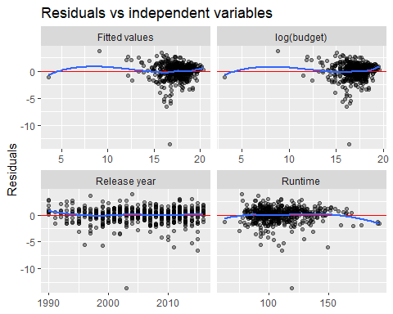
# Residuals by genre2
ggplot(movies_clean, aes(x = genre2, y = resid)) +
geom_boxplot() +
geom_hline(yintercept = 0, color = "red") +
labs(x = "genre2", y = "Residuals", title = "Residuals by genre2")
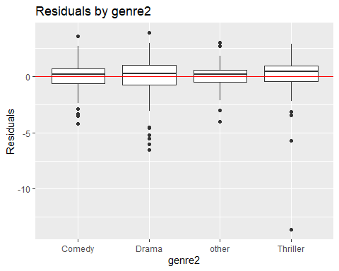
Your Answer:
Yes, there is evidence of heteroskedasticity. The residuals are most dispersed for low-budget movies and become less dispersed as the budget increases, while the plots against release year and runtime show no pattern.
step f
library(sandwich)
## Warning: package 'sandwich' was built under R version 4.6.1
library(lmtest)
## Warning: package 'lmtest' was built under R version 4.6.1
## Loading required package: zoo
## Warning: package 'zoo' was built under R version 4.6.1
##
## Attaching package: 'zoo'
## The following objects are masked from 'package:base':
##
## as.Date, as.Date.numeric
movies_clean$month <- factor(movies_clean$release_month) # January = baseline
model_f <- lm(log(revenue) ~ log(budget) + genre2 + release_year + runtime + month,
data = movies_clean)
summary(model_f)
##
## Call:
## lm(formula = log(revenue) ~ log(budget) + genre2 + release_year +
## runtime + month, data = movies_clean)
##
## Residuals:
## Min 1Q Median 3Q Max
## -13.0054 -0.6519 0.1782 0.8590 3.6415
##
## Coefficients:
## Estimate Std. Error t value Pr(>|t|)
## (Intercept) -1.3966665 19.7407485 -0.071 0.9436
## log(budget) 0.9767192 0.0505069 19.338 <2e-16 ***
## genre2Drama -0.4584392 0.1772981 -2.586 0.0100 **
## genre2other -0.0650676 0.2272986 -0.286 0.7748
## genre2Thriller -0.2411212 0.2038163 -1.183 0.2374
## release_year 0.0012720 0.0098457 0.129 0.8973
## runtime -0.0006524 0.0038852 -0.168 0.8667
## month2 -0.3098389 0.3711966 -0.835 0.4043
## month3 -0.0882725 0.3654386 -0.242 0.8092
## month4 -0.0226683 0.3695579 -0.061 0.9511
## month5 0.3723674 0.3639759 1.023 0.3068
## month6 0.2619590 0.3646560 0.718 0.4729
## month7 0.2040307 0.3704564 0.551 0.5820
## month8 -0.0752971 0.3550860 -0.212 0.8322
## month9 -0.6125004 0.3350806 -1.828 0.0682 .
## month10 0.1428420 0.3572908 0.400 0.6895
## month11 0.4431832 0.3939999 1.125 0.2612
## month12 0.3177083 0.3522370 0.902 0.3675
## ---
## Signif. codes: 0 '***' 0.001 '**' 0.01 '*' 0.05 '.' 0.1 ' ' 1
##
## Residual standard error: 1.47 on 501 degrees of freedom
## Multiple R-squared: 0.5272, Adjusted R-squared: 0.5111
## F-statistic: 32.86 on 17 and 501 DF, p-value: < 2.2e-16
# H0: all 11 month coefficients = 0
anova(model_d, model_f) # F about 2.08, p about 0.020
## Analysis of Variance Table
##
## Model 1: log(revenue) ~ log(budget) + genre2 + release_year + runtime
## Model 2: log(revenue) ~ log(budget) + genre2 + release_year + runtime +
## month
## Res.Df RSS Df Sum of Sq F Pr(>F)
## 1 512 1132.6
## 2 501 1083.1 11 49.484 2.0809 0.02023 *
## ---
## Signif. codes: 0 '***' 0.001 '**' 0.01 '*' 0.05 '.' 0.1 ' ' 1
# Same test, robust to heteroskedasticity
waldtest(model_d, model_f, vcov = function(x) vcovHC(x, type = "HC3"), test = "F") # F about 1.96, p about 0.031
## Wald test
##
## Model 1: log(revenue) ~ log(budget) + genre2 + release_year + runtime
## Model 2: log(revenue) ~ log(budget) + genre2 + release_year + runtime +
## month
## Res.Df Df F Pr(>F)
## 1 512
## 2 501 11 1.9585 0.03057 *
## ---
## Signif. codes: 0 '***' 0.001 '**' 0.01 '*' 0.05 '.' 0.1 ' ' 1
# Predicted median revenue of our movie by release month
newdata_months <- data.frame(
budget = 20000000,
genre2 = factor("Drama", levels = levels(movies_clean$genre2)),
release_year = 2026,
runtime = 120,
month = factor(1:12, levels = levels(movies_clean$month))
)
round(setNames(exp(predict(model_f, newdata = newdata_months)) / 1e6, month.abb), 1)
## Jan Feb Mar Apr May Jun Jul Aug Sep Oct Nov Dec
## 25.7 18.9 23.6 25.2 37.4 33.4 31.6 23.9 14.0 29.7 40.1 35.4
# Jan 25.7, Feb 18.9, Mar 23.6, Apr 25.2, May 37.4, Jun 33.4, Jul 31.6, Aug 23.9, Sep 14.0, Oct 29.7, Nov 40.1, Dec 35.4
Your Answer: The model from step d was extended with month dummies (January as baseline), and a joint F-test of H₀: all month coefficients equal zero was used. H₀ is rejected at the 5% level (classical p = 0.020, robust p = 0.031), so the month of release affects revenue. The advise to the studio would be to release the movie in May–June or November–December and to avoid September.

