# Project 2 Report

## 1. How Algorithm Works

For 5 nodes 10 edges, we assume nodes all work well, each edge is either Up or Down, and we will know the p for each edge. if the system is operational, it means there is no unconnected node.

Exhaustive enumeration:

List all possible states of the system.

Assign “up” and “down” system condition to each state

Reliability can be obtained by summing the probability of the “up” states

We are going to calculate all possible combinations, since 10 edges will have 210 combinations, we store each system state in one int array: int[11] , first 10 integer will be represent the components`(edges`s) states, the last integer will represent system condition(Up or Down). All integer arrarys will be combined into one list : List<int[]>, thus if we want choose one random system condition, we just need to generate a random index of the List, then pick the correspond integer array out, that will be one random combination.

While calculating the System Reliability, we first check the last integer in the integer arrays to see if the System will be Up, if it is down, ignore it. We will check all 1024 integer arrays and pick those System Condition is Up, then find the p of each edges to figure out the final system reliabilities.

## 2. Pseudo Code

SetCombinations{

List<int[11]> combinations; //to store 1024 combinations plus //system condition

int[] studentID; //store my student ID

Graph graph;

int d[10] //d[i] to store student ID digit

setCombinations(List<int[11]> combinations){ //set 1024

//combinations

for( i = 0; i < 10; i++){

setCombin(i,0); // i decide how many

} //edges will be Up in

} //one combination

setCombin(int i, int startPoint){ //when edges are Up, get the

//system and component state

int[11] combination from List<int[11]> combinations;

if(i == 0){

if(System is operational)

combination[11] = 1;

else

combination[11] = 0;

store the result combination into the list;

}

for(j == startPoint; j < 10; j++){

combination[j] = 1;

setCombin(i-1, j+1);

}

}

}

CalculateReliability{

for(every combination[11] in List<combination> == 1){ //for every // combination

//that system is UP

result = 1;

for(every combination[j]){

if(combination[j] == 1)

result *= edge[j].p;

else

result *= (1 - edge[j].p)

}

}

Sum all results to get the System Reliability;

}

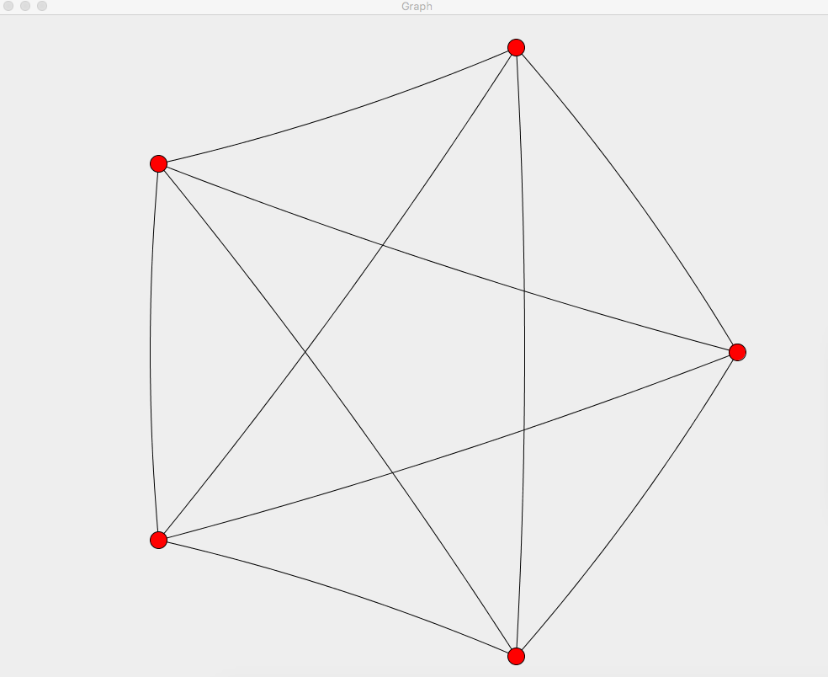

The Original Graph Generated

## 3. Checking correctness

For each combination, an integer array has been created to store all components and System state, if component/system is UP, the represented int in the array will be 1 otherwise 0,each time their state changes, we will update the int array



For checking correctness, I have checked each combination by traversal all edges to make sure every node in the graph is connected, means the System State is UP,then added all the UP combinations together via exhaustive enumeration to calculate the final System Reliability.

Figure 1 illustrate the method to traversal edges in the graph of one combination, if the System is Up, return true. If System is Down, return false.

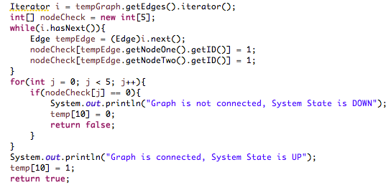

Figure 1

3. ReadMe file

## 4. Calculate Component Reliability

Using randomIndex() we get a non-duplicate index for one edge, with this index we calculate the p, and create the edge added into the graph.

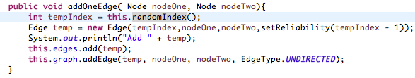

Figure 2

Figure 3 shows how to calculate the p for each edge. My Student ID is stored in the studentID[] array. .

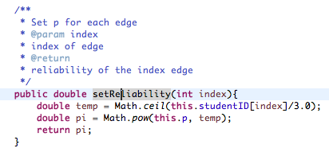

Figure 3

## 5. Run for different value of p

Let p run over [0.05,1] in steps of 0.05, show how the obtained network reliability values depend on p, since all edges are working, System Reliability can be calculated as follow:

Rsystem = 1 – anyNodeNotWork

= 1 – (1 – allNodeWork)

= 1 – (1 - oneNodeWorknumOfNodes)

= 1 – (1 - (1 – allEdgesOfNodeNotWork)numOfNodes)

= 1 – (1 - (1 – (1 - p)numOfNodes - 1 )numOfNodes)

Figure 4 is the method using for loop to get all p value from 0.05 to 1, and calculate their relative System Reliability.

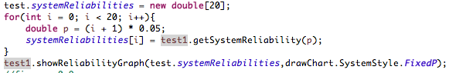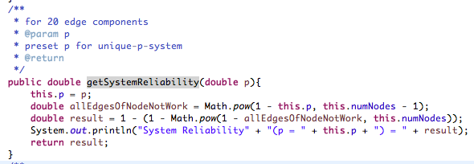

Figure 4

Figure 5 shows the result graphically.

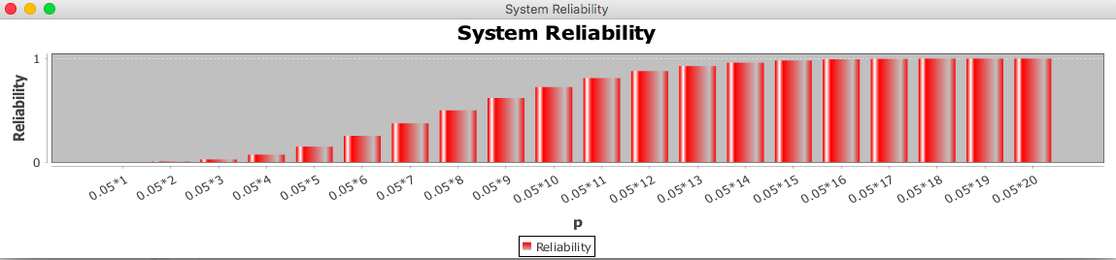

Figure 5

## 6. Fix p Parameter at 0.9

Then fix p = 0.9, among 210 combination states pick k of combinations randomly and flip the corresponding system condition, show in diagram how the reliability of the system changes due to this alteration. Show in diagram how the change depends on k range 0,1,2,3….20, run several experiments for each k, and average them out. Give several paragraph explanation.

First, calculate all 1024 possible original combinations.

### Combination algorithm:

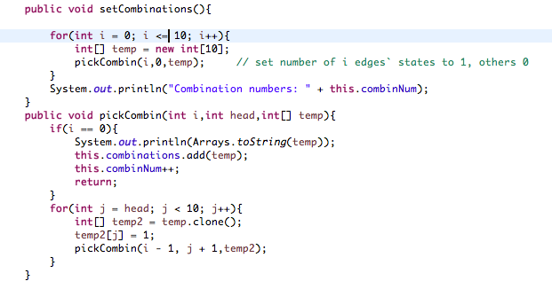

Figure 6

We create a temporary array ‘temp[]’ which stores all outputs one by one. The idea is to start from first index (index = 0) in temp[], one by one fix elements at this index and recur for remaining indexes. We first fix 1 number in data[] as 1, then return and recur for remaining indexes, then we fix 2 number in data[] as 1, return and recur. Finally, we will fix 1 for all remaining indexes. Following diagram shows recursion tree, number in the block represent the index of array to be set as 1.

[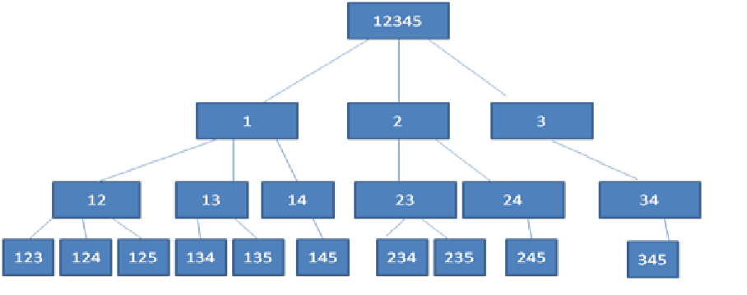](http://d1gjlxt8vb0knt.cloudfront.net//wp-content/uploads/combination.png)

Figure 7

The result format is as Figure 8, after we get all edges` condition in one combination, we could calculate the System Condition by the method checkConnectivity() to check if the System is operational, if yes , we add 1 to the end of the array, else add 0 as Figure 8

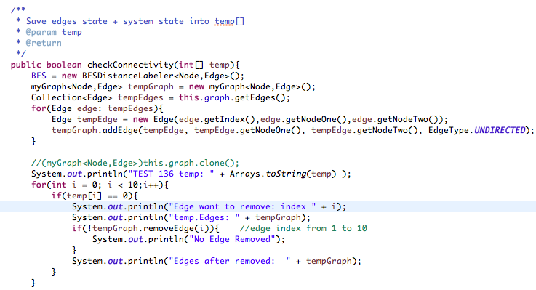

Figure 8

checkConnectivity(int[] temp){} will be used to check system state if components` state have changed, we first copy a new graph from the original graph, if an edge is DOWN(not working), we will delete the edge from the new graph, The running sample is as follow:

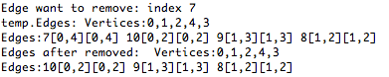

Edge with index 7 is not working, the current graph has edges 7, 10, 9 , 8, we are going to delete edge 7, after delete it, the graph contains edges 10, 9 ,8

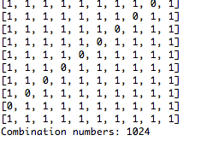

Figure 9

When generating the 1024 combinations, uses variable this.combinNum to count each combination we get for checking correctness, finally get this.combinNum == 1024, and list all of them with no error.

### 7. Pick k Combinations Randomly

The solution is that we generate k non-duplicate random index for the combination List, and get the k combination arrays.

First, generate k random index in the range from 0 to 1023. And put all the k random index in one array ID[] of size k, return it:

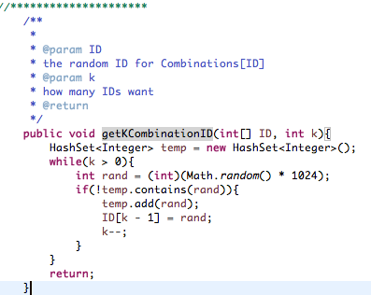

Figure 10

Then use index in the ID[], we retrieve the System State arrays in the combination list, and flip the 11th integer( the system state integer) ,as Figure 11.

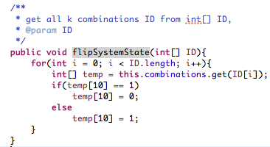

Figure 11

Then after flip k System states , we get the new combination list.

The following method will calculate the system reliability:

this.combinations will store all 1024 possible combinations, get each system state via int[] itr, itr[10] will indicate if system is UP(1) or DOWN(0). By Exhaustive Enumeration method, multiply all components reliability within one combinations, then add all combinations` reliability altogether, we get the final System Reliability.

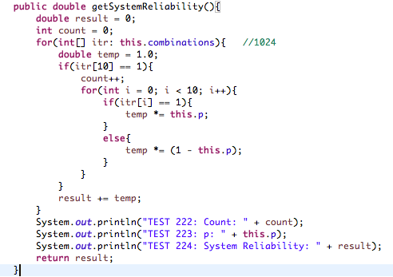

Figure 12

Run the program from k = 0 to 20

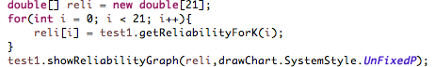

Figure 13

Fix p = 0.9, System Reliability depends on K as follows:

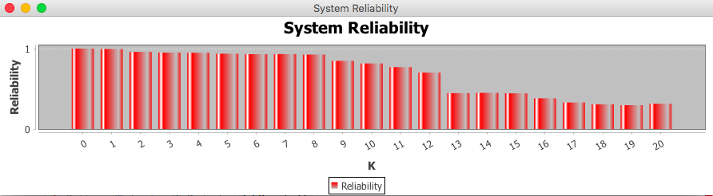

Figure 14

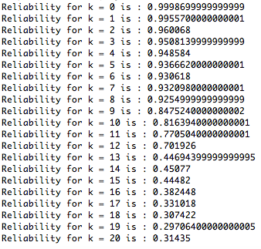

Figure 14

For each k, calculate 5 times then average the result out:

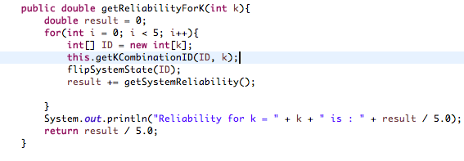

Figure 15

## ReadMe

Project is written by Java

JUNG is used to draw graphs, download from : <http://jung.sourceforge.net/>

JFree is used to draw charts, download from: <http://www.jfree.org/jfreechart/>

## Source Code

**package** TEST;

**import** NetworkElements.*;

**import** Drawing.drawChart;

**import** java.awt.Dimension;

**import** java.text.DecimalFormat;

**import** java.util.*;

**import** java.util.concurrent.TimeUnit;

**import** javax.swing.JFrame;

**import** edu.uci.ics.jung.algorithms.layout.CircleLayout;

**import** edu.uci.ics.jung.graph.*;

**import** edu.uci.ics.jung.graph.util.EdgeType;

**import** edu.uci.ics.jung.visualization.*;

**import** edu.uci.ics.jung.visualization.renderers.Renderer.VertexLabel.Position;

**import** edu.uci.ics.jung.algorithms.shortestpath.BFSDistanceLabeler;

**public** **class** test {

**static** **double** *systemReliabilities*[];

**int** numNodes;

**int** numEdges;

**int** combinNum;

**double** p; //edge reliability

myGraph<Node,Edge> graph;

ArrayList<Integer> indexList; //d[i] to calculate p[i]

List<Node> nodes;

List<Edge> edges;

**int**[] studentID;

drawChart barChart; //bar chart to show system reliabilities depends on p

List<**int**[]> combinations; //combinations of component states

**int**[] systemState; //1024 system state;

BFSDistanceLabeler<Node,Edge> BFS;

**public** test(**int** num, **double** p){

numNodes = num;

**this**.p = p;

numEdges = numNodes * (numNodes - 1);

studentID = **new** **int**[]{2,0,2,1,2,2,1,1,3,7};

graph = **new** myGraph<Node, Edge>();

indexList = **new** ArrayList<Integer>();

indexList.addAll(Arrays.*asList*(1,2,3,4,5,6,7,8,9,10)); //index from 1 to 10

combinations = **new** ArrayList<**int**[]>();

Collections.*shuffle*(indexList);

nodes = **new** ArrayList<Node>();

edges = **new** ArrayList<Edge>();

**this**.addNumberOfNodes();

**this**.addEdges();

System.***out***.println(**this**.graph.getEdgeCount() + " Undirected Edges Created");

}

//di

**public** **int** getIDDigit(**int** index){

**return** studentID[index];

}

**public** **int** randomIndex(){

**int** index = **this**.indexList.remove(**this**.indexList.size() - 1);

**return** index;

}

//start from 0

**public** **void** addNumberOfNodes(){

**for**(**int** i = 0; i < **this**.numNodes; i++){

Node temp = **new** Node(i);

//this.graph.addVertex(temp); if edges be added, nodes will be added to graph automatically

**this**.nodes.add(temp);

}

System.***out***.println(**this**.numNodes + " Nodes Created");

}

/**

* Add one edge to this.edges & this.graph

* **@param** nodeOne

* **@param** nodeTwo

*/

**public** **void** addOneEdge( Node nodeOne, Node nodeTwo){

**int** tempIndex = **this**.randomIndex();

Edge temp = **new** Edge(tempIndex,nodeOne,nodeTwo,setReliability(tempIndex - 1));

System.***out***.println("Add " + temp);

**this**.edges.add(temp);

**this**.graph.addEdge(temp, nodeOne, nodeTwo, EdgeType.***UNDIRECTED***);

}

/**

* loop to add all edges

*/

**public** **void** addEdges(){

**for**(**int** i = 0; i < **this**.numNodes; i++){

**for**(**int** j = i + 1; j < **this**.numNodes; j++){

**this**.addOneEdge(**this**.nodes.get(i), **this**.nodes.get(j));

}

}

}

/**

* Set p for each edge

* **@param** index

* index of edge

* **@return**

* reliability of the index edge

*/

**public** **double** setReliability(**int** index){

**double** temp = Math.*ceil*(**this**.studentID[index]/3.0);

**double** pi = Math.*pow*(**this**.p, temp);

**return** pi;

}

/**

* Save edges state + system state into temp[]

* **@param** temp

* **@return**

*/

**public** **boolean** checkConnectivity(**int**[] temp){

BFS = **new** BFSDistanceLabeler<Node,Edge>();

myGraph<Node,Edge> tempGraph = **new** myGraph<Node,Edge>();

Collection<Edge> tempEdges = **this**.graph.getEdges();

**for**(Edge edge: tempEdges){

Edge tempEdge = **new** Edge(edge.getIndex(),edge.getNodeOne(),edge.getNodeTwo());

tempGraph.addEdge(tempEdge, tempEdge.getNodeOne(), tempEdge.getNodeTwo(), EdgeType.***UNDIRECTED***);

}

**for**(**int** i = 0; i < 10;i++){

**if**(temp[i] == 0){

**if**(!tempGraph.removeEdge(i)){ //edge index from 1 to 10

//System.out.println("No Edge Removed");

}

}

}

Iterator i = tempGraph.getEdges().iterator();

**int**[] nodeCheck = **new** **int**[5];

**while**(i.hasNext()){

Edge tempEdge = (Edge)i.next();

nodeCheck[tempEdge.getNodeOne().getID()] = 1;

nodeCheck[tempEdge.getNodeTwo().getID()] = 1;

}

**for**(**int** j = 0; j < 5; j++){

**if**(nodeCheck[j] == 0){

System.***out***.println("Graph is not connected, System State is DOWN");

temp[10] = 0;

**return** **false**;

}

}

System.***out***.println("Graph is connected, System State is UP");

temp[10] = 1;

**return** **true**;

}

/**

* for 20 edge components

* **@param** p

* preset p for unique-p-system

* **@return**

*/

**public** **double** getSystemReliability(**double** p){

**this**.p = p;

**double** allEdgesOfNodeNotWork = Math.*pow*(1 - **this**.p, **this**.numNodes - 1);

**double** result = 1 - (1 - Math.*pow*(1 - allEdgesOfNodeNotWork, **this**.numNodes));

System.***out***.println("System Reliability" + "(p = " + **this**.p + ") = " + result);

**return** result;

}

/**

* get System Reliability of Non-unique-p-system

* **@return**

* (double)System Reliability

*/

**public** **double** getSystemReliability(){

**double** result = 0;

DecimalFormat numberFormat = **new** DecimalFormat("#.00000");

**int** count = 0;

**for**(**int**[] itr: **this**.combinations){ //1024

**double** temp = 1.0;

**if**(itr[10] == 1){

count++;

**for**(**int** i = 0; i < 10; i++){

**if**(itr[i] == 1){

temp *= **this**.p;

}

**else**{

temp *= (1 - **this**.p);

}

}

}

**else**{

temp = 0;

}

temp = Double.*parseDouble*(numberFormat.format(temp));

result += temp;

result = Double.*parseDouble*(numberFormat.format(result));

//System.out.println("Current Result: " + result);

}

//System.out.println("TEST 222: Count: " + count);

//System.out.println("TEST 223: p: " + this.p);

//System.out.println("TEST 224: System Reliability: " + result);

**return** result;

}

**public** **void** showGraph(){

CircleLayout temp = **new** CircleLayout(**this**.graph);

temp.setRadius(380);

BasicVisualizationServer vs = **new** BasicVisualizationServer(temp,**new** Dimension(1000,800));

vs.getRenderer().getVertexLabelRenderer().setPosition(Position.***CNTR***);

JFrame frame = **new** JFrame("Graph");

frame.getContentPane().add(vs);

frame.setDefaultCloseOperation(JFrame.***EXIT_ON_CLOSE***);

frame.pack();

frame.setVisible(**true**);

}

**public** **void** showReliabilityGraph(**double**[] systemRel,drawChart.SystemStyle systemSty ){

barChart = **new** drawChart("System Reliability", systemRel, systemSty);

barChart.centerChart();

barChart.setVisible(**true**);

}

//Combination Generating Module

/**

* set combinations to Combinations<int[]>, each int[] will represent one system state

* for each component 1 flip , 0 remain

*/

**public** **void** setCombinations(){

**for**(**int** i = 0; i <= 10; i++){

**int**[] temp = **new** **int**[11];

pickCombin(i,0,temp); // set number of i edges` states to 1, others 0

}

}

**public** **void** pickCombin(**int** i,**int** head,**int**[] temp){

**if**(i == 0){

**if**(checkConnectivity(temp) == **true**){

temp[10] = 1;

}

**else**{

temp[10] = 0;

}

**this**.combinations.add(temp);

**this**.combinNum++;

**return**;

}

**for**(**int** j = head; j < 10; j++){

**int**[] temp2 = temp.clone();

temp2[j] = 1;

pickCombin(i - 1, j + 1,temp2);

}

}

//*********************

/**

*

* **@param** ID

* the random ID for Combinations[ID]

* **@param** k

* how many IDs want

* **@return**

*/

**public** **void** getKCombinationID(**int**[] ID, **int** k){

HashSet<Integer> temp = **new** HashSet<Integer>();

**while**(k > 0){

**int** rand = (**int**)(Math.*random*() * 1024);

**if**(!temp.contains(rand)){

temp.add(rand);

ID[k - 1] = rand;

k--;

}

}

**return**;

}

/**

*

* **@param** k

* get System Reliability with K, repeatedly 5 times and average them

* **@return** result

* return averaged reliability

*/

**public** **double** getReliabilityForK(**int** k){

**double** result = 0;

**for**(**int** i = 0; i < 5; i++){

**int**[] ID = **new** **int**[k];

**this**.getKCombinationID(ID, k);

flipSystemState(ID);

result += getSystemReliability();

}

System.***out***.println("Reliability for k = " + k + " is : " + result / 5.0);

**return** result / 5.0;

}

/**

* get all k combinations ID from int[] ID,

* **@param** ID

*/

**public** **void** flipSystemState(**int**[] ID){

**for**(**int** i = 0; i < ID.length; i++){

**int**[] temp = **this**.combinations.get(ID[i]); // get int[] components state for one system state

**if**(temp[10] == 1)

temp[10] = 0;

**else**

temp[10] = 1;

}

}

**public** **static** **void** main(String args[]){

test test1 = **new** test(5,0.85); //(numOfNodes,p) = (5,2)

//test1.showGraph();

test.*systemReliabilities* = **new** **double**[20];

**for**(**int** i = 0; i < 20; i++){

**double** p = (i + 1) * 0.05;

*systemReliabilities*[i] = test1.getSystemReliability(p);

}

test1.showReliabilityGraph(test.*systemReliabilities*,drawChart.SystemStyle.***FixedP***);

//fix p = 0.9

test1.getSystemReliability(0.9);

//pick k combinations randomly and fix the corresponding system condition

test1.setCombinations();

//test1.checkConnectivity(test1.graph);

//System.out.println("System Reliability: " + test1.getSystemReliability());

// pick k of the combinations, flip the system condition, then calculate the System Reliability

**double**[] reli = **new** **double**[21];

**for**(**int** i = 0; i < 21; i++){

reli[i] = test1.getReliabilityForK(i);

}

test1.showReliabilityGraph(reli,drawChart.SystemStyle.***UnFixedP***);

}

}