Amandeep Gill

CS454 – Theory of Computation

HomeWork 2

1) The following is a DFA for the language defined (trap state and transitions not shown for clarity)

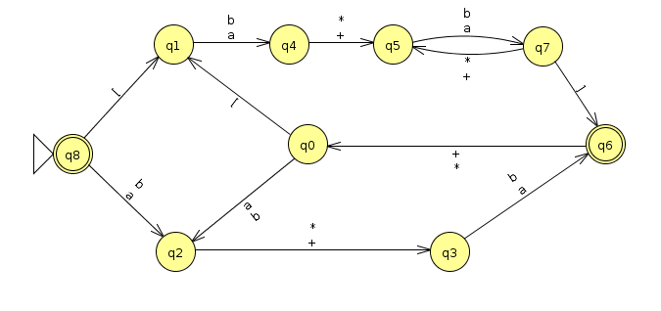

2) Given the language D, which is the strings over $Σ_{2}$ where the top row represents a larger binary number than the bottom row,and

3) Given the rules of the game, person B can choose boxes in the following order to guarantee a win: “223344”

A description...

If the rules of the game changed to allow person A to treat the boxes as circular, then person B can choose the following order of boxes: “1155114411331122”

Starting from an arbitrary box (and choosing each box twice), B selects a direction and chooses the box next to the starting box. B then chooses the starting box again, then the box next to the second box that has not been opened yet. B continues selecting the starting box and the next unopened box until B comes back to the start box. Using this algorithm, B can guarantee a win.