|  |  |  |  |
| --- | --- | --- | --- |
| Width (px) | Height (px) | Width (m) | Height (m) |
| 960 | 144 | 15.32 | 2.25 |

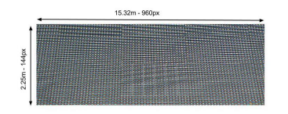

**Content format**

*Video*

Must be in **mp4** or **mov,** with H264 encoding and the required resolution (960x144)

*Image*

Must be in **jpg** or **png** with the required resolution (960x144)

*Direct from computer (Applications or programs)*

The LED screen works as any other monitor, but it only shows 960x144 px, starting from the upper left corner. As shown in the following example

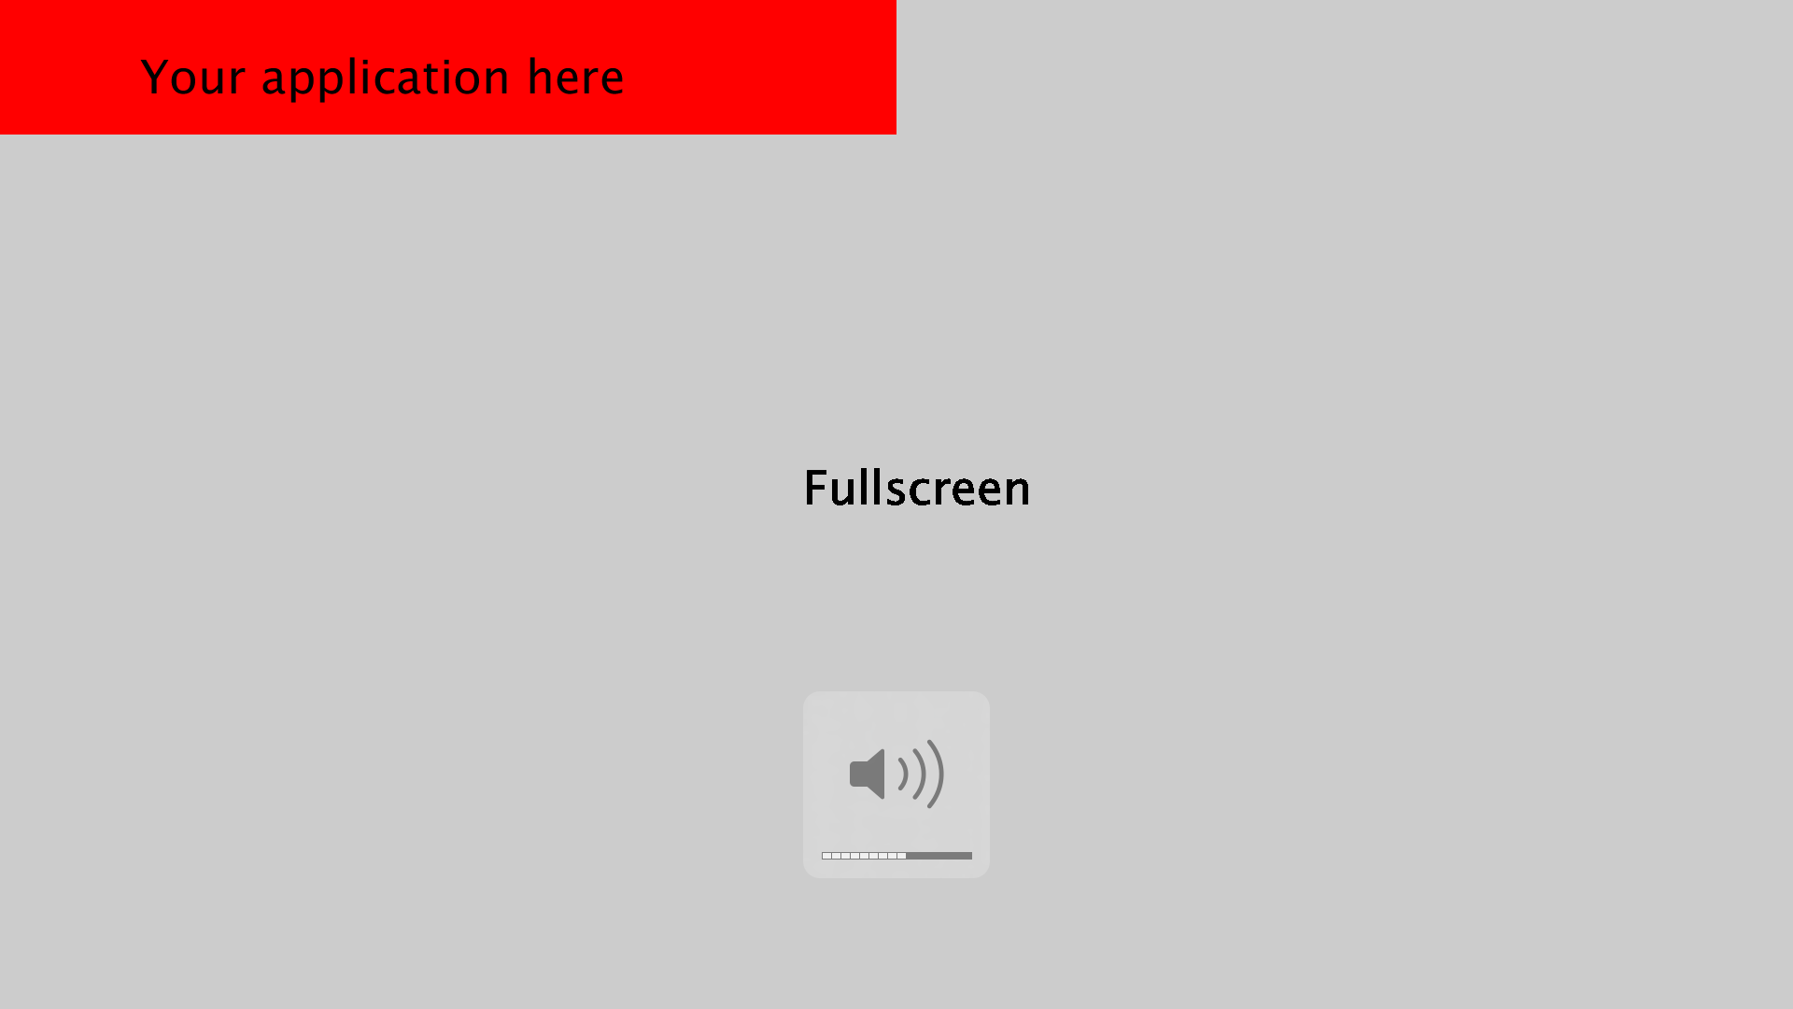

In case that the content shows text or logos, it's highly recommendable that they be as large as possible, otherwise they will not be displayed correctly due to the low resolution of the screen