Please, credit me [Tibu / https://www.youtube.com/@TibuYoutube] when using the Event Creator. Thank you. <3
When you first start the application, you will be met with the following screen:
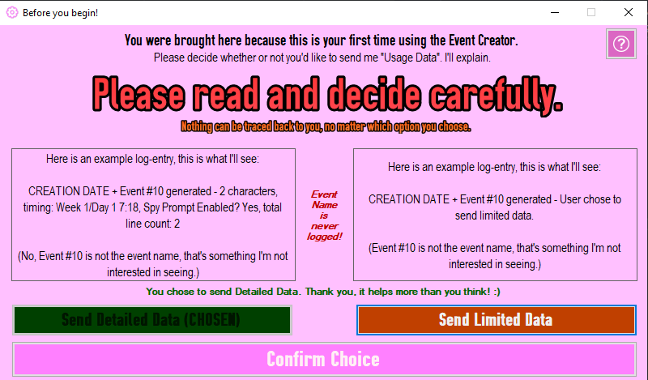
By default, you're sending Detailed Data. But why? Why do I need this information?
Well, it's simple, and it's all explained if you click the little question mark icon:
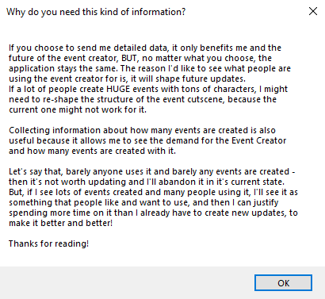
Sending Detailed Data looks like this:
2025-07-21 09:29:36 | Event #565 generated - 2 characters, timing: Week 3/Day 1 7:5, Spy Prompt Enabled? Yes, total line count: 11
Sending Limited Data looks like this:
2025-07-20 23:45:36 | Event #547 generated - User chose to send limited data.
This is up to you, nothing will change regarding the Event Creator if you choose to send limited data or vice versa.
If you changed your mind, you can always edit your selection in the settings menu.

There are 3 main options: Events, Tutorials, Creator.
If you click the Events button, you will be able to see all your events, create new ones, or edit existing ones.
If you click the Tutorials button, you will be brought to this screen, as you probably already figured out.
If you click the Creator button, you will be shown the credits and my youtube channel.
It's important to mention that none of this would have been possible without kgftbz, who is the creator of PoseMod.
On the bottom, you can see these 3 buttons, hovering over them will show what they're for: 
By clicking on , you will be able to view the changes made in the latest version / changelog.
By clicking on , you will be able to view the settings menu.
By clicking on , you will be able to send feedback about the event creator.
You can report issues/bugs, or if you have event-specific issues, you can report that too, by selecting the problematic event from the list.
