3.1 fix: Fixed bug with timed-cutscenes starting at 07:00AM.
Event Creator 3 (Change Log)
This is one of the biggest Event Creator updates ever.
- The last version was 2.7, but due to the large amount of changes / improvements, I decided to jump right to 3!
- Added more template events
- Added a “Switch Animation” button. (of course, it only shows up when you have more than one character in your event)
- Improved the “Arrange Dialogue/Lines” Form:
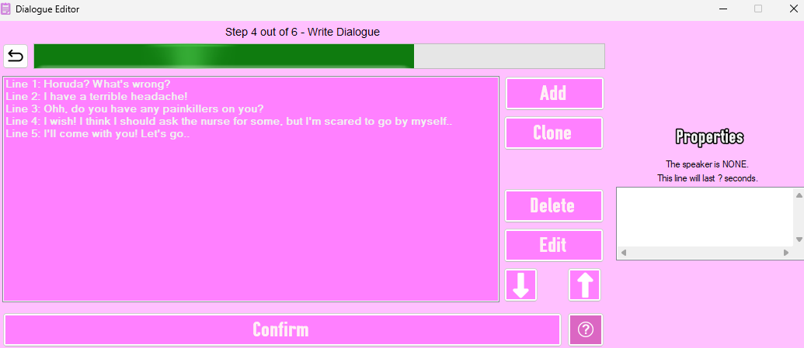
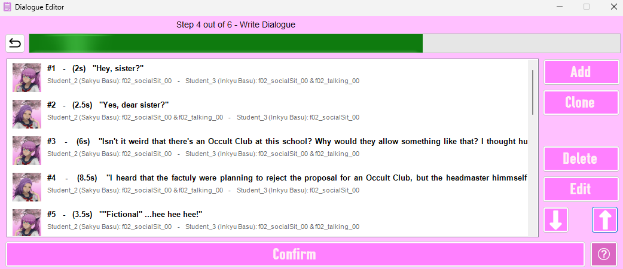
- Changed fonts in some places (eg. Coordinates use the Courier New font)
- Cleaned up the cutscene-structure (as much as possible)
- The "Spy-Setup Form" did NOT have the "Learn more.." option next to coordinate-fields. This has been corrected.
- The "Line Duration" field is now displayed using the "Courier New" font
- The "Subtitle / Dialogue Text" field is now displayed using the "Arial" font. It's size has also been increased from 8.5 to 12, so it's easier to read
- The "Line Editor" now shows the selected speaker's portrait next to the "Edit Speaker.." button (IF it was able to load)
- The "Custom Commands Form's Command Line is now displayed using the "Courier New" font
- I made several changes to cutscene-generation:
  - Cleaned up the cutscene
  - Added more notes that give a brief explanation of what each section does
  - Added information at the bottom, such as my channel, tutorials, and the creation time of the event. This is all “commented out” (//) so it does not affect any of the commands but might save you some headache if you don’t know how conditions work (for example).
  - After each line, there is a quick check to see if all the characters are alive = Can the event continue? For some reason, the labels were named using the current line’s index, so after the first line, you would see: “progressTo1”, which is not technically correct. This has been fixed, though it doesn’t make a difference to how the cutscene works.
  - The event now won’t even start if one or more of the characters are inactive/dead.
  - Made some changes to the “Cutscene Generation Form” itself
    - You can now open the game’s folder from the Cutscene Generation Form directly
    - You can now open the folder containing the Event Cutscenes from this form
    - You can now open the cutscene you are currently viewing from this form
- I also made some changes to the “Feedback Tab”!
    - You can no longer upload any file. The media tab is now limited to:
      - audio files
      - images
      - videos
      - GIFs
      - text files
      - dll files (if – for some reason – you need to attach your Assembly)
    - From now on, if the Send Button is disabled, there will be a reason displayed above it
    - If you report an issue with a specific event, the following files will also be shared from now on (if they exist):
      - Cutscenes/WeekSystem/X.txt (X being the week of the event) [this is the event creator’s own week system that gets generated]
      - Cutscenes/Week/X,txt (X being the week of the event) [PoseMod example week-system also made by me]
      - Cutscenes/Week/WeekXDays/Y.txt (X being the week of the event and Y being the day of the event)
      - Cutscenes/ModScript/SchoolScene.txt
      - these files won’t be shared with anyone, only me, and I only need them to see if the event is actually being started properly, as this has been an issue for many people.
- Fixed Player-related event issues
- Added a „location marker” in the position the player needs to stand (can be turned off)/
- Characters no longer have to turn towards the other character while waiting. A toggle was added to disable this.
- You can now send characters to new destinations mid-event. Like the Osana-Raibaru Club Event, where they go around school.
- Re-made the animation screen completely:
  - you can now set custom animation speeds
  - you can now make the animation loop
  - there is now a search-bar for animations
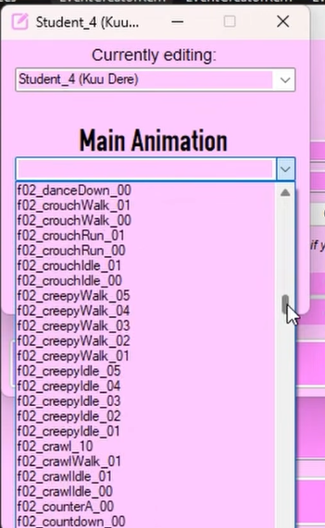
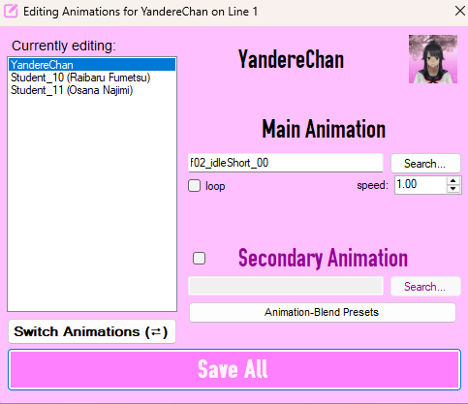
Please, credit me [Tibu / https://www.youtube.com/@TibuYoutube] when using the Event Creator. Thank you. <3 ,, https://ko-fi.com/ttibs

