VUSAL

CEFEROV

FRONT - END DEVELOPER

I am a front-end developer with extensive experience in website coding and design

# EXPERIENCE

**2020-2023**

**Ticcer Company**

FRONT-END DEVELOPER

I worked on the design of the company's website

# EDUCATION

**Baku State Vocational Education Center for Industry and Innovation**

**2021-2024**

Web Designer and Software Support

**2019 - 2020**

**AzeriCOM Courses**

Computer repair, installation and support of windows operating systems

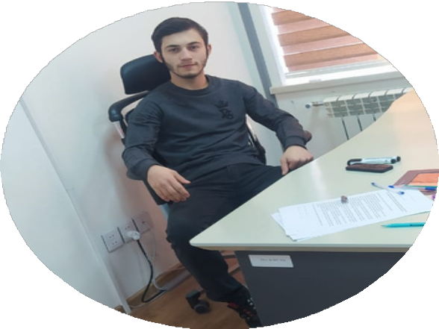

# CONTACT

+994-50-452-79-94

[ticcersoftwarecompany@gmail.com](mailto:ticcersoftwarecompany@gmail.com) https://ticcercompany.github.io/ticcercompany/Main/# Gobu settlement, Baku city

# SKILLS

HTML & CSS JAVASCRIPT

C#

100%

50%

68%