 | Dimitar Antoniev Tsonev
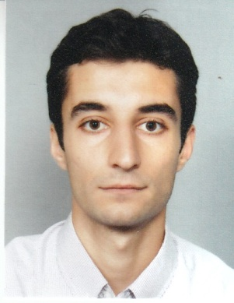 | Bulgaria,Varna,9000,. Bul. “Knqz Boris” 43 A
Mobile:0885/ 64 70 87

Date of birth: 17.04.1986
 | mail: tsonev.dimitur@gmail.com

Proffesional experience

Period: 07.2018- Present
Name of the company: test IO GmbH
Position: Quality Assurance Freelancer
Responsibilities:
- Responsible for checking new software products, such as those for gaming
systems or mobile applications, for defects or issues.
- Also running various tests on software to ensure it meets all standards and guidelines and is
ready to be marketed to consumers.
Business sector: IT

Period: 05.2018- Present
Name of the company: BugFinders Ltd.
Position: Quality Assurance Freelancer
Responsibilities: To make and report test artefacts(all bugs, test cases, test data, test scripts and
other test artifacts implemented by BugFinders).
Business sector: IT

Period: 09.2016-09.2018
Name of the company: TrainArea Ltd.
Position: Data entry
Responsibilities: Maintains data entry requirements by following data program techniques and
procedures, extracts and organize information from databases in a specially designed program for the .
the purposes of the company.
Business sector: IT, Marketing

Period: 07.2014- 03.2016
Name of the company: Eatglobe Ltd.
Position: Data Entry
Responsibilities: Maintains data entry requirements by following data program techniques and procedures, extracts and organize information from databases to produce routine and specialized reports.
Business sector: IT, Marketing
Period: 05.2012- 07.2014
Name of the company: AGPSMIPIBK-“ Tsonevi” OOD
Position: technical secretary
Responsibilities: Answers correspondence,
Acts as information source on established organizational policies and procedures.
Gathers, compiles and reports pertinent information
Business sector: Healthcare

Period: 07.2011-03.2012
Name of the company: Regional Health Insurance Fund-Varna
Position: senior expert
Responsibilities: All Administrative Control Activities concerning hospitals
Business sector: Healthcare

Period: 06.2009 - 09.2009
Name of the company: Sosciete Generale Expressbank, Varna
Position: Probationer
Responsibilities: Different type of jobs related to the bank documents and other support technical activities
Business sector: Banks
Level: Administrative and support staff

Period: 05.2005 - 09.2005
Name of the company: Airport-Varna AD, Varna/Varna district/Bulgaria
Position: Check-in Assistant
Business sector: Transport and Logistics
Level: Administrative and support staff
Education

Period: 03.2012- 03.2013
Name of the university: Business Academy “ D. A. Tsenov”
Degree: Master
Specialty: Health management

Period: 09.2009 - 06.2010
Name of the university: Economics university-Varna
Degree: Master
Specialty: Commerce and PR
Address: Varna/Varna district/Bulgaria

Period: 09.2005 - 06.2009
Name of the university: Economics university-Varna
Degree: Bachelor
Specialty: Marketing
Address: Varna/Varna district/Bulgaria

Language skills

Bulgarian: native
English:
- Reading: Excellent
- Speaking: Good
- Writing: Excellent

Certifications

- Achieved certificate in “Online marketing and web design”
- Achieved certificate “Management of projects and programs from EU”
- Cerificate in English for Speaker of Other Languages (ESOL)
Intermediate ESOL City and Guilds Pitman Qualifications
- Achieved certificate „QA Fundamentals“ from Advance Academy, Varna



Linkedin profile:

https://www.linkedin.com/in/dimitar-tsonev-387aa9162/

