12/5/2018


System Programming

Coursework Testing Documentation
By Tício Victoriano

Name: Tício Torcato Fortuna Victoriano
Email: tvicto200@caledonian.ac.uk
Student id: S1803453
Features | Testing description & Steps | Expected result | Actual result
Automatically creating the .trashCan folder | Running the command, bash safeDel.sh, for the first time. | A hidden folder named trashCan should be automatically created on the user’s directory. | A hidden folder named trashCan automatically created on user’s directory.  Refer to img.1 in the appendix
Deleting a single file
Listing files in the trashCan folder with -l option | Listing the files of the .trashCan folder using bash safeDel.sh command
Deleting several files at once
Listing files in the trashCan folder from menu
Recover a file with -r option
Recover a file using the menu
Listing files in the trashCan folder from the menu | Listing the files of the .trashCan folder using bash safeDel.sh command
Listing files when trashCan is empty | Test what will happen when the trashCan folder is empty and the user tries tries to list the its content.  Steps to follow:  1. Delete trashCan: rmdir $HOME/.trashCan  2. List content: ./safeDel.sh -l
Recovering files when trashCan is empty
Displaying total usage when trashCan is empty | Test what will happen when the trashCan folder is empty and the user tries to check the folder usage.  Steps to follow:  1. Delete trashCan: rmdir $HOME/.trashCan  2. List content: ./safeDel.sh -t

Appendix

img.1
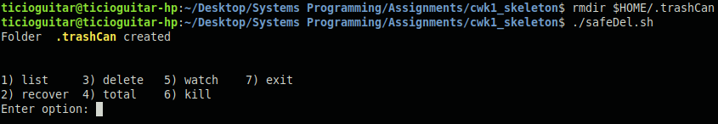

img.2

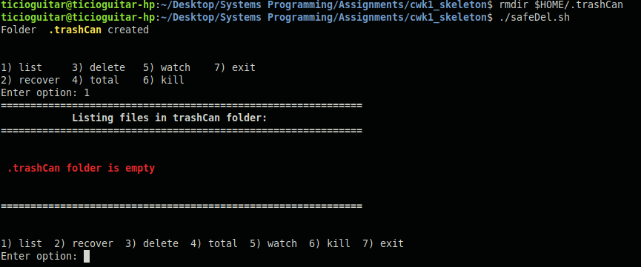

img.3
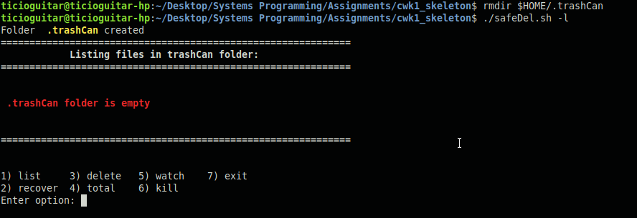

img.4

