Jacob Bowers

Professor Dunren Che

CS-430-001 – Database Systems

15th November 2020

Jacob_Bowers’_Big_Database_Project_Screenshots

The following document was designed to both show of and describe screenshots of the Jacob_Bowers’_Big_Database. The descriptions will attempt to be short and snappy as to not waste the readers time, as the README file was designed to convey the important information about the database in written form.

1: The Main-Menu

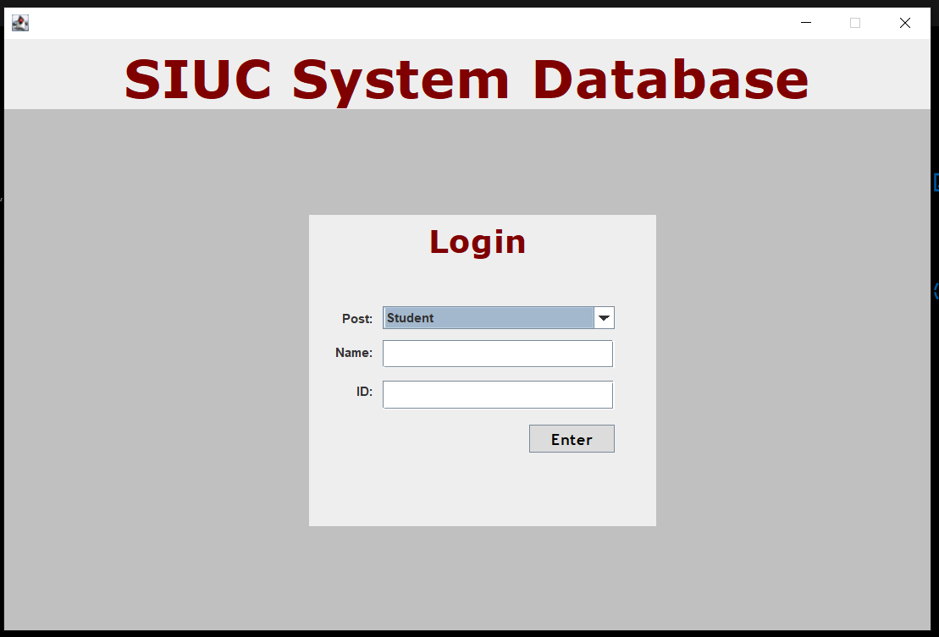

The main-menu screen is what users will be prompted with the moment they boot up the application and it embodies all the goals of this project. The design was intended to look professional. Muted colors will little clutter, the user immediately knows what is required of them.

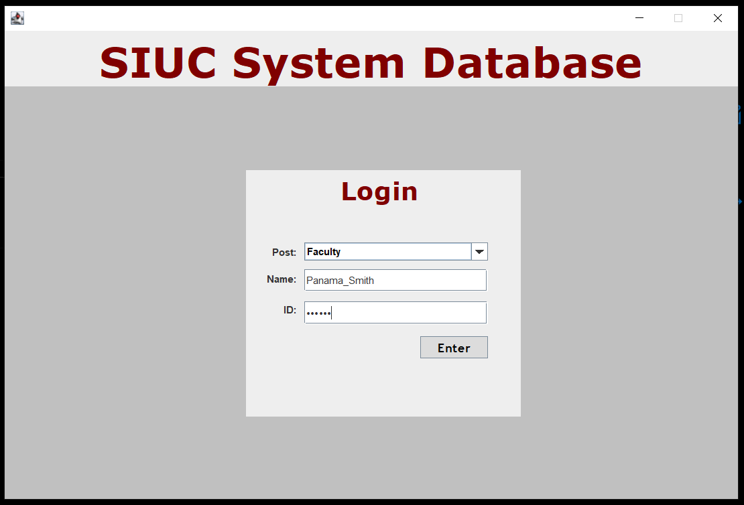

When logging in the user’s ID is kept confidential.

2: Faculty-Menu

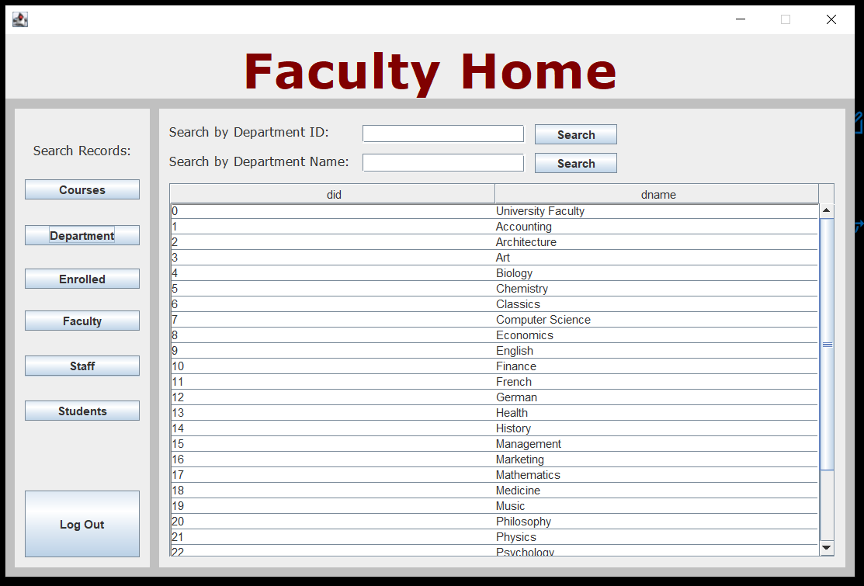

The faculty have access to the powerful search engine giving access to all information in the database.

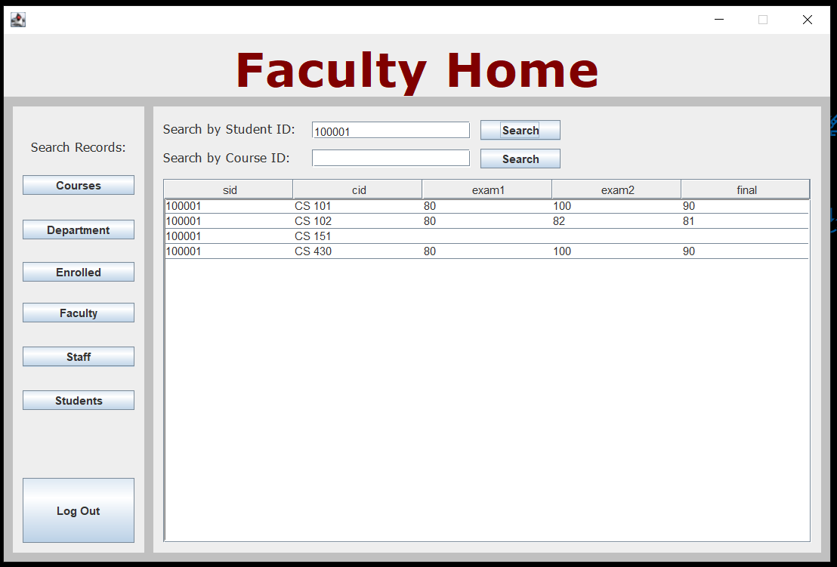

Using this tool to sift through information is incredibly useful.

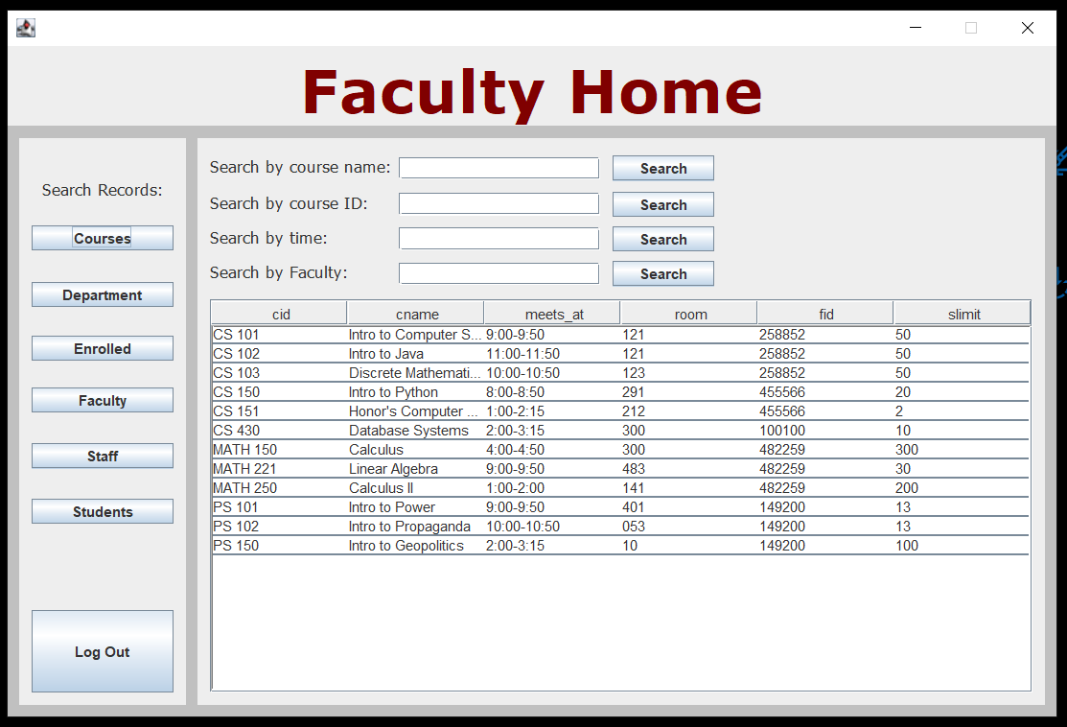

3: Student-Menu

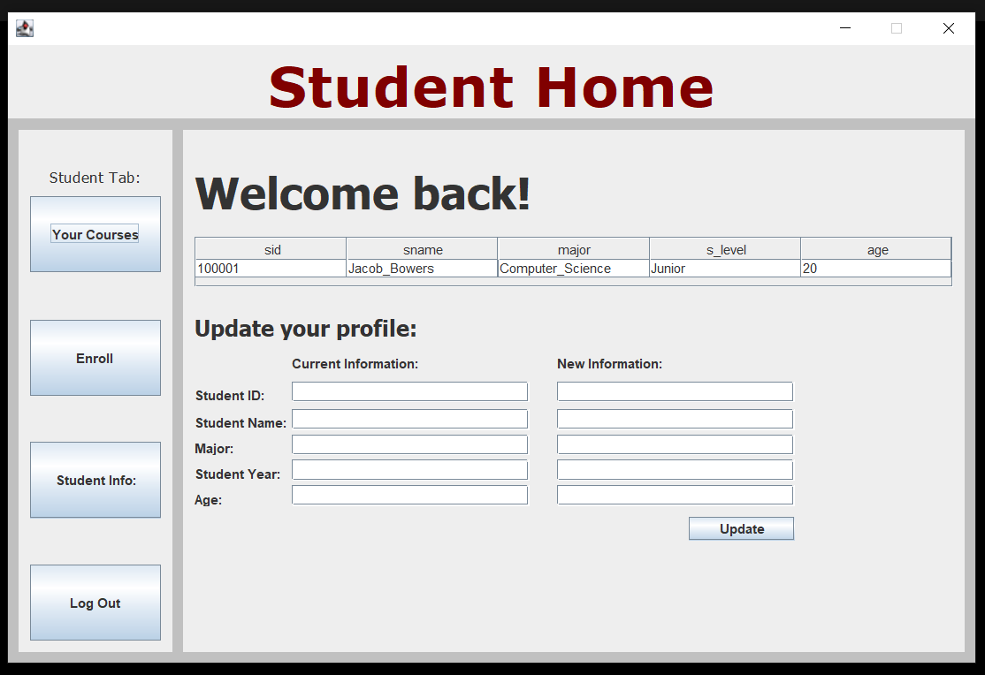

All students are greeted with this window upon opening up the Student-Menu.

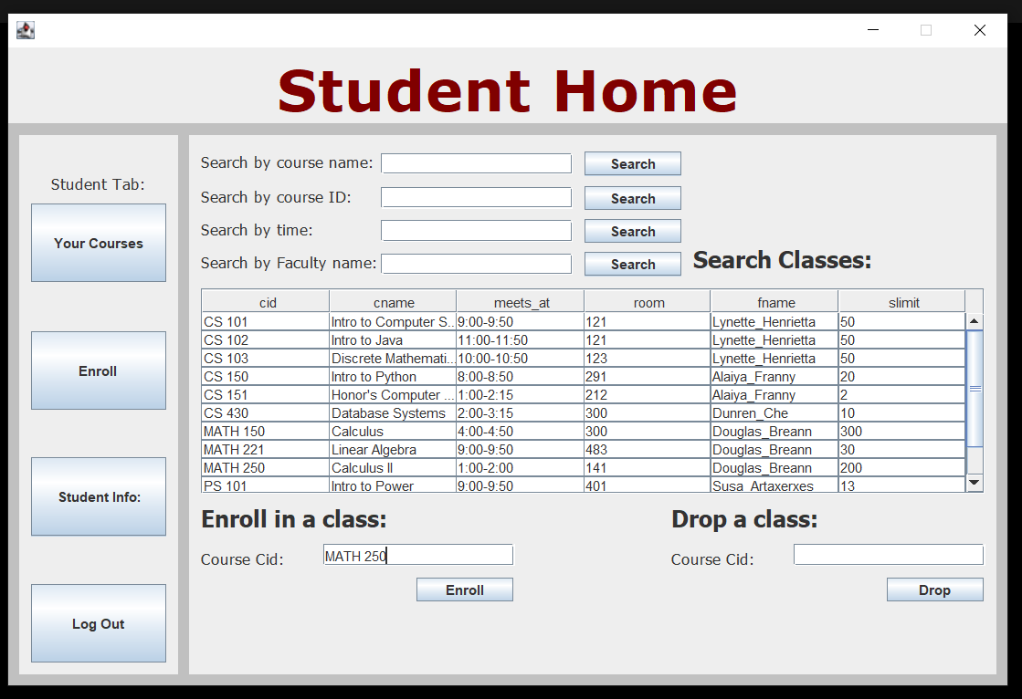

The enroll tab allows for quick access to enrolling and dropping courses. Let’s in roll in Calculus II.

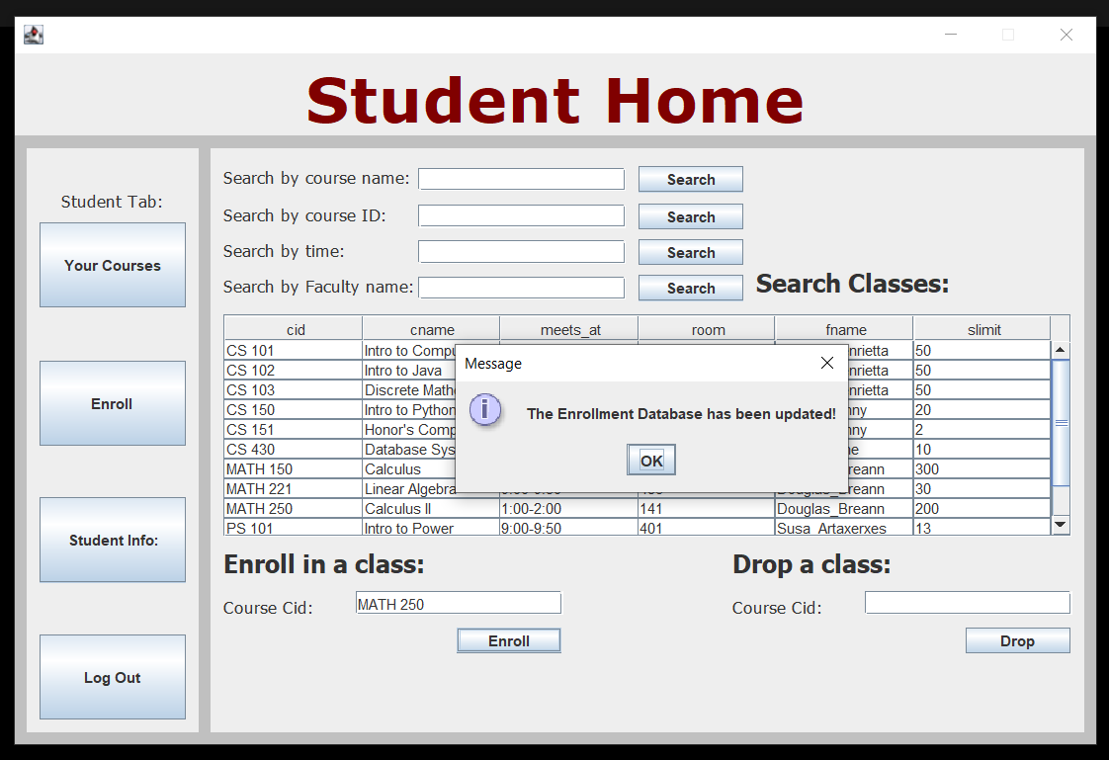

Success! Let’s go quickly check if it was added to this students courses.

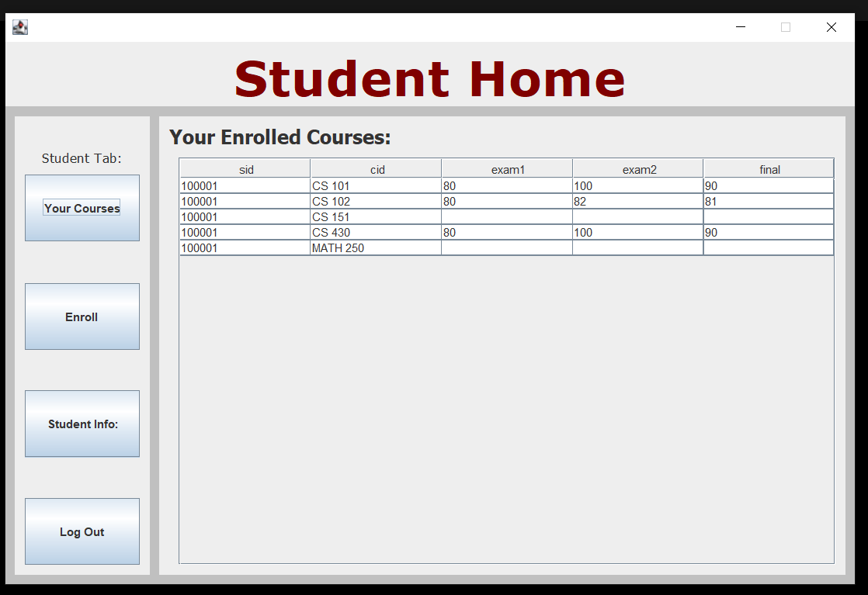

Bingo! Dropping a course is just as simple.

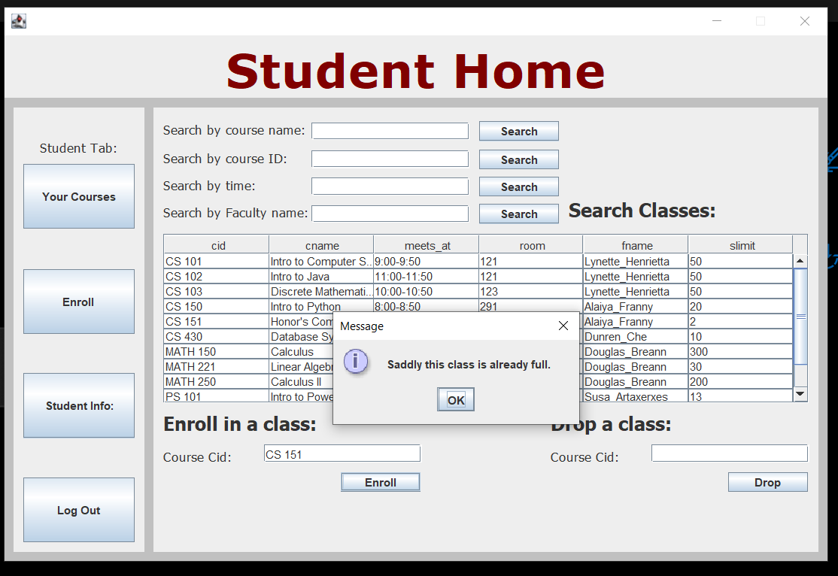

One last note about enrollment. Students cannot enroll if the class limit has been reached.

4: Staff-Menu

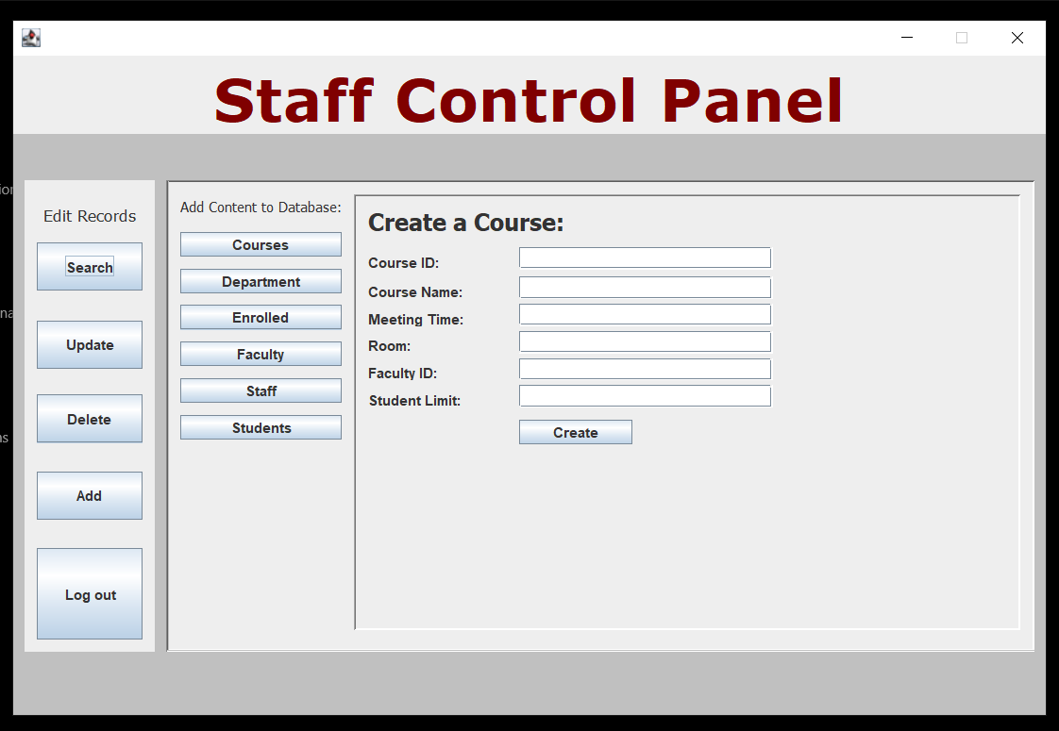

The Staff-Menu is easily the largest in the database.

Real quickly lets add a new CS Staff member.

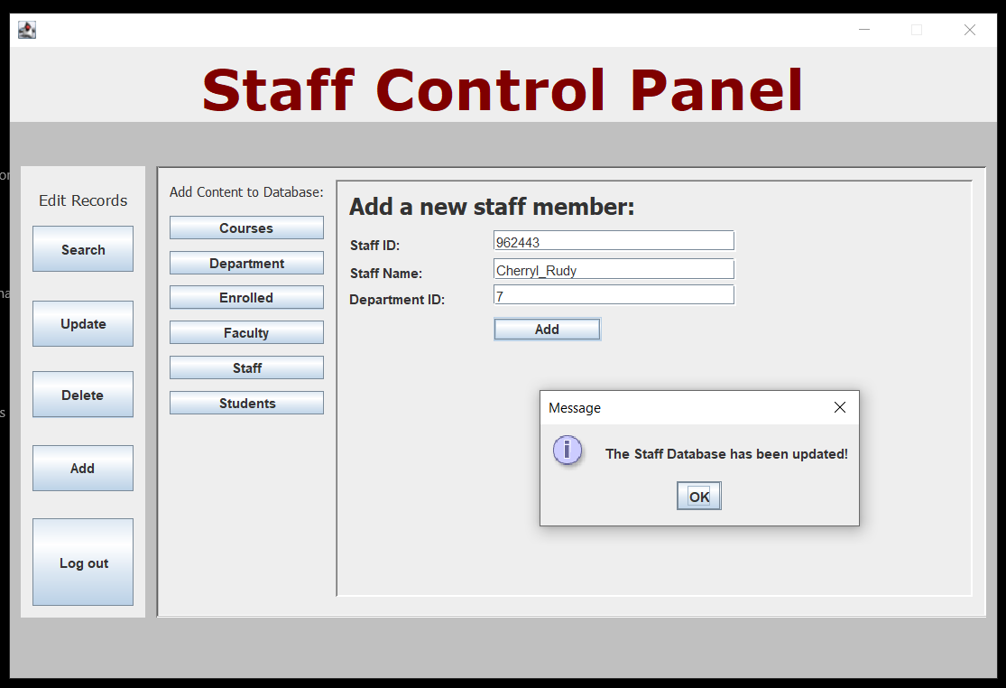

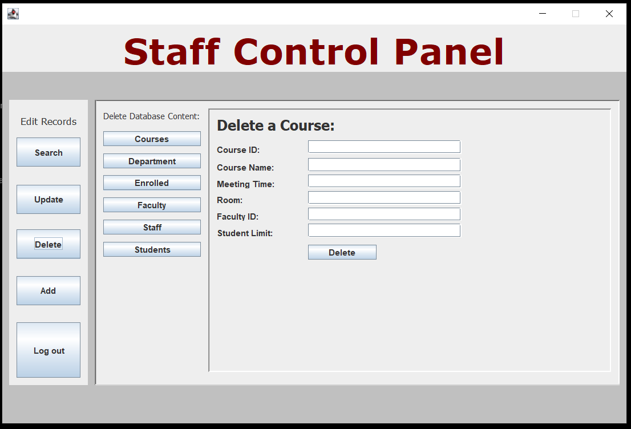

Content could also be deleted or updated.

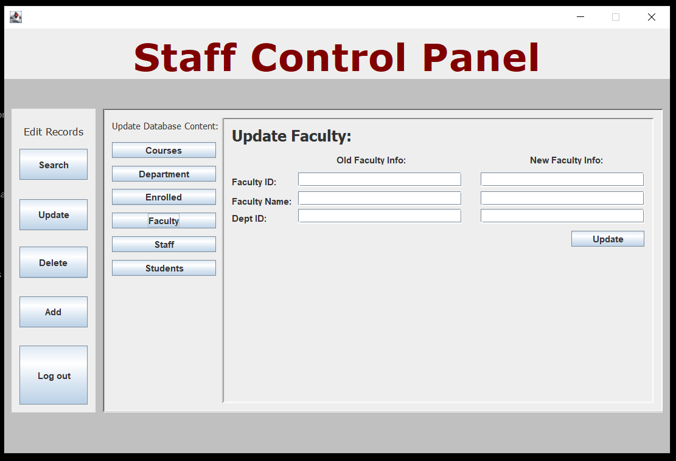

Finally, we have the Staff-Search option giving the Staff access the powerful database search engine.

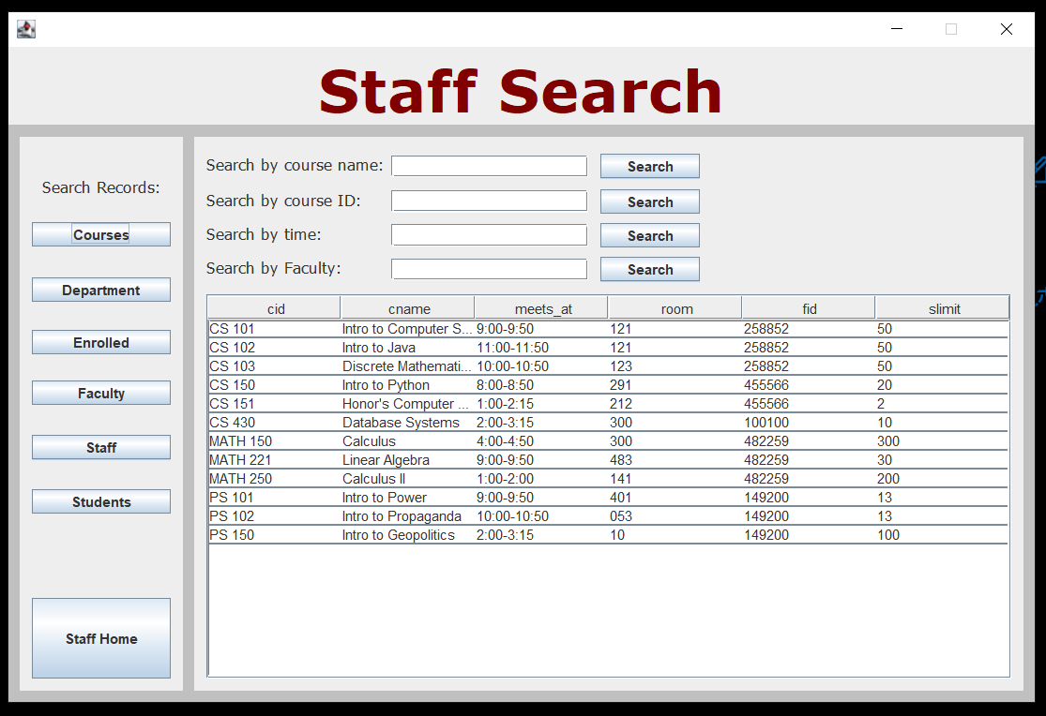

To return to Staff-Home a user simply must press the corresponding button.

MySQL:

