Question 1
The new school year signalled a new beginning. I was excited to go back to school to hit the books once again. There were many new things to learn, new friends to make and new challenges to face. Above all, I could not wait to find out who my new classmates were. Who among my previous classmates would be joining me again this year? Who were the fresh faces I was going to meet?

On my first day back at school, I was filled with anticipation. I was later overjoyed to learn that many of my good friends, including Alice, Sue, Damien and Roy were posted to the same class as me. However, my heart sank when I saw Alvin Foo into the classroom.

Alvin was a notorious school bully who had earned himself the reputation of being the only student in the history of the school to have been publicly caned by the discipline master the previous year after he had slapped a female trainee teacher whet she had caught him cheating during a test. In fact, Alvin's string of misdemeanour! stretched all the way back to the time he first joined the school.

I had had a first-hand experience of Alvin's bullying in Primary One. While I was queueing up at the noodle stall during recess, Alvin came up to me and tried to cut the queue. When I told him off, he left in a huff. After I had bought a bowl of piping hot soup noodles, I was gingerly carrying my purchase to a vacant table when Alvin crept up behind me and yanked my ponytail forcefully. The surprise attack caused me to drop the bowl of noodles onto the floor. Till today, I still remember the searing pair as the hot soup spilt onto my arms, leaving in its wake a patch of almost raw, tender pink skin. Thankfully, the soup was not at boiling point or my injuries would have beer much worse.

In the years that followed, Alvin's pranks on his schoolmates never ceased. He once pushed Damien during a Physical Education lesson, causing the latter to fall down and graze his knee against the rough running track. When we were in Primal Three, Sue once went hungry for an entire month because Alvin had forced her to give him all her pocket money daily. He threatened that he would snip off her long, ponytail when no one was looking if she failed to comply or told on him. Fearing to lose her lovely tresses, Sue did not report about the extortion until she fainted in class one day due to starvation and dehydration. Only then did she reveal the truth to her teacher.

Why was Alvin allowed to continue with his seemingly endless spate of bullying% In fact, he had been hauled up to the principal's office countless times to face the music for various misdeeds. His parents were also called up so often that they were embarrassed to face their son's teachers and principal to hear of yet another wrongful act he had committed. However, throughout the years, Alvin remained unrepentant. Given all that he had done to terrorize me and my friends in the past

I was understandably apprehensive to be his classmate this year. In the next few days, my friends and I kept a distance from Alvin. As the days passed, we were quite surprised that he did not try to bully us or any of our classmates. During lesson time, Alvin also seemed very attentive. Not once did he attempt to disrupt the lesson by misbehaving in class or talking loudly. In fact, on a few occasions, he even raised his hand to volunteer the correct answer when the teacher asked a question. Alvin was always at his best behaviour. Gradually, we let our guard down and accepted Alvin as our friend.

Alvin later told us that his parents had sent him for professional counselling during the school holidays. During the counselling sessions, he had come to realize that his arts of bullying others were actually his way of trying to attract the attention of those around him. Inside, he was a lonely boy who craved acceptance and friendship. His counsellor had made him understand that in order to be loved and accepted by others, he had to change his ways or he would risk ending up alone and friendless.

On hearing Alvin's honest confession, we were glad to bury the past, welcome him into our fold and be his friend. We admired his courage in wanting to change. Above all, we were glad that the biggest bully in our school was no more a bully. The new school year was indeed going to be a happy and peaceful one.
Question 2

Early evening had given way to dusk. The sun was no longer shining and darkness had started to envelop the surroundings. My friend, Sunil, and I were walking along Changi Beach. We had broken away from our friends who were having a barbecue so that we could enjoy some peace and quiet and soak in the cool night breeze.

We were walking along a deserted stretch of the beach when we spotted a speedboat heading in our direction. Before we knew it, the speedboat had reached the shore. From where we were standing, we saw a group of five or six small-built men disembark from the boat. Afraid to be seen by them, we ran and hid behind a clump of bushes.

From our vantage position, we saw the men, all dressed in singlets and shorts. They were of Asian origin. Our first idea was that they were illegal immigrants who were trying to enter the country without valid documents. However, we next saw the men unload some wooden crates from their boat. One of the men stood on the shore and acted as a lookout.

Seeing the mens furtive behaviour, we smelt a rat and immediately called the police using Sunils mobile phone. We gave the police a detailed description of what we had seen, along with our exact location. The mainland police alerted the police coastguards, who radioed a message to all police coastguard vessels in the vicinity.

Within minutes, a police coastguard vessel sailed inland to where the boat was. Their arrival was so sudden and unexpected that the men on the boat had no time to escape. We witnessed all six men being apprehended and handcuffed by the police. By that time, two police cars and several customs officers had also arrived at the scene. One of the officers pried open one of the wooden crates. It contained contraband cigarettes. All the suspects were taken away by the police and the entire consignment of contraband cigarettes was seized.

We later learnt that in order to escape the high tax imposed by the government on cigarettes imported into Singapore, the six men had attempted to illegally smuggle cigarettes into Singapore. However, they failed to realize that the harsh penalties they had to pay if they were caught made their shady venture a very risky one indeed.

Following the arrest of the smugglers, Sunil and I were commended by the police for our vigilance and public-spiritedness. The feeling of pride and joy upon receiving our plaque and letter of commendation in front of our family and many reporters Was a moment we would forever cherish in our hearts. However, we were even more satisfied that we had helped the police in preventing a crime from taking place.

Question 3

A passing shower had just bathed the vicinity. On that dark, moonless night, the weather was cool and yet the air was still. At nine, Mr Lim started his shift as a taxi driver. The roads were still wet and the forecast of intermittent rain throughout Mr the night kept most people indoors. Lim was expecting a slow night, but hopeful that he would at least get a few passengers to cover his taxi rental and fuel costs. Fortunately, he was flagged down by a passenger soon after.

Throughout the night, Mr Lim ferried a number of passengers. Business was not all that bad after all. Finally, at around four the next morning, fatigue began to set in and Mr Lim decided to drive home for a well-deserved rest. As he was driving along Choa Chu Kang Road, a lady flagged down his taxi. She was carrying a newborn baby in her arms. With her slender figure, porcelain clear complexion and long, flowing hair, she appeared rather attractive. She had light make-up on her face and was dressed in a simple pink blouse paired with a long, white skirt. Her beautiful, rosy-cheeked baby was sound asleep in her arms, a picture of peace and serenity. The lady told Mr Lim that she wanted to go to Block 12A, Serangoon Avenue One.

Mr Lim jokingly asked what a pretty young woman like her was doing out in the middle of the night with her young child. She told him that her abusive husband had come home drunk that night. Afraid that his drunken stupor might induce yet another violent outburst, she had left the house with her baby daughter while he was in the bathroom to go to her mother's house to stay until he became sober. Mr Lim found her explanation for her late-night journey a logical one, although he felt that she was rather well-dressed for someone who had to leave her home in such a hurry. However, he kept his thoughts to himself. Before she alighted at her destination, Mr Lim told her to take care and advised her to call the police if her husband ever tried to lay a hand on her or her baby.

After Mr Lim dropped the lady off at her mother's place, he headed home. He was worn out after the long drive and eager to get home to have a good sleep. When he reached home and parked his taxi in a vacant lot downstairs his flat, he turned his head to check the back seat to see if anyone had inadvertently left anything behind. He could hardly believe his eyes when he found a newborn baby on the floorboard behind the driver's seat! He must have been so exhausted that he had failed to notice that the lady had alighted from his taxi without her child! Mr Lim thought that he might have been tricked by the lady and her sob story. She had the intention of abandoning her baby in his taxi all along.

Mr Lim's first instinct was to take the abandoned infant to the nearest police station and make a police report. However, seeing how cute and adorable the chubby baby looked, Mr Lim, who had been childless after ten years of marriage home, decided to take the baby home to his wife for a while. He thought for a few hours before taking the baby to the police station later that day.

Back home, Mrs Lim welcomed the baby. She wrapped it in a blanket and caressed it in her arms as she lay on the bed. Soon, she and Mr Lim fell fast asleep. When they woke up at around ten in the morning, Mrs Lim jumped up in fright. In her arms was the thick, warm blanket, but the baby was gone!

When Mr Lim counted his takings for the previous night he was short of twenty-two dollars and sixty cents, the exact amount which the lady passenger had paid him. It was as if he had never picked up his last passenger and her baby. Could their intense longing for a child have affected Mr and Mrs Lim so deeply that they dreamt up the whole episode? But how could both husband and wife have had the exact same dream of having the baby right in their house?

The following day, there was a report in the newspapers. A young housewife and her month old baby daughter had been found dead in a flat in Choa Chu Kang the previous morning. They had been knifed to death by the lady's husband, who had since surrendered himself to the police. He had admitted to killing his wife and daughter while under the influence of alcohol after accusing her of seeing another man. He said that he had lost control of his anger after he had caught her trying to sneak out of the house with their baby. The numerous defensive stab wounds all over the lady's body showed that she had used her body as a human shield to protect her child during the brutal attack. Forensic pathologists put the time of death at around four the previous morning ...

Question 4

The mid-year examinations were just round the corner. Being in the final year of their primary school and with the dark cloud of the all-important Primary School Leaving Examination looming ahead towards the end of the year, the whole class was especially hardworking since January. Four months on, everyone had settled comfortably into study mode and was eager to do well in their mid-year examinations. They know how well they fared in the examinations would be a good gauge of how well they had absorbed their lessons and how prepared they were for their preliminary examinations and the actual PSLE later in the year. For the students in Primary 6A, the best class in the level, the competition was even more intense.

Jeremy was starting to feel the heat from all directions. His parents had high expectations of him to ace the examinations and he did not want to disappoint them. He himself was a high achiever and put a lot of pressure on himself to do well. Jeremy was a conscientious and consistent student who had been constantly paying attention in class and doing his assignments. He also did many assessment books for revision and to expose himself to a variety of possible examination questions. In spite of all this, Jeremy still suffered from pre-examination jitters. He was especially nervous about his Mathematics examination since Mathematics was his weakest subject. As the day of the Mathematics examination drew near, Jeremy's anxiety increased.

The day before the Mathematics examination, Jeremy's form teacher, Mrs Tan, asked him to carry a pile of workbooks to the staff room during recess. Inside the staff room, Jeremy met his classmate, Hasli. Hasli was standing by the photocopier with his back facing Jeremy. Curious about why Hasli was in the staff room, Jeremy moved closer towards him and looked over his shoulder. He saw that Hasli was about to make a photocopy of a set of examination papers. Jeremy caught sight of the cover page and was shocked to see that it was a copy of the Mathematics examination for that year!

Jeremy immediately confronted Hasli about his dishonest act. Hasli told him that he knew the teachers were having a meeting during recess and he had actually sneaked into the staff room to try to secretly get back his mobile phone which had earlier been confiscated by Mrs Tan when she caught him using it in class. He was desperate to get it back because his father would cane him if he knew he had brought the phone to school.

Hasli had rummaged through Mrs Tan's handbag and found a set of keys. He tried every key and finally found the right one which opened the drawer of her desk. When he opened the drawer, he found his mobile phone atop a copy of the next days Mathematics examination script. He SOW it as a 'golden opportunity' he was not going to pass up on. He planned to photocopy a set of the examination paper and put it back in the drawer. He would also put his mobile phone back into the drawer so that Mrs Tan would not suspect anything. A caning from his father Was a small price to pay for acing the examination.

For a moment, Jeremy was tempted to join Hash in making a photocopy of the coveted examination paper. However, he also thought about how he would be letting his parents and teacher down if he committed such a dishonest act. After all, he had studied very hard and should face the examination bravely. He felt that he should have more confidence in his own ability, especially since he had been preparing very hard for the examinations. He told Hash that they would be making a big mistake if they tried to cheat in the examination. What if they got caught? Having made it thus far in their primary school education without cheating, they should maintain a clean record and a clear conscience.

On hearing what Jeremy had to say, Hasli too realized that the risk he was taking was not worth it, both for attempting to cheat in the examination and for trying to retrieve his confiscated mobile phone. With that, he put the examination paper back into the drawer and placed his mobile phone above it before putting the key back into Mrs Tan's handbag. Jeremy and Hash then walked out of the staff room with their heads held high. They were going to try their best to ace the next day's examination based on their own merit and nothing more.

Question 5

The school bell rang and the only thing that could be heard was the screeching of chairs being pushed back abruptly against the floor, and the excited chatter of students eager to get home. Everybody rushed towards the stairs, and ran out of the school gate.

On my way out, I suddenly noticed a commotion at the school gate. Many pupils were present and some who were too short, stood on tiptoes. Out of curiosity , I made a beeline towards the crowd. "I did not do that on purpose!" I heard a boy say. I pushed my way through the crowd, and finally got to the front.

Two big and burly boys stood facing one another and they glared at each other menacingly. I recognised one of them as a notorious boy in school, Ben. He had gotten himself into trouble many times, mostly due to fighting, and it looked like a fight was going to break out any moment.

I was right. Ben made the first move. He punched the other boy in the face and said, "There, Danny, this is what you get for not saying sorry!" Danny froze momentarily, before kicking Ben in the shin. Both of them then started hurling vulgarities at each other.

The crowd gasped when Ben whipped out a penknife from his pocket. He brandished it, and the shiny stainless steel blade gleamed in the sunlight. Danny held up his hands in defeat and backed away. However Danny was not fast enough and Ben cut his forehead! My eyes opened wide in shock as I saw blood stream down Danny's forehead. An ominous rage seemed to have taken hold of Danny and he drew in his breath with a long hiss. Danny then kicked Ben's leg a few times, before hitting him hard on the chest, causing Ben to fall. Ben's leg must have twisted as he fell. A sickening crack was heard and I saw Ben's leg lying at such an awkward angle that it was apparent that it was broken. Ben let out a shocked gasp before fainting. Danny too, clutched his forehead and collapsed to the ground.

A few pupils called for the ambulance immediately. After what seemed like an eternity, we could hear the incessant wailing of an ambulance. Paramedics climbed out of the ambulance, and ran towards Ben and Danny. The paramedics' eyes widened in shock when they saw the horrendous bloodstains on Danny's clothes. They carried both boys onto the stretchers and drove off. The crowd slowly dispersed, with some students shaking their heads as they walked away.

The next day, our principal, Mrs Tan, talked about the fight. She said that the boys were lucky to have got to the hospital in the nick of time. Both boys would be suspended for a month as a result of their recalcitrant behaviour. Mrs Tan also told us not to follow in their footsteps. Ben and Danny were punished for their errant act and I hoped that I would never have to witness such a gruesome incident ever again.

Question 6

It was a bright and sunny day. While walking home from his tuition class, David passed a street hawker along the roadside. The hawker was selling snacks and cakes, which were displayed in the open on a tray.

Seeing the delicious-looking snacks, David felt hungry and bought a slice of kayo cake. He did not think much about the flies hovering around the food, nor was he worried about the dust settling on it. After David paid the hawker, he was handed his chosen slice of cake and given his change. The hawker used the same bare hand to handle the food and money.

Two hours later, David was at home doing his homework when he was hit with a bad stomachache. This was followed by diarrhoea and vomiting. Poor David was in agony.

When his mother asked him what he had eaten earlier, David told her about the hawker from whom he had bought a slice of kayo cake. His mother was horrified to learn that David had bought food from an unhygienic, illegal street hawker. She told him that it was unsafe to consume food bought from such illegal hawkers. The food sold was exposed to the dust and flies around. The hawker also handled the food with his dirty hands. Imagine how many germs might be present on the food!

David's mother took him to the doctor's and he recovered within a few days. After all the suffering he had to go through, he learnt his lesson and never dared to patronize illegal hawkers again.

To prevent others. from suffering a similar fate, David's mother later lodged a complaint to the Ministry of Health about the illegal street hawker. Following the tip-off, health officers investigated the case and the illegal hawker WQS arrested and fined five thousand dollars for illegal hawking.

He later changed his livelihood and became a lawful businessman. After his application for a licence was approved, he started selling food at a hawker centre. He followed all hygiene procedures and no one ever got foodpoisoni ain. ng after consuming his food again

Question 7

I woke up to an exceptionally chilly morning. My entire body was shivering. When my bare feet stepped onto the icy cold surface of the ceramic flooring of my bedroom, I jumped up in shock. I put on my warm bedroom slippers and went to the windows to take a look. Outside, everything was covered in a blanket of pristine white snow. I could not believe that I was in Singapore.

I turned on the radio to listen to the news broadcast. According to the news report, the El-lina monsoon had caused a temporary dip in temperatures to an all-time low for this region. The low temperature had caused the rain drops to freeze before they could reach the earth, resulting in snowfall for the very first time in Singapore. This freak phenomenon would probably last for only a day before the EI-lina monsoon made its way eastwards away from Singapore.

While dad was frustrated with the massive traffic jams caused by the snow piling up on the street and Mum was displeased that the snow had ruined the flowers she had painstakingly planted, I was in seventh heaven. I put on my thermal underwear and warm clothes which were usually only used when my family travelled overseas to cold countries for holidays.

As it was a Saturday, I did not have to go to school. I rushed into my backyard to experience the snow. All around me was a blanket of dazzling white snow. It was no longer snowing, but the thick layer of snow that had fallen earlier had turned the landscae into a winter wonderland. I called out to my neighbours, Reuben and Ruth, to come and play in the snow with me. We tumbled around in the soft snow, getting our warm clothes covered with snowflakes. Reuben rolled a handful of snow into a ball and hurled it in my direction. Not to be outdone, I retaliated by throwing a bigger snowball at him. We were having a snow fight.

Ruth then suggested that we build a snowman. We made a large snowball for the body and a smaller one for the head. I used two black buttons for its eyes and a carrot for its nose. For a mouth, Reuben used a short piece of red ribbon. He stuck two twigs in the snowman's sides for arms and wrapped his scarf around its 'neck'. To complete the look, Ruth placed a top hat above its head. When we were done, we stood back and admired our very own Mr Frosty. After that, our parents called us back indoors. They did not want us staying out in the cold for too long for fear that we might catch a chill.

The next day when I arose, it felt warmer. Warm rays of gentle sunshine were streaming in through the windows. I rushed to look out of the window. The scarf, top hat, twigs, buttons, carrot and piece of ribbon lay in a wet heap on the ground. Mr Frosty had melted, along with most of the rest of the snow. Everything was wet and soggy. Although I wished that the snow would last for a few more days, I was glad that I had the unique experience of one day of snow in tropical Singapore.

Question 8

I had been looking forward to our family trip to Tembusu for weeks. I was curial to have first-hand experience of how the natives lived. It was said that Ternbul was one of the last few places on earth yet to be transformed by modernization. was a nature lovers' paradise, taking its visitors back to another era in history whe life was simple and man lived off the land. To me, it was an excellent opportunity to escape the hustle and bustle of city life in Singapore for a while. Images of a tranquil village setting where my family and I could relax and rejuvenate came to my mind.

The day of our departure finally dawned. I had packed my luggage well in advance and checked to ensure that I had brought along everything I needed. My parents, younger sister, Joyce, and I took a taxi to the airport. There, we caught a flight which would take us to our destination.

The flight was a pleasant one. I spent my time watching the in-flight movies and catching up on some sleep. Finally, our plane landed and it was time for us to disembark. There was a long queue at the customs and immigration checkpoint, but the queue moved quite quickly as each person in line was waved through after having his or her passport checked and stamped. My parents and Joyce went ahead of me and passed through immigration with no problems.

Next, it was my turn. The immigration officer scrutinized my passport carefully. He then shook his head and said, "I'm sorry, your passport seems to have been tampered with. I can't let you pass." What was I to do? My parents and sister were already on the other side.

Sensing that something was wrong, my father turned back and asked the immigration officer what the problem was. The officer told my father that my passport looked like it had been tampered with. He said that for security reasons, he had to deny my entry into the country.

I was overcome with confusion. I remembered the time I had accidentally spilt some lemonade on my Passport during my last vacation. It had left a stain on my passport. However, the stain was barely visible. My photograph and personal particulars could still be seen clearly. Thinking that the stain might be the reason why I was denied entry into the country, I tried to explain the situation to the immigration officer. My father, too, assured him that my passport was genuine and added that I was after all a child who posed no threat to the country.

At first, the immigration officer seemed unrelenting. For a moment, I thought that my holiday dreams were dashed. The officer then said to my father that he fifty , was . able to let me through my father was willing to pay an 'administrative fee' of US dollars. Catching his hint, my father agreed to pay the 'administrative fee' and the officer happily stamped my passport and waved me through. Our whole family heaved a collective sigh of relief that our holiday could go on as planned.

My father later explained to me that in certain countries, the government officers were not very honest when dealing with the public. He believed that the immigration officer had detained me on purpose so that he could demand the 'administrative f fte` , which was actually a lame disguise for a bribe. The officer had resorted to such underhand tactics to earn some extra cash. However, as he was a government employee, his dishonest act had certainly brought shame upon his government. By preying on tourists, he was actually tarnishing the reputation of his government.

In Singapore, there are harsh penalties for government officers who accept bribes or commit other dishonest acts This has helped to bring about a clean and honest public service which is efficient and trustworthy. In fact, Singapore is known for being one of the least corrupt countries in the world. Many multinational companies have chosen to do business in Singapore for this reason.

Apart from my encounter with the immigration officer, I enjoyed the other aspects of my holiday in Tembusu. Nevertheless, I was glad to return home to Ingopore after the trip. My overseas experience was indeed an eye-opener and had ode me even more proud to call myself a Singaporean.

Question 9

I could not believe what I was seeing. Chaotic thoughts raced through my mind and my legs were trembling. I slumped to the ground, lapsing into unconsciousness ...

I woke up in a hospital bed with a splitting headache. There was a bandage around my head. Mr Tan and my camp mates were all by my side, looking at me with anxious faces. I also spotted my parents in my ward. Mr Tan told me that I had been knocked unconscious by a wooden pole. My attacker was the big, burly man's accomplice. He had seen me peeping through the window of the hut and realized that I had stumbled upon their hiding place where they held a girl they had kidnapped while awaiting her parents' ransom. The kidnappers wanted to get rid of me so that I would not be able to tell the police what I had seen.

Fortunately, Mr Tan and my camp mates had come looking for me at just the right moment after they got worried I failed to rejoin the group for a long time. From afar, they witnessed a man hitting me on the head. I then slumped onto the ground and the man went into the hut. Mr Tan Immediately crept up to me and carried me to safety without drawing the .attention of the men in the hut. Meanwhile, John, one of my camp mates, called the Police on his mobile phone. He also called for an ambulance.

The kidnappers were taken by surprise when the police stormed their hideout, arrested them and rescued the kidnapped girl. While these events unfolded, I was sent to hospital.

Lying in the safety of my hospital bed, I realized how close I had been to danger. If Mr Tan had not rescued me in time, I might have been dead. I was lucky to have survived. Curiosity killed the cat. In this case, my curiosity could have killed me. Yet, looking at things from another angle, I felt that it was as if it had been the intervention of fate. I was glad that not only was I safe, the little girl who had been kidnapped was, too.

Question 11

I was waiting for my mother outside a shop in a shopping mall when I heard a strange notse. I had been tasked to accompany my mother and help her with
her Christmas shopping that day. I had been constantly peering at my watch as
I wanted to return home to catch my favourite television programme, but it
had not seemed likely as my mother did not look like she would be finishing any
time soon.

I heard the strange noise again. What was that? It sounded like someone gasping for breath. I turned around and saw a girl in her teens clutching her chest and looking very pale. She was wheezing in agony and appeared to be in great pain. Some other shoppers had also noticed her. However, none of them went up to help her. I immediately ran into the shop to inform my mother. My mother was a former nurse and she would most probably know what to do in a situation like this, I thought.

My mother ran to the girl's side and held her in her arms. My mother seemed to know what was wrong with the girl because she proceeded to search the girl's bag and passed a tube-like device to her, which she promptly took and inhaled. After a while, colour returned to the girl's face ond her breathing became normal. The girl thanked my mother for her help. It turned out that she had an asthma attack as there were too many people in the shopping mall. By this time, the crowd which had gathered around had dispersed. My mother offered to send the girl home to rest but she politely
declined. However, my mother insisted and proceeded to hail a taxi. We sent
the girl home before returning home ourselves. As I opened the door to our house.
I inadvertently glanced at my watch again. It was almost eight. "Don't worry, I recorded your television programme for you," said my mother. I smiled sheepishly and gave my mother a hug.

Question 12

My friends and I were at a bus stop when we notice an elderly woman walking in an unsteady manner towards us. Joel, Rachel and I were not expecting this. It was a hot and humid afternoon and we simply wanted to go home to take a shower after a tiring day in school. The elderly woman looked extremely pale and kept clutching her neck.

“Are you alright?” I asked worriedly as I ran to help her to a seat at the bus stop.

“My gold chain,” she cried. “It’s been stolen!”

While I tried my best to calm her down, Joel ran back to school to find a teacher who could help us. Thankfully, our English teacher, Mrs Goh, was talking to some pupils at the school gate. She rushed over to render assistance. After we told her what had happened to the elderly woman, she promptly dialed for the police.

“Are you heard in any way?” Mrs Goh asked the elderly woman.

“I believe she’s in a state of shock,” Rachel answered. “Her hands are slightly bruised too.”

The police arrived shortly after. A police officer spoke gently to the elderly woman, who after recovering from her shock, gave a vivid description of the robbers’ appearance. After taking down the statements from Joel, Rachel, Mrs Goh and myself, they accompanied the elderly woman to a nearby clinic for a check up.

During morning assembly the next day, our school principal praised the three of us and Mrs Goh for our helpfulness. The elderly woman’s son, Mr Wee, had personally contacted our school principal. He was extremely grateful to us for assisting his mother in a time of distress. Although the thief was still at large, Mr Wee was relieved that his mother suffered only minor bruises to her hands. It was a proud moment for my friends and me and we gave one another a pat on the back.

Question 13

I was walking towards a shop. Suddenly, I saw people running out of the shop. They looked fearful arid some were even screaming hysterically. I had been tasked by my mother to purchase some groceries from the shop located near a park, and I was certainly not expecting this scene. Alarmed, I walked ahead cautiously and peeked into the shop to see what was causing the commotion.

The whole shop was in disarray. Food items and tins that had been neatly stacked on the shelves now lag scattered on the floor. The contents of milk cartons and packets of fruit juices had also spilt on the floor. Some low shelves had also toppled over, adding to the mess in the shop. "What could have happened?" I wondered to myself as I slowly ventured into the shop.

Suddenly, there was a chattering sound as well as some loud shouting, the voice I recognised as belonging to Mr Wong, the owner of the shop. Walking further into the shop, I caught sight of Mr Wong. His face was red with fury and there were beads of perspiration on his brow. He was yelling loudly and brandishing a broom at two monkeys in a corner of the shop. So that was what caused the mess in the shop! The monkeys looked aggressive and were chattering loudly. However, Mr Wong was not intimidated and stood his ground. As he approached the monkeys to chase them away, one of them scratched Mr Wong on his hand, causing it to bleed.

I instinctively approached Mr Wong to help him. However, before I could do so, a hand held me back. "Get out of the shop, boy. It is too dangerous. We'll take care of the monkeys.” The voice belong to a man wearing a shirt bearing logo of the National Parks Board. I stood outside the shop and with other curious onlookers, watched as the man and his three colleagues used a net to caputure the two monkeys. Mr Wong was treated for his injury by the paramedics who had also been called to the scene.

According to the officer from the National Parks Board, the monkeys had entered the shop to look for food since it was near the park, which was probably where they were living, They advised Mr Wong to add more security measures like a fence as well as to lock his back door, as that was probably how the monkeys had entered the shop.

They also advised us not to feed the monkeys so that they would not be encouraged to venture from the park to seek food.

Relieved that Mr Wong was all right, I joined everyone in helping him clean up his shop. I certainly hope that there would not be any more incidents of this kind in future.

Question 14

I was in a library when I heard an unusual sound that grew louder and louder. At first, I thought it was my imagination. However, the quietness of my surroundings confirmed that what I heard was real. I looked around me trying to locate the source of the sound. It seemed like it was coming from the corner of the library. It sounded like a machine had broken down and was getting more audible by the minute. Curious, I venture over to see what could be causing the strange sound.

I had my answer soon enough - the sound was coming from the air conditioner It seemed that it had malfunctioned and was making a loud whirring noise. As I approached, I realised that the air conditioner was emitting smoke. Alarmed, I immediately went to inform librarian on duty about it. At this time, a crowd had gathered as they had probably heard the sound too. A librarian on duty asked the crowd to evacuate the library for safety reasons while another called for the electrician to come and check the malfunctioning air conditioner.

I decided to wait outside the library to see what was causing the problem since I was in no hurry to return home. Soon, the electrician arrived carrying his box of tools and a librarian immediately directed him to the faulty air conditioner. After half an hour or so, the electrician reappeared. I overheard him telling the librarian that the cause of the problem was because the air conditioner was very old and had not been checked in a while. As a result, the machinery inside the air conditioner had corroded, causing it to malfunction.

Subsequently, the library had to be closed for a week while maintenance work was carried out on all the air conditioners in the library. I was glad that the problem had been identified before any serious damage was caused.

Question 15

It was Monday afternoon and Sam was at Bishan MRT station, waiting for the train so that he could return home. He was extremely hungry and hoped that the train would arrive soon. He was standing on the platform as all the seats had been taken. After five minutes of waiting, the train arrived. The doors opened and the passengers alighted from the crowded train. Two boys rushed out of the train, while their mother, who was behind them, shouted at them to stop running. However, they did not heed their mother’s shouts and continued to run about the platform.
Sam was preparing to board the train when the boys ran into this path. Quickly, he took a step back to avoid colliding into them. However, Sam tripped over a bag on the floor, causing him to lose his footing and fall. The folder he was holding also flew out of his hands, scattering his documents all over. They were documents that he had painstakingly prepared for an important meeting the next day!

Full of anguish, Sam immediately picked himself up and tried to retrieve the papers. Some people who had noticed his predicament also offered a helping hand. The two boys had stopped in their tracks and were looking at Sam sheepishly. The mother, looking very apologetic, ordered her sons to help him. The boys obediently did as they were told this time. When Sam had gathered all his documents and placed them safely in his folder, the mother apologised for causing a delay as the train had already pulled out of the station. The boys knew they were in the wrong and offered their apologies too.

By then, Sam’s anger had subsided so he forgave them, but not without warning the two boys not to play on the platform again as it could be dangerous. The next train arrived and Sam proceeded to board it, clutching his folder in his arms tighter this time.

Question 16

Joel and Emma were hiding under a table in the living room. It was the last part of their plan to surprise their mother for it was her birthday. Earlier, they had wrapped the present they had purchased. It was a bag in her favourite colour. They had also thought of decorating the living room and had used their art supplies to point some pictures on the wall. They hoped that their mother would like their masterpiece.
Just as they were finishing up, they heard the door opening. Thinking that it was their mother, they had hidden under the table, waiting in anticipation to surprise her. As the figure entered the room, the two of them emerged from their hiding place and yelled, “Surprise!” Their excitement, however, soon died down when they realised that it was not their mother.

“Dad! Why are you home so early?” asked Joel.

“I left the office early to get a birthday cake for your mother,” answered Mr Fong, as he took in the sight before him. The wall had pictures in various colours drawn on it and the floor was littered with paints, brushes and wrapping paper.

“Do you like our drawings? We spent a lot of time on it.” announced Emma proudly. As Mr Fong looked at what his children had done to the wall, he was sure that his wife would not be pleased. Looking at his watch, he made up his mind.

“Kids, your work is lovely. However, I don’t think your mother would like her clean walls to have any other decorations. Why don’t we clean the place up before your mother gets home? Besides, nothing pleases your mother like a clean home. You can draw your pictures on your sketchbooks and present them to her instead,” Mr Fong said.

The two children understood their father’s intentions. They knew what they had done was not very right-there were proper places to draw on and the wall was not one of them. Mr Fong used liquid detergent to wash away the paintings on the wall while the two children helped to clean up the mess on the floor. When Mrs Fong arrived home, she was greeted enthusiastically by her family. Joel and Emma presented their drawings and present to her and wished her a happy birthday. They were overjoyed when they saw how happy their mother was.

Question 17

Dave opened the door and was immediately greeted by cries of “Happy birthday!” He broke into a smile as he saw the beaming faces of his parents as well as his sister, Marilyn. His mother then took out a cake with twelve lighted candles and set it before Dave. He closed his eyes to make a wish before blowing out the candles to much applause from his family members.

After everyone had taken a slice of the cake, Marilyn announced excitedly, “It’s time for the presents!” She took out a card and a bookmark and presented them to Dave, declaring proudly, “I made them myself.” Dave thanked his sister for her gifts. Just then, his father walked into the hall with a large box. His mother made him sit down on a chair and covered his eyes with her hands for she wanted to create some suspense. After Dave’s father opened the box, his mother told him to feel inside the box and try to guess what the gift was.

By now, Dave could not wait. Could it be the laptop that he had been wishing for the past few months? He slowly lowered his hands into the box. Initially, he could not feel anything and realised that the gift was something small. Then, he felt it. A pang of disappointment crept into his heart as he realised that it was not a laptop. Rather it was something spherical, probably a football. Dave enjoyed playing football but he already owned two footballs. However, he tried to mask his feelings as he played along with his parents, trying to figure out what the gift was.

When Dave’s mother finally removed her hands, Dave’s eyes gleamed when he saw what was in the box. It was not just any football; rather, it was a football bearing the signature of his favourite footballer! Dave shouted in glee as he hugged the football before thanking his parents for their gift. It was a memorable birthday gift that he would always treasure.

Question 18

Gareth marvelled at the graceful giraffes and their long slender necks. They looked so calm and peaceful feeding on the leaves on the trees. After admiring them for a while, he followed his mother to the next enclosure. Gareth's mother had taken him to the zoo that day as a treat for doing well in his test. Gareth was very excited as he loved animals and this was an opportunity to see them up close.

Gareth and his mother approached the elephant enclosure. There were two majestic grey elephants inside. A woman was feeding bananas to one of them while her young son hid behind her, seemingly afraid of the gentle elephant. As Gareth was observing the elephants, he noticed a man with a camera on his right. He was trying to take a photograph of a girl, probably his daughter.

All of a sudden, the elephant Gareth had been observing used its truck to suck some water from a small pool in its enclosure and mischievously sprayed the water at the man. This happened so fast that the man had no time to react, resulting in him being drenched. A little boy who was standing nearby pointed and laughed at the man’s plight. He found the scene amusing. The man did not look angry but seemed stunned by what had happened.
At this moment, two zookeepers who had seen what had happened came up to the elephant. As one of them chided the elephant for misbehaving, the other apologised profusely to the man and offered him a change of clothing which he gratefully accepted. The man managed to see the funny side of his situation and even managed a few chuckles, as he walked off with his daughter.

Gareth was glad that he had not been the victim of the elephant’s prank. As he walked off with his mother, he made a mental note to himself not to wander too close to elephants in future.

Question 19

"Who's there?" I asked in a nervous whisper. In the dark, all I could see were the shadows of the tall trees that lined the deserted street. Feeling slightly unnerved, I resumed my walk. However, the minute I started walking, the footsteps started again! I quickened my pace, and the footsteps got faster as well! My pulse raced as my imagination ran wild. Was a masked murderer stalking me? Was a phantom pursuing me? I started to run, but the footsteps pursued me relentlessly. There was a crowded food centre up ahead. I decide to seek safety there..

The food centre was well lit and more importantly, it was packed. The stalker would not dare to try anything there. I took a few steps forward, confident that I had shaken off the unwanted attention. To my horror, the unmistakable "tippity-tap" still echoed behind me. I decided to face my fears. I took a deep breath and turned around. "Who are you? What do you want?" I shouted. The diners sitting around stared at me in alarm. "Show yourself!" I demanded.

In the ensuing silence, a little boy's voice caught my undivided attention. "Mum," he began, "look at that girl's shoe. It's broken!" With a growing sense of dread, I looked down at my shoes. True enough, the rubber sole had detached itself from my right shoe. Tentatively, I took a few steps forward. "Tippity-tap, tippity-tap," came the sound again. This time, a sense of embarrassment replaced my initial feeling of fear. It was I who was making the sound of the unidentified footsteps all along! My face flushed and I smiled apologetically. I wished that the ground would crack open and swallow me up. I resolved never to allow panic to rule my actions again. It would be a long while, if ever, before I let my imagination run wild again.

Question 20

Ding Dong! I dragged myself off the sofa and went to see who was at the door. It was a Sunday afternoon and my whole family was engrossed in the suspenseful movie that was being shown on television.

Two men dressed in jeans and T-shirts were standing at the door. They smiled warmly and said that they were from the Public Utilities Board. They had come to check for leaking pipes. As I was eager to get back to the movie, I hurriedly pointed out the bathrooms to them and left them to do their job. Ten minutes later, the men reappeared. With looks of extreme satisfaction on their faces, they informed us that they had completed their inspection. Then, they left.

"Such hardworking people," remarked my mother, "they even work on Sundays!" When Father heard this, a shadow of doubt flickered across his face. He turned to me and asked whether the men had shown me their identification passes. I shook my head. With a furrowed brow, Father rushed into his bedroom. He headed straight for Mother's jewellery box and flung it open. Mother and I gave cries of despair when we saw that the box had been emptied! All of Mother's treasured gold jewellery was gone! They had even taken the ornate mother-of-pearl pendant that had belonged to Granny!

Father quickly called the police. Two hours later, we received the news that the crooks had been arrested and that the stolen items had been recovered. The sense of relief that we felt was beyond description. I felt very ashamed that I had been so careless as to let a robbery take place right under my nose. Nevertheless, I learnt an important lesson that day. I learnt that it is always necessary to be extra careful before letting strangers into the house.

Question 21

I was curled up comfortably on a plush armchair with my favourite mystery book. Just as the plot thickened, I was rudely interrupted by my sister, Lisa, who came barging into the room. At the top of her voice she shouted, "You despicable creature! You stole my money!"

Lisa is famous for her quick temper. This time she was seething with rage because she was convinced that I had taken her money. In actual fact. I was completely innocent! "Lisa," I said in a calm and composed manner, "perhaps you misplaced your money or dropped it in school. Please don't accuse me without any evidence." However, Lisa refused to be reasoned with. She retorted by saying, "Don't try to deny it You took my ten dollar note to buy a new mystery book!" As Lisa continued to hurl accusations at me, I felt the tips of my ears tinge with anger. I felt deeply hurt by her unjust treatment.

That evening, as Lisa and I were setting the table for dinner, our mother said, "Lisa, I found this ten dollar note in your skirt pocket. Please be more careful in the future." On hearing this, Lisa's face turned crimson and she gave me an apologetic smile.

The next day, Lisa came into my room with something in her hands. It was the new mystery book I had been saving up for! "I'm really sorry," Lisa said meekly, "I should have trusted you. Please accept this gift as an apology." I forgave Lisa and we agreed to trust each other from then on.

Question 22

As I was walking home from school one sweltering afternoon, an object on the ground caught my eye. It was a small, shiny box that glittered in the sunlight. Full of curiosity, I peered at it before deciding that it would be perfect for my collection of odds and ends. As I bent over to pick it up, a thought pricked my conscience. What if the box belonged to someone? Should I bring it to the nearest police post? However, the box was too beautiful to resist. I darted my eyes to the left and right. The coast was clear. There was no one in sight. T quickly seized the shining box.

Just then, a tall man grabbed my arm. A wave of panic swept over me. Before I could say or do anything, he ordered me to drop the box. Feeling very frightened, I quickly obeyed. He then pulled me behind a large pillar. In an urgent whisper, he explained that he was a plain-clothes policeman and that the box I had picked up contained ransom money for a kidnapper. "We are waiting for him to turn up so that we can arrest him," he concluded.

Soon, a dishevelled character appeared. When he spotted the box, he broke into an evil grin. As he bent over to retrieve it, several policemen jumped out of their hiding places. The man was encircled. He had walked right into their trap! In no time, the efficient policemen had the criminal handcuffed. I was exhilarated to have witnessed such an adventure. I could hardly wait to tell my friends about it!

Question 23

The sun hung in the sky like a blazing fireball. It was a perfect day for a swim with my friends, Lily and Amelia, at the neighborhood swimming complex. We were laughing and splashing in the cool waters when I suddenly noticed something big and white nose-diving towards us. "Look out!" I cried.

There was a tremendous splash as the object hit the water. Lily, Amelia and I moved cautiously towards it to get a closer look. Peering up at us was a beautiful white swan. It was a sight to behold! Unfortunately, its long graceful neck was drooping to one side. "The poor swan is injured," Lily said, pointing to its great white wing that stuck out awkwardly. "We should take it to a vet," Amelia chipped in. By this time, a small crowd had gathered around us. A distinguished looking gentleman with greying hair and spectacles stepped forward. With a charming smile, he introduced himself as Dr. Mike Tan, a trained vet. l le offered to take a look at the swan. My friends and I gently lifted the swan out of the water so that Dr. Tan could tend to it. After a quick but thorough inspection, Dr. Tan explained that the swan's wing had been injured in mid-flight and that it needed some time to recuperate. He decided to take it back to his clinic. He thanked us for our help and we bade the kind doctor and the swan farewell.

Two weeks later, I received a call from Dr. Tan. He said that the swan was in the pink of health. He invited my friends and I to visit him at his clinic. At the clinic, we saw the swan in its full splendour. Its feathers were white and shiny and it even flapped its wings excitedly! We exchanged smiles. In our hearts, we felt proud that we had helped a feathered-friend in need.

Question 24

I was just about to board the MRT train when I heard a voice calling my name. Alarmed, I turned around. Aunty Ho, the mother of my best friend, Peter, was waving_ frantically in the crowd. "Tom! Tom!" she cried. It was obvious that she was in great distress.

"What is the matter, Aunty Ho?" I asked anxiously as I walked towards her. Peter had been absent from school that day, perhaps he was seriously ill or injured. "Oh Tom," Aunty Ho said, "Peter is missing! He did nut come home from school yesterday. No one knows where he is! Please Tom, you have to help me find him!"

When I saw the tears coursing down her cheeks, fear crept into my heart. My mind raced with wild thoughts of all the horrible things that could have happened to Peter. Had he been kidnapped? Perhaps he had been brutally murdered! I took deep gulps of air and tried not to panic. Suddenly, I remembered that Peter had been gravely depressed after he had received his report card the day before. He had not performed up to mark and was sorely disappointed. Could he have run away because of that? If that was the case, I knew exactly where Peter would be. I led Aunty Ho to the beach where Peter and I had once discovered a cave perfect for hiding in. There, true to my instinct, we found an exhausted and famished Peter. As soon as he saw us, Peter's eyes widened in surprise. Aunty Ho gave a cry of relief and embraced him.

It was a tearful reunion between mother and son. As they embraced each other, it dawned on me that nothing is more precious than the love and support of family and friends.

Question 25

Tears of horror streamed down her pale and sallow face. Her round eyes were wide with terror and her lips trembled with fear. She tugged at my hand, wordlessly imploring me to follow her. "What happened little girl?" I asked repeatedly. "I found something," she replied in an almost inaudible whisper.

She led me to a stream that gurgled restlessly. There, lying motionless in the shallow water was a grotesque human figure. My heart palpitated wildly and I bid back a scream. I felt icy fingers of fear crawl up and down my spine. It was a horrendous sight. The corpse was mercilessly mutilated. There was a deep gash in her neck where she had been slashed. Her face was blue and her eyes stared up blankly at the sky. The little girl who led me to this brutal sight stood frozen. She was clearly traumatized by her grisly discovery.

I quickly called the police and related what I had seen. They arrived at the scene with lightning speed. The detective informed me that the deceased woman often went to the park and sat listlessly by the stream li)r long hours. "Why?" I asked curiously. With a sad shake of his head, he said that her young daughter had drowned in the stream several months ago and that the woman had never forgiven herself for letting that happen. At that moment, I remembered the little girl who had led me to the corpse. I quickly scanned the area but she was nowhere to be seen. After a while, the detective took a photograph out from his case file and showed it to me. "This was her daughter," he said sorrowfully. I looked at the photograph. My blood froze. The little girl's pale face stared back at me.

Question 27

I tilted my head to the left. A faint rustling sound was coming from the bushes behind me. I was intrigued and decided to investigate. My hands quivered with excitement as I parted the thick branches. I wondered what I would see. Then, I heard a soft mew. Nestled behind the bush was a family of cats!

A newborn litter of kittens was cuddling with a mother cat. The mother cat had a shiny coat of fine golden Fur. She looked tired but content. I stood entranced by the blissful scene before me. As I moved closer, I noticed that the mother cat had a tag around its neck. Upon closer inspection, I realized that a name and address was inscribed on the tag. It read: Missy, 10 Olive Grove. There was only one thing to do. I had to return the cat and her kittens to its owner. I found a large box and gently lifted the mother cat and her kittens into it. They did not resist. Perhaps they were aware of my good intentions. As I made my way towards Olive Grove, I wondered if I would receive a reward. "Maybe even a sum of money!" I thought gleefully. Within no time, I arrived at my destination. I knocked on the door and was greeted by an elderly couple. The minute they saw Missy and her litter, their faces lit up with joy.

I realized that they were a lonely couple who treated Missy like a part of their family. Their eyes lighted up excitedly when they saw the newborn kittens. They thanked me from the bottom of their hearts and apologized that they could not afford to reward me. However, I felt that I had already received the best reward. The warmth and satisfaction that came with reuniting the couple with their beloved cat was far better than anything money could buy!

Question 28

Beads of perspiration trickled down my forehead. I knitted my brow in concentration. The algebra test I was sitting for was a very difficult one. Silently, I wished for something to happen so that the test would be postponed.

As I struggled with the sums, some teachers rushed past my classroom with anxious faces. They whispered nervously amongst themselves. Distracted by all the action, I wondered what the fuss was about Suddenly, Mr Lim, our science teacher, burst into our classroom. He looked disconcerted and tense. The whole class stared at him in surprise as he rattled on like a train. He spoke so rapidly that we could barely catch a word he was saying! Mrs Lee, our math teacher, asked him to slow down. Mr Lim swallowed hard and said, "There's a bomb in the school! Everyone file out now!" What resulted was a flurry of activity as we quickly and efficiently made our way to the school field. Fear and anxiety was written on everyone's face. When I wished for something to happen, a bomb scare was the last thing on my mind!

In no time, the school building was evacuated and everyone was assembled on the school field. The noise made by the sea of pupils was like the heavy drone of busy bees. Mr Gopal, the principal, ordered us to calm down. We were told that firemen were in the building searching for the bomb. With a feeling of dread, we waited for the outcome. After what seemed like an eternity, the team of firemen reported that they had located the bomb and detonated it in the nick of time. A wave of relief swept across the field. I gazed in rapt admiration at the heroes. Thanks to their selflessness and courage, we were all safe.

Question 29

The sound of hawkers boasting their best bargains rang out loudly. The aroma of exotic spices tickled my nose. My brother, Andrew, and I were accompanying our mother on her weekly trip to the market. This weekend, it was particularly crowded. Hordes of busy buyers pushed and shoved us from all directions. "Alison, take your brother and wait for me outside. It's safer there," said my mother. I nodded obediently and led Andrew to a bench outside the market.

The bench was right in front of a brightly-lit fish shop. From where I was seated, I could see the fish swimming languidly in their tanks. It was a mesmerizing sight. There were graceful angelfish, electric blue guppies and topaz-coloured seahorses. I sat hypnotized as I watched the fish. I wondered what it would be like to lead their carefree lives. Wanting to share my thoughts with Andrew, I turned towards him. Alas, he was gone! Frantic with worry, I called out his name repeatedly but there was no reply. Just then, my mother came out of the market. When I told her that Andrew was missing, she dropped her bags in alarm. Together, we searched all over for him. Just as we were about to lose hope, a familiar voice cried, "I tricked you!" I whirled around and saw Andrew's cheeky face peeking out from behind an enormous oak tree. "Watching the both of you running around like that was hilarious!" he giggled.

Mother's face turned a deep shade of red. She gave Andrew a sound scolding for pulling such a naughty prank on us. Andrew's face was marked with remorse. He promised that he would never do such a thing again.

Question 30

I sank contentedly into my favourite armchair and looked forward to my favourite local comedies on television. Just as I was getting comfortable, I detected a faint whiff of smoke. Then, I heard the scream of my next door neighbour, a newly married young woman by the name of Annie. I jumped up and ran to the rescue.

When I got there wispy strands of smoke were snaking out from beneath her front door. Other neighbours who had heard her call for help had also gathered to offer their assistance. People ran along the corridors, absorbed in the task of carrying buckets of water to the scene. The whole place was a picture of pandemonium and panic! Meanwhile, Annie continued to cry for help. A few of us kicked the front door open and ran into the kitchen. T here, we found p oar Annie bawling uncontrollably. On the table in front of her was a very charred roast chicken giving off a last tiny flame. This was the cause of the great panic! I filled a jug with water and doused the chicken. Sizzle! Splat! Fizz. Just like that, the 'fire' was put out. "Wah! Wall! I just wanted to impress my mother-in-law!" bawled the failed cook. I found the whole situation quite hilarious and tried my best to suppress the laughter welling up inside of me.

The men who had rushed to the rescue with buckets of water exchanged sheepish looks. They stared foolishly at the charred chicken and the crying woman before hastily making their way out. I patted Annie on the shoulder and led her to the living room. With a small sigh, I picked up the yellow pages. I flipped to the caterers' section and solemnly handed it to the startled young wife.

Question 31

Ring! Ring! I rushed to answer the phone. It was my friend, Daniel. He was so excited that he could barely get the words out of his mouth. "Come quickly! Hurry!" he exclaimed breathlessly. "What? Why?" I asked, astounded. "Meet me in the park! Quick!" was all he said in reply.

Daniel's excitement was contagious. I ran all the way to the park. Once there, I spotted Daniel crouching beside a drain. His face was encrusted with dirt but he was grinning from ear to ear. -What happened'?" I asked. Daniel flashed a grin at me and said, "I climbed into the drain to retrieve my ball. You will not believe what I found while I was down there! It was tucked away in the far corner, wedged between the crevices." With an air of secrecy, he extracted a velvet pouch from his pocket and handed it to me. I took a peek inside. A flash of brilliant white light hit my eyes and dazzled me. I gaped in awe. The pouch was filled to the brim with diamonds!

"I'm rich!" exclaimed Daniel with a glint in his eye. I was flabbergasted. "You're not going to keep them, are you?" I asked incredulously. Daniel shook his head reluctantly. "I wish I could," he said with a wistful sigh, "but I'm sure the owner misses his jewels." That same afternoon, we reported our find to the police. Daniel was a little sore at having to part with the diamonds but he knew that it was the right thing to do.

A week later, Daniel called again. Once again, he was bursting with excitement. The man to whom the diamonds belonged had given Daniel a two hundred dollar reward! I was overjoyed for him. Indeed, honesty is always the best policy!

Question 32

"James, there's a parcel for you. It was on the doorstep when I came home," said my mother. "Oh wow!" I gushed. I was delighted, especially since it was neither my birthday nor Christmas.

Thrilled, I picked up the parcel. It was wrapped in brown paper and had my name scrawled on it in big bold letters. "Hmm," I mused, "I wonder who it's from." With mounting excitement, I ripped off the wrapping paper. Underneath was an expensive-looking black leather box with an intricate gold clasp. With trembling fingers. I undid the clasp. The sight that greeted me made my heart skip a beat. Lying there, nestled between yellow satin, was a gun. A genuine gun complete with a row of bronze coloured bullets! I exhaled slowly and touched the shining object. A chill ran down my spine. "Mum! Come quick!" I cried. When my mother saw the gun, her hand flew to her mouth in astonishment. "Don't touch it," she ordered. She quickly reached for the telephone and dialled 999.

What ensued was a whirlwind of activity. Inspectors in smart black suits together with policemen in crisp blue uniforms came to our house. They piled me with questions. After hours of interrogation, they finally took their leave, taking the parcel and the gun with them.

A few days later, I was informed that the gun was smuggled into our country by a band of underworld gangsters. It was meant for a triad member who shared my name. By some mistake, the gun had ended up with me. It was because of this that the police had managed to track down the gangsters. I was greatly relieved that the whole episode was over. Deep in my heart, I applauded the crime fighters who had handled the case so efficiently.

Question 33

Sounds of merriment filled the entire house. It was my twelfth birthday party and there was an unmistakable mood of celebration in the air. Suddenly, the doorbell rang. As all my guests had already arrived, I wondered who it could be.

I raced to the door. Standing there looking back at me was a girl who was a mirror image of myself! I could not believe my eyes! I stood there with my mouth agape, spellbound. My parents invited the girl and the two adults accompanying her to come in. I searched my parents' faces for signs of shock and disbelief, but all I could see there was joy. It was as if they had been expecting this body double of me to turn up all along "What's going on?" I asked in disbelief.

After an uncomfortable silence, my father spoke. "Jane, this is Mr and Mrs Leong," he said, introducing the two adults. After a dramatic pause he said, "This is your twin sister, Jeanette." I felt hot tears prick my eyes as I struggled to understand what I had just heard. "How can this be?" I asked in astonishment. My mother took a deep breath and explained the whole story to me. She told me that my real parents had died in a car crash shortly after the birth of Jeanette and I. While she and father had adopted me, Mr and Mrs Leong had adopted Jeanette. The four of them had agreed to reunite us on our twelfth birthday.

A whirlwind of emotion raced through my mind. As I looked at my long lost twin sister, Jeanette, I felt an indescribable bond between us. With tears of joy, we embraced each other. We had so much to catch up on! It was a new beginning for the both of us. Finding Jeanette has been the most precious birthday present I have ever received.

Question 34

Last weekend, my family and I decided to spend a day relaxing at me beach. We were lounging on our straw mats and enjoying the peaceful lull of the waves and the soothing cool breeze when all of a sudden, our peace was shattered. Cries for help filled the air as people began running frantically in different directions.

My family and I were greatly appalled. We wondered what could have created such frenzy. Then I saw a dishevelled man chasing after the people. His hair was in wild disarray, his clothes were dirty and he was wielding an axe that glinted in the sunlight! A menacing smile lurked on his face. We were all in grave danger. I knew that I had to act fast before someone got hurt. Without a second thought, I got on my feet and ran towards the man. In no time, I was face to face with him. His eyes flashed wildly as he stared at me. Without warning, he charged towards me with his deadly weapon. I had nothing to defend myself with except for my black-belt karate skills. I executed a powerful hand chop to make him drop the axe. I then delivered a merciless flying kick straight to his stomach. He fell to the ground moaning in agony.

Soon the police arrived. They explained that the man had escaped from the mental hospital that very day. They praised me for my courage and quick-thinking. They even wanted to reward me with a medal, but I humbly declined. Knowing that no one had been hurt was enough of a reward for me. As my family and I headed home, we felt tired but happy with the way the day had unfolded.

Question 35

I had just returned home from school and was taking the lift up to the ninth storey. When I stepped out of the lift, I saw two men with their backs towards me standing in front of Aunty and Uncle Loh's flat. Aunty and Uncle Loh were my relatives as well as my neighbours. At present, their flat was unoccupied as they were both vacationing overseas. I was just about to offer my assistance to the men, when the taller of the two started struggling violently with the Loh's front door!

The phrase "Daylight robbery" popped into my mind. I stood rooted to the spot and quivered with dread as I imagined all the horrors that could unfold. However, when the men turned around, all my misgivings vanished instantly. Standing in front of me was none other than Theodore, my cousin, who was supposed to be overseas studying!

Theodore rushed over to me and affectionately ruffled my hair. He embraced me in an enthusiastic bear-hug. "I'm really happy to see you!" he exclaimed. He then introduced the young man at his side as Bala. Bala was his friend who had come to spend the holidays with him. After we had exchanged pleasantries, I informed Theodore that his parents were not expecting him back for another week. As, such, they had not yet returned from their vacation. With a wry smile, Theodore explained that due to a misunderstanding he had arrived sooner than scheduled.

In the end, Theodore and Bala spent the week at my place. My whole family welcomed them wholeheartedly. I must admit that I was a little sad when Theodore returned to his own home, even though his home was only two doors away!

Question 36

I watched, aghast, as the beautiful ring with the glittering red ruby sank slowly to the bottom of the swollen river. I was leaning over the railing, admiring the sparkling gem, when all of a sudden, the ring slipped off my finger and disappeared into the murky waters below. I had pleaded with my sister to lend it to me. She would never forgive me if I went home without it!

There was no other alternative. I mustered up my courage and dived into the river. The water was freezing cold! suddenly, the current grew stronger and I was dragged along by it, I panicked and thrashed about ineffectually. In my flustered state, I swallowed large volumes of dirty water. Soon, it became difficult to draw a breath and I struggled just to stay afloat. Within no time, my limbs felt like lead. Against my will, I started to sink. Then, everything went black.

I woke up in the hospital. A passerby had rescued me and brought me there. My sister was sitting by my bedside. Her brow was creased with worry. "You foolish girl!" she said, "What on earth were you doing?" With a sinking heart, I told her that I had lost the precious ring she had entrusted to me. I expected her to blow up. Instead, she hugged me and said, "You are more precious to me than all the jewels in the world! Your life is something that money cannot buy." When I heard her loving words, I felt a warm glow in my heart. Indeed, nothing is more precious than the gift of life and the love of your family.

Question 37

I could tell that Mother was trying hard to control her emotions even as fresh tears rolled down her cheeks. I felt afraid. I had never seen her in such a state before. In a voice choked with grief, she said, "Son, your lather was involved in a serious accident. He has slipped into a coma. The doctors think that he might not make it through the night."

I could not believe my ears. My mind whirled and my heart pounded. I felt as if the earth was crashing down around me. My first instinct was to deny what I had heard. However, as Mother's tear-stained face stared back at me, the ugly truth sank in. My heart contracted painfully.

My father had been involved in a car accident. He was driving along the expressway when another motorist, travelling at high speed, lost control of his vehicle and rammed straight into him. The sudden impact was so great that my father was flung through the windscreen of his car. He suffered multiple injuries, the worse of which was the blow to his head. The driver of the speeding vehicle was drunk. His inconsiderate behaviour had placed my family in our present predicament.

There was nothing we could do but pray and wait. Mother and I spent a harrowing and helpless night outside the hospital's intensive care unit. We paced up and down. Time seemed to come to a standstill. Finally, at the break of dawn, the news we had been praying for came. Father was going to pull through. He was going to live! Eventually, Father was able to resume life as normal. This experience taught me a valuable lesson - driving while drunk is unforgivable.

Question 38

There goes that snobbish new girl," Jane, my classmate, hissed. I fumed around and there was Melissa. As usual, her nose was in the air mid she had a look of superiority on her face. Melissa had transferred to our school a week ago and the whole class felt intimidated by her apparent arrogance. Nevertheless, as the class monitor, I felt that it was my duty to help her fit in. With a warm and welcoming smile on my lace, I walked towards her.

"Hi Melissa, my name is Meiling. I am pleased to meet you," I said, extending my hand. However, Melissa simply gave me an icy glare and turned her back on me. I felt rejected and discouraged, but I was determined to befriend her. I volunteered to take her on a school tour and even asked her to join me for recess. However, regardless of how hard I tried, Melissa continued to give me the cold shoulder. Just as I was about to give up, I discovered a side of Melissa that I had never seen before.

As I was walking home from school, I saw Melissa offer her assistance to an old lady. As she helped the old lady, her face radiated with warmth and compassion. I could hardly believe my eyes! When I confronted her about her split personality she burst into tears! She told me that she had been cheated and hurt by her friends at her old school. Thus, she was reluctant to make new friends for fear of being hurt again.

My heart went out to her. Not knowing what else to do, I gave her a hug. I told her that I would be a good friend to her if she would let me. It was a heartwarming moment when Melissa gave me a small smile in return. I was filled with a glimmer of hope for the start of a new friendship.

Question 39

The whistle blew. The crowd erupted in thunderous cheers as we launched a fierce attack. It was the semi-final match of the National School Basketball Championship. Our team was up against the team of our rival school. Tension hung like a thick cloud in the air. On the court, my teammates and I knew that we had to emerge victorious in this crucial match in order to clinch a place in the finals.

It was a close fight. Both sides were evenly matched. After some time, it was still a draw. Suddenly, our team captain, I im, secured possession of the ball. Just as he was about to pass it to me, he was pushed roughly from behind and fell to his knees. He got up immediately and confronted the player who had pushed him. His eves flashed with anger and his cheeks flushed with fuly. The player was the captain of the other team, Sean. He stared back at Tim with a steady gaze and an indignant expression. "It was an accident," Sean claimed. Upon hearing this blatant lie, Tim quaked with rave. He raised his fist in the air and delivered a solid punch to Sean's jaw. Sean retaliated with a blow. The referee blew his whistle repeatedly but the captains ignored him. Totally oblivious, they continued their brawl. Finally, the other players and I managed to drag the two hotheaded captains apart. The referee was furious at them. He delivered a crushing punishment. Both teams were disqualified from the championship!

When the news sank in, both captains were filled with regret and remorse. However, it was too late. Their inability to control their tempers had shattered their teams' championship dreams.

Question 40

It was a breathtaking evening. The dazzling stars twinkled in the heavens as the full moon shimmered beautifully. It was the night of the mid-autumn festival and my father, brother and I exchanged happy smiles as we strolled along the cobbled pathway of the neighbourhood park.

All around us, happy families lifted their multi-coloured paper lanterns high in the air. Each lantern gave off a mystical glow as the candle secured within burned steadily. My brother and I had opted for the smaller lanterns. Surprisingly, it was Father who had chosen an elaborately decorated and enormous lantern which required not one, but three candles! We looked on with great delight as he paraded in the park with his lantern proudly held up high. All the children we came across gaped in open-mouthed admiration at Father's lantern. Unfortunately, a few minutes later, disaster struck! As we walked on, Father's fabulous lantern suddenly burst into flames! Aghast, Father gave a cry of dismay as the fire devoured his beauty. We had to ask him three times before he agreed to let go of the burning lantern! Within seconds, all that remained of it was a smoldering pile of ashes.

The next year, we all expected Father's lantern to be of a more sensible size. To our amazement, the lantern he chose was twice the size of last year's! Although we teased him, we admired his great spirit.

Question 41

I crept stealthily into the pet shop, tempted by the singing birds and the irresistible gold fish. I had not eaten for nearly two days. Scavenging around for scraps of food was getting more and more difficult. I was Famished. However, as soon as the owner of the pet shop saw me, this mangy, scrawny cat with a matted coat of fur, he gave a yelp, seized his broom and chased me away. I scrambled for cover behind a stack of boxes.

I was petrified of human beings. They always treated me with contempt and cruelty. Once, a group of nasty boys had tried to cut off my tail! Ever since I was born, I roamed the streets as a stray cat. Most of the lime, I was cold, hungry and lonely. As I was wallowing in these thoughts of self-pity, I heard a gentle voice say, "You poor thing, you must be very frightened." I looked up to see a young girl with an angelic Face beaming down at me. I had noticed her earlier as she was admiring the fish at the front of the shop. To my great delight, she picked me up and declared that I would make the perfect pet!

With the consent of her father, the gentle girl with the smiling eyes brought me home. She gave me a warm, soapy bath and fed me a saucer of' creamy milk. I felt as if I was in heaven! In the days that followed, she took great care of me. When it was cold, she cuddled me. Whenever I felt hungry, she served me scrumptious meals. I felt that I had finally found a place to call home.

Question 42

I paced up and down the void deck with my older brother, Josh. Five minutes to show time! I looked at Josh and rolled my eyes. I still could not get used to his new image. His hair was spiked and styled with gel. He had replaced his spectacles with contact lenses and was wearing a bright yellow T-shirt with tight fitting pants. I sighed. The people that strolled past cast bemused glances in our direction.

This was all part of Josh's grand scheme to impress the pretty, new girl who had just moved into our block. Her name was Emma and Josh had fallen for her instantly. In an attempt to impress her, he had cajoled me into assisting him with the scene we were about to stage. It was simple enough. Every afternoon, Emma went down to the void deck at four o'clock. Today she would witness a supposedly powerful and macho Josh ticking me off for a wrongdoing. Josh hoped that this would make Emma swoon in admiration. DING! The bell signalled the arrival of the lift. I quickly got into position. Josh towered over me and passionately launched into the speech which he had been practicing all week. "Don't ever let me catch you doing that again!" he concluded, pointing a threatening finger in my face. From the corner of my eye, I saw Emma's startled face looking in our direction. What happened next was far from our expectations.

Emma walked straight up to us and took me protectively to her side. She reprimanded Josh for abusing his position of authority. "This is no way to teach him, Josh," she chided gently. Her eyes widened in shock as she took in Josh's new look. Poor Josh, he looked crestfallen! In the end, Josh and I learnt that power itself is not attractive. It is how you use it that counts.

Question 43

"She's coming round," whispered Candy, my classmate. We were sitting at the bedside of Sulin, our friend. True enough, Sulin stirred slightly as her eyes fluttered open. "Hi there," we murmured. The corners of Sulin's mouth turned up slightly in a smile of greeting. Gently, Candy brought her hand to Sulin's forehead and touched the white gauze bandage. "Does it still hurt?" she asked.

The previous day, Sulin had risked her own safety for my sake. Unfortunately, her brave and noble act had landed her in the hospital with five stitches on her forehead. It had all started out innocently. Sulin's pet dog had just delivered a litter of puppies and Sulin had invited Candy and I to her house to have a look at them. Under the mother dog's watchful gaze, the puppies frolicked playfully. No one knows exactly what triggered the mother dog's sudden, vicious attack. Maybe, as I lifted the puppies high in the air, it thought that I meant to harm them. Whatever the reason, the huge dog growled deeply and bared its fangs. Its unblinking eyes bore steadily into mine. I will never forget that hair-raising sound. Just as it reached out its massive paw towards me, Sulin pushed me out of harms way. The dog's paw slashed through the air and landed heavily on Sulin's forehead.

Now, as I stood by Sulin's bedside, I was oppressed b_y an unbearable feeling of guilt. I should have been the one in bed with the stitches. Yet, I knew that Sulin held me blameless. She had done what she had thought was necessary. Blushing, she dismissed all praise of bravery. I will never forget her act of courage.

Question 44

"Please Mum, let us go and see what is happening over there!" Lionel and I pleaded with our mother. We were walking along Orchard Road when loud music accompanied by a round of applause caught our attention. It was the grand opening of Sun Plaza and celebrations were in full swing. "Okay," relented our mother, "but we cannot stay for long."

Excitedly, Lionel and I joined the large crowd gathered at the entrance of Sun Plaza. Dazzling lights flashed across the stage set up there. Dancers in sequined costumes moved energetically to the pulsating music. Balloons in a bright array of colours were released into the air. It was a feast for the eyes! After the dance, the master of ceremonies announced that the staff of Sun Plaza would be distributing free hot dogs to everyone present. The crowd cheered in exaltation. The delicious aroma of hotdogs filled the air and my stomach rumbled in anticipation. I sank my teeth into the piping hot treat and flashed a satisfied grin at Lionel.

Soon, the master of ceremonies asked for a volunteer to assist him with a magic trick. I waved my hand enthusiastically. To my delight, I was picked! As I ran upstage, my heart pounded wildly. I was asked to clench a pebble in my hand. The master of ceremonies waved his magic wand over it. Presto! The pebble magically transformed into a white pigeon! What an illusion!

When I rejoined the crowd, Mother said that it was time to go. Reluctantly, Lionel and I obeyed. As we walked off, I knew that I would always remember the day with fond memories.

Question 45

Camping outdoors is one of my favorite activities. Taking in the clean, fresh air and enjoying the gifts of Mother Nature makes me feel healthy and alive! Thus, I could barely contain my excitement when Mr Loh, our teacher, announced that our boy scouts group was going camping at a remote farm area in Singapore.

On the first day of our camp, my friend, Jim, pulled me aside. Jim is the most mischievous member of the boy scouts. I wondered what he had up his sleeve this time. "Psst! Raj! Let's go and explore the farm next door!" he urged. It was an enticing idea. I glanced around furtively. When Mr Loh turned his back on us, Jim and I crept away.

At the entrance of the farm, a goat stood blocking our path. To distract the goat, Jim bent down, picked up a stone and threw it. He aimed for a spot behind the goat but the stone hit the goat squarely on its head! Without warning, the goat charged angrily towards us! Screaming and yelling at the top of our voices, Jim and I turned and fled back to the camp. I quickly scrambled up a tree and clung on for dear life. I was safe from the goat's attack! Jim, on the other hand, was not so fortunate. He ran round the tree in circles with the enraged goat hot on his heels! Mr Loh and the other scouts laughed hilariously at us. Finally, Mr Loh managed to coax the goat to leave us alone.
Jim and I became laughing stocks. Everyone teased us mercilessly. The next time Jim tries to involve me in one of his adventures, I think I will decline.

Question 46

"If you want to be in my gang, you will have to perform an initiation rite," Kim Seng snarled. I listened eagerly. I desperately wanted to be a member of his "cool" and notorious gang. "What must I do?" I asked earnestly. With a twinkle in his eye Kim Seng said, "If you can steal a bottle of fruit soda from the minimart over there, you're in." I gulped hard. "I'll do it," I said, trying to sound brave. In fact, inside I was shaking like a leaf.

Plucking up my courage, I made a mad dash towards the minimart and seized a bottle of fruit soda. As I ran off, my heart thumped wildly. Suddenly, a loud, shrill voice screamed, "Come back here you little thief!" It was the minimart owner. I ignored his command and ran like the wind. The passerbys cast me questioning looks and pointed fingers in my direction. Then, to my horror, I spotted a policeman coming round the corner. As soon as he saw me, he gave chase. In no time, he closed the gap between us. I knew that it was all over for me. In the distance, I saw Kim Seng run away. He had deserted me! The policeman grabbed me and pinned my arms behind my back. I hung my head in shame.

I was brought to the neighborhood police post. I felt deeply ashamed that had succumbed to peer pressure. The policeman advised me to stay away from bad company. He let me off with a stern warning never to steal again. From then on I chose my friends carefully. That is, based on how much I could trust and depend on them rather than how "cool" they appeared to be.

Question 47

"Look at all these presents Father brought back from Europe!" my little brother squealed with delight. Our father had just returned from a business trip and our whole family had gone to the airport to welcome him home. As I peered curiously into the brightly coloured shopping bags, I suddenly heard a voice shouting, "Help! Stop thief!"

A man in a striped shirt and sunglasses was running towards us. In his hand he clutched a red handbag. Behind him, a frail and elderly lady cried for help. The man had snatched the old lady's handbag and was trying to make a quick get away! I knew exactly what I had to do. As he ran past me, I stuck my foot in his path. The man tripped and fell flat on his face. Without hesitation, I jumped on top of him, pulled his hair and pounded on his back with my fists. "How dare you prey on an old lady!" I hollered. The man begged for mercy, "Let go of me! It's not what you think!" he pleaded. Suddenly, a voice from a distance yelled, "Cut!" Only then did I notice a film crew stationed in the background. I had disrupted a scene that was being filmed! I flushed with embarrassment. My face felt as if it was on fire!

Fortunately, the director was a kind and understanding man with a sense of humour. He even praised me for my bravery and said that my actions were commendable. Father gave me a loving pat on the head. He said that even though it was only a staged robbery, I was still a hero in his eyes. When I heard this, m_y spirit soared and my heart surged with pride. I might have made a fool of myself but I knew that I had done the right thing!

Question 48

My grandfather is a gentleman whom I look up to with awe and respect. He always handles awkward and dangerous situations with an air of regality. He never allows panic to take control of him. Just last week, he won the admiration of our neighbours when he rescued a young boy from danger.

Every evening, Grandpa takes a leisurely stroll in the park. It makes him happy to hear the cheerful sounds of children at play and to watch the ducks swim tranquilly on the lake. Last week, as he was sitting serenely on one of the benches, he heard a voice shout, "Don't!" The explosive shout was followed by a loud 'whack' and all of a sudden, a wild buzzing noise broke out. A playful boy had hit a bees' hive with his slingshot. The angered bees swarmed out in full force to launch a counter-attack. When Grandpa saw that the boy was in danger, he swiftly sprung into action. He grabbed the boy in his arms, jumped into the lake and used his newspapers to shield their heads and faces from the angry bees.

Grandpa remained in this position and reassured the boy with soothing words until help arrived. The people who had witnessed the scene spread the news of Grandpa's heroic act. Now the whole neighbourhood always greets Grandpa with wide-eyed admiration and respect. The little children feel safe in his presence and the adults trust him. As for me, I feel proud and honored to be his grandchild.

Question 49

It was a particularly bright and sunny morning. My classmates and I were busy doing our warm-up exercises with our Physical education teacher, Mrs Poon, when the unmistakable wail of a police siren caught our attention.

We scrambled towards the school fence just in time to witness two men atop a midnight black motorcycle travelling towards us at a reckless speed. The men wore identical helmets with shaded visors. Despite the clamour and uproar that their presence had excited, I could not help noticing that one of the men was clutching a black briefcase in his free hand 'as if his life depended on it. My heart pounded wildly as I watched a police car race after the motorcycle in hot pursuit. "Obviously," I thought to myself, "this is a get away chase!"

In the course of the chase, the motorcycle tilted dangerously towards its side. I looked on at the amazing spectacle with breathless anticipation. "Surely it would topple over!" I exclaimed. True enough, the motorcycle fell on its side with an unceremonious crash. The two men were trapped beneath its considerable weight.

By this time, the surrounding environment was abuzz with horror and excitement. As it turned out, the motorcyclists were snatch-thiefs who had just robbed an unsuspecting citizen of his briefcase. In the end, the criminals were handcuffed and law and order was restored. As my friends and I filed back towards the field, we realized the undeniable fact that crime never pays!

Question 50

Grr! My stomach growled hungrily as I made my way towards school. I licked my lips as I thought of the eggs that I would buy during recess. However, a quick peek into my wallet confirmed that the fifty-cent treat was beyond my budget. I sighed. I was so disappointed that I scarcely noticed the bright red lorry driving past. It was loaded with numerous wire cages and packed with squawking chickens. As the lorry made its way past our school, the door to one of the cages at the rear end of the lorry flew open. Pandemonium broke out as half a dozen noisy chickens spilled out on to the street!

I stood rooted to the spot as I watched the chickens flap about excitedly. Other students who had witnessed the accident broke out in laughter. In the hubbub that ensued, I knew that something had to be done. I quickly mobilized my friends to form a circle in which to trap the chickens. With a harried look on his face, the lorry driver kept an eye on our progress. He too had his hands full as he chased after a lone escapee. Within no time, my friends and I had the six chickens surrounded. One of the more excited hens flapped its wings and lifted itself in mid air. Quickly, I reached out and grabbed hold of it. The driver thanked us as he replaced his chickens in their cage. He was drenched in perspiration. "I could never have done it without your help!" he exclaimed. When he noticed the hen cradled in my arms, he grinned and said, "Keep that one as a token of appreciation!- I could not believe my ears!

As he drove off, I stroked the speckled feathers of my new pet. I smiled happily and said, "How wonderful! Now I will never have to long for eggs that I cannot afford!"

Question 51

I hurried down the school corridor towards the staff room. There was so much to do! As I hastened along, pupils greeted me dutifully. "Good afternoon, Mr Tan," they chorused as they strolled by in groups. I smiled at them. As I rounded the corner, I came to a sudden halt. Lloyd and his friends were at it again!

"Cards!" I muttered under my breath as I struggled to control my temper. My hands flew to my hips and my foot started its habitual tapping. I felt myself grow hot under my collar as I waited for the boys to notice my presence. Mentally, I counted the number of times I had warned them about gambling. "Countless!" I fumed. Yet here they were again, flagrantly breaking the school rule in plain view of everyone! "This time they even have a pile of money in front of them!" I thought angrily. Just as my temper reached boiling point, Lloyd glanced up. "Oh! Hi Mr Tan," he said sheepishly as his friends scrambled to remove all incriminating evidence. With cards and dollar notes slipping out of their pockets, Lloyd and his friends slowly started backing away. Suddenly, I remembered what it was like to be in their shoes. "Boys," I said resignedly, somewhat calmed by the recollection. "We know Mr Tan. We are truly sorry!" they said. I shook my head and held out my hand. Lloyd gave me the deck of cards. As I pocketed the cards, they solemnly promised never to gamble again.

Back in the staff room, I stretched backwards in my chair. I took out the deck of cards and shuffled them. Reminiscing, I laid them out and settled down to a quiet game of solitaire.

Question 52

"Raise your weapon brave soldier!" I said in a tone of mock bravado, brandishing my broom in Yusofs face. He chuckled and pointed the mop handle he was holding at me. It was our school's annual spring cleaning day and everyone was busy with their tasks. Yusof and I had been appointed to sweep and mop the floor. It was a rather dull and monotonous job, so I decided to inject some fun into it by pretending that we were medieval warriors.

"Cling! Clang!" I said, imitating the sound of metal weapons as my broom clashed with Yusofs mop. "Surrender yourself, Sir Matthew," Yusof challenged, "you are no match for my sword fighting skills!" I chortled and refuted his challenge, "In your dreams, Sir Y use Twill triumph in this battle!" I thrust my broom in Yusof s direction, causing him to stumble backwards. As he did so, he knocked over a pail of soapy water and created a huge puddle on the floor. In the heat of our duel, we did not notice this. At least, not until we heard the shrill shriek of Miss Lim, our form teacher, as she slipped and fell. The stack of worksheets she was carrying flew into the air. Yusof and I looked on in horror as Miss Lim slowly stood up. She stared daggers at us. I could practically see smoke coming out of her ears! "As your punishment," she said in a deadly whisper, "the both of you will sweep and mop all the classrooms on the second level." Yusof and I rushed to obey her. Deftly, we made our way up the staircase with our broom, mop and pail.

Once upstairs, we quickly set to work. It was an incredibly dull activity! glanced about furtively. There was not a soul in sight. I felt my face break into an impish grin. "Psst! Sir Yusof!" I whispered mischievously, "Raise your weapon!"

Question 53

The sound of lapping waves and merry laughter greeted my ears. The sun-spangled sea glistened like a huge sapphire. It was a picture-perfect day at the beach. My family and I picked out a shady spot under a tall coconut tree and lay down our mat and picnic basket.

Just as Mother was preparing to hand out ham and cheese sandwiches, my brother, Samuel, let out a cry of shock. "Look out!" he exclaimed, pointing up the coconut tree. There, a cheeky brown monkey sat with a ripe coconut in its hands. It suddenly let go of the coconut, sending it plummeting down towards us like a cannon ball! Before we could respond, it grabbed another coconut and hurled it down at us. Two more coconuts followed in quick succession! Dad, Mum, Samuel and I quickly bounded out of the way. We watched in amazement as the monkey chattered gleefully to itself It looked proud of its work. Then, in the blink of an eye, the monkey scrambled down the tree and disappeared into the forested area nearby.

"What a rare occurrence! Do you think the monkey meant to hurt us?" asked my mother. "I don't think so, I think it meant to give us a treat!" said my father with a wide smile on his face. I looked down at the pile of coconuts. There were exactly four golden-green coconuts. One for each of us! I laughed in delight as my father cut open the coconut husks. We sat down and indulged in the sweet and refreshing drink. I decided there and then that monkeys were my favourite animals!

Question 54

We wish you a Merry Christmas!" The popular Christmas carol blared from the loudspeakers. The shopping centre was particularly crowded. It was Christmas Eve. All around me, people were laughing gaily. The beautifully decorated Christmas trees, laden with exquisite baubles and twinkling lights, added to the atmosphere of festivity. As I shopped, I scanned the crowd and smiled warmly at all who walked past. To my great delight, I spotted my classmate, Mei Mei, up ahead. As I made my way towards her, she reached out and took something from the counter in front of her. Unaware that I had witnessed her actions, she slipped the item into her bag.

I stopped in my tracks. The spirit of joy I felt quickly evaporated. I did not know what to do. Then, Mei Mei turned around. Our eyes met. Her face was flushed and her hands were trembling. "Why did you do that?" I asked. At first, Mei Mei feigned ignorance. However, as I continued to look at her, she finally broke down and confessed. In a voice tinged with shame, she told me that she had taken the watch for her grandfather. "I only wanted to make him happy!" she sobbed. Not wanting to draw attention to ourselves, I guided her to a quiet corner. There, she removed a handsome, leather-strapped watch from her bag. Together, we went back to the counter and replaced it on its velvet bed.

Mei Mei had realized her mistake. She turned towards me with an abashed expression and said, "I don't know what overcame me." I gave her a reassuring smile. She decided to make a homemade card for her grandfather. That day, we learnt that the true spirit of Christmas lies in the well wishes we have, rather than in the exchange of expensive gifts.

Question 55

As I made my way home from school one particularly humid afternoon, I was bursting with anticipation. Mother had promised to add a specially grafted orchid to my collection of potted plants. We lived at block 315, which was just a stone's throw away from school. Eager to tend to my new plant, I quickened my pace.

As I rounded the corner, my gaze automatically flew to the second storey. There on the corridor stood my mother. She was busy watering my plants. In a voice filled with exuberance, I called out to her. She waved back and gestured to her left where the new plant stood in prime position. In her excitement, she failed to notice that one of the other pots was perched precariously close to the edge. Everything happened all at once. The plant, an exceptionally beautiful rose cutting in full bloom, toppled over the edge just as an unsuspecting pedestrian strolled past. CRASH! The pot shattered just inches away from the startled man. "Are you okay?" Mother and I exclaimed simultaneously. Fortunately, apart from the shock he had received, the young man was unscathed. From her position on the corridor, mother apologized profusely. The young man dusted his hands on his trousers and assured us that he was fine. He then turned to the task of picking up the broken pieces. I rushed to assist him and insisted that he leave the job to me.

It turned out that the young man, Kenny, was a botanist. He gave me some invaluable advice on how to t end to my plants, not to mention, where to place them in future!

Question 56

I stretched lazily and lifted my trunk in the air as the sun rose. It was another glorious morning at the Zoo. Soon, the visitors would arrive. I snuggled up to my newborn baby, Popi the elephant, and raised my head to see what was for breakfast. It was bananas again! I stifled a groan.

In a few minutes, the visitors arrived. They were armed with cameras and wasted no time in snapping pictures of Popi and I. I did not mind visitors, as long as they kept their distance and behaved well. However, those who threw things at us and made a lot of jarring noise got on my nerves. As I posed for the pictures, I spied two boys inching their way towards my enclosure. "Ooh! Look at the baby elephant!" one of the boys gushed. "He's cute!" his friend added. Then they did something unpardonable. They reached out and pulled Popi's tail! I was extremely vexed. They had no regard for privacy! I let out a mighty bellow and glared at them with displeasure. I expected them to back away. Instead, they threw a banana at me! That was the last straw! I chased after the boys, flapping my ears in anger. Their cheeky expressions gave way to fear and they ran away as fast as they could. I chased them past the giraffe enclosure, past the parading peacocks and past the monkeys that jumped in excitement. The other visitors at the Zoo looked on with shocked faces. As a last resort, the two boys jumped into the duck pond. I dipped my trunk into the pond and sprayed the boys with a fountain of water. They looked utterly miserable.

I was pleased with myself for having taught those boys a lesson. Let us see if they will disturb animals again!

Question 57

KABOOM! The deafening clap of thunder signaled the approach of rain. Just as I took shelter under my umbrella, it started to pour. I moved closer to my older sister, Lana. She took hold of my hand and together we made our way home.

As we approached the pedestrian crossing, I saw a big tree lying on its side by the road. It had been uprooted during the storm and its branches and leaves waved about as if it was calling for help. I could not help but feel sorry for it. Suddenly, I thought I heard the excited chirping of birds. I strained my ears to listen for it. The heavy rain drowned out all other sounds. I tugged at Lana's hand. "Can you hear that?" I questioned excitedly. Lana shook her head and tried to get me to move on. I stubbornly resisted as my eyes scanned the area. Then, I saw a sparrow. It was chirping desperately! Its nest of eggs was trapped in the branches of the fallen tree and was in danger of toppling over! "There!" I exclaimed, pointing it out to Lana. In my eagerness, I dropped my umbrella. Sensing that I would not budge until an attempt was made to help the bird, Lana made her way towards the nest. I followed closely behind.

Calmly and gently, Lana disentangled the nest from the gnarled branches. Inside the nest were six fragile sky-blue eggs. As the sparrow watched in silence, Lana transferred the nest to the lower branches of a neighbouring tree. She then looked towards the sparrow and beckoned gracefully. The sparrow needed no further invitation. It flew over and spread its beautiful wings protectively over its nest. This time, as we walked away, it was to the sound of happy, melodious chirping.

Question 58

By the time I arrived, the party was in full swing. Balloons filled with helium bobbed about gaily and coloured streamers added the perfect finishing touch. The place was packed with the familiar faces of my classmates. The farewell party was held in honor of Shala, the boy who had come from Cambodia on a student exchange programme. He was a joy to have around and we were all sorry that he was returning home soon.

As I mingled with my friends, I saw Shala standing by the buffet table. I made my way over to him. The buffet table was laden with a feast fit for a King! There was an assortment of goodies and sparkling fizzy drinks. "A perfect feast for a perfect party!" I thought to myself. However, just as I was about to say hello to Shala, a terrible thing happened. A giant pizza whizzed past my ear and landed on the floor with an unceremonious splat! I looked on in disbelief as a beautiful cream cake, topped with fresh strawberries, catapulted in the opposite direction. A food fight had broken out! I glanced over at Shala to gauge his reaction but he was no longer standing by my side. He had rushed over to the scene of action. He was on the verge of tears as he lay a restraining hand on Abel, who was about to launch another pizza in the air. A silence descended on the room as Shala said, "Please, I beg of you, let's not continue with this. In my country, many people don't have enough to eat!" All of reddened with embarrassment.

Soon, the party drew to a close. Shala had imparted a lesson we would never forget. As he waved goodbye, we promised him that we would always appreciate our blessings. With a grin, Shala quipped, "Waste not! Want not!"

Question 59

It was a Sunday morning. As the weather was fine, my parents decided to have a picnic at West Coast Park. When I heard that, I was so excited that I jumped for joy. Mother quickly packed a picnic basket while Father packed a mat and some other items for the picnic.

When we reached the park, we quickly placed our mat on the grass and unpacked our food and drinks. Being a lovely day, many people were at the park and everyone seemed to be enjoying themselves. There was a boy playing with a football and two other boys flying their kites. The kites looked lovely against the clear blue sky.

While enjoying our food, we watched one of the boys, in particular the one in a striped shirt, flying his kite. He was running excitedly, pulling the kite along, which flew higher and higher in the sky. In his excitement, he did not notice a large hole in front of him, and he fell into it.

Everyone was shocked, and my father quickly ran over to see if he could help. Some other people in the park also ran over to provide assistance. Luckily, the boy had landed on his feet and was unhurt. The hole was quite a shallow one and so my father was able to pull him out easily and quicky. My mother made sure he was not hurt. The boy thanked us and ran off. We then went back to enjoying our interrupted picnic.

Question 60

It was a bright and sunny day, the perfect weather to be at the beach. However, I was at the beach neither for a picnic nor for o swim in the sea. Rather, my class was at the beach to pick litter as part of the school's efforts to clean up the environment.

We were decked out in our RE. attire and equipped with metal tongs and garbage bags to accomplish our task. Led by Mr Kang, our form teacher, the whole class started the task with enthusiasm. I was startled at how much litter there was on the beach and wondered why people could not be more considerate and clear up after themselves, instead of littering the beach, which could have profound consequences on the ecosystem.

As I started filling my second garbage bag, I heard someone laughing. Looking up. I realised that it was Derek. He had grown tired of the task and had diverted his attention to some crabs that were crawling on the sand. I ignored him and carried on picking up litter. Within minutes, a piercing yell rang out. I looked up, wondering what had happened. Did someone injure himself? The source of the cry was from Derek again. Apparently, one of the crabs had pinched his finger with its pincer, causing him to yell in agonising pain. Some of my classmates laughed at him for being so foolish as to disturb the crabs while others looked on in concern, not knowing how to help him.

Just then, Mr Kang came running up for he, too, had heard Derek yelling. When he realised what had happened, he grabbed a twig from the sond and jabbed the eyes of the crab. The crab, to our astonishment, released its grip and dropped to the ground. Derek, whose tears could not stop flowing and whose face had become white from the shock and pain, choked back his tears and heaved a sigh of relief. Mr Kong then
took some antiseptic cream from the first aid box that he had brought along and
applied it on Derek's finger, gently chiding him for his behaviour at the same time.
The class was relieved that Derek was all right, for we knew that there was no
malice behind his actions.

We continued to clean up the beach and were proud of how beoutiful it looked after our hard work. To reward ourselves, we proceeded to fill our stomachs with a satisfying lunch, which was ironically fried rice with morsels of crab meat.

Question 61

It was a Friday evening and Hillside all was packed with shoppers. Holly and Grace had stayed back in school for choir practice. After that, they decided to get some ice cream from their favourite ice cream shop at the mall. After purchasing an ice cream cone each, they stopped by the railing to chat while enjoying their delicious ice cream tones. Engrossed in the conversation, Grace loosened her grip on the cone she was holding and it slipped from her hands.

A smartly-dressed man in a shirt and tie had stopped directly under the railing where Grace was. He seemed preoccupied with locating some documents from his bag. Grace gasped loudly knowing that the ice cream cone would land on him. An Indian lady who was walking down the staircase gave a shout to warn him but it was too late. Splat! The man's face was a mask of anger and disgust as chocolate ice cream streamed down his face and stained his shirt.

Grace and Holly ran down the stairs, apologising profusely to the man who was rooted to the spot. A quick-thinking lady who had witnessed the scene from a bench nearby came forward and offered him tissue paper to clean himself. Grace was red with embarrassment. Fortunately the man had just got off from work and was on his way home. Although irritated at his misfortune, he accepted the girls' apologies and told Grace to be careful in future. It would be a longtime before she went around eating ice cream cones in the mall again!

Question 62

As I walked into the barber's with my Mom to wait for my turn for a haircut, I had a flashback to the day where I showed my mischevious side. No doubt I was given a tongue-lashing and was punished after that incident. No, it is not an elaborate prank I performed. It only involved a pair of scissors.

That school day, I walked into class to find a huge crowd gathering around Jane, my classmate. I guessed that she was probably showing off again as usual. I was right. When it comes to this kind of things, I usually am.

I really hated Jane. She is just a show-off. I recalled an incident where she was the only person in the class who got an 'A' for her essay. During recess, she walked around the class showing every single person her essay. Not only that, she passed off comments like "See? I'm the only person to get an 'A'. Then again, it's nothing out of the ordinary when I'm gifted with good looks and of course, smarts".

My thoughts were interuppted when the school bell rang, signalling the start of lessons. By the way, if you are wondering what Jane was bragging about this morning, it was her new haircut which supposedly was done by the best hairdresser in town.

At this moment, Mr Eng, our art teacher, came in. After the class settled down, he started teaching us how to make a collaige. Soon, everyone was lining up to get the art materials provided. As I was lining up, I saw Jane strutting down the classroom with her art materials, flicking her inky, black hair in the process. Seriously, why does she do that? She is just plain irritating.

When we all had our art materials, we got down to work. Jane, who sat beside me, starting cutting her white paper neatly into strips. As I looked at my black piece of paper, I imagined Jane flicking her hair about but shook the image out of my mind. When I was about to cut it, a mischevious idea came into my mind.

I picked up my scissors and... "Snip!" This was followed by an ear-piercing scream echoing throughout the class. As I looked at that thick lock of hair on the ground, I grinned.

However, my grin was wiped of my face when the teacher approached. "What happened?" he asked in a worried tone. Before I could even open my mouth to explain, Jane shouted "This horrid boy cut off my hair! Oh my beautiful hair! It had to be cut off by this monster!"

The expression on the teacher's face changed. My, my! If looks could kill, I would be lying in a coffin right now.

Now, it is obvious what happened next. I was given a harsh scolding and a long lecture. Even when I mentioned how vain Jane was, the teacher gave me another long lecture about tolerance. However, I gave in and even felt repentent. I apologised to Jane, not expecting her to forgive me. This was one rare occasion when I was wrong.

I was shocked. "Why?" I said, my eyes growing as big as dinner plates. She replied "You can't expect a good girl like me who has all the character traits in the world to not be forgiving? Won't Mom be proud! I even forgave a monster like you!"

Sigh. Looks like she was still vain Jane. I wanted to shout that she lacked the character trait called humility, but I controlled myself. However, being an optimist, I found a silver lining in this cloud. I had learnt about thinking before I act and I learnt to be tolerant.

I came back to earth as I heard the barber call my name. I walked over to him, the events of that day still lingering in my mind.

Question 63
QuestionID: 71
Question Type: Continuous
Question Category: Picture-Based
Theme: Outdoor Activities

Write a story based on the picture below.
Your story should be at least 150 words long.
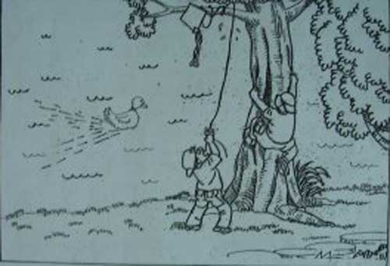

For your story, make use of the points below:
- what happened before this
- what the children were doing
- what happened next
- what happened in the end

You may reorder the points. You may also include other relevant points.

Sample Solution
"Mom, please let us go to the park. I want to fly my new kite!" said Tim. "Okay. But you have to let Henry have a go too." Mom replied. "I will", said Tim.

It was the perfect day to go to the park. The sun was shining and there was an occasional breeze. They even saw a duck or two in the pond. When there was a breeze, Tim started flying his kite. It was a lovely sight. The kite's yellow and orange tail stood out against the pale blue sky and the picture of an eagle on the kite looked as if it was really flying.

"My turn, my turn!" shouted Henry. "Not yet, not yet!" said Tim. "But you have flown it for five minutes already!"

"Well, it is my kite."

"Mom said to share!"

So, an argument began. Both of them were arguing so badly that they did not notice the kite being blown towards a tree. When they finally noticed, the kite was already tangled up in the tree's branches.

"Here is the deal", said Tim, "the first person to untangle the kite gets to fly it for the whole day." "Okay!" said Henry as he climbed up the tree while Tim tried to pull the kite down from below. Then, as Henry was about to reach for the kite, he lost his balance.

He fell of the tree, landed on the grass and rolled into the lake. "Help!" said Henry, "I'm going to drown!" "But you can swim. I can't help you because I cannot swim", said Tim. "I can't swim either with a sprained ankle. It hurts," said Henry.

Luckily, a passer-by stopped by to help. He jumped into the lake and saved Henry. "T.. Thank you", said Henry. "My pleasure!" said the kind passer-by. He even dropped the boys home. Henry's mother was told about the situation. She was too relieved to be angry and thanked the passer-by.

From that day on, Tim took up swimming lessons and Henry never climbed another tree. As for the kite, it is still stuck up there to this day!

Question 64
QuestionID: 72
Question Type: Continuous
Question Category: Situation-Based
Theme: Unexpected Events

One day, you and your sibling were strolling in a nearby park. Suddenly, you heard a noise coming from behind you.

Based on the above situation, write a composition of at least 150 words.

In your story, make use of the points below:
- how you and your sibiling felt
- what the both of you did
- what happened in the end

You may reorder the points. You may also include other relevant points.

Sample Solution
The sky was dark and raindrops made a "pitter patter" sound on my window. The wind was howling loudly outside my window. In the past, I hated storms. The flashes of lightning and claps of thunder made me feel uneasy, sometimes scared. Now, with my furry companion asleep in my lap, nothing about the storm scares me. He probably has a calming influence on me. I marvel at the fact that he is not afraid of storms himself, after all, he had been through a terrible ordeal involving a storm...

Alicia and I were walking at the park. We both loved that park. The occasional breeze would seem to whisper to me, as if it is saying: "Do you remember all the fun you and Alicia had in this park?" and I would recall how we used to sit on the swings while waiting for the ice-cream man to come and how we rode on the round-a-bout until we got dizzy. That day, the park was cooler than usual because of the rain the previous night and the playground was wet. Because of this, we had almost the whole place to ourselves and the park was peaceful without the laughter of young children sliding down the slide.

"Sis! Did you hear that?" Alicia asked, her voice trembling.

"Hear what?"

"The bush, it rustled!"

"The bushes always rustle when there's a breeze."

"I know that, but this one it... whined."

"Bushes don't whine!"

"But this..."

Her sentence was cut short. Then, I heard it too. A faint whine coming from a bush. I peeked in but I saw nothing. I felt something brush against my calf. It was hairy and a little wet. What was it? An image of a big, slimy hairy caterpillar crossed my mind.

"Yuck! Get it of my leg!" I shrieked.

"Get what of, Sis?"

"The caterpillar!"

She started giggling.

"Some fine sister you are! Help me now!"

"Does that look like a caterpillar?"

I turned around and saw the muddiest dog in the world. Its fur was matted and drenched and it looked as if it had rolled around in a pigsty.

"Aww... Sis! Let's take him home!"

Was she nuts?

"Why?"

"He is in the most sorry state ever!"

"Why would you want him? Just because Mom and Dad are vets and would take in an animal anytime doesn't mean that you should take him home! You don't even know what breed he is, let alone know how to take care of him!"

"He is a Jack Russell."

How did she know that? Anyway, I stood my ground. I wasn't going to let Alicia take that dog home. Being a Jack Russell, he would probably be hyperactive and would be able to tear the house down.

I dragged a protesting Alicia home leaving the dog behind. Our parents were not home yet. Thank God they work on weekends and come home late at night after bedtime or they would instruct me to bring the Jack Russell home after hearing Alicia's story. By the time Alicia wakes up tommorow, she would have forgotten about the dog. She is very forgetful.

Knowing Alicia, she would probably sneak out to go and get the dog. However, she could not as a storm was brewing.

As I looked out the window at those dark clouds, I could not help thinking about the dog who was going to get soaked again in the rain. On imagining how sickly it would look if it caught a chill, my heart softened. I wanted to go back to the park to bring it home. But one thing stood in my way. My fear of storms. The lightning and thunder always scared me, since young. However, I pluckered up my courage and went out the door.

I returned home with a shivering dog in my arms. Both of us were drenched, but it was worth it.

A clap of thunder brought me back to earth. The wind was still howling outside, reminding me of the day Fluffy came into my life.

Question 65
QuestionID: 73
Question Type: Continuous
Question Category: Situation-Based
Theme: Family

You were walking towards the staffroom when you caught your friend quietly sobbing in a corner.

Based on the above situation, write a composition of at least 150 words.

In your story, make use of the points below:
- why your friend was sobbing
- what happened next
- what happened in the end

You may reorder the points. You may also include other relevant points.

Sample Solution
It was recess. I was walking towards the staffroom to see my teacher. Before I reached the staffroom, I heard someone sobbing. It seemed to come from the flight of stairs ahead.

Surprised, I went to investigate the source of the sound. The sobbing gradually got louder as I approached the stairs. Sitting on the top of the stairs was my classmate, Cheryl. My sudden presence startled her and she promptly wiped away the tears on her face. Cheryl stumbled to get up and was about to walk away when I called out, “Cheryl! Wait!”

“I’m going to the canteen,” Cheryl muttered quietly with her head down. “What’s wrong?” I asked. Suddenly, Cheryl broke down in fresh tears, her shoulders heaving. She began to explain her problem to me, pausing between fits of uncontrollable crying. Cheryl’s mother was a very strict parent and she would constantly punish her with a cane. Bad results, inappropriate behavior, and even the smallest of things would trigger off her mothers’s temper. I finally comprehended the cause of all the streak marks on Cheryl’s arms that were often present. Cheryl was deeply afraid of her mother and her dismal mid-year results would be the reason for another violent course of breating.

Cheryl’s predicament reflected her helplessness and I vowed to help her. Her mother’s tendency to overreact was taking a toll on Cheryl’s emotional and mental state. Together, Cheryl and I approached Miss Tan in the staffroom to inform her of Cheryl’s situation. Miss Tan listened to Cheryl attentively and assured her that she would speak to Cheryl’s mother.

After meeting Cheryl’s mother, Miss Tan could sense the intense protectiveness of Cheryl’s mother towards Cheryl. When Cheryl’s mother knew that Cheryl had been crying, she was also upset and promised not to hit her again. She gave Cheryl a hug and apologized. For the first time in many months, a smile broke out on Cheryl’s face.

Question 66
QuestionID: 74
Question Type: Continuous
Question Category: Situation-Based
Theme: Humour

You were at the pool. All of a sudden, you saw something big flying towards the pool. Then you heard a loud splash.

Based on the situation above, write a composition of at least 150 words.

In your story, make use of the points below.
- What the flying saucer was
- What happened next
- What happened in the end

You may reorder the points and may include other relevant points.

Sample Solution
The cool water of the condominium swimming pool surrounded me as I floated on my back. Turning to my side to look out for my buddies, I saw them — they had just arrived. I stopped floating immediately and began to tread water at the same spot, making slot of splashes as I hollered and waved frantically, trying to attract their attention.

Suddenly, a large orange and white 'doughnut' landed in front of me. Passers-by looked at me. Some giggled while others whispered to one another. Then came another splash. Turning towards the direction of the second splash, I spotted the lifeguard swimming towards me. He then looped his arm around my neck and swam towards the edge of the pool, pulling me along.

'Hey! Let go of me!' I shouted, flailing my arm in the air, struggling to break free from the burly lifeguard's grasp. Upon reaching the edge, the guard asked me if I was okay and if I needed the hospital. Puzzled, I asked 'Why would I need to be hospitalised?' Annoyed, the guard answered, 'You were drowning!' Rolling my eyes, I sighed and mumbled, was only waving to my friends.

The guard's face turn pink as a wave of embarrassment washed over him. After apologising profusely, he rushed back to his duties. When my friends heard about the incident, they burst out laughing. I then became the laughing stock amongst these 'buddies', even now.

Question 67
QuestionID: 75
Question Type: Continuous
Question Category: Picture-Based
Theme: Unexpected Events

Write a story based on the picture below.
Your story should be at least 150 words long.
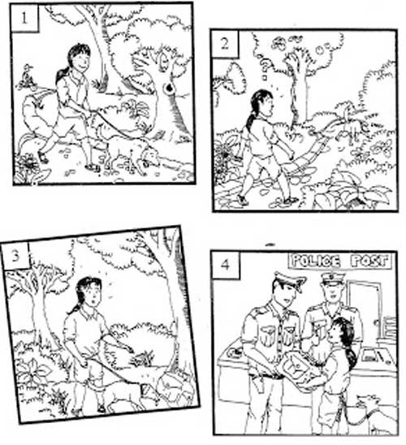

For your story, make use of the points below:
- what did the dog found
- what happened next
- what happened in the end

You may reorder the point. You may also include other relevant points.

Sample Solution
The sun was shining brightly in the azure sky. Fluffy white clouds that looked like white cotton candy drifted across the horizon lazily. It was a pleasant morning. Ella had brought her pet dog, Mocha Chip, out for a walk in the neighbourhood park. Mocha Chip was Ella’s miniature dachshund and was brown in colour. Ella had had it since she was five. It was Ella’s most beloved pet. Ella looked forward to enjoying her stroll in the park. She took a deep breath of the cool, fresh air. Mocha Chip was sniffing left and right. There were many interesting things on the path.
All of a sudden, Mocha Chip yelped loudly. This was very unusual behaviour for the dog. Then, it broke free and dashed off. Ella was taken aback. Mocha Chip had never behaved that way before. She shouted at Mocha Chip to stop but to no avail.

Anxiously, Ella followed Mocha Chip. When she caught up with her dog, she yanked its leash tightly. Then, Ella’s eyes widened in surprise. She had discovered a brown bag among the bushes. She looked around for someone to claim the bag but there was not a single soul in sight. Out of curiosity, Ella opened the bag.

Ella’s jaw dropped. There were wads of notes in the bag! Stunned, Ella rubbed her eyes. She wanted to keep the money as she recalled an incident that took place the previous week. She and her mother had seen a beautiful sapphire necklace in a jewellery shop while they were window shopping. She remembered how Mother had looked at the necklace yearningly. Ella was tempted to keep the money to buy the necklace as a present for her mother as it was her mother’s birthday next week. But in the end, she decided not to.

After thinking for a while, Ella took the bag to the police station which was a street away. She related the whole incident to the police officers on duty. The police commended her for her honesty. Ella was glad that she had done the right thing because honesty is the best policy.

Question 68
QuestionID: 76
Question Type: Continuous
Question Category: Situation-Based
Theme: Action

You were in a shopping mall when you heard a loud noise...

Based on the above situation, write a story of at least 150 words.

You must make use go the points below in your story:
- what made the loud noise
- what happened next
- what happened in the end

You may reorder the points. You may also include other relevant points.

Sample Solution
Christmas was in the air. As I strolled towards Ngee Ann City, I could not help noticing that Orchard Road was lined by creamy and carmine little trees. When I entered Ngee Ann City, I was immediately greeted by a huge emerald Christmas tree which towered over me. There were turquoise, lavender and crimson balls hanging from it, with 'snow' that never melts scattered convincingly across the tree and right at the very tip of it was a huge lilac star. Hordes of shoppers thronged the mall and the excited buzz of the crowd drowned out the faint muzak playing in the background.

'She's late again,' I thought exasperatedly. I had arranged to go shopping with my friend, Jia Rong, to purchase some Christmas gifts for the upcoming festive season.

Just as I was about to call Jia Rong, a loud explosion rocked the building. After that, the mall was filled with the screams of ladies, wails of children and shouts of grown men. For a moment, I froze, to stunned to react.

That moment of paralysis was shattered when some men wielding guns appeared and began shooting into the crowd randomly. The shoppers, so jolly some moments ago, descended into a madness of desperate chaos. Screaming and shouting in terror, they charged blindly towards the exits, pushing me along. In the pandemonium, I saw a man collapse. He had been hit by a bullet and crimson blood was gushing out from his chest. No one bothered to help him He twitched in agony for a while and then stopped moving. My heart turned icy with fear.

Suddenly, I saw some masked men in uniforms. From their attire, I recognised our counter-terrorist forces! My hopes rose only to plummet seconds later. Gunshots rang out as the criminals and law enforcers exchanged shots. Caught in the crossfire, I crouched as low as possible, praying that I would not be hit by any stray bullet.

As the soldiers engaged the outlaws, I clumsily made my way towards the exit of the mall, trying to move forward while staying as low as I could. After some time, my muscles were straining and my lungs felt like they were burning. But I ignored the discomfort and focused on the exit. Just when I was a few feet away from the sliding glass, my left leg seized up in agony. Of all times to be struck by cramps!

I could have wept in despair. Then unexpected, a figure darted in, grabbed me and hauled me out of the mall. It was Jia Rong! The moment I stepped out of the mall, I slumped against her and started crying uncontrollably. Relief, fear, sadness - they all coursed through me, separate at times and mingling at others.

Later, I would learn that it was a terrorist attack. I was of course immensely grateful to Jia Rong. If she had not risked her life to save me, I do not know what would have happened to me. The incident left such a scar on me that I refused to go out for weeks. I also did not care to read the newspaper reports about it. Maybe after a long, long time has passed, I may become curious and then I would want to find out the whys, the whats and the hows. But not yet. Currently, all I want to do is to forget the incident.

Question 69
QuestionID: 77
Question Type: Continuous
Question Category: Picture-Based
Theme: Characters

Write a story based on the picture below.
Your story should be at least 150 words long.
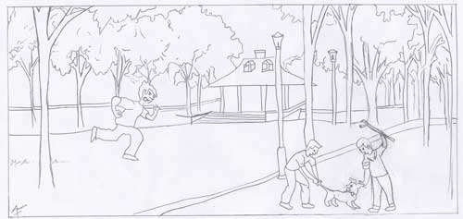

For your story, make use of the points below:
- what the two boys are doing
- what the others did
- what happened in the end

You may reorder the point. You may also include other relevant points.

Sample Solution
I sniffed. Fresh air at last! It was a relief to be away from the toxic fumes on the road. I barked happily and leapt all around my owner., who had taken me to the park near our home for my daily walk.

After sniffing for a while, I smelled a cat. Scanning my surrounding, I spotted the feline some distance away. Growling with determination to catch the cat, I leapt away from my owner and ran as fast as my legs could carry me to the scrawny cat.

However, after running for a distance, I saw two pairs of legs in front of me. Looking up, I saw two boys. One was holding a stick and snickering. Feeling threatened, I lunged forward and bit the stick held by the boy. Alarmed, the boy swung the stick with all his might and flung me onto the rough pavement.

I yelped as I tried to stand up and flee. A sharp pain exploded in my front leg. The boy told his partner beside him, “Get it!” To my horror, the youngsters started attacking me. One was using a stick to hit me while the other pulled me by my tail to prevent me from escaping.

“Hey! Put it down now!” Turning my head I saw my superhero – my master. The cowardly boys fled for their lives at once. My master came up to me, carried me and brought me to the animal hospital.

There the nurses treated my wounds and placed my right front limb in a cast, as it was broken. From this experience, I earnt of my master’s true care and love for me. He visited the hospital daily to take care of me. From that day onwards, I would never dare to leave my master’s side whenever we were out for walks.

Question 70
QuestionID: 78
Question Type: Continuous
Question Category: Picture-Based
Theme: Accidents and Disasters

Write a story based on the situation in the picture below.
Your story should be at least 150 words long.
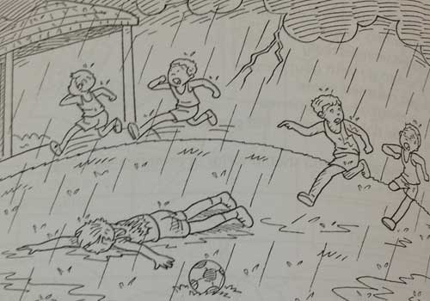

You must make use of the points below in your story:
- what happened to one of the boys
- how the other boys felt and what they did
- what happened in the end

Sample Solution
Lightning streaked across the darkened sky. For a few seconds, the sky brightened ominously, but the five boys dashing for the football in the field were oblivious to it. Each side was bent on scoring the next goal for the game hung in a balance.

Fat raindrops were falling fast. “Crack!” The sound of thunder seemed to split the air. Kai Feng and Ravi jumped. Ravi glanced at the dark rolling clouds, worry furrowing his brows. The distant rumble of thunder was beginning to unnerve him. He opened his mouth to utter a warning to his friends to take shelter but the words were stuck in his throat. Wide-eyed, he stared at the lightning bolt which shot to the ground, forming a bridge that stretched from heaven to earth momentarily. It missed him by a few centimetres. Next to him, he saw James fall to the ground. Everything seemed to freeze, like a snapshot captured on camera.

“James!” The name was torn from Ravi’s throat in a long drawn-out shriek.

Panic propelled their feet. Ravi and Kai Feng sprinted towards James as Ahmad and
Kevin rushed towards the shelter. Ahmad took his mobile phone out and called for the ambulance, panting out the location to the operator. Ravi and Kai Feng half-squatted as they ran towards James, keeping as low as they could to the ground. James lay unmoving, faced down. Both boys did not dare ask the dreaded question. Ravi reached out a hand and pressed two fingers against James’ neck. He let out a sigh of relief. Beneath his fingers, he could feel a faint pulse. The rain was pelting down, stinging the boys’ bare skins mercilessly. Together, the two boys rolled James over. His lips were blue and his hair was singed. There was a black burn mark on his right arm. Should they try to carry him to the shelter? Staying out in the open seemed too dangerous.

Another bolt of lightning streaked across the sky, followed closely by the inevitable clap of thunder. That helped them make up their minds. As they began lugging James to the shelter, Ahmad and Kevin came over hesitantly, ashamed that they had thought of their own safety first instead of attending to their fallen friend. The water made it too slippery for them to get a firmer grip on James; however, bit by bit, they pulled him towards the shelter.

Soon, the paramedics showed up. After a quick check, they lifted James into the ambulance and sped away. Once more, Ahmad’s fingers reached for his mobile phone. This time, it was to call James’ mother. His voice shook as he delivered the bad news. Solemnly, the boys waited till the storm abated before heading home, each one a sorry bedraggled figure. They met again at the hospital the following day, and were thankful to know that James would recover. The five friends had learnt their lesson painfully – it was definitely unwise to ignore a storm. They realised now that Mother Nature could sometimes be ruthless; she was not always benign.

Question 71
QuestionID: 102
Question Type: Continuous
Question Category: Situation-Based
Theme: Unexpected Events

You were rollerblading near the lift lobby of your block of flats when you noticed a brown haversack next to one of the lifts. You went closer and realised that there was something sharp inside the bag.

Based on the above situation, write a composition of at least 150 words. In your composition, make use of the points below:

- what you did next
- how you felt
- what happened in the end

Sample Solution
I zoomed down the slope, turned round a bend and sailed towards the lift lobby in less than ten seconds. I glided back and forth in front of the lift, jumping up and making a complete turn at each end. Plugged into my MP4, I was in a world of my own. I was about to make another turn when I noticed a brown canvas haversack next to one of the lifts. I looked around and realised that the lift lobby was deserted. The bag looked like the one that I carried to school. There were two compartments—a main one and a smaller one in front. There were two netted pockets at the side of the haversack which were empty. When I got nearer, I realised that there was something protruding from inside the bag.

Overcome with curiosity, I squatted in front of the bag and stared hard at it. I poked it, wondering if there was an abandoned pet inside, but nothing moved. I lifted it and realised that it was much heavier than my school bag, almost like the sack of rice that i helped my father to carry home from the supermarket. Remembering what I had watched on television recently about terrorist attacks, I decided to call the police immediately.

After a brief conversation, I stood a short distance from the bag to wait for the police to arrive. I stood there with my arms folded, feeling like a security guard keeping watch over a valuable item. Two police officers arrived before long and I pointed out the bag to them. In my excitement, I exaggerated what I had seen and how I felt. I told them that I thought I sae a figure running away in the distance. I even told them that I had seen several suspicious characters walking past the void deck in the past few weeks.

I was told to step aside while the police officers examined the bag. Their faces turned grim when they heard my story. I watched as one of the officers picked up the gloved hands and opened the zip. He pulled the cover apart cautiously at first and peered in. Suddenly, he burst out laughing and opened the bag further. Suddenly small rocks tumbled out. "They are just rocks, boy," he called out. "The sharp object that you thought was a knife is actually a twig. See," held up the L-shaped twig and waved it in the air.

My face flushed. I was so embarrassed that I wished the ground would open up and shallow me. However, the police officers told me that I had done the right thing. It was better to have a false alarm than to ignore a real bomb. Feeling slightly better, I nodded and turn to return home.

That night, I told my parents what had happened. They praised me for being alert and calling the police. I did not tell them about the story that I had spun to make the situation more exciting. I regretted doing that. I realised how tensed the situation must have been and how my story had created unnecessary anxiety for the police officers.

Question 72
QuestionID: 129
Question Type: Continuous
Question Category: Situation-Based
Theme: Unexpected Events

You had arranged to meet a friend to play in the park at 4 o'clock one afternoon. By 5 o'clock your friend had still not arrived.

Based on the above situation, write a composition of at least 150 words.

Make use of the following points in your composition:
- how you felt
- what happened next
- what happened in the end

You may reorder the points. You may also include other relevant points.

Sample Solution
It was last Saturday and I had arranged to meet my friend Jo in the park. We both wanted to practise some new moves on our roller blades. I had to go shopping with my mother first, so we agreed to meet at 4 o'clock.

When we got home from the shops, I changed my clothes, grabbed my rollers, shouted goodbye to my parents and dashed off to the park. I arrived on the dot of four, but there was no sign of Jo. I sat down on a bench to wait for her. I knew she would not be very late because she was a very punctual person. While I was waiting, I watched the other children on their bikes, their roller blades and skateboards. Some of them were really good and some of them were not so good, like Jo and me. I glanced down at my watch. It was 4.20. I was puzzled as this really was not like Jo at all. If there was a problem, she could ring or message me. So, I tried ringing her but she did not reply.

I was getting a bit impatient and time seemed to be passing slowly. I kept looking at my watch — 4.30... 4.40... 4.50. There was still no sign of Jo. I tried ringing several times, but still she did not answer. By now I was more worried than angry. I decided to wait 10 more minutes and then catch the bus to her house. On the dot of 5 o'clock, I left the park, walked to the bus stop and caught the bus. As I was getting off the bus, I saw Jo and her family near the entrance of their apartment block.

I ran towards them. "Hello Mr Lee, hello Mrs Lee," I said breathlessly. "Jo, what happened? I've been waiting for you for ages!" It was only then that I noticed Jo's brother, Phil, standing behind his father. He was walking on crutches and looked very pale. "Oh!" I exclaimed. "Are you all right, Phil?" Then, Jo explained. Phil had been playing with his friends, running around, when he had stumbled over a piece of wood and hurt his ankle badly. Jo had seen the accident and had quickly got her parents. They had rushed Phil to the hospital and then waited. Fortunately, it turned out that Phil had just sprained his ankle. Nothing was broken.

"I couldn't ring you to tell you what had happened," Jo explained. "Because the hospital asks you to turn off all mobile phones and I didn't want to leave Phil and my parents to go outside to ring."

"Of course," I said. "Making sure Phil was all right was much more important. We can always go to the park another time."

Question 73
QuestionID: 130
Question Type: Continuous
Question Category: Situation-Based
Theme: Unexpected Events

You were a little late for school and got off the bus in a hurry. When you arrived at school, you realised that you had left your school bag on the bus.

Based on the above situation, write a composition of at least 150 words.

Make use of the following points in your composition:
- how you felt when you realised you had left your bag on the bus
- what you did
- what happened in the end

You may reorder the points. You may also include other relevant points.

Sample Solution
Friday morning I was a little late leaving the house for school. I could not find my Science homework and spent some time searching for it in my bedroom. Then I realised that in fact I had already put it in my bag! This made me late and instead of getting the usual bus, I caught the next one. This still meant I would arrive on time, but would not have any extra time with my friends before going into class.

The bus arrived at the school bus stop and I jumped off. I could just see some of my friends and wanted to join them. I rushed up to them and we started chatting about various things. Then the bell rang. We all lined up to go into the classroom and I looked around for my bag. My heart sank when I realised that I did not have my bag. I felt my face go all hot and I put my hand up.

"Yes, Katy, what is it?" the teacher asked me.

"Miss Lee," I started, "I think I've left my school bag on the bus." Everyone turned round and stared at me and I felt really awful.

"Well, that was a stupid thing to do!" Miss Lee replied, but then she went on. "Never mind. We'll sort something out. Let's go in everyone." to the classroom.

We filed in to the classroom. I was still feeling awful but at least I knew the bag was clearly marked with my name, address and telephone number and the name of my school. The teacher lent me some pens and i pencils and we started lessons as usual. She said during recess she would phone the bus company and see if anyone had found my bag.

When the bell rang for recess, there was as a knock at the door and the school secretary came into the room. She was carrying my school bag! All the other students left the room and I stayed to thanks the secretary.

Apparently, a passenger on the bus had noticed that I had forgotten my bag. This lady picked up the bag and she saw the name of my school inside. She very kindly went out of her way to bring bag to my school for me! Luckily, the school secretary asked the lady for her name an address so that I could write a letter to thank her for her kindness.

Question 74
QuestionID: 131
Question Type: Continuous
Question Category: Situation-Based
Theme: Interesting Places and Events

Your friend had invited you to a beach barbecue one Saturday lunchtime. when you arrived, there was nobody there.

Based on the above situation, write a composition of at least 150 words.

Make use of the following points in your composition:
- how you felt
- what happened next
- what happened in the end

You may reorder the points. You may also include other relevant points.

Sample Solution
Last Saturday I was really excited. Tom and his family had invited me to join them for a beach barbecue. Tom had explained that it was his brother's birthday and that his parents were going to organise lots of games. It sounded like really good fun. My parents had agreed to take me to the train station to get the train to the coast. It was only a 15 minute journey and I had taken the same train many times.

We arrived at the station. "Now, have you got everything? Swimming trunks, towel, beach shoes, sun cream?" my mother asked.

"Yes, I've got everything!" I replied.

"Well, have a lovely day! And we'll be here to pick you up at five o'clock," she said.

I jumped on the train, waved goodbye to my parents, and settled down for the short journey. I looked out of the windows. The city passed quickly and we were in the countryside heading for the coast. After another five minutes, I could see the sea shining blue in the sunshine.

I got off the train and looked at the instructions Tom had sent me. "Take the beach road from the station. When you get to the beach, go to the right. You will see a small café and a souvenir shop. We will be on the beach just in front of these." I walked along the road until I came to the beach. It looked beautiful with clean, golden sand. I turned right and walked along till I came to the café and shop. I scanned the beach but could not see Tom or his family.

"Was I in the right place?" I asked myself. I checked the instructions again carefully. Yes, I was in the right place. I checked the time. It was midday, just as Tom had said. "Perhaps, they are caught in the traffic," I thought. I knew the roads out of the city were very busy on Saturdays.

I waited for about 15 minutes and then began to get a bit worried. I could not decide whether to ring Tom or to ring my parents. I thought it might be a bit rude to ring Tom. He might think I was angry at him for being late. So, I decided to ring home. I explained what had happened to my mother. She asked me if I was sure that I had followed the instructions carefully. I told her I had. "Well," she said. "I'll just go and look at the email Tom sent you and check. Wait a moment."

Through the phone I could hear my mother walking into my room and clicking on the computer. "Right!" she said. "I've got the email in front of me" She went through the instructions again. "Yes," I said impatiently. "I'm standing in front of the café and souvenir shop and I've been here since midday!" Then i heard her say, "Oh, dear!"

"What's the matter?" I asked. "Well, you've got the right place and the right time. But, the barbecue is on Sunday not today! You'd better get the next train home!"

I walked back to the station feeling a bit upset until I remembered! I had not missed the barbecue because I could come back to the beach again tomorrow!

Question 75
QuestionID: 132
Question Type: Continuous
Question Category: Situation-Based
Theme: Unexpected Events

You decided to do agood turn for your neighbour and clean out his bird cage. As you opened the cage, the bird flew out of the cage and perched on the open window sill.

Based on the above situation, write a composition of at least 150 words.

Make use of the following points in your composition:
- how you felt when you saw the bird on the window sill
- what you did
- what happened in the end

You may reorder the points. You may also include other relevant points.

Sample Solution
I love animals but, unfortunately, my parents have always said that we cannot have any pets. One of my sisters is allergic to animal hair and we live in a fairly small flat so keeping pets is not really possible. Our neighbour, Mr Jones, on the other hand, has quite a few pets. He has a small dog, a canary and some fish. I get on well with Mr Jones and often walk his dog with him and help out looking after his animals.

One day, I had finished all my chores at home and was at a loose end. I saw Mr Jones leaving his flat and asked if there was anything he wanted me to do. He said he was just going to the supermarket, but if I wanted to go into his flat and play with his dog, I could.

I checked with my mother that it was all right for me to go next door and then I went. The dog was asleep in its basket and did not even raise its head when I went in, so I thought I would leave it alone. The bright yellow canary, Tweetie, was chirping merrily in its cage, so I went over to it and started talking to it. I noticed that its cage was not very clean so I decided to clean it. It would be a nice surprise for Mr Jones.

I had already seen Mr Jones clean the cage, so I knew how to do it and where the clean sand was kept. But I forgot one important thing! I got everything ready, old newspapers, a plastic bag for the used sand and opened the cage door. The bird looked at me calmly for a moment and then it hopped into the doorway of the cage and before I could do anything, it flew out and straight over to the window. It was that moment that I realised I had forgotten to check that the windows were closed and to my horror I saw that one was open!

I called out the bird's name and tried to stay calm, "Tweetie! Tweetie! Come here! " The bird just stayed where it was. I got some bird food and put it in a little dish near the cage. I rattled the food. The bird hopped along the window sill, and cocked its head at me.

At that very moment, I heard a key turn in the front door. Mr Jones was back! At the sound of the door opening, Tweetie flew away from the window and perched on top of its cage. I rushed over to the window and shut it just as Mr Jones walked into the room.
"Oh that's nice," said Mr Jones. "You're cleaning the cage for Tweetie." He, gave a quick glance over to the window. "I'm glad you closed the window first, though. Tweetie could easily have flown away."

I am afraid to say that I did not confess that I had only just closed it and that indeed, Tweetie had nearly flown away. I just mumbled something and finish cleaning the cage. I felt incredibly relieved that everything had turned out all right in the end.

Question 76
QuestionID: 133
Question Type: Continuous
Question Category: Situation-Based
Theme: Action

You were walking down the street with your mother when you saw a man in front of you snatch the bag of an elderly woman and run off down the street.

Based on the above situation, write a composition of at least 150 words.

Make use of the following points in your composition:
- what you saw
- what happened next
- how it all ended

You may reorder the points. You may also include other relevant points.

Sample Solution
My mother and I had been to the cinema together. After the film, we were walking along the street talking about what we had seen and saying how much we had enjoyed it. It was about five o'clock in the afternoon, and the street was not very busy. Most people must have done their shopping and gone home. Ahead of us, I noticed an elderly woman carrying two heavy-looking bags of groceries.

I was just about to mention her to my mother and to suggest that we could help the woman with her bags, when an extraordinary thing happened! I watch the event as if it were in slow motion, like a scene from a film! This young man in jeans and a white T-shirt came rushing across the road, bumped into the old woman, and then ran off. My mother and I rushed up to the old woman and helped her to stand up. I started collecting her fallen groceries, when she cried, "He's taken my handbag!"

I look up quickly to where the young man had run. At the far end of the street, I just spotted him turning into the shopping mall. Mother got out her mobile phone to ring the police. In what seemed like a few seconds, a police car arrived. We explained what had happened and I described the young man and told the police I had seen him go into the shopping mall.

"Well done!" said the police officer. "Now if you could stay with this poor woman until another police car arrives, my colleague and I will try to find this thief."

Of course, we agreed to stay and helped the old woman to a nearby bench. We knew she was not hurt, but she was very upset by the experience. So, we just chatted about everyday things to try and keep her mind off her lost handbag. After about ten minutes, the second police car arrived and the officers offered to take the woman home.

We were just helping to put her shopping bags into the back of the car when the first car returned. The police officer came over to the car. He was smiling. "Is this your bag, madam?" he asked the elderly woman.

"Oh, you've found it!" she excilaimed. "Oh thank you. Thank you so much!

"Yes, we found the bag and thanks to this sharp-eye young person, we've got the thief as well!" the officer said.

Question 77
QuestionID: 134
Question Type: Continuous
Question Category: Situation-Based
Theme: Family

It was your mother's birthday and you decided to make her a cake. While cake was baking, your friend phoned you and you forgot about the cake. The cake burnt badly and the kitchen smelled of burnt food.

Based on the above situation, write a composition of at least 150 words.

Make use of the following points in your composition:
- how you felt when you realised the cake was burnt
- what you did
- what happened in the end

You may reorder the points. You may also include other relevant points.

Sample Solution
It was my mother's birthday last Friday and I decided that I would surprise her and make a cake. There is a simple recipe we use for a delicious chocolate cake and I know that it is a favourite with all the family.

I got all the ingredients ready, carefully followed the instructions and prepared the mixture. I checked with my older brother that it was all right to use the oven and he helped me set it at the right temperature and put the cake inside. He then told me he was going out, so I would have to do the rest on my own. That was fine because I knew what to do next.

I set the timer and started to clear up the kitchen, washing the dishes I had used. I had just about finished when my phone rang. It Was my best friend and he wanted to discuss the Maths homework. I went into my room, chatting to Mark on the phone. I sat down at my desk and got out my Maths book.

I suppose I was on the phone for quite a while. When I had finished and left my room I could hear an unfamiliar beeping noise. I went into the kitchen and to my horror could see smoke coming out of the oven. The beeping was the timer that I had forgotten about. Just at that moment I heard the front door opening. Oh no! I thought it was Mum coming back and I had ruined everything.

Luckily it was not Mum, but my brother.

"What's going on here?" he asked. "What's that terrible smell?" He threw open the windows in the kitchen, turned off the oven and, taking a pair of thick oven gloves, took my blackened cake out and put it out on the balcony.

"What are we going to do? The cake's burnt, the kitchen smells of smoke and it's Mum's birthday!" I moaned. I felt terribly disappointed that I had ruined everything.

"Never mind," said my brother. "We'll leave all the windows open for a while. That will get rid of the smell. You make Mum a really special card with a nice picture on it. I'll phone Dad and ask him to buy something."

It all turned out all right. Dad bought Mum a lovely bunch of flowers. My brother made her a CD of her favourite songs and Mum was delighted with my card. Of course, she found out about the cake, but said, "It is the thought that counts."

Question 78
QuestionID: 135
Question Type: Continuous
Question Category: Situation-Based
Theme: Interesting Places and Events

I was looking out of my bedroom window one night when I noticed a strange object in the sky. It was brightly lit and appeared to be getting closer.

Based on the above situation, write a composition of at least 150 words.

Make use of the following points in your composition:
- what you saw
- what happened next
- what happened in the end

You may reorder the points. You may also include other relevant points.

Sample Solution
Last week, I had a most peculiar experience. I had gone to bed at my usual time and had fallen asleep quickly. However, a bit later I woke up again. I looked around my bedroom and wondered what could have woken me up. It was then I realised that there was a lot of light in my room and it seemed to be coming through the window. I checked my watch. It was two o'clock in the morning, so it certainly was not the sun!

I got out of bed and went to the window. Drawing the curtains apart, I looked out. Immediately I could see where the light was coming from. There was a strange object in the sky and it was brightly lit up. What could it be?" I asked myself.

I continued to look and watch, absolutely fascinated. I was sure it was an alien spaceship! I thought about waking up the rest of the family, but thought I might miss something while I was getting them. The object seemed to be getting nearer and nearer, and the lights got brighter and brighter. And then suddenly, it disappeared from sight!

At this point, I rushed into my parents, room and told them what I had seen. They both thought that I had imagined or dreamt it. "No, it was real!" I said. "I was wide-awake. I didn't dream it and I'm sure it was aliens from outer space!" My father returned with me to my bedroom and we both looked out of the window. There was nothing to see. "Go back to sleep," my father said. "you've got a busy day tomorrow."

I got back into bed very disappointed that my parents did not believe what I had seen. However, I soon fell asleep.

The next morning, I got up as usual and went into the kitchen. My mother was preparing breakfast and my father was listening to the early morning news on the radio.

"The city council wishes to apologise for any inconvenience caused by last night's fire-prevention practice," the newscaster said. "Helicopters from the Fire Department were practising over the city and a number of citizens have complained about the disturbance. However, the council wishes to remind citizens that, for their own security, these drills are essential."

"So, that's what you saw!" my father said "The Fire Department's helicopters."

"It must have been," I said. But secretly I still believed that I had seen an alien spaceship!

Question 79
QuestionID: 136
Question Type: Continuous
Question Category: Situation-Based
Theme: Outdoor Activities

You were cycling through the park when you noticed up ahead of you a child lying on the ground, crying.

Based on the above situation, write a composition of at least 150 words.

Make use of the following points in your composition:
- how you felt when you saw the crying child
- what you did
- what happened in the end

You may reorder the points. You may also include other relevant points.

Sample Solution
Last Saturday I cycled through the park on my way to my piano lesson. I had plenty of time and was enjoying the ride. Suddenly, I realised that ahead of me, there was a small child lying on the ground.

I slowed down when I got closer to the child and jumped off my bike. A boy of about three or four years old was lying on the ground, crying. I laid my bike on its side and went up to the boy. I was worried that he was seriously injured, but he sat up and looked at me as I approached.

"What's the matter?" I asked him. "Are you all right?"

The small boy just started sobbing even louder.

"Come on," I tried to calm him down. "It's all right. My name's Emily. What's your name?" I sat down on the grass next to him. I wanted to be friendly and gain his trust.

"James," he said after a pause.

"Well, James," I replied, "what are you doing here?"

"I fell over," he sobbed.

"Right, well, are you hurt?" James showed me his grazed knee, which was bleeding a little. Eventually, he told me that he was having a picnic with his family and that they were playing hide and seek. He had run off to hide behind a tree, but had fallen over and no one had come to look for him. I decided that I would have to take him round the park until I found his family. I heard a voice shouting "James! James!" A girl of about my age came into view and James told me it was his sister. We shouted and waved at her.

When the girl came up to us, she started to tell James off for wandering so far away, but when she saw that he had been crying, she softened her tone. James cheered up when he saw her and I explained what had I happened. She thanked me for consoling him and led him back to the family picnic. I picked up my bike and I went on my way.

Question 80
QuestionID: 137
Question Type: Continuous
Question Category: Situation-Based
Theme: Unexpected Events

Your friend lent you a DVD a few weeks ago and you enjoyed it very much. Yesterday, your friend asked for the DVD back but, when you looked, you could not find it anywhere.

Based on the above situation, write a composition of at least 150 words.

Make use of the following points in your composition:
- how you felt
- what happened next
- what happened in the end

You may reorder the points, You may also include other relevant points.

Sample Solution
Jack and I were best friends. One day he told me about a great new DVD film he had watched, and so I asked him if I could borrow it. Of course, he agree straightaway. I took the film home and thought I would watch i over the weekend.

The next Saturday, my brother and I sat down to watch the film. Jack was right. It was a great film and my brother and I really enjoyed it. I remember that at the end of watching, my mother called and said it was time to go to bed. I ejected the DVD, put it back in its box and put it on the shelf above my desk.

A couple of weeks passed and Jack asked for the film back. "Sure," I said. "I'll bring it to school tomorrow." That evening, I went home and decided to put the DVD into my school bag while I remembered. I went into my bedroom and looked on the shelf. The DVD was not there! "Where could it be?" I thought to myself. I searched my bedroom, looking on my desk and in my drawers. It was nowhere to be seen!

Then, I thought perhaps my brother had borrowed it. I went to him and asked but he said he had not seen the DVD since we had watched it together. Now, I was really worried. What would Jack say if I told him I had lost his DVD? I searched again but still could not find it.

The next morning I woke up for school with a heavy heart. Jack would be very angry. Perhaps, my parents would advance my pocket money so that I could buy him a new copy. I went into the kitchen and explained the situation to my parents.

"Would it be possible to have my pocket money in advance so that I can replace Jack's film?" I asked.

"Do you mean this DVD?" my mother asked, holding up Jack's film.

"Yes, where did you find it?" I replied.

"Well, I knew you had borrowed the film from Jack so I thought I'd leave it here in the kitchen so you wouldn't forget to return i.t You know how untidy your bedroom is!" said my mother.

"Thank goodness!" I said. "Now, I can give it back to Jack."

I went to school feeling happy. When I saw Jack, I rushed over to him and returned the film. I told him how much my brother and had enjoyed it. But, I did not tell him that I thought I had lost the DVD forever!

Question 81
QuestionID: 138
Question Type: Continuous
Question Category: Situation-Based
Theme: Family

Your mother had given you some money to buy your little sister an ice cream and something for yourself. You bought your sister the ice cream and had decided to buy yourself a magazine. Just as you left the ice cream stand your sister dropped her ice cream and burst into tears.

Based on the above situation, write a composition of at least 150 words.

Make use of the following points in your composition:
- how your sister felt when she dropped her ice cream
- what you did
- what happened in the end

You may reorder the points. You may also include other relevant points.

Sample Solution
On Saturday my mother wanted to clean the flat from top to bottom and she asked me to take my little sister out for a walk.

"Take Polly to the park," said Mum. "Here's some money to buy her an ice cream and something for yourself as well."

I took Polly's hand and we set off to the park. As we were walking along, I wondered what to buy for myself. It was a hot afternoon so an ice cream would have been nice, but finally I decided to go to the newsagent's and see if I had enough money to get the magazine Science Today, which I enjoyed reading.

We walked through the park to the ice cream stand. There Polly took a long time to decide on the flavour she wanted. Eventually she chose strawberry. I bought the ice cream for her and handed it over to her. Her face lit up and she gave me a big smile as she thanked me. We started to walk towards the park gate as I explained that I wanted to go to buy my magazine. Polly was gazing at her ice cream and not where she was walking. Suddenly she tripped over a stone and stumbled. She tabbed my hand and dropped the ice cream onto the sandy path.

Polly turned to me aghast. She bent down to pick up the ruined ice cream, but I had to stop her.

"No, Polly," I started, "you can't have it now. It's all dirty." Her little face crumpled up and she started to cry. Her sobs were heart-rending and I was sorry to see her so upset

I took the money I had left out of my pocket and coined it. I had enough to buy Polly another ice cream, but that meant I would not be able to afford my magazine. One more glance at my unhappy sister convinced me. I turned back to the ice cream stand and I bought her another ice cream. This time I took her over a bench and we sat while she ate it. I would have to wait another week to buy my magazine.

Question 82
QuestionID: 139
Question Type: Continuous
Question Category: Situation-Based
Theme: Characters

One night, I was woken up by a strange noise coming from somewhere in our flat. I got out of bed to investigate.

Based on the above situation, write a composition of at least 150 words.

Make use of the following points in your composition:
- how you felt
- what happened next
- what happened in the end

You may reorder the points. You may also include other relevant points.
Sample Solution
Last night I went to bed quite early because I was very tired. I had been at school during the day and then had been to basketball practice. I got into bed and thought about reading for a while, but in the end I just turned off the light and went straight to sleep.

Then, in the middle of the night, I woke up suddenly. I wondered what had woken me up, but the house was quiet and all my family were asleep. I picked up my glass, had a sip of water, and then tucked down into bed to go back to sleep. It was then I heard a noise! It was a strange sound like a creaking but not very loud. I listened again but the noise had stopped. I settled back into bed when the noise started again.

By now, I was wide awake so I turned on the light and kept listening. This time the sound continued. “What could it be?” I wondered. I was not afraid because I was sure the noise was not made by a person. “Could it be an animal?” I asked myself.

There was only one way to find out. I got up and opened the bedroom door. The hall was dark and quiet. I did not turn the light on because I did not want to wake the rest of the family. I could hear the noise more clearly now. It seemed to be coming from the sitting room. I tiptoed down the hall, and slowly opened the door into the living room.

Yes, the noise was definitely louder. I turned on the light and looked around. The noise stopped so I could not see where it was coming from. Then I noticed that the door onto the balcony was slightly open. This made me a little scared and I thought about getting my parents. Then, I felt a slight breeze and the balcony door moved in the wind… and creaked as it moved!

“That’s all it is!” I said to myself with some relief. I closed the door firmly and went back to bed. “I must remember to tell the others to check the door the next time!” I thought. “I don’t want my sleep disturbed again!”

Question 83
QuestionID: 140
Question Type: Continuous
Question Category: Situation-Based
Theme: Family

You were walking through the park and saw a girl picking flowers from one of the beautiful display beds.

Based on the above situation, write a composition of at least 150 words.

Make use of the following points in your composition:
- how you felt when you saw the girl picking flowers
- what you did
- what happened in the end

You may reorder the points. You may also include other relevant points.

Sample Solution
I love going to the park with my grandmother. She always enjoys seeing the beautiful flowers and she is incredibly knowledgeable about all the different types of flowers and plants. She tells me their names and origins and something interesting about them. Each year the park has different displays of flowers and for us city-dwellers it is a haven of peace and beauty.

One day however, my grandmother and I were shocked to see a girl walking in a flowerbed and bending over as if she was examining the flowers.

“What is she doing?” I asked my grandmother. “She’ll damage the flowers by walking through the bed like that.”

My grandmother did not reply and we made our way slowly towards the girl. As we got closer, we could see that she was picking some of the flowers and that she already had quite a big bunch in her hand! I was amazed that someone should do such a thing. I felt angry and wanted to make the girl stop.

“What are you doing?” I shouted to the girl.

The girl looked a little embarrassed and said, “They’re not for me. These flowers are for my mother.”

“You can’t pick them!” I started to shout at her crossly. My grandmother stopped me with a hand on my arm.

“Come here,” she said to the girl. The girl obeyed and stepped out of the flowerbed to where we were standing.

“Now look at the flowers,” Grandmother went on. “Tell me what you can see.”

The girl look rather surprised but she replied, “Flowers; I can see the beautiful flowers.”

“Yes,” said grandmother, “and they are for everyone to enjoy. If you pick some, there will be fewer left. If everyone picked some, there would be none there. If your mother likes flowers, why doesn’t she come to the park to see them?”

“My mother is ill. She can’t leave the house,” the girl replied, sadly.

“Well, in that case,” said Grandmother, “why don’t you paint her a picture of the flowers and give that to her? Then, when she is better, she can come here and there will still be lots of flowers for her to enjoy.”

“Yes, you’re right,” said the girl. “I’ll do that. I’m sorry. I was only thinking about my mother and I wanted to make her happy. But I didn’t think about what would happen if everyone did the same as me!”

Grandmother and I continued our walk through the park. I was impressed that Grandmother had made the girl realise her mistake, without shouting at her or getting cross.

Question 84
QuestionID: 141
Question Type: Continuous
Question Category: Situation-Based
Theme: Celebrations

Your friend, Mei, invited you to her birthday party and, as a present, you bought her a book you knew she would like. When you got to the party, you saw that someone else had already given her the same book.

Based on the above situation, write a composition of at least 150 words.

Make use of the following points in your composition:
- how you felt
- what happened next
- what happened in the end

You may reorder the points. You may also include other relevant points.

Sample Solution
I woke up last Saturday morning really looking forward to the day. It was my friend Mei’s birthday that day, and she had invited me to her birthday party. I had planned to go shopping in the morning to buy her a present.

After breakfast, my older sister and I went to the shopping mall to look for something suitable. We were just passing the bookshop when I remembered that Mei was reading the ‘Wizard’ series of books, but she was only up to the second book. “I know!” I told my sister. “I’ll buy Mei the third book in the ‘Wizard’ series. She really enjoyed the first two.“ I bought the book and some nice wrapping paper and a card.

That afternoon, after wrapping the present carefully. I walked the short distance to Mei’s flat. I rang the bell and Mei answered the door. “Happy birthday!” I said and gave her the present and card.

“Oh, thank you!” she said. “What lovely wrapping paper! I’ll open the card now but save the present for later.”

We went in to the living room and I greeted her parents, and said hello to the other guests. Then, Mei’s mother organised some party games and we all had a wonderful time.

“Right!” said Mei’s mother. “Let’s have a break from games now and I’ll bring in the tea.”

While Mei and her mother organised the food, I wandered over to the side table to look at Mei’s cards and presents. To my horror, I saw a copy of the same ‘Wizard’ book that I had bought!

We had our tea but Mei noticed that I was a bit quiet. She came over to me and said, “What’s the matter? Aren’t you enjoying yourself?”

Yes, I am.” I said. “I’m having a lovely time but I’m really disappointed about the present I’ve got you.” I explained about the book.

“Oh, don’t worry!” Mei said. “It was a lovely thought and I know what to do.”

“What?” I asked.

“I’ll take one copy of the book back to the bookshop and exchange it for the fourth book in the series! What could be better?”

“Oh, what a good idea!” I said. “Now, I can really enjoy the party!”

Question 85
QuestionID: 142
Question Type: Continuous
Question Category: Situation-Based
Theme: Characters

On your way home you took a short cut down a narrow street. As you rounded the corner you came face to face with an angry-looking dog.

Based on the above situation, write a composition of at least 150 words.

Make use of the following points in your composition:
- how you felt when you saw the dog
- what you did
- what happened in the end

You may reorder the points. You may also include other relevant points.

Sample Solution
Yesterday after school I decided to take a short cut on the way home. Instead of following the main road I turned off and took a narrow street. It was getting dark and the streets were quite dimly lit. There was no one else around.

There was a sharp bend in the road and as I turned the corner I came face to face with a large angry-looking dog. It was loose, just standing in the middle of the street. There was no one near it; no one else in the street.

I do not really like dogs and this one was quite scary. It seemed to stare at me in a threatening way. A low growl came from its throat as it took a few paces towards me. I began to feel very frightened. I knew that if I started to run, the dog could run faster. That would be a stupid thing to do. I also remembered hearing that if you are frightened, animals can sense it.

I took a deep breath and in a stern voice said, “Go away! Go home!”

The dog stopped growling and looked at me.

“Go on!” I continued. “Go home!” I stood still and waited. After a while the dog lost interest in me and turned away. I waited until it had walked off a few metres, then I too, turned around and quietly walked back to main road. I could feel my heart beating loudly in my chest, but I controlled my desire to run as fast as I could. I walked calmly on and safely reached the busy main road. I decided not to take that short cut again!

Question 86
QuestionID: 143
Question Type: Continuous
Question Category: Situation-Based
Theme: Unexpected Events

Your father was driving you home one evening when the car started making a funny noise and slowing down. Suddenly, the car stopped completely.

Based on the above situation, write a composition of at least 150 words.

Make use of the following points in your composition:
- how you felt - what happened next
- what happened in the end

You may reorder the points. You may also include other relevant points.

Sample Solution
My father and I had had a great day out together walking through the park. We had walked for miles and It was getting late. “I think it is time to go home,” my father said.

“Yes,” I agreed because it was beginning to get dark and I was quite tired.

We walked briskly back to where we had parked the car. We got in, put on our seat belts, and Dad started the car. We had been travelling for about half an hour, happily chatting about all the things we had seen in the park, when the car suddenly started making a funny noise.

“What’s that noise, Dad?” I asked.

“I’m not sure,” he replied. “But I don’t think it is anything serious.”

He had hardly finished speaking when the car started to slow down and then came to a complete standstill.

“Oh, no!” said Dad. He turned on the warning lights, got out of the car and quickly found the warning triangle. “I’ll put this up so that other drivers are warned,” he told me. “Meanwhile, just stand away from the road and car.”

I did what he said. When he came back, he lifted the bonnet and started to examine the engine but he could not see what the problem was. By this time, I was feeling very tired and It was beginning to get cold too. I started worrying that we could never get home!

“What are we going to do, Dad?” I asked.

“Don’t worry!” he replied. “I’ll phone the insurance company and they’ll send a pick-up for us.” Dad phoned the emergency number he had on his mobile phone and explained the situation. Then he turned to me and said that he expected the tow truck to arrive in about 30 minutes.

“I’ll just ring your mother so that she isn’t worried,” he said.

As we waited, I realised that no other traffic passed us. It was a very quiet and isolated place to break down. I thought it was a bit scary. I kept looking up the road hoping to see the headlights of the rescue vehicle.

Eventually, after what seemed like hours, I looked up the road again, and in the distance I could just make out some faint lights.

“Look, Dad!” I exclaimed. “Lights!”

The lights grew stronger and brighter and suddenly the rescue vehicle was parked beside us, its orange lights flashing.

The mechanic quickly looked over the car engine and then explained that the car would need to go into a garage to be fixed. He told my father that he would put the car onto the back of his vehicle and he would drive us home.

This was almost the best part of the day, sitting up in a big truck with orange lights flashing and knowing we would get home safely after all.

Question 87
QuestionID: 144
Question Type: Continuous
Question Category: Situation-Based
Theme: Unexpected Events

You had bought a DVD in a shop and were just walking out through the doors when the anti-shoplifting alarm sounded.

Based on the above situation, write a composition of at least 150 words.

Make use of the following points in your composition:
- how you felt when the alarm went off
- what you did
- what happened in the end

You may reorder the points. You may also include other relevant points.

Sample Solution
For my birthday I had been given some money by my grandparents, and this meant that I could buy the DVD I wanted. So, last Saturday I went to the shopping mall with my mother. Mum wanted to look round some clothes shops, so we arranged to separate and meet up later.

I walked into the busy CD and DVD shop and looked through the racks of DVDs on sale. I quickly found the one I wanted, but spent a few minutes sifting through the new releases.

After a while, I looked at my watch and realised that if I did not hurry up, I would be late meeting my mother. I went to the cashier and paid for my DVD, put it in my backpack and started to walk out of the shop.

I was just going through the doorway when the shoplifting alarm was set off. A loud repetitive noise echoed all over the mall. I stopped immediately and looked around. I was the only person walking through the doorway at that time. A security guard was making his way over to me and I thought that everyone had stopped to stare at me. I felt nervous, but knew I had done nothing wrong.

The security guard asked me to follow him over to the desk. He asked me to open my bag and show him what was inside. I did as he asked and took everything out of my backpack. When the guard saw the DVD, he asked if I had a receipt for it. Of course I did, so I gave it to him. He nodded his thanks and examined it carefully. He then picked up the DVD and took it over to the cashier.

A few minutes later, the guard came over, gave me my DVD and accompanied me through the doorway. This time no alarm went off.

“It was just a problem with the anti-theft device on the DVD. It’s all right now,” the security guard explained to me. “Thank you for your understanding!” The guard left me and I hurried off to meet Mum and tell her why I was a few minutes late!

Question 88
QuestionID: 145
Question Type: Continuous
Question Category: Situation-Based
Theme: Technology

I had entered a competition to win a bike. On the day the results were to be posted on the website, my Internet access went down.

Based on the above situation, write a composition of at least 150 words.

Make use of the following points in your composition:
- why you entered the competition
- what happened next
- what happened in the end

You may reorder the points. You may also include other relevant points.

Sample Solution
About three weeks ago, I noticed a competition that was being advertised on the school notice board. It looked very interesting. The competition was to write an essay describing what the world would be like in 2050. I really like science fiction and technology and things like that, so I thought the topic was very interesting. What’s more, the prize for the best essay was a bike. I had wanted a new bike for some time as my old one was now too small for me. So, I decided to enter the competition.

I spent the next few days racking my brains for ideas. I thought about ‘intelligent’ houses. I thought about how people would travel. And, I thought about the climate and how it might have changed. When I had enough ideas, I sat down and wrote my essay. When I was finished, I read through it and checked for mistakes. I made a few changes and then read the essay again. I thought it was quite good.

I went to the competition site on the web and looked at how to submit my entry. It was all very easy and I sent the essay off. Almost instantly, I got an email saying that my entry had arrived. The instructions said that the essays would be judged two weeks later, on the 25th and that the names of the winners, and their essays would be posted on the website.

The next two weeks passed as usual and then it was the 25th. That morning, I got up quickly and immediately checked the website but the results were not on it. Perhaps it was too early. Unfortunately, it was a school day so I could not spend any more time on the computer. The school day seemed to pass slowly because I really wanted to find out if I had won the competition or not!

At the end of the school day, I rushed home and went straight to my room and clicked on the competition website. Instead of seeing that page, there was a notice saying there was no connection. I looked at the bottom of my computer screen. Oh no! There was no WiFi! I had no internet connection! “What can I do?” I thought to myself. “The public library has computers but it is too far away. I don’t know anyone with a computer on this floor.” Then I had a great idea.

I rang my best friend, Lee, and explained the situation to him. I told him how desperate I was to find out if I won a bike or not. I gave him the web address, and waited with bated breath while he logged on.

“Are the results there?” I asked.

“Hold on a minute!” he said. “I’m just looking, yes, the results are here. Oh, that’s a pity!”

“I haven’t won,” I said miserably.

“Well, you haven’t won the first prize, but you have won the second prize of $100! Well done!”

“$100!” I exclaimed. “That’s brilliant! Now I can start saving to buy myself a new bike!”

Question 89
QuestionID: 146
Question Type: Continuous
Question Category: Situation-Based
Theme: Unexpected Events

My friends and I had arranged to go swimming. I paid my entrance fee and went in. When I got to the changing rooms I realised I had forgotten my swimming things.

Based on the above situation, write a composition of at least 150 words.

Make use of the following points in your composition:
- how you felt when you realised you had forgotten your swimming things
- what you did
- what happened in the end

You may also include other relevant points. You may reorder the points.

Sample Solution
I love going swimming and I usually go at least once a week. I am hoping to get into the school swimming team and for that I must practise regularly. I also like having fun in the water with my friends, and often meet them in the pool.

Last Saturday afternoon, I had arranged to meet my friends outside the pool. We went in and paid the entrance fee. In the changing room, I started to get my things out of my bag but to my horror I realised that my swimming things were not there! I had forgotten to put them in. I felt such a fool. How could I manage to forget something like that?

“Oh no!” I exclaimed.

“What’s the matter?” Lucy asked me.

“I’ve forgotten my swimming things.”

“What? Are you sure?” Molly questioned.

“What am I going to do?” I moaned.

Lucy suggested that perhaps they had swimming things you could borrow or hire at the entrance desk. I went off to see. Unfortunately, the lady at the desk could not help me. They did not have anything I could borrow. I could not go swimming.

I went back to my friends and explained the situation. At first I thought I would have time to go back home, get my things and then join them at the pool. But in the end we worked out that it would take too long. I felt disappointed, but had only myself to blame.

I left my friends at the pool and went home. Mum was surprised to see me back so soon. When I explained what had happened, she consoled me saying, “Oh well, you won’t do that again, I’m sure!” And she’s right. I will always make doubly sure that I have all my things when I go swimming again!

Question 90
QuestionID: 147
Question Type: Continuous
Question Category: Situation-Based
Theme: Unexpected Events

Your father had asked you to fetch his glasses trom the car, which he parked in the street. When you tried to open the door of the car with the key, the alarm turned on and a man started shouting at you.

Based on the above situation, write a composition of at least 150 words.

Make use of the following points in your composition:
- how you felt
- what happened next
- what happened in the end

You may reorder the points. You may also include other relevant points.

Sample Solution
It was a late Saturday afternoon and my parents, my brother and I were all at home. I was playing chess with my brother, my mother was emailing my aunt, and my father was settling into his armchair to read the paper.

“Bother!” my father suddenly exclaimed. “I must have left my reading glasses in the car.”

“I’ll get them for you, Dad,” I offered.

“Thank you!” replied my father as he handed me the car keys.

I left the flat, went down in the lift, and came out into the street. “Now, where has Dad parked the car?” I asked myself. Then I spotted the black saloon a hundred metres or so down the road. I walked down the road till I got to the car. I put the key in the lock to open the door and suddenly, there was aloud wailing noise. It was the car alarm! At the same time, a man who was walking down the street, started running towards me and shouting.

I was so astonished I dropped the car keys. As I bent down to pick them up, the man grabbed hold of my arm.

“Are you trying to steal my car?” he demanded.

“No, sir!” I stuttered.

“Then what exactly are you doing?” he asked still holding onto my arm. It was at that point that I looked at the car more carefully. Oh no, it was not my Dad’s car!

I explained what had happened to the man and showed him the keys. He looked at me carefully and then released my arm.

“We had better try to find your father’s car,” he said.

We both looked up and down the road and then I spotted it.

“That’s it!” I said pointing to the black saloon just across the road. “That’s my father’s car!”

“Well,” said the man, “be more careful next time! You don’t want someone else thinking you are a car thief, do you?”

I crossed the road and this time, I checked the care carefully before putting the keys in. it was all right! It was my father’s car! I found his glasses and then locked the car. I went back to the flat and gave the glasses to my father.

“Thank you!” he said. “But what took you so long?”

I told him what had happened.

“The man was right,” my father said. “You must be more careful in future.”

Question 91
QuestionID: 148
Question Type: Continuous
Question Category: Situation-Based
Theme: Accidents and Disasters

We were waiting at the bus stop when suddenly a dog ran into the road. A car swerved to avoid the dog and hit another car.

Based on the above situation, write a composition of at least 150 words.

Make use of the following points in your composition:
- how you felt when you saw the accident
- what you did
- what happened in the end

You may reorder the points. You may also include other relevant points.

Sample Solution
Every Friday, I take the bus to go visit my grandparents. Last Friday, I was waiting at the bus stop as usual when I was witness to a car accident.

I was the only person waiting at the bus stop. I checked my watch. It was 4.50pm. Normally, there would be a bus in five minutes. It was quite a busy time of the day so there was a reasonable amount of traffic. I hoped that the bus would not be held up.

Then I noticed a young man coming down the street with a dog at his heels. The dog looked vey well-behaved and was calmly trotting along. Suddenly the dog stopped. Suddenly, the dog stopped. It was then I noticed that it was not on a lead. The young man called to it but the dog ignored him. It lifted its head and looked across the road. The next thing I saw was the dog running into the traffic to cross the road!

A car coming along the road swerved to the right to avoid the dog and drove straight into another car, coming in the opposite direction! There was a loud bang as the two cars collided. Passers-by stopped and stared as the two drivers got out of their cars, thankfully, unhurt.

Everyone stayed calm but the driver of the second car could not understand why the first car had driven into him.

“I swerved to avoid the dog,” the first driver said.

“What dog?” asked the second driver.

Sure enough, there was no trace of the dog or its owner. “Did anyone else see a dog?”

I realised that I has a duty to inform the drivers that I had seen everything. So I walked over to them and explained what I had seen. By that time, someone had called the police and within a few minutes they arrived. The police took control of the situation and asked everyone to move along. They took my name and address as a witness and I described the dog and its owner.

The police interviewed a few other witnesses including one person who recognised the dog owner. It was clear that the dog owner was responsible for causing the accident. The police said that they would be contacting him very soon.

After about fifteen minutes, the road was cleared and the traffic was moving normally. In fact, the cars were not badly damaged and both of them could be driven away. I caught my bus and had a story to tell my grandparents when I finally arrived!

Question 92
QuestionID: 150
Question Type: Continuous
Question Category: Situation-Based
Theme: Unexpected Events

I was in the supermarket yesterday doing some shopping for my mother. It was only when it was my turn at the checkout that I realised I had forgotten the money.

Based on the above situation, write a composition of at least 150 words.

Make use of the following points in your composition:
- how you felt
- what happened next
- what happened in the end

You may reorder the points. You may also include other relevant points.

Sample Solution
Last weekend I had a very embarrassing time. It was a normal Saturday. Dad was out playing golf, my sisters had gone to see some friends, my mother was preparing dinner, and I was playing a game on my computer.

Then, my mother called out to me. "Would you mind going to the supermarket for me? I need a few things but I need to keep an eye on the cooking."

"No, of course not I replied. "

My mother gave me handed me the Shopping basket. "Take some money from my purse," she said

I went into my room to get my shoes and jacket. I looked at the computer screen and realised that I had nearly finished the game. "I'll quickly finish this game and then I'll go to the supermarket," I said to myself.

The next thing I knew, my mother came into the room. "Haven't you gone yet?" she dinner asked. "Hurry up! I need those things for dinner."

I dashed out of the flat and down to the shop. I wandered around the supermarket gathering all the things on my mother's list. Then I went to the checkout. There was a long queue. I waited and waited and slowly moved forward. Eventually, it was my turn. The young woman on the till, scanned my shopping and then said , "That will be 20 dollars and 15 cents."

I felt in my pocket for the money. "Oh, no!" I said. "I'm sorry I've left my money at home! What shall I do?" I felt myself go very red. I could feel the other people in the queue behind me getting a bit impatient.

The young woman was very kind. "Put the shopping in your bag and leave it with me. Go and get your money and when you come back, you can come straight to me. You don't have to queue again."

I thanked her and rushed home. As I burst in through the door, I saw my mother standing there holding her purse. I apologised to her and explained what the young woman had said.

"Go back to the shop and pay," my mother said. "But do not jump the queue. It was your mistake so you must line up again!"

I returned to the supermarket and did what my mother had said. I joined a long queue and waited patiently for my turn. When I got to the checkout, the young woman said, "I told you to come to the front of the queue."

"It was my mistake," I explained. "So it was only right that I should queue again."

Question 93
QuestionID: 151
Question Type: Continuous
Question Category: Situation-Based
Theme: Family

Last weekend I offered to help my parents in the garden. They were very pleased and asked me to tidy the vegetable patch. Unfortunately, I do not know much about plants.

Based on the above situation, write a composition of at least 150 words.

Make use of the following points in your composition:
- how you felt when your parents asked you to tidy the vegetable patch
- what you did
- what happened in the end

You may reorder the points. You may also include other relevant points.

Sample Solution
My family and I are very lucky to live in a house with a garden. My sisters and I love playing outside and my parents are keen gardeners. My mother is particularly fond of her flowerbeds and grow a stunning array flowers. My father is keener on growing vegetables and we all enjoy the delicious fresh vegetables he grows.

One day I walked outside into the garden where my parents were busy mowing the grass and weeding the flowerbeds. They looked so busy I thought I ought to offer help.

"Is there anything I can do to help?' I asked.

My parents exchange glances.

"Thank you," said Dad "Actually, you can tidy the vegetable patch. That would be a great help".

I was not quite sure what he meant, but before I could ask he a started up the mower again and was cutting the grass. I looked at my mother enquiringly.

"Here you are!" she said and handed me some tools. "Put the weeds in the a wheelbarrow." She too turned away and continued her work.

I do not know much about plants but I do know that weeds are plants that grow where you do not want them. Usually, they are small and not very interesting to look at. I felt quite excited about the task I had been given and pleased that I could help my parents in this responsible way.

The vegetable patch had been divided up into rows. I could see lines of small plants and guessed that they must be something my father had planted. One end of the patch looked a bit messy. There was nothing growing there but someone had left some sticks in the ground. That must be what my father meant, I thought. I carefully picked up all the sticks and Iaid them on the ground in a heap. Then I looked round to see what else I could do.

Just then Dad came over. "How are you getting on?" he asked.

"Fine." I replied.
"Oh no!" Dad exclaimed. "Someone has removed all my markers." He picked up the sticks had taken out.

"Oh, that was me," I confessed.

Dad explained that he had sown seeds in that area and the sticks were in fact markers showing where and what he had had sown. I had not noticed that the sticks had writing on them, 'carrots', 'leeks' and so on. I felt terrible. I had ruined the garden just then Mum came over.

"Don't worry," she said when she heard what I had done. "When the seeds grow a few inches in height we will recognise the plants. You haven't really done any damage." Dad agreed with her. He had just been a bit surprised.

Afterwards, Mum gave me another job but this time she explained carefully how to do it!

Question 94
QuestionID: 152
Question Type: Continuous
Question Category: Situation-Based
Theme: Unexpected Events

Yesterday morning, I left the apartment and got into the lift as usual to go school. I pressed the button for the ground floor and the door closed, but the lift did not move. It was stuck!

Based on the above situation, write a composition of at least 750 words.

Make use of the following points in your composition:
- how you felt
- what happened next
- what happened in the end

You may reorder the points. You may also include other relevant points.

Sample Solution
It started off a normal day. I had got up and got ready for school as usual. I picked up my school bag, said goodbye to my parents, and left the flat. I walked down the corridor to the lift and pressed the button.

The doors opened immediately and I stepped into the lift. I pressed the button for the ground floor and the doors closed. But the lift did not move. I pressed the button again. The lift still did not move. I decided to get out of the lift and walk down the stairs but when I pressed the door button, nothing happened. I was stuck!

At first I was not worried because I had decided to ring my parents on my mobile and they could come and help me. I took out my phone and tried to ring them, but there was no signal inside the lift. I looked at the emergency buttons but I did not want to inconvenience the security people. However, I was beginning to feel a little nervous and a little bit hot.

I decided to bang on the lift door and hope someone would hear me and come to my rescue. I started banging on the door and Shouting. "Help! Help!" I called. "I'm stuck in the lift. Can anyone hear me?"

There was no reply. I tried again but there was still no reply. By now I was getting a little scared. I wondered how much air there was in the lift.

I decided that I would bang on the door and shout one more time and, if nobody came, I would press the emergency button. I lifted up my fist to bang on the door, when he doors opened and in front of me I saw my father.

"What are you doing here?" he asked.

I explained what had happened. "That must have been a bit frightening," he said gently.

"It was a bit," I replied.

"Well, let's put a notice on the lift so that no one else gets trapped, and then we'll walk down the stairs and report the fault to the security guard."

I have to say I was very relieved to get out of the lift and very happy to walk down the stairs.

Question 95
QuestionID: 153
Question Type: Continuous
Question Category: Situation-Based
Theme: Unexpected Events

Yesterday evening, I was at home doing my homework. My father was not back from the office and my mother had just popped out to the supermarket, so when the phone rang I answered it.

Based on the above situation, write a composition of at least 150 words.

Make use of the following points in your composition:
- who the caller was
- what the caller said
- What happened in the end

You may reorder the points. You may also include other relevant points.

Sample Solution
This term we get quite a lot of homework and yesterday was no exception. I had just finished my Maths exercises and starting the Science exercises, when my mother said she was going out to the supermarket to get something she had forgotten. My father was not home yet, so I would be on my own for a few minutes.

As Mum closed the front door I settled down to read through the work that had been set. After a few minutes, I was startled by the phone ringing in the living room. I got up to answer it and as I lifted the receiver I heard a woman's voice asking to speak to me.

"Speaking," I replied.

"This is Fiona Lee," the lady continued. "I work for Kingsdown Publications. You recently entered a short story competition and I have some very good news for you."

My heart started beating faster as I remembered the competition that I had seen in my monthly magazine. I had written a short story entitled 'My happiest day' and had sent it in at least two months ago. I had almost completely forgotten about it.

"Yes?" I stuttered.

"Congratulations! Your story has won first prize," Ms Lee continued. "You will be receiving confirmation by post in a few days, but I wanted to tell you straightaway.

I was delighted to hear the news and could hardly believe it. I thanked Ms Lee profusely. She said she was looking forward to meet me at the prize giving in a few weeks' time. I then remembered the prize was a notebook computer!

I hung up the phone and could not wait for my mother to comeback from the shops. After what seemed like ages I heard the front door opening and I ran out to greet my mother.

"You'll never guess what!" I said, and then proceed to give her my very good news.

Question 96
QuestionID: 154
Question Type: Continuous
Question Category: Situation-Based
Theme: Family

I sing in the school choir and had been rehearsing very hard for the school concert. However, on the morning of the concert, I woke up with a bad headache.

Based on the above situation, write a composition of at least 150 words.

Make use of the following points in your composition:
- how you felt
- what happened next
- what happened in the end

You may reorder the points. You may also include other relevant points.

Sample Solution
I love singing an choir and so I joined the school. The choir master had very standard and we practised very hard. But he was very kind, and we all enjoyed the work. Last month we had had to practise even harder because we were giving a concert. I was going to sing a solo for the first time, so I was excited and a bit nervous too.

The night before the concert, we had one last rehearsal. At the end of it, the choir master said, "Well done, everyone! You have all worked very hard. Good luck for the concert tomorrow and I advise everyone to get an early night!" We all left happily. When I arrived home, I told my parents all about the rehearsal and about the choir master's advice.

"I think that is very sensible advice," my mother said. "You should have an early night tonight so that you are bright and ready for the concert.

I went to bed quickly and fell asleep. The next morning my alarm clock went off, and I woke up. I felt awful! I had a terrible headache! I got up and went into the kitchen an told my mother how I felt. She was very sympathetic because she knew how much I was looking forward to concert.

"Listen!" she said. "Its Saturday and the concert is not until this evening. Go back to bed and I'll bring you a headache tablet and some water. Then you can try to rest

I felt so unhappy about the concert that I nearly cried. I took the tablet, drank some water and fell asleep again. I woke up a few hours later when my mother came into my room.

"How are you feeling now?" she asked.

"It's gone!" I exclaimed. "My headache's gone. I feel fine!"

"Good!" said my mother. "It was probably all the excitement and worry about the concert that gave you the headache. You must spend the rest of the afternoon quietly and then I'm sure you will be fine for the concert this evening."

I did what my mother said and she was right! That evening I sang my solo at the concert. My dream had come true.

Question 97
QuestionID: 155
Question Type: Continuous
Question Category: Situation-Based
Theme: Interesting Places and Events

A foreign student came to Singapore to study at your school for a week as part of a student exchange programme. You volunteered to host this student at your home during his or her stay in Singapore.

Based on the above scenario, write a story of at least 150 words about your experiences.
You may make use of the following points:
- where the student is from
- what activities you did with the student at school and at home
- how both of you felt when it was time to leave

You may reorder the points. You may also include other relevant points.

Sample Solution
"Ni hao, wo de ming zi jiao Hong Yi" greeted the petite girl in Beijing accented Mandarin. Her pink, rosy cheek and large sparkling eyes accentuated her china-dool features, set out on a canvas of porcelain smooth and clear skin. Standing in front of the class of forty boys and girl, she smiled shyly as she introduced herself. The meaning of her greeting was 'Hello, my name is Hong Yi.'

Hong Yi was a Grade Five student from a public school in Beijing, China. She and five other students from her school were in Singapore for a weeklong student exchange programme. They would be attending our school for a week to experience what it was llike to be a student in Singapore. Each student was posted to a different class and Hong Yi was to join my class. In addition, I had volunteered to be a student host, so Hong Yi would stay with me and my family during her visit in Singapore.

Being an only child, I was looking forward to having company around for a week. My bilingual education in Singapore made it easy for me to communicate with Hong Yi in Mandarin. However, Hong Yi tried to use as much English as she could. She was in he presence of competent speakers of the English language and did not want to pass up the opportunity to practise her English.

Hong Yi sat next to me during lessons. She was a keen student and absorbed conducting experiments in the laboratory. Hong Yi was also very everything like a sponge. Science lessons were the most enjoyable for her. She loved conducting experiments in the laboratory. Hong Yi was also very impressed with the the Internet in the computer laboratory during an English lesson on the theme of 'local festivals'.

Hong Yi was a Mathematics whizz who put the rest of the class to shame during Mathematics lessons. Needless to say, she breezed through our Higher Chinese lessons. Our Chinese teacher encouraged us to interact more with Hong Yi and learn more about her language and culture. After all the academic lessons, Hong Yi welcomed Physical Education. That week, we played table tennis and Hong Yi beat all of us.

Outside the classroom, we tried to make Hong Yi feel welcomed by asking her to join us for recess. Hong Yi also introduced her other Chinese friends to us. They were being hosted by students from other classes. However, she did not keep to he own circle of Chinese friends but tried to mix with the local students. Everyone was interested to find out more about the Chinese students. Hong Yi and her counterparts gamely fielded questions pertaining to their country, their culture, the education system in China and even more personal question about their hobbies, likes and dislikes.

Outside of school, my family and I did our utmost to make Hong Yi feel at home. My Parents took time off from work to take us to a different place of Interests each afternoon after school. In all, we visited the Singapore Zoological Gardens, the Science Centre, National Museum, Singapore Discovery Centre and Chinatown. During the weekend, we took Hong Yi on a fun-filled trip to Sentosa. There was so much to see and do that we were unable to squeeze in all the sights, sounds and tastes for Hong Yi to experience in a mere week. However, we manage to give her a better understanding of Singapore and a sampling of what our sunny island had to offer.

Before we knew it, it was time for Hong Yi and her fellow Chinese students to go. On their last day at our school, they treated us to a Chinese dance performance as a gesture of thanks and appreciation. After that they left for the airport with their chaperone.

Student exchange programmes such as this are an excellent way for Singaporean students to interact with their foreign counterparts and vice versa. In this way, we can bring about a better understanding of one another's country, culture and traditions to promote bonding among people on our small planet.

Question 98
QuestionID: 156
Question Type: Continuous
Question Category: Picture-Based
Theme: Criminal Acts

Write a story based on the pictures below. Your story should be at least 150 words long.
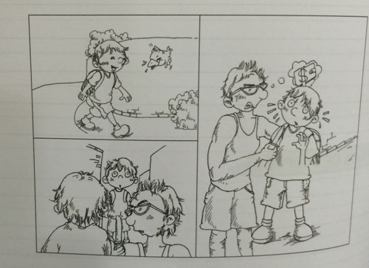

You may make use of the following points:
- what the boy was doing out at night
- what the two gangsters wanted
- what happened in the end

You may reorder the points. You may include other relevant points.

Sample Solution
The moon had retreated to seek refuge behind the clouds. The road leading to Peter's house was almost pitch-dark, save for a row of streetlights which cast a yellowish glow to dimly light up the path. Peter had just alighted from the bus and was on his way home. He had a pro ject meeting at school which ended at eight.

Suddenly, as if out of nowhere, came two youths. If Peter had met the duo elsewhere, he would have thought they were ordinary teenagers, dressed in casual clothes. However, there were sinister expressions on the twoyouths' faces. Up close, they looked mean and menacing. They surrounded Peter, preventing him from moving forward. One of them whipped out a knife from his pocket and held it to Peter's neck.

"Hand over your wallet, kid!" demanded the robber. Trembling with fear, Peter did not dare to utter a word. Beads of sweat were streaming down his face. Fearing for his own safety, Peter reached into his pocket for his wallet and handed it over to the robber. The robber grabbed the wallet from Peter's hand and the two fled in different directions.

Peter stood rooted at that spot, his legs felt like jelly. However, he soon regained his composure and ran home to tell his parents about the incident. Peter's father immediately accompanied him to a nearby neighbourhood police post to report the robbery. Fortunately, Peter did not forget what he had been told during a personal safety talk given by a police officer at his school a few months before. During the robbery, Peter had studied the facial and bodily characteristics of each of the two robbers and committed it to memory. He was able to give the police a detailed description of what the robbers looked like. Following his description, a sketch artist was able to draw impressions of the two suspects.

Within a week, the robbers were caught when they attempted to prey on another helpless schoolboy. Peter was called to the police station to confirm that the robbers were the same pair who had robbed him previously. After the robbers were caught, Peter and his parents were relieved. Nevertheless, as a safety measure, his parents made it a point to pick him up from the bus stop whenever he came back late from school.

Question 99
QuestionID: 158
Question Type: Continuous
Question Category: Picture-Based
Theme: Characters

Write a story based on the picture below. Your story should be at least 150 words long.
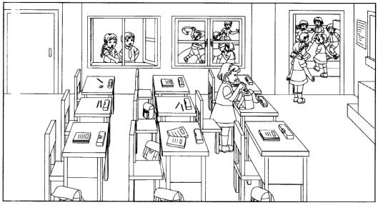

For the story, make use of the points below:
- what the girl in the classroom was doing
- what the girl at the door was doing
- what happened in the end

You may reorder the points. You may also include other relevant points.

Sample Solution
"Come on! This is the best time to do it. If we work together, we will definitely not get caught," Susan whispered conspiratorially into Jasmine's ear. The pint-sized girl hesitated for a moment before nodding her head in agreement. Recess was the perfect time to steal Naomi's wallet. The silly girl always boasted about bringing a lot of money to school, yet she never took the wallet with her for recess. When the bell rang, Susan and Jasmine walked in the opposite direction from their classmates, pretending to look for the form teacher. Once they were certain that all their cIassmates had left, they darted back to the classroom and slipped in from the backdoor.

Susan headed straight to Naomi's seat and rummaged about in her bag. Jasmine raced to the front door and stood guard. She looked left and right to make sure that no one was walking down the corridor outside. Occasionally, she glanced at Susan. Jasmine was peering to her right when John and Sandy turned the corner and walked down the corridor. Just then, Sandy saw Susan in the classroom. Tugging at John's sleeve, she pointed at Susan. Shocked, they watched in silence as Susan took out a wallet from the bag. John's brows creased in a frown. "A thief?" he wondered. His suspicions were proven seconds later when Susan waved the wallet triumphantly in the air and called out, "I've found her wallet! Let's go before we get caught!" The two girls pumped their fists in the air and were about to dash out when they came face to face with John and Sandy.

"We . . . we forgot something," stammered Jasmine while Susan immediately tried to shove the wallet into her pocket.

"I don't think so." John said firmly. "The both of you are coming with us to the office right now!" Jasmine and Susan tried to push him aside. However, John raised his hands at his sides and formed a barrier to stop Jasmine from escaping. Sandy grabbed Susan's hands to stop her from running. They then dragged the two girls to the office with them.

At the office, they recounted the incident to the discipline master. When he demanded to know what had happened, Susan lied that it was Naomi who wanted them to get the wallet from her. However, her lie was exposed when the discipline master called Naomi into the office. Naomi insisted that she never asked Susan to get her wallet for her and was so horrified that she immediately grabbed her wallet to count if all her money was inside. As the theft had been foiled, Susan and Jasmine were let off with a stern warning.

The two girls were so shaken by what had happened, that they promised never to steal again. Naomi on the other hand, had learnt her lesson. She never brought large sums of money to school again and she always took her wallet with her when she went for recess.

Question 100
QuestionID: 159
Question Type: Continuous
Question Category: Situation-Based
Theme: Family

My parents were out and I was studying in my room one afternoon when I heard a loud crash. I rushed out of my room immediately and saw my older brother running out of the front door.

Based on the situation above, write a composition of at least 150 words.

In your composition, make use of the points below:
- why your brother ran out of the house
- what you did next
- what happened in the end

You may reorder the points. You may also include other relevant points.

Sample Solution
I let out a voluminous sigh and turned the page of my Science textbook. My eyes were getting blurry and I wished that I did not have to study for the examinations. However, my parents had gone to Malaysia for a few days and I had promised them that I would study hard after school every afternoon. To keep myself awake, I decided to listen to music. I was about to reach for my MP3 player when I heard a loud crash. It resounded throughout the entire house. Jumping up from my seat, I dashed out of my room.

Stepping out of my room, I saw my older brother, Matthew, run out of the front door. "Matt! Where are you going?" I called out, but he ignored me. In a flash, he had disappeared around the corner. Without a second thought, I rushed out of the house to see if I could find out where Matthew had gone. However, he was nowhere to be seen. Scratching my head in bewilderment, I made my way back to the house. Just then, I remembered the loud crash I had heard earlier. Scanning the living room, I noticed that one of the windows was open. We seldom opened that window. When I walked closer, I was stunned to see that my mother's favourite crystal glass was no longer on the coffee table. It had shattered a distance away, near the kitchen.

At that moment, Matthew ran back into the house. He was panting and beads of sweat dripped down his forehead in a continuous stream. Bending down to catch his breath, he motioned for me to get the phone. When I did, he immediately called the police. I stared at him, dumbfounded. From what he said on the phone, I gathered that a burglar had entered our house, but Matthew had heard him and chased him out of the house and down the street. He lost sight of him a short distance away. I shook my head in disbelief. I could not believe that anyone would have the audacity to burgle a place in broad daylight.

When the police arrived, I listened intently as Matthew recounted what had happened to one of the officers. He was getting a drink from the kitchen when he heard a sound coming from the living room. A stranger in a black T-shirt, black pants and dark grey cap was stealing money from a drawer. When Matthew yelled at him, he was so startled that he grabbed the vase and threw it at him. After stuffing all the money into his pocket, he flung open the front door and ran out of the house. The police officers told us to search the rest of the house to check if anything else was missing. To our relief, only the three hundred dollars in the drawer was gone. Everything else was intact.

We decided not to inform our parents about the burglary until they returned from their trip since no one was hurt. However, we did keep all the doors and windows tightly locked from that day onwards.

Question 101
QuestionID: 161
Question Type: Continuous
Question Category: Picture-Based
Theme: Action

Write a story based on the picture below. Your story should be at least 150 words long.
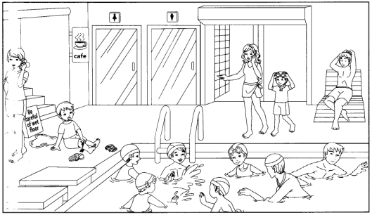

For the story, make use of the points below:
- why the boy was on the floor
- what the lady on the left was doing
- what happened in the end

You may reorder the points. You may also include other relevant points.

Sample Solution
Jordan squinted at the colourful object on the floor near the swimming pool. It looked exactly like the latest toy car that he had seen on television. He swivelled about to ask his mother if he could take a closer look at the toy, but she was talking incessantly into the phone and paying no attention to him. Jordan was in a dilemma. His mother had told him not to go too near the swimming pool, but he really wanted to look at the toy. Unable to contain his curiosity, Jordan sprinted towards the toy. He did not notice the huge puddle of water on the floor right in his path.

"Help!" shrieked Jordan as his feet slid out from under him and he felt himself falling to the floor. He flailed his arms about, but there was nothing for him to hold on to. He scraped his knee on the rough tiles and landed with such a thump on the floor that the pain shot through his body. Jordan's face was creased in pain. For several seconds, he sat there, stunned. No one came to his help. His mother was still on the phone and oblivious to what had happened. The life guard was sprawled on a deck chair. He had dozed off.

Jordan's mouth puckered and he looked as though he was about to cry. He glanced around and realised that his slippers had fallen off. They were too far for him to reach. He tried to stand up, but his leg and back hurt too much. Just then. a lady ran towards him, shouting, "Are you all right? You should not run on the wet floor!" She was about to help Jordan up when his mother turned around. She had stopped talking and was startled to see Jordan sitting on the floor. Together with the kind lady, they helped Jordan to his feet. A young boy, the lady's son, retrieved Jordan's slippers for him and placed them near Jordan's feet.

Jordan was about to put on his slippers when he remembered the toy. Still unrepentant about what he had done, Jordan pushed his slippers aside and ran towards the toy on the floor. He picked it up and began examining it gleefully. It was the toy that he had always wanted. "Hey! That's my toy! I dropped it earlier and was coming back to look for it!" shouted the boy who had just kindly given Jordan his slippers a while ago. He snatched the toy from Jordan's hands and marched off. His mother merely nodded and smiled apologetically at Jordan and his mother before scurrying after her son.

Jordan looked at his mother dejectedly, but she told him firmly that he should not have been so greedy. It was his greed that had made him fall. Jordan put on his slippers quietly and walked towards the cafe on the second floor with his mother.

Question 102
QuestionID: 162
Question Type: Continuous
Question Category: Situation-Based
Theme: Action

You were getting ready for school one morning when you realised that your thumb drive was not in your bag. You needed it for class presentation that day. You and your parents tried hard to search it.

Based on the situation above, write a composition of at least 150 words.

In your composition, make use of the points below:
- what your parents did
- what you did next
- what happened in the end

You may reorder the points. You may also include other relevant points.

Sample Solution
Each time I use the purple and green thumb drive that my mother had bought for me, it will remind me of the time I misplaced my thumb drive on the day of an important presentation. The presentation was crucial as my friends and I had worked a long time on the project. As the project leader, I was the one who saved all the work we did. I was responsible for ensuring that our project was a success.

I woke up extra early that Wednesday morning as I was meeting my friends for a last rehearsal before the presentation. After breakfast, I checked my haversack before leaving to make sure that the thumb drive was in it. To my horror, the palm-sized silver thumb drive was missing! A sense of panic coursed through me. I took out everything in my bag and turned it inside out. I even checked the side pockets. The thumb drive was nowhere to be found!

When my parents came down for breakfast, they were puzzled to see me kneeling on the floor with all my books and stationery spread out around me. I was almost in tears when I told them what had happened. My mother immediately searched through my things on the floor. However, my father frowned and glared at me. "How could you not have made a backup copy? Why didn't you print a hardcopy? How could you be so dumb?" he stood there with his arms folded across his chest, chastising me in his harshest tone. I racked my brains, trying hard to remember if one of the other team members had another copy of the presentation. With a sinking feeling, I realised that I had confidently boasted that our presentation would be intact and there was no need to print a hardcopy or for anyone else to do a backup copy. My mother and I turned my entire room upside down to search for the thumb drive. My mother even crawled behind the computer table to search for the thumb drive. Eventually, my father gave in and helped us to search the rest of the house. Still, none of us was able to find the thumb drive.

I had no choice but to leave for school twenty minutes later as I did not want to be late. I had never felt so despondent before. My friends just stared at me open-mouthed when I broke the news to them. I knew that they were livid, but there was nothing that they could do. I took the blame for everything and asked the teacher if we could present our project a week later. She agreed, but she would deduct a few marks from our final score as we were late with our presentation.

My friends and I spent the next week pouring over our notes and drafts to redo the presentation. This time, we made a backup copy at the end of each day. Each of the team members also saved a copy in his own thumb drive. Although I was still the leader, I knew that my team members no longer trusted me like they used to.

Question 103
QuestionID: 164
Question Type: Continuous
Question Category: Picture-Based
Theme: Outdoor Activities

Write a story based on the picture below. Your story should be at least 150 words long.
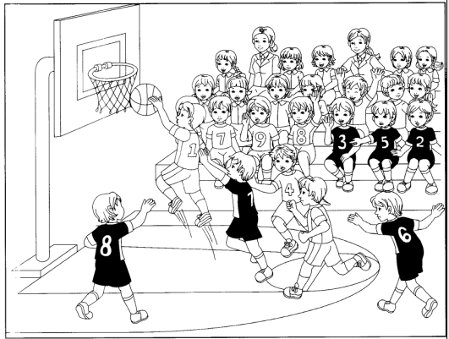

For the story, make use of the points below:
- what the player in midair was trying to do
- what was about to happen to him
- what happened in the end

You may reorder the points. You may also include other relevant points.

Sample Solution
The usually quiet basketball court roared with excitement and anticipation. A crucial basketball match between two schools was going on. Greenville Primary players in dark coloured singlets were playing Baxton Primary players. The two teams were equally matched. There were only a few more minutes left to play. A cacophony of sounds were emanating from the place. Team members and supporters were shouting themselves hoarse; many were clapping; some were singing and chanting. Jack, the star player from Baxton Primary school, saw the ball sail into the air towards him. Immediately, he jumped up to grab it.

Adamant about stopping Jack, Terry, the captain of the Greenville team, rushed forward, intending to shove Jack as hard as he could. If Jack fell, Terry would be able to get the ball and his team would win the match. Two of his teammates watched smugly. They knew what Terry had up his sleeve. Jack would surely fall and injure himself. Jack was in midair when he felt a strong shove from behind.

"Ooh," he groaned, stumbling forward. He lost his footing and twisted his left ankle, causing him to fall hard on the ground. Andrew, one of his teammates ran towards him.

"What happened?" he asked, but even before Jack could answer, there was a roar from the spectators and a whistle was blown long and hard. Jack's heart sank. It was the signal for the end of the match. He did not manage to score before the whistle was blown. Greenville Primary had won. Jack rubbed his swollen ankle and stared in dismay as he watched the players from Greenville Primary hug each other. They carried Terry and tossed him into the air, shouting gleefully. Out of the corner of his eye, Jack realised that there was bedlam among the supporters of his team. They were shouting and gesturing angrily at the Greenville players. Jack felt a lump in his throat and anger rising within him at the same time. He did not see Terry push him, but his gut feeling told him that he must have. He recalled seeing Terry glare at him when he was running towards the hoop. He wondered if any of their supporters had seen Terry push him. Still, the game had already ended. There was nothing they could do about the score now.

However, one of the players from Greenville detached himself from his team and walked towards Jack. He mumbled an apology before running off to join his teammates. As Jack was hobbling off the court, the rest of his teammates ran towards him. They told him not to feel discouraged and in unison told him that they would all train harder so as to defeat Greenville in the next match.

Question 104
QuestionID: 165
Question Type: Continuous
Question Category: Situation-Based
Theme: Interesting Places and Events

I was at the park when I saw a sudden movement in a bush. The leaves rustled loudly. Then stopped. Just when I was about to find out what had happened, I heard a loud screeching sound coming from the bush.

Based on the situation above, write a composition of at least 150 words.

In your composition, make use of the points below:
- why was there a screeching sound
- what you did next
- what happened in the end

You may reorder the points. You may also include other relevant points. (Use your own paper.

Sample Solution
"Nothing exciting ever happens at the park," I grumbled aloud as I trudged along the footpath. It was after a downpour and the place was wetter than usual. Mud was everywhere and I had a hard time avoiding the muddy puddles on the ground. Humming quietly, I wondered where the birds and animals were. I did not even see a single bird this bright and cheery day and the park was devoid of any other insects.

I was about to turn towards a small stall selling drinks when I saw a sudden movement in the bush next to me. I backed away, staring hard at the spot where I had seen the movement. I wondered if my eyes were playing tricks on me. Then, I saw it again. The movement was less now, hardly perceptible. I took several cautious steps forward. I was about to bend down when the leaves rustled loudly and the entire bush shook. Then, the movements stopped and everything was still. Taking a deep breath, I decided to find out what had happened. Afraid that there was an animal there and I would get bitten, I picked up a stick and used it to poke at the leaves. Suddenly, an ear piercing screeching sound came from the bush.

"Ah!" I screamed and fell backwards in fright. I backed away on my hands, hoping that I had not antagonised something dangerous in the bush. Seconds later, one bright yellow feather protruded from the bottom of the bush. Before long, a lemon coloured bird with a myriad of colours on its tail hopped out from the bush. It had a dull red beak and a navy blue crown. I had never seen such a colourful bird before. Noticing me, the bird made the most horrible screeching sound I had ever heard. Then, it reached into the bush and pulled something out. I stared at the round dark red mound in its beak, wondering if it was just a piece of dirt. Then the mound twitched and I noticed a tiny yellow beak. It was a baby bird! It was so tiny. It must have only just hatched. It needed to be in a nest.

Looking around me, I picked up as many twigs as I could find. Some were thin while some were much bigger. Gathering some mud from the wet ground around me, I used it to hold the sticks together to build a small nest. Then, lifting it as gently as I could, I placed it on a low tree branch. I backed away and watched as the bird hopped about watching me for a while. Then, when it was sure that it was safe, it picked up its chick and flew into the nest. I must have done something right because the bird stopped its detestable screech and began chirping a melodious tune.

The interesting incident at the park certainly made my walk less boring. My hands felt icky from touching the mud, but I did not mind. As I left, I saw the bird picking up a worm from the ground. I could not wait to return the next day to see if the bird and its chick would still be there.

Question 105
QuestionID: 167
Question Type: Continuous
Question Category: Picture-Based
Theme: Outdoor Activities

Write a story based on the picture below. Your story should be at least 150 words long.
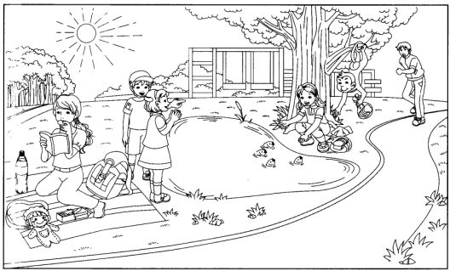

For the story, make use of the points below:
- what the girl squatting by the pond was doing
- what the monkey was doing
- what happened in the end

You may reorder the points. You may also include other relevant points.

Sample Solution
Jessie had always wanted to feed the fish at the pond, so when her mother suggested that they go to the park that afternoon, Jessie was thrilled. Using her own pocket money, she bought two loaves of bread on her way to the park. The fish pond was just as she had imagined it to be. The small black and grey fish swam swiftly about in the pond. Sometimes, they went so deep that it was hard to find them in the slightly murky water. Jessie settled down by the pond with her bag of bread while her mother laid out the picnic mat a short distance away and took out a book to read.

Jessie watched in fascination as the fish swam towards her to get the bread. The more bread she threw in, the more the fish swam towards her. There were scores of fish in the pool, more than Jessie had ever imagined. She watched them, enthralled at the way their sleek bodies moved gracefully in the water. Jessie was so engrossed in what she was doing that she did not hear the rustling of leaves behind her and the high pitched chattering sound. She was so focused on the fish that she did not even see a long hairy arm reach past her and bony fingers curl around her bag of bread. It moved quickly and in a flash, it had already grabbed the bread. However, instead of going back into the tree, the monkey continued hanging by its tail. It started breaking off pieces of bread and putting them into its mouth.

"A monkey!" hollered a young girl who was standing opposite Jessie. She clapped her hands in delight and laughed out loud as she watched the monkey stuff mouthfuls of bread into its mouth. The boy next to her gasped in horror and immediately shouted for Jessie to get out of the way. His shouts caught the attention of Jessie's mother who looked up just in time to see the monkey swing back into the tree. Afraid that the monkey would attack Jessie, she rushed towards her daughter to pull her to safety. A jogger nearby noticed the monkey still in the tree, now staring hard at the packet of biscuits that Jessie's mother had been munching on. He shouted at the monkey to try to scare it away. Fortunately, the monkey chattered loudly; then left, still clutching the bag of bread.

The encounter with the monkey had scared Jessie's mother out of her wits. Worried that even more monkeys would return and aggressively look for food, she refused to let Jessie stay at the pond. Disappointed, Jessie left the park with her mother. She would have liked to stay longer but she was glad that she still had the chance to feed the fish.

Question 106
QuestionID: 168
Question Type: Continuous
Question Category: Situation-Based
Theme: Criminal Acts

You were at the bus stop when you saw an elderly lady chasing a young man. Just then, the young man bumped into you and he shoved something in your hand and ran off.

Based on the situation above, write a composition of at least 150 words.

In your composition, make use of the points below:
- why the young man gave you something
- what the elderly lady did
- what happened in the end

You may reorder the points. You may also include other relevant points.

Sample Solution
"Stop!" came a feeble cry. I glanced around to see where the sound was coming from. Out of the corner of my eye, I spotted a young man weaving through the tables and stools at the food centre. He navigated his way through a group of boisterous teenagers and sprinted towards the bus stop that I was waiting. At his heels was an elderly lady who was sprightly for her age. Although she was panting, she was almost catching up.

However, the man managed to speed up. The distance between him and the lady widened and he was soon much further ahead of her. I expected the man to run past me, but instead, he slowed down when he neared me. Before I could move out of the way, he thrust a small hard object in my hand and ran off. I was about to protest, but he was already out of sight. I stared after the man, my hand still at my side, clutching the object. For several seconds, I did not dare to move. My mind was in a whirl and I was too afraid to even look at what I was holding. Finally, I looked down and saw that I was holding a multi-coloured purse. It was made of many tiny stones stuck closely to one another. At the top was a small silver clasp. I guessed that the purse belonged to the elderly lady.

I scanned the crowd around me to search for the elderly lady that I had seen earlier. The man was probably a thief and her cries must have frightened him, so he decided to abandon the purse. I was looking past the group of teenagers at the spot where I had last seen the elderly lady when I felt someone grip my arm firmly. Looking up, I saw a stern looking policeman with the elderly lady who was running earlier. "She's his accomplice!" she insisted, glaring at me. Snatching the purse from my hand, she opened it. She cried out in dismay when she found it empty. "Where's my money?" she demanded in a booming deep voice that attracted the attention of almost everyone nearby. I started protesting, but the policeman silenced me and insisted that I go to the police station with him.

"No! No! No!" I cried, backing away. "There was a man! He shoved the purse in my hand and then he ran off!" I insisted repeatedly, but neither the elderly lady nor the policeman would believe me. After a while, I realised that I was creating a spectacle of myself. I decided to go to the police station with him instead.

After giving my statement, I was allowed to leave the station. As I walked out, the elderly lady glared at me and mumbled that she would get her revenge on those who dared to steal from her. I hurried away. Despite having a head full of white hair and walking almost half bent, she was certainly a feisty person. I hoped the police would apprehend the thief soon.

Question 107
QuestionID: 170
Question Type: Continuous
Question Category: Picture-Based
Theme: Accidents and Disasters

Write a story based on the picture below. Your story should be at least 150 words long.
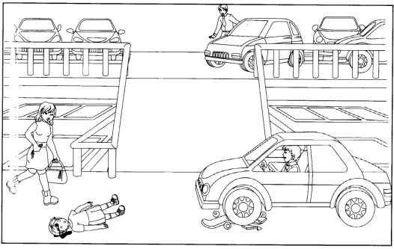

For the story, make use of the points below:
- what happened to the boy lying on the ground
- what the lady did
- what happened in the end

You may reorder the points. You may also include other relevant points.

Sample Solution
Wonderful! The car park was deserted! Brandon rubbed his hands gleefully. It was the perfect time to practise his skateboard stunts. He would be able to make use of the slope to try out his new back flip. With his skateboard clutched tightly in his hand, Brandon raced up the steps to the fourth floor. He would be safe there. Even if cars entered the car park, they would not park at the top floor of the car park. Brandon positioned himself at the top of the slope. He was ready!

"Whee!" Brandon shouted as he flew down the slope. He moved so quickly that his skateboard hardly touched the ground. In seconds, he found himself almost at the bottom of the slope. He was about to brake when he heard the screeching of tires. "Look out!" someone shouted. Brandon turned and saw the car coming at him just before it crashed into him. He flew off his skateboard and was tossed into the air. His body slammed into a wall before crashing onto the ground. Almost immediately, a dark pool of blood oozed from his head. He moved his head slightly and moaned in pain. Still conscious, he moved his arms and mouthed the word 'help me'. However, seconds later, he felt a darkness overcoming him and he no longer had the strength to move.

The driver of the car sat stock still behind the wheel, frozen with horror. With both arms still gripping the steering wheel, he stared wide-eyed at the young boy lying on the ground. At that moment, a woman ran towards them. She slowed down when she neared the car and gestured wildly for the driver to come out to help her. When he continued staring blankly ahead, she screamed at him in frustration and ran towards Brandon. She reached into her handbag to get her mobile phone, pressing the keypad furiously with one hand while checking Brandon for a pulse with the other hand. She felt a faint pulse and heaved a sigh of relief. She hit Brandon's cheek and tried to rouse him, but there was no reaction. "What happened?" a man yelled as he ran down the slope. He had been on the fifth floor when he saw Brandon lying at the bottom of the slope. Neither of them dared to move Brandon as they were afraid of hurting him even more.

Fortunately, the ambulance and police arrived less than ten minutes later. Brandon was lifted gingerly onto a stretcher and whisked away to the hospital. The police opened the car door and helped the trembling man out of his seat. He appeared to be in a daze and was unable to say a word. Without protesting, he allowed himself to be led away. The lady agreed to go to the police station to give her statement. It was certainly a tragic day. Everyone prayed that Brandon would be all right.

Question 108
QuestionID: 171
Question Type: Continuous
Question Category: Situation-Based
Theme: Accidents and Disasters

You were shopping at a store when the fire alarm went off. The few people in the store started running out. You were about to leave as well when you felt someone dragging you towards the front door.

Based on the situation above, write a composition of at least 150 words.

In your composition, make use of the points below:
- why the person dragged you out of the store
- what you did
- what happened in the end

You may reorder the points. You may also include other relevant points.

Sample Solution
Popular songs were blasting from the tiny speakers mounted at the corners of the store. I was in my favourite stationery shop looking for pieces of paper with unique designs to make a scrapbook for my mother for her birthday. It was a shop in a row of shophouses. As it was still early, there were only a handful of people in the store. The owner was busy arranging several pieces of brightly coloured paper stars on a shelf. I carried a basket with me to pick up what I needed. Stepping into the far corner of the shop, I bent to search through a box with packets of paper cut outs of birthday cakes.

I found a packet that I liked and was about to check out the corner where they sold colourful ribbons when I heard a series of sharp bleeps. It sounded like a fire alarm. I ignored it at first as fire alarms were always being set off accidentally. However, the bleeps did not stop. Looking around, I saw the few people in the shop tossing aside their things and hurrying out. Even the store owner was nowhere to be seen. I panicked and threw down my basket. I hastened towards the front door, but I was so nervous that I kept getting lost among the maze of shelves. Just then, I felt someone grabbing my arm and dragging me towards the front door. I tried to shake off the person, but he was much stronger than I was. Looking up, I saw that it was the store owner. He was looking straight ahead, his eyes narrowed and his mouth set in a straight line.

We were halfway out of the shop when there was a sudden whiff of smoke. Alarmed, I slowed down and turned around to find out the source of the smoke. "Walk!" the store owner commanded in such a firm voice that made me so petrified, I hurried as fast as I could. We crossed the road and waited across the street with the rest of the customers who had left the shop. While waiting for the fire fighters to arrive, the store owner told me that he had been boiling water on a portable stove in the storeroom when he accidentally dropped a stack of paper near the fire. Although he managed to put out the fire on the paper, there was so much smoke in the room that the alarm went off. He was so flustered that he forgot to turn off the stove. In his haste, he tossed the papers aside and left the storeroom. Afraid that the entire shop would be on fire, he immediately told everyone to leave the shop.

Fortunately, the fire fighters arrived soon. The fire that the store owner had expected did not occur. Everyone heaved a sigh of relief, but the store owner was severely warned by the fire fighters not to use a stove in the store. There were too many fire hazards around. The store owner readily agreed and I saw him throwing out the portable stove when I was leaving the store later that morning.

Question 109
QuestionID: 173
Question Type: Continuous
Question Category: Picture-Based
Theme: Characters

Write a story based on the picture below. Your story should be at least 150 words long.
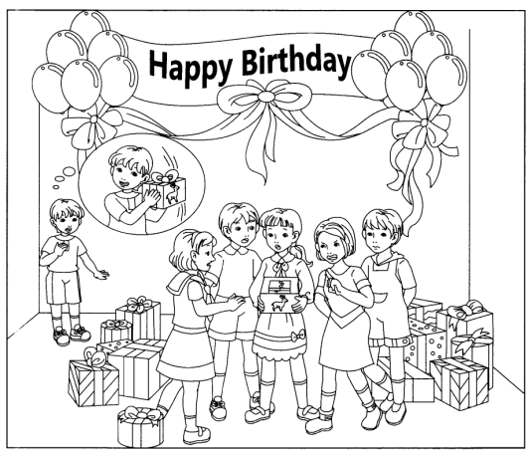

For the story, make use of the points below:
- why the birthday girl looked shocked
- what the young boy was thinking
- what happened in the end

You may reorder the points. You may also include other relevant points.

Sample Solution
When everyone had settled down and the clapping had stopped, Cheryl looked uncertainly at the mountain of presents around her. She did not know which one to open first. There was silence as everyone waited for Cheryl to reach for the first present. Cheryl shrugged and glanced about at her friends with a smile. Almost immediately, everyone pushed their presents towards her to ask her to open it first. After much hesitation, Cheryl picked a wrapper with pictures of deer all over it. The box was heavier than she had expected and there was a clinking sound when she shook it slightly.

Cheryl tore open the wrapper and eagerly opened the dark blue cardboard box. "Oh no!" she exclaimed in dismay when she looked in. "What a beautiful present! But it's ruined!" Everyone fought to see what was in the box. There were gasps of shock and the clicking of tongues as everyone stared at the broken pieces of glass in the box. It was a heart-shaped glass jewellery box with coloured stones around it. In the middle of the cover had been a huge pink butterfly. However, the wings of the butterfly had broken off and part of the glass casing was also broken. There was a large chip on the cover as well. Cheryl held the box open in front of her and stared at it, flabbergasted. She remembered putting all her presents safely in her room during the party. How could it have been damaged?

Emma, Cheryl's best friend, cried out in anger when she saw the damaged jewellery box. It was her present to Cheryl. She could not believe that it was damaged. When Cheryl found out that the jewellery box was from Emma, she was so upset that she burst into tears. She tried to pick up the pieces to put them together, but Emma immediately told her not to touch the pieces or she would hurt herself.

Seeing how upset his sister was, Cheryl's brother walked meekly towards her and mumbled an apology. At first, Cheryl did not understand why her brother was apologising. Then, it struck her that he must have caused the damage. "Did you?" she hollered so loudly that her friends immediately tried to calm her down. Her brother backed away, almost falling backwards in fright. He ran away, wailing. Cheryl wanted to go after him, but her friends held her back. Even Emma, who was so upset about the broken box told Cheryl that her brother probably did not mean to damage the present.

Cheryl was about to apologise to Emma for spoiling her present, but Emma told Cheryl that she would buy her another jewellery box. Everyone encouraged Cheryl to open the other presents and the jewellery box was soon forgotten.

Question 110
QuestionID: 174
Question Type: Continuous
Question Category: Situation-Based
Theme: Family

You and your father were at the supermarket when your father received a call. At first, he could not hear clearly what was being said. Then, his face turned pale and he began running out of the supermarket.

Based on the situation above, write a composition of at least 150 words.

In your composition, make use of the points below:
- why your father was in a rush
- what you did
- what happened in the end

You may reorder the points. You may also include other relevant points.

Sample Solution
I stared after my father in disbelief. What could have set off such behaviour? First, his jovial demeanour had disappeared. His face turned ashen and without a word he had run out of the supermarket. I was tempted to go after him but I was weighed down by a heavy basket of fruits and a trolley filled with toiletries and raw food. My father had left me standing in the middle of the supermarket. I was an obstacle to those around me and after several irritated 'excuse me', I tried my best to navigate the trolley to the side.

Fiddling with my mobile phone, I wanted to call my father. To my dismay, the battery icon blinked twice and then my screen went dark. I shoved it back into my back pocket in frustration. Leaving the trolley and basket at the corner, I walked towards the front door of the supermarket to check if my father's car was still in the parking lot. As I had expected, it was gone. I stamped my foot in frustration as my wallet was in the car, along with my haversack. I was about to make my way back to the trolley when I heard my name being called through the loudspeakers in the supermarket.

I rushed towards the counter near the entrance. The lady behind the counter told me that my father had called and wanted to speak to me. The colour drained from my face once I heard what my father had to tell me. My mother had been in a serious accident and was in a coma in the hospital. My father told me to leave the groceries we had picked and to take a taxi to the hospital. He would meet me at the taxi stand and pay for the fare. Throwing down the receiver, I dashed out of the supermarket and flagged the first taxi that I saw.

When I arrived at the hospital, I saw my father waiting by the taxi stand. He pulled open the taxi door even before the taxi came to a complete stop. Throwing a ten-dollar note at the taxi driver, he told me to hurry and ran back into the hospital. I almost fell as I was running after him. My heart was pounding and I felt dizzy from rushing around.

Minutes later, I was staring at the slim delicate figure of my mother through a glass window. Numerous tubes were attached to her and a huge bandage was around her head. A machine monitored her heartbeat and a drip was attached to her left arm. I burst into tears. Less than half an hour ago, my father and I were just thinking of a surprise feast to cook for my mother that night.

Question 111
QuestionID: 176
Question Type: Continuous
Question Category: Picture-Based
Theme: Characters

Write a composition of at least 150 words, based on the picture below.
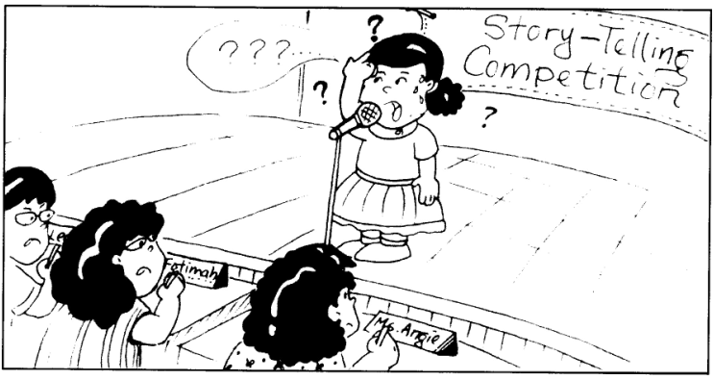

In your composition, make use of the points below:
- what the girl was doing
- what happened to her next
- what happened in the end

You may reorder the points. You may also include other relevant points.

Sample Solution
Anna approached the stage uneasily. She was participating in her school's Storytelling Competition for the first time. Anna had entered the competition with her teacher's encouragement.

She breathed in deeply and looked at the judges. She shifted her feet, cleared her throat, and began her story. "My... my... child... childhood..." stammered Anna. Her poor start made her feel even more nervous. Although she had memorised her story, she could not overcome her stage fright.

Just as Anna was about to throw in the towel, her teacher began to clap. The rest of the teacher-judges joined in the clapping. Anna was hugely encouraged by the teachers' actions. Closing her eyes and taking a few deep breaths, Anna opened her eyes and started her story again. This time, she recited her story fluently and smoothly. As her confidence grew, she became more lively.

When she had finished her story, Anna took a deep bow, to the enthusiastic applause of her teachers.

Question 112
QuestionID: 178
Question Type: Continuous
Question Category: Situation-Based
Theme: Characters

The pupils of 6K had just finished a test. Their teacher, Miss Smith, was collecting the test paper when someone in class shouted, "Help, Help, Miss Smith!"

Write a composition of at least 150 words, based on the situation above.

In your composition, make use of the points below:
- who shouted for help
- what happened next
- what happened in the end

You may reorder the points. You may also include other relevant points.

Sample Solution
The class had just finished a test. Their teacher Miss Smith, was collecting the test papers when someone in the class shouted, "Help, help, Miss Smith!"

Miss Smith looked up to see Jonathan, who sat in the back row, waving frantically at her. She strode hurriedly to the back of the classroom and asked what the matter was. Some curious pupils turned their heads around to see what the commotion was about.

"Aaron has a fever and has fainted, Miss Smith," explained Jonathan. "Earlier on, he told me that he was feeling unwell. He burnt the midnight oil last night for today's test."

Quickly, Miss Smith asked Jonathan to help her carry Aaron to the sick bay. She popped two paracetamol tablets into Aaron's mouth while Jonathan placed a cold face towel on Aaron's forehead.

When Aaron regained consciousness, he saw the concerned look on Miss Smith and Jonathan's faces. "I'm sorry for the trouble I've caused," said Aaron apologetically.

"Although the test is important, so is your health," said Miss Smith gently. "You really should get enough rest."

Hearing Miss Smith's advice, both Aaron and Jonathan nodded their heads in agreement. "Don't worry, Miss Smith," said Jonathan. "We'll make sure we stay healthy and also do well in our exams!

Question 113
QuestionID: 180
Question Type: Continuous
Question Category: Picture-Based
Theme: Outdoor Activities

Write a composition of at least 150 words, based on the picture below.
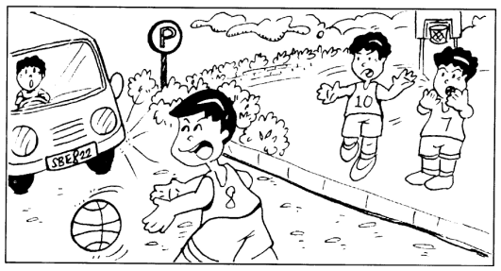

In your composition, make use of the points below:
- why the boy ran into the road
- how the driver of the van reacted
- what happened in the end

You may reorder the points. You may also include other relevant points.

Sample Solution
"Quick! Shoot the ball in," said Kevin. He and his two friends were having a game of basketball at the court near his block. In front of the basketball court was a car park.

Kevin aimed a shot and threw the basketball with all his might. The basketball hit the board and rebounded. It went over the fence that surrounded the basketball court and rolled into the middle of the road.

"I'll get it," volunteered Kevin. As he ran to retrieve the basketball, a van was turning into the car park. With bated breath, Kevin's two friends helplessly watched the moving van heading towards Kevin.

The van screeched to halt. It narrowly missed Kevin by an inch. Opening the van door, the driver got out and helped Kevin to his feet. Kevin's friends ran to him immediately.

"That was dangerous, boy," said the van driver. "I could have knocked you down. Luckily you're all right."

Kevin was glad that he had escaped unhurt. He told himself that he would never again run into the road.

Question 114
QuestionID: 182
Question Type: Continuous
Question Category: Situation-Based
Theme: Unexpected Events

I was waking home from school one day, when I head the sound of running footsteps behind me. A man ran into me and knocked me to the ground.

Write a composition of at least 150 words, based on the situation above.

In your composition, make use of the points below:
- who the man was
- why he was running
- what happened in the end

You may reorder the points. You may also include other relevant points.

Sample Solution
I was walking home from school one day, when I heard the sound of running footsteps behind me. A man ran into me and knocked me to the ground.

The fall almost winded me. The man looked as if he were being chased by a dog, I thought to myself, as I tried to get up.

Just then, a dog ran past me, hot on the man's heels. It pounced on the man and pinned him to the ground. Another man, holding a stick, arrived on the scene almost immediately. He stopped and helped me to my feet. I thanked him for his assistance.

"This man here is a burglar," said the man who helped me up. "He climbed over my fence with the intention of breaking into my house. He tried to escape, so I set my dog on him."

The burglar struggled to get free, but the huge dog had him pinned under his big strong paws. The police came a few minutes later, and the burglar was put into the police car.

"Thank you, boy," said the owner of the house to me. "If it weren't for you, my dog might not have been able to catch the burglar."

I flashed him a wry smile and went home. I do not want to have an experience like that again!

Question 115
QuestionID: 184
Question Type: Continuous
Question Category: Picture-Based
Theme: Unexpected Events

Write a composition of at least 150 words, based on the picture below.

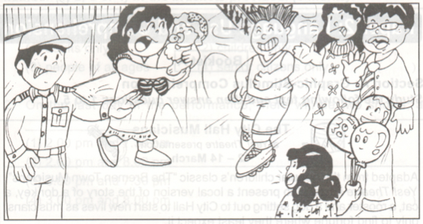
In your composition, make use of the points below:
- what the boy was doing
- how the man reacted
- what happened in the end

You may reorder the points. You may also include other relevant points.

Sample Solution
It was a crowded Saturday afternoon at the shopping centre. Shoppers thronged the shopping complex. "What luck!" thought Gavin to himself. "I can breeze through the crowd easily in my new pair of Heelys."

A newcomer to the fad of roller-shoes, Gavin rolled forward unsteadily. He brushed past several shoppers as he moved along the narrow passageway. Some people cast disapproving looks at him. To stop rolling, Gavin stretched out his arms for the nearest wall. In his haste to get there, he did not notice a woman with a baby in her arms in front of him, and almost knocked her down. Fortunately, she stopped in her tracks just in time to avoid a collision.

A security guard who had witnessed the incident approached Gavin and said, "It's dangerous to skate in crowded places. What if you hurt someone? How would you feel?"

Realising his folly, Gavin apologised to the woman, who accepted his apology. He also promised the security guard that he would not be so reckless again. He went outside and found a quiet place to practice using his Heelys properly.

Question 116
QuestionID: 186
Question Type: Continuous
Question Category: Situation-Based
Theme: Characters

The school bell rang for recess. It was raining heavily outside as the pupils walked slowly from their classrooms to the canteen. Suddenly, there was a loud thud. Everybody turned to look.

Based on the situation above, write a composition of at least 150 words.

In your composition, make use of the points below:
- what caused the loud thud
- what happened next
- what happened in the end

You may reorder the points. You may also include other relevant points.

Sample Solution
The school bell rang for recess. It was raining heavily outside as the pupils walked slowly from their classrooms to the canteen. Suddenly, there was a loud thud. Everybody turned to look.

"Ouch!" cried Johnny, lying sprawled on the canteen floor. While Bradly rushed forward to help his classmate up, Charlie went to alert the teacher. Johnny howled in pain while Bradly tried to touch him. Soon, Charlie had returned with their form teacher, and the three of them carried the injured Johnny to the sick-bay.

Johnny had suffered a slight cut to his chin and had bruises on his arms. As Johnny's teacher dressed his wound, he asked what had caused Johnny to fall.

Guiltily, Johnny said, "I was hungry, and I didn't want to be the last in the queue . In my haste, I slipped and fell."

Johnny's teacher shook his finger at Johnny and said, "You should have realised that it's dangerous to run about, especially on rainy days. Floors tend to be slippery, and accidents will happen if one isn't careful."

Johnny hung his head in shame. As a punishment to Johnny, his teacher made him write a composition about the accident. It reminded Johnny not to make the same mistake again.

Question 117
QuestionID: 188
Question Type: Continuous
Question Category: Picture-Based
Theme: Characters

Write a composition of at least 150 words, based on the situation above.
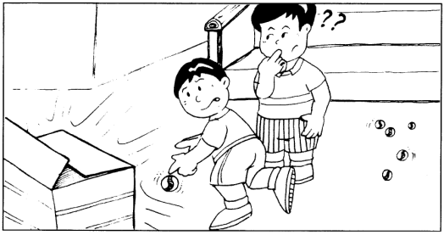

In your composition, make use of the points below:
- what the boys were doing
- what was inside the box
- what happened in the end

You may reorder the points. You may also include other relevant points.

Sample Solution
Aaron and Harry were playing a game of marbles. Being avid players, they often visited each other's block for a friendly game. Aaron aimed a shot at Harry's favourite marble which he had been eyeing for some time. However, he misjudged the distance, and his own marble missed Harry's marble by a few centimeters. The marble rolled to the second landing of the staircase.

While Aaron was jogging down the stairs to retrieve his marble, he saw a box at the bottom of the staircase. "Hey, Harry! Take a look at this. I wonder what's inside," said Aaron.

As Aaron reached for the box, Harry stopped him. "Be careful! It could be something dangerous," warned Harry.

The two boys then approached the box cautiously. Aaron used a stick to lift the flap of the box slowly. When the opening was big enough, the boys peered into the box to see what mysterious object it contained. To their surprise, it was a star tortoise. Someone must have abandoned the animal.

Harry suggested that they inform the authorities at the Agri-Food and Veterinary Office. Within an hour, two officers came and picked the tortoise up. Before leaving, one of the officers said to them, "Thank you, boys, for saving an endangered star tortoise."

Question 118
QuestionID: 190
Question Type: Continuous
Question Category: Situation-Based
Theme: Characters

It was time for recess. Nicholas opened his bag. He dug deep into the bag, looking for something, and was dismayed to find that it was missing

Write a composition of at least 150 words, based on the situation above.

In your composition, make use of the points below:
- what was missing
- what happened next
- what happened in the end

You may reorder the points. You may also include other relevant points.

Sample Solution
It was time for recess. Nicholas opened his bag. He dug deep into the bag, looking for something, and was dismayed to find that it was missing.

"My wallet is gone!" cried Nicholas.

Roger walked over to Nicholas's table, concerned. "I had my wallet with me this morning. Then we had a P.E. lesson. Someone must have sneaked into the classroom to steal my wallet. Or maybe it's someone in our class," Nicholas concluded.

Roger advised Nicholas to search his bag thoroughly again, but Nicholas was too agitated to listen to him. Just then, Danny walked into the classroom. Nicholas' eyes widened when he recalled that Danny had missed the P.E. lesson. Before Roger could stop Nicholas, he had already stormed towards Danny and demanded that he return his wallet.

A baffled Danny denied having taken Nicholas's wallet. But Nicholas insisted, "You must be the one, because you were alone in the classroom just now."

Suddenly, Roger called out to them. Dangling Nicholas's wallet from his little finger, he said, "I found your wallet in the front pocket of your hag. You must have missed checking there."

A red-faced Nicholas then apologised to Danny for jumping to conclusions. Danny graciously accepted his apology. "Hey! We've only ten minutes left for recess. Hurry!" said Roger.

And so the three boys hurried to the canteen for their lunch.

Question 119
QuestionID: 191
Question Type: Continuous
Question Category: Picture-Based
Theme: Criminal Acts

Write a story based on the picture below. Your story should be at least 150 words long.
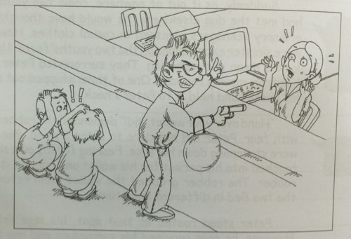

You may make use of the following points:
- what the robber demanded
- how the banker cashier reacted
- what happened in the end

You may reorder the points. You may also include other relevant points.

Sample Solution
It started out as an ordinary work day for Linda, a bank teller who worked at the Bukit Timah branch of Singapore Savings Bank. From the time the bank opened its doors, there had been a steady stream of customers Linda had to attend to. By three thirty in the afternoon, half an hour before closing time, the crowd started to dwindle. There were only four customers left in line at Linda’s counter, the only remaining counter which was kept open.

Next in line at Linda’s counter was a short and stout Chinese man in his thirties. He was dressed casually in a T-shirt and jeans, with a leather jacket to complete the biker look. He was also carrying a motorcycle helmet in one arm. When he came face to face with Linda, he promptly reached into his helmet and whipped out a pistol, pointing it directly at Linda. Staring down the barrel of a gun, this was the closest Linda had ever been to death’s door.

“Hand over all the cash in the bank’s vault!” demanded the robber in a gruff voice. The three customers behind him were scared speechless. The staff members at the bank were also taken by surprise.

“Don’t try to move or I’ll shoot!” threatened the armed robber, directing his threat to everyone in the bank. With trembling hands, Linda opened the drawer behind the counter and took out wads of cash, placing them before the robber. She also discreetly pressed the silent alarm located below the counter. This would not produce any sound to alarm the robber but would instead activate a distress signal to be sent directly to the police.

Meanwhile, the robber, not content with the wads of cash he had taken and put into a black bag he had with him, demanded that Linda hand over more cash.

“O-Only the manager has the key to the vault,” stammered Linda in a tone as soft and meek as a mouse. Realizing that it would be a risk to remain in the bank for too long and demand that the vault be opened, the robber grabbed the loot that he already had and dashed for the main door.

“Bang!”

The robber fell to the ground the moment he stepped outside. Unknown to him, following Linda’s pressing of the silent alarm, the police had already arrived at the scene. Armed officers were hiding at the strategic positions outside the bank, waiting to ambush the escaping robber.

The robber was shot in the leg and slumped on the ground, writhing in pain. He was handcuffed and arrested before being taken by an ambulance to a hospital for treatment. For Linda and the other staff and customers at the bank, their ordeal was finally over.

As she made her way home from work that evening, Linda pondered over the most eventful day of her career. She was thankful that there had been no causalities. Despite the fact of Singapore being a very safe and secure country, it did not mean that everyone could rest on their laurels. As the slogan for the police force’s advertising campaign goes, “Low crime does not mean no crime.”

Question 120
QuestionID: 192
Question Type: Continuous
Question Category: Picture-Based
Theme: Accidents and Disasters

Write a story based on the picture below. Your story should be at least 150 words long.
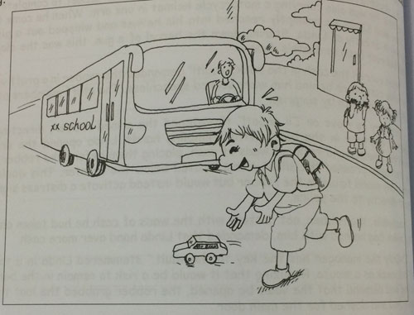

You may make use of the following points:
- what the children were doing
- whether the school bus was able to stop in time
- what happened in the end

You may reorder the points. You may also include other relevant points.

Sample Solution
It was a beautiful early afternoon. The sun was at its height, but the harsh heat was soothed by a blanket of fluffy white clouds across the sky. At exactly twelve noon, John bade goodbye to his mother and went to the nearby pick-up point to wait for his school bus. There, he met his two fellow schoolmates, Lisa and Daniel. The trio would wait at that spot daily for their school bus, which usually arrived at around twelve fifteen.

John was especially excited to see his two friends that day. He took out his gleaming red model toy car and showed it proudly to his friends. It was a gift from his father for doing well in his common test.

“Wow! That’s cool! Can It move by itself?” enquired Daniel, who was obviously envious of John for his latest possession.

“How fast can it go?” added Lisa.

Eager to show off the toy car’s capability for high speed, John gave his friends a demonstration. The miniature car zoomed along the pavement, racing down the kerb and onto the main road. In a haste to retrieve his prized to car, John dashed across the road without consideration for his personal safety.

From a distance, the children’s school bus was fast approaching. When Daniel and Lisa saw the bus zooming towards John, they shouted out to warn John of the impending danger, but it was too late. The bus driver was travelling at quite a high speed. As soon as he spotted John running in his path, he applied his emergency brakes. Unfortunately, he was unable to stop in time. As the massive vehicle screeched to a halt, it knocked into John. Upon impact, the tremendous force of the bus flung John a few metres from his original position on the road.

John’s limp and lifeless body landed on the hard tarmac. He had lost consciousness and was bleeding profusely from his forehead. The bus driver rushed out from his bus to check on John. Quick-witted Daniel whipped out his mobile phone and dialled ‘995’ for an ambulance. Meanwhile, the bus driver knelt beside John and tried to stop his bleeding with a handkerchief.

Question 121
QuestionID: 193
Question Type: Continuous
Question Category: Picture-Based
Theme: Interesting Places and Events

Write a story based on the picture below. Your story should be at least 150 words long.
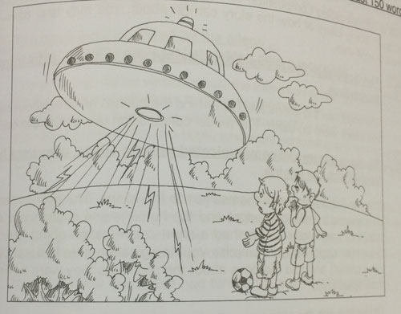

You may make use of the following points:
- what the boys saw
- what the aliens did
- what happened in the end

You may reorder the points. You may also include other relevant points.

Sample Solution
It was a cool and breezy evening. The football match was over. Dave and I were walking across the field when we saw a beam of multicoloured, blinking lights darting across the sky.

Overcome with curiosity, we hid behind a clump of bushes to witness the scene that was to unfold before our disbelieving eyes. As the light got nearer, we could see that it was being emitted from a circular, disc-shaped object. The strange object was heading towards us at breakneck speed!

Crash! When the dust had settled, the disc flipped open ad out came a pair of strange-looking creatures. They had conical-shaped heads atop a slender body. Their ears were large in proportion to their other facial features and protruded out awkwardly. Their bodies were clad in a spacesuit-like garment made of a reflective material. The duo seemed to be having a conversation in a strange-sounding language which comprised of electronic-like beeps.

From our vantage position behind the bushes, we could hardly believe what we were witnessing. At first, I thought we had walked straight into a movie set, but there were no cameras in sight. The bald alien was gesturing wildly to his counterpart, presumably a female, who had long, flowing tresses atop her conical-shaped head. She then went back into the spaceship and emerged with a toolbox. The male alien took out a spanner and prised open a hutch on the spaceship. He looked like he was doing some repairs. Dave and I guessed that the aliens must have encountered some trouble with the engine during their flight and had to make an emergency landing on earth to repair their spaceship before they could resume their flight.

A part of us wanted to go up to the aliens and introduce ourselves. After all, they did not look all that hostile to us. However, we decided against it as we did not know whether the aliens would welcome our intrusion. Furthermore, we did not speak their language and foresaw communication problems.

After about ten minutes, the male alien closed the hutch and gestured to his female counterpart to come back up into the spaceship with him. The spaceship then flipped close and the blinking lights came on again.

Just as quickly as they had appeared, the spaceship was gone. We wiped our eyes and slapped our faces to make sure that we had not been dreaming. Could it have been a mere figment of our imagination? To us, it seemed real enough.

Although we would hardly contain our excitement and our first instinct was to run home to tell everyone what we had seen, we realized that our story seemed too incredible for anyone to believe. Telling our story would only make us laughing stocks. With that in mind, we decided to keep our encounter with the aliens a secret as we made our way home for dinner that evening.

Question 122
QuestionID: 194
Question Type: Continuous
Question Category: Picture-Based
Theme: Accidents and Disasters

Write a story based on the picture below. Your story should be at least 150 words long.
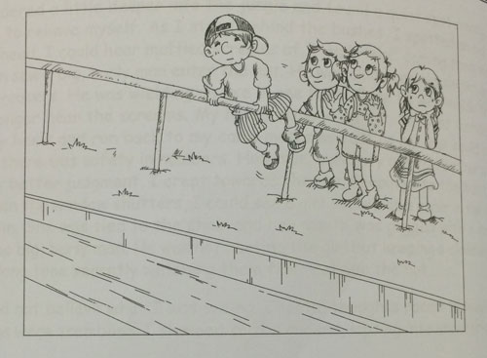

You may make use of the following points:
- who the boy was
- why the boy was climbing over the railing
- what happened to him in the end

You may reorder the points. You may also include other relevant points.

Sample Solution
The day was cool and breezy. Despite the weather forecast of showers in the mid-afternoon, the fluffy cottony white clouds in the sky seemed to suggest the opposite. Amanda, Benny, Crystal and Dennis had decided to meet at a fast-food restaurant near their homes for a study session. The mid-year examinations were approaching and the four Secondary Two students wanted to do well so that they would be posted to a good class the following year.

The foursome arranged to meet by the large canal and walked to the restaurant together. By one o’clock, Benny, Crystal and Dennis were already there. They were chatting when Amanda walked up to them. She was using her mobile phone to send a text message to her mother to inform her that she had arrived safely.

“Wow, Amanda! You’ve got a new mobile phone!” exclaimed Benny.

“Very stylish, eh? Looks expensive,” added Crystal.

“Let me have a look at it,” said Dennis, grabbing the mobile phone from Amanda’s hand. He scrolled through her list of text messages in her inbox.

“So many messages from this guy named tommy. Is he your boyfriend?” teased Dennis. Crystal and Benny rushed to huddle around Dennis to steal a look at the mobile phone screen.

“Hey, that’s private!” retorted Amanda. She tried to grab back the mobile phone, but Dennis raised his arm to put it out of her reach. Dennis passed the mobile phone to Benny, who ran a distance along the canal with it. Amanda ran after him, followed by Dennis and Crystal. Amanda again tried to grab back her mobile phone. During the commotion, the mobile phone slipped out of Benny’s hand and landed into the murky waters of the canal.

Feeling guilty to have been the one who had started it all, Dennis jumped into the canal to help to retrieve Amanda’s mobile phone. After a few minutes, seeing that Dennis was still swimming around in search of the phone, Benny removed his T-shirt and jumped in as well. Being a good swimmer, Amanda followed Benny by jumping into the canal. She was desperate to get back her mobile phone, which was a gift from her mother for her fourteenth birthday.

Crystal looked over the railing as the trio swam around searching for the mobile phone. Suddenly, she realized that the water level in the canal was rising. It must have started to rain nearby and the rainwater was pouring in to fill up the canal. This water level was now rising more and more quickly. Crystal looked closer over the railing. She could no longer see Amanda and Benny. Dennis seemed to be having some difficulty in the water. Before she knew it, he too was swept away by the incoming currents. Crystal was at a loss about what to do. She immediately called ‘995’ on her mobile phone.

Within ten minutes, a civil defence team was at the scene. Two civil defence rescuers plunged into the raging canal waters to search for the missing trio. Before thirty minutes was up, they managed to find Benny and Dennis and carried them to safety. The boys were subsequently resuscitated and taken to a hospital for observation. Amanda, however, was yet to be found. By that time, Amanda’s parents’ had arrived at the scene. Crystal, too, had stayed on.

As the hours dragged on, hopes of finding Amanda alive diminished. Crystal, together with Amanda’s parents, kept a vigil at the site, clinging on to whatever little hope they had.

At around six the following morning, Amanda’s body was finally found floating in the canal, two hundred metres away from where she had originally jumped in. Everyone, especially Amanda’s parents, was devastated at the news.

Following the tragedy, the civil defence reiterated their warning to the public to stay away from public canals, even during times of dry weather when the water level was very low. The water level in canals is unpredictable and could rise very quickly, showing no mercy to anyone inside. If Amanda’s death has convinced others of the dangers of swimming in public canals and in that way prevented similar tragedies from taking place, then at least her death would not be in vain.

Question 123
QuestionID: 195
Question Type: Continuous
Question Category: Picture-Based
Theme: Family

Write a story based on the picture below. Your story should be at least 150 words long.
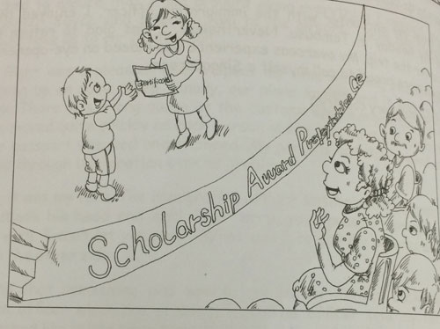

You may make use of the following points:
- what the boy was up for stage for
- why the lady in the crowd was beaming with pride
- what happened in the end

You may reorder the points. You may also include other relevant points.

Sample Solution
“And the winner for this year’s Dr Tan Kim Mock Memorial Scholarship Award goes to … Jacob Ong of Achievement Primary School!”

As Jacob walked up on stage to receive the award amid the thunderous applause from the audience, he was filled with pride and gratitude. He had emerged the top student in his constituency for the Primary School Leaving Examination with an aggregate score of 279. Along with the prestige of winning the award, Jacob would also receive a full scholarship to study at a top independent secondary school. The scholarship would cover his school fees, books and stationary, uniforms as well as a monthly allowance of one hundred dollars for four years. The scholarship was especially valuable to Jacob as it would ease his mother’s financial burden considerably.

Jacob came from a humble family background. His father was an alcoholic who has abandoned the family a long time ago. His mother worked as a washerwoman by day and a cleaner at a food court by night to make enough money to support Jacob and his two younger siblings, a seven-year-old sister and nine-year-old brother. The family of four survived on Mrs Ong’s meagre monthly income of about nine hundred dollars, which was barely enough to make ends meet. They lived in a sparsely furnished two-room rented flat. Jacob and his siblings did not receive any pocket money. They brought their own lunchboxes to school, which contained a sandwich made up of two slices of plain white bread spread with a thin layer of margarine in the middle. Their school books and uniforms were all second-hand, donated by their school, who knew of their family situation.

Since their mother held two jobs, she was hardly home most of the time. Before she left for work each morning, she would prepare some food for the children’s breakfast, lunch and dinner. Being the eldest child, the task of looking after his younger brother and sister fell on Jacob’s young shoulders. The three Ong children went to school and came home together every day. In the afternoon and evening, Jacob would warm up the lunch and dinner respectively which his mother had prepared in advance. Knowing that his mother worked very hard outside and needed to rest when she was at home, Jacob also tried to lessen his mother’s burden by doing most of the household chores. Although his younger siblings sometimes helped out a bit, it was only after much nagging and persuasion from their elder brother. The bulk of the chores were still done by Jacob. In the absence of adult supervision, Jacob assumed the role of mentor and disciplinarian to his siblings. He tried his best to make sure that they did their homework and acted as a mediator when his brother and sister got into any squabbles.

On top of all that, Jacob also had to cope with his own schoolwork. Fortunately, he was good at time management. Being a hard-working and conscientious student, he made it a point to be attentive in class and revise his work consistently. After every lesson, he would go over what had been taught and if he had any doubts, he would clarify them with his teacher the following day. He completed all his assignments on time and never let his homework pile up. Although he did not have any additional help with his schoolwork outside of school in the form of tuition, he studied by himself and practised by doing old assessment books which were donated by his neighbours. Through his hard work and determination, Jacob excelled academically, leading to him clinching the scholarship award.

At the award presentation ceremony, seated among the audience was Jacob’s mother. Her weather-beaten face beamed with motherly pride as she watched her firstborn accept the award from the guest of honour. It was during moments like these that she felt all her sweat and toil in bringing up her children were not in vain. Seeing how Jacob had turned out made all her suffering worthwhile. Jacob was indeed her pride and job. His achievements gave her much hope for the future. She was also glad that her younger children had such an outstanding brother as a role model and hope that they, too, might one day follow in Jacob’s footsteps.

Question 124
QuestionID: 196
Question Type: Continuous
Question Category: Picture-Based
Theme: Accidents and Disasters

Write a story based on the picture below. Your story should be at least 150 words long.
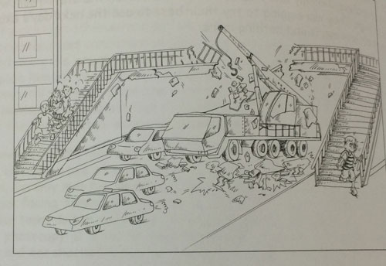

You may make use of the following points:
- how the overhead bridge collasped
- whether anyone was injured in the collaspe
- what happened in the end

You may reorder the points. You may also include other relevant points.

Sample Solution
Warm sunshine bathed the earth. Cottony white clouds lined the pale blue afternoon sky, stretching as far as the eye could see. However, the endless stream of traffic whizzing past the busy street disrupted the idyllic setting, turning the place into yet another enclave of modern civilization in an urban landscape.

Every afternoon, Jeff had to brave the heavy traffic to reach his home, which was across the road from the bus stop where he usually alighted. Fortunately, a fine piece of modern engineering and architecture had been erected to enable Jeff and many other pedestrians to make it safely across the road at any time of the day. This was the overhead bridge.

On that fateful afternoon after a football practice, Jeff crossed the overhead bridge. He was just two steps away from reaching the ground at the other side of the road when he heard an earth-shattering crashing noise, accompanied by what he felt was the ground shaking. Jeff instinctively jumped down the last two steps and ran a short distance.

When he turned around, he was horrified to see that a tall crane had crashed into the overhead bridge. Half of the bridge had collapsed, leaving the other half dangling precariously in midair. The collapsed section of the overhead bridge had flattened the back of the crane and two other passenger vehicles. Traffic in both directions came to a standstill.

Within minutes, the police were at the scene. They cordoned off the area to keep unauthorized personnel from getting too close to the scene. The wailing sirens and flashing red lights signalled the arrival of some ambulances and civil defence officers. There was a flurry of activity as rescue workers rushed to rummage through the broken concrete slabs and twisted metal heaps to get to the unfortunate victims in the vehicle which had been directly struck down by the falling overhead bridge.

By then, a huge crowd of curious onlookers had gather on the pavements on either side of the road next to the accident site. Jeff joined in the gawking crowd but his small stature prevented him from getting a clear view of the chaos. The burning question on his mind was whether there had been any pedestrians crossing the overhead bridge during the time of the collapse. He pondered on his narrow escape and shuddered at the thought that had he crossed the bridge just a minute later, he might not have been there standing in one piece.

Meanwhile, the task of extricating the trapped victims was a delicate one. Heavy machinery could not be used for fear of causing further injury to the victims. At the same time, the rescue workers had to work fast since to the injured survivors, if any, time was of the essence. In the time that Jeff was at the scene, he saw two bodies being removed from the rubble. The pristine white sheet that covered their bodies told him that they did not make it out alive. After about half an hour, Jeff decided to head home as he did not wanted to cause his mother any unnecessary worry.

The next day, Jeff read about the collapse of the overhead bridge in the newspapers. It was reported that the tragic accident had claimed three lives: the drivers of the two cars which had been flattened and a front-seat passenger in one of the cars. Two rear-seat passengers seated in one of the cars suffered non-life-threatening injuries and were now in hospital. The crane driver escaped unhurt. He was currently being investigated by the authorities for driving a tall, heavy vehicle on a stretch of road that had a height limited for passing vehicles. There was a height limit sign on the overhead bridge to warn tall vehicles not to pass. Miraculously, there were no pedestrians on the overhead bridge at the time of the collapse. There were a few teenagers who were halfway up the stairs leading to the overhead bridge when the crash occurred. Since the stairs withstood the impact on the overhead bridge, the pedestrians were able to run down the stairs and were unhurt.

For Jeff and his parents, they were only glad and relieved that Jeff was alive and well following his close shave with death.

Question 125
QuestionID: 197
Question Type: Continuous
Question Category: Picture-Based
Theme: Criminal Acts

Write a story based on the picture below. Your story should be at least 150 words long.
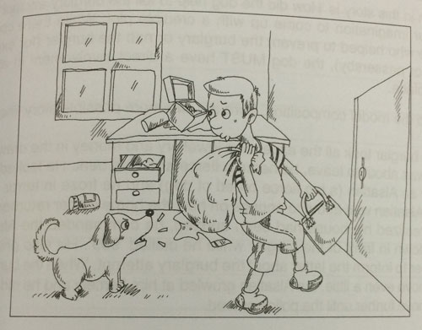

You may make use of the following points:
- how did the burglar broke into the house
- what the dog did to foil his burglary attempt
- what happened in the end

You may reorder the points. You may also include other relevant points.

Sample Solution
Both John’s parents were working late again, for the fourth night in a row. John resented spending his evening alone in the cold, empty house. After a while, the novelty of having the whole house to himself had worn off. He had surfed all the interesting websites, played many games on his gaming console and watched all that was worth watching on television. He had even completed all his holiday assignment, both from school and tuition class. John was bored to tears being cooped up at home. He decided to go to the nearby community club to play basketball with his friends. John found it inconvenient to carry his house keys with him as he was wearing a singlet and a pair of basketball shorts which had no pockets. He was also aware of his tendency to lose his keys while on the road, so he decided to hide his keys in a flowerpot next to his main door.

Little did John know that he was being watched. After he left, nobody was home except Barky, his pet Alsatian puppy. Seizing the opportunity, a burglar broke into the house. In fact, he did not have to break in. He simply took the keys which John had left in the flowerpot and let himself in. Barky tried to play the part of a true guard dog and ‘growled fiercely’ at the intruder, but the burglar was unfazed by the yelps made by the puppy. Once inside, he made his way upstairs and began searching the rooms for valuables.

When John came home, he did not sense that there was anything out of the ordinary until he went upstairs and caught the burglar red-handed in his parents’ bedroom trying to pry open the safe.

The burglar caught sight of John and grabbed him. He was not going to let a young boy foil his burglary attempt. The burglar tied John’s hands tightly to the bedpost with a rope and gagged his mouth with a rag. John struggled to free himself but was unsuccessful. He was also unable to scream for help.

Meanwhile, the burglar continued to search the entire house for valuables worth stealing. When he was out of sight, Barky crept up to John. With a little prompting, Barky bit the rope around John’s wrists until it snapped, setting John free. Sensing the tension of the situation, John steeled himself to remain calm. He immediately latched the master bedroom door from inside, locking himself and Barky in. He also locked all the windows and drew the curtains. Once holed up in his safe enclave where the burglar could not get him, John took out his mobile phone and secretly phoned the police to make a report. He told the officer his predicament and gave him his address and location within the house. He also telephoned his parents to warn them not to enter the house should they arrive home before the police came.

Within minutes, a posse of police officers arrived at the scene of the crime. They stormed John’s house and arrested the burglar just as he was coolly walking out through the main door with his loot. They then rushed upstairs to tell John that the worst was over and he could come out safely. By that time, John’s parents had returned home. His mother ran and hugged her son tightly. She was relieved that he was all right and promised not to work late and leave him alone at home again. John admitted to his mother that it was actually his fault since he had gone out and left the keys in the flowerpot. He then carried Barky in his arms and introduced the real hero to everyone. If Barky had not bitten the rope to set him free, he would not have been able to call the police and the burglar would have got away scot-free. Everyone patted Barky on the head and agreed that the cute little puppy deserved some credit for his crime-busting effort.

Question 126
QuestionID: 198
Question Type: Continuous
Question Category: Picture-Based
Theme: Accidents and Disasters

Write a story based on the picture below. Your story should be at least 150 words long.

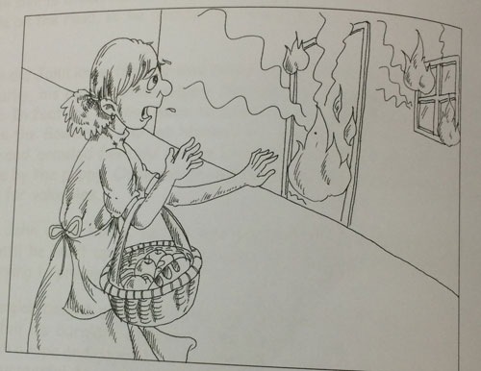

You may make use of the following points:
- how the fire started
- who was inside the flat, if any
- what the lady did
- what happened in the end

You may reorder the points. You may also include other relevant points.

Sample Solution
Tomatoes were in season again. Ripe, red and juicy, they were going at just two dollars a kilogram. The prices of seafood were also very reasonable. At the butcher’s stall, the red meat was succulent and lean, perfect for dishing up her sweet and sour pork speciality. Madam Ong had a fruitful marketing trip that morning. Armed with bags of fresh produce, she was eager to get home to whip up a sumptuous meal for her family that evening.

As she walked along the corridor leading to her flat, there was an uneasy silence. Usually, her two children, Mark and Tina, would be tearing the house down with their endless chatter and laughter. The two youngsters aged seven and nine, were indeed a handful.

As Madam Ong neared her flat, she could see smoke billowing out of the window, as well as from under the wooden door. Sensing that something was not right, Madam Ong quickly rushed to unlock the iron grille, followed by the wooden door. When she opened the door, she found the living room filled with clouds of thick, grey smoke. She shouted for her children, but her screams were muffled by the dense, suffocating smoke.

Fearing for her dear children’s lives, Madam Ong braved the flames and rushed into the house. She found Mark and Tina huddled together in a corner in the master bedroom. The smoke had started to seep in from under the door and despite having the window open, the room was becoming filled with smoke, causing the children to cough. Madam Ong grabbed Mark and Tina by the arms and told them to hurry out of the house. It was miraculous that she had come home in time before the smoke thickened and the fire spread. Madam Ong managed to make it safely out of the house with her children.

By this time, a few neighbours had already gathered outside Madam Ong’s flat. One of them told her that she had just called the fire brigade. From the outside, Madam Ong saw that her kitchen was on fire. Bright orange flames had engulfed the indoor clothes drying stand with a few pieces of laundry hanging on it. The fire seemed to be spreading to the wooden kitchen cabinets. As the wood fuelled the flames, the fire grew. The blankets of smoke became thicker and blacker as it continued to fill the place, reducing the visibility of what was happening inside the house. Standing outside the main entrance, Madam Ong and her children could feel the intense heat of the fire.

The firemen arrived within ten minutes in their compact but well-equipped red rhino emergency vehicle. Armed with protective gear and powerful water hoses, they braved the billowing layers of smoke to come face to face with the fire. The fierce, raging fire had met its match. The firemen directed their hoses at the angry fire spraying jets of water to douse the flames. They brought the fire under control in a matter of minutes and completely put it out soon after.

Part of the kitchen was badly damaged in the fire. A row of cabinets had been reduced to ashes. The walls were blackened and a layer of soot covered everything in the kitchen. Fortunately, no one was hurt in the blaze and the fire did not spread beyond the kitchen or to the neighbouring units.

Mark and Tina later admitted that they had been playing with matches by the kitchen window while their mother was out. Five minutes before their mother returned, Mark had accidentally set fire to his father’s shirt, which was hanging on the clothes stand to dry. Seeing the flames on the burning shirt spread so quickly, the children panicked. Unable to run out of the house as they did not have the key, they hid in the master bedroom because it was furthest from the kitchen.

Madam Ong chided her children for playing with fire. She told them that they were lucky she had come back in time or else the consequences would have been disastrous. Following the incident, Mark and Tina understood first-hand the dangers of playing with fire and promised never to do it again.

Question 127
QuestionID: 199
Question Type: Continuous
Question Category: Picture-Based
Theme: Outdoor Activities

Write a story based on the picture below. Your story should be at least 150 words long.
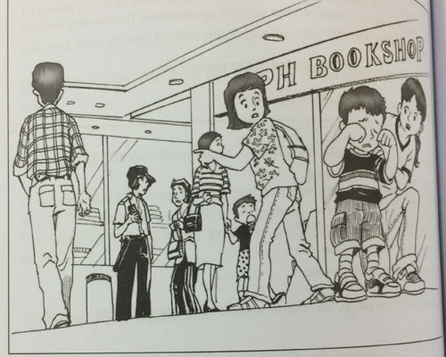

Make use of the following points in your story:
- why the little boy was crying
- where the girl was going
- what happened in the end

You may reorder the points. You may also include other relevant points.

Sample Solution
It was a Saturday afternoon and my best friend, Linda, and I were at the Central Shopping Mall. We did not want to buy anything in particular but were just enjoying walking around, looking in the shop windows, and chatting.

I remember that as we were approaching a book shop we suddenly heard a loud crying noise. At first, we could not see where it was coming from, but as we turned the corner, we saw a little boy crying his heart out.

"Look!" I said to Linda. "The poor little thing must have got separated from his mother."

We rushed up to the crying child and tried to comfort him.

"What shall we do?" asked Linda.

"I know," I replied. "You stay with the little boy and I will go and find a security guard. Perhaps, he can make an announcement that the boy's mother will hear."

So, I left Linda with the child, who had now stopped crying so loudly, and went in search of a guard. Then, at the far end, I spotted a guard's uniform.

As I ran towards him, I realised that he was speaking to a distraught-looking woman.

"That must be the boy's mother," I thought.

I came up to them and said a bit breathlessly, "Are you looking for your son?"

The woman looked at me as if she could not believe her ears.

"Yes! Yes! Have you seen him?" she said hurriedly.

"Yes," I replied. "Don't worry! He's with my friend and he's fine."

I led the guard and the boy's mother back to where Linda and her son were. She rushed up to the boy, picked him up and held him tight. Then she turned to Linda and me an said quietly, "I will never be able to thank you enough!"

"You just have!" I replied. "It's enough to see you and your son reunited."

Question 128
QuestionID: 200
Question Type: Continuous
Question Category: Picture-Based
Theme: School and You

Write a story based on the picture below. Your story should be at least 150 words long.

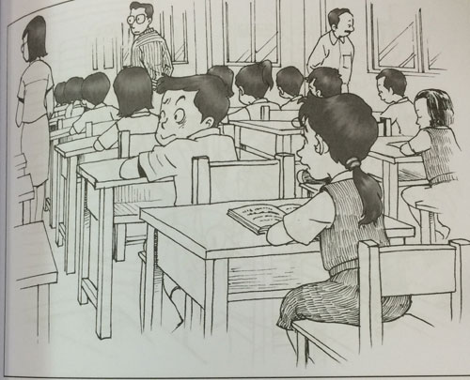
Make use of the following points in your story:
- how the girl felt when she realised the boy was cheating
- what the girl did
- what happened in the end

You may reorder the points. You may also include other relevant points.

Sample Solution
It was during the final part of the English exam when Marie suddenly noticed that a boy in front of her was bending over his desk in a strange way. She looked at him more closely and had the strong impression that he was listening to something up his sleeve. What could he be doing? The boy looked around him in a furtive way, as if he was checking that no one was watching him.

Marie felt shocked and worried. She had the distinct feeling that the boy was cheating. He appeared to be listening to an MP3 player that he had hidden on his arm, under his shirt. She knew that any kind of listening device was forbidden during school time, and if anyone was caught using one in a lesson, it would be confiscated immediately. During an exam this was obviously wrong and was a clear breach of the rules. Marie knew she had to report this to the teacher. It was unfair on the other students and it was her responsibility to inform the invigilator.

Marie put up her hand and eventually the teacher noticed and came over to her desk. "Yes?" asked the teacher quietly. "I think that boy is listening to something up his sleeve," said Marie as she pointed to the boy who had by now removed his arm from the desk.

"Are you sure?" asked the teacher. Marie nodded gravely. The teacher went over to the boy in question. She asked him a few questions quietly, then red-faced, the boy was led from his desk to the front of the room. Eventually, another teacher came and he was taken out of the exam room.

Question 129
QuestionID: 201
Question Type: Continuous
Question Category: Picture-Based
Theme: Characters

Write a story based on the picture below. Your story should be at least 150 words long.
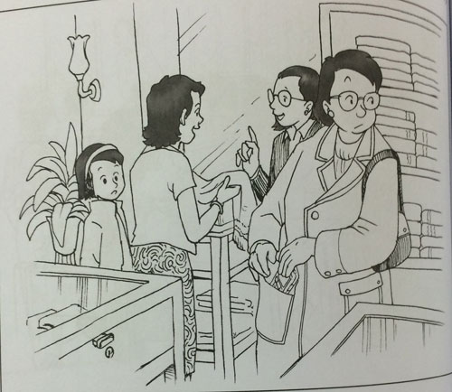

Make use of the following points in your story:
- where the mother and daughter were
- what the girl saw
- what happened in the end

You may reorder the points. You may also include other relevant points.

Sample Solution
Last weekend, my mother and I decided to have a day out together. We planned to do some shopping and then have lunch. But things did not turn out quite the way we expected.

We caught the bus into town and went to the department store. There, Mum saw a new collection of silk scarves.

"Oh, look at those! Aren't they lovely?" she said.

"I could buy one for your Aunty May's birthday."

So, we started looking through the scarves. They were all so nice it was difficult to choose. Mum kept picking up one, putting it down, and picking up another. I have to admit I began to get a little bored and started looking around at the other customers.

It was then that I saw her. She was a middle-aged woman, smartly-dressed in a fashionable coat. That was perfectly normal. What was not normal was the way she quickly put something into her coat pocket.

"Mum, Mum!" I whispered.

"What is it, darling?" she asked.

"Mum, you see that woman over there?" I said quietly. "I just saw her shoplifting."

"Are you sure?" replied Mum. "That's a very serious accusation!"

"I'm positive!" I replied and told her what I had seen.

Mum told me to wait at the scarf counter and not to move. She went off and returned very quickly with a man in a smart suit.

"Tell this gentleman what you saw," said Mum.

I repeated my story to the man, who was the chief security officer for the store. He listened carefully and then turned away to speak on his walkie-talkie. Seconds later, two women approached the shoplifter and escorted her away.

"Follow me, please," instructed the officer.

Mum and I followed the man to an office. He told us to wait outside. I was beginning to feel very nervous. After a few minutes, the door opened and the officer came out with a big smile on his face. We entered the room and immediately saw the woman in the coat. She was smiling, too!

"Is this the woman you saw?" asked the officer.

"Yes, it is," I replied quietly.

The officer then explained that the woman had just been putting her mobile phone back into her pocket. She was not a shoplifter at all.

I felt terrible. "I'm so sorry!" I stuttered.

"Not at all," replied the woman kindly. "You did exactly the right thing."

"Yes," said the security chief. "You should feel proud of yourself. Reporting what you think is a crime is always the correct thing to do!"

Question 130
QuestionID: 202
Question Type: Continuous
Question Category: Picture-Based
Theme: Characters

Write a story based on the picture below. Your story should be at least 150 words long.
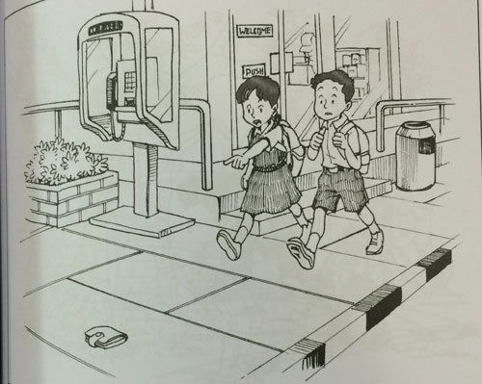

Make use of the following points in your story:
- what was on the pavement
- what the children did
- what happened in the end

You may reorder the points. You may also include other relevant points.

Sample Solution
My sister and I were walking along Wellington Avenue yesterday on the way to school, when she noticed something lying on the ground in front of us. At first I thought it was just a piece of litter and I was going to pick it up and put it in the litter bin, but as we got closer I realised that in fact, it was a wallet.

My sister picked up the wallet and turned to me with a questioning look. I glanced around the street to see if there was anyone who might have dropped it. However, at that time of the morning there were only a few children making their way to school and this brown leather wallet obviously did not belong to a young person.

We quickly realised that the only thing to do was to take the wallet to the police. Fortunately, the police station was only a few hundred metres away, and if we hurried, we could drop in there and not be late for school. Just as we had made this decision, an elderly lady came out of the convenience store in front of us. She had a very worried look on her face and she was accompanied by the store assistant. They were looking for something and we could hear the lady say "I know I had it with this morning, because I bought some bread earlier on. It must have fallen out of my bag."

"My sister approached the lady and said, "Excuse me. Have you lost something?"

It did not take long to establish that the lady had in fact lost her wallet and it was the one that we had found. With grateful thanks the lady recovered her lost wallet and we continued on our way to school. "All's well that ends well" as they say!

Question 131
QuestionID: 203
Question Type: Continuous
Question Category: Picture-Based
Theme: Outdoor Activities

Write a story based on the picture below. Your story should be at least 150 words long.
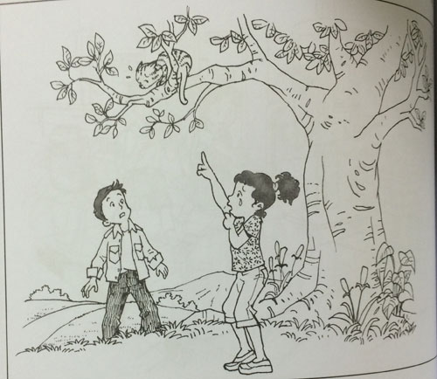

Make use of the following points in your story:
- why the young girl was crying
- what the boy did
- what happened in the end

You may reorder the points. You may also include other relevant points.

Sample Solution
David was on his way to the park the other day when he heard a little girl crying. He looked over in the direction the sobs were coming from, and saw a little girl crying at the bottom of a tree.

"What's the matter?" asked David. The little girl was so upset she could only point up at the tree. There, on one of the thin branches was a very scared-looking cat. Eventually, the girl managed to explain that her cat had been chased by a dog and had climbed the tree to escape the frightening dog. The cat had been there for at least 15 minutes and had not moved. The girl was convinced that it was stuck and could not get down on its own.

David looked at the fairly low branches on the tree and decided he could quite easily climb up to the cat and rescue it. He took off his jacket and started to hoist himself up onto the first branch. Nimbly moving from branch to branch, he approached the frightened cat, which had still not moved. He grasped the thin branch where the cat was crouched but there was a terrible creaking noise and the branch bent low. Was it going to break? David looked down at the ground, which seemed suddenly far below him. The little girl cried out and the cat sprang onto a lower branch and, before they knew it, was safely in the arms of the little girl.

David managed to get himself back down onto the ground and, leaving the ittle girl hugging her cat, and mumbling her thanks to him, he continued on his way to the park.

Question 132
QuestionID: 204
Question Type: Continuous
Question Category: Picture-Based
Theme: Characters

Write a story based on the picture below. Your story should be at least 150 words long.
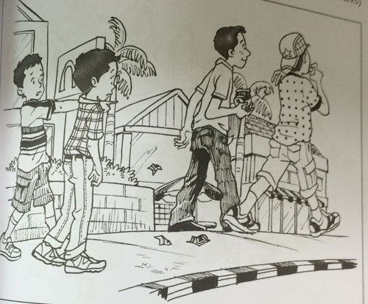

Make use of the following points in your story:
- what the other two older boys were doing
- what the two younger boys were doing
- what happened in the end

You may reorder the points. You may also include other relevant points.

Sample Solution
Last weekend, my best friend, Tom and I went to the cinema to watch a movie. At the end of the movie, Tom and I decided to walk home together.

We were happily walking along the street, talking about the movie and making plans for the following weekend when Tom suddenly nudged me.

"Look!" he said and pointed to the two teenagers in front of us. I looked but did not see anything strange. "What about them?" I asked.

"Just keep watching them," Tom insisted.

So I did. I watched them as they walked along and then saw what Tom had seen. The two of them had packets of sweets and were eating them and then dropping the wrappers onto the pavement.

"They shouldn't do that!" I said.

"I know," replied Tom. "But what can we do? They are much older than us."

Tom was right. They were older than us but this just made me angrier. Boys their age should know better.

"I know what to do," I said to Tom. "First, let's collect all their wrappers!"

Tom looked at me, puzzled, and then he smiled. We rushed back and collected all the wrappers the boys had dropped. Then we returned and caught up with the two culprits.

Tom and I looked at each other. We were both a bit nervous. I stepped forward, took a deep breathe and then tapped one of the boys on the shoulder.

"Excuse me," I said, "I think these are yours." I held out the handful of litter we had collected.

The two boys looked at each other in surprise and then turned back to us. I thought they were going to shout at us or something. But, to my surprise, they put out their hands and took their wrappers back.

"Sorry!" said one of the boys. "We just weren't thinking about what we were doing. Thank you for reminding us.

They took the wrappers over to a rubbish bin and dropped them in. Then they turned back to us.

"Here said the boy with a big smile. "Have these sweets us a reward. But don't be like us and drop the wrappers!"

Question 133
QuestionID: 205
Question Type: Continuous
Question Category: Picture-Based
Theme: Accidents and Disasters

Write a story based on the picture below. Your story should be at least 150 words long.
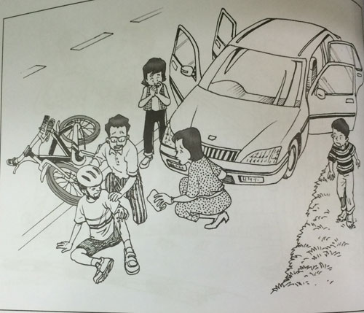

Make use of the following points in your story:
- what had happened to the cyclist
- what the family did
- what happened in the end

You may reorder the points. You may also include other relevant points.

Sample Solution
Last Saturday, my family and I were driving along a country road on the way to see my aunt, when we came across an accident. Ahead of us, on the side of the road, a young cyclist was sitting next to his bike, holding his leg and looking worried.

My father stopped the car and we all got out. My mother rushed up to the boy. She asked him if he was all right and he replied in a shaking voice that he was fine. Even so, my mother told him to go and sit in our car for a while. She gave him a drink of cold water while he explained what had happened.

Apparently, he was cycling along the road and, without any warning, he lost control of his bike. The boy fell off and hurt his leg slightly. My mother looked at the boy's grazed leg, but it was not seriously injured. My father was looking around the road to see what might have caused the accident and it was then that he noticed shards of glass. He picked up the bike and realised that the front tyre was punctured. He brought the bike back to our car and explained to the boy that he must have ridden over some of the sharp glass and that had punctured the tyre. This had caused him to lose control of his bike.

We put the bike in the boot of our car and gave the boy a lift back to his house, which was only a few kilometres out of our way. He thanked us profusely and invited us in to his house but we did not have much time, so we continued on our journey.

Question 134
QuestionID: 206
Question Type: Continuous
Question Category: Picture-Based
Theme: School and You

Write a story based on the picture below. Your story should be at least 150 words long.
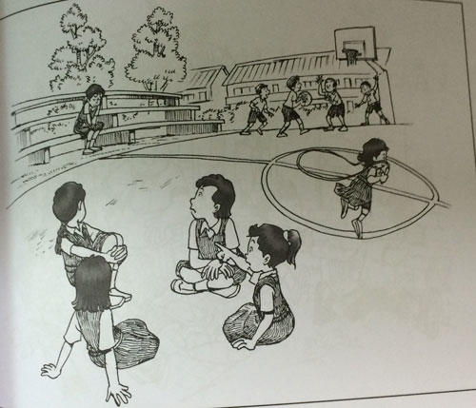

Make use of the following points in your story:
- what the four girls at the bottom of the picture were doing
- why the sad girl was alone
- what happened in the end

You may reorder the points. You may also include other relevant points.

Sample Solution
It was the first day of the new school year. When the bell went for break, we all rushed out into the basketball court to meet up with our friends and classmates again. There was a lot of noise as people cheerfully greeted each other. You could hear laughter and shouts as old friends chattered about their holidays and what they had done.

Gradually, we all settled into groups of friends. A few boys were throwing a ball around and some girls were skipping. I was with my best friends, Helen, Janet and Lily. We were excitedly catching up with each other's news when I happened to look up and see a girl sitting alone on a bench. She looked very sad and lonely. I pointed her out to my friends.

"Look at that girl. Doesn't she seem sad? I wonder what the matter is," I said to them.

"I haven't seen her before," said Helen. "Perhaps she's new."

"Do you think we should do something?" asked Janet.

"Yes," I replied firmly. "Just imagine if it was your first day at a new school and nobody talked to you!"

"You're right!" the others chorused.

We went over towards the girl. The nearer we got, the lonelier she appeared. I did feel sorry for her. I went up to her.

"Hello," I said. "My name's Sarah. What's your name?"

"My name's May," she replied timidly.

"Welcome to our school, May," I said. "Let me introduce you to my friends: Helen, Janet and Lily. We were wondering if you would like to join us."

"Oh!" May said. "That would be ever so nice. You see, I'm new and I don't have any friends yet."

"Well, you do now!" said Lily.

"Yes, you do now!" I repeated and the five of us went off together.

Question 135
QuestionID: 207
Question Type: Continuous
Question Category: Picture-Based
Theme: Accidents and Disasters

Write a story based on the picture below. Your story should be at least 150 words long.
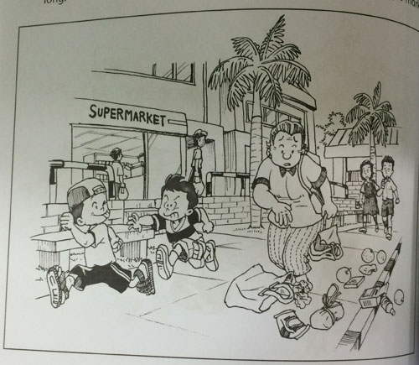

Make use of the following points in your story:
- what had happened to the old lady
- what the two children walking behind the old lady did
- what happened in the end

You may reorder the points. You may also include other relevant points.

Sample Solution
My brother and I were witnesses to an accident last week. We were coming out of a shop and in front of us an elderly lady was quietly walking along the pavement, carrying her bag of groceries. Suddenly, from out of nowhere two children appeared, apparently having a game of chase. They were weaving in and out of the shoppers, jumping over benches and generally frightening everyone. One of them swerved in front of the lady and the other was so close behind that he bumped straight into her! The lady stumbled and lost her footing. She dropped her shopping bag and the groceries spilled out over the pavement.

The two children did not even stop to see the damage they had caused, but ran off down the street.

My brother and I quickly went to the aid of the lady. My brother started to collect the groceries while I led the lady to a bench. She sat down to compose herself and she reassured us that she was unhurt, just a little shaken up. Unfortunately, the two irresponsible children had disappeared and we were unable to identify them. What a terrible thing to happen to a poor elderly lady!

Question 136
QuestionID: 1
Question Type: Situational
Question Category: Letter

The picture below show how you lost your rabbit after a “Show-and-tell” session in school where you introduced your rabbit to your class.

Imagine you are the girl in the picture.
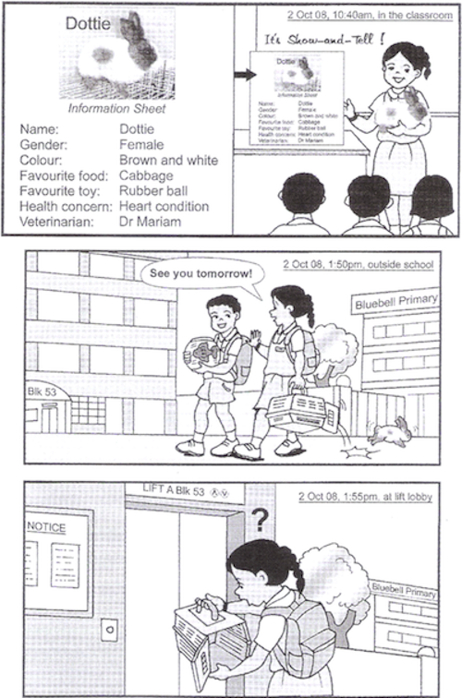

Write a letter to the residents of your neighbourhood asking them to return your rabbit to you if they see it.
You are to refer to the given pictures and information for your letter.

In your letter, include the following information:
- the date you lost your rabbit
- where you were when you found your rabbit was missing
- two physical features of your rabbit that will help people recognise her as soon as they see her
- why your rabbit is in need of care
- how you can be contacted

You may reorder the points. Write in complete sentences.

Sample Solution
Dear residents,

My name is Marianne, and I am a resident of Block 53, Ang Mio Kio Avenue 4. I am writing to appeal to anyone who has seen my pet rabbit, Dottie, who has been missing since 2 October 2008.

On that day, I was walking home from my school, Bluebell Primary carrying my pet rabbit in a cage. I had her with me as she was a subject of a “Show-and-Tell” session in school. When I reached the lobby of Lift A of my blocks of flats, I noticed that door of the cage was opened, and Dottie was not inside.

Dottie is a female rabbit, and she is brown and white. There is a brown patch on one side of her face. As she has a heart condition, it is important that she has the appropriate medical care.

Thus, I hope that anyone who has seen her will call me at 64674225 or 98765432

Thank you for your help.

Marianne Tan
3 October 2008

Question 137
QuestionID: 16
Question Type: Situational
Question Category: Email

It is now Friday evening and the end of a busy week for you

Write an email to your best friend, Tom, telling him of the busy week you have had and your plans for the weekend.

You Should refer to your weekly planner below.
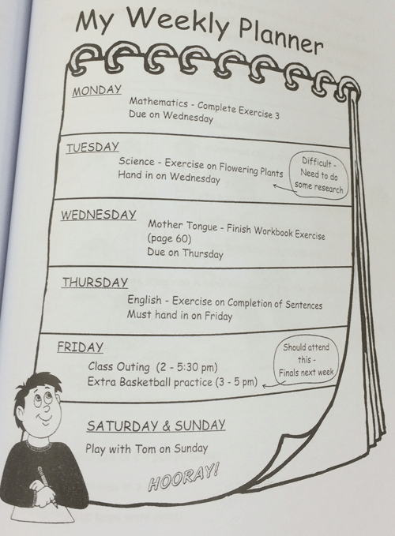

Sample Solution
Dear Tom

Greetings! I can’t believe it is already Friday! The past week has been a flurry of activities and i am glad that I finally have the chance to relax before the start of another hectic week. Let me tell you the things i have done and my weekend plans.

On Monday, I was given Mathematics Exercise 3 to complete. Although it was due on Wednesday, I decided to complete the homework on the day itself. This proved to be a wise decision challenging Science assignment on Tuesday that was also due on Wednesday. As I lacked knowledge on the topic of flowering plants, I spent many hours researching on the Internet.

On Wednesday, I had to complete a Mother Tongue workbook exercise due on Thursday. On Thursday, I was given an exercise on Completion of Sentences which i had to submit on Friday.

This morning, I found myself in a dilemma. I had to choose between attending the class outing or the extra basketball practice as their timings clashed. I was tempted to participate in the class outing from 2-5.30 p.m., which was a movie screening. It would have been a great opportunity to bond with my classmates. However, basketball finals will take place next week and the extra practice will definitely boost our chances at winning the championship. In the end, I decided to attend the extra practice from 3 to 5 p.m. as I felt that it was of great importance in this final lap of the competition.

However, the activity that i am most looking forward to is meeting you on Sunday! It has been a long time since we spent the entire day together and I am open to any suggestions as to where we can play. See you on Sunday!

Your best friend
Jack

Question 138
QuestionID: 61
Question Type: Situational
Question Category: Email

Study the pictures below carefully.

Imagine you are the girl in the pictures.

Write an email to the Manager of Bedok Public Library to inform him of the librarian's good deed.

You are to refer to the given pictures and details for your email.

In your email, include the following information:
- when you were at the library
- the name of the librarian on duty
- what you discovered at the bus stop
- how the librarian helped you
- why you could not thank her
- why you feel thankful to the librarian

You may reorder the points. You should write in complete sentences.
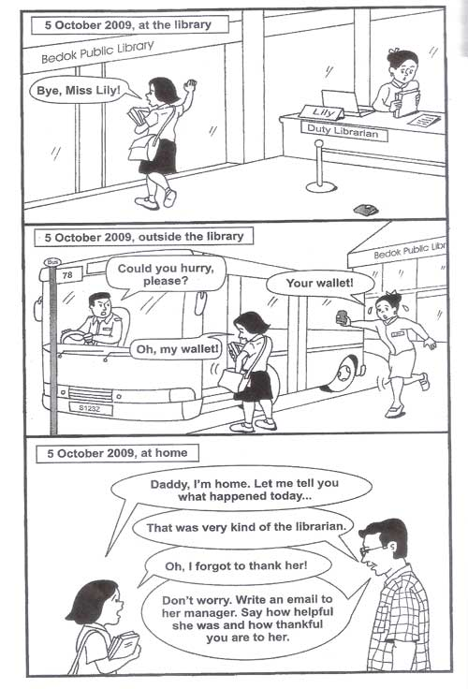

Sample Solution
Dear Manager

My name is Kristen Wong and I am a pupil of Ocean View Primary School. I am writing this email to inform you of how kind and helpful one of your staff, Miss Lily was to me.

On 5 October 2009, I was at Bedok Public Library at around 2.p.m. doing some research for my Science project. As I had difficulty searching for some books, I approached the duty librarian at the counter, Miss Lily for help. She patiently attended to me. After I had sourced the relevant books, I borrowed them, said goodbye to Miss Lily and left the library. I walked to the bus stop and my bus soon arrived. As I was about to board the bus, I realized that my wallet was missing from my bag. I became flustered and panicked. Just then, Miss Lily came running towards me with my wallet in her hand. She noticed a wallet on the floor after I left the library and had chased after me, guessing that it was mine. As the bus was about to leave, I forgot to thank her as I hurried up the bus after getting my wallet back.

I would like to commend Miss Lily on her act of kindness as well as to express my gratitude for finding my wallet and taking the trouble to come after me to return it. Once again, I would like to convey my heartfelt appreciation towards Miss Lily and commend her for her actions.

Yours sincerely
Kristen Wong

Question 139
QuestionID: 62
Question Type: Situational
Question Category: Email

During recess, you and your friends discussed what birthday gift to buy for Sally.
You took notes during the discussion. Study the pictures below carefully.
Imagine you are Ben.

Write an email to Roy to tell him of the choice of the gift.

You are to refer to the given information for your email.

In your email, include the following information:
- what you and your friends decided to buy for Sally
- why Sally would find the gift useful
- who disagreed to buying a watch and why
- why Devi thought a purse was not a good idea
- how you and your friends would not make the gift special

You may reorder the points. Write in complete sentences.
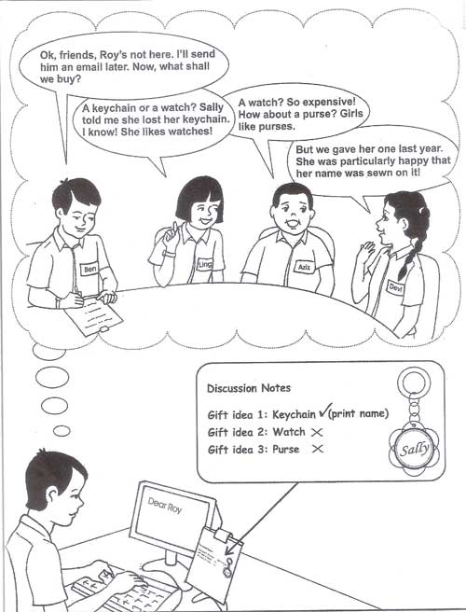

Sample Solution
Dear Roy

While you were at the librarians; meeting during recess today, the others and I had a discussion regarding what to buy for Sally’s birthday next Tuesday. We have decided to buy her a keychain as a birthday gift.

A keychain, which was Ling’s suggestions, would be an ideal gift as Sally had told Ling that she had lost her keychain. Thus, this would be a practical gift for her as she can use it. Ling also suggested a watch but Aziz was opposed to the idea as he felt it would be too expensive. He proposed buying a purse as he felt that girls would like purses but Devi was not inclined towards that idea as we had already given her a purse the previous year.

In the end, we decided to buy a keychain. Since Devi noted that Sally was especially happy when the purse that she received from us last year had her name sewn on it, we will have her name engraved on the keychain to make the gift more special and special and personalized. We will be going to Riverview Shopping Centre on Friday after school to buy the gift. Would you like to join us? Do let me know.

Regards
Ben

Question 140
QuestionID: 63
Question Type: Situational
Question Category: Email

Your school library will be organising a library festival. Shown below is an information sheet on the event with some notes you have made on it.

Your classmate, Chris, has been unwell and will be away from school for a few more days. Chris has not seen the information sheet yet.

Write an email to inform Chris about the event.

You are to refer to the given information.

In your email, include the following information:
- the name of the event
- what Primary Six pupils need to do to take part in the event
- the venue for 'Write a story competition' and what to bring for the activity
- one activity which both of you are likely to take part in and why

You may reorder the points. Write in complete sentences.
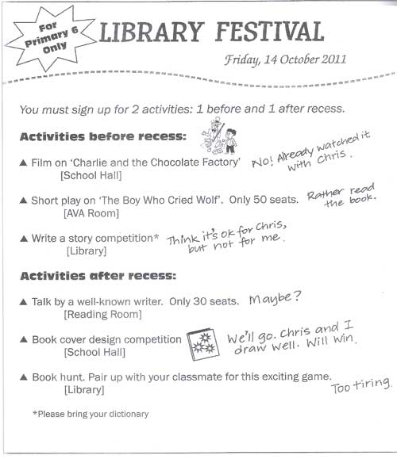

Sample Solution
Dear Chris

How are you? Hope you are feeling better. I am writing this email to inform you o the Library Festival, an event only for Primary Six pupils organized by our school library on Friday 14 October 2011.

Primary Six pupils have to sign up for two activities, one before and one after recess for the event. One activity which I think might be suitable for you would be the ‘Write a story competition’ which will be held in the library before recess. Participants have to bring their dictionary for this activity.

One activity that I think will be suitable for both of us to participate in would be the ‘Book cover design competition’. This will be held in the school hall after recess. As both of us are artistically inclined and can draw well, I think we will stand a good chance of winning the competition.

Do let me know what you think. I hope to see you in school soon.

Regards
Nicholas

Question 141
QuestionID: 64
Question Type: Situational
Question Category: Letter

The pictures below show what Amy Tay did after she saw what happened to a boy in school.

Imagine you saw what happened in the pictures.

Write a letter to your Principal, Mr Raj, requesting him to include in the assembly talk what Amy Tay did.

You are to refer to the given information for your letter.

In your letter, include the following information:
- the date you saw what happened
- what Amy told the boy not to do, and why
- what Amy immediately did for the boy
- the advice Amy gave the boy about his worksheet
- one important value that pupils can learn from Amy

You may reorder the points. Write in complete sentences.
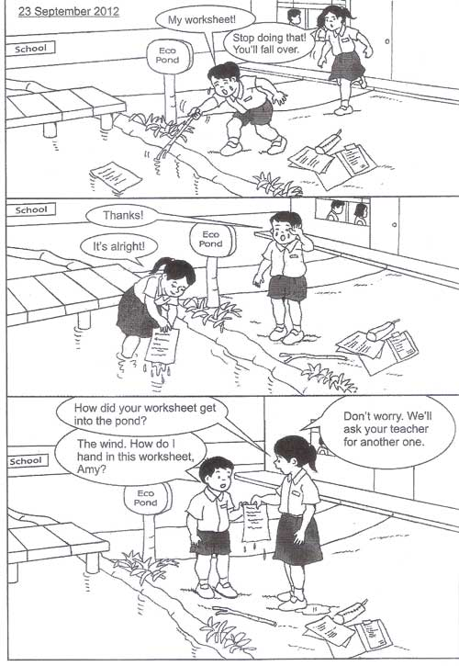

Sample Solution
Dear Mr Raj

I am Leanne Teoh of Primary 6A. I am writing this letter to inform you of what one of the pupils in my class, Amy Tat did. I hope that you can mention it in your assembly talk next week.

On 23 September 2012, I was walking towards the school gate after lesson had ended. As I was walking past Eco Pond, I saw a lower primary male pupil in tears trying to retrieve his worksheet which had fallen into the pond. At the moment, Amy came rushing up to him and asked him to stop in case he might fall over. She then proceeded to wade into the pond to retrieve the worksheet for him.

As Amy handed the worksheet to the boy, he thanked her for her help and explained that the wind had blown his worksheet into the pond. He then asked Amy how he should hand in the worksheet since it was already wet. Amy told him not to worry and told him that she would accompany him to ask his teacher for another one.

I feel that all pupils of the school can learn from Amy’s actions and that we that we should all strive to help our fellow schoolmates whenever they are in need of help. Thus, I hope that you can commend Amy’s actions since she is a role model for us to follow.

Yours sincerely
Leanne Teoh

Question 142
QuestionID: 65
Question Type: Situational
Question Category: Email

Study the pictures below carefully.
Imagine you are Mary, the president of the club.

Write an email to Mrs Choo to request her help.

You are to refer to the given information for your email.

In your email. include the following information:
- which club you belong to
- the purpose of the camp
- when and where the camp will be held
- what specific help you need from Mrs Choo
- when Mrs Choo need to reply to you

You may reorder the points. Write in complete sentences.
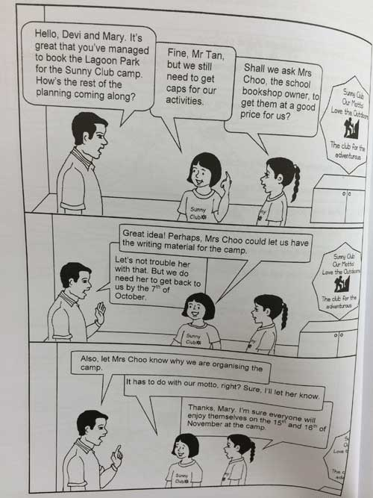

Sample Solution
Dear Mrs Choo

I am Mary Tan, the president of the Sunny Club. I am writing this email as I need some help from you and hope you will be able to assist us.

My club is organising a camp for members to cultivate a love for the outdoors. It will be held on the 15th and 16th of November at Lagoon Park. We need to purchase caps for our camp activities and hope you will be able to get them at a good price for us.

I would appreciate it if you could get back to me by the 7th October. I look forward to your favourable reply.

Yours sincerely
Mary

Question 143
QuestionID: 79
Question Type: Situational
Question Category: Report

Police Report – Witness At an Accident Scene

You have jut witnessed an accident along a major road near your home. Write a report about what you have seen to submit to the police. In your report, include the following points:

- the time of the accident
- where the accident happened
- what you were doing at the time
- how the accident happened
- what you did / how you reacted

You may reorder the points. You should write in complete sentences.

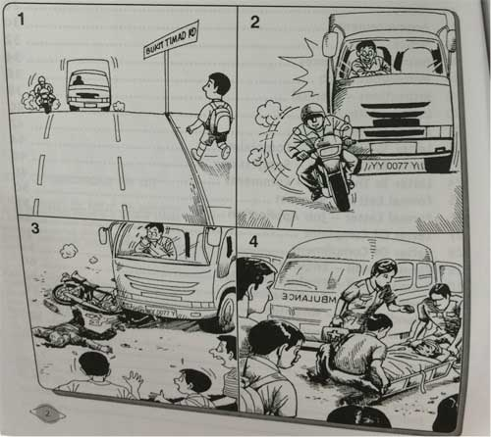

Sample Solution
It was 3 p.m. I was walking along Bukit Timah Road, on my way home from school.

Suddenly, I noticed a huge truck (YY 0077Y) speeding down the road. At the same time, a young motorcyclist was crossing the lanes into the path of the truck. I heard a loud screeching sound. Within seconds, there was a loud crash. The truck has slammed into the motorcycle. The motorcycle was caught under the front wheel of the truck. The motorcyclist flew off the bike and landed a distance away. There was blood all around him.

I quickly ran towards him and helped two other male passers-by to turn him over, but there were no more signs of life in him. The ambulance arrived 10 minutes later and he was pronounced dead.

Question 144
QuestionID: 80
Question Type: Situational
Question Category: Report

Police Report – Witness At A Crime Scene

You were shopping with a friend at the busy HDB Hub. There, you witnessed a crime in action.

Write a police report about what you saw.

In your report, include the following points:
- the time of day
- who you were with
- what you were doing at the time
- what you saw

You may reorder the points. You should write in complete sentences.

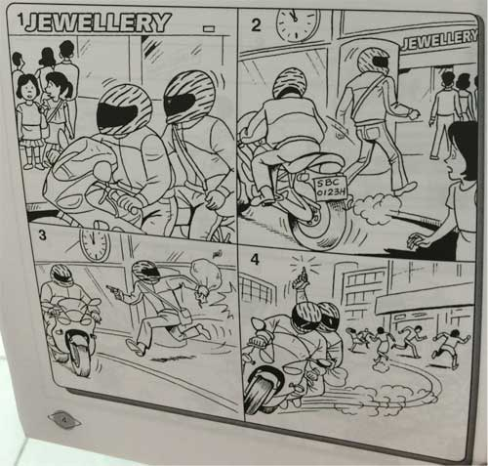

Sample Solution
It was about 11 a.m. I was shopping at the HDB Hub with my friend, Mei Fong.

We were just passing by the Poh Kim Jewellery shop when a motorcycle with a pillion rider stopped right in front of us. Both the motorcyclist and the pillion rider were men. They both wore black leather jackets, faded jeans, black boots and dark sunglasses. Both had striped helmets on their heads. The motorcyclist was small and fat, while the pillion rider was tall and skinny.

The pillion rider got off the motorcycle and went into the jewellery shop, and the motorcyclist rode away. I saw that the number plate of the motorcycle was SBC 0123H.

About 5 minutes later, the pillion rider came running out of the shop. He was stil wearing his helmet and dark glasses. He had a sack in one hand and a pistol in the other. At the same time, the motorcycle came speeding back to the shop. The pillion rider hopped onto the motorbike and fired a shot into the air with his pistol. Everyone ran out of their way, and they sped away. That was the last time I saw them.

Question 145
QuestionID: 81
Question Type: Situational
Question Category: Email

Below is an article from a newspaper.

Your friend lives in the area where the flood occurred.
Write an email to enquire about your friend and tell your friend what you have found out from the article.

You should refer to the article.
Include the following information in your email:

- What happened to your friend's house
- how many people are affected
- how your friend;s life has changed
- what your friend and her family plan to do
- how you intend to help your friend

You may reorder the points. You should write in complete sentences.

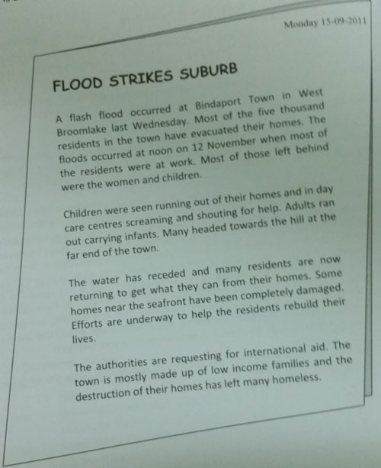

Sample Solution
Dear Kelly,

I found out from the newspaper that a flash flood occurred in your hometown, Bindaport Town in West Broomlake, last Wednesday. How are you and your family? I hope everyone is all right.

I read from the newspaper that most of the residents in your town have evacuated their homes and houses along the seafront were completely damaged. I remember your house was quite near the sea. Has it been badly damaged? The article mentioned that five thousand residents have been affected. Are there any fatalities? What do you and your family plan to do now? Did you manage to salvage most of your belongings?

Do write and tell me more about your plans. My family and I would like to help you. We were thinking of sending some daily necessities like soap and towels, as well as food, like rice and canned food. Do write and let us know what you need. Hope to hear from you soon.

Love,
Isabel

Question 146
QuestionID: 82
Question Type: Situational
Question Category: Report

Police Report – Stolen Properties

Imagine you were at a busy shopping area yesterday. The following shows what happened while you were there.

Write a report for submission to the Police about your missing mobile phone.
In your report, indicate:
- where you have been
- the time of day
- what you did with the phone
- when you last saw the phone
- when you discovered the phone was missing
- what else you have discovered

You may reorder the points. You should write in complete sentences.

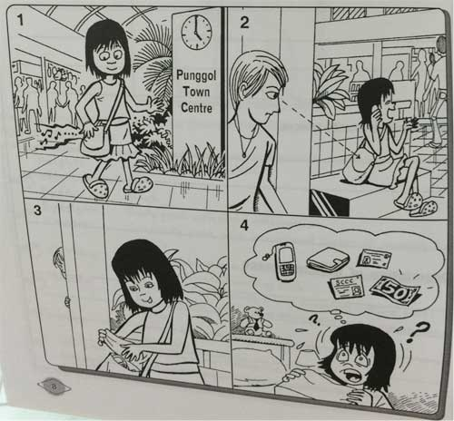
Sample Solution
I was walking through Punggol Town Centre at about 5 p.m. yesterday. My mobile phone, which was in my bag, rang. I took it out and answered it. After that, I threw it back into my bag. That was the last time I saw it.

When I got home, I discovered that my bag had been slit open. My mobile phone and my wallet were missing. Inside my wallet were my Identity Card, a $50-note and my ‘SCCC’ card.

Question 147
QuestionID: 83
Question Type: Situational
Question Category: Report

Police Report – Lost Property

Imagine you are making a police report on your lost wallet the next day. Use the pictures below to help you write your report. In your report, indicate:
- where you were (going)
- the time of day
- what bus you took
- where you alighted
- when you discovered the loss
- what you had in your wallet

You may reorder the points. You should write in complete sentences.

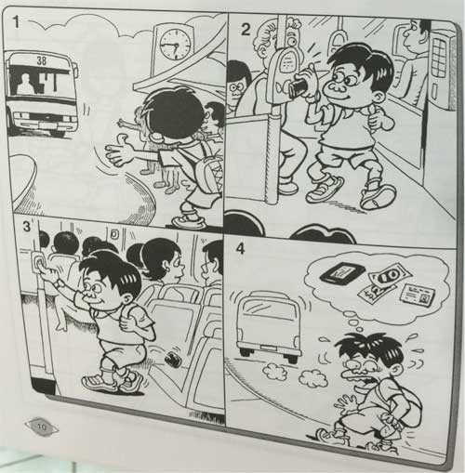
Sample Solution
I was going home after school yesterday at about 6.45 p.m. Bus number ‘38’ came and I boarded it, along with many other of my fellow students. I scanned my EZ-link card, which was in my wallet, and then put my wallet in the pocket at the back of my shorts. Then I found a seat on the bus and sat there until I reached the bus stop near my home.

After I alighted, I reached for my back pocket expecting my wallet. To my horror, I discovered that my wallet was not there and the bus had already drove off. I had $12 and my Student Pass in the wallet.

Question 148
QuestionID: 84
Question Type: Situational
Question Category: Report

Sales Report

Your school has just had a one-day flea market to raise funds for a new extension. Together with a few of your classmates, you were placed in charge of a stall selling several food items. You are required to report on the sales of the items and make recommendations for the next fund-raising event. The following is a compilation of the sales figures you have recorded during the flea market. Make use of it to write a sales report for submission to your teacher.

In your report, include:
- the kinds of items you sold at the stall
- the cost and sales price of each item
- the amount of money you collected for each item
- the profit (or loss) made for each item
- your conclusion and recommendations

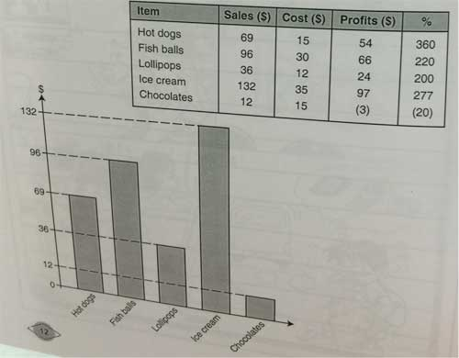

Sample Solution
During the June 2008 flea market, my team was placed in charge of the stall selling hot dogs, fish balls, lollipops, ice cream and chocolates.

The sale proceeds collected were as follows:
Hot dogs: $69
Fish balls: $96
Lollipops: $36
Ice cream: $132
Chocolates: $12

The hot dogs and ice cream were sold at $1 per piece while the fish balls, lollipops and chocolates were sold at $1 for 3 pieces each. The profits made were: $54 (360%) for hot dogs, $66 (220%) for fish balls, $24 (200%) for lollipops, $97 (277%) for ice cream and -$3 (-20%) for chocolates.

Thus, in terms of percentage, the item which made the most profit was the hot dogs, followed by ice cream and fish balls. The least saleable item was chocolates. (The sales proceeds from chocolates did not cover the cost.)

From the above figures, we have concluded that hot dogs, ice cream and fish balls are the favourite items. They are also the most profitable items. Less people are willing to buy lollipops and chocolates.

Question 149
QuestionID: 85
Question Type: Situational
Question Category: Report

Your Science teacher, Mrs Lim is about to start an enrichment class for the students in your level. Imagine that you are Kelly, the Science Representative for your class, and that you have been asked by Mrs Lim to help do a review on some new assessment books in the market, for the purpose of choosing one for use during the enrichment class. Below are the notes you have taken as you go through the books.

Write a report to your teacher on your review.

In your report, include:
- the titles of the books you were reviewing
- the price of the books
- your feeling about the books
- your conclusion and recommendation
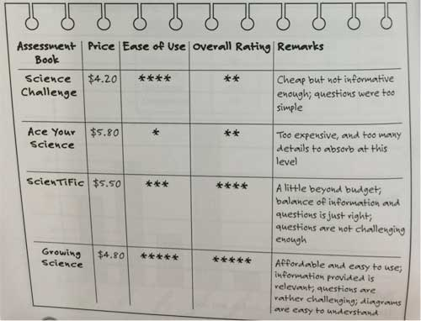

Sample Solution
To: Mrs Lim

Review of Science Assessment Books

A total of four new Science assessment books are being reviewed: Science Challenge, Ace Your Science, ScienTiFic and Growing Science.

Of the four books, Science Challenge is the cheapest, selling at $4.20, but it is not informative enough, and I find the questions too simple.

Ace Your Science is the most expensive, at $5.80, and I find that it has too many details to absorb at this level. It is the most difficult to use.

ScienTiFic is a little beyond budget, at $5.50, but is relatively easy to sue. However, compared to the other books, it has just the right balance of information and questions.

Nevertheless, I feel the questions are not challenging enough for this level.

Growing Science, at $4.80, is both affordable and very easy to use. The information provided is relevant for this level. The questions are also rather challenging and the diagrams are easy to understand.

Conclusion and Recommendation

Based on the above findings, I conclude that Science Challenge and ace Your Science are not suitable for our use. Between ScienTiFic and Growing Science, the latter is more affordable and relevant.

I therefore recommend that we use Growing Science for the enrichment class.

Submitted by: Kelly

Question 150
QuestionID: 86
Question Type: Situational
Question Category: Report

Imagine that you are Carol. You have been assigned to do a Science experiment with three other friends, Jaclyn, Joseph and Kane. The following is a chart your group members have drawn up based on the results of the experiment.

Objective:
To find out if plants lose water through their leaves

Materials:
2 clear plastic bags, sticky tape, a growing plants, plastic plate, timer

Method:
1. Tape a clear plastic bag around some leaves of a growing plant. Make sure the bag is closed tight. Leave the plant in the sun.
2. Fill the other plastic bag with air and close it tight, then tape it to the plastic plate to keep it from flying away. Put the plate and bag next to the plant.

Below is the Observation chart.

Other observations:
1. The bag of air remained unchanged throughout the experiment.
2. The bag around the leaves got foggier and foggier as time passed. The droplets of water in the bag also became bigger and bigger.
3. The leaves inside the bag were wet with water. The other leaves were dry.

Write a report for your Science teacher, Mr Soon, based on your observations. In your report, include the following:

- what your experiment was about
- the materials you used
- how the experiment was done
- how often you made the observations
- your observations
- your conclusion

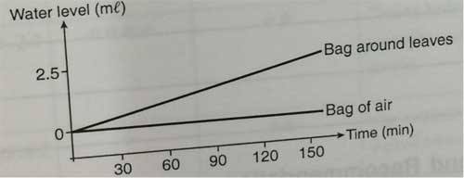

Sample Solution
To: Mr Soon

Experiment to Find Out Whether Plants Lose Water through Their Leaves

For our experiment, we used two clear plastic bags, sticky tape, a growing plant, a plastic plate and a timer.

First, we taped a clear plastic bag tightly around some leaves of the plant. The pant was them left in the sun.

Next, we filled the other plastic bag with air and closed it tight. Then we taped it to the plastic plate to keep it from flying away. The plate and bag were then placed next to the plant.

After every 30 minutes, we checked on the plant and observed that the bag around the leaves got foggier and foggier. There were water droplets in the bag, and they got bigger and bigger. All this while, the bag with the air in it remained unchanged.

After 2 ½ hours, we stopped the experiment and removed the bag from around the leaves. The leaves that had been wrapped in the bag were wet, while the other leaves remained dry. We measured the water in the bag and found that it was about 2.5 ml.

Conclusion

By wrapping the bag around the leaves, the water is trapped so that it could not evaporate, resulting in the leaves being wet.

From the experiment, we conclude that plants do lose water through their leaves.

Report submitted by:
Carol, Jaclyn, Joseph and Kane

Question 151
QuestionID: 87
Question Type: Situational
Question Category: Review

Book Review

Your teacher requires you to write a review about a book that you have read during the school holidays. You have just read the book from ‘The Chronicles of Narnia’ = ‘The Lion, The Witch And The Wardrobe’ written by C.S. Lewis, and decide to write a review on it. The following are some notes you have jotted down about the book. Use them to write your review. In your review, include the following points:
- who wrote the story
- what the story is about
- what you have learnt from the story
- what you like/dislike about the story
- whether you would recommend it to anyone else.

You may reorder the points. You should write in complete sentences.
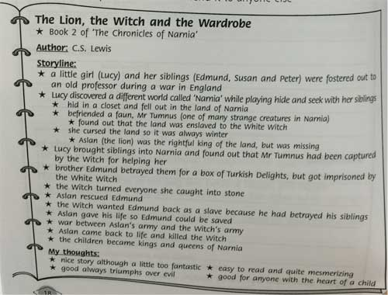

Sample Solution
Book Title: The Lion, the Witch and the Wardrobe

Author: C.S. Lewis

Story:
The story is about a little girl (Lucy) and her siblings (Edmund, Susan and Peter) who discovered a different world called ‘Narnia’ while playing hide and seek.

It all started with Lucy, who had gone into a quaint looking wardrobe to hide, but fell out in the wintry land of Narnia. There, she befriended a faun, one of the many strange creatures in Narnia, and found out that the land was enslaved to the White Witch, and was under her curse, so it was always winter in Narnia. Aslan (the lion), who was the rightful king of the land, was nowhere to be found.

Lucy later brought her siblings into Narnia, where she discovered that her friend had been captured by the White Witch. Her brother Edmund betrayed them for a box of
Turkish Delights, but got imprisoned by the White Witch instead. Through a series of dangerous trials, Lucy and her siblings finally found Aslan.

Aslan rescued Edmund, but the White Witch wanted him back as a slave because he had betrayed his siblings. Aslant gave his life so Edmund could be saved. War then broke out between Aslan’s army and the Witch’s army. Finally, by some miraculous power, Aslan came back to life and killed the Witch, and the children became kings and queens of Narnia.

Remarks:

The moral of the story is that good always triumphs over evil. The book is easy to read and the story is quite mesmerizing, although a little too fantastic. I would recommend it to anyone who has the ehart of a child.

Question 152
QuestionID: 88
Question Type: Situational
Question Category: Summary

Summary

Below is a passage you have just read. You find it interesting and wish to share it with your brother. Unfortunately, he is too busy to read it. Write a summary of the passage in a maximum of 100 words, so that your brother can read it and understand your concerns.

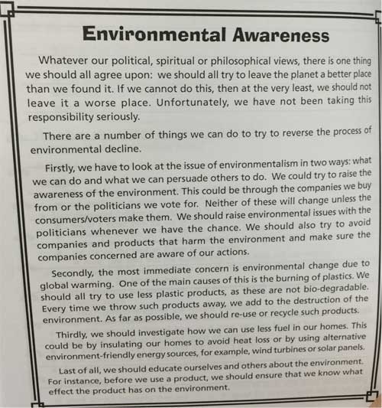

Sample Solution
We should all either try to leave the planet a better place than we found it or not leave it a worse place.

Firstly, we can try to reverse the process of environmental decline by doing what we can and persuading others to do the same.

Secondly, we should try to use less plastic products, as these are not bio-degradable. As far as possible, we should try to re-use or recycle such products.

Thirdly, we should use less fuel in our homes, or use alternative environment-friendly energy sources.

Finally, we should educate ourselves and others about the environment.

Question 153
QuestionID: 89
Question Type: Situational
Question Category: Advertisement

Advertisement For The Notice Board

Your mother has a portable Chillo air-conditioner that is almost as good as new. It has dimensions of 914mm X 508mm X 419mm and a power of 18000 BTU. It comes with a remote control and is fairly easy to operate. After buying it, she finds that the family does not need it after all. As it has been almost a year since she purchased it, she has decided to sell it off at 30% discount off the price she paid for it (S900). As she is very busy, she has asked you to help her write an advertisement to post on the common notice board of your flat. Below is her business card.

In your advertisement, include:
- the caption
- a catchy phrase or sentence to attract attention
- a short description of the air-conditioner
- the price
- the person to contact
- the contact number



Sample Solution
Portable Air-conditioner for Sale

Is the weather getting unbearable for you? Don’t you wish you could enjoy the coolness of an air-conditioner without having to visit the shopping mall? Here’s the good news:

Get a ‘brand new’ Chillo portable air-conditioner that is fairly easy to operate! Measuring only 914 mm x 508 mm x 419 mm, it has a power of 18,000 BTU and comes complete with a remote control.

Price: $630 ONLY!

If you are interested, please contact:

Jasmine

7-321-1234

Question 154
QuestionID: 90
Question Type: Situational
Question Category: Advertisement

Advertisement For the Newspapers

Below is an Advertisement taken from a newspaper.

Imagine that you are Jason. Write an advertisement to sell your puppies, for posting in the newspapers. In your advertisement, include:
- the caption
- a catchy phrase or sentence to attract attention
- a short description of the puppies
- the price
- your name and telephone number.
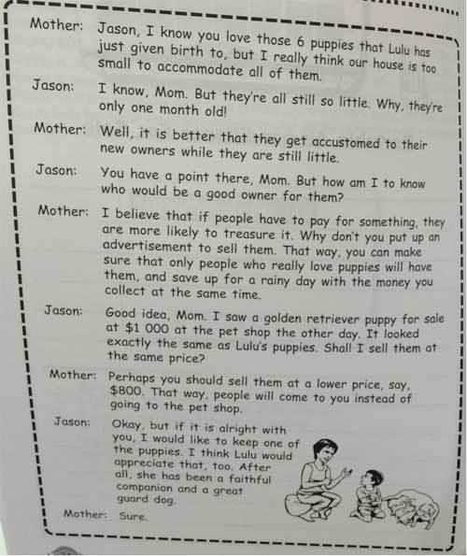

Sample Solution
Puppies for Sale!

If you’re looking for a faithful companion, look no further!

Five 1-month-old golden retriever puppies selling at $800 each. They are very adorable and fun to play with when they are little, and make great guard dogs and faithful companions as they grow older. This will be the best investment you will ever make!

If you are interested, please contact Jason at 7-301-9876

Question 155
QuestionID: 91
Question Type: Situational
Question Category: Notice

Notice – Lost Pet

Your faithful dog, Lulu, a white fluffy Maltese, has gone missing. You have searched for two days and are getting desperate. You decide to put up a “Lost Pet” notice. Below is a page from your diary.

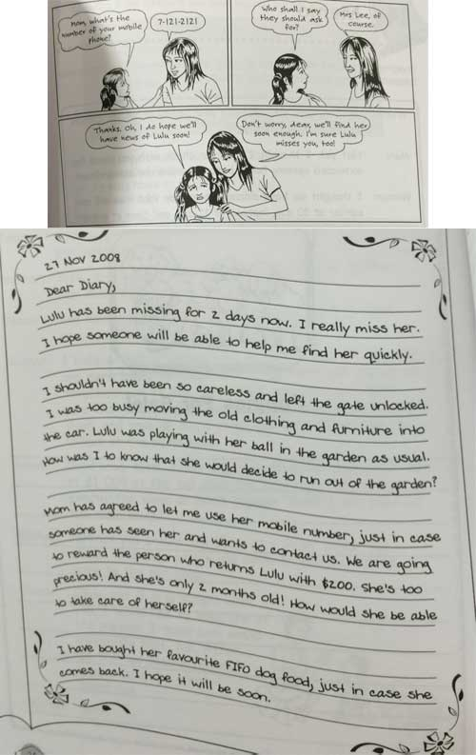

Sample Solution
Reward: $200

White, fluffy Maltese, 2 months old.
Responds to ‘Lulu’.

If found, please contact: Mrs Lee
Telephone: 7-121-2121

Question 156
QuestionID: 92
Question Type: Situational
Question Category: Email

Below is a brochure from the Singapore Zoo.

You want to celebrate your birthday at the zoo.
Write an email to enquire more about having a party at the zoo.

You should refer to the brochure.

Include the following information in your email:

- which part of the zoo can the party be held at
- if there is a discount for larger groups
- where the food is catered from
- if adults need to be present at the party
- what is in the gift bags

You may reorder the points. You should write in complete sentences.

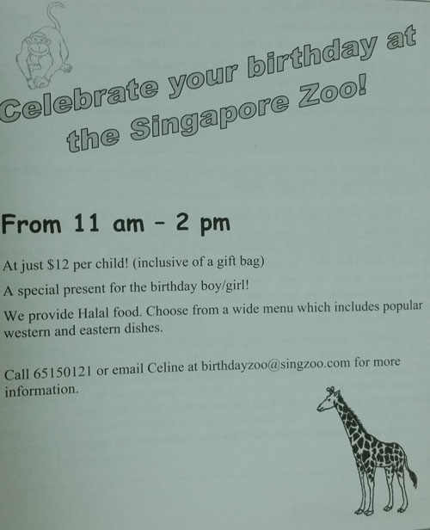

Sample Solution
Dear Celine,

I am interested in celebrating my birthday at the zoo. I have read the brochure and would like to obtain more details about have a party at the zoo.

Which part of the zoo can the party be held at? Will there be a discount for larger groups? I intend to have about thirty guests. The brochure states that there will be Halal food. May I know where the food is catered from? Is it necessary for adults to be present at the party as well? According to the brochure, there will be a gift bag for each child. May I know the contents of the gift bag?

I hope to hear from you soon. You can reply at this email address or contact me at 97429742. Thank you.

Yours sincerely,
James

Question 157
QuestionID: 93
Question Type: Situational
Question Category: Announcement

Announcement

Imagine you are working at the information counter of a big shopping mall. Currently, the mall is having a 3-day ‘free gift’ promotion (from 20 Feb to 22 Feb) in which every shopper who produces a receipt for more than $50 purchase at the mall gets a free designer mug.

Unfortunately, the response has been overwhelming and you have run out the mugs within a day. Below is a memo you have just received from the mall’s management.

Due to a bout of flu, you have lost your voice and are unable to make the announcement. Write out the announcement for your part-time helper. In the announcement, include:
- what happened to the designer mugs
- what the shoppers can do (when and how) to redeem their mugs
- how the Management feels about the arrangement

You may reorder the points. You may also include other relevant points.

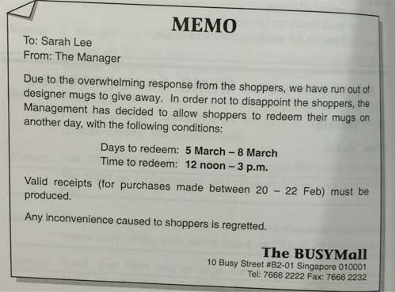

Sample Solution
Dear Shoppers,

Due to the overwhelming response, we have currently run out of the designer mugs for give-away. However, you may still redeem your free designer mug from 5 to 8 March, between 12 noon and 3 p.m. Valid receipts for purchases made between 20 and 22 Feb must be produced when redeeming the mug.

We apologise for any inconvenience caused.

Question 158
QuestionID: 94
Question Type: Situational
Question Category: Notice

Notice

Imagine you are the manager of the ‘Towering Heights’ condominium. Following a consensus during the last Annual General Meeting on 31 July 2008, you have arranged to have all the common water pipes changed. Below is the schedule you have worked out with the contractor, Beta Water Pte Ltd.

As advised by the contractor, the water supply to the affected blocks will be cut off at the schedule time. Residents of the affected blocks will have to store enough water for their use before the work on the pipe replacement begins.

Write a notice to post on the common notice board of the condominium.

In your notice, include:
- the reason for the cessation of water supply
- the blocks affected and the dates and time for the works
- what the residents have to do
- how the management feels about the inconvenience caused to the residents

You may reorder the points. You should write in complete sentences.

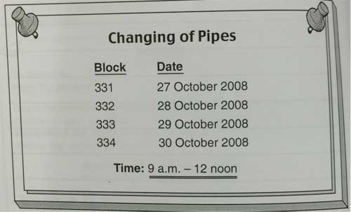

Sample Solution
Dear Residents,

Please be informed that the common water pipes of this condominium will be changed as follows:

Block Date
331 27 October 2008
332 28 October 2008
333 29 October 2008
334 30 October 2008

Time: 9 a.m. to 12 noon

In order to facilitate the change of pipes, the water supply to the affected blocks will be cut off at the scheduled time. Kindly ensure that sufficient water for your use is stored before the time of the scheduled works.

The Management
MCST No. 0099

Question 159
QuestionID: 95
Question Type: Situational
Question Category: Instruction

Instructions – Chores

Your mother has just employed a new foreign domestic helper. She is from the village and has never operated any modern machinery in her life. Now, she is nervous about having to operate the various machines in your home. On top of that, she is worried that she will forget what things she has to prepare for you because of certain special requirements based on your school schedule.

Draw up an instruction sheet to help her remember what she has to do on which day.

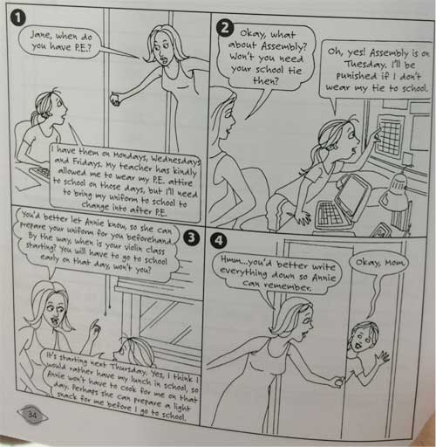

Sample Solution
Dear Annie,

Please remember to:

1. Prepare my P.E. attire on Monday, Wednesday and Friday. Please fold my uniform neatly and put it in a plastic bag for me on those days;

2. Get my school tie ready on Tuesday;

I will be going to school early on Thursday, so you need not cook lunch for me on that day. Do prepare a light snack for me before I go school, though.

Thank you.
Jane

Question 160
QuestionID: 96
Question Type: Situational
Question Category: Note

Instructions – Job

Imagine that you are working as a customer service officer at a big toy shop. You have to go on urgent leave the next day but need to get some things done. Below are some notes you have taken down about your duties for the next day:

Leave a note for the officer covering your duties, Louise, to instruct her about the things to do while you are absent.

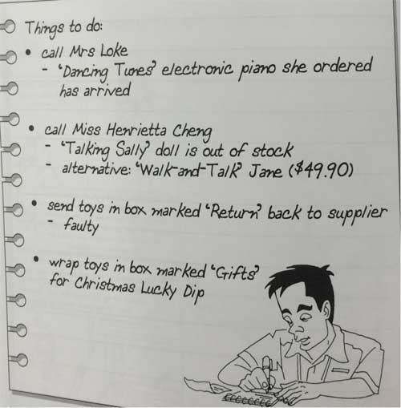

Sample Solution
Dear Louise,

Please take care of the following while I am out of the office:

1. Call Mrs Loke and tell her that the ‘Dancing Tunes’ electronic piano she ordered has arrived;

2. Call Miss Henrietta Cheng and inform her that the ‘Talking Sally’ doll is out of stock. Ask her if she would like to buy the ‘Walk-and-Talk’ Jane at $49.90 instead;

3. Send the toys in box marked ‘Return’ back to the supplier as they are faulty;

4. Wrap the toys in box marked ‘Gifts’ for the Christmas Lucky Dip.

Thank you.
Jerry

Question 161
QuestionID: 97
Question Type: Situational
Question Category: Instruction

Instructions – Manual

Below is a page from the instruction manual for a washing machine.

It is too complicated for Tessie, the new foreign domestic worker that your mother has just employed. Simplify it and write a new set of instructions for her so that she can understand how to operate the washing machine more easily.

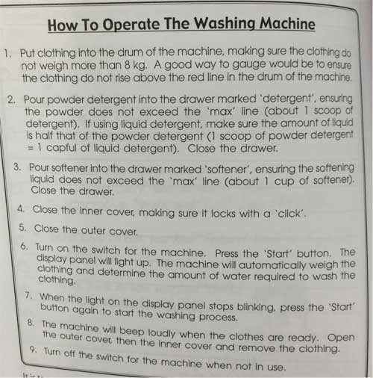

Sample Solution
How to Operate the Washing Machine

1. Put the clothing into the drum of the machine. (The clothing must not rise higher than the red line in the drum.)

2. Pour 1 scoop ‘Spin-off’ detergent into the drawer marked ‘Detergent’ and close the drawer.

3. Pour 1 cup ‘Soffit’ softener into the drawer marked ‘Softener’ and close the drawer.

4. Close the inner cover. (Make sure it is locked with a ‘click’)

5. Close the outer cover.

6. Turn on the switch for the machine.

7. Press the ‘Start’ button and wait for the light on the display panel to stop blinking, then press the ‘Start’ button again.

8. When the clothes are ready, the machine will beep loudly.

9. Take the clothes out and turn off the switch.

Question 162
QuestionID: 98
Question Type: Situational
Question Category: Letter

Letter – Instructions

Imagine you have just shifted to a new apartment. Below is your address.

Currently, you are subscribing to a magazine, ‘Kidophrenia’. Your subscriptions number is KP-331. You need to inform the magazine distributor (Mega-Zeens Pte Ltd) to direct the magazine to your new house. Moreover, because you are going to migrate to America in Jan 2009, you need to stop your subscription after the December issue. As you have already paid for the subscription up to June 2009, you need to obtain a refund from the magazine distributor.

Write a letter to the Director (Customer Service) of the magazine distributor with your instructions. In your letter, indicate:
- where to direct the magazines to
- when to send the magazines to a new place
- your reason for terminating the subscription early
- when to stop the magazines subscription
- what you expect from the magazine distributor

You may reorder the points. You should write in complete sentences.

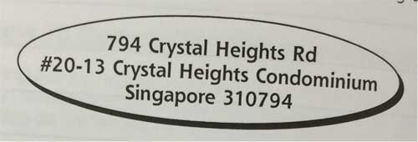

Sample Solution
To: The Director (Customer Service)
Mega-Zeens Pte Ltd

Dear Sir,

Re: Change of Address and Early Termination of Subscription

I refer to my subscription of the ‘Kidophrenia’ magazine (subscription number: KP-331).

Please be informed that my new address is:
794 Crystal Heights Rd
#20-13 Crystal Heights Condominium
Singapore 310794

Kindly direct all magazines to the above address with immediate effect.

As I will be migrating to America in Jan 2009, I wish to terminate the subscription with effect from 1 Jan 2009. Please give me a refund of the monies paid for the subscription from January to June 2009.

Thank you.

Sincerely,
Catherine

Question 163
QuestionID: 99
Question Type: Situational
Question Category: Email

Below is an advertisement at a community club.

You find the course very interesting.
Write an email enquiring more about the course.

You should refer to the advertisement.

Include the following information in your email:

- what the class size is
- how to sign up for a trial lesson
- differences and similarities with other Math courses
- when the lessons will be held
- how the lessons are taught

You may reorder the points. Remember to write in complete sentences.

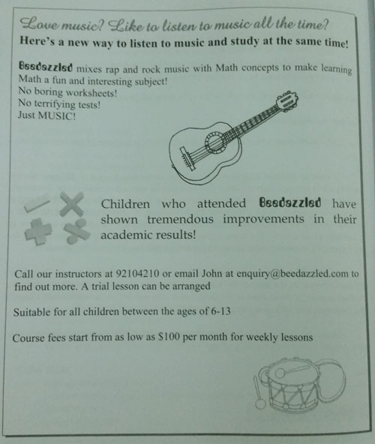

Sample Solution
Dear John,

I found out about your course from an advertisement at the community dub and am intrigued. I would like to find out more about the lessons.

What is the class size? From the advertisement, I understand that it is different from other Math classes because there are no worksheets or tests. Music is certainly a great pull. It is a novel way to introduce Math concepts to children. Are there any similarities to the usual Math classes? Please tell me more about how the lessons will be taught. Where will these classes be held? Lastly, how do I sign up for a trial lesson?

I hope to hear from you soon. You may contact me at this email or at 90145612. Thank you.

Yours sincerely,
James

Question 164
QuestionID: 100
Question Type: Situational
Question Category: Letter

Letter to the Press – Complaint

Lately, your housing estate has become very hot. The trees that used to line the street have been chopped down after complaints by some neighbours about the noise caused by some roosting crows. Unfortunately, the chopping down of the trees not only did not solve the problem, as the crows have decided to settle on the rooftops, but also gave rise to some other problems, like the damage to the scenery, the unbearable heat and the dirtying of the rooftops by the crows’ dropping. You wish the authorities will spare a thought for the environment and replant the trees while getting rid of the crows by some other means.

Write a letter of complaint to the press to express your displeasure at what has happened. In your letter, indicate:
- the original problem
- what action was taken to solve the problem
- what new problems have arisen
- what you expect to be done

You may reorder the points. You should write in complete sentences.

Sample Solution
Dear Editor,

Re: Unsound Solution To Crow Problem

I wish to complain about the recent act by the relevant authorities to reduce the noise pollution in my estate.

Due to the noise created by crows roosting in the trees lining my street, the residents in my neighbourhood have made various complaints to the relevant authorities. In an unwise move, the authorities have chopped down the trees in an attempt to eliminate the noise. However, instead of solving the problem, it has now led to a series of problems worse than before.

Firstly, our street is now very unattractive due to the lack of foliage. What used to be a beautiful homely street is now a bald, ugly road.

Secondly, the street is now unbearably hot due to the lack of shelter once provided by the trees.

Thirdly, instead of getting rid of the crows, the birds now take to the roofs of the houses, littering them with bird droppings, and bringing the noise closer to our homes.

I hope the authorities will spare a thought for the environment and attend to the problem of the crows by other methods. They should also replant the trees that they have chopped down and restore the street to its former beauty.

Signed,
Distressed Resident

Question 165
QuestionID: 68
Question Type: Situational
Question Category: Email

Your teacher gave you a flyer shown below, advertsing an enrichment programme to be conducted during the school holidays and encouraged to sign up for it.

You are planning to sign up for the programme and wish to invite your friend from another school, Ravi, who is of the same age as you, to join in as well. You believe that the programme will help him to improve in his studies. Write an email to Ravi to ask him if he would like to enrol for the programme.

You should include the following points in your email:

- what the programme is about
- the benefits of joining the programme
- why you want him to join the programme
- where and when the programme will be held
- how much he must pay to attend the programme
- how to register and pay for the programme

You may reorder the points. You must write in complete sentences.

Sample Solution
Dear Ravi,

Do you have any plans this June school holidays? If not, how about signing up for an enrichment programme with me? 'Accelerated Learning — The Seven Skills of Highly Effective Students' is a specially designed hands-on programme which provides a brief introduction to techniques that teach students to become effective, all-round and ready to face the challenges of school and society, academically, mentally and socially. Students will learn to apply Accelerated Learning concepts to their schoolwork to make learning more enjoyable and effective and unlock their hidden potential to boost their grades! According to the flyer given to me by my teacher, the programme covers memory enhancement, speed reading, mind-mapping, logical thinking, creative thinking, problem-solving and critical analysis. I believe these skills will be very useful for us in the classroom and beyond. Besides, my teacher strongly recommends this programme. She said that it isgoing to be fun.

I have already obtained my parents' permission to sign up. If you join too, at least I will have a companion I can relate to. The six lessons will be held during the June school holidays. Classes will be conducted at Creative Culture Education Centre, #08-06 Parkway Centre. If you register before 15 May, there is an early-bird offer, so the fees will be one hundred and eighty dollars. On or after 15 May, the fees will be two hundred dollars. Interested students have to register in person at Creative Culture Education Centre, which is open from ten in the morning to nine at night daily. I'm going to register this Saturday, and it would be great if you can come along to register with me. Seats are available on a first come, first served basis, so it's best to register early.

All right, that's all for now. Remember, if you would like to join the programme, let me know as soon as possible. I hope to get a positive reply. Meanwhile, take care and have a great evening ahead.

Yours sincerely,
Melvin

Question 166
QuestionID: 104
Question Type: Situational
Question Category: Email

Read the cinema advertisement below.

Your mother has offered to take you and a friend to the cinema this weekend.

Write an email to a friend inviting him or her to come with you to see one of the films.

Refer to the cinema advertisement when writing your email.

Include the following information in your email:
- your mother's offer
- the films featured in the advertisement
- which film you want to see and why
- information about time and place
- arrangements for meeting and travelling to the cinema

You may reorder the points. You should write in complete sentences.

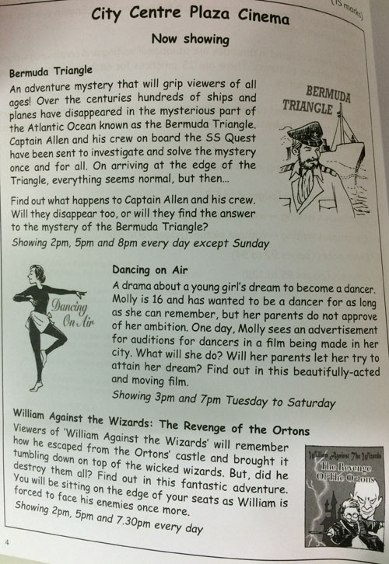

Sample Solution
Hi Jane,

Good news! My mother has said she will take me to the cinema this weekend and that I can bring a friend. So, of course, I thought of you!

There are three new films to choose between at the City Centre Plaza Cinema. I do not really like the sound of 'Dancing on Air's as I do not like dancing very much. So, it is choice between 'William Against the Wizards' and 'Bermuda Triangle'. Do you remember we both went to see the first part of the William films last year? I thought it was a bit too far-fetched and the special effects were not very good either. So, I am not very keen on seeing the second part.

But, 'Bermuda Triangle' sounds brilliant. Have you heard about it? It is an adventure mystery film and sounds really exciting. A ship is sent to find out why planes and ships keep disappearing into the sea in the Bermuda Triangle. The ships arrives there and it seems to be all right and then things start happening! I love this type of film!

Does this sound good to you? I thought we could go to the Saturday 2pm showing. You could walk around to my flat, and then my mum could take us both into town in her cafe. We would have to leave at about 1.15 to make sure we got there on time.

Email ot message me and let me know if you want to come.

All the best,
Lily

Question 167
QuestionID: 105
Question Type: Situational
Question Category: Email

Read the flyer below.

You and your family are going to the Blue Lagoon Water Park on Saturday, 22 May in the afternoon, from 1.30pm - 6pm. Your parents have said you can invite a friend to come with you.

Write an email inviting your friend Jack to spend the afternoon with you.

Refer to the flyer when writing your email.

Include the following information in your invitation:
- why Jack should come with you
- name of the water park, date and time to meet
- attractions of the water park
- some safety aspects of the park
- address of the website to find out more about the water park

You may reorder the points. You should write in complete sentences.
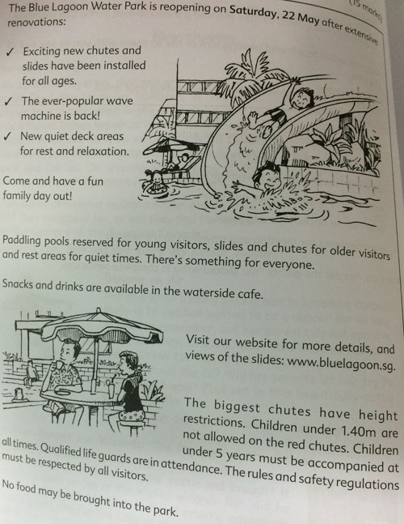

Sample Solution
Dear Jack,

My family and I are going to the Blue Lagoon Water Park on Saturday, 22 May and my parents have said I can invite a friend to come too. I would like to invite you!

I am really looking forward to going there, as the whole park has been renovated and new installations have been built. There are exciting new chutes and slides of different sizes. These look really good from the website. You slide down really fast and splash into a deep pool. We might not be able to reserved for taller people, but there are plenty of smaller ones. There is a wave machine in one of the pools. Have you ever tried out a wave machine? They are really great fun! There is rest area if we get tired, (but i do not expect we will,) and there is a cafe where we can get a snack.

You can tell your parents that are life guards in attendance at all times, and the safety regulations are quite strict to ensure that everyone has a happy and safe time at the park!

We will spend the afternoon at the parl. We can meet outside at 1.30pm and my father will take you home at 6pm. Bring your swimming things!

If you want more information, go on the park's website: www.bluelagoon.sg. Here you can see the new chutes they have put in.

I really hope you can come, as I know we will have a great time. Let me know soon.

Your Best friend,
Kim

Question 168
QuestionID: 106
Question Type: Situational
Question Category: Letter

Look at the birthday card below.

Your grandparents have sent you a birthday card with pictures of four presents.

Write a letter to them saying which present you would like.

Refer to the card when writing your letter.

Include the following information in your letter.
- your thanks
- which present you prefer and why
- enquiries about your grandparents' health
- information about your family

You may reorder the points. You should write in complete sentences.

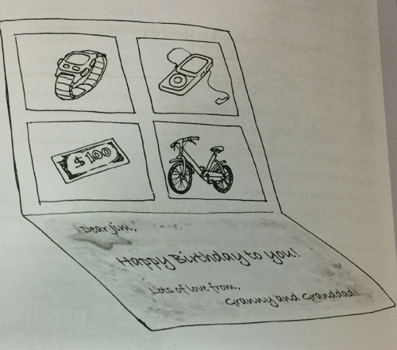

Sample Solution
Dear Granny and Granddad,

Thank you ever so much for the lovely birthday card and the wonderful choice of presents! They are all so great that it is difficult to choose!

At first, I thought I would have the bike, but I am so busy with school and scouts I do not have much spare time. The watch looks amazing, too, but the one Mum and Dad gave me to years ago is still working well. And, although it is always nice to have the money, I wanted to have something that would make me think if you when I used it. So, please may I have the music player? I can load all my favourite songs and music onto it and listen when I am on the school bus or walking to the shops.

I told Anna and Toby I was writing to you and they both send their love (so do Mum and Dad). Toby is doing well at his new school and Anna has just joined a table tennis club. She is a very good player.

I hope both of you are very well. What are you doing at the moment, and when are you planning to visit? It would be lovely to see you again, soon.

Well, I have to start my homework now. So, many, many thanks again.

Lots of Love
Jim

Question 169
QuestionID: 107
Question Type: Situational
Question Category: Report

Look at the programme and the notes below.

Your school organised a visit to the Science Museum last Friday.

Write a report of the visit.

Refer to the programme and the notes.

Include the following information in your report.
- when you visited the museum
- what you did at the museum
- the different topics you learnt about
- why you enjoyed the day
- how you felt about the different activities

You may reorder the points. You should write in complete sentences.
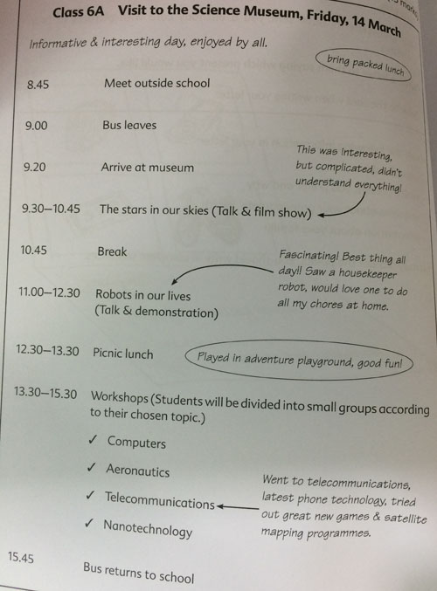

Sample Solution
On Friday, 14 March Class 6A had their outing to the Science Museum. It was a very interesting and informative day, which all the students enjoyed.

The class met outside the school at 8.45 and we took our seats on the bus. We left promptly at 9 o'clock and arrived shortly afterwards, at 9.25. We entered the Science Museum and were directed to the first event of the day, entitled 'The stars in our skies'. We listened to a talk and watched a film about the different constellations. To be honest, although it was a very interesting subject, I found it very complicated and was not able to understand everything. After a short break we were given a fascinating talk called 'Robots in our lives'. This was followed by a demonstration. A housekeeper robot was particularly clever, being able to do many different household duties. I would love to have one in my house, to do all my chores!

For lunch we picnicked outside and afterwards had fun playing on the adventure playground. We had been given a choice of workshops for the afternoon session and I had chosen 'Telecommunications'. This dealt with new mobile phone technology and we were given the opportunity to explore new applications. I appreciated discovering some new games and a new satellite-mapping device.

The bus took us back to school at 3.45 and we arrived tired but happy after our very enjoyable visit to this facinating museum.

Question 170
QuestionID: 108
Question Type: Situational
Question Category: Email

Look at the advertisement below.

You want to do some of the activities described in the advertisement and want a friend to come with you.

Write an email to your best friend, Tim, to suggest that he join you on a Saturday Adventure.

Refer to the advertisement when writing your email.

Include the following information in your email.
- the activities you want to do and why
- why you want your friend to come
- ask what activities your friend wants to do
- what other activities your friend wants to do
- what other information you need to find out

You may reorder the points. You should write in complete sentences.
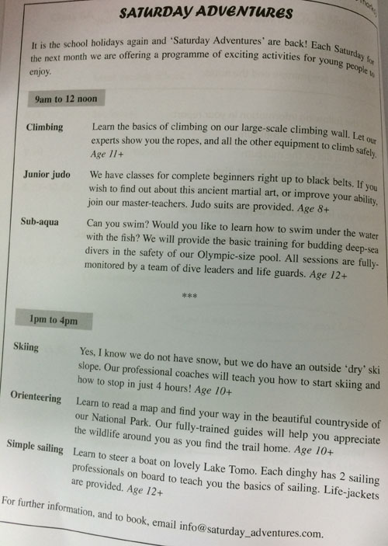

Sample Solution
Hi Tim,

I have attached an advertisement I saw in the newspaper about things to do on Saturdays during the school holidays. They look really good.

I would like to do the climbing class. I have always liked the idea of climbing in the mountains and this class seems like a good way to start. They will shows equipment and how to use it all, as well as how to climb the wall. I think it sounds really exciting. In the afternoon, I really fancy the sailing course. I have been to Lake Toma with my parents and it is absolutely beautiful. And to learn to sail as it does not matter if we fall in the water!

I think it would be much more fun doing these things with a friend and I know you like doing exciting things so I thought it would be great if you came with me. What do you think? And which activities would you like to do? I am happy to do different things if you are not keen on climbing and sailing. They all look fun!

I am going to email them to find out how much the classes cost and where exactly each activity takes place. I will send you another email once I have got more information but in the meantime message me and say if you want to come.

All the best,
Mark

Question 171
QuestionID: 109
Question Type: Situational
Question Category: Postcard

Look at the advertisement below.

You have been staying at the Seahorse Family Resort with your parents and younger brother for a wonderful week's holiday. You and your younger brother, Mark, have been swimming in the sea and in the pools, and have been joining in classes in one of the offered sports or leisure activities.

Write a postcard to your grandparents, explaining how you have spending your holiday.

Refer to the advertisement when writing your postcard.

Include the following information when writing your postcard.
- a description of the resort
- the accommodation
- the activities you have been doing
- how much you enjoying yourself

You may reorder the points. You should write in complete sentences.
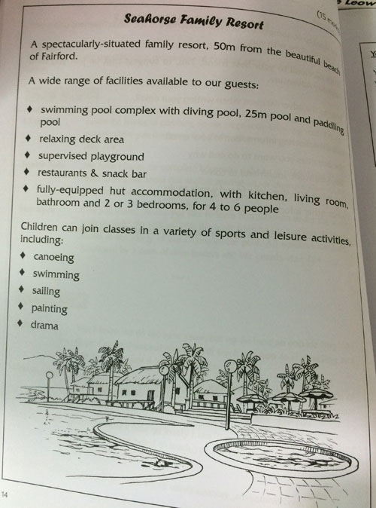

Sample Solution
Dear Grandma and Grandpa,

Greetings from Seahorse Family Resort!. We have been having a great holiday here. It is a fantastic place. Mark and I have been having great fun doing loads of different things. We go swimming in the pools and in the sea everyday and I have been learning how to canoe! It is quite easy and good exercise. Mark had been going to painting classes, which he enjoyed a lot. The resort is perfect for a family holiday. In addition to the pools, of which there are three, it is only a few metres from the beach. So we have been playing in the water as much as possible. There are several restaurants and a snack bar. We have our own fully-equipped hut just a few minutes from the swimming pools. It is a really wonderful place and we are all having a lovely holiday. See you soon!

Love
Janice

Question 172
QuestionID: 110
Question Type: Situational
Question Category: Email

Look at the notice below.

You want to participate in the sponsored swim and raise $50.

Write and email to your aunt asking her to sponsor you. Refer to the notice when writing your email.

Include the following information in your email:
- information about the event
- who is sponsoring the event
- why 'Link the World' should be supported
- how many laps you may swim
- how much money you want to raise

You may reorder the points. You should write in complete sentences.

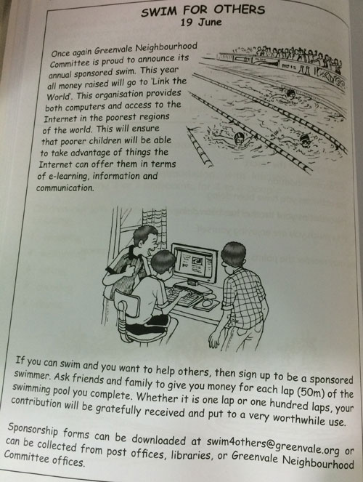

Sample Solution
Dear Aunt Sally,

The Greenvale Neighbourhood Committee is holding a sponsored swimming event on 19 June. The idea is that lots of people volunteer to swim laps of the pool to raise money for an organisation called 'Link the World'. Apparently, they provide computers for poor people and even make the Internet available to them.

I think this is really important because people can get lots of useful information from the Internet. I do a lot of my homework using the computer and it helps me learn many things.

I am not a very strong swimmer so I will probably just try and do ten laps. It does not sound much but it is 500 metres! My hope is to raise $50 for the charity. So, would you like to sponsor me? Dad suggested that I ask for $5 a lap. If I do ten laps, that will be $50. Would that be all right?

Thank you very much in advance and please say hello to Uncle John and Matthew for me.

With love
Tracy

Question 173
QuestionID: 111
Question Type: Situational
Question Category: Email

Look at the flyer below.

You are a member of Eastbay Primary School Geography Club and would like to attend the talk on 'Crossing Greenland'. You wish to interview Ms Henderson about her trip and write an article for the school newsletter.

Write an email to Ms Henderson asking if it would be possible to ask her a few questions after her talk.

Refer to the flyer when writing your email.

Include the following information in your email:
- why you want to interview Ms Henderson
- what the best and worst moments of your trip were
- what other details you wish to obtain from Ms Henderson
- other aspects of the trip you are particularly interested in
- if you can use some of her photos for your article

You may reorder the points. You should write in complete sentences.

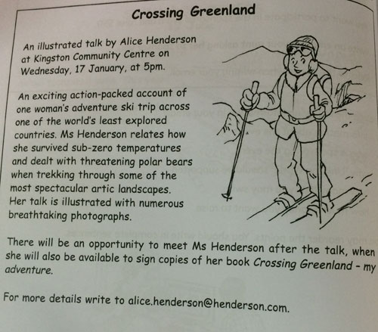

Sample Solution
Dear Ms Henderson,

I am writing to you on behalf of Eastbay Primary School Geography Club. We would be very interested in interviewing you after your talk on Wednesday, 17 January.

Our club would like to write an article about your exciting trip for our school newsletter and so, would be very pleased, if we could ask you a few questions. We are particularly interested in what, for you, were the best and the worst moments of your adventure. In addition, our readers will be fascinated to hear how you felt when you saw the polar bears for the first time. Other details that will make our article interesting are the kind of food you ate and the extremes of temperature you had to endure.

I would also like to ask you if it would be possible to use some of your photographs to illustrate our article.

I hope you will be able to give us a few minutes of your time on Wednesday after your talk, as I know that this is a wonderful opportunity for us to meet such an intrepid explorer. Thank you in advance for considering our request.

Yours sincerely,
Lewis Lee

Question 174
QuestionID: 112
Question Type: Situational
Question Category: Email

Look at the diary below.

It is Friday evening and you have had a wonderful five days.

Write an email to a friend telling him or her what you have been doing

Refer to the diary when writing your email.

Incude the following information in your email:
- your arrival
- the volleyball match
- the local area
- windsurfing
- how you feel

You may reorder the points. You should write in complete sentences.
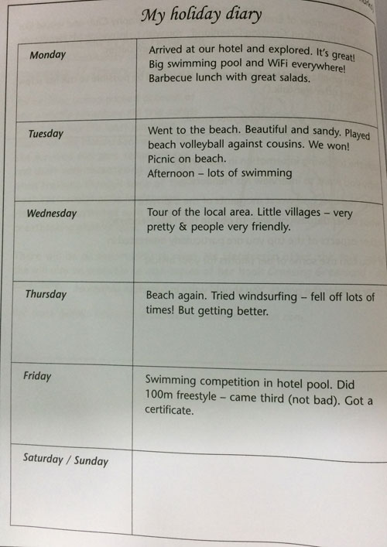

Sample Solution
Dear Sue,

It is Friday evening and I have had a great holiday so far. We arrived at the hotel on Monday and I immediately started exploring. It is really great with a huge swimming pool and there is WiFi everywhere so I can stay in contact with my friends.

On Tuesday we all went to the beach. It is long, sandy and beautiful. It was a lovely day. In the morning we arranged a volleyball match against my cousins. They were good but we were better! We won! We had a delicious picnic lunch on the beach. I was starving after the volleyball. Then we spent the afternoon swimming and playing in the sea.

On Wednesday Dad hired a car and took us to look at the area. It is full of small villages that are very pretty. We stopped occasionally for water and petrol, and everyone was very welcoming and friendly.

We spent Thursday on the beach. I had a go at windsurfing but I was not very good and I kept falling off. Luckily the sea is very warm! It was great fun, though.

Today I entered a swimming competition run by the hotel. I did the 100m freestyle and came third, which I thought was pretty good.

It has been a great few days and a wonderful start to the holiday. Hope you are having a good time too. Write soon.

All the best,
Kate

Question 175
QuestionID: 113
Question Type: Situational
Question Category: Letter

Look at the announcement below.

You and your family are attending the school concert. You would like to bring a friend.

Write a letter to a friend inviting him or her to the concert.

Refer to the announcement when writing your letter.

Include the following information in your letter:
- what the occasion is
- why you want your friend to come
- time and place
- arrangements for going to the concert
- when your friend should decide

You may reorder the points. You should write in complete sentences.
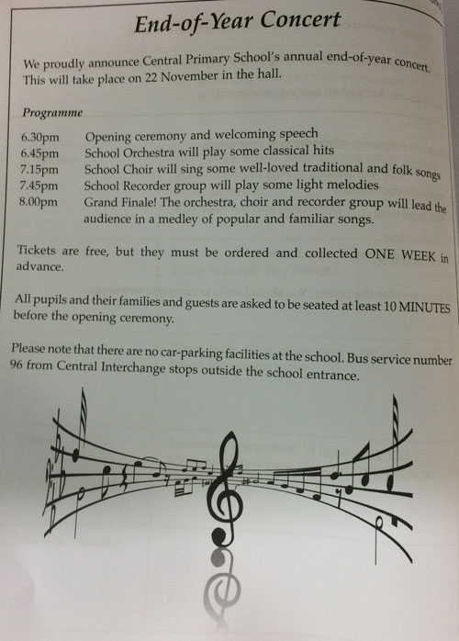

Sample Solution
Dear Janet,

It is nearly the end of term and my school is giving an end-of-year concert. Would you like to come with me and my family? I know you love music and our orchestra and choir are really good. I am sure you will enjoy it.

It is on 22 November in the hall at my school. The concert actually starts at 6.30 but we should be there about 10 minutes beforehand. There is no car-parking, so Dad cannot take the car, but we can all go by bus. Why don't you come to our place at about 5.30 and we can all go together?

After the opening ceremony the School Orchestra will play some classical music. Then the choir will sing some folksongs, which I am really looking forward to. After that there is some recorder music and then the Grand Finale. I think we will be able to join in that! It should be fun!

I hope I have convinced you to come! Let me know as soon as possible because I have to collect the tickets a week in advance of the actual concert.

All the best,
Anne

Question 176
QuestionID: 114
Question Type: Situational
Question Category: Letter

Look at the advertisement below.

Your parents organised a birthday party for you and your friends on 6 June at Billy's Burger Restaurant. Unfortunately, the party was very disappointing.

Write a letter of complaint to the manager of the restaurant.

Refer to the advertisement in your letter.

Include the following information in your letter:
- guests were divided into two tables of six and one table of two
- there was no salad with the meal
- only one party game was organised
- play area was closed for renovation, guests had nothing to do before the meal
- 'gift' was a plastic toy car, unsuitable for 12 year-olds
- date of the party
- request for a refund of some of the price your parents paid

You may reorder the points. You should write in complete sentences.

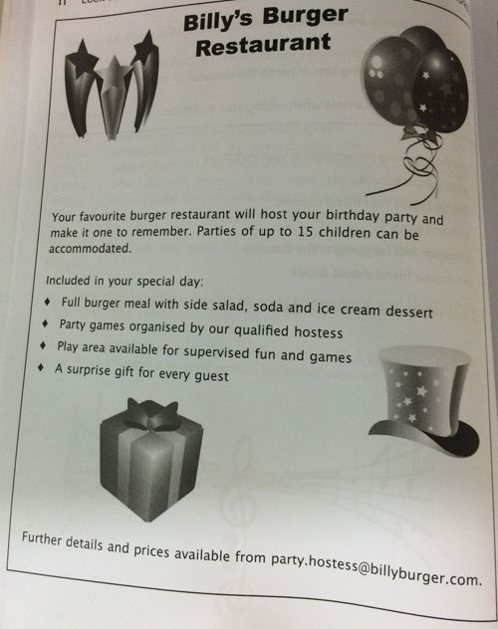

Sample Solution
Dear Sir or Madam,

I am writing to complain about the birthday party Billy's Burger Restaurant hosted for me and my friends on 6 June. There were a number of reasons why we were so disappointed with the party.

Firstly, on our arrival we were expecting to be greeted by a hostess who would organise party games for us. In fact, the hostess started only one game and then we were left to our own devices. The supervised play area mentioned in your advertisement was closed for renovations, so we had do before our meal was served

Secondly, when we were invited into the restaurant for the meal we were divided unevenly into three groups. There were 2 tables of of six and two of my guests were separated on another table. There were no salads with the meal, although this was clearly stated on the menu.

Finally, when we left the restaurant everyone was given the surprise gift, but what a disappointment! Each of us received the same plastic toy car. A gift that is hardly suitable for a 12 year old!

All in all we were disappointed with the party and as a result, are asking for a partial refund of the price that was paid for this very unmemorable party.

Yours faithfully,
Kate Lee

Question 177
QuestionID: 115
Question Type: Situational
Question Category: Letter

Look at the email below.

You would like to go to the circus school with your friend.

Write to Tom accepting his invitation.

Refer to the email and advertisement when writing your letter.

Include the following information in your letter:
- a thank-you for the invitation
- what you would like to do and why
- questions about Tom's choice of activities
- asking for more information (when, where, cost etc.)

You may reorder the points. You should write in complete sentences.
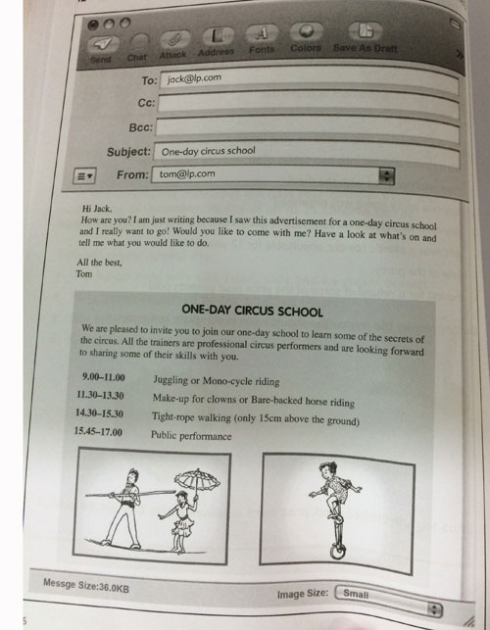

Sample Solution
Dear Tom,

It is great to hear from you. Thanks very much for your email and the invitation. A circus school sounds like a really exciting idea.

I have looked at the programme. All the classes look really interesting. For the first session, I think I would like to learn how to juggle. I have always wanted to do it, and it is something I could continue practising after the class. Then I would like to find out about making up clowns. I think that would be fun. It is also a skill we could use after we have learnt how to do it. We could go as clowns to fancy-dress parties, for example! Also, I have to confess I am a bit afraid of horses! Learning to walk a tight-rope will be brilliant. I am glad it is only 15cm above the ground, though. That way we will not hurt ourselves when we fall off!

But what do you think? What activities would you like to do? I am happy to try anything if you do not like my suggestions. It was your idea, after all!

You did not say when the school is taking place or where it is. Could you let me know so I can tell my parents? Also, they will want to know how much it is going to cost.

Again, many thanks for thinking of me I am really looking forward to it.

Best wishes
Jack

Question 178
QuestionID: 116
Question Type: Situational
Question Category: Email

Look at the publicity material below.

You would like to attend the Music Summer School but need more information

Write an email to Miss Sing.

Refer to the publicity material when writing your email.

Include the following information in your email:
- you play the violin (five years experience, intermediate level) and the piano (recently started), is instruction in two instruments possible?
- you recently had a small operation and cannot swim for months. Is there another sport you could do?
- ask for more information about accommodation. Are the rooms shared? How many children per room?
- Is vegetarian food available?

You may reorder the points. You should write in complete sentences.

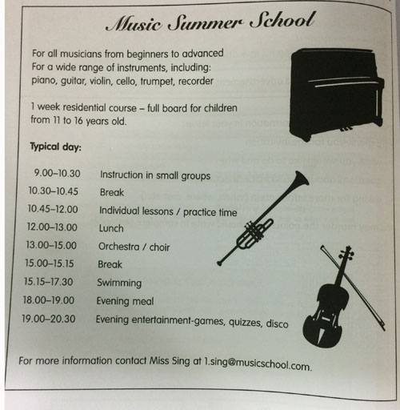

Sample Solution
Dear Miss Sing,

I am very interested in attending the Music Summer School and would like to have some more details about the courses and other activities.

I have been playing the violin for five years and have reached a good intermediate level. I have also recently started learning a second instrument, the piano. Would it be possible for me to have instruction in both of these instruments?

I see in the programme that there is swimming in the afternoon. Unfortunately, I had a small operation a few weeks ago and am not allowed to go swimming for the next 2 months. Is there an alternative sporting activity I could participate in?

Could you also give me some more details about the accommodation? Do the students share a bedroom? If so, how many children are there in each room? Are all dietary requirements catered for? I am a vegetarian.

Thank you in advance for your help. I look forward to hearing from you.

Yours sincerely,
Sally

Question 179
QuestionID: 117
Question Type: Situational
Question Category: Letter

Look at the programme below.

You would like to enrol in two after-school activities. You would prefer to do them with a friend.

Write to a friend to persuade him or her to enrol with you.

Refer to the programme when writing your letter.

Include the following information in your letter:
- your choice of activities
- reasons for choice
- description / explanation of activities
- time of activities
- why your friend should come

You may reorder the points. You should write in complete sentences.
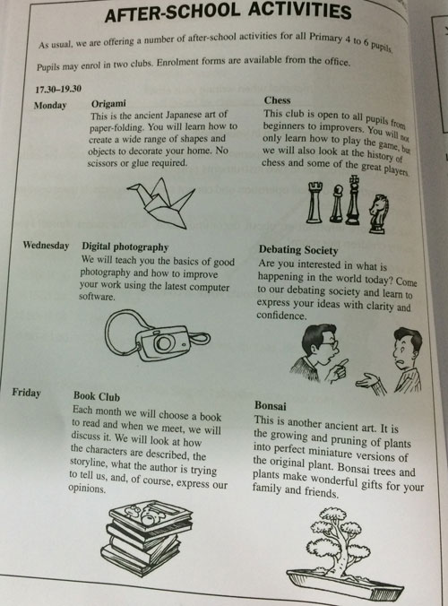

Sample Solution
Hi Anna,

I thought I would email you because I have just seen this term's programme of after-school activities. There is a really good choice this time.

I want to enrol in two classes. On Mondays 5.30 there is an origami class. Origami is the art of folding paper into different shapes and objects. It is a very old Japanese art. I have chosen it because it is something I can do in my free time as well as at the club. You do not need any equipment, just bits of paper.

Why don't you enrol in this class, too? I am sure you would enjoy it because you are very artistic. Also, I know you enjoy making things with your hands. You are always sewing or doing collages!

My second choice is the Book Club after school on Friday sturting at 5.30. Every month we choose a new book to read and then we discuss it at the club. We are going to look at the plot and the characters and give our opinions about the book. l know you love reading as much as I do, so I am certain you will want to join the Book Club.

Please say you will enrol in these two activities with me. It would be so much more fun doing them with you. Say `yes' and I will get you a form from the office!.

Best wishes,
Janice

Question 180
QuestionID: 118
Question Type: Situational
Question Category: Email

Look at the flyer below.

You want to invite a friend to go to the City Zoo open day with you.

Write an email inviting your friend.

Refer to the flyer in your invitation.

Include the following information in your email:
- why you want to go
- why you want your friend to go
- date, times and cost of open day
- some of the activities available
- which activities you would like to do

You may reorder the points. You should write in complete sentences.

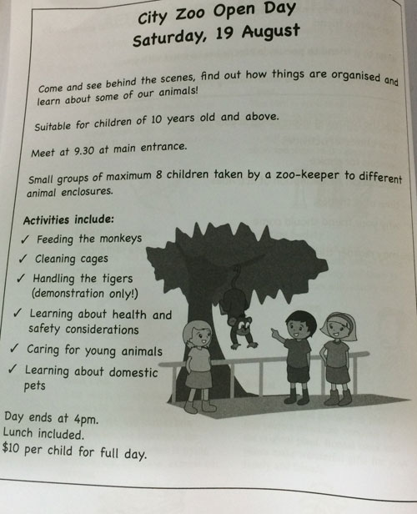

Sample Solution
Hi Kate

Would you like to go with me to the City Zoo open day? It is being held on Saturday, 19 August from 9.30 to 4.00 and costs $10 each.

I think it will be a great day out as we can learn a lot about many different animals and find out about how the zoo really works. There are different activities throughout the day. The ones I think sound particularly interesting are: feeding the monkeys, caring for young animals and handling the tigers! (Training the tigers is only a demonstration, of course. They will not let children try this out!) But there are others too, such as cleaning the cages, health and safety considerations and learning about domestic pets.

I hope you can come, as it will be more enjoyable if I go with someone I know. Tell me if you can come as soon as possible!

Hope to see you very soon.

All the best,
Lily

Question 181
QuestionID: 119
Question Type: Situational
Question Category: Email

Look at the programme below.

A penfriend is visiting your city for the first time. You have planned a day out.

Write an email describing your plans for your day out together.

Refer to the programme when writing your email.

Include the following information in your email:
- how you will travel in the city
- things you like in the museum
- animals you like in the zoo
- your penfriend's opinion
- leaving the city

You may reorder the points. You should write in complete sentences.

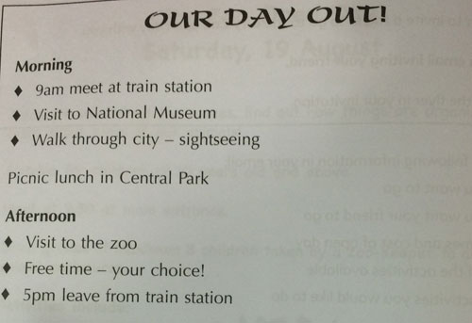

Sample Solution
Dear Teresa,

I am really happy that your parents are letting you visit my city. I cannot wait to see you again. I have planned a really nice day of for us. First of all, my parents and I will meet you when you arrive at the train station at 9 o'clock. Then we will walk to the National Museum. It is only about ten minutes away. The museum is very big so we will not be able to see everything, but I would like to show you my favourite. It is the dinosaur hall. It is huge and there are lots of enormous skeletons of dinosaurs, and a great video showing how they used to walk, and run, and even fly! I am sure you will enjoy it.

Then, we are going to take a short walk through the city and do some sightseeing. Do not forget to bring a camera! We finish our walk at a beautiful park and we will have a picnic lunch there. My mother is preparing lots of delicious food for us.

After lunch, we will stroll around the zoo, which is just next to the park. What animals would you like to see? I really enjoy watching the monkeys. They are so funny!

When we have finished at the zoo, there will still be time to do something else. Is there anything in particular that you would like to do? Please let me know.

Finally, we will catch a taxi back to the rain station in plenty of time for your 5 'clock train. Do not worry, we will not let you miss it!

Please give my best regards to your Tents. I am really looking forward to seeing u again.

All the best,
Laura

Question 182
QuestionID: 120
Question Type: Situational
Question Category: Email

Look at the flyer below.

You would like to volunteer to take care of someone's pet as part of your Community Service duty for your scout's badge.

Write an email offering your services.

Refer to the flyer when writing the email.

Include the following information in your email:
- you have a dog at home and walk it daily
- your parents agree to let you volunteer
- why you want to volunteer
- you are free for one hour on Wednesday and Saturday afternoons
- you have already done some community service, picking up litter

You may reorder the points. You should write in complete sentences.
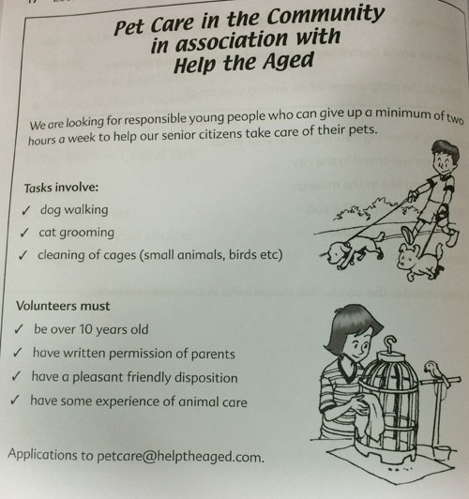

Sample Solution
Dear Sir or Madam,

I read your flyer on Pet Care in the Community with great interest and would like to offer my services as a volunteer.

I am preparing a Community Care badge for the scouts and this involves several hours community service helping others. I have already volunteered to pick up litter in our local park and feel I am a responsible person who will not let you down.

I have always loved animals and been very fond of taking care of them. We have a pet dog at home and I walk it every day, so I am used to exercising dogs and am aware of the responsibility this involves I am also willing to do other pet care duties mentioned in your flyer.

I am free to help out for an hour a week, on Wednesday und Saturday afternoons. My parents are in total agreement with my volunteering activities and will give me written permission to do so.

I hope that you will accept me as a volunteer and I look forward to hearing from you soon.

Yours faithfully,
Fred

Question 183
QuestionID: 121
Question Type: Situational
Question Category: Letter

Look at the email and programme below.

Your friend Helen has invited you to join her for some beach activities.

Write a letter accepting the invitation.

Refer to the programme and email when writing your letter.

Include the following information in your letter:
- thanks for and acceptance of the invitation
- how well you can swim
- your two choices of activities
- the reasons for your choice
- inquiries about Helen's wishes

You may reorder the points. You should write in complete sentences.
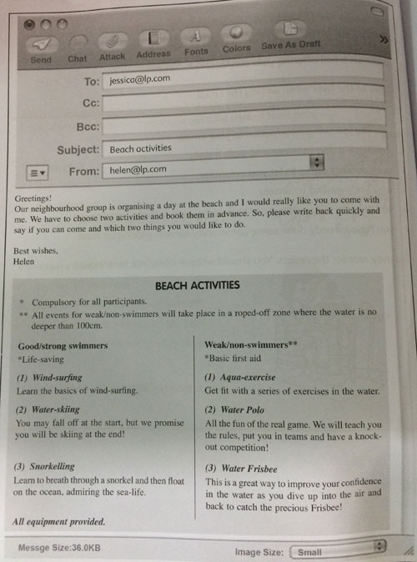

Sample Solution
Dear Helen,

Thank you very much indeed for the invitation to the day out at the beach. I would love to come. The programme looks great!

I think it is a really good idea that everyone has to do life-saving or first aid as these are very useful skills to have. I am quite a strong swimmer and would be very interested in knowing how to help someone in trouble.

It is very difficult to choose just two of the three activities on offer for good swimmers. I would certainly like to learn to snorkel, It must be marvellous just to lie on the surface of the sea and look at the fish and plants. So, that would be my number one choice.

I have seen people windsurfing and it looks as if you have to be quite strong to do it, whereas water-skiing looks quite easy. So, I think I will choose water-skiing.

What about you? Are you a good swimmer or not? Which activities would you prefer? In fact, all of the activities sound like fun! So, I am quite happy to do whatever you would like.

Thanks again for the kind invitation.

Best wishes
Jessica

Question 184
QuestionID: 122
Question Type: Situational
Question Category: Email

Look at the webpage below.

You are interested in subscribing to Kids' Crafts and Activities but would some more information.

Write an email asking for more details.

Refer to the webpage in your email.

Include the following information in your email:
- if you change your mind and wish to unsubscribe, are you entitled to a refund?
- how many activities are available each month, always the same number?
- are ideas for all categories (food fun, science projects etc) included every month?
- are all the activities available to every subscriber, or does it depend on the age of the subscriber?

You may reorder the points. You should write in complete sentences.
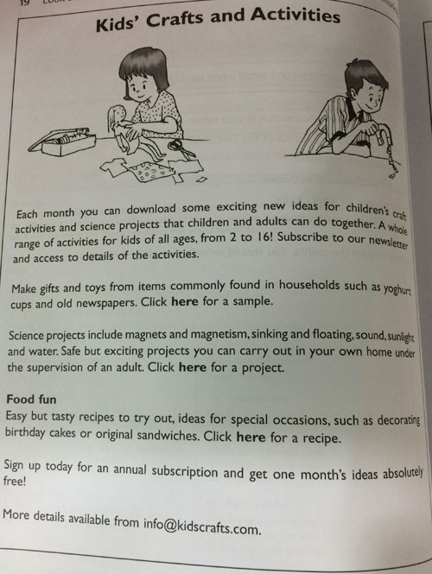

Sample Solution
Dear Sir or Madam,

I am interested in subscribing to your newsletter to receive new ideas for different activities every month and would like to have further information.

Firstly, could you tell me exactly how m any activities are available each month? Is there a fixed number or does it vary?

Secondly, are there always activities in every category? For example, every month will there be a science project and food fun ideas?

Thirdly, are all the activities available every subscriber, or does it depend on the age of the subscriber?

Finally, if a subscriber wishes, for any reason, to cancel the subscription, are they then entitled to a refund?

Thank you in advance for your help. I look forward to hearing from you.

Yours faithfully,
Tim

Question 185
QuestionID: 123
Question Type: Situational
Question Category: Letter

Look at the announcement below.

You wish to invite a friend to Come to the Carnival with you. Write an invitation to your friend.

Refer to the programme when writing your invitation.

Include the following information in your invitation:
- date and time of the carnival
- the main events
- your suggestions for afternoon activities
- what 'Hands Across the Ages' is
- how your friend can get further information

You may reorder the points. You should write in complete sentences.

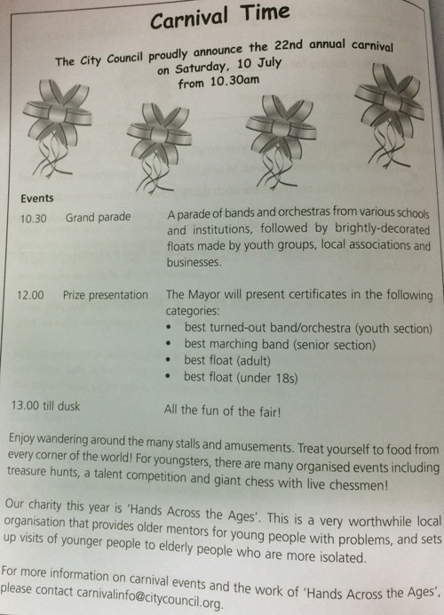

Sample Solution
Dear Yusof,

It is carnival time again in my city, so would like to invite you to spend the day with me enjoying all the fun. I am sure we will have a wonderful time together!

The carnival is on 10 July and starts at 10.30 in the morning with a grand parade. We should get there a bit earlier to find a good place to watch the march. There is going to be lots of music from school orchestras and other bands. These will be followed by decorated floats, which are trucks that are painted and covered with flowers and they look beautiful.

At midday, the Mayor will give certificates to the best bands and orchestras, and to the best floats.

After that we can spend time together just wandering around. The announcement says that there will be stalls selling food from all around the world. It would be fun trying different things. There is also a treasure hunt we can join or we can play giant chess with live chess pieces! That sounds really strange!

The money we spend is going to a very good cause. It is an organisation called 'Hands Across the Ages', which helps both Young people with problems and elderly people who are lonely by bringing the generations together.

I am sure you will agree that this will be a great day out and I hope you will come with me. If you want to find out more, you can email carnivalinfo@citycouncil.org.

Best wishes
Ali

Question 186
QuestionID: 124
Question Type: Situational
Question Category: Email

Look at the recipe below.

Your best friend came to lunch and you made an omelette. Your friend thought it was delicious.

Write an email to your friend and include instructions for making the omelette.

Refer to the recipe when writing your email.

Include the following information in your email:

- why you are sending the recipe
- the secret of making the omelette light
- how much seasoning to use
- why the cooking time is important
- how to present the dish

You may reorder the points. You should write in complete sentences.
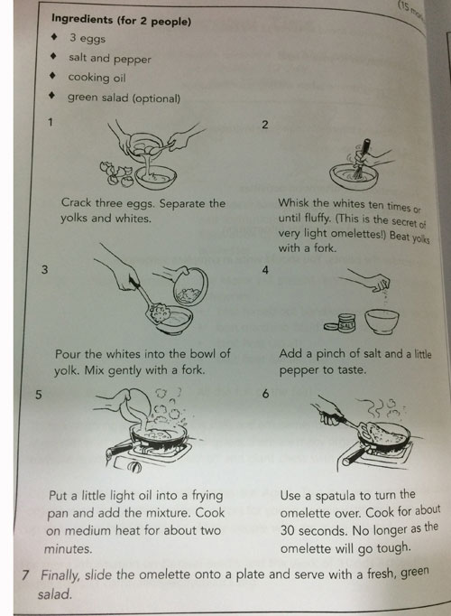

Sample Solution
Dear Susan,

Thank you for coming to lunch with me. It was great seeing you. You said how much you had enjoyed the meal, and so I thought I would send you the recipe.

If you are making the omelette for two people, you will need three eggs. Crack the eggs carefully and put the yolks in one bowl and the whites in another. Then whisk the egg whites about ten times or until they are slightly fluffy. This is the secret of perfectly light omelettes! Beat the yolks with a fork and pour the fluffy whites in and mix gently. Then add a pinch of salt and some pepper, if you like pepper.

Put a frying pan on the top of the stove and add a little oil. Pour in the omelette mixture and cook using medium heat for about two minutes. Then, carefully, use a spatula to turn the omelette over. Cook it on the other side for about 30 seconds. You should not cook it any longer because the omelette will go tough and will not be at all light and fluffy!

When it is cooked, slide it onto a plate and put it on the table. I think that it is nice to serve it with a fresh, green salad.

I hope you enjoy making and eating this omelette. You can invite me to lunch one day to try it!

See you soon,
Jennifer
Question 187
QuestionID: 125
Question Type: Situational
Question Category: Report

Look at the map and notes below.

You went on a school visit to the zoo. You made notes on what you saw.

Write a report on your visit.

Refer to the map and notes when writing your report.

Include the following information in your report:
- date and venue of the trip
- what you saw in the monkey house
- how you felt in the reptile house
- your reactions to the lions and elephants
- the best thing about the visit

You may reorder the points. You should write in complete sentences.

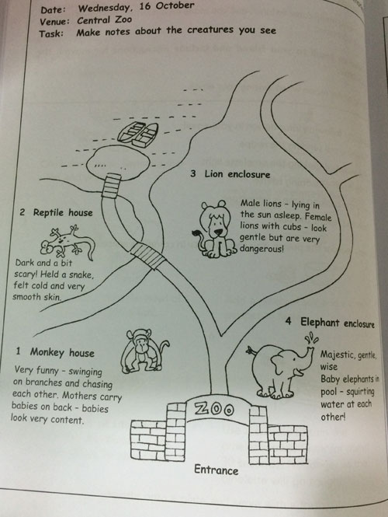

Sample Solution
Last Wednesday, 16 October, our class made a visit to the Central Zoo. The first place we went to was the monkey house. I thought the monkeys were very amusing. They swung from tree to tree, often chasing one another. The mother monkeys carried their young on their backs. The baby monkeys looked very safe and very happy being carried around like this.

The next stop was the reptile house. I did not enjoy this so much as it was dark and a little bit frightening. We were allowed to hold one snake. I was surprised how cold and very smooth it felt.

Our third destination was the lion enclosure. There was a group of male lions lying asleep in the sun. They looked very content. There were also some female lions with their cubs. Although they looked very gentle, in fact lionesses with cubs are extremely dangerous. I thought they looked quite magnificent.

Our last stop was the elephant enclosure. Elephants are superb creatures. They look so wise and so gentle. There were some younger elephants in the pool. They seemed to be playing and having fun squirting water at each other.

All in all, it was a very interesting trip and I learnt a good deal about these creatures. The highlight for me was watching the monkeys because they were funny and because I liked the way the mothers looked after their young.

Question 188
QuestionID: 126
Question Type: Situational
Question Category: Review

Look at the handout and notes below.

Your parents took you and your younger sister (aged eight) to see the play 'Mulan' last Saturday.

Write an review of the play.

Refer to the handout and your notes on the play in your review.

Include the following information in your review
- which book / film the play was based on
- what the theatre was like
- the story of the play
- what you thought of the character of Mulan
- why you recommend the play

You may reorder the points. You should write in complete sentences.
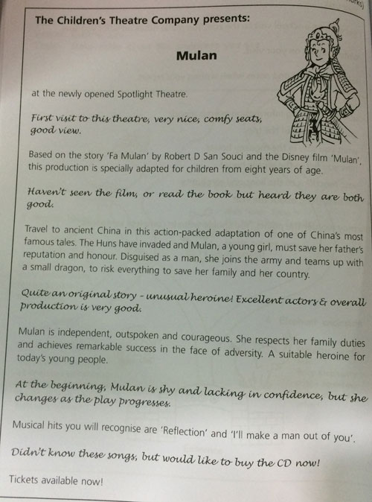

Sample Solution
Last Saturday evening my parents took my younger sister and me to the theatre to see the new production of 'MuIan'. It was a very enjoyable evening, which I recommend for a pleasant evening out.

The play is based on the book 'Fa Mulan' and the Disney film 'Mulan'. It is set in ancient China, just after the invasion of the Huns. To save her father's honour, Mulan, disguises herself as a man and joins the army. From a shy, retiring young girl Mulan develops into a courageous, outspoken and independent young woman. She saves her family and her country!

I enjoyed this play for several reasons. First of all, the production was excellent and all the actors were extremely good. Secondly, the story was quite unusual in that the heroine was a strong girl whose character developed as the play progressed. Mulan is a heroine that young people can identify with today.

The Spotlight Theatre recently opened and this production is a wonderful opportunity to discover it. The seating is very comfortable and allows even the youngest members of the audience a good view of the stage.

To conclude, I recommend this play as an entertaining but also thought provoking evening out.

Question 189
QuestionID: 127
Question Type: Situational
Question Category: Email

Look at the poster below.

You and your friend are interested in mountain climbing.

Write an email inviting your friend to the Cinema.

Refer to the poster in your invitation.

Include the following information in your email:
- film only showing for one night, on weekday in school term
- which aspects of the film should interest you both
- reserve to make sure you can get seats
- need to get parents' permission first will need to do homework before going out

You may reorder the points. You should write in complete sentences.

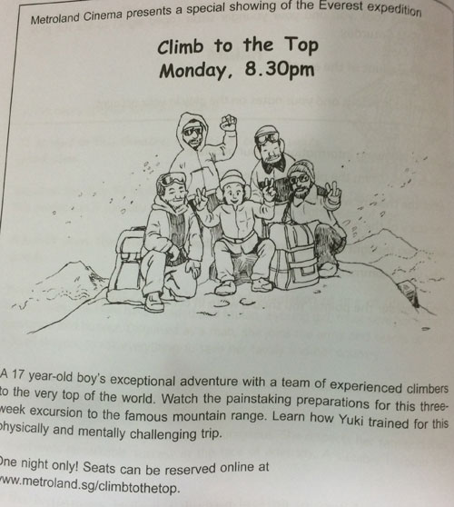

Sample Solution
Hi Nick

How are things? Have you heard that the film 'Climb to the Top' is being shown next Monday at Metroland Cinema?I really think we should go and see it.

The film is only being shown on one night and even though it is in the week and during term time I believe it is a unique opportunity to see something that we are very interested in. The film relates the incredible achievement of a 17-year old boy who climbed Everest. It gives details about how he prepared for the challenge, both physically and mentally. I think we could learn a lot about just what such an adventure really involves.

Since there is only one showing I think it is essential that we book our seats in advance. If you agree, I can reserve our seats online. Obviously, we need to get our parents' permission to go, but I think my parents may agree if I manage to do all my homework first.

Let me know as soon as possible. I hope you can come!

All the best,
Tom

Question 190
QuestionID: 128
Question Type: Situational
Question Category: Letter

Look at the flyer below.

You want to do the 10km fun run because you like running and think that the charity is a very good cause. You need sponsors to raise as much money as charity possible. You have already started training by attending the training sessions on a Wednesday afternoon.

Write a letter to your aunt, asking her to sponsor you.

Refer to the flyer when writing your letter.

In your letter include the following points:
- why you want to do the race
- how you are preparing
- what the money will be used for
- an invitation to watch the race
- the date and time of the race

You may reorder the points. You should write in complete sentences.
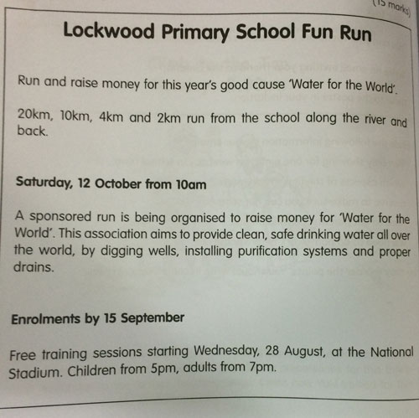

Sample Solution
Dear Aunt Annie,

I am writing to ask you to sponsor me to run 10km in the Lockwood Primary School Fun Run.

This race is being organised to raise money for the charity we are supporting this year `Water for the World'. This organisation aims to provide clean, safe drinking water in as many places as possible all over the world, by digging wells, installing purification systems and proper drains. We all feel this is a very worthwhile cause and deserves as much help as we can give. Our aim is to raise as much money as possible, of course!

I want to compete in the race as I enjoy running and, at the same time I feel it is important to help our charity. I have started preparing for the race by attending some training sessions, which are held every Wednesday afternoon. Each week gets a little easier, but 10km is still a long way!

It would be great if you could come and cheer me on the day of the run. It is being held on Saturday, 12 October, starting at Lockwood Primary School at 10am.

I hope you will agree to sponsor me. Every little helps!

Love,
Peter

Question 191
QuestionID: 157
Question Type: Situational
Question Category: Email

Below is a leaflet for a Children's Day celebration organised by Fun Resorts.

You are Lance and you would like to go to the carnival with your parents and your cousin who is four years old. Your parents are unsure of whether to drive there or take a shuttle service.

Write an email to enquire more about it.
You should refer to the leaflet above.

In your email, ask about the following:
- whether the games and rides at the carnival are suitable for young children
- what the entrance fees for adults and children are
- the frequency of the shuttle service
- what the usual parking charges are
- how one can get from First Avenue to Resorts Fun

You may reorder the points. You should write in complete sentences.

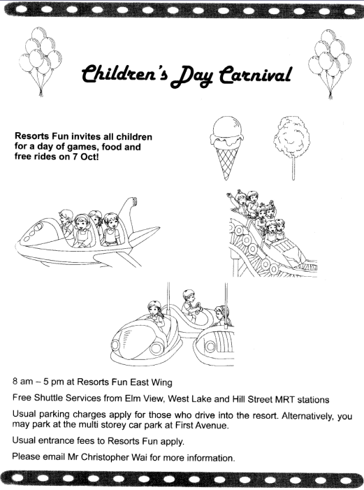

Sample Solution
Dear Mr Christopher Wai,

I am keen to attend the Children's Day carnival at Resorts Fun on 7 October and would like to enquire more about it.

Please let me know the entrance fees for adults and children to Resorts Fun. If my father drives, what are the parking charges at the resort itself? If he parks at the multi storey car park at First Avenue, how do we get to Resorts Fun? If I take the shuttle service, what is the frequency of the bus at the various MRT stations?

I would also like to find out if the games and rides available at the carnival are suitable for a child aged four.

I look forward to hearing from you.

Yours sincerely,
Lance Lee

Question 192
QuestionID: 160
Question Type: Situational
Question Category: Email

Below is an email your cousin sent about a trip to Malacca.

You and your mother are keen to go for the trip.

Write an email to your cousin enquiring about the trip.

You should refer to the email above.

In your email, include the following:
- enquire about your cousin's well being
- when the trip will be
- what the accommodation will be like
- how you and your mother would prefer to travel to Malacca and why
- what your cousin and her parents plan to do there

You may reorder the points. You should write in complete sentences.

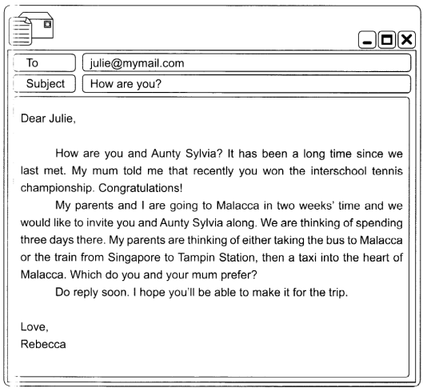

Sample Solution
Dear Rebecca,

I was pleased to receive your email. I had not heard from you for so long. How have you been? Are you still scuba diving? How are your parents? Please send my regards to them.

My mum and I will be delighted to go to Malacca. Do you have the specific date for the trip? My mother needs to apply to take leave from work at least a week in advance. I've read up on Malacca. It seems to be quite an interesting place with several historic buildings. What do you and your parents plan to do there? Have your parents decided on the accommodation in Malacca? Would we be staying in a hotel or a hostel? My mother and I would prefer to travel to Malacca by train. We have heard that the train is very comfortable. I've also not taken a train before, so it would be a good experience for me.

Do reply soon. I cannot wait to go for the trip.

Love,
Julie

Question 193
QuestionID: 163
Question Type: Situational
Question Category: Report

Below is a newspaper article.

You read about your friend performing in the ChildLove concert.

Write an email to your friend asking her more about the concert.

You should refer to the newspaper article above.

In your email, ask about the following:
- how your friend got involved in charity work
- when your friend started preparing for the concert
- what it was like performing with an international star
- whether your friend will be involved in any other charity work
- details about the concert"

You may reorder the points. You should write in complete sentences.
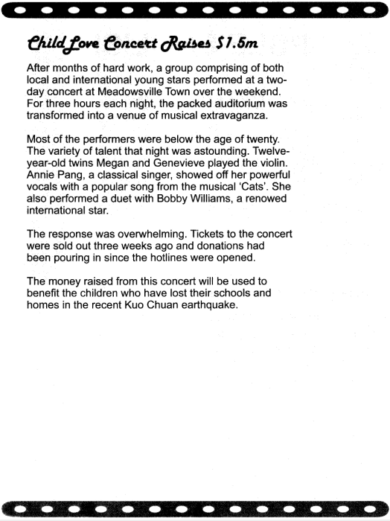

Sample Solution
Dear Annie,

It has been a while since we last spoke. How have you been? I was surprised to read about your performance in the ChildLove concert last week. You were always such a quiet girl at school. I did not know you were able to sing so well.

How did you get involved in charity work? Was this the first time you were involved in charity work? It must be a rewarding experience. Did you spend a long time preparing for the concert? How did you cope with school work and concert preparation at the same time? It must have been tough. I already find it tough to juggle my swimming practice and school work. What was it like performing with Bobby Williams? Did you enjoy it? You were so lucky! You must have picked up a lot of useful singing tips from him. Tell me what he was like.

Do write and tell me more about the concert. The newspaper article only mentioned several performers. Who else performed at the concert? Was there a big audience at the performances? Will you be involved in any other charity work? Do let me know if you will be. Maybe, I could help out too.

Love,
Jessie

Question 194
QuestionID: 166
Question Type: Situational
Question Category: Email

Below is a poster about being a volunteer at Save A Dog.

You would like to volunteer at Save A Dog.

Write an email to enquire about the volunteer programme.

You should refer to the poster above.

In your email, ask about the following:
- a specific date and time for the camp
- how many hours you need to volunteer
- the type of dogs at the place
- whether prior experience with dogs is necessary
- how to apply to be a volunteer

You may reorder the points. You should write in complete sentences.

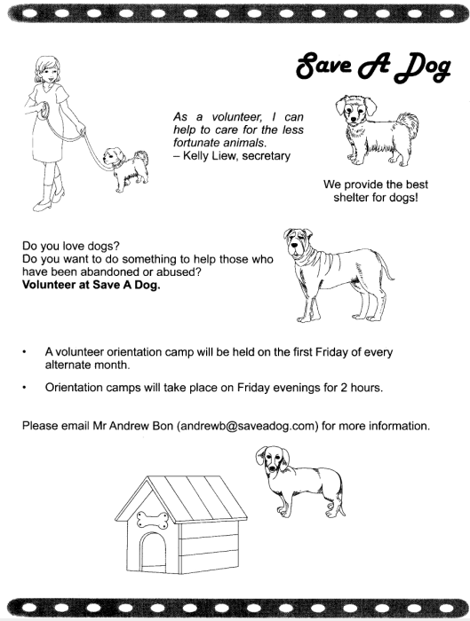

Sample Solution
Dear Mr Andrew Bon,

I came across the poster for volunteering at Save A Dog and I would very much like to be a volunteer. I would like to find out more about being a volunteer there.

Is prior experience with dogs necessary? I love dogs very much, but I've never had a chance to look after them. My knowledge of dogs is limited to what I've read in books. Will I still be a suitable volunteer? What types of dogs are at the shelter? Please tell me more about them.

As mentioned in the poster, there will be a volunteer orientation camp. Could you give me a specific date and time for the camp? Which months will the camp be held and what time will it be held on Friday? Is there a certain number of hours that a volunteer has to complete each week? I cannot commit more than five hours a week. Lastly, please let me know how I can apply to be a volunteer. I hope I can help the abandoned and abused dogs at the shelter.

Yours sincerely,
Janet

Question 195
QuestionID: 169
Question Type: Situational
Question Category: Email

Below is a list you have made in your planner for the coming September holiday.

It is the Friday just before the one week September holiday. Your pen-pal, Emily, in Taiwan has just started her school term.

Write an email to tell your pen-pal how you intend to spend your holiday.

You should refer to the list when writing your email.

In your email, include the following:
- ask your pen-pal how she spent her school holiday
- what you intend to do with your friends and why it might be hard to meet up with them
- what you have to do to your room
- what you have not done before
- what you need to do for school

You may reorder the points. You should write in complete sentences.

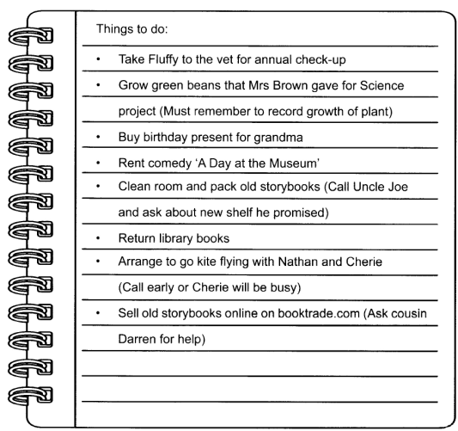

Sample Solution
Dear Emily,

How was your school holiday? Did you travel overseas? My school holiday is just round the corner. I cannot wait for it to begin. It is just for a week, but there are so many things I've to do.

Starting tomorrow, I've to grow the green beans that my Science teacher, Mrs Brown, gave me. I've got to record the daily growth of the green beans and submit it to her when the term starts again. Have you grown green beans before?

Since it is the holidays, my mother has insisted that I clean my room. I have to admit that it's a mess! My Uncle Joe has promised to give me a new shelf. I must remember to ask him about it. What about you? Does your mother always ask you to clean your room too? After I clean my room, I know that there will be a lot of old storybooks that I no longer want to read. I'm going to sell them on booktrade.com. I've not done it before, so I'm going to ask my cousin, Darren, to teach me how to do it. Have you bought or sold anything on booktrade.com before?

Although I'm very busy, I intend to go kite flying with my friends, Nathan and Cherie. they are both kite flying enthusiasts. However, Cherie is always very busy. I need to contact her early or she might not have the time to go kite flying.

I'd better get started on some of the things that I've to do. Do reply soon.

Love,
Genie

Question 196
QuestionID: 172
Question Type: Situational
Question Category: Email

Below is a leaflet about an audition for a musical.

You came across this leaflet and decide to ask your friends, Jess and Kenneth, to go for the audition with you. Like you, both of them are also interested in performing on stage.

Write an email to both your friends giving them more information about the audition.

You should refer to the leaflet when writing your email.

In your email, include the following:
- what you think of the musical (e.g. fun, interesting, exciting, etc.)
- when the audition will be and what is needed for it
- information on what the children in the chorus are required to do
- how the registration can be done
- why you think your friends will be interested in the musical (e.g. attended dance and singing lessons, like to act, etc.)

You may reorder the points. You should write in complete sentences.
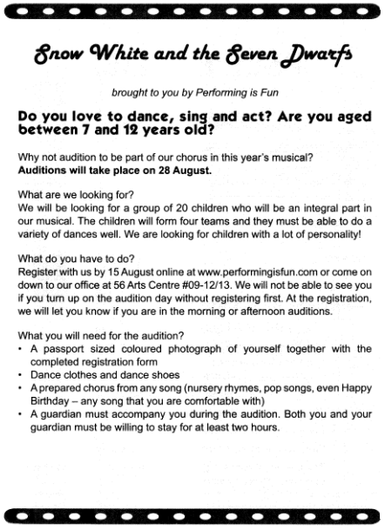

Sample Solution
Dear Jess and Kenneth,

I just found out that an audition will be held for chorus members in a new musical 'Snow White and the Seven Dwarfs'. I am thinking of going for the audition. I am sure the both of you would be interested in going too. Do you remember how we performed in this same musical when we were in kindergarten? We had so much fun then! I can't wait to perform again!

The company is looking for children between the ages of seven and twelve to form a group of twenty children that will be split into four teams. They need children who can dance well, sing and act. They also want children with a lot of personality. That certainly describes us! Finally, we can put our years of dance practice and singing training to use.

The audition will either take place in the morning or in the afternoon on 28 August, but we must register by 15 August. We can do it online at www.performingisfun.com or at the office of Performing is Fun at 56 Arts Centre #09-12/13. For the audition, we need to bring a passport sized coloured photograph with the completed registration form. We also need to bring dance clothes and dance shoes and prepare a chorus from any song we choose. The audition might take at least two hours and each of us must go with a guardian.

I really hope the both of you will go for the audition with me. It will be so exciting to perform together! Do reply soon.

Love,
Sue

Question 197
QuestionID: 175
Question Type: Situational
Question Category: Email

Below is a notice on your school's Photography Club board.

You are a member of the club. Your classmate, Richard, also a member, is absent from school.

Write an email to Richard, telling him about the reminder, and including all your teacher's instructions.

You should refer to the notice when writing your email.

In your email, include the following information:
- the change in date
- what your teacher needed help in
- how many helpers are required
- the time to be in school on that day
- what Richard must bring

You may reorder the points. You should write in complete sentences.

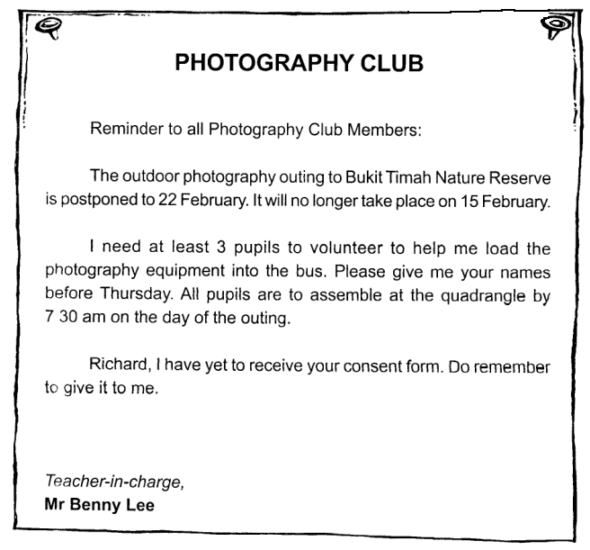

Sample Solution
Dear Richard,

I hope you are feeling better today. I want to inform you that our photography outing to Bukit Timah Nature Reserve on 15 February has been postponed to 22 February.

Mr Benny Lee is looking for three pupil volunteers to help him load the photography equipment onto the bus on the day of the outing. I am going to volunteer. If you are interested too, you can give your name to Mr Benny Lee before Thursday.

Mr Benny Lee also reminds you to bring the consent form, which you have not handed in yet. Also, be at school at 7.30 am on the day of the outing. Get well soon!

Marcus

Question 198
QuestionID: 177
Question Type: Situational
Question Category: Note

Below is a notice from a library's notice board.

You want to be a junior librarian. You think your best friend, Juliet, will be interested too. She is not at home when you look for her there.

Write a note to Juliet, telling her about the junior librarian session and asking her whether she wants to join you.

You should refer to the notice when you are writing your note.

In your note, include the following information:
- the duties of a junior librarian
- where and when the session will be held
- when it ends
- where and when to register
- how you feel about the idea

You may reorder the points. You should write in complete sentences.
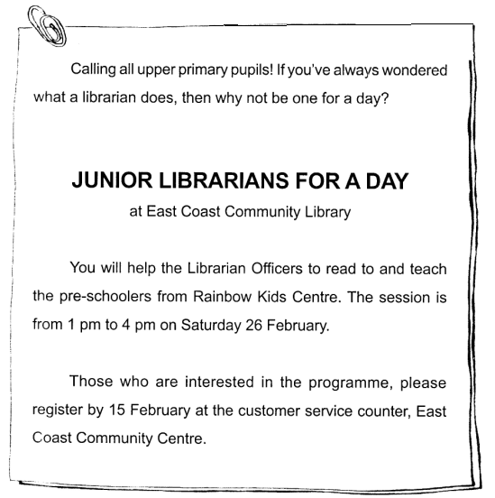

Sample Solution
Dear Juliet,

I came across an interesting notice at East Coast Community Library today. The library is looking for people to be "Junior Librarians for a Day" on Saturday, 26 February. The junior librarians will help the Librarian Officers to read to, and to teach, pre-schoolers from Rainbow Kids Centre. The programme starts at 1 pm and ends at 4 pm. I am going to sign up for this programme because I think it will be a good experience for me. If you are interested too, you can register at the customer service counter before 15 February. I hope to see you there!

Angela

Question 199
QuestionID: 179
Question Type: Situational
Question Category: Postcard

Below is a list of English programmes.

You intend to attend one of the English workshops.

Write a postcard to your friend, Ben, telling him about your decision.

You should refer to the list when writing your postcard.

In your postcard, include the following information:
- which movement the programmes are being held in conjunction with
- the types of workshops available
- your opinion of the workshops
- which workshop you have chosen
- why you think you will benefit from it

You may reorder the points. You should write in complete sentences.
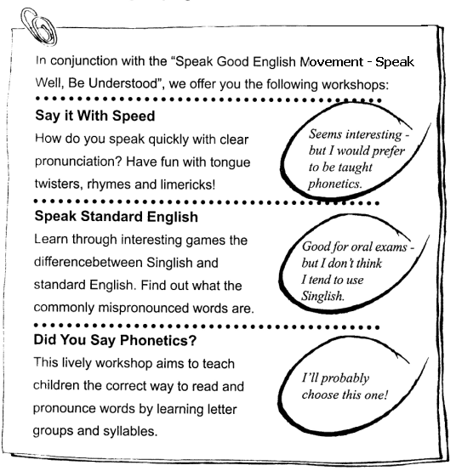

Sample Solution
Dear Ben,

I came across a list of English programmes which are being held in conjunction with the "Speak Good English Movement - Speak Well, Be Understood". In one of the workshops, "Say it with Speed", tongue twisters, rhymes and limericks teach one how to speak quickly with clear pronunciation. It seems interesting enough, but I would prefer to be taught phonetics. The second one, "Speak Standard English", is good for oral exams. The difference between Singlish and standard English, and the commonly mispronounced words, are taught through interesting games. I will not choose this because I don't think I tend to speak Singlish. I shall pick the last one, "Did You Say Phonetics?" It is a lively workshop that teaches the correct method to read and pronounce words through letter groups and syllables. This will be useful as it will teach me to pronounce any word.

Edwin

Question 200
QuestionID: 181
Question Type: Situational
Question Category: Email

Below is a page from your weekly planner.

It is now Friday evening and the end of a busy week for you.

Write an email to your cousin, Samuel, telling him about the busy week you have had and your plans for the weekend.

You should refer to your weekly planner when writing your email.

In your email, include the following information:
- all the subjects you had homework in
- the title of the composition you had to write
- why Thursday's homework was difficult
- your plans for the weekend
- what special occasion is about to take place

You may reorder the points. You should write in complete sentences.
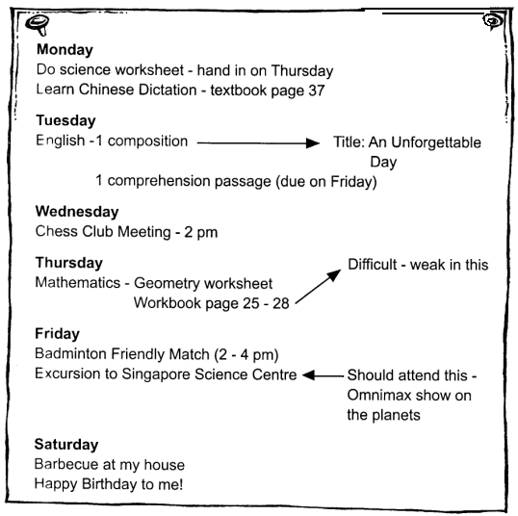

Sample Solution
Dear Samuel,

I had such a busy week! On Monday, I had to do a science worksheet which had to be handed in on Thursday. I also had Chinese dictation to learn for a test. On Tuesday, I wrote a composition titled "An Unforgettable Day" and did a comprehension passage. On Wednesday, I attended a chess club meeting at 2 pm. Doing my geometry homework was difficult for me because I am weak at geometry. I also had to do four pages of the maths workbook on Thursday. Today, I was going to play a friendly badminton match, but I decided to go on an excursion to the Singapore Science Centre instead. I wanted to watch a documentary on the planets at the Omnimax Theatre. I cannot wait for tomorrow to come because it is my birthday! Remember to come to my house for a barbecue. See you!

Gabriel

Question 201
QuestionID: 183
Question Type: Situational
Question Category: Email

Refer to the journal entry below.

You have set yourself target grades and drawn up a plan to improve your performance in the semestral examination.

Write an email to your best friend, Jacob, telling him about your plans to do better, and asking him whether he wants to study with you.

You should refer to the journal entry when writing your email.

In your email, include the following information:
- your target grades for the semestral examination
- what you plan to do in class
- how you plan to improve your grades for all subjects
- a request to Jacob to help you in your weakest subject
- what you intend to do to keep yourself healthy and fit

You may reorder the points. You should write in complete sentences.

Sample Solution
Dear Jacob,

After receiving my Continual Assessment results, I hope to improve by at least a grade for each subject in the Semestral Assessment examination. I shall listen attentively in class, and ask more questions in order to clear any doubts. I have also decided to do more exercises for all subjects, especially for English and mathematics. Would you be prepared to study with me? That would be great, because I need your help in mathematics. I also intend to jog at least twice a week to keep fit and healthy. Would you like to join me? Please let me know.

Oliver

Question 202
QuestionID: 185
Question Type: Situational
Question Category: Letter

Refer to the notice below.

You have a cousin, Heidi, who lives in Begonia Estate.

Write a letter to Heidi, tellling her about the recycling project and asking her to participate.

You should refer to the notice when writing your letter.

In your letter, include the following information:
- what project your school is launching
- what the pupils are required to do
- the days and times of collection
- the objectives of the project
- what your cousin can do to help you

You may reorder the points. You should write in complete sentences.
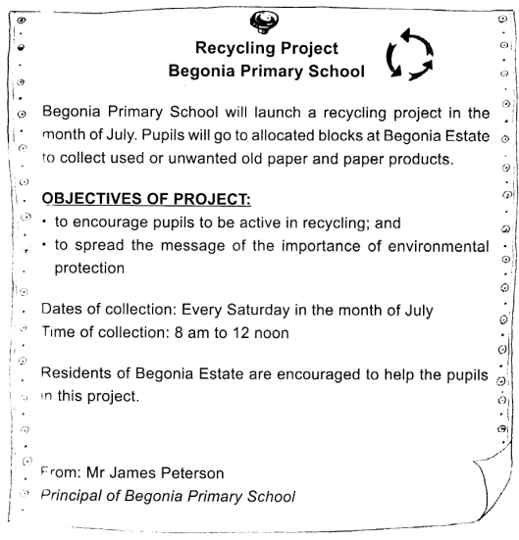

Sample Solution
Dear Heidi,

My school is launching a recycling project during the month of July. We will be going round the Begonia Estate to collect unused and unwanted old paper and paper products. Collection will take place every Saturday in the month of July from 8 am to 12 noon.

Through this project, my school principal, Mr James Peterson, hopes that we will become active in recycling. He also wants us to understand the importance of environmental protection.

Being a resident of Begonia Estate yourself, I hope that you will help me in this project by giving me your unwanted paper. I shall drop by your flat one of these Saturdays. Thank you!

Cindy

Question 203
QuestionID: 187
Question Type: Situational
Question Category: Email

Below is a notice that you found in your letterbox.

Stephen Lee is your classmate, and you want to help him to get his wallet back.

Write an email to your friend, Karen, telling her about the lost wallet.

You should refer to the notice when writing your email.

In your email, include the following information:
- where and when the wallet was lost
- a description of the wallet
- what important documents it contains
- how to contact the owner
- how your friend might be of help

You may reorder the points. You should write in complete sentences.

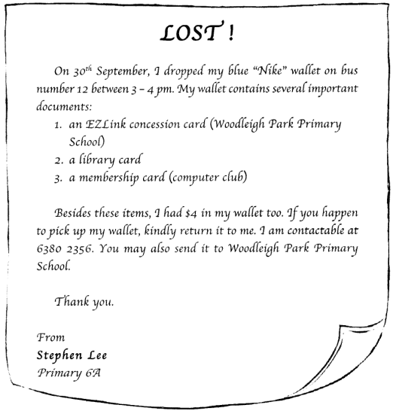

Sample Solution
Dear Karen,

I have a classmate by the name of Stephen Lee who lost his wallet on 30th September. He was travelling on the number 12 bus between three and four in the afternoon. I know you take the same bus. I wonder if you happen to have seen a blue "Nike" wallet. The wallet contains an EZLink concession card with "Woodleigh Park Primary School" printed on it. There is also a library card, a computer club membership card, and the small sum of $4. Perhaps you can help Stephen by keeping a lookout for it. Should you have any news, you can contact him at 6380 2356 or inform the staff at my primary school. I hope to hear good news from you soon!

Christopher

Question 204
QuestionID: 189
Question Type: Situational
Question Category: Letter

Below is a page from a booklet.

You intend to enrol in one of the music classes.

Write a letter to your friend, Shirley, telling her about your plan to learn a new instrument and what decision you have made.

You should refer to the page from the booklet when writing your letter.

In your letter, include the following information:
- where the music classes are held
- the types of music class offered
- how some time-slots and lessons clash with your time-table
- which class you have decided to choose
- why you have made that choice

You may reorder the points. You should write in complete sentences.

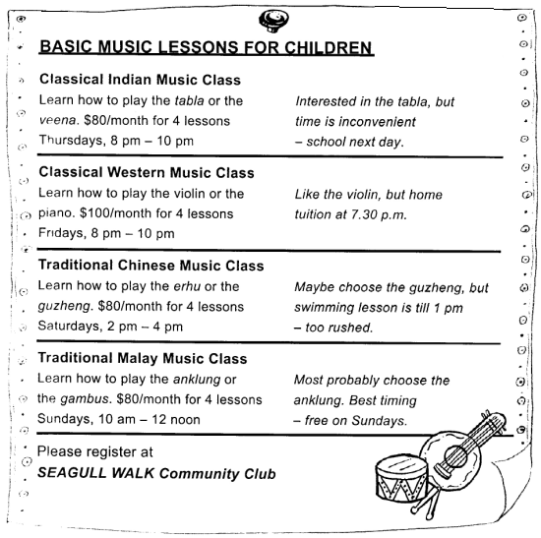

Sample Solution
Dear Shirley,

I read in a booklet that Seagull Walk Community Club is offering basic music lessons for children aged 10 years and above. There are Indian classical music classes on the tabla and the veena. I am interested in the former, but the time is inconvenient at 8 pm on Thursdays. I would not want to be tired for school the next day. I prefer the violin to the piano for the classical western music class. Unfortunately, I have home tuition at 7.30 pm, so I can't choose the violin class, which starts at 8 pm. As for the traditional Chinese music class, I would like to take the guzheng class, held on Saturdays, but I have swimming lessons till 1 pm. I don't think I will be able to get to class on time at 2 pm. I have made my final decision to learn the anklung, and not the gambus, for the traditonal Malay Music class. It has the best timing at all, at 10 am every Sunday. Now, I am looking forward to starting my music lessons!

Marie

