
2026

ATTENDEE WORKBOOK
Monday, September 14, 2026
The Statler
1914 Commerce Street, Dallas, TX 75201

Welcome

Welcome to We Run on EOS® North Texas. Today we come together as an EOS community — entrepreneurs, leadership teams, and the Implementers who serve them — to sharpen our tools, share what’s working, and get better at running our businesses.
If you’re running on EOS, this day is designed to make you stronger. World-class speakers. Practical workshops. Books you can actually use on Monday morning. And a room full of North Texas leaders who are on the same journey.
If you’re just getting started, welcome. You picked a great day to see what happens when a whole community rallies around one operating system. Ask questions. Take notes. Introduce yourself to the person next to you.
A few suggestions to make the most of the day:
- Use this workbook. Every session has space for the ideas that hit you hardest.
- Talk to the sponsors. They’re here because they believe in EOS and want to help you win.
- Introduce yourself to at least three people you don’t know. Business is a team sport.
- Stick around for the Happy Hour. Some of the best conversations of the day happen there.

Here’s to a great day — stronger teams, healthier companies, and clearer visions.

Let’s get to work.

— The North Texas EOS Implementer Community

“Vision without traction is merely hallucination.”
— Gino Wickman, Traction

Agenda

Monday, September 14, 2026 · The Statler

TIME | SESSION | PRESENTER | PAGE
7:30 – 8:00 AM | Coffee, Snacks & Registration
8:00 – 9:35 AM | Get a Grip on your Business with EOS | Ann Sheu  Certified EOS Implementer | 4
9:35 – 9:50 AM | Break
9:50 – 10:40 AM | Journey with an EOS Implementer | Brian Dosal  Strety | 5
10:40 – 10:55 AM | Break
10:55 – 11:55 AM | Your Sales Team Isn’t the Problem. Your System Is. | Steve Heroux  The System of Selling | 6
11:55 – 1:00 PM | Lunch and Learn: Healthy Matters | Walt Brown  EOS Worldwide Head Coach | 7
1:00 – 1:10 PM | Break
1:10 – 2:40 PM | Profit Power: Stronger — or Just Bigger? | Mark Stanley  Expert EOS Implementer | 12
2:40 – 2:55 PM | Break
2:55 – 4:25 PM | Rollout, Reworked: Your Plan for Running EOS® Company-Wide | Beth Fahey  Expert EOS Implementer | 16
4:25 – 4:45 PM | Break
4:45 – 6:15 PM | The 10 Pillars of Visionary Greatness | Mark C. Winters  Expert EOS Implementer | 36
6:15 – 8:00 PM | Happy Hour + Networking | Ninety.io

NETWORKING & REFLECTION
Capture the people, ideas, and moments you don’t want to forget.
CONNECTIONS
NAME | BUSINESS | ROLE | PHONE | EMAIL
TABLE-MATES
NAME | BUSINESS | ROLE | PHONE | EMAIL
GOLD NUGGETS

MY NOTES · GET A GRIP ON YOUR BUSINESS WITH EOS
8:00 – 9:35 AM · Ann Sheu (Certified EOS Implementer)

“Do you have a grip on your business, or does your business have a grip on you?”
— Gino Wickman, Traction
1. Rate your grip on the business today, 1 to 10. What is the one thing that would move it a full point?
2. Of the Six Key Components (Vision, People, Data, Issues, Process, Traction), which is weakest in your company? What is that weakness costing you every month?
3. Where are you hitting the ceiling right now: the whole company, one department, or you personally?
4. What are you holding onto that you would have to let go of for the business to grow past you?
ACTION:
My To Do from this session is: _____________________________________________ Due Date: ______________

MY NOTES · JOURNEY WITH AN EOS IMPLEMENTER
9:50 – 10:40 AM · Brian Dosal (Strety)

“Let go of the vine.”
— Gino Wickman, Traction
1. What has an Implementer, a peer, or this room already told you that you have not acted on? What is really stopping you?
2. Who on your leadership team is watching the journey instead of rowing? What conversation are you avoiding with them?
3. Twelve months from today, what will your team say is different about you, not just the company?
4. If you are self-implementing, where has “good enough” quietly become the standard?
ACTION:
My To Do from this session is: _____________________________________________ Due Date: ______________

MY NOTES · YOUR SALES TEAM ISN’T THE PROBLEM. YOUR SYSTEM IS.
10:55 – 11:55 AM · Steve Heroux (The System of Selling)

“Systemize the predictable so you can humanize the exceptional.”
— Isadore Sharp, Founder of Four Seasons
1. If your top salesperson walked out today, how much of your sales process walks out with them?
2. Is your sales process documented, simplified, and followed by all? Or do you have as many sales processes as you have reps?
3. Which leading indicators sit on your sales Scorecard? Would they have warned you a quarter ago about this quarter’s number?
4. Where does your pipeline leak: lead generation, qualifying, proposal, close, or the handoff to operations? Name the root cause, not the symptom.
ACTION:
My To Do from this session is: _____________________________________________ Due Date: ______________

MY NOTES · LUNCH AND LEARN: HEALTHY MATTERS
11:55 AM – 1:00 PM · Walt Brown (EOS Worldwide Head Coach)

“The single greatest advantage any company can achieve is organizational health.”
— Patrick Lencioni, The Advantage
1. Walt’s seven questions: Do I belong? Do I believe? Am I accountable? Am I measured? Am I heard? Am I developed? Am I balanced? Which one gets the weakest yes from your people today?
2. Is your leadership team healthy, or just polite? What Issue has been sitting on the list because nobody wants to enter the danger?
3. Are you running EOS for your people or to your people? How would they answer that?
4. Whose future is aligned with yours? Who on your team would you struggle to say that about?
ACTION:
My To Do from this session is: _____________________________________________ Due Date: ______________
SESSION
1:10 – 2:40 PM
Profit Power: Stronger — or Just Bigger?

PRESENTED BY
Mark Stanley
Expert EOS Implementer®
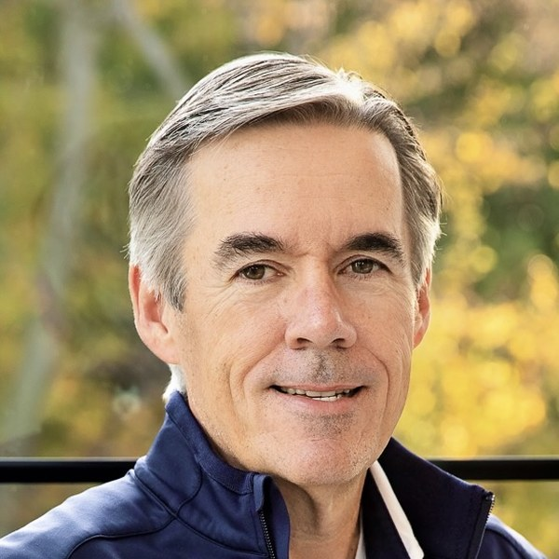 | One of the first EOS® Implementers in the world (2009) and now an Expert EOS Implementer with 1,700+ full-day sessions across 180+ leadership teams. Co-author of The Data Book, co-founder of the UNSTOPPABLE! Data-Driven Leader community, and a three-time entrepreneur. Brings a Theory of Constraints, Lean, and Six Sigma toolkit — plus a bias for action — to every session. BBA (Iowa), MBA (Drake). Lives in Johnston, Iowa.
MY NOTES · PROFIT POWER: STRONGER — OR JUST BIGGER?

MY NOTES · PROFIT POWER: STRONGER — OR JUST BIGGER? (continued)

“Everyone has a number.”
— Gino Wickman, Traction
1. Without looking, write your five numbers: Revenue, Directly Variable Costs, Gross Profit, OPEX, Net Profit. Which one did you have to guess?
2. Of the 7 Power Moves, which one would your team call impossible? Is it impossible, or just uncomfortable?
3. If you raised prices 1% tomorrow, who would actually notice? What would it add to gross profit?
4. What is your First Move Monday, who owns it, and which Scorecard number turns red if it stalls?
ACTION:
My To Do from this session is: _____________________________________________ Due Date: ______________
SESSION
2:55 – 4:25 PM
Rollout, Reworked: Your Plan for Running EOS® Company-Wide

PRESENTED BY
Beth Fahey
Expert EOS Implementer®
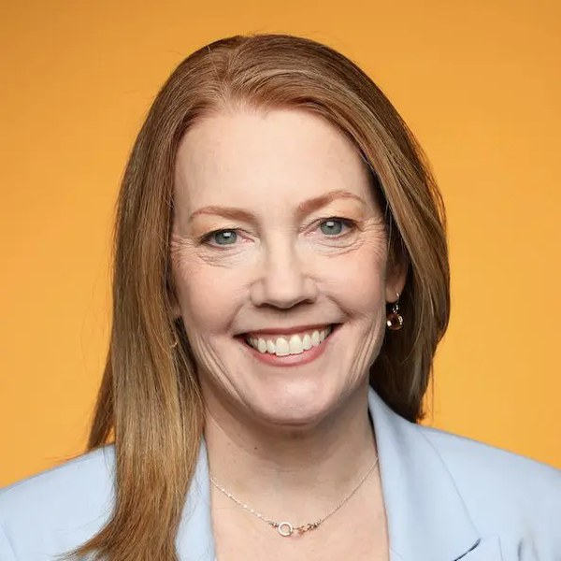 | Expert EOS Implementer® with 500+ client sessions and an EOS Worldwide Coach who trains other Implementers. Co-author of ROLLOUT: Get Your Entire Team Running on EOS® to Achieve Your Vision, and co-creator of the Great Boss™ Workshops with René Boer — more than 40 workshops delivered to thousands of managers. Host of the Bad Boss Confessional podcast. Founder-first perspective: she built a bakery, ran it on EOS, and led the Retail Bakers of America before going full-time as an Implementer. Based in the Chicago area.
MY NOTES · ROLLOUT, REWORKED: YOUR PLAN FOR RUNNING EOS® COMPANY-WIDE

MY NOTES · ROLLOUT, REWORKED: YOUR PLAN FOR RUNNING EOS® COMPANY-WIDE (continued)

“People copy what they see, not what they hear.”
— Rollout Troubleshooting Guide, Marisa Smith and Beth Fahey
1. Could every person in your company explain your Core Values and Core Focus without notes? If not, who owns fixing that, and is it a Rock?
2. Which Rollout stage are you actually in: Preparation, Launch, Integration, or Sustainability? What is the next NO on the tracker you need to turn into a YES?
3. Which of the 10 troubleshooting issues is alive in your company right now? What is the root cause, not the symptom?
4. Which of your managers would say EOS is being done to them? What did leadership do, or fail to do, that created that?
ACTION:
My To Do from this session is: _____________________________________________ Due Date: ______________
SESSION
4:45 – 6:15 PM
The 10 Pillars of Visionary Greatness

PRESENTED BY
Mark C. Winters
Expert EOS Implementer®
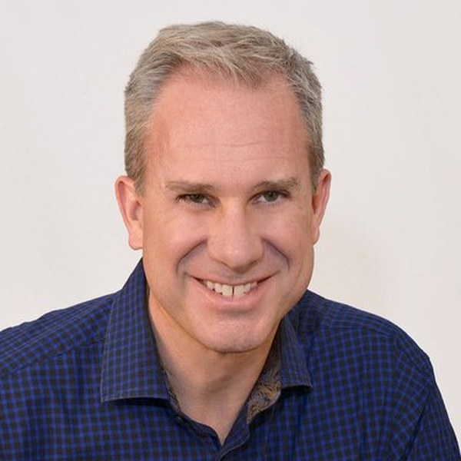 | Expert EOS Implementer® since 2012 with 1,000+ full-day sessions delivered. Author of Visionary and co-author of Rocket Fuel with EOS founder Gino Wickman — the definitive book on the Visionary/Integrator partnership. Founder and Visionary of Rocket Fuel University and host of the Rocket Fuel Podcast. Serial entrepreneur (14 companies started, bought, sold, or shut down) with one exit at a 100x cash return in under three years. MBA from The University of Chicago. Based in Dallas.
MY NOTES · THE 10 PILLARS OF VISIONARY GREATNESS

MY NOTES · THE 10 PILLARS OF VISIONARY GREATNESS (continued)

“Structure fuels freedom.”
— Mark C. Winters, Visionary
1. Know Thyself ★ Where does your Intrinsic Genius (Competence × Joy × Drive) actually live, and what share of last week did you spend there?
2. Maintain Warrior Shape ★ Which lever is red on your personal Scorecard right now: Body, Mind, or Spirit? What is the one habit that turns it green?
3. Surround Yourself ★ Which of your Seven Special Posts is empty or weak: Integrator, Leadership Team, Assistant, Coaches and Advisors, Peer Group, Family, Friends?
4. Commit to Your Operating System ★ Have you chosen one operating system and committed to mastery, or are you still waffling? What does the waffling cost your team?
5. Support Your Integrator ★ Which of the Five Rules did you break most recently: Stay on the same page, No end runs, The Integrator is the tie-breaker, Owner vs. Employee, Maintain mutual respect? What did it cost your Integrator?
Integrators ★ Which rule did your Visionary break, and did you call it?
6. Think About What You Think About ★ Where are you tampering when you should be guiding?
7. Watch Out for Pitfalls ★ Where are you the bottleneck? What decision is sitting with you right now that your team is waiting on?
8. Help Others Stretch ★ Is your next big idea on the Ledge of Conceivability or in the Pit of Inconceivability? Who on your team is allowed to tell you which?
9. Go Slow to Go Fast ★ How many ideas have you put on your team’s on-ramp in the last 90 days? How many made it all the way through?
10. Do No Harm ★ When did you last make a special exception for a favorite or a family member? What did it signal to everyone else?
ACTION:
My To Do from this session is: _____________________________________________ Due Date: ______________

Your Books

Every Full Day ticket includes three hardcover books — your working library from today’s presenters.

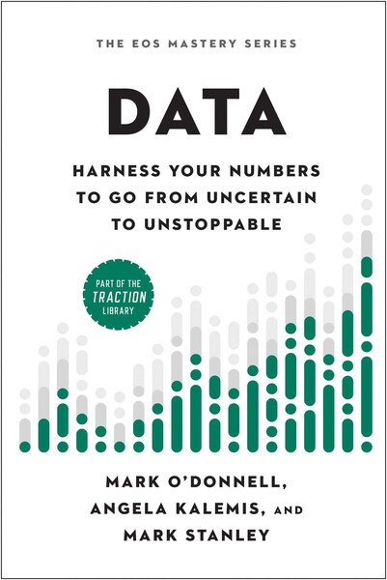 | Data  by Mark Stanley  Harness Your Numbers to Go from Uncertain to Unstoppable. A practical playbook for using data to drive decisions and accountability.

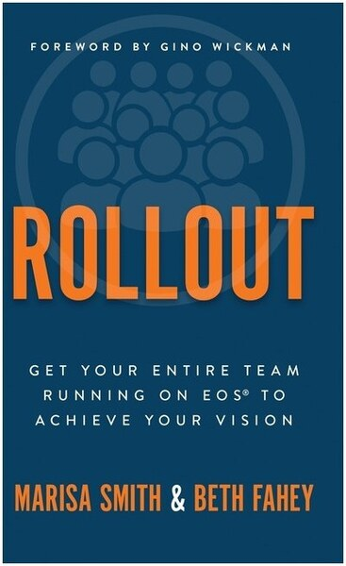 | Rollout  by Beth Fahey  Get Your Entire Team Running on EOS® to Achieve Your Vision. A field-tested guide for taking EOS deeper across your whole organization.

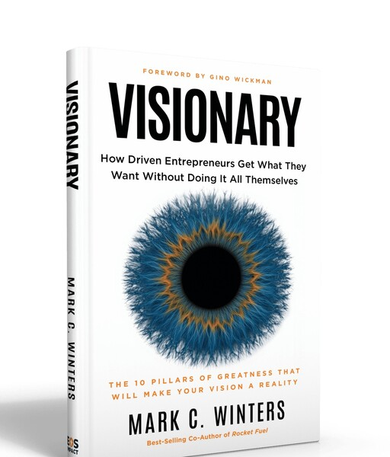 | Visionary  by Mark C. Winters  How Driven Entrepreneurs Get What They Want Without Doing It All Themselves. The Visionary/Integrator dynamic that powers great companies.

Thank You to Our Sponsors

This day is made possible by the generosity of these sponsors. Scan any QR to visit the sponsor.

Title Sponsors
    Strety | 
    The System of Selling | 

Hosted by
  North Texas EOS Implementers | 

Book Sponsors
    ProCFO Partners | 
    Titus Talent | 

Happy Hour & Lounge Sponsors
  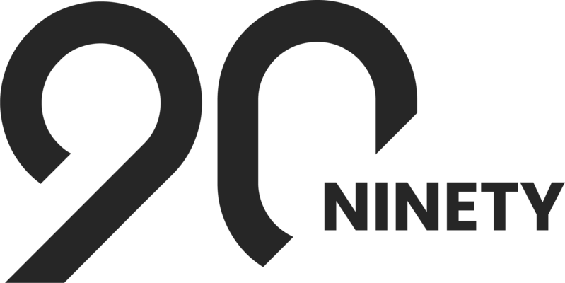  Ninety.io | 
    Vsimple | 

Swag Bag Sponsors
    Strata Wealth Advisors | 
    Success.co | 

Booth Sponsors
    360 Consulting DFW | 
  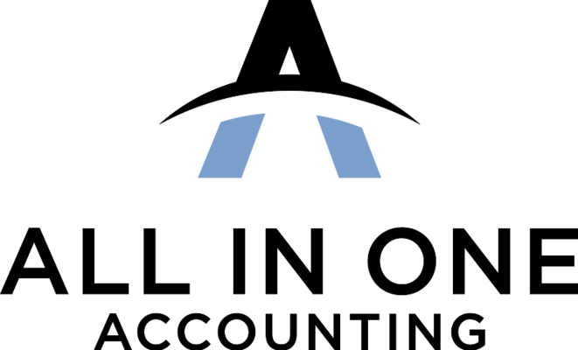  All In One Accounting | 
    Chief AI Officer | 
    Hoops HR | 
    Next Level Revenue | 
    Profit Works | 
    Talent Harbor | 
    Wolf's Edge Integrators | 
    vcfo | 

North Texas EOS Implementer® Directory

The certified EOS Implementers serving North Texas businesses. Scan any QR to view the full profile on EOSWorldwide.com.

  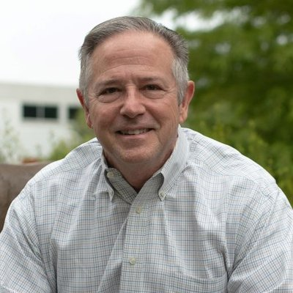 | Greg Benson  Certified EOS Implementer®  Primary: DFW | 
  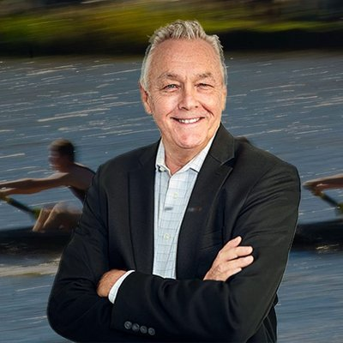 | Jim Brewer  Professional EOS Implementer®  Primary: DFW | 

  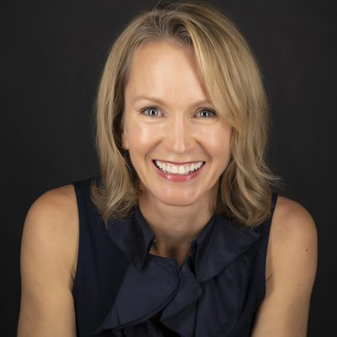 | Dawn Clarke  Expert EOS Implementer®  Primary: DFW | 
  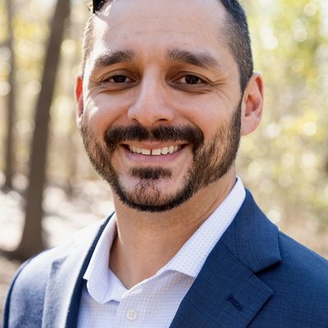 | Aaron Garcia  Professional EOS Implementer®  Primary: DFW | 

  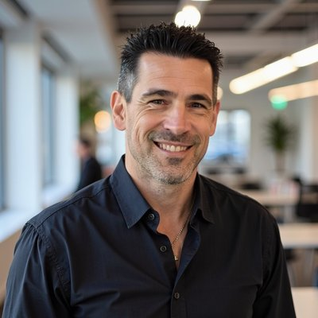 | James Hill  Professional EOS Implementer®  Primary: DFW | 
  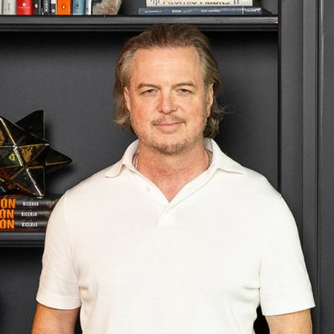 | Daniel Ignatius Himel  Certified EOS Implementer®  Primary: DFW | 

  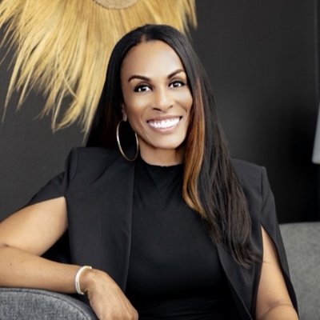 | Andrea Holmes  Professional EOS Implementer®  Primary: DFW | 
  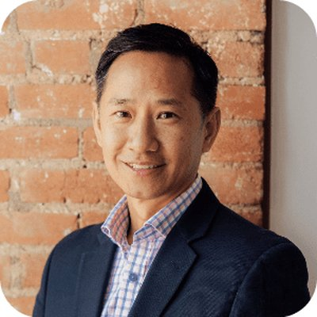 | Stewart Hsu  Professional EOS Implementer®  Primary: DFW | 

  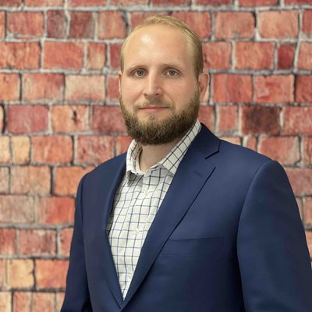 | Harrison Jenkins  Professional EOS Implementer®  Primary: DFW | 
  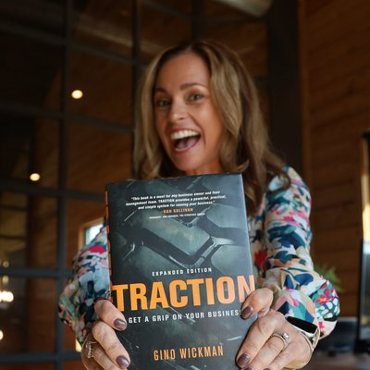 | Amy Johannesen  Certified EOS Implementer®  Primary: DFW | 

  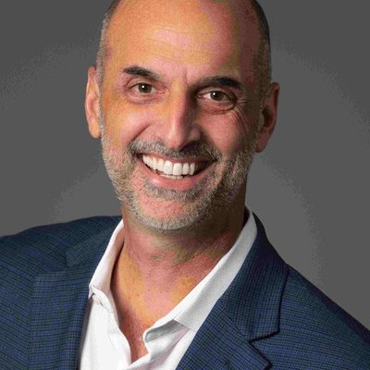 | Gary Leeman  Professional EOS Implementer®  Primary: DFW | 
  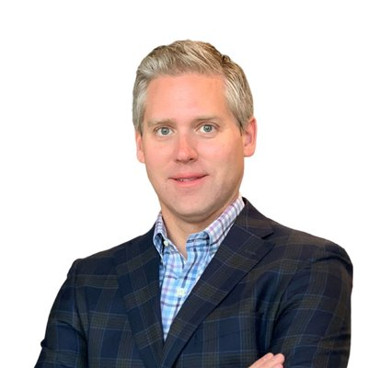 | John Lewis  Professional EOS Implementer®  Primary: DFW | 

  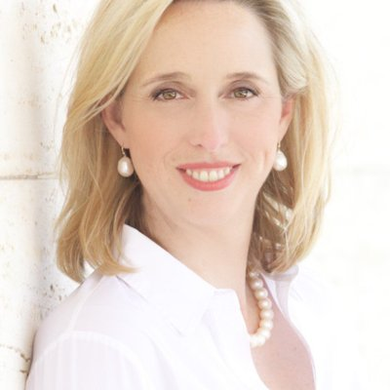 | Brooke Lively  Certified EOS Implementer®  Primary: DFW | 
  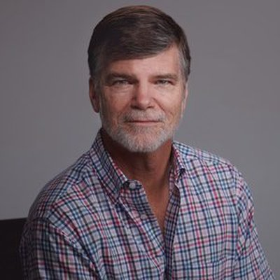 | Leonard Lynskey  Expert EOS Implementer®  Primary: DFW | 

  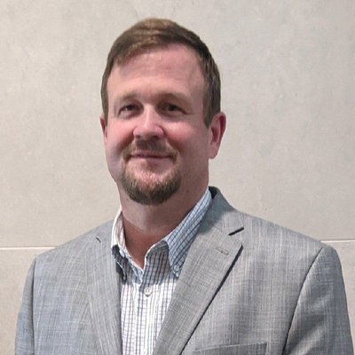 | Willard Martin  Professional EOS Implementer®  Primary: DFW  Other: Iowa | 
  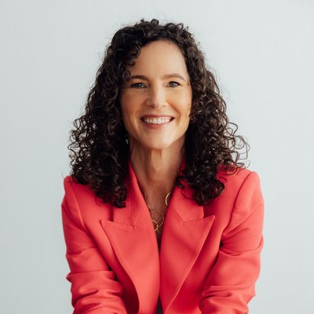 | Amanda Matthews  Certified EOS Implementer®  Primary: DFW  Other: Austin | 

  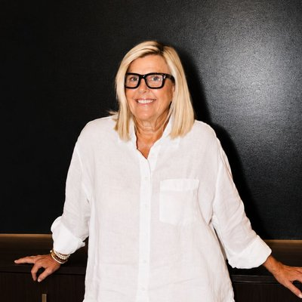 | Sally Michael  Professional EOS Implementer®  Primary: Central texas | 
  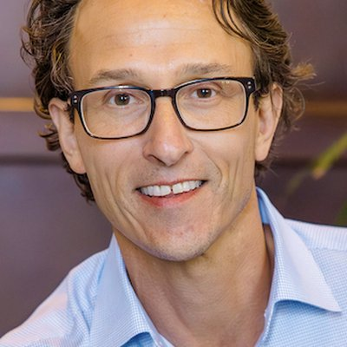 | Justin Mink  Certified EOS Implementer®  Primary: DFW | 

  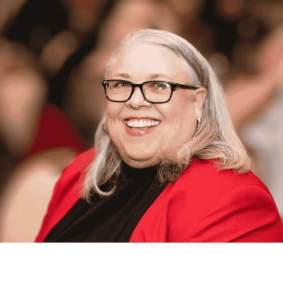 | Sandi Mitchell  Certified EOS Implementer®  Primary: DFW | 
  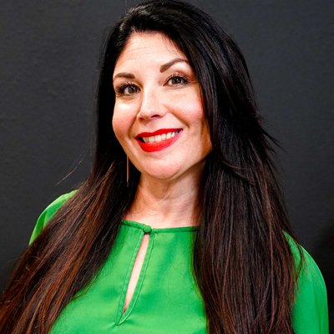 | Natalie Mitro  Professional EOS Implementer®  Primary: DFW | 

  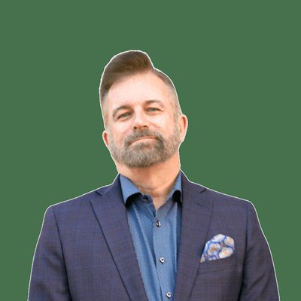 | Ray Myers  Professional EOS Implementer®  Primary: DFW | 
  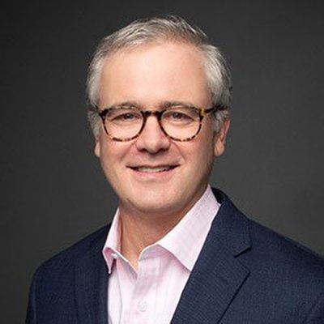 | Andrew Newsom  Certified EOS Implementer®  Primary: DFW | 

  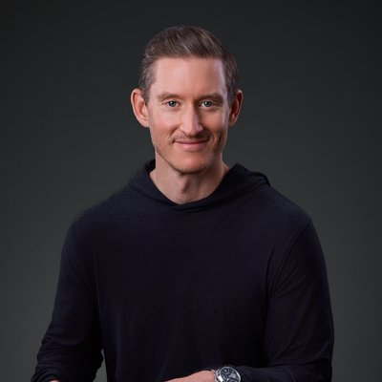 | Zachary Perry  Professional EOS Implementer®  Primary: DFW | 
  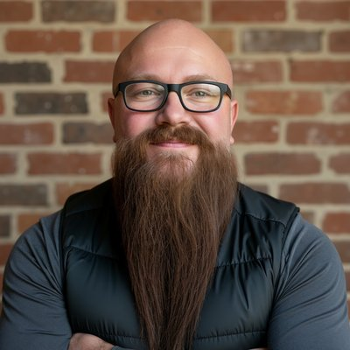 | Brian Prescott  Professional EOS Implementer®  Primary: DFW  Other: Mid-Atlantic | 

  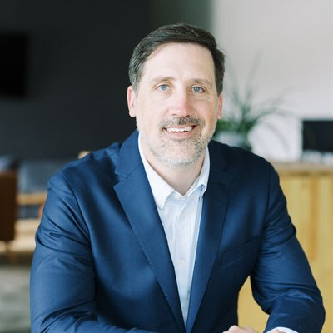 | Duke Revard  Certified EOS Implementer®  Primary: DFW  Other: Bentonville, AR | 
  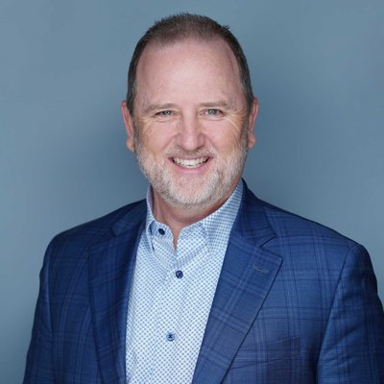 | Curtis Rippee  Certified EOS Implementer®  Primary: DFW | 

  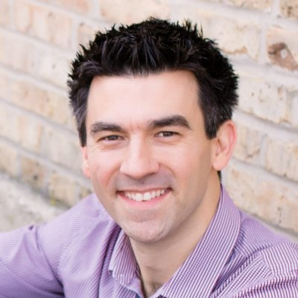 | Sean Rosensteel  Certified EOS Implementer®  Primary: DFW | 
  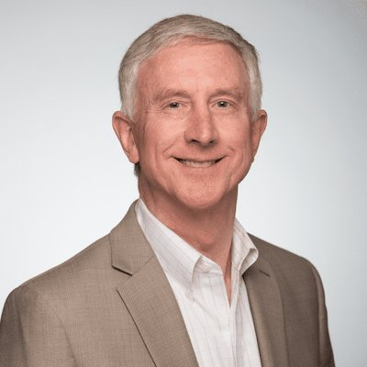 | Steven Ross  Certified EOS Implementer®  Primary: DFW | 

  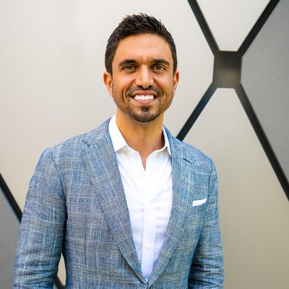 | Ray Salinas  Certified EOS Implementer®  Primary: DFW | 
  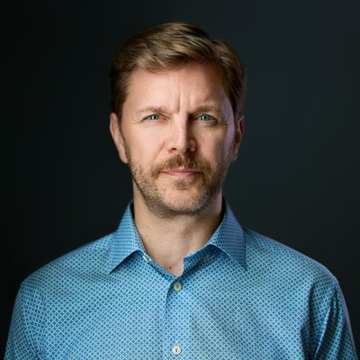 | Jeff Schafer  Certified EOS Implementer®  Primary: DFW | 

  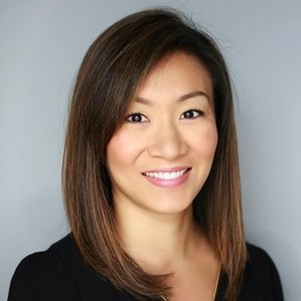 | Ann Sheu  Certified EOS Implementer®  Primary: DFW | 
  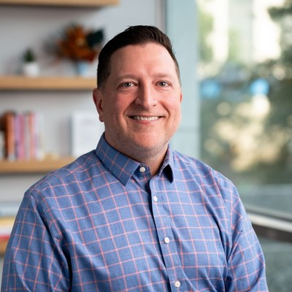 | Shane Spillers  Expert EOS Implementer®  Primary: DFW | 

  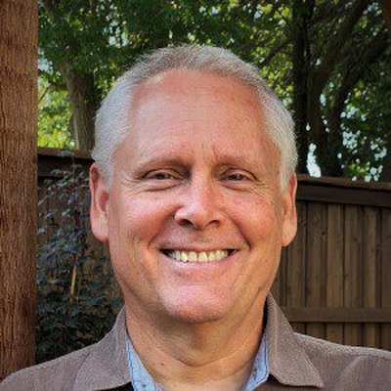 | Curt Swindoll  Certified EOS Implementer®  Primary: DFW | 
  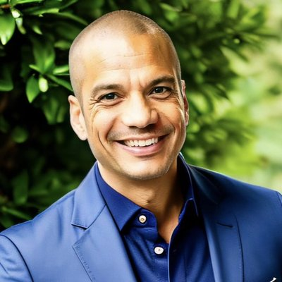 | Kevin Taylor  Professional EOS Implementer®  Primary: DFW | 

  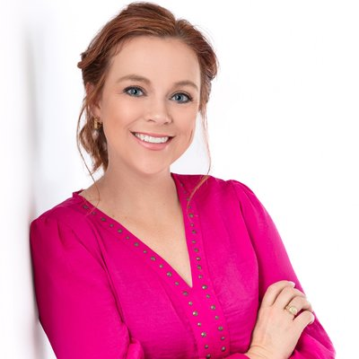 | Erin Thiem  Certified EOS Implementer®  Primary: DFW | 
  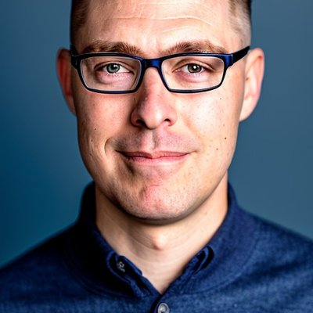 | Jarrod Upton  Professional EOS Implementer®  Primary: DFW  Other: West Texas / Midland | 

  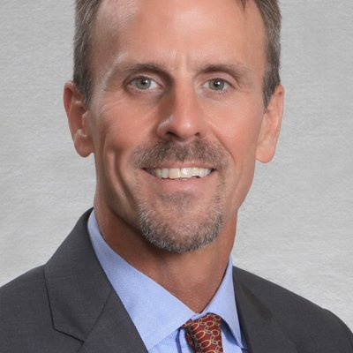 | Michael Visentine  Certified EOS Implementer®  Primary: DFW | 
  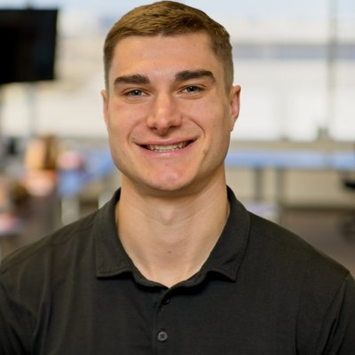 | Blake Winters  Certified EOS Implementer®  Primary: DFW | 

  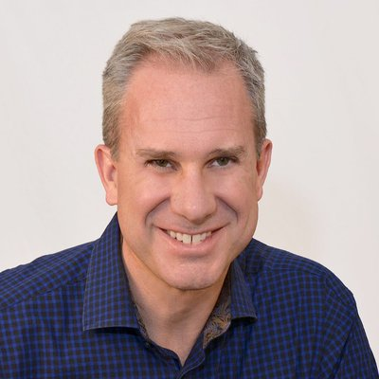 | Mark C Winters  Expert EOS Implementer®  Primary: DFW | 
  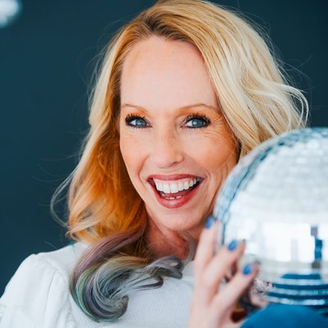 | Jill Young  Expert EOS Implementer®  Primary: DFW | 

Thank You

See y’all next year.
EOSNorthTexas.com

Feedback Form

