FIFTH ANNUAL
WE RUN ON
EOS® NORTH TEXAS
2026

ATTENDEE WORKBOOK
Monday, September 14, 2026
The Statler Dallas
1914 Commerce Street, Dallas, TX 75201

Welcome

[Welcome letter — coming soon]

Placeholder for the opening letter from the North Texas EOS® community.

Suggested contents:
• Thanks to attendees, sponsors, and speakers
• Theme of the day / what to expect
• How to make the most of the workbook
• Sign-off from the host committee

Agenda

Monday, September 14, 2026 · The Statler Dallas

TIME | SESSION | PRESENTER
7:30 – 8:00 AM | Coffee, Snacks & Registration
8:00 – 9:35 AM | Get a Grip on your Business with EOS | Ann Sheu
9:35 – 9:55 AM | Break
9:55 – 10:45 AM | Journey with an EOS Implementer | Strety
10:45 – 11:00 AM | Break
11:00 AM – 12:00 PM | Your Sales Team Isn’t the Problem. Your System Is. | The System of Selling
12:00 PM – 1:00 PM | Lunch with Walt Brown: Healthy Matters | Walt Brown
1:00 – 2:30 PM | Profit Power: Stronger — or Just Bigger? | Mark Stanley
2:30 – 2:50 PM | Break
2:50 – 4:25 PM | Rollout, Reworked: Your Plan for Running EOS® Company-Wide | Beth Fahey
4:25 – 4:45 PM | Break
4:45 – 6:15 PM | The 10 Pillars of Visionary Greatness | Mark C. Winters
6:15 – 8:00 PM | Happy Hour + Networking | Celebrate wins. Connect. Go home fired up.
SESSION
8:00 – 9:35 AM
Get a Grip on your Business with EOS

PRESENTED BY
Ann Sheu
Certified EOS Implementer®

CONTENT
Coming soon — the presenter’s slides and key takeaways will be printed here.

ANN SHEU · CONTENT

[Content placeholder — 1 to 4 pages provided by the presenter.]

ANN SHEU · MY NOTES

SESSION
9:55 – 10:45 AM
Journey with an EOS Implementer

PRESENTED BY
Strety
Title Sponsor

CONTENT
Coming soon — the presenter’s slides and key takeaways will be printed here.

STRETY · CONTENT

[Content placeholder — 1 to 4 pages provided by the presenter.]

STRETY · MY NOTES

SESSION
11:00 AM – 12:00 PM
Your Sales Team Isn’t the Problem. Your System Is.

PRESENTED BY
The System of Selling
Title Sponsor

CONTENT
Coming soon — the presenter’s slides and key takeaways will be printed here.

THE SYSTEM OF SELLING · CONTENT

[Content placeholder — 1 to 4 pages provided by the presenter.]

THE SYSTEM OF SELLING · MY NOTES

SESSION
12:00 – 1:00 PM
Lunch with Walt Brown: Healthy Matters
Unlocking the power of Healthy. Introduction to the latest EOS Trust Builder → 7 Critical Needs.

PRESENTED BY
Walt Brown
EOS Worldwide Head Coach

CONTENT
Coming soon — the presenter’s slides and key takeaways will be printed here.

WALT BROWN · CONTENT

[Content placeholder — 1 to 4 pages provided by the presenter.]

WALT BROWN · MY NOTES

SESSION
1:00 – 2:30 PM
Profit Power: Stronger — or Just Bigger?

PRESENTED BY
Mark Stanley
Expert EOS Implementer®

CONTENT
Coming soon — the presenter’s slides and key takeaways will be printed here.

MARK STANLEY · CONTENT

[Content placeholder — 1 to 4 pages provided by the presenter.]

MARK STANLEY · MY NOTES

SESSION
2:50 – 4:25 PM
Rollout, Reworked: Your Plan for Running EOS® Company-Wide

PRESENTED BY
Beth Fahey
Expert EOS Implementer®

CONTENT
Coming soon — the presenter’s slides and key takeaways will be printed here.

BETH FAHEY · CONTENT

[Content placeholder — 1 to 4 pages provided by the presenter.]

BETH FAHEY · MY NOTES

SESSION
4:45 – 6:15 PM
The 10 Pillars of Visionary Greatness

PRESENTED BY
Mark C. Winters
Expert EOS Implementer®

CONTENT
Coming soon — the presenter’s slides and key takeaways will be printed here.

MARK C. WINTERS · CONTENT

[Content placeholder — 1 to 4 pages provided by the presenter.]

MARK C. WINTERS · MY NOTES

Your Books

Every Full Day ticket includes three hardcover books — your working library from today’s presenters.

 | Data  by Mark Stanley · Retail $20.66  Harness Your Numbers to Go from Uncertain to Unstoppable. A practical playbook for using data to drive decisions and accountability.

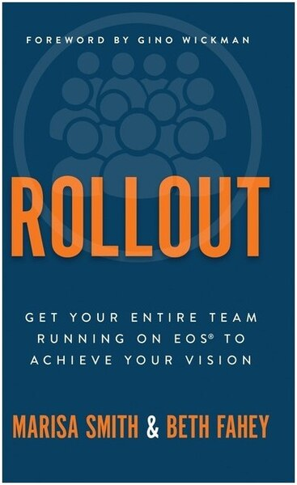 | Rollout  by Beth Fahey · Retail $29.99  Get Your Entire Team Running on EOS® to Achieve Your Vision. A field-tested guide for taking EOS deeper across your whole organization.

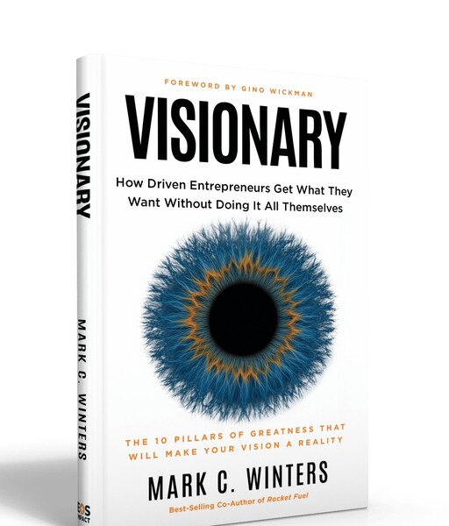 | Visionary  by Mark C. Winters · Retail $29.99  How Driven Entrepreneurs Get What They Want Without Doing It All Themselves. The Visionary/Integrator dynamic that powers great companies.

Thank You to Our Sponsors

This day is made possible by the generosity of these North Texas businesses.

Title Sponsors
  Strety  strety.com |   The System of Selling  thesystemofselling.com

Book Sponsors
  ProCFO Partners  procfopartners.com |   Titus Talent  titus-talent.com

Happy Hour Sponsor

Ninety.io
ninety.io

Lounge Sponsor

Vsimple
vsimple.com

Swag Bag Sponsors
  Strata Wealth Advisors  stratawealth.com |   Success.co  success.co

Booth Sponsors
  360 Consulting DFW  360consultingdfw.com |   All In One Accounting  allinoneaccounting.com

  Chief AI Officer  chiefaiofficer.com |   Hoops HR  hoopshr.com

  Next Level Revenue  readyforthenextlevel.com |   Profit Works  profitworksllc.com

  Talent Harbor  talentharbor.com |   Wolf's Edge Integrators  wolfsedgeintegrators.com

DFW EOS Implementer® Directory

The certified EOS Implementers serving North Texas businesses.

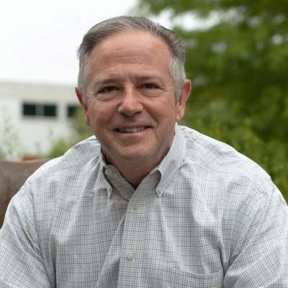 Greg Benson Certified EOS Implementer® Primary: DFW greg.benson@eosworldwide.com EOS Worldwide Profile | 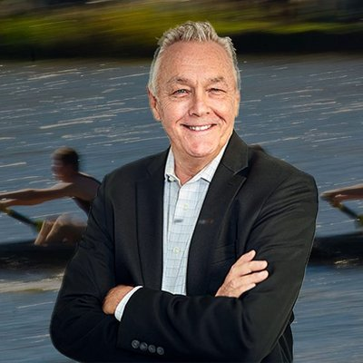 Jim Brewer Professional EOS Implementer® Primary: DFW jim.brewer@eosworldwide.com EOS Worldwide Profile

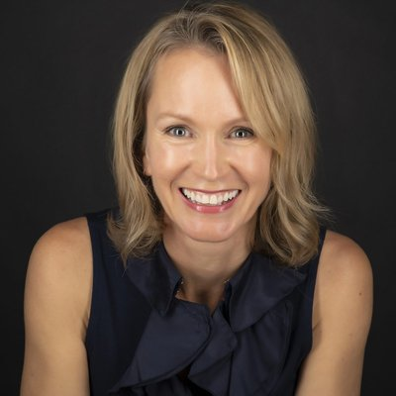 Dawn Clarke Expert EOS Implementer® Primary: DFW dawn.clarke@eosworldwide.com EOS Worldwide Profile | 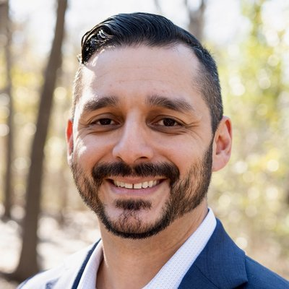 Aaron Garcia Professional EOS Implementer® Primary: DFW aaron.garcia@eosworldwide.com EOS Worldwide Profile

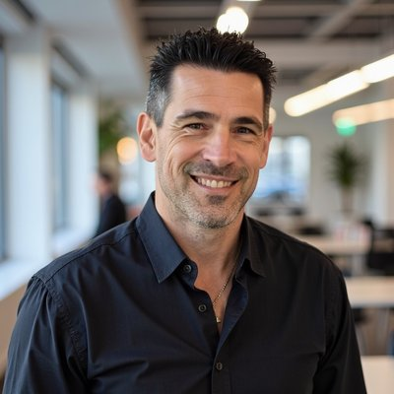 James Hill Professional EOS Implementer® Primary: DFW james.hill@eosworldwide.com EOS Worldwide Profile | 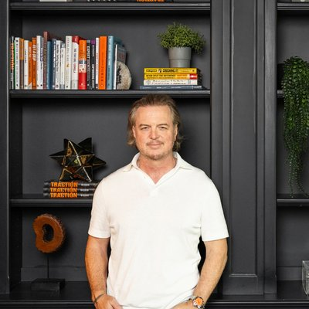 Daniel Ignatius Himel Certified EOS Implementer® Primary: DFW daniel.himel@eosworldwide.com EOS Worldwide Profile

AH Andrea Holmes Professional EOS Implementer® Primary: DFW andrea.holmes@eosworldwide.com | 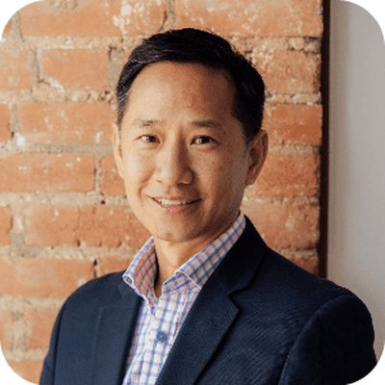 Stewart Hsu Professional EOS Implementer® Primary: DFW stewart.hsu@eosworldwide.com EOS Worldwide Profile

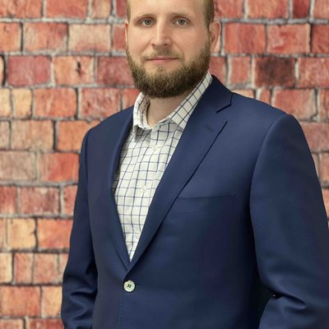 Harrison Jenkins Professional EOS Implementer® Primary: DFW harrison.jenkins@eosworldwide.com EOS Worldwide Profile | 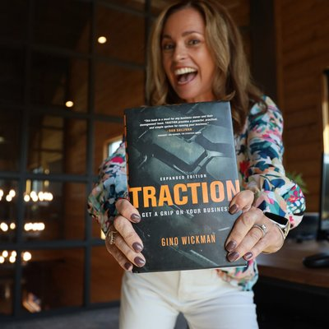 Amy Johannesen Certified EOS Implementer® Primary: DFW amy.johannesen@eosworldwide.com EOS Worldwide Profile

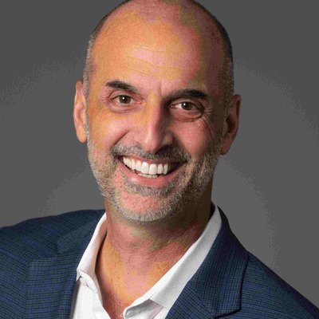 Gary Leeman Professional EOS Implementer® Primary: DFW gary.leeman@eosworldwide.com EOS Worldwide Profile | 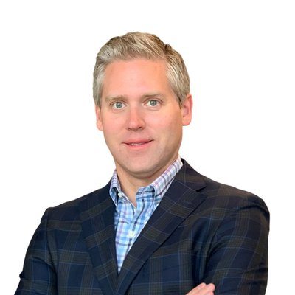 John Lewis Professional EOS Implementer® Primary: DFW john.lewis@eosworldwide.com EOS Worldwide Profile

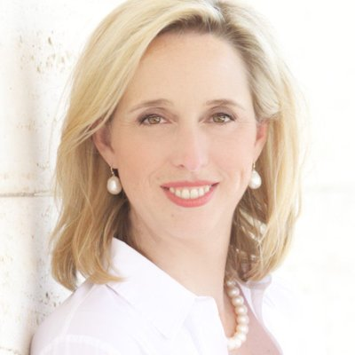 Brooke Lively Certified EOS Implementer® Primary: DFW brooke.lively@eosworldwide.com EOS Worldwide Profile | 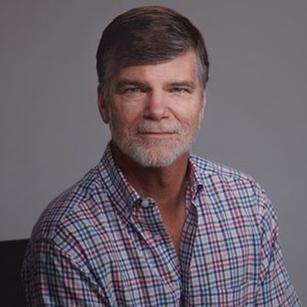 Leonard Lynskey Expert EOS Implementer® Primary: DFW leonard.lynskey@eosworldwide.com EOS Worldwide Profile

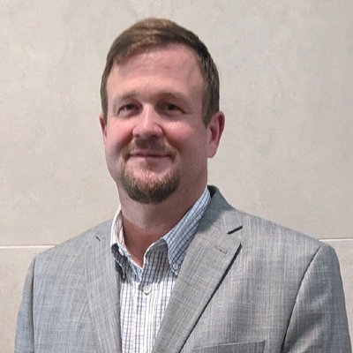 Willard Martin Professional EOS Implementer® Primary: DFW Other: Iowa willard.martin@eosworldwide.com EOS Worldwide Profile | 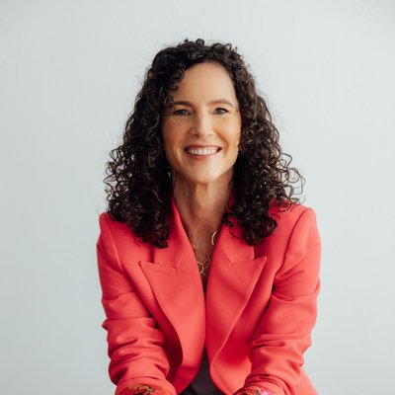 Amanda Matthews Certified EOS Implementer® Primary: DFW Other: Austin amanda.matthews@eosworldwide.com EOS Worldwide Profile

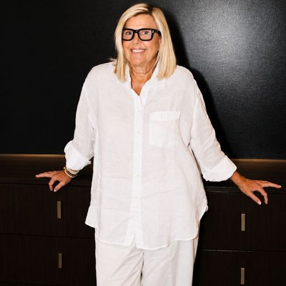 Sally Michael Professional EOS Implementer® Primary: Central texas sally.michael@eosworldwide.com EOS Worldwide Profile | 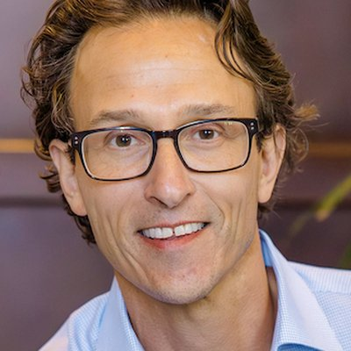 Justin Mink Certified EOS Implementer® Primary: DFW justin.mink@eosworldwide.com EOS Worldwide Profile

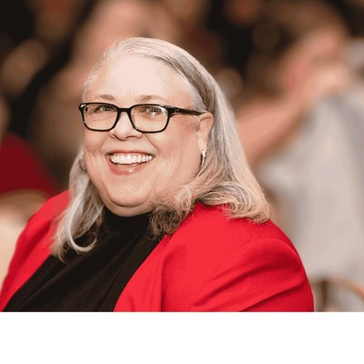 Sandi Mitchell Certified EOS Implementer® Primary: DFW sandi@apexcatalystgroup.com EOS Worldwide Profile | 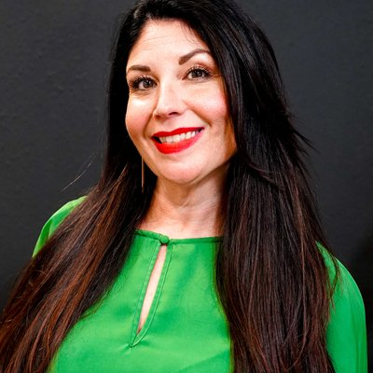 Natalie Mitro Professional EOS Implementer® Primary: DFW natalie.mitro@eosworldwide.com EOS Worldwide Profile

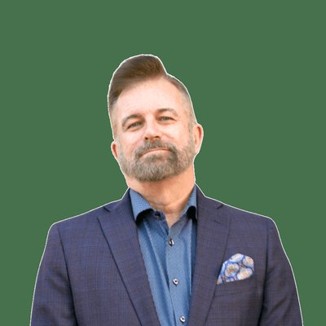 Ray Myers Professional EOS Implementer® Primary: DFW ray.myers@eosworldwide.com EOS Worldwide Profile | 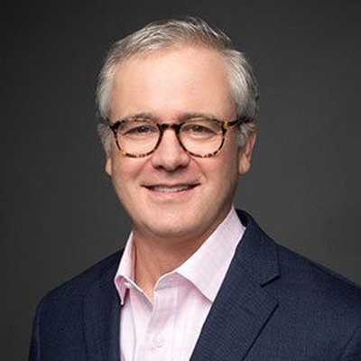 Andrew Newsom Certified EOS Implementer® Primary: DFW andrew.newsom@eosworldwide.com EOS Worldwide Profile

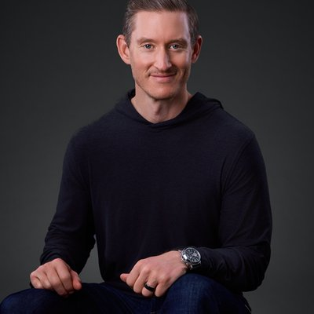 Zachary Perry Professional EOS Implementer® Primary: DFW zack.perry@eosworldwide.com EOS Worldwide Profile | 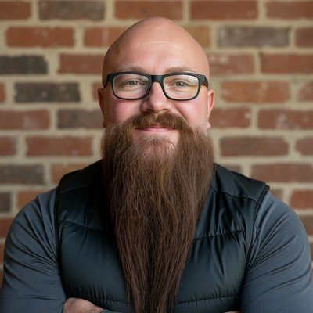 Brian Prescott Professional EOS Implementer® Primary: DFW Other: Mid-Atlantic brian.prescott@eosworldwide.com EOS Worldwide Profile

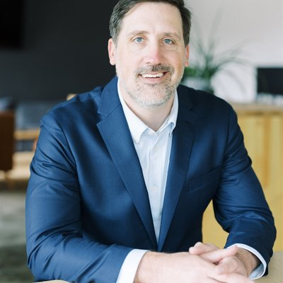 Duke Revard Certified EOS Implementer® Primary: DFW Other: Bentonville, AR duke.revard@eosworldwide.com EOS Worldwide Profile | 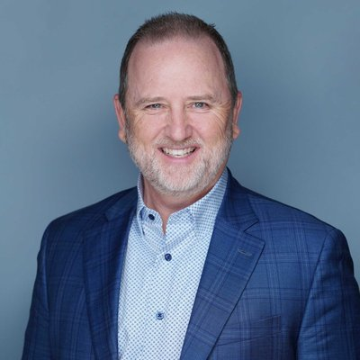 Curtis Rippee Certified EOS Implementer® Primary: DFW curtis.rippee@eosworldwide.com EOS Worldwide Profile

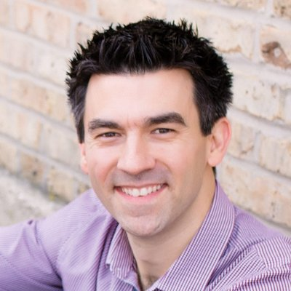 Sean Rosensteel Certified EOS Implementer® Primary: DFW sean.rosensteel@eosworldwide.com EOS Worldwide Profile | 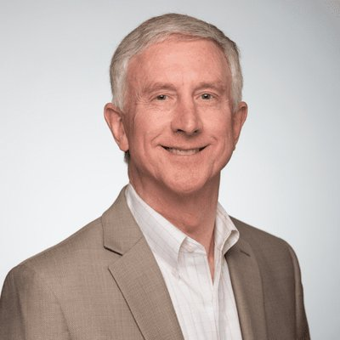 Steven Ross Certified EOS Implementer® Primary: DFW steven.ross@eosworldwide.com EOS Worldwide Profile

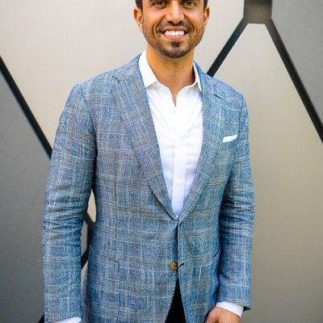 Ray Salinas Certified EOS Implementer® Primary: DFW ray.salinas@eosworldwide.com EOS Worldwide Profile | 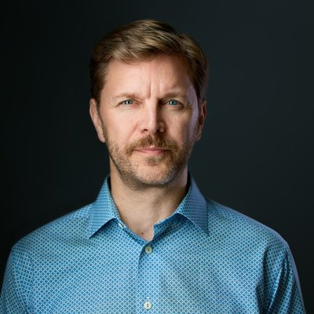 Jeff Schafer Certified EOS Implementer® Primary: DFW jeff.schafer@eosworldwide.com EOS Worldwide Profile

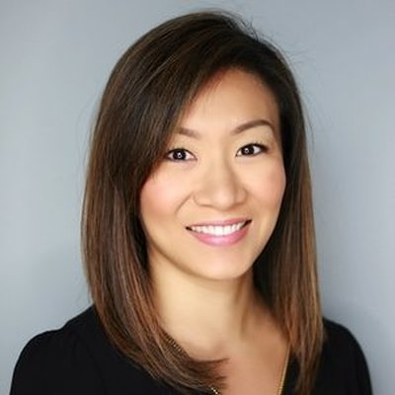 Ann Sheu Certified EOS Implementer® Primary: DFW ann.sheu@eosworldwide.com EOS Worldwide Profile | 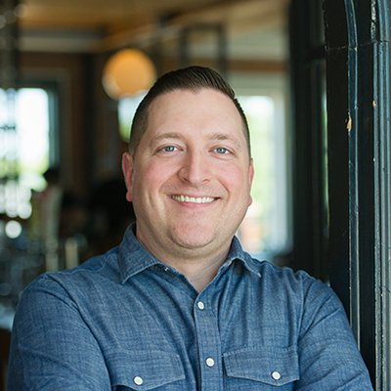 Shane Spillers Expert EOS Implementer® Primary: DFW shane.spillers@eosworldwide.com EOS Worldwide Profile

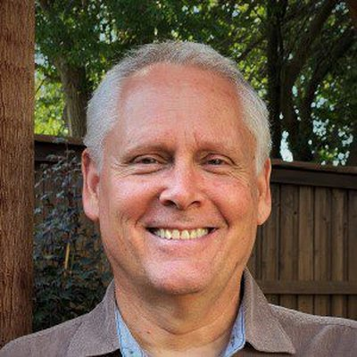 Curt Swindoll Certified EOS Implementer® Primary: DFW curt.swindoll@eosworldwide.com EOS Worldwide Profile | 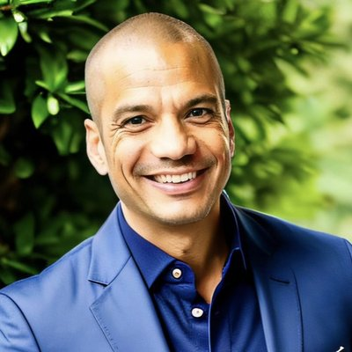 Kevin Taylor Professional EOS Implementer® Primary: DFW kevin.taylor@eosworldwide.com EOS Worldwide Profile

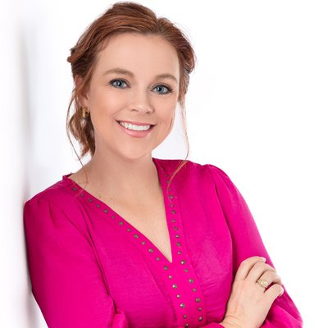 Erin Thiem Certified EOS Implementer® Primary: DFW erin.thiem@eosworldwide.com EOS Worldwide Profile | 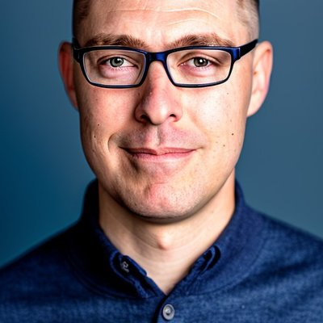 Jarrod Upton Professional EOS Implementer® Primary: DFW Other: West Texas / Midland jarrod.upton@eosworldwide.com EOS Worldwide Profile

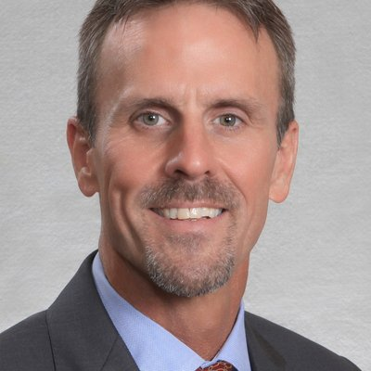 Michael Visentine Certified EOS Implementer® Primary: DFW michael.visentine@eosworldwide.com EOS Worldwide Profile | 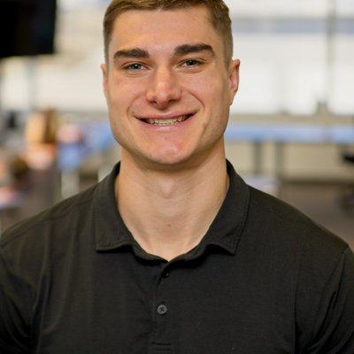 Blake Winters Certified EOS Implementer® Primary: DFW blake.winters@eosworldwide.com EOS Worldwide Profile

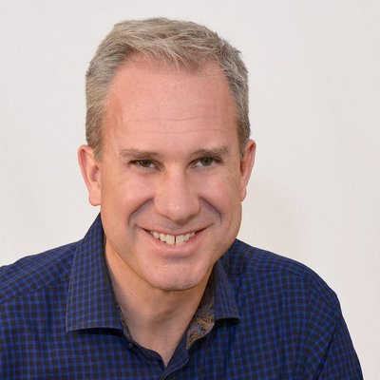 Mark C Winters Expert EOS Implementer® Primary: DFW mcw@markcwinters.com EOS Worldwide Profile | 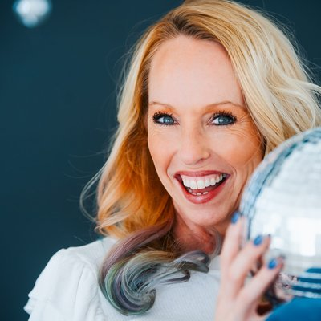 Jill Young Expert EOS Implementer® Primary: DFW jyoung@eosworldwide.com EOS Worldwide Profile

Thank You

See you next year.
EOSNorthTexas.com

