Jordan Thomas

DECEMBER 1, 2022 | CYBR410-T301

M1.2

Github REpo setup

# Deliverable 1

1. Link to your GitHub repository.

My GitHub repository can be found here: <https://github.com/TidOS/csd-310>.

# Deliverable 2

1. Screenshot of your GitHub repository

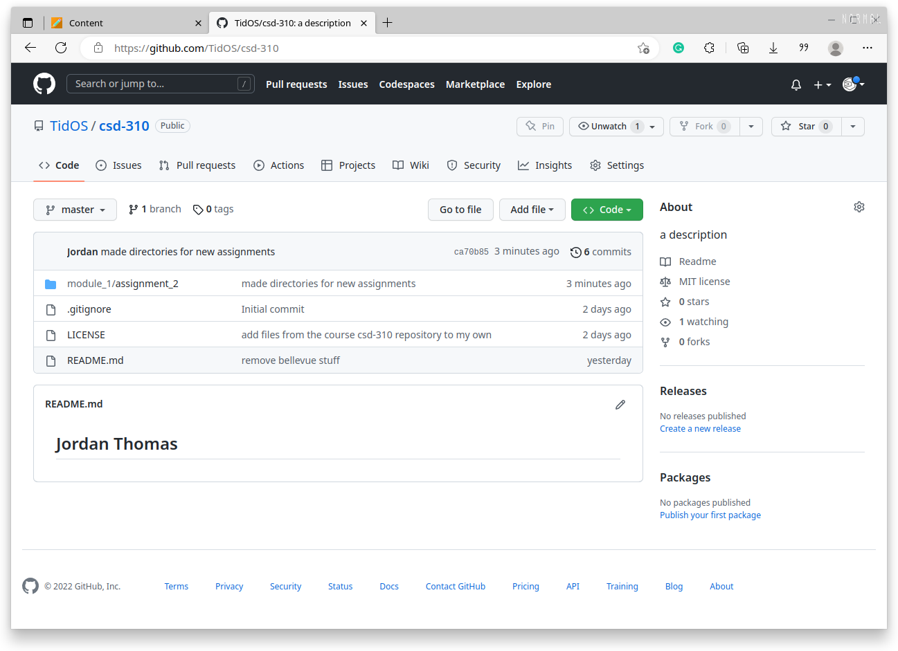

# Deliverable 3

1. Screenshot of your local directory (properly formatted).

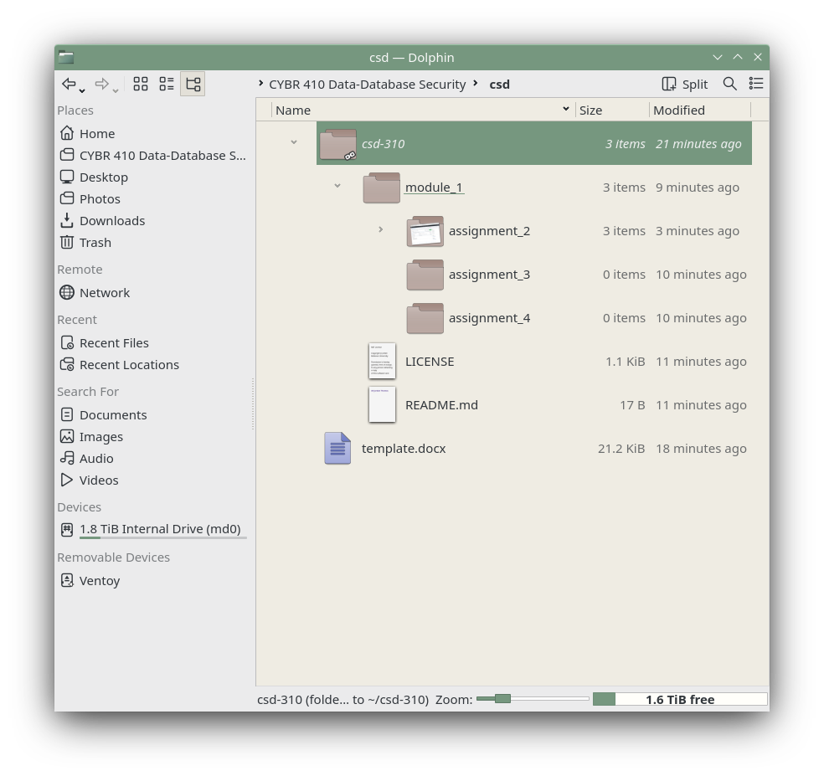

# Deliverable 4

1. Combine all 3 items into a single word document and title it <your-last-name>-<assignment-name> .docx.

See: this document