Jordan Thomas

DECEMBER 1, 2022 | CYBR410-T301

M1.3

UMLet installation

## Take a screenshot of UMLet running on your desktop

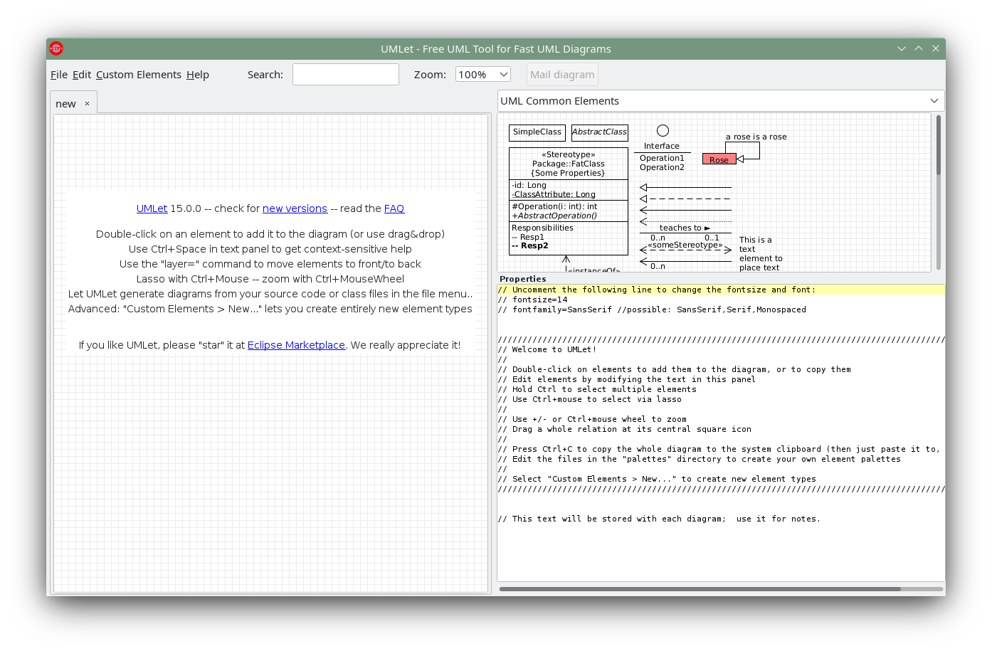

## Take a screenshot of the directory where UMLet was installed

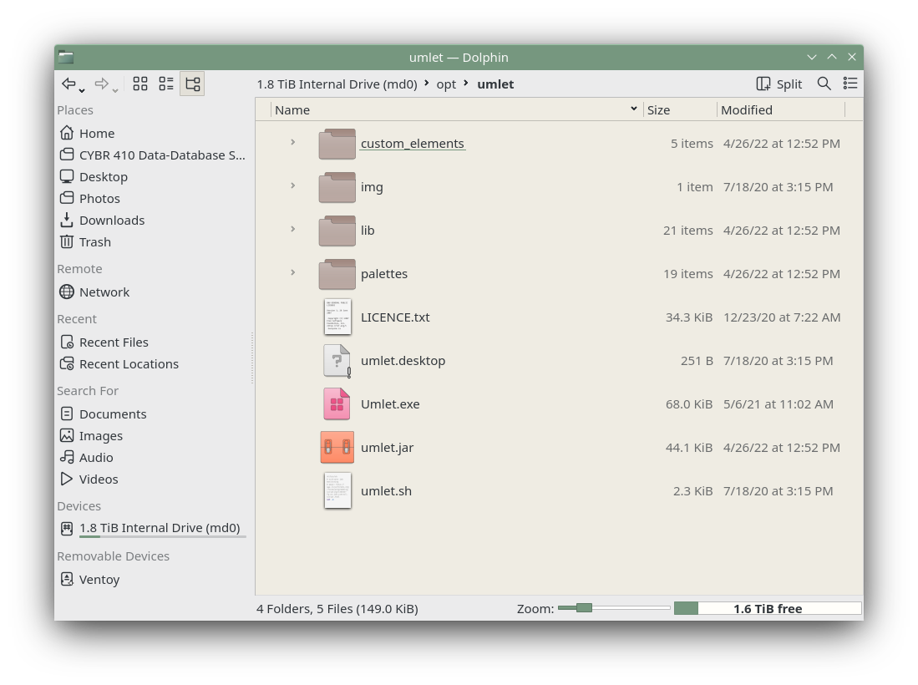

I installed UMLet to /opt/umlet and made a copy of **umlet.sh** in my PATH variable with an updated path to the installation.