Exercise 1: Control Structures
CREATE TABLE customer (
customer_id NUMBER PRIMARY KEY,
name VARCHAR2(50),
age NUMBER,
balance NUMBER,
IsVIP VARCHAR2(5) DEFAULT 'FALSE'
);

CREATE TABLE loan (
loan_id NUMBER PRIMARY KEY,
customer_id NUMBER,
interest_rate NUMBER,
due_date DATE,
FOREIGN KEY (customer_id) REFERENCES customer(customer_id)
);

INSERT INTO customer VALUES (1, 'Tanima Bose', 65, 15000, 'FALSE');
INSERT INTO customer VALUES (2, 'Kalpana Basu', 45, 8000, 'FALSE');
INSERT INTO customer VALUES (3, 'Susmita Debnath', 70, 12000, 'FALSE');
INSERT INTO customer VALUES (4, 'Gopal Mitra', 30, 5000, 'FALSE');

INSERT INTO loan VALUES (101, 1, 10.5, SYSDATE + 15);
INSERT INTO loan VALUES (102, 2, 11.0, SYSDATE + 40);
INSERT INTO loan VALUES (103, 3, 12.0, SYSDATE + 5);
INSERT INTO loan VALUES (104, 4, 9.5, SYSDATE + 10);

COMMIT;

SELECT * FROM customer;
SELECT * FROM loan;
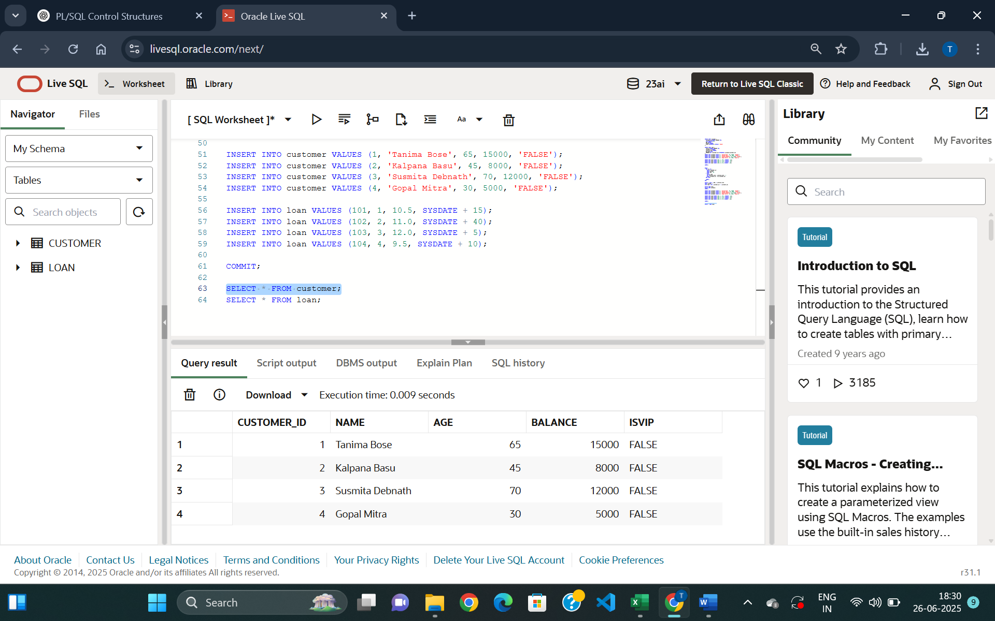
Figure 1: Customer Table Creation

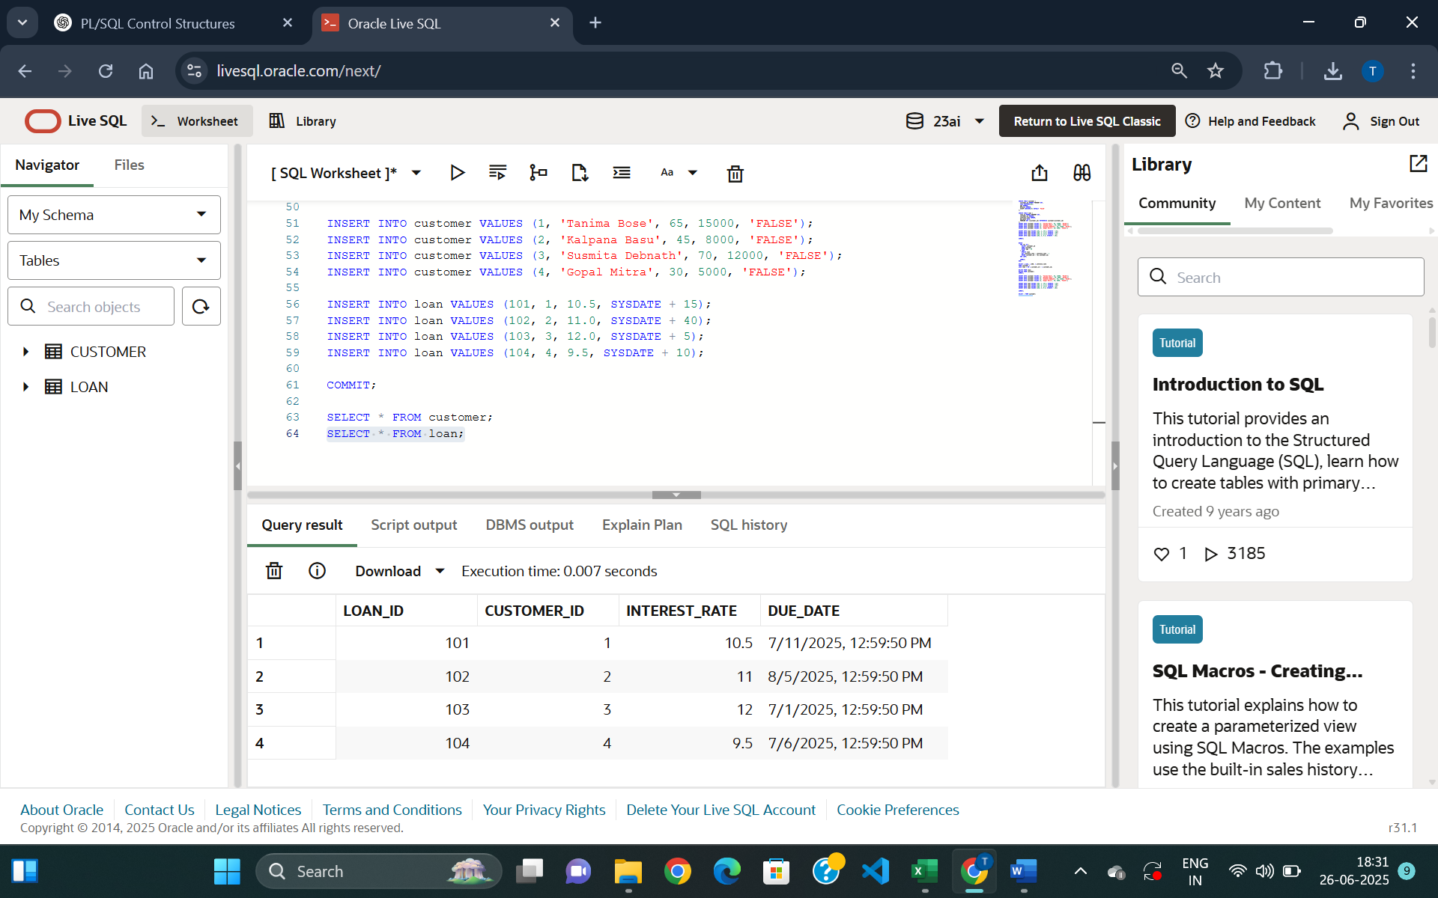
Figure 2: Loan Table Creation

Exercise 1:
Scenario 1:
The bank wants to apply a discount to loan interest rates for customers above 60 years old.

Question: Write a PL/SQL block that loops through all customers, checks their age, and if they are above 60, apply a 1% discount to their current loan interest rates

--Scenario1

BEGIN
FOR rec IN (
SELECT customer_id
FROM customer
WHERE age > 60
) LOOP
UPDATE loan
SET interest_rate = interest_rate - 1
WHERE customer_id = rec.customer_id;
END LOOP;

COMMIT;
END;

SELECT c.name, c.AGE, l.interest_rate
FROM customer c
JOIN loan l ON c.customer_id = l.customer_id;

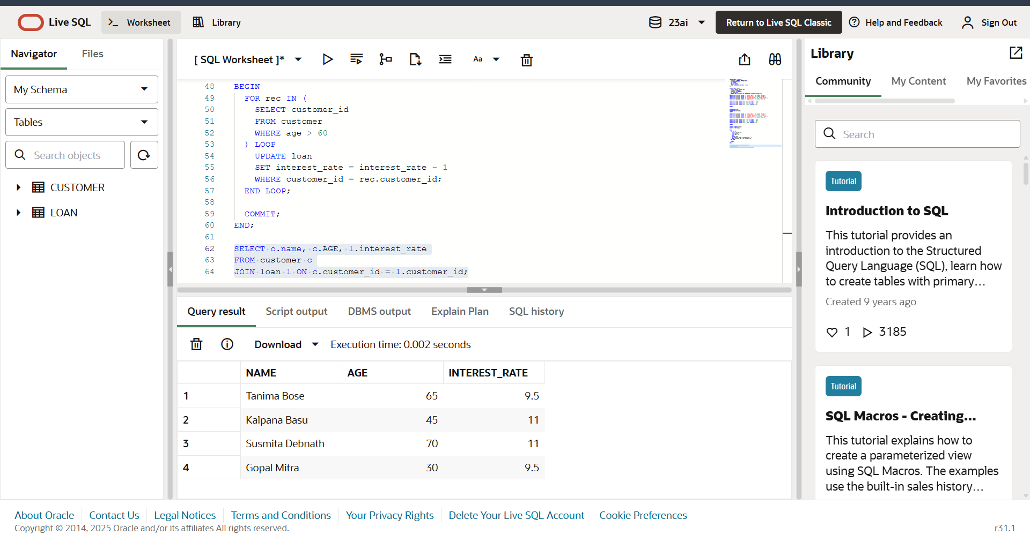
Figure 3: Applied a 1% discount to current loan interest rates for customers with age above 60

Exercise 1:
Scenario 2:
A customer can be promoted to VIP status based on their balance.

Question: Write a PL/SQL block that iterates through all customers and sets a flag IsVIP to TRUE for those with a balance over $10,000.

--Scenario2

BEGIN
FOR rec IN (
SELECT customer_id
FROM customer
WHERE balance > 10000
) LOOP
UPDATE customer
SET IsVIP = 'TRUE'
WHERE customer_id = rec.customer_id;
END LOOP;

COMMIT;
END;

SELECT customer_id, name, balance, IsVIP
FROM customer;

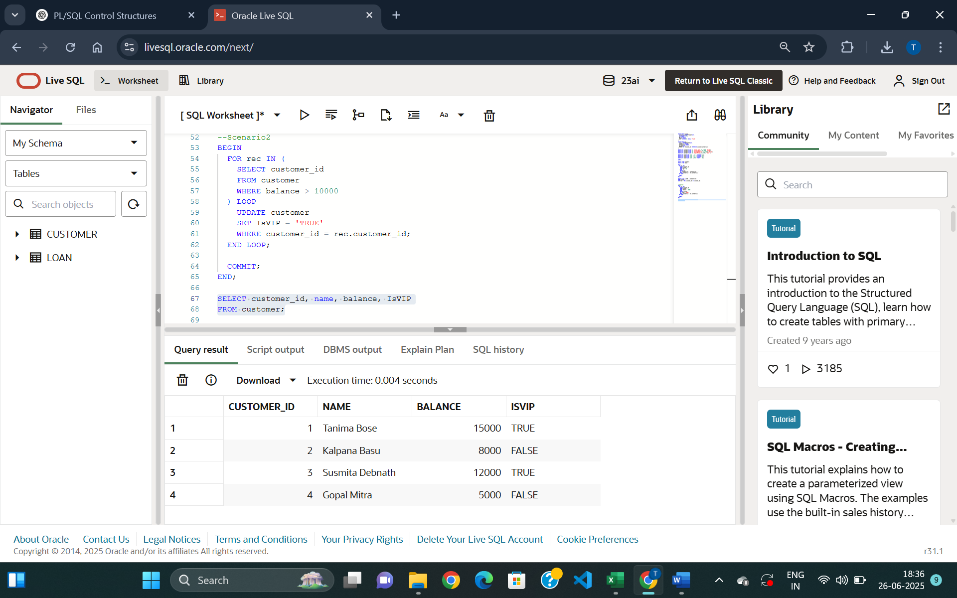

Figure 4: Gives VIP status to customers with balance over 10000

Exercise 1:
Scenario 3:
The bank wants to send reminders to customers whose loans are due within the next 30 days.

Question: Write a PL/SQL block that fetches all loans due in the next 30 days and prints a reminder message for each customer.

--Scenario3

SET SERVEROUTPUT ON;
BEGIN
FOR rec IN (
SELECT c.name, c.customer_id, l.due_date
FROM customer c
JOIN loan l ON c.customer_id = l.customer_id
WHERE l.due_date BETWEEN SYSDATE AND SYSDATE + 30
) LOOP
DBMS_OUTPUT.PUT_LINE(
'Reminder: ' || rec.name ||
' (Customer ID: ' || rec.customer_id ||
') has a loan due on ' || TO_CHAR(rec.due_date, 'DD-MON-YYYY')
);
END LOOP;
END;

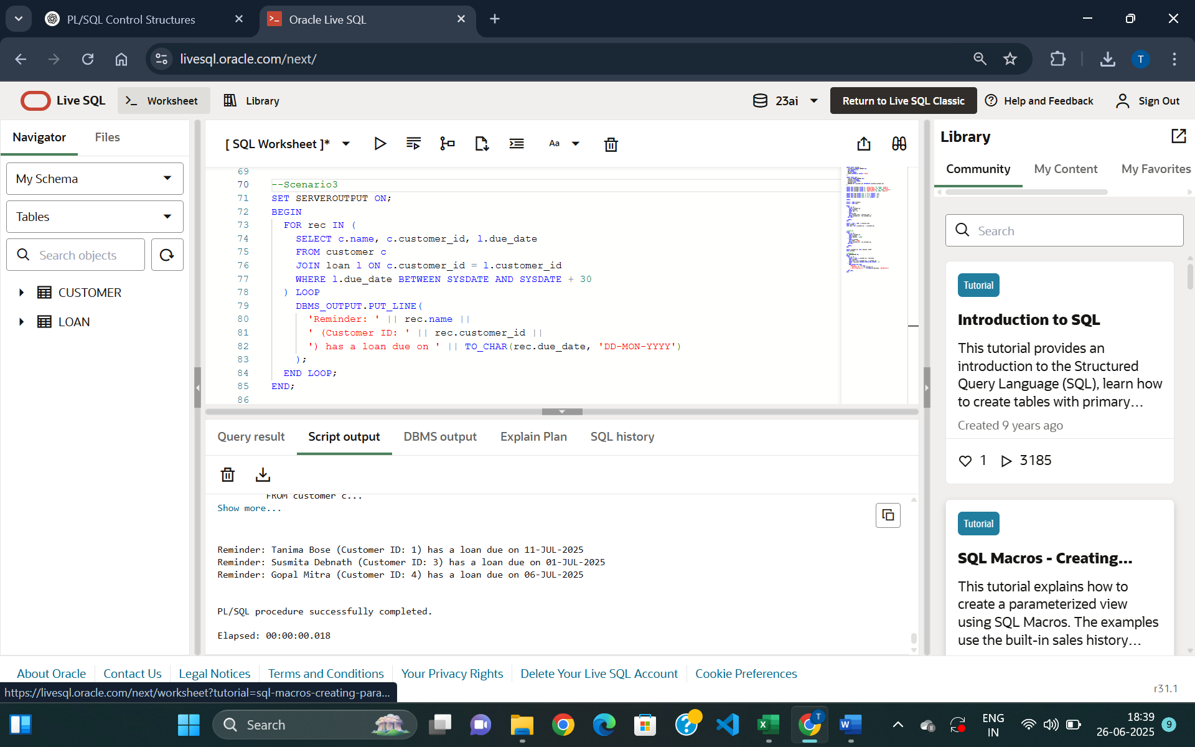
Figure 5: Prints a reminder message for customers whose loan is due in next 30 days.

Exercise 3: Stored Procedures
Scenario 1:
CREATE TABLE savings_account (
account_id NUMBER PRIMARY KEY,
customer_id NUMBER,
balance NUMBER
);
INSERT INTO savings_account VALUES (1, 101, 10000);
INSERT INTO savings_account VALUES (2, 102, 20000);
INSERT INTO savings_account VALUES (3, 103, 15000);
COMMIT;

SELECT * FROM SAVINGS_ACCOUNT;
--Scenario1
CREATE OR REPLACE PROCEDURE ProcessMonthlyInterest IS
BEGIN
FOR rec IN (SELECT account_id, balance FROM savings_account) LOOP
UPDATE savings_account
SET balance = balance + (rec.balance * 0.01)
WHERE account_id = rec.account_id;
END LOOP;
COMMIT;
END;

EXEC ProcessMonthlyInterest;

SELECT * FROM savings_account;
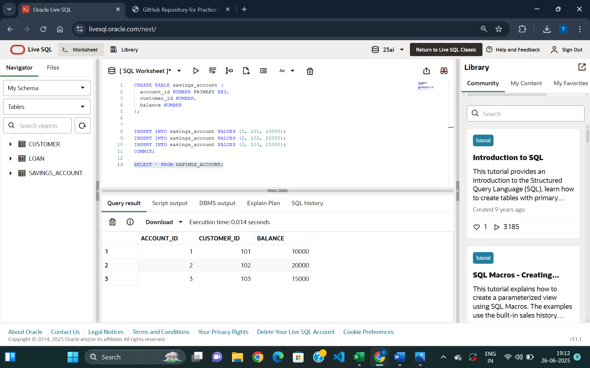

Figure 1: Table savings_account
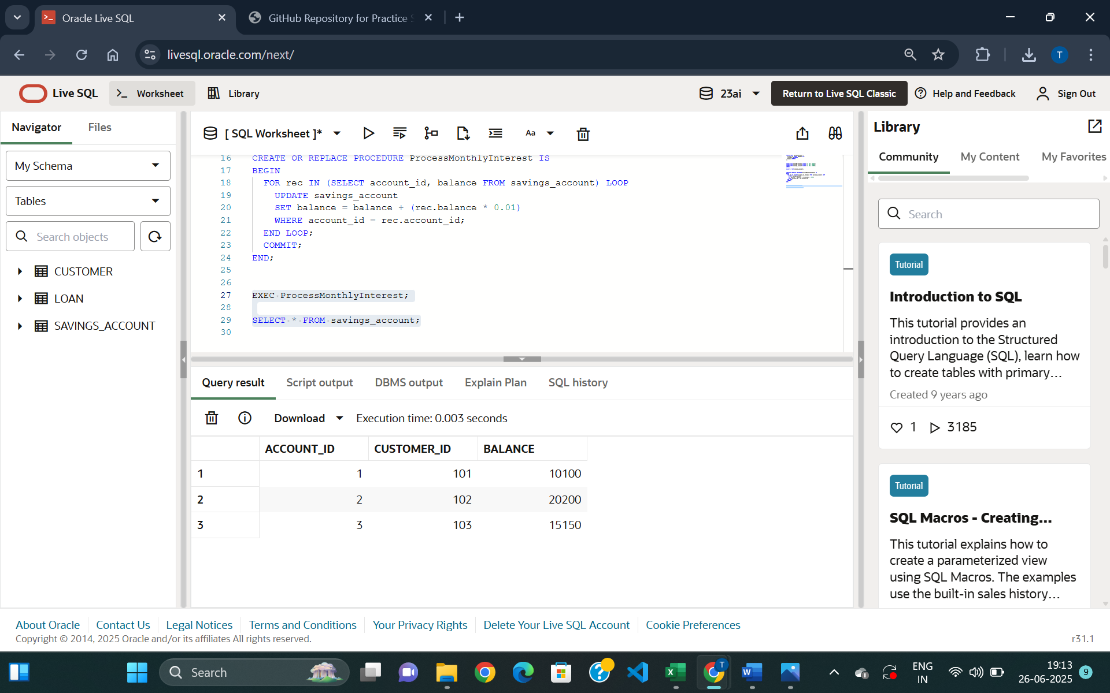

Figure 2: Updated balance of all savings accounts by applying an interest rate of 1% to the current balance
Scenario 2:
--Scenario2
CREATE TABLE employee (
emp_id NUMBER PRIMARY KEY,
name VARCHAR2(50),
department VARCHAR2(30),
salary NUMBER
);

INSERT INTO employee VALUES (1, 'Nirupam Ghosh', 'IT', 50000);
INSERT INTO employee VALUES (2, 'Sumita Sen', 'HR', 40000);
INSERT INTO employee VALUES (3, 'Sandip Pal', 'IT', 60000);
INSERT INTO employee VALUES (4, 'Srideep Dey', 'Finance', 70000);
COMMIT;

SELECT * FROM EMPLOYEE;

CREATE OR REPLACE PROCEDURE UpdateEmployeeBonus (
dept_name IN VARCHAR2,
bonus_percent IN NUMBER
) IS
BEGIN
UPDATE employee
SET salary = salary + (salary * bonus_percent / 100)
WHERE department = dept_name;

COMMIT;
END;

EXEC UpdateEmployeeBonus('IT', 10);

SELECT * FROM employee;
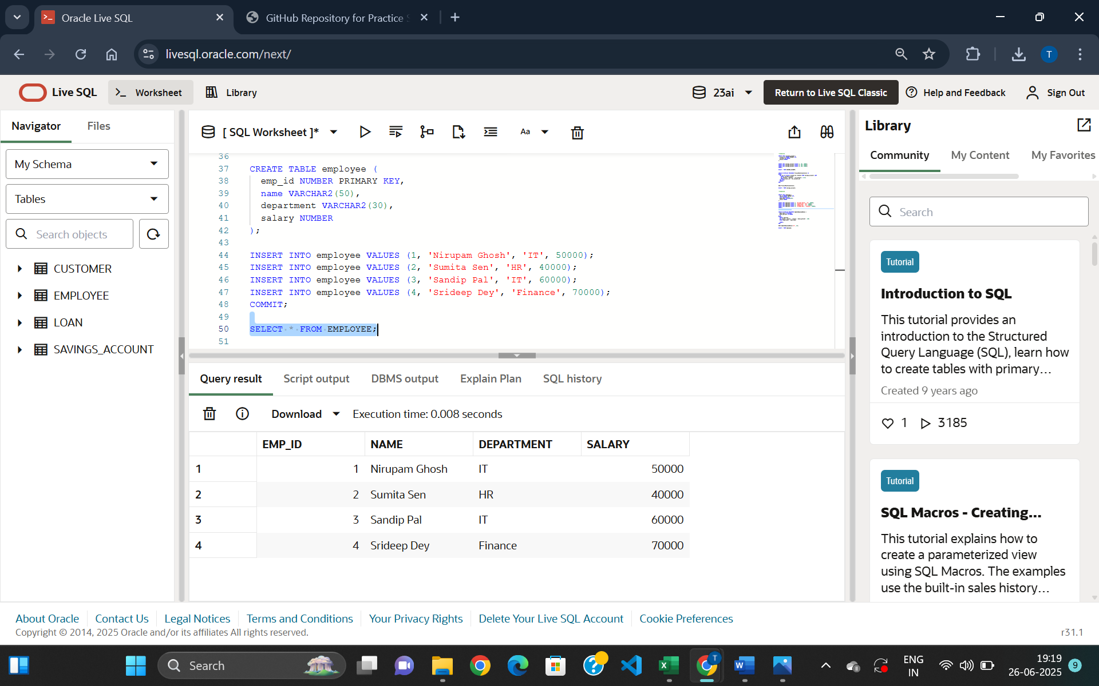

Figure 3: Table Employee Creation
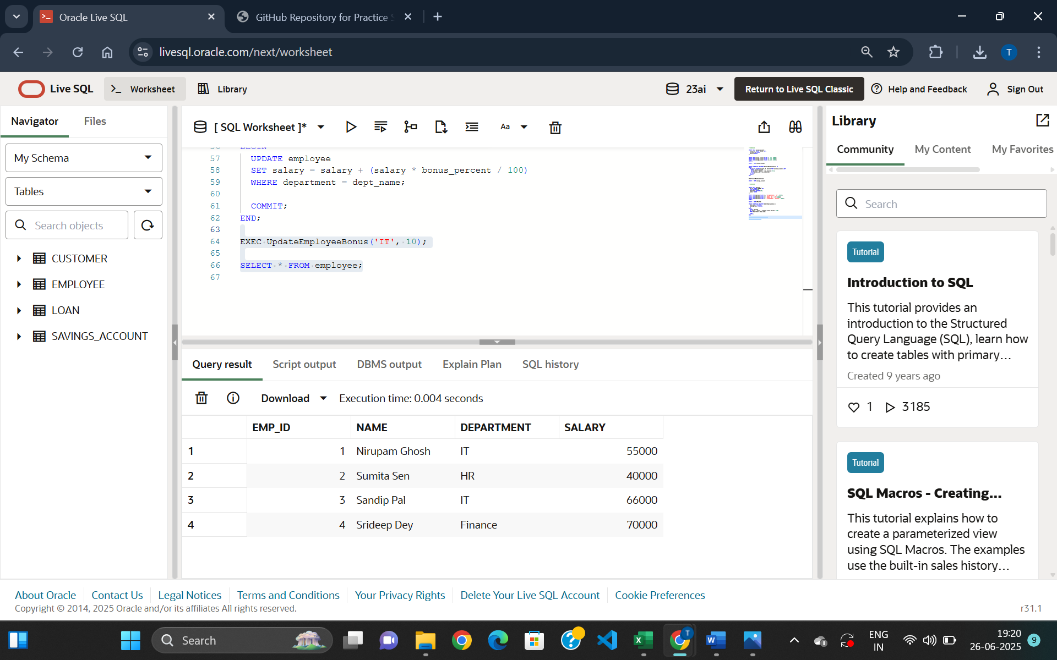

Figure 4: Updated salary of employees in ‘IT’ department by a bonus percentage
Scenario 3:
--Scenario 3

CREATE TABLE bank_account (
account_id NUMBER PRIMARY KEY,
customer_id NUMBER,
balance NUMBER
);

INSERT INTO bank_account VALUES (101, 201, 10000);
INSERT INTO bank_account VALUES (102, 202, 8000);
INSERT INTO bank_account VALUES (103, 203, 5000);
INSERT INTO bank_account VALUES (104, 204, 7000);
COMMIT;

SELECT * FROM bank_account;

CREATE OR REPLACE PROCEDURE TransferFunds (
from_account IN NUMBER,
to_account IN NUMBER,
amount IN NUMBER
) IS
insufficient_balance EXCEPTION;
BEGIN
DECLARE
source_balance NUMBER;
BEGIN
SELECT balance INTO source_balance FROM bank_account WHERE account_id = from_account;

IF source_balance < amount THEN
RAISE insufficient_balance;
END IF;

UPDATE bank_account
SET balance = balance - amount
WHERE account_id = from_account;

UPDATE bank_account
SET balance = balance + amount
WHERE account_id = to_account;

COMMIT;

DBMS_OUTPUT.PUT_LINE('Transfer successful: ' || amount || ' transferred from account ' || from_account || ' to account ' || to_account);

EXCEPTION
WHEN insufficient_balance THEN
DBMS_OUTPUT.PUT_LINE('Transfer failed: Balance is Insufficient');
WHEN NO_DATA_FOUND THEN
DBMS_OUTPUT.PUT_LINE('Transfer failed: Invalid account ID');
END;
END;

SET SERVEROUTPUT ON;

EXEC TransferFunds(101, 102, 2000);
SELECT * FROM bank_account;

--Insufficient Balance
EXEC TransferFunds(103, 104, 6000);

--Invalid Account Id
EXEC TransferFunds(999, 102, 1000);

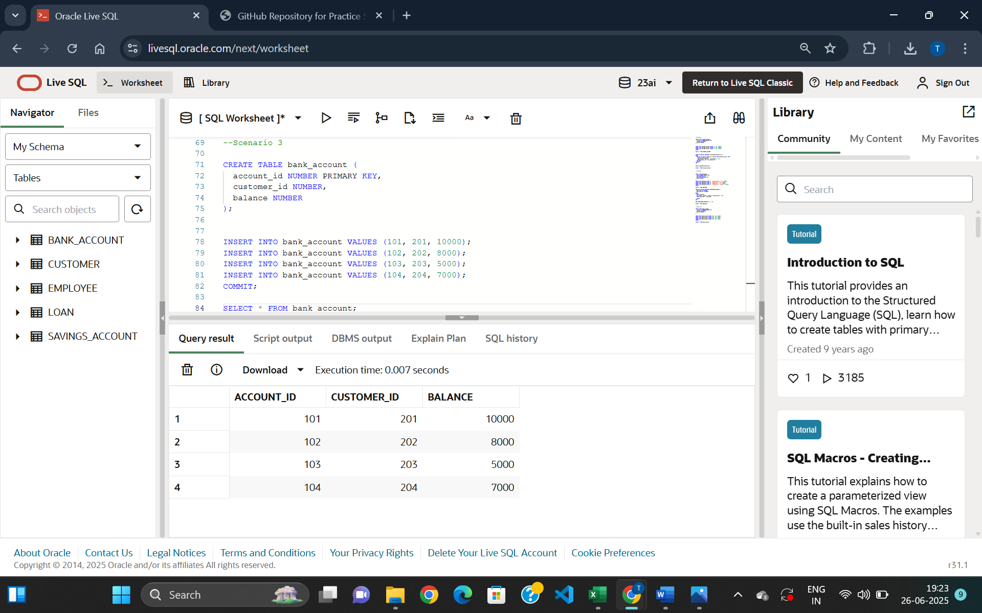

Figure 5: Table bank_account creation

Success Cases:

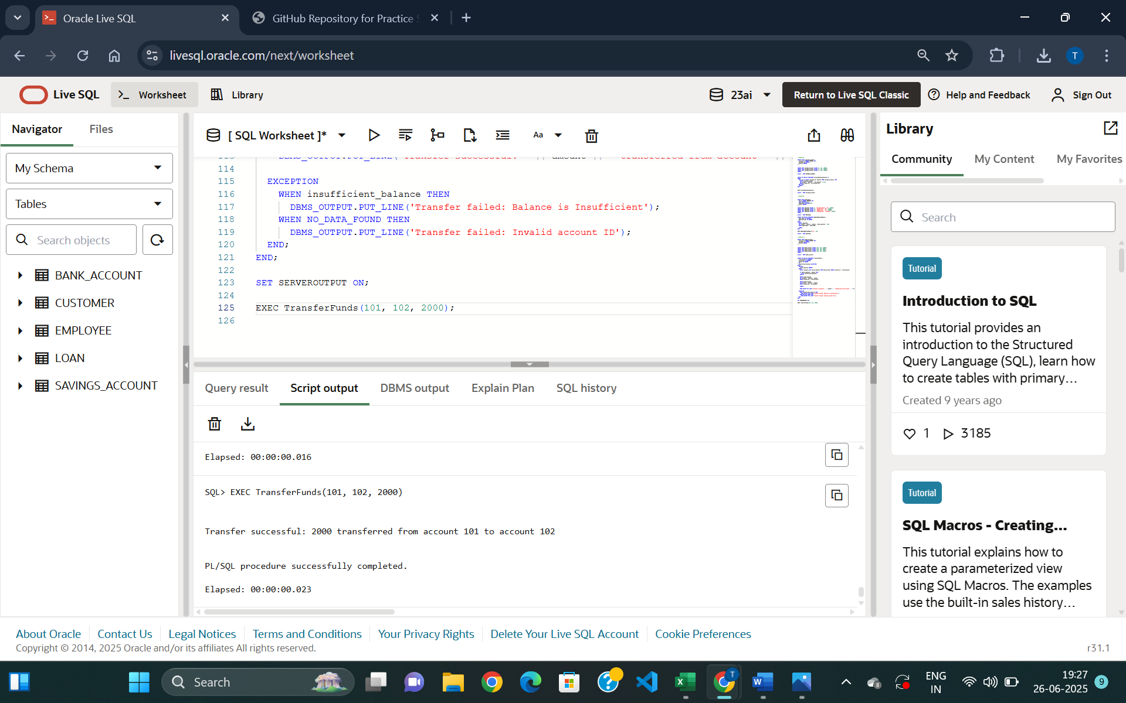

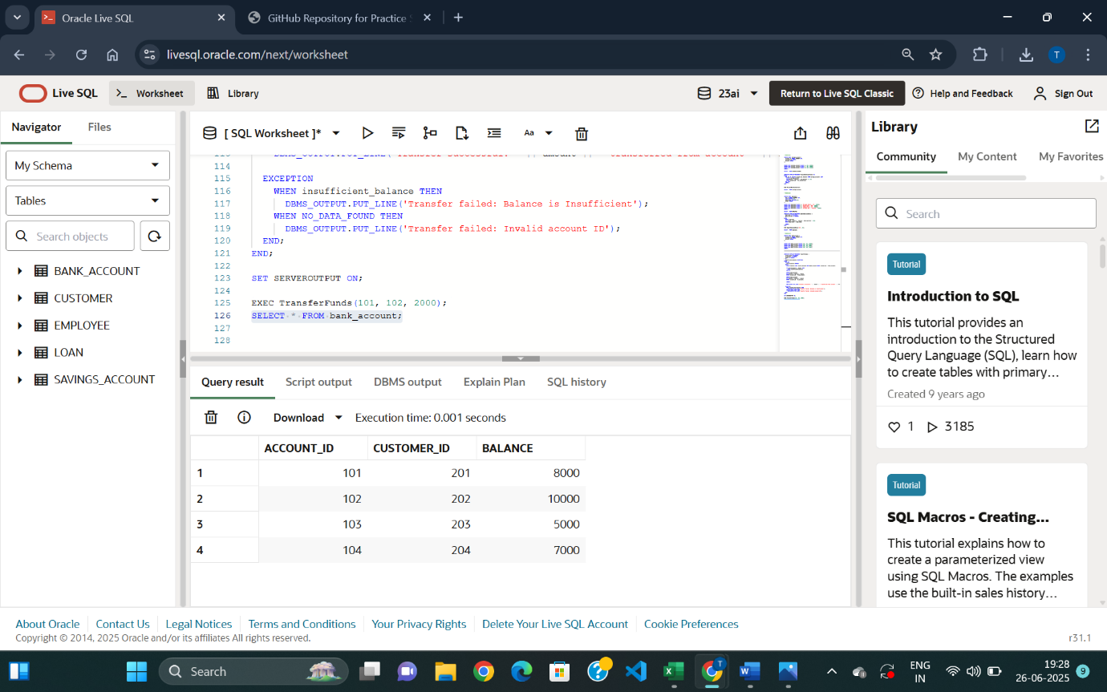
Figure 7: Transferred amount 2000 from account 101 to account 102
Figure 6: Stored Procedure executed

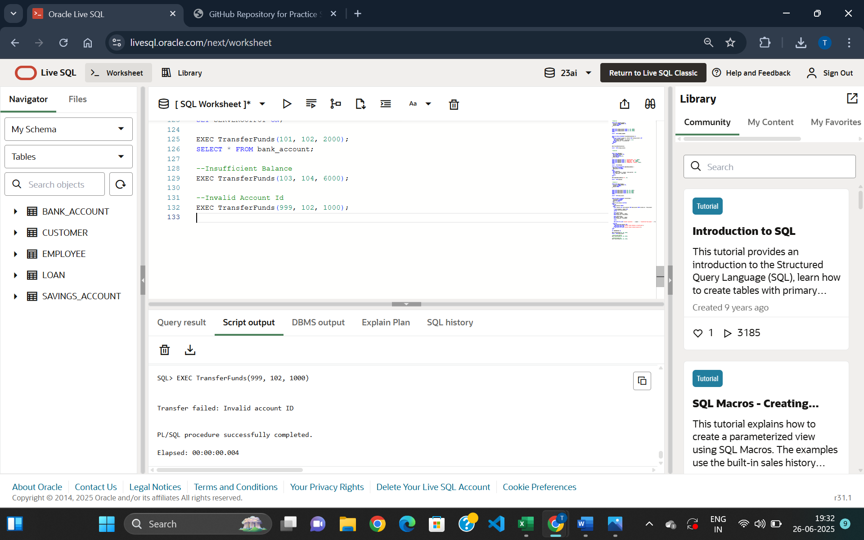
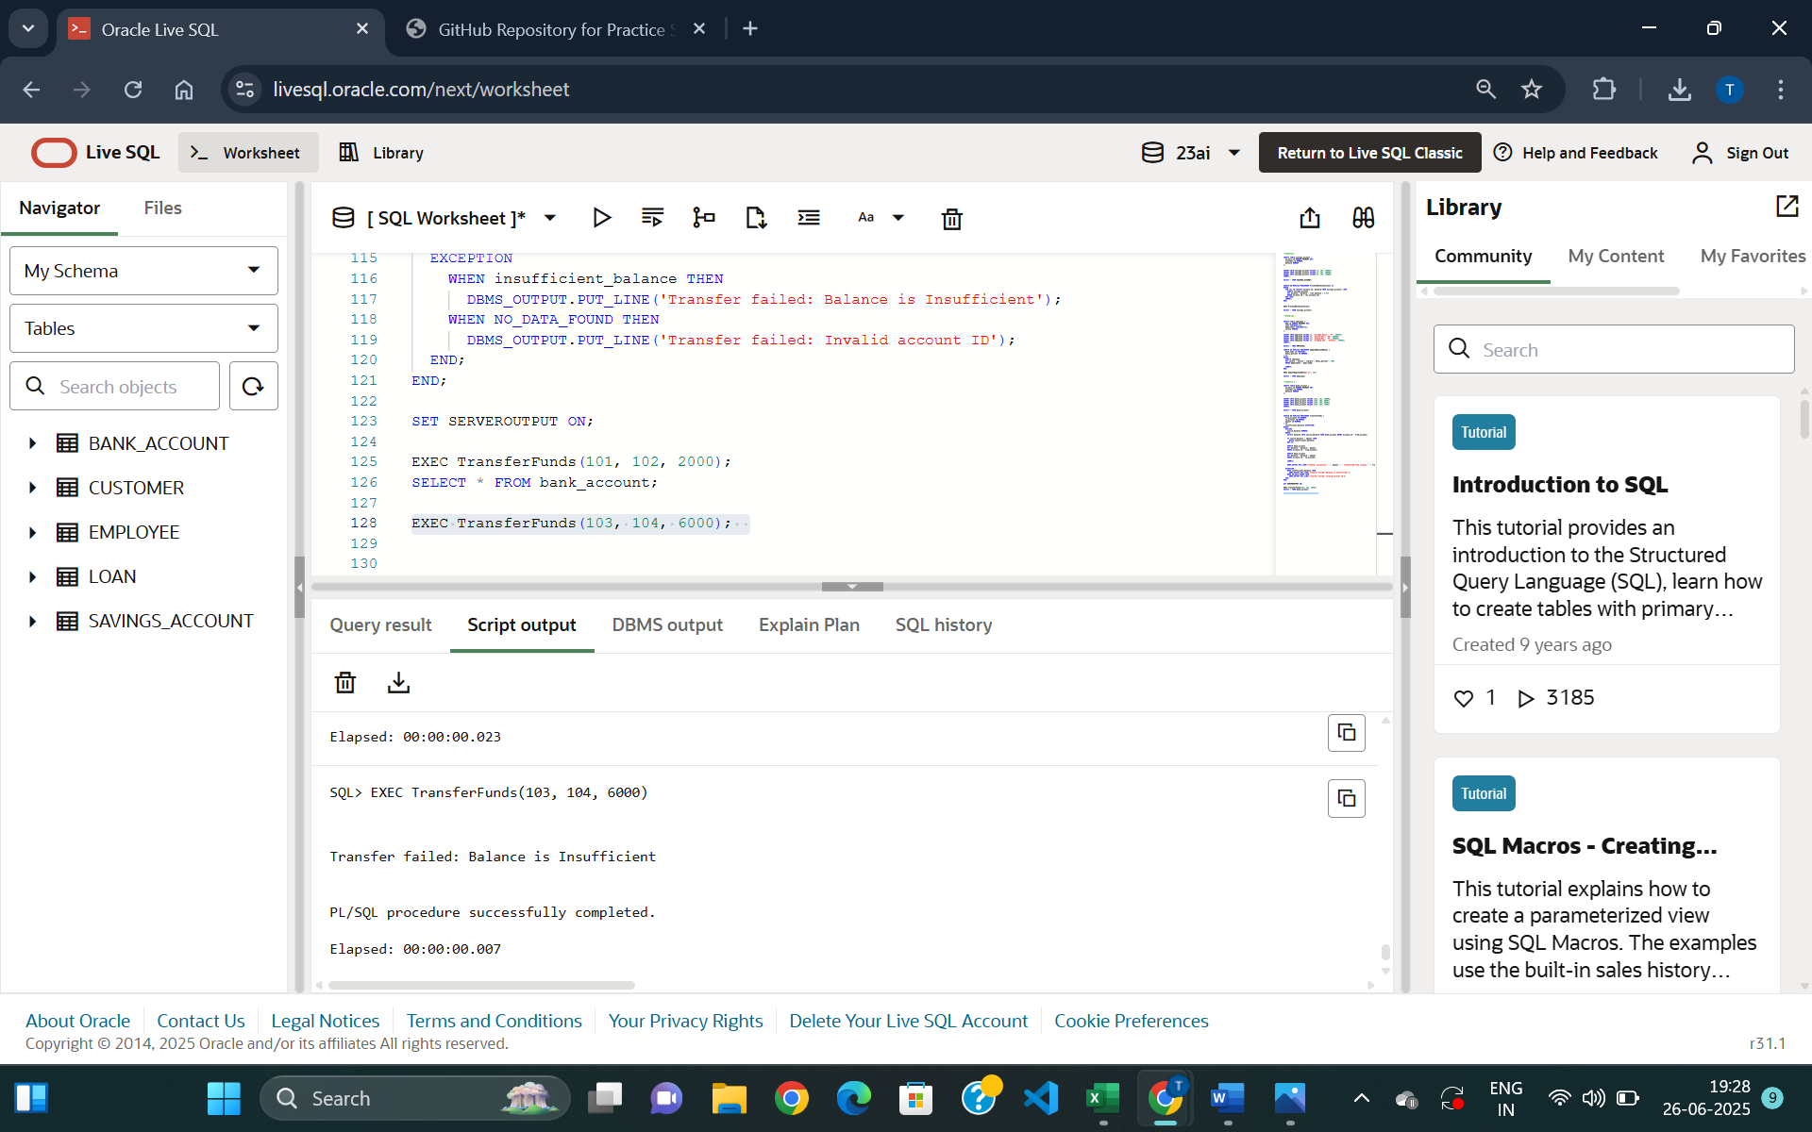
Failure Cases:
Figure 8:
Insufficient Balance Case since account 103 has balance less than 6000
Figure 9:
Invalid Account ID case since account 999 does not exist

