- JUnit_Basic Testing Exercises
Exercise 1: Setting Up Junit

pom.xml
<project xmlns="http://maven.apache.org/POM/4.0.0" xmlns:xsi="http://www.w3.org/2001/XMLSchema-instance"
xsi:schemaLocation="http://maven.apache.org/POM/4.0.0 http://maven.apache.org/maven-v4_0_0.xsd">
<modelVersion>4.0.0</modelVersion>
<groupId>com.example</groupId>
<artifactId>Exercise1_SettingUpJUnit</artifactId>
<packaging>jar</packaging>
<version>1.0-SNAPSHOT</version>
<name>Exercise1_SettingUpJUnit</name>
<url>http://maven.apache.org</url>
<dependencies>
<dependency>
<groupId>junit</groupId>
<artifactId>junit</artifactId>
<version>4.13.2</version>
<scope>test</scope>
</dependency>
</dependencies>

<build>
<plugins>
<plugin>
<groupId>org.apache.maven.plugins</groupId>
<artifactId>maven-surefire-plugin</artifactId>
<version>3.0.0-M5</version>
</plugin>
</plugins>
</build>

</project>

Multiplication.java
package com.example;

public class Multiplication {
public int multiply(int a, int b) {
return a * b;
}
}
MultiplicationTest.java
package com.example;

import org.junit.Test;
import static org.junit.Assert.assertEquals;

public class MultiplicationTest {

@Test
public void testMultiply() {
Multiplication calc = new Multiplication();
assertEquals(36, calc.multiply(9, 4));
}
}

Output:
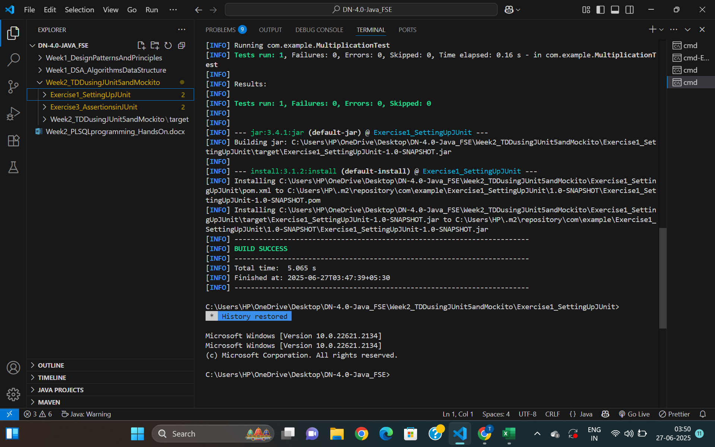

Exercise 3: Assertions in JUnit
AssertionsTest.java
package com.example;

import org.junit.Test;
import static org.junit.Assert.*;

public class AssertionsTest {

@Test
public void testAssertions() {

assertEquals(5, 2 + 3);
assertTrue(5 > 3);
assertFalse(5 < 3);
assertNull(null);
assertNotNull(new Object());
}
}

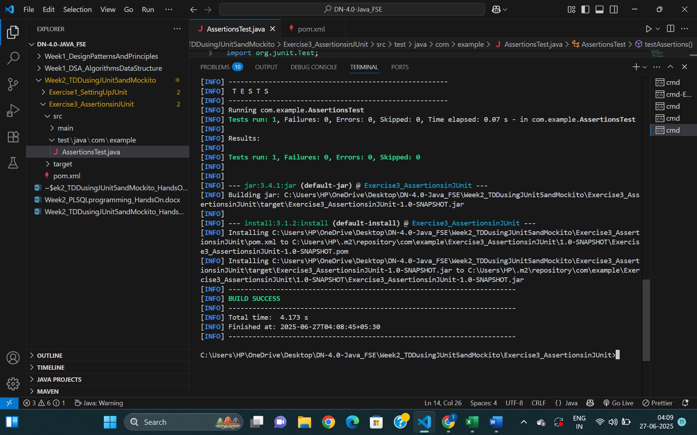
Output:

Exercise 4: Arrange-Act-Assert (AAA) Pattern, Test Fixtures, Setup and Teardown Methods in JUnit

Calculator.java
package com.example;

public class Calculator {
public int sum(int a, int b) {
return a + b;
}
}

CalculatorTest.java
package com.example;

import org.junit.After;
import org.junit.Before;
import org.junit.Test;

import static org.junit.Assert.assertEquals;

public class CalculatorTest {

private Calculator calculator;

@Before
public void setUp() {
// Arrange
calculator = new Calculator();
System.out.println("Setup complete.");
}

@After
public void tearDown() {
// Cleanup
calculator = null;
System.out.println("Teardown complete.");
}

@Test
public void testAddPositiveNumbers() {
// Act
int result = calculator.sum(10, 5);

// Assert
assertEquals(15, result);
}

@Test
public void testAddNegativeNumbers() {
int result = calculator.sum(-2, -3);
assertEquals(-5, result);
}
}

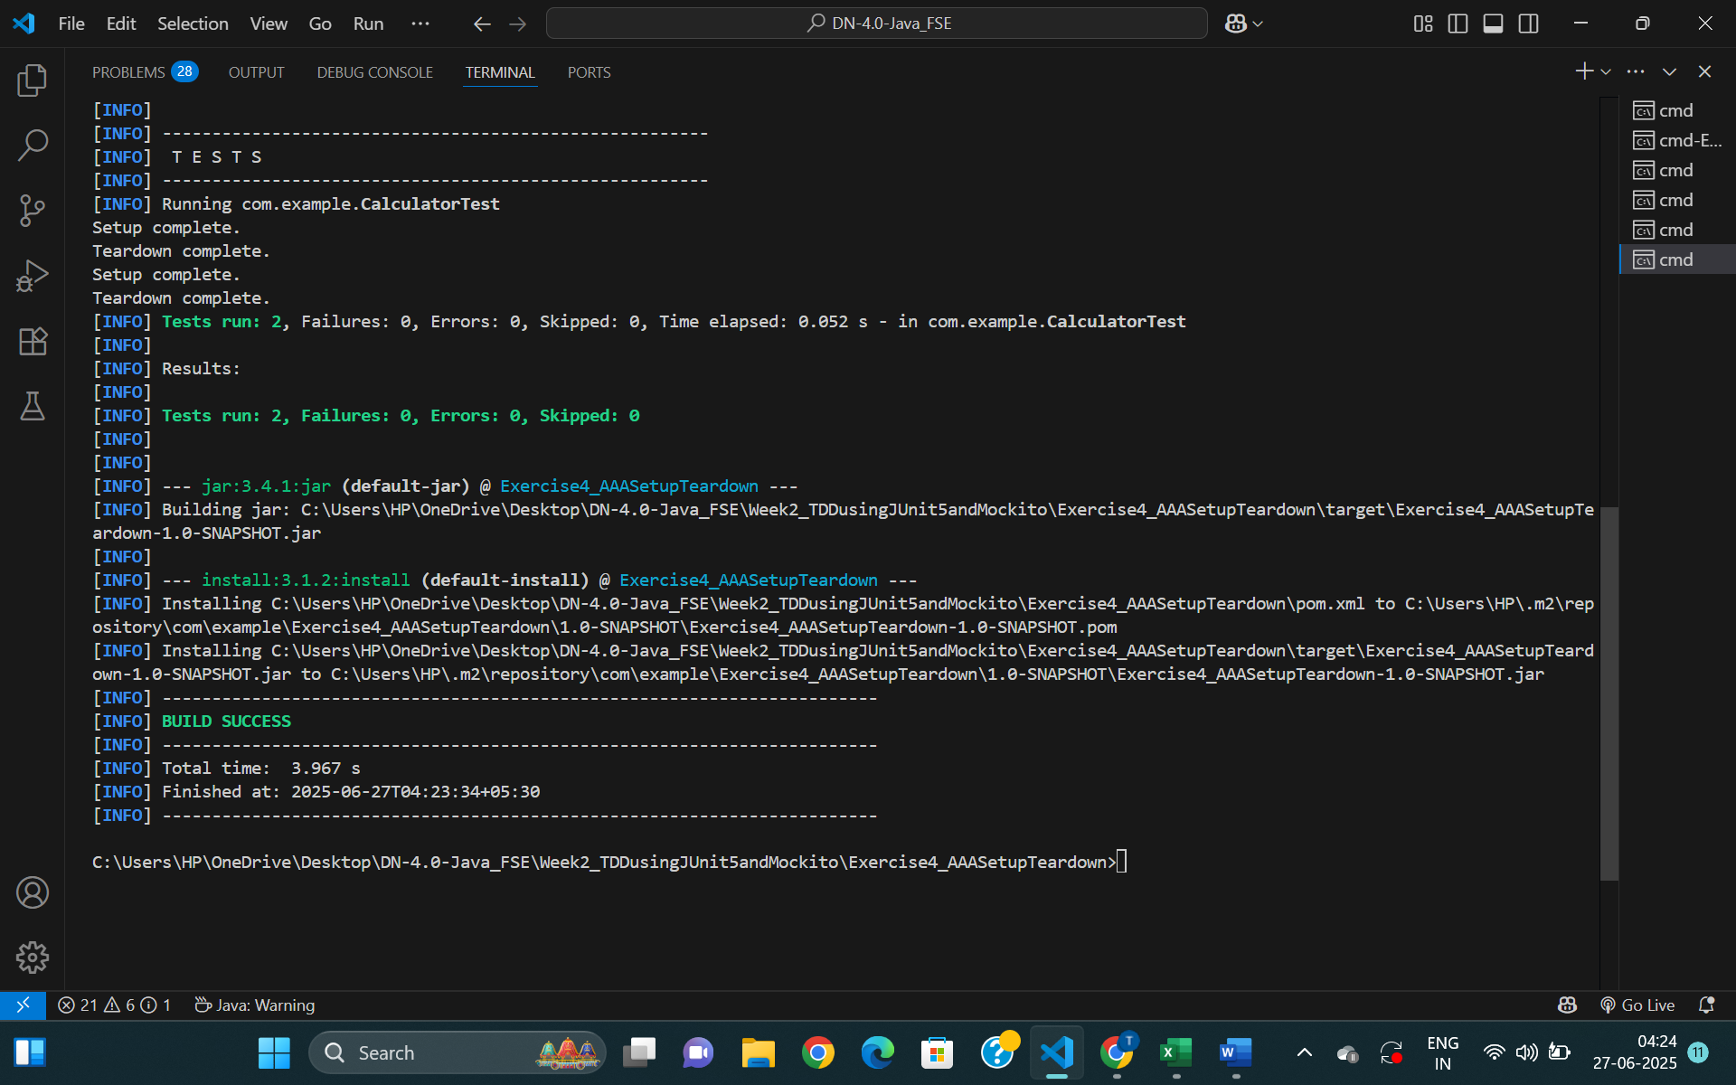
Output:

- Mockito exercises
Exercise 1: Mocking and Stubbing
pom.xml
<project xmlns="http://maven.apache.org/POM/4.0.0"
xmlns:xsi="http://www.w3.org/2001/XMLSchema-instance"
xsi:schemaLocation="http://maven.apache.org/POM/4.0.0 http://maven.apache.org/maven-v4_0_0.xsd">
<modelVersion>4.0.0</modelVersion>

<groupId>com.example</groupId>
<artifactId>Exercise1_MockingAndStubbing</artifactId>
<version>1.0-SNAPSHOT</version>

<properties>
<maven.compiler.source>17</maven.compiler.source>
<maven.compiler.target>17</maven.compiler.target>
</properties>

<dependencies>
<!-- JUnit 5 -->
<dependency>
<groupId>org.junit.jupiter</groupId>
<artifactId>junit-jupiter</artifactId>
<version>5.10.2</version>
<scope>test</scope>
</dependency>

<!-- Mockito -->
<dependency>
<groupId>org.mockito</groupId>
<artifactId>mockito-core</artifactId>
<version>5.11.0</version>
<scope>test</scope>
</dependency>
</dependencies>

<build>
<plugins>
<plugin>
<groupId>org.apache.maven.plugins</groupId>
<artifactId>maven-surefire-plugin</artifactId>
<version>3.2.5</version>
</plugin>
</plugins>
</build>
</project>

ExternalApi.java
package com.example;

public interface ExternalApi {
String getData();
}
MyService.java
package com.example;

public class MyService {
private final ExternalApi externalApi;

public MyService(ExternalApi externalApi) {
this.externalApi = externalApi;
}

public String fetchData() {
return externalApi.getData();
}
}
MyServiceTest.java
package com.example;

import org.junit.jupiter.api.Test;
import static org.mockito.Mockito.*;
import static org.junit.jupiter.api.Assertions.*;

public class MyServiceTest {

@Test
public void testExternalApi() {
ExternalApi mockApi = mock(ExternalApi.class);
when(mockApi.getData()).thenReturn("Mock Data");

MyService service = new MyService(mockApi);
String result = service.fetchData();

assertEquals("Mock Data", result);
}
}

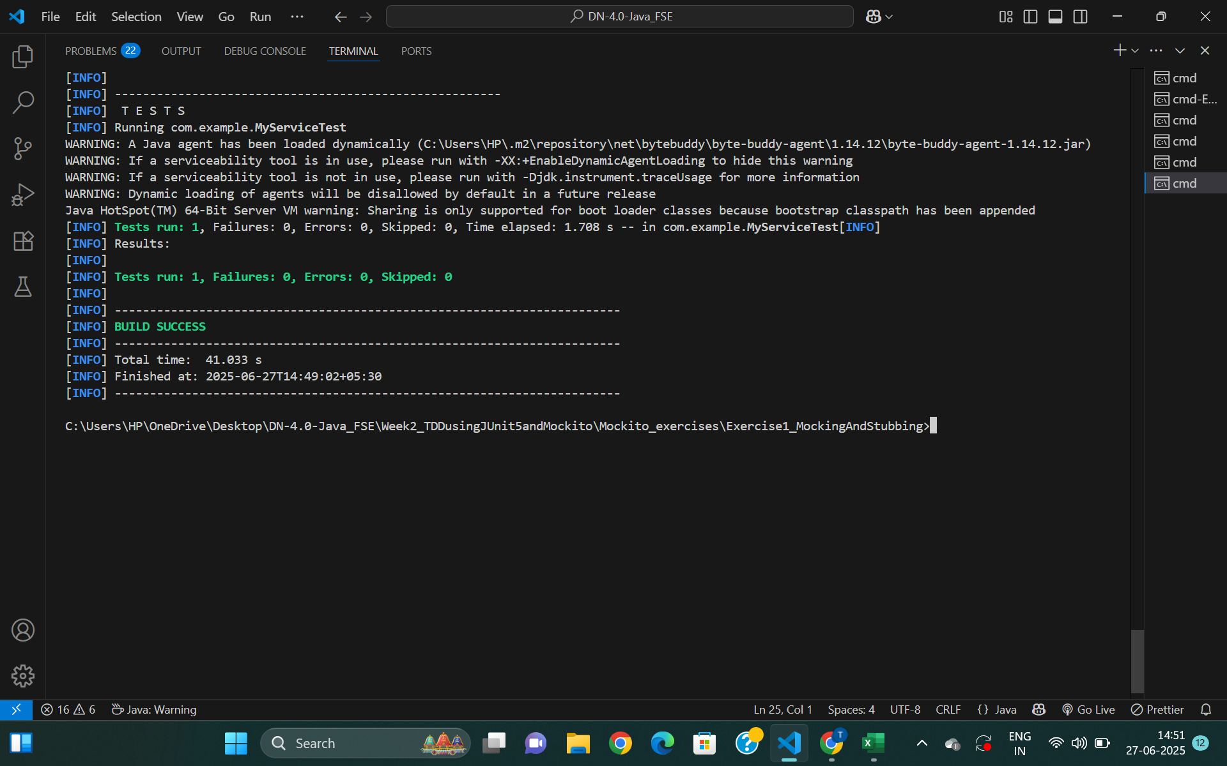
Output

Exercise 2: Verifying Interactions
ExternalApi.java
package com.example;

public interface ExternalApi {
String getData();
}

MyService.java
package com.example;

public class MyService {
private final ExternalApi externalApi;

public MyService(ExternalApi externalApi) {
this.externalApi = externalApi;
}

public String fetchData() {
return externalApi.getData(); // Method to verify interaction
}
}

MyServiceTest.java
package com.example;

import org.junit.jupiter.api.Test;
import static org.mockito.Mockito.*;

public class MyServiceTest {

@Test
public void testVerifyInteraction() {
ExternalApi mockApi = mock(ExternalApi.class);
MyService service = new MyService(mockApi);

service.fetchData();

verify(mockApi).getData();
}
}

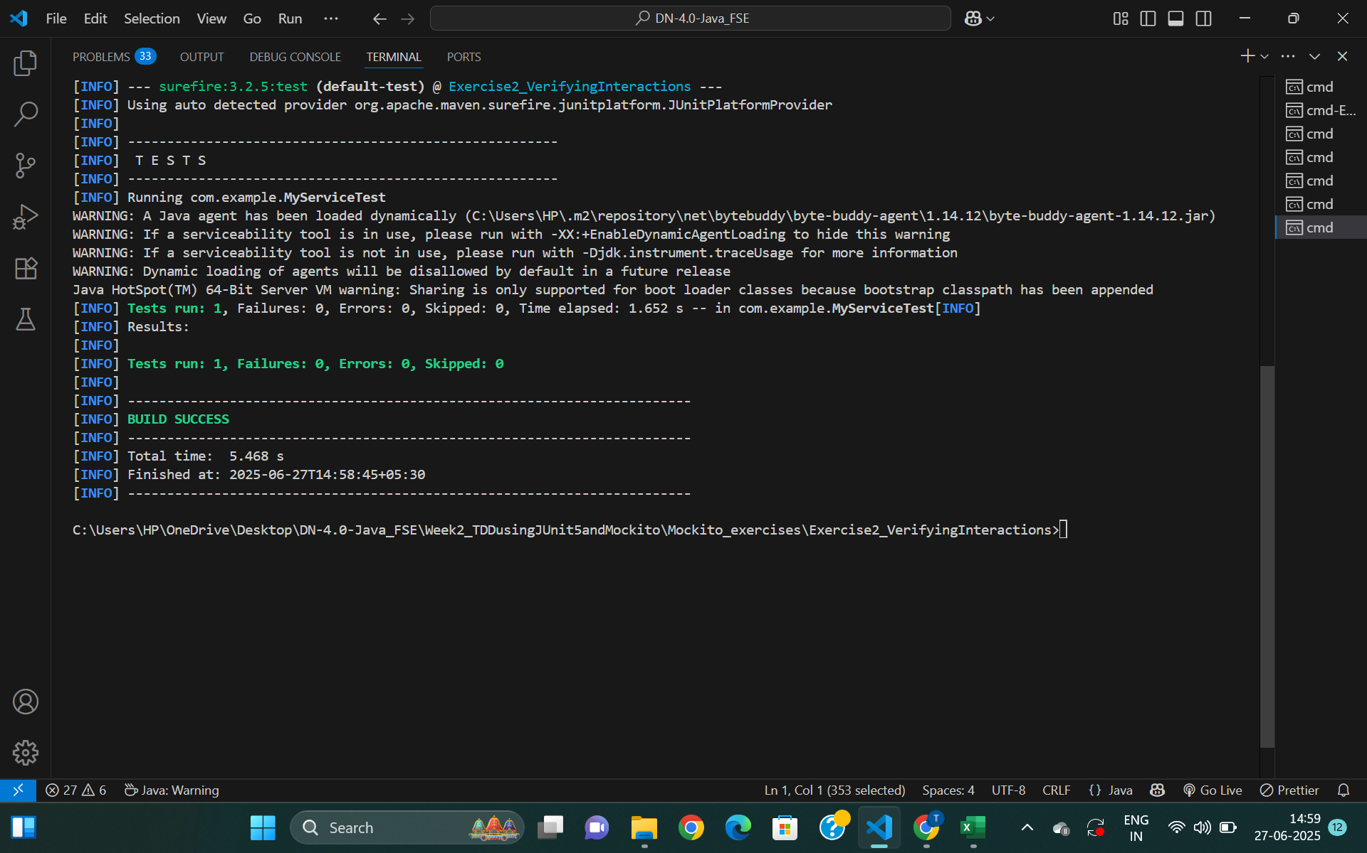
Output

