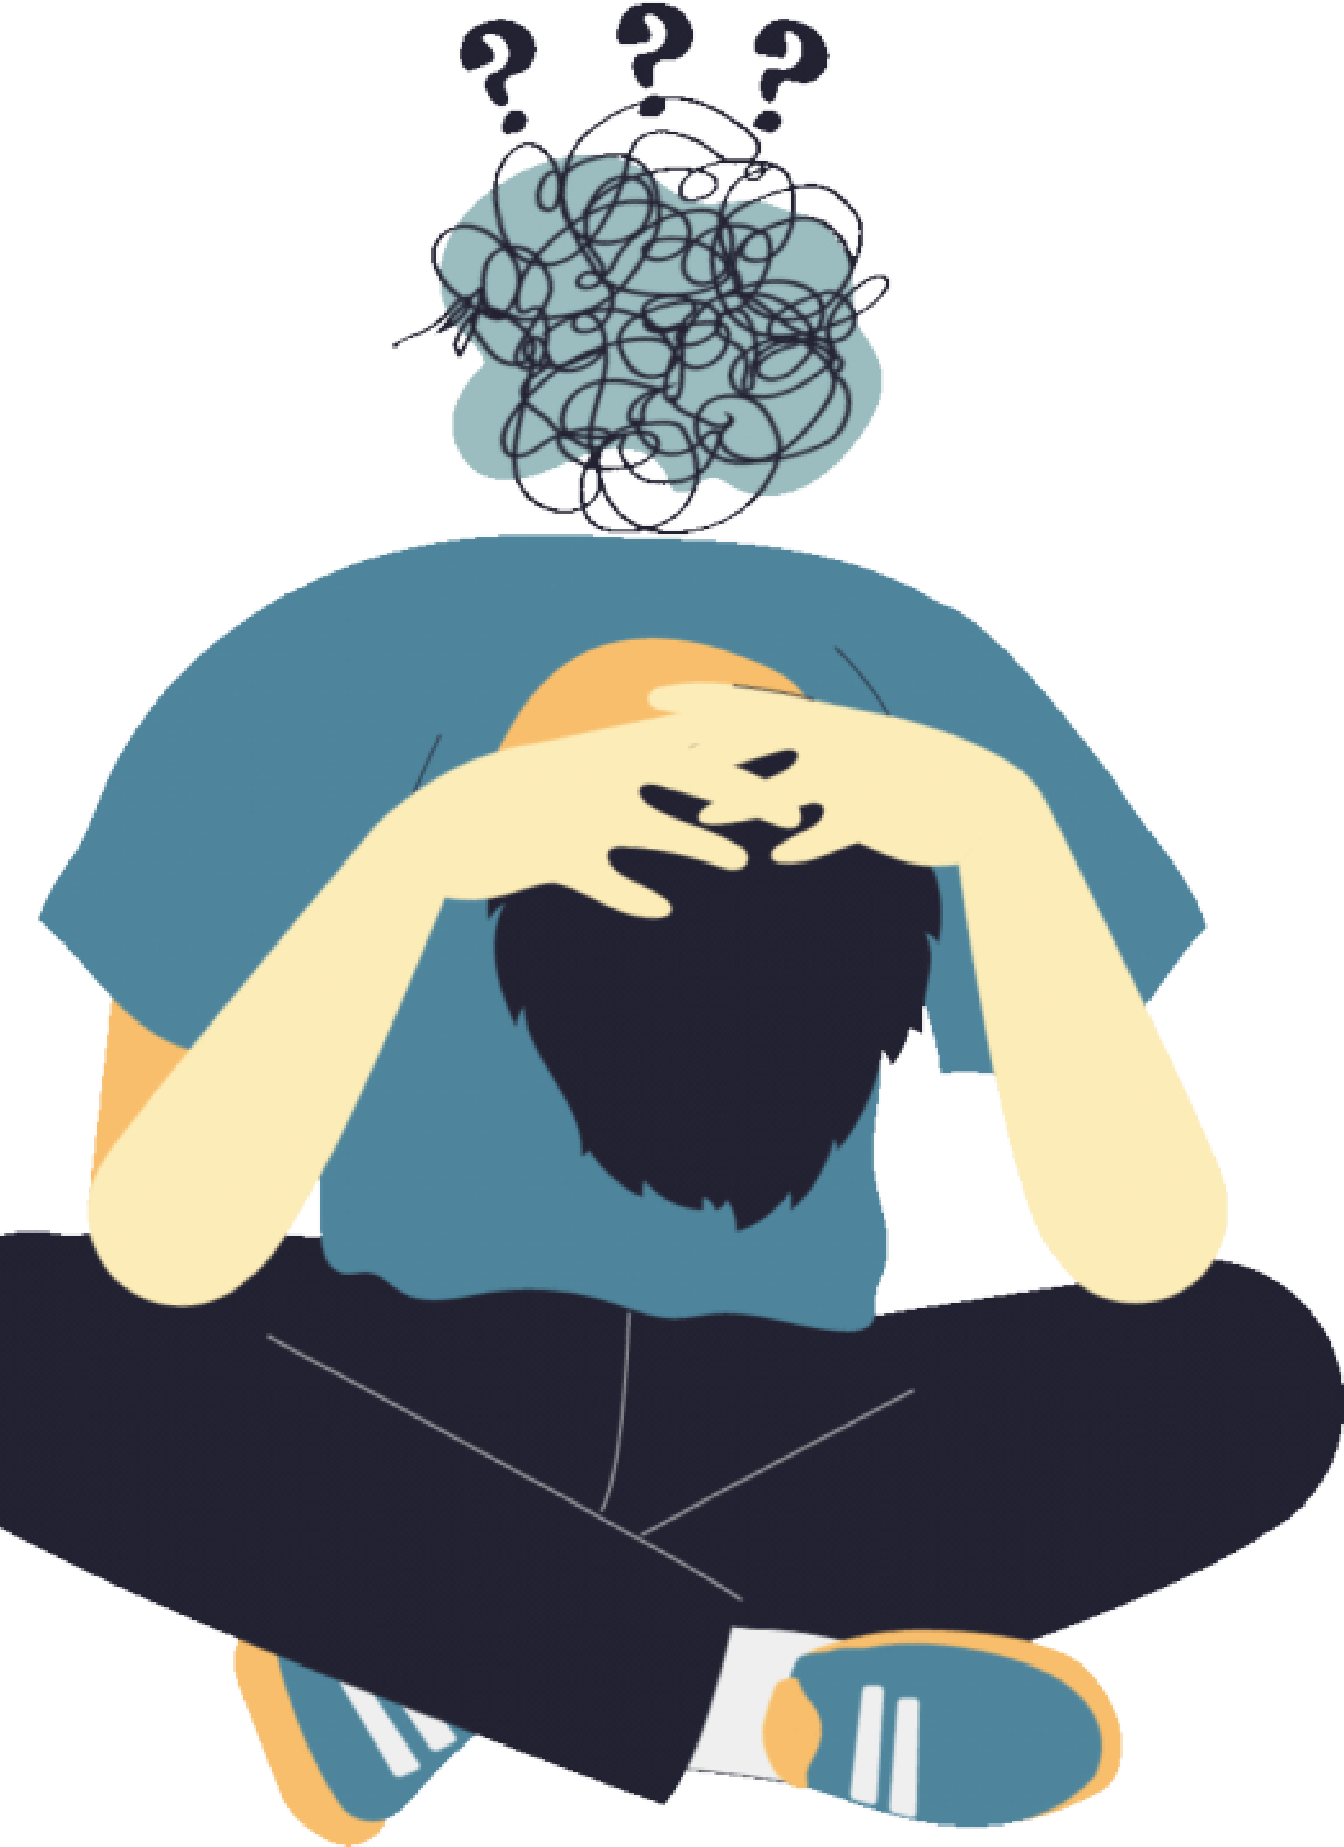
Treatment plan

Major Depressive Disorder (Depression)
Psychotherapy (talk therapy):

- Cognitive Behavioral Therapy (CBT): This approach helpsidentify and change negative thinking patterns and develop strategies to cope with difficult situations.
- Interpersonal Therapy (IPT): Focuses on interpersonalrelationships and problem-solving.
- Psychodynamic Therapy: Explores past experiences andrelationships to understand and address the underlying causes of depression.

Major Depressive Disorder (Depression)
Electroconvulsive Therapy (ECT):
Considered in severe cases of depression resistant to other treatments.
2.Physical Exercise:
Regular exercise has demonstrated positive effects on mood and may be included in the treatment plan.
3.Stress Management:
Relaxation techniques, meditation, deep breathing to help manage stress and anxiety.

Major Depressive Disorder (Depression)
1.Social Support:
Involvement of family, friends, or a support network can be essential in the healing process.
2.Patient Education:
Informing the patient about depression, possible causes, treatments, and coping strategies.
3.Regular Follow-up:
Regular consultations with a mental health professional to assess treatment response, make adjustments as necessary, and provide ongoing support.

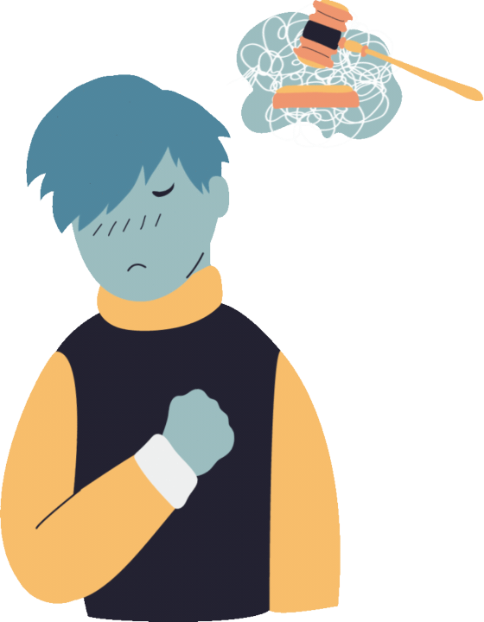
(GAD)
Cognitive Behavioral Therapy (CBT):
CBT is an effective therapeutic approach for GAD. It helps identify and change anxious thought patterns and develop skills to cope with stress.
Relaxation techniques, time management, and problem-solving can be integrated into CBT.

(GAD)
Exposure Therapy:
CBT may also include progressive exposure exercises to feared situations to help desensitize the individual to anxiety.
Self-help and lifestyle changes:
Encourage healthy lifestyle habits, including balanced diet, adequate sleep, and regular physical exercise.
Learning stress management techniques, such as meditation, deep breathing, and progressive muscle relaxation.

(GAD)
1.Social Support:
Involving family, friends, or participating in support groups can provide emotional and practical support.
2.Patient Education:
Providing the patient with information about GAD, potential causes, available treatments, and coping strategies.
3.Regular Follow-Up:
Regular consultations with a mental health professional are essential to assess treatment response, make adjustments if necessary, and provide ongoing support.

Disorder (OCD)
Cognitive-Behavioral Therapy (CBT):

CBT is often the treatment of choice for OCD. It may include:
Exposure and Response Prevention (ERP): Gradual exposure to situations that trigger obsessions, with voluntary prevention of compulsions. Cognitive restructuring: Working on the underlying thought patterns of obsessions to change unhelpful and unrealistic beliefs.

Disorder (OCD)
1.Group therapy or support therapy: Participating in group sessions provides emotional support, practical advice, and the opportunity to share experiences with others affected by OCD.
2.Patient and family education:
Educating the patient and their family about the nature of OCD, treatment mechanisms, and how to support the healing process.

Disorder (OCD)
1.Regular Follow-up:
Frequent follow-up with a mental health professional is essential to assess treatment progress, adjust interventions as needed, and provide ongoing support.
2.Family Interventions:
Involving the family in the treatment process can help improve understanding and support for the patient.
3.Self-Help:
Encouraging self-help practices such as relaxation, meditation, and adopting healthy routines.

Schizophrenia
1.Cognitive Behavioral Therapy (CBT):

CBT can help individuals with schizophrenia understand and manage their symptoms, identify irrational thoughts, and develop strategies to cope with daily challenges. It can also be used to improve stress and emotion management.
2.Individual or Group Therapy:
Individual or group therapy sessions can provide a space to discuss experiences, emotions, and difficulties related to mental illness. This can also help strengthen social skills and foster mutual support.

Schizophrenia
1.Family Support:
Involving the family in the treatment process can be crucial. Education about schizophrenia, strengthening communication skills, and providing emotional support can help improve the patient's well-being.
2.Management of Risk Factors:
Encouraging healthy lifestyles, including balanced diet, regular physical exercise, and effective stress management, can contribute to better overall outcomes.

Schizophrenia
1.Psychosocial Rehabilitation:
Psychosocial rehabilitation programs aim to help individuals with schizophrenia regain social, vocational, and educational skills. This may include vocational training, job support, and other interventions aimed at improving quality of life.

Schizophrenia
1.Integrative Medicine:
Some patients may benefit from complementary therapies such as relaxation techniques, meditation, art therapy, or music therapy to help manage stress and improve emotional well-being.
2.Regular Medical Follow-Up:
Individuals with schizophrenia require regular medical follow-up to adjust medications based on symptom changes, monitor side effects, and assess treatment response.

Bipolar Disorder
1. Mood Stabilizers:
Mood stabilizers such as lithium, valproate, and lamotrigine are commonly used to manage mood swings and prevent episodes of mania or depression.
2.Psychotherapy:

Various forms of psychotherapy, including cognitive-behavioral therapy (CBT) and psychoeducation, can help individuals with bipolar disorder better understand their condition, develop coping strategies, and manage stressors.
3.Lifestyle Changes:
Healthy lifestyle habits such as regular exercise, adequate sleep, and a balanced diet can complement medication and therapy in managing bipolar disorder symptoms.

Bipolar Disorder
1.Support Groups:
Joining support groups or participating in peer support networks can provide individuals with bipolar disorder with encouragement, understanding, and practical advice from others facing similar challenges.
2.Regular Monitoring:
Regular monitoring by mental health professionals is essential to track symptoms, adjust treatment plans as needed, and ensure overall wellbeing.

Bipolar Disorder
1.Psychoeducation:
Providing the patient and their family with information about bipolar disorder, including symptoms, potential triggers, and coping strategies. Psychoeducation can help enhance understanding of the illness and improve symptom management.
2.Cognitive-Behavioral Therapy (CBT):
CBT can assist in identifying negative thought patterns, developing strategies to cope with symptoms, and enhancing stress management skills.

Bipolar Disorder
1.Interpersonal Therapy (IPT):
IPT can help the patient improve social skills, manage interpersonal relationships, and cope with mood changes.
2.Sleep Management:
Establishing regular sleep routines and promoting healthy sleep hygiene can help prevent manic and depressive episodes.
3.Stress Management:
Encouraging stress management strategies, including meditation, relaxation, and regular physical exercise.

Bipolar Disorder
1.Regular Medical Follow-Up:
Medication adjustments and regular follow-up with a mental health professional are essential to monitor
2.symptoms, assess treatment response, and address changes in the patient's condition.
3.Family Support:
Involving the family in the treatment process can provide a crucial support network and help manage symptoms.

1.Initial Assessment:
A detailed assessment is necessary to understand sleep habits, bedtime behaviors, stress factors, and other elements that may influence sleep.
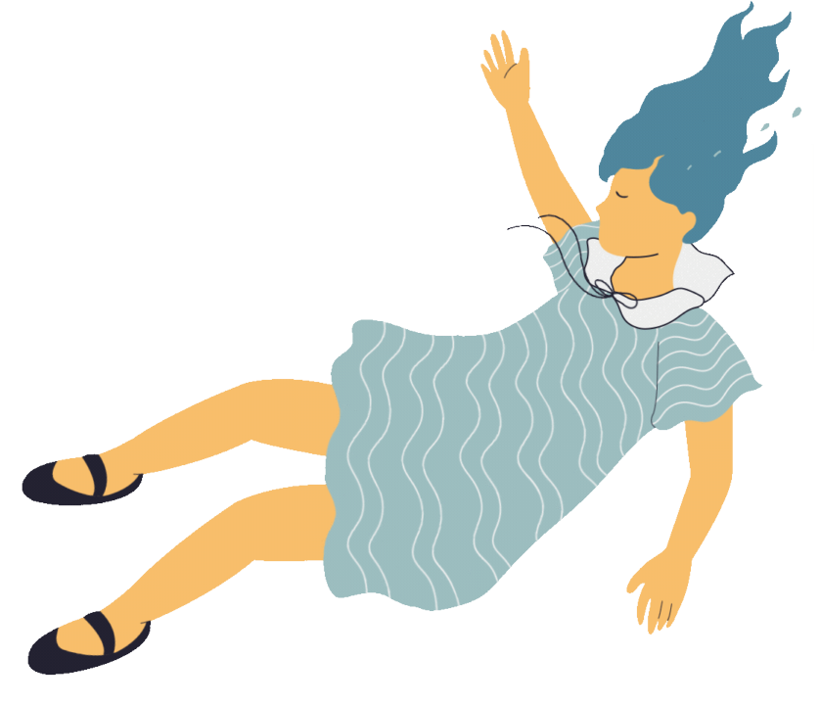
2.Sleep Hygiene:
Encourage good sleep habits, including maintaining a regular sleep routine, creating a sleep-friendly environment (comfortable temperature, darkness, silence), and avoiding excessive consumption of caffeine or alcohol.
1.Cognitive Behavioral Therapy for Insomnia (CBT-I): CBT-I is an effective approach for treating insomnia. It aims to change beliefs and behaviors related to sleep and may include techniques such as time-in-bed restriction and stimulus control.
2.Treatment of Underlying Disorders:
If there are underlying medical, psychological, or psychiatric disorders, treating these conditions can often improve sleep.
1.Stress Management:
Teaching stress management techniques, such as relaxation, meditation, and deep breathing, can help reduce anxiety that may interfere with sleep.
2.Light Exposure:
Regulating exposure to light, especially exposure to natural daylight in the morning, can help regulate the circadian rhythm and improve sleep quality.
1.Physical Exercise:
Regular exercise can promote deeper sleep and improve sleep quality. However, it's best to exercise earlier in the day rather than just before bedtime.
2.Regular Follow-Up:
Regular follow-up with a healthcare professional may be necessary to assess the progress of treatment, adjust interventions as needed, and provide ongoing support.

Social Anxiety
1.Cognitive-Behavioral Therapy (CBT):

CBT is often considered the first-line treatment for social anxiety. It helps identify and change negative thoughts and behaviors associated with social anxiety. CBT may include gradual exposure exercises, where the person is progressively exposed to feared social situations to reduce anxiety.

Social Anxiety
2.Group Therapy:
Participating in social therapy groups can provide a safe environment to practice social skills, share experiences, and receive mutual support. 3.Anxiolytic Medications:
Medications such as selective serotonin reuptake inhibitors (SSRIs) or benzodiazepines may be prescribed to alleviate symptoms of social anxiety. However, they are often used in conjunction with therapy.

Social Anxiety
Social Skills Training: Learning and practicing specific social skills can help improve self-confidence and reduce anxiety in social situations. Relaxation and Breathing Exercises: Learning relaxation techniques, such as deep breathing and meditation, can help manage symptoms of social anxiety.

Social Anxiety
1.Self-Observation and Journaling:
Keeping a journal to identify negative thought patterns, anxiety-triggering social situations, and associated emotions can be helpful in gaining a better understanding of contributing factors.
2.Education and Awareness:
Understanding social anxiety, its causes, and mechanisms can help normalize the patient's experiences and strengthen motivation to work on treatment.

Social Anxiety
1.Regular Follow-Up:
Regular follow-up with a mental health professional is essential to assess treatment progress, make adjustments as necessary, and provide ongoing support.
2.Social Support:
Involving family, friends, or joining support groups can provide an important support network and help the patient practice social skills in an encouraging environment.


claustrophobia
1.Thérapie cognitive and comportementale (TCC): Cognitive and Behavioral Therapy (CBT) is often considered the treatment of choice for claustrophobia. It may involve graduated exposure to anxiety-provoking situations (exposure therapy) and modification of irrational thoughts related to claustrophobia.
2.Progressive Exposure:
Gradual desensitization to enclosed spaces can be conducted under the supervision of a mental health professional. This can help reduce anxiety associated with claustrophobia.

claustrophobia
1.Relaxation and Breathing Techniques: Learning relaxation techniques such as deep breathing and meditation can help manage anxiety in confined situations.
2.Online Cognitive Behavioral Therapy (CBT): Some online programs offer CBT modules for claustrophobia, allowing individuals to work on their symptoms autonomously.

claustrophobia
1.Anxiolytic Medications:
In some cases, short-term anxiolytic medications may be prescribed to alleviate anxiety. However, this is often considered a complementary option to therapy.
2.Self-Help:
Books, audio recordings, or applications offering relaxation exercises and practical tips can complement therapy.

claustrophobia
1.Social Support:
Involving family, friends, or joining support groups can provide emotional and practical support network.
2.Education and Awareness:
Understanding the mechanisms of claustrophobia, triggers, and coping strategies can help normalize the experience and strengthen motivation to work on the disorder.
3.Regular Follow-up:
Regular follow-up with a mental health professional is important to assess treatment progress, adjust as needed, and provide ongoing support.

1.Education about panic attacks:

Informing the patient about the physiological and psychological mechanisms of panic attacks can help normalize the experience and reduce anxiety related to the fear of new attacks.
2.Cognitive-behavioral therapy (CBT):
CBT is often recommended for treating panic attacks. It may include modifying catastrophic thoughts, progressively exposing the individual to bodily sensations associated with panic, and learning stress management techniques.

1.Gradual exposure:
Cognitive-behavioral therapy (CBT) may involve gradual exposure exercises to situations or physical sensations that trigger panic attacks. This helps desensitize the individual to these triggers.
2.Breathing and relaxation techniques:
Learning deep breathing, progressive muscle relaxation, and mindfulness techniques can help manage the physical symptoms of anxiety during a panic attack.

1.Self-help:
Encouraging regular practice of relaxation exercises, mindfulness, and adopting a healthy lifestyle, including regular physical exercise.
2.Stress management:
Teaching stress management techniques and problemsolving skills can help reduce anxiety triggers.

See the Light www.reallygreatsite.com
1.Regular follow-up:
Regular follow-up with a mental health professional is important to assess treatment progress, make adjustments as necessary, and provide ongoing support.
2.Social support:
Involving family, friends, or joining support groups can provide an important support network for the patient.

1.Psychotherapy:
Cognitive-behavioral therapy (CBT) is often recommended as a first-line treatment for PTSD. It may include:
2.Eye Movement Desensitization and Reprocessing (EMDR):
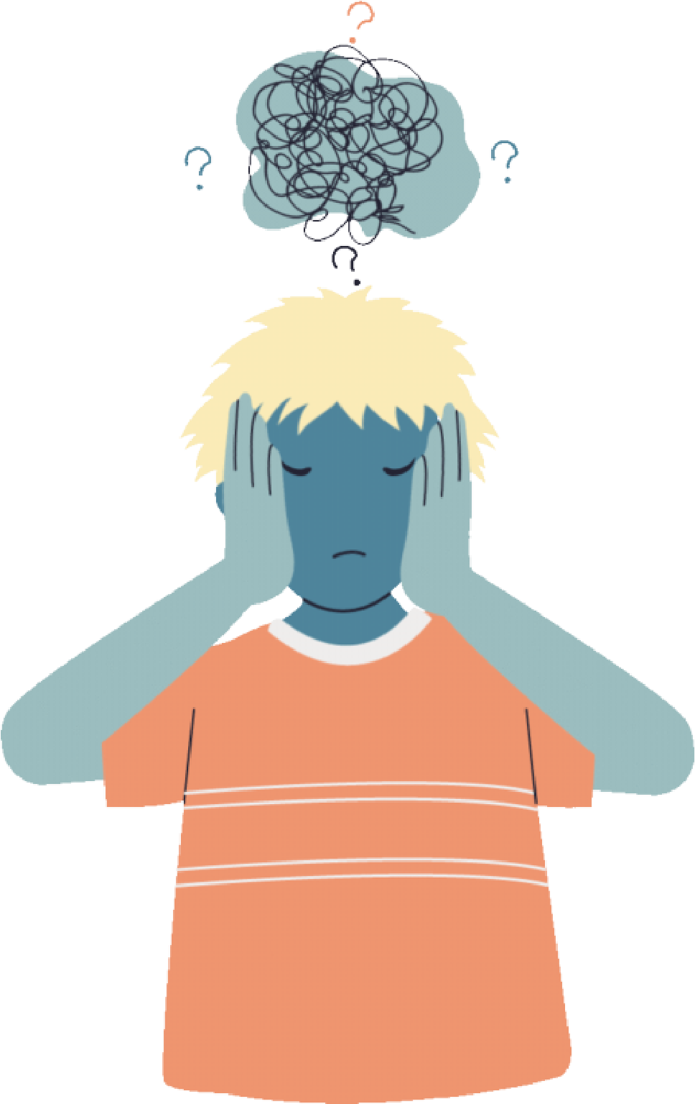

A specific approach to treat traumatic memories.
3.Behavioral activation:
Working on resuming avoided behaviors due to trauma. Cognitive restructuring: Identifying and changing negative thoughts related to the trauma.
1.Group therapy:
Participation in support groups or group therapy sessions can provide an emotional support framework and allow individuals to share their experiences.
2.Self-help:
Encouraging self-help practices such as relaxation, meditation, and mindfulness.
Trauma reprocessing therapy (TRT):
A specific approach that aims to treat traumatic experiences by focusing on the memory of the trauma and its impact on emotions and behavior.
Education about PTSD:
Providing the patient with information about the nature of PTSD, its symptoms, and coping strategies can help normalize the experience and enhance understanding.
1.Stress management:
Teaching stress management techniques to help the patient cope with stress-triggered symptoms.
2.Regular follow-up:
Regular follow-up with a mental health professional is essential to assess treatment progress, make adjustments as needed, and provide ongoing support.

Eating disorders
1.Initial assessment:
A comprehensive evaluation of physical and mental health, including the severity of eating symptoms, medical history, and psychosocial stressors.
2.Individual psychotherapy:
Psychotherapy, especially cognitive-behavioral therapy (CBT), is often used to treat eating disorders. It can help identify negative thoughts and dysfunctional behaviors related to food.

Eating disorders
1.Family therapy:
Family therapy is commonly used, especially in adolescents, to involve the family in the treatment process and address family dynamics that may contribute to eating disorders.
2.Nutritional counseling:
Working with a nutritionist to develop a balanced meal plan tailored to the individual needs of the patient.
3.Patient and family education:
Educating the patient and their family about the nature of eating disorders, triggers, and strategies to promote healing.

Eating disorders
1.Regular medical monitoring:
Regular medical follow-up is necessary to monitor physical health, weight gain, and adjust the treatment plan as needed.
2.Support groups:
Participation in support groups, consisting of other individuals dealing with eating disorders, can provide emotional support and practical advice.

Eating disorders
1.Intensive hospital or outpatient treatment: In cases of severe eating disorders, intensive hospital or outpatient treatment may be necessary for constant monitoring, nutritional rehabilitation, and intensive symptom management.
2.Treatment of underlying psychological issues: If mood disorders, anxiety, or other underlying psychological issues are present, specific treatment for these disorders may be necessary.

Fear of the future
1.Social support:
Involving family, friends, or joining support groups can provide a crucial support network.
2.Antidepressants or anxiolytics:
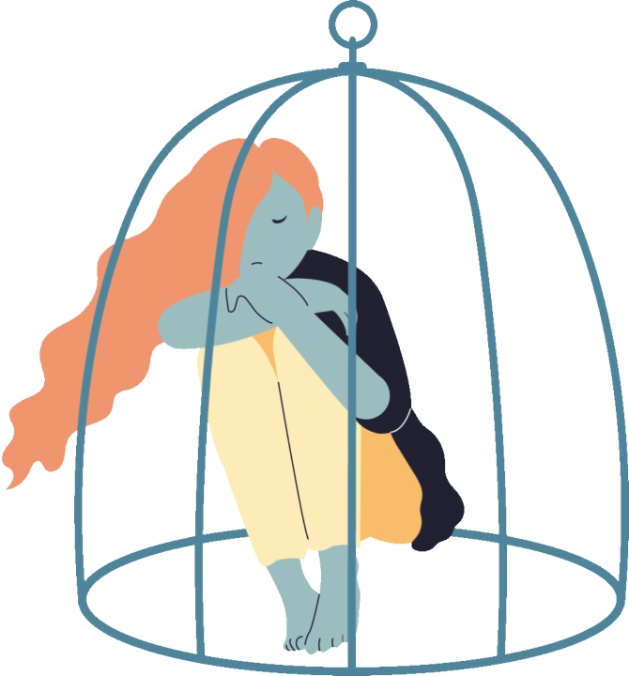
In some cases, a mental health professional may prescribe medications to temporarily alleviate severe anxiety symptoms. However, this is generally considered a complementary option to psychotherapy.
3.Building resilience:
Working on strengthening emotional resilience can help cope with future challenges in a more adaptable and resilient manner.

Fear of the future
1.Problem-solving skills development:
Learning problem-solving skills can help cope with future challenges more effectively, thereby reducing anxiety.
2.Individual or group therapy:
Individual or group therapy can provide a space to explore concerns related to the future, share experiences, and receive support.
3.Meditation and mindfulness:
Regular practice of meditation and mindfulness can help develop awareness of the present moment and reduce future anxiety.

