Macro-environment of Business

Tutor

Institution

Department

Date

Macro-environment of Business

The world has had a constant and steady sustainable economic growth since 2004, which has been volatile since 1960 and 1970 in line with the low inflation levels. The recent economic growth has been strong and of equal distribution across countries, signifying low volatility. This may seem surprising due to the emergence of a market with high volatility and developing nations accounting for a growing p percentage of the global economy. However, the 1970s marked a brief pause in the trend of gradually developing advanced economies experiencing ever-longer booms. This was partly due to extraordinary oil supply interruptions and a decrease in productivity, but it was also due to monetary policy blunders. The global economy rousted significantly during the first half of 2007, despite the turbulence that accumulated in the financial market that clouded the judgment of prospects.

Output volatility is an important business aspect. IMF Provided that the output volatility and the trend growth rate influence the period it takes for economies to expand or go to recesses (IMF 2007, P. 175). The financial leakages and the growing restrictions in trade since 1960 led to a less connectedness of economic results across the nation resulting in varying degrees of output volatility moderation and national and global levels. Since the mid-1980s, research has shown statistically that the economy's behavior has changed fundamentally. Since then, the business cycle has been smoother, but random variations in economic growth have also been reduced. This is attributed to the change in the economy's structure and policies.

Economic fluctuation is dangerous to the economy. Fewer fluctuations are desirable since they enable countries to progress steadily and gain a flow of investment which is worthwhile for reduced volatility. The 2008 financial crisis created a situation that countered the established fiscal policy. According to Dickens (2010), for a time, the concerns about budget deficits became a secondary issue. The US and China were at the forefront of pursuing the policies while other governments increased or decreased taxes to counter the severity of the situation (Par. 1). Fiscal policy had long been the forgotten stepchild of government economic control. In the opinion of many theoreticians and policymakers, monetary policy—basically, interest rate control- had become the preferred policy weapon to combat either recession or economic overheating and the only effective countercyclical policy tool. After the 1980 recession, several central banks made a low inflation rate (Great moderation) their policy objective. However, these principles were profoundly challenged by the 2008 recession crisis.

Volatility and reduced consumer confidence make the economy fluctuate in the short run, and dismal forecasts make the investors further reduce investments, leading to a reduction in output. As a result of the growth in consumer spending, the economy can maintain its expansion. If consumer confidence drops for whatever reason, customers feel less confident in their financial outlook and begin to spend less money; this, in turn, impacts companies as sales begin to diminish. For this reason, most major countries return to fiscal measures in concert with broad monetary policies to alleviate the recession when it comes down to it. Long-term challenges such as population aging, rising opposition to globalization, and global warming, are a cause of concern (IMF, 2020, P. 86). Also, the rising concerns include trade tensions, oil price volatility, and monetary and fiscal policy failure to address growth slowdowns since interest rates are already negative in some developed nations, leaving less flexibility for monetary policy to address slowdowns. Research by Teresiene (2021) addresses that the regressing models for the global consumer confidence showed that the consumers for a country were confident based on the adverse reaction to the rate of infections (p.15). With the rising diversity of risks facing sustainable, stable economic growth, several entirely different reactions and tendencies could be present in critical global situations. These factors need to be given close attention while establishing strategic decisions and regional diversification.

Countries may experience economic distress with increased unemployment, with extremely low unemployment rates signifying overheated economies. These results because there is a lower economic output while subsistence is required. When an economy is not the recession, the natural unemployment rate is represented by the lowest unemployment rate with stable or non-accelerating inflation. It is caused by political, social, and economic forces (Daly et al., 2012, p. 4). It requires that the real wage stays above the market to clear the level that equates supply and demand.

The natural rate of unemployment can be affected by several factors, including productivity shifts. The effect of employee productivity will affect the number of wages that are made from an economy over time. A company's bankruptcy is assured if it pays employees whose productivity does not equate to their pay. Alternatively, companies in a competitive environment may lose their employees to other companies who regard them as productive if they pay them less than their productivity. The average unemployment level will tend to be higher with unexpectedly low productive and slightly lower with unexpectedly higher productivity.

Public policies can have significant impacts on the natural rate of unemployment. On the supply side of the labor market, governmental measures to assist the jobless can impact people's willingness to look for employment by providing retirement benefits and incentives in case someone loses a job. These packages may discourage someone from seeking a different job despite their productivity levels. Not the amount of these advantages, but how long they stay, appears to be the most important factor. A society that gives significant unemployment assistance for a limited period, such as six months, may provide less incentive for unemployment than one that provides less generous assistance for a longer period. Government helps for job search or retraining, on the other hand, may encourage people to return to work sooner in some instances.

Saudi Arabia is a country with a high rate of unemployment among youths. Alhamad (2014) attributes the high unemployment rates in the past decade to competition from foreign workers who prefer low pays, many unskilled Saudi Arabian workers, and the demographic issues where most of the Saudi population ranges from 20-to 34 years (p. 1). Currently, Saudi Arabia is facing issues that touch all the corners of the world due to its high population of immigrants who are likely to be affected by the changes in policy and laws. For this reason, the country has adapted policies that are meant to curb the limitations while encouraging entrepreneurship. The absence of information on entrepreneurship and unemployment data limits the study. However, the problem faced by unemployment in Saudi Arabia cannot be solved completely with the massive injection of public funds or policy matters. For instance, the country has two distinct labor markets, I.e., Saudi's and foreigners. This called for establishing sustainable policies that are discreet and distinct to both parties. Rather, the country needs to overcome several obstacles and deal with the challenges that they're facing

**Fig 1:** AD-AS framework.

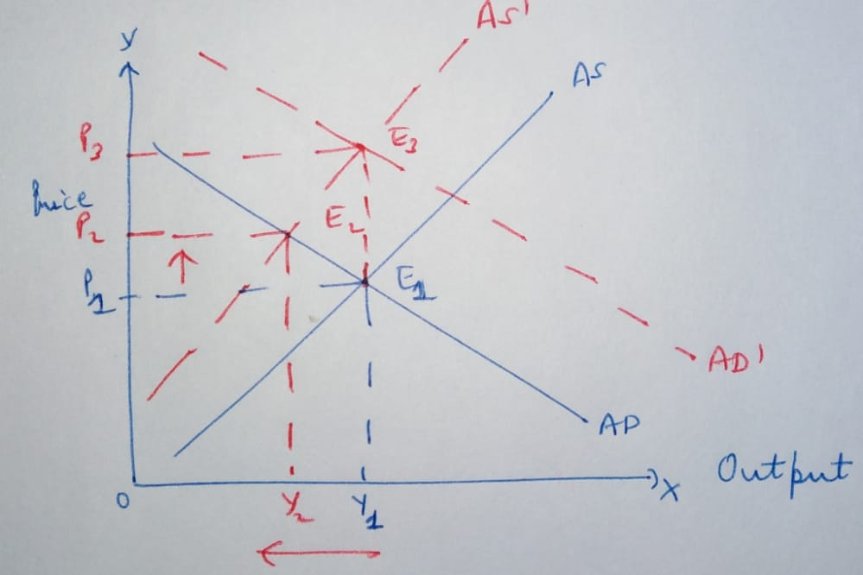

Stagflation in the economy occurs due to a leftward shift of the aggregate supply curve in the economy. The condition is due to the combination of slow economic growth, high unemployment, and inflation of prices. The condition was experienced in 1970 following monetary and fiscal policies and an oil embargo. The AD-AS framework divides the economy into the supply side and tends in the demand side, then analysis the behavioral relationship of the two using different domains (Dutt and Skott, 2006, p. 3). From the diagram provided above, point E1 represents the initial position of the economy. When the curve shifts from point AS to AS' will move the equilibrium point from point E1 to point E2. The result will be an increase in the price level to OP2 and a corresponding decline in the national output level to OY2.

The government may return the economy to its original production in the short term. This will be done through pursuing the expansionary fiscal policy that will inflict a rightward push to the AD curve onto AD'. The equilibrium will be shifted from point E2 to E3 in the short run. The lost output will be regained at point Y1. In the short term, the government may return the economy to its original production level by pursuing expansionary fiscal policy, pushing the AD curve rightwards to AD' and shifting equilibrium from point E2 to E3 in the short run lost output recouped and ultimate output at Y1.

References

Teresiene, D., Keliuotyte-Staniuleniene, G., Liao, Y., Kanapickiene, R., Pu, R., Hu, S. and Yue, X.G., 2021. The Impact of the COVID-19 Pandemic on Consumer and Business Confidence Indicators. *Journal of Risk and Financial Management*, *14*(4), p.159.

Dutt, A.K. and Skott, P., 2006. Keynesian theory and the AD-AS framework: A reconsideration. *Contributions to Economic Analysis*, *277*, pp.149-172.

Daly, M.C., Hobijn, B., Şahin, A. and Valletta, R.G., 2012. A search and matching approach to labor markets: Did the natural rate of unemployment rise?. *Journal of Economic Perspectives*, *26*(3), pp.3-26.

Dickens, W., 2010. Long-term consequences of economic fluctuations. Retrieved from <https://www.newamerica.org/economic-growth/policy-papers/long-term-consequences-of-economic-fluctuations/>

Al-Hamad, H., 2014. The Labor Market in Saudi Arabia: Foreign Workers, Unemployment, and Minimum Wage. Retrieved from <http://www.inquiriesjournal.com/articles/905/the-labor-market-in-saudi-arabia-foreign-workers-unemployment-and-minimum-wage>