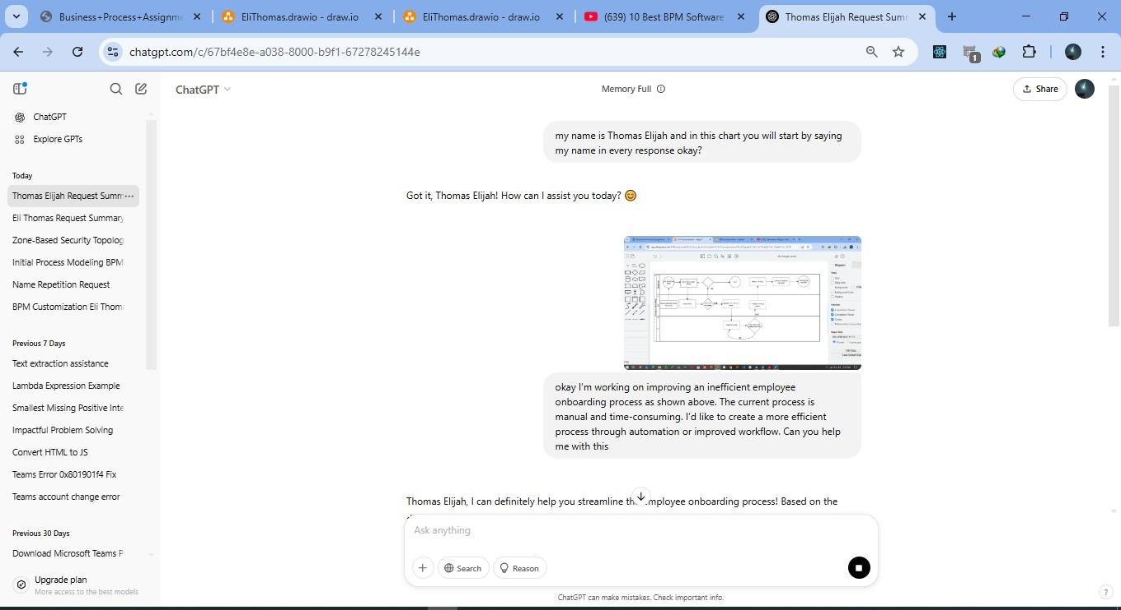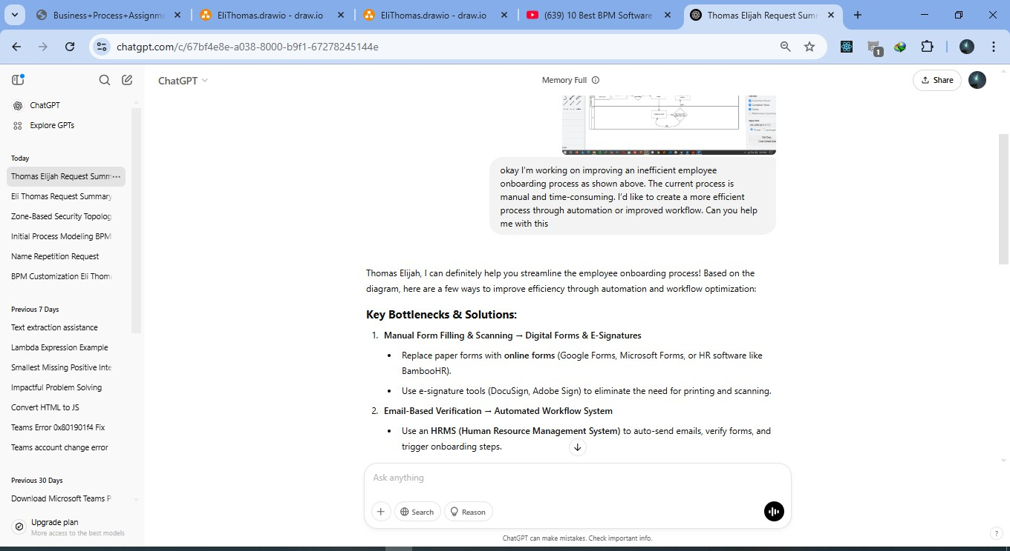ChatGPT Engagement

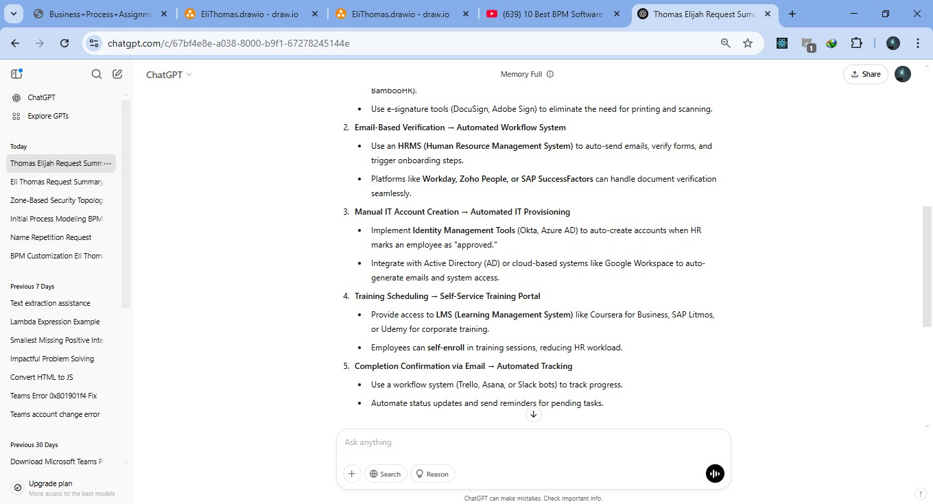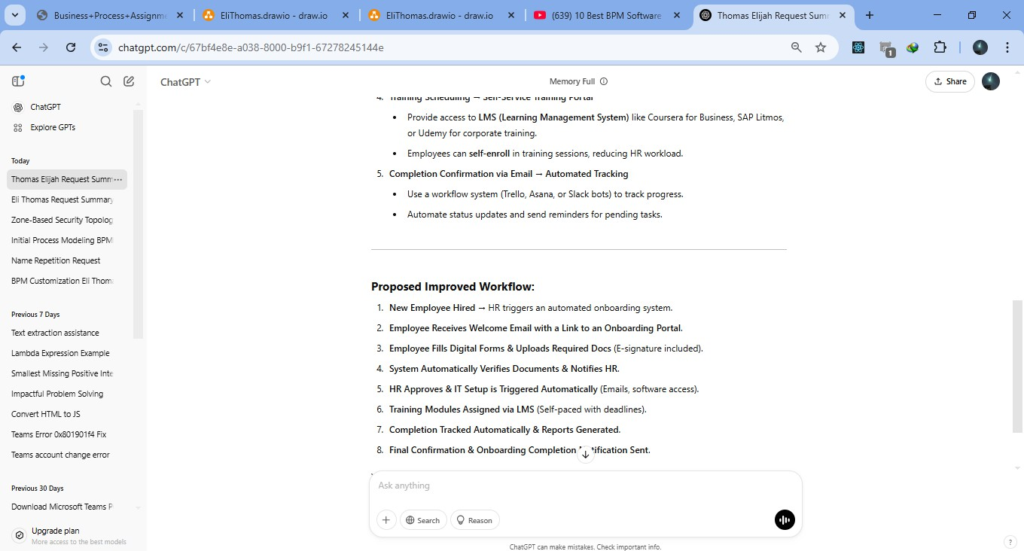

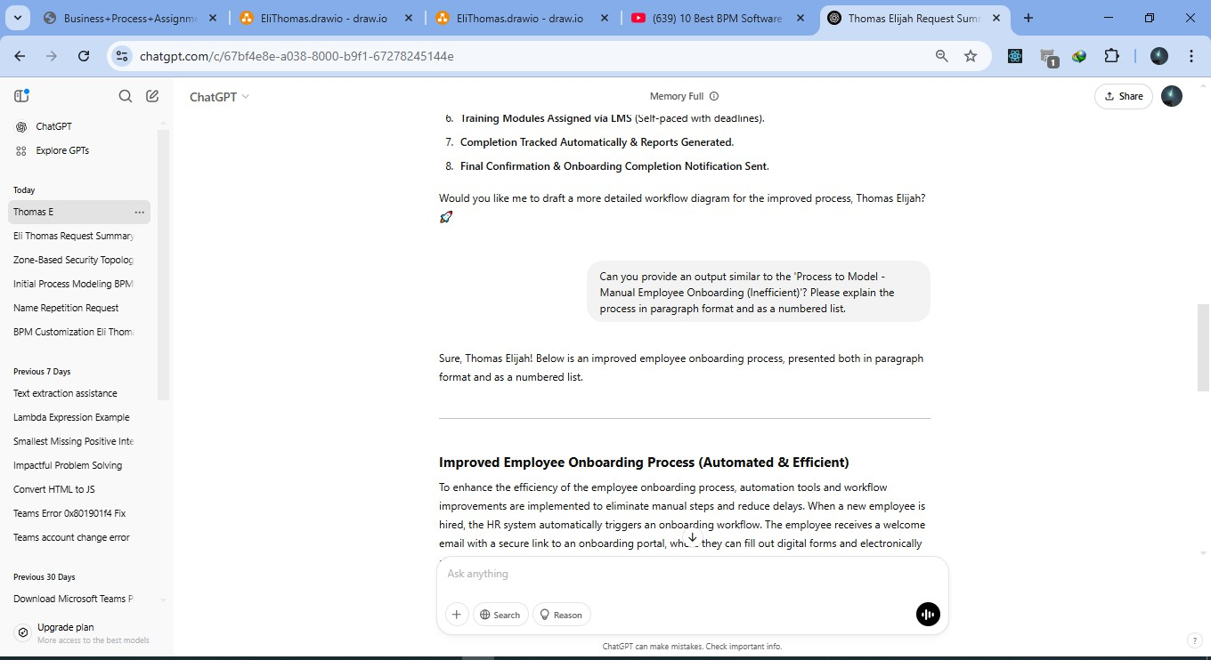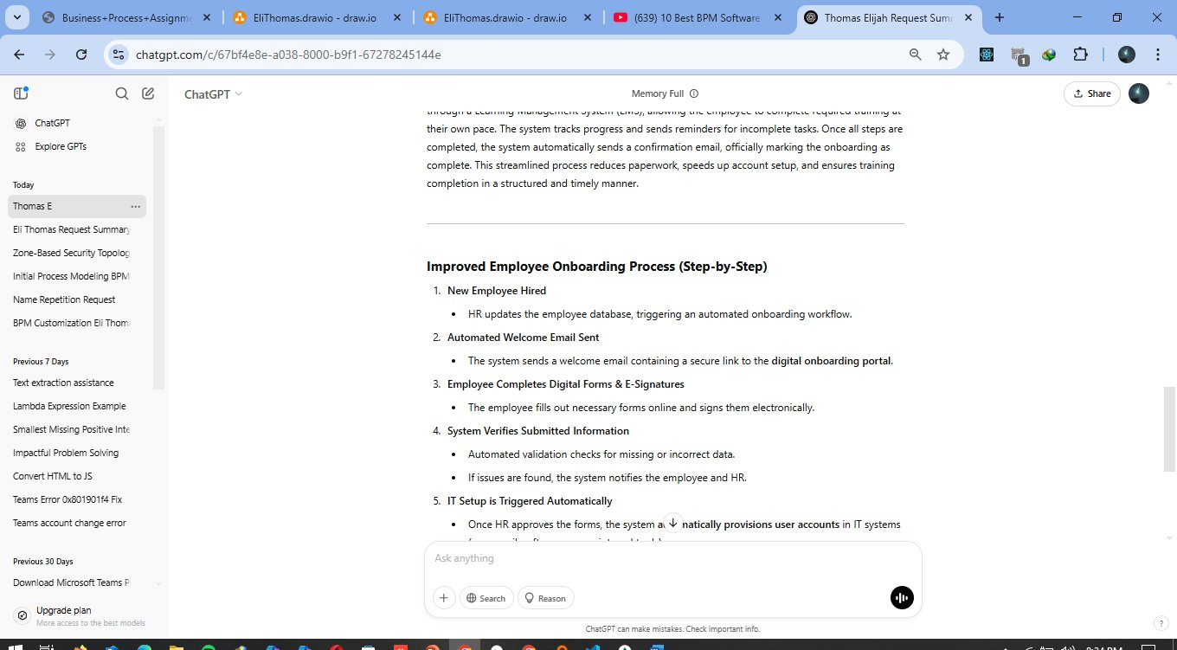

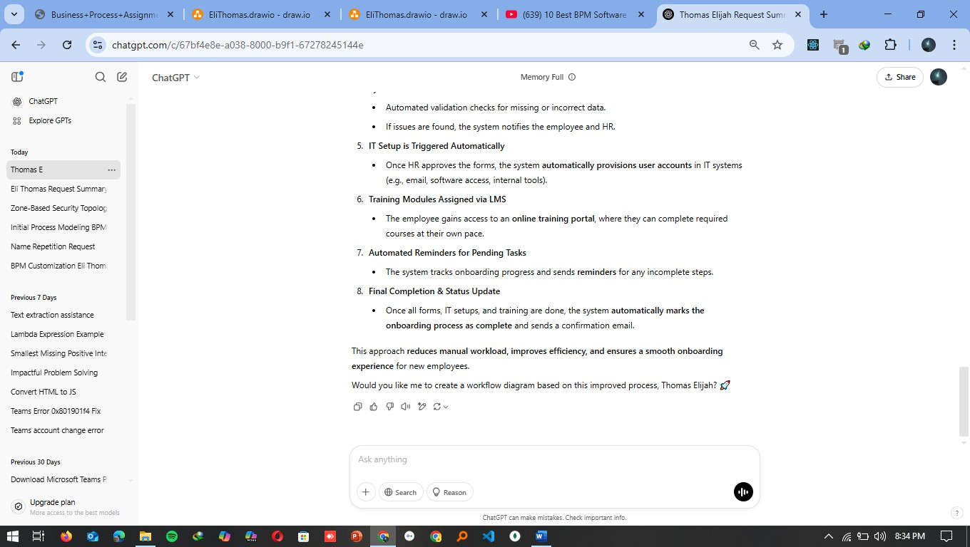

my name is Thomas Elijah and in this chart you will start by saying my name in every response okay?

**ChatGPT said:**

Got it, Thomas Elijah! How can I assist you today? 😊

**You said:**

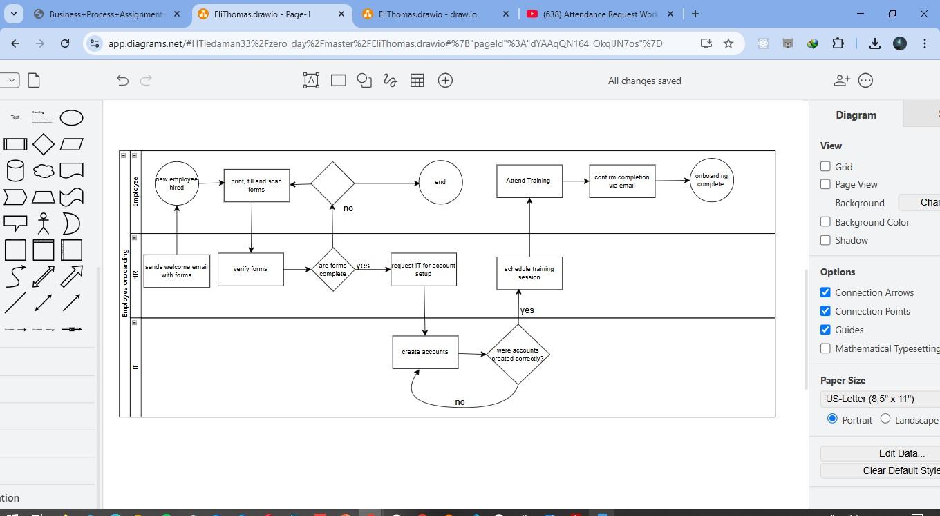

okay I’m working on improving an inefficient employee onboarding process as shown above. The current process is manual and time-consuming. I’d like to create a more efficient process through automation or improved workflow. Can you help me with this

**ChatGPT said:**

Thomas Elijah, I can definitely help you streamline the employee onboarding process! Based on the diagram, here are a few ways to improve efficiency through automation and workflow optimization:

**Key Bottlenecks & Solutions:**

1. **Manual Form Filling & Scanning → Digital Forms & E-Signatures**
   * Replace paper forms with **online forms** (Google Forms, Microsoft Forms, or HR software like BambooHR).
   * Use e-signature tools (DocuSign, Adobe Sign) to eliminate the need for printing and scanning.
2. **Email-Based Verification → Automated Workflow System**
   * Use an **HRMS (Human Resource Management System)** to auto-send emails, verify forms, and trigger onboarding steps.
   * Platforms like **Workday, Zoho People, or SAP SuccessFactors** can handle document verification seamlessly.
3. **Manual IT Account Creation → Automated IT Provisioning**
   * Implement **Identity Management Tools** (Okta, Azure AD) to auto-create accounts when HR marks an employee as "approved."
   * Integrate with Active Directory (AD) or cloud-based systems like Google Workspace to auto-generate emails and system access.
4. **Training Scheduling → Self-Service Training Portal**
   * Provide access to **LMS (Learning Management System)** like Coursera for Business, SAP Litmos, or Udemy for corporate training.
   * Employees can **self-enroll** in training sessions, reducing HR workload.
5. **Completion Confirmation via Email → Automated Tracking**
   * Use a workflow system (Trello, Asana, or Slack bots) to track progress.
   * Automate status updates and send reminders for pending tasks.

**Proposed Improved Workflow:**

1. **New Employee Hired** → HR triggers an automated onboarding system.
2. **Employee Receives Welcome Email with a Link to an Onboarding Portal**.
3. **Employee Fills Digital Forms & Uploads Required Docs** (E-signature included).
4. **System Automatically Verifies Documents & Notifies HR**.
5. **HR Approves & IT Setup is Triggered Automatically** (Emails, software access).
6. **Training Modules Assigned via LMS** (Self-paced with deadlines).
7. **Completion Tracked Automatically & Reports Generated**.
8. **Final Confirmation & Onboarding Completion Notification Sent**.

Would you like me to draft a more detailed workflow diagram for the improved process, Thomas Elijah? 🚀

**You said:**

Can you provide an output similar to the 'Process to Model - Manual Employee Onboarding (Inefficient)'? Please explain the process in paragraph format and as a numbered list.

**ChatGPT said:**

Sure, Thomas Elijah! Below is an improved employee onboarding process, presented both in paragraph format and as a numbered list.

**Improved Employee Onboarding Process (Automated & Efficient)**

To enhance the efficiency of the employee onboarding process, automation tools and workflow improvements are implemented to eliminate manual steps and reduce delays. When a new employee is hired, the HR system automatically triggers an onboarding workflow. The employee receives a welcome email with a secure link to an onboarding portal, where they can fill out digital forms and electronically sign documents. The system verifies the submitted information and automatically notifies HR if any corrections are needed. Once the forms are validated, the IT department is alerted to set up the employee’s accounts and system access. An identity management system like Okta or Azure AD automates this process, reducing manual input errors. Simultaneously, the training module is assigned through a Learning Management System (LMS), allowing the employee to complete required training at their own pace. The system tracks progress and sends reminders for incomplete tasks. Once all steps are completed, the system automatically sends a confirmation email, officially marking the onboarding as complete. This streamlined process reduces paperwork, speeds up account setup, and ensures training completion in a structured and timely manner.

**Improved Employee Onboarding Process (Step-by-Step)**

1. **New Employee Hired**
   * HR updates the employee database, triggering an automated onboarding workflow.
2. **Automated Welcome Email Sent**
   * The system sends a welcome email containing a secure link to the **digital onboarding portal**.
3. **Employee Completes Digital Forms & E-Signatures**
   * The employee fills out necessary forms online and signs them electronically.
4. **System Verifies Submitted Information**
   * Automated validation checks for missing or incorrect data.
   * If issues are found, the system notifies the employee and HR.
5. **IT Setup is Triggered Automatically**
   * Once HR approves the forms, the system **automatically provisions user accounts** in IT systems (e.g., email, software access, internal tools).
6. **Training Modules Assigned via LMS**
   * The employee gains access to an **online training portal**, where they can complete required courses at their own pace.
7. **Automated Reminders for Pending Tasks**
   * The system tracks onboarding progress and sends **reminders** for any incomplete steps.
8. **Final Completion & Status Update**
   * Once all forms, IT setups, and training are done, the system **automatically marks the onboarding process as complete** and sends a confirmation email.

This approach **reduces manual workload, improves efficiency, and ensures a smooth onboarding experience** for new employees.

Would you like me to create a workflow diagram based on this improved process, Thomas Elijah? 🚀