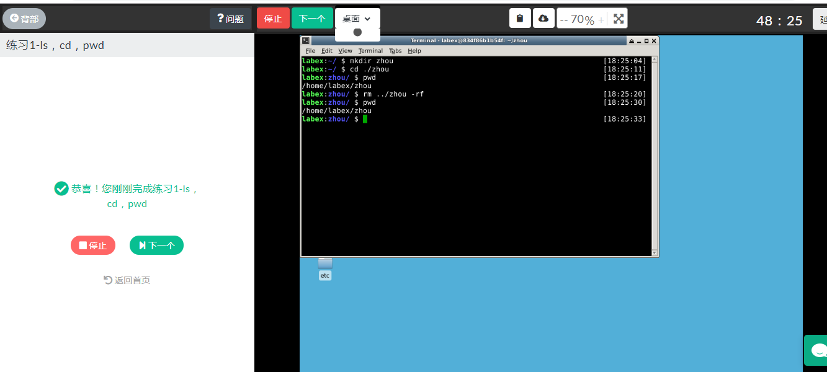
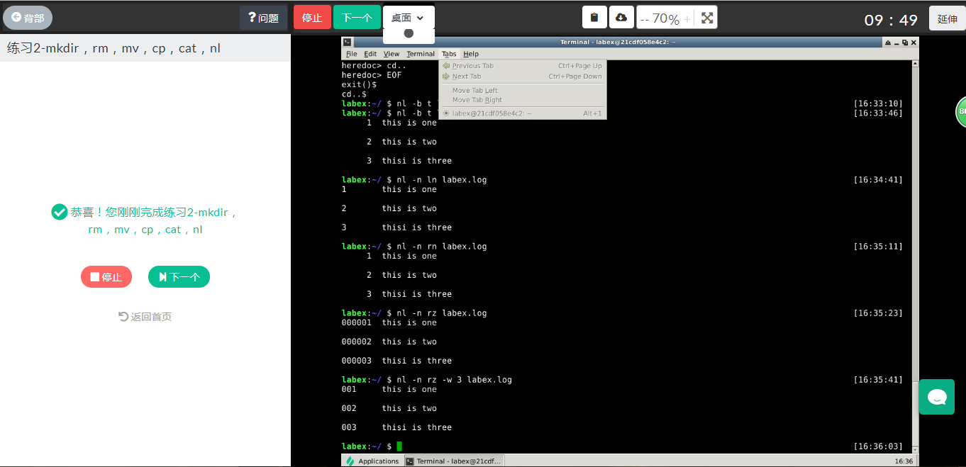
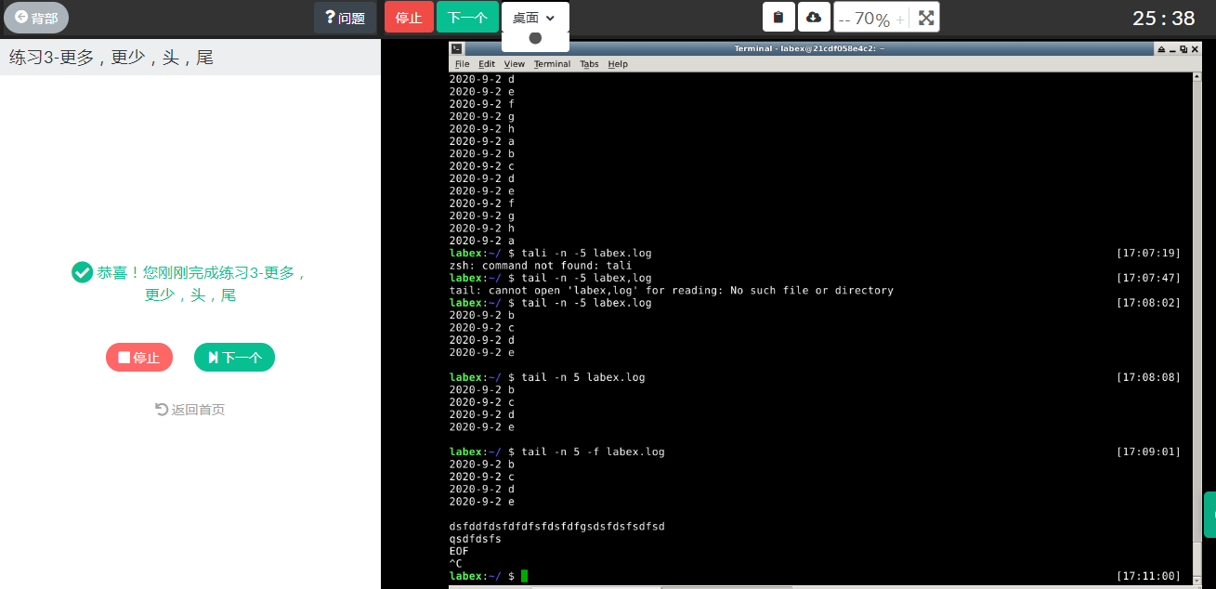
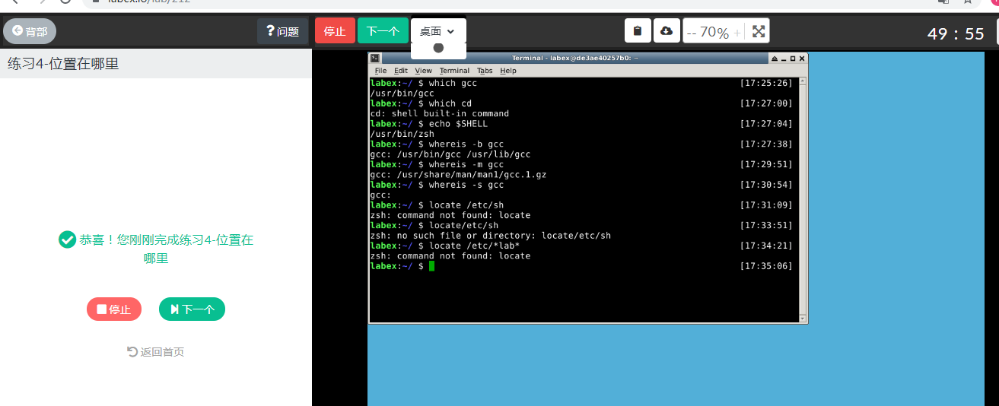
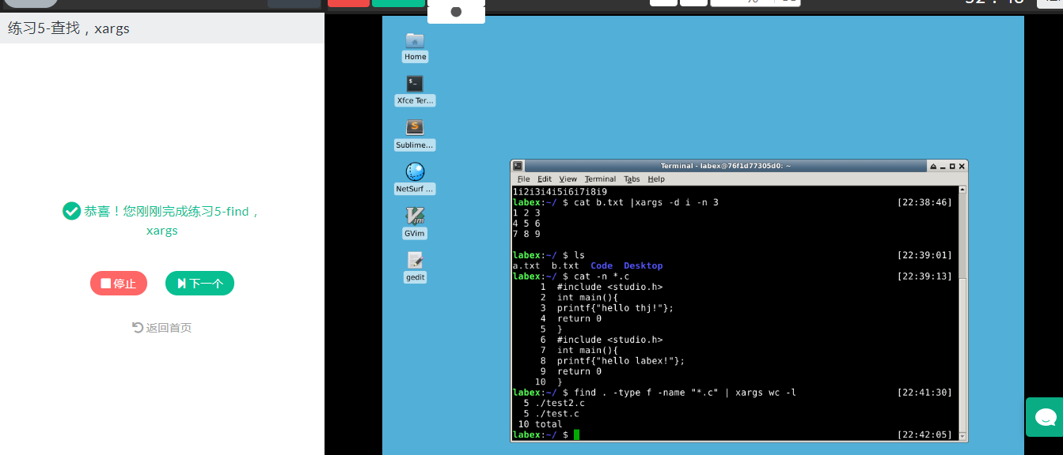
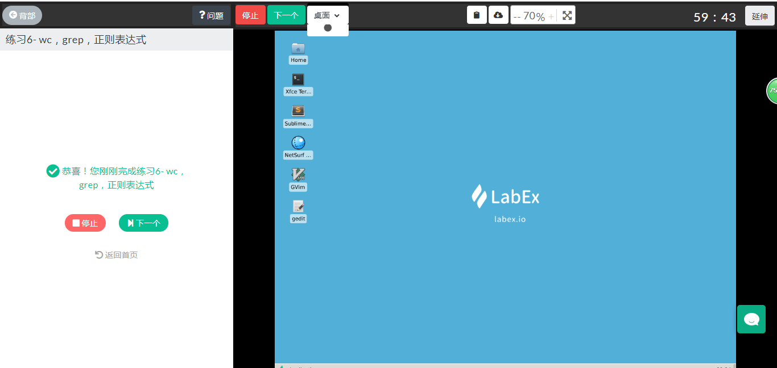
1、mkdir cli-practice
2、touch v ~/cli-practice/readme.md
3、echo 'Hi there, this is a readme file.' > ~/cli-practice/readme.md
4、echo 'This is the second line of the readme file.' >> ~/cli-practice/readme.md
5、mv ~/cli-practice/readme.md readme.txt
6、mkdir ~/cli-practice/document
7、mv ~/cli-practice/readme.txt ~/cli-practice/document/introduction.txt
8、cp ~/cli-practice/document/introduction.txt ~/cli-practice/document/readme.txt
9、echo ' The quick brown fox jumps over a lazy dog'> ~/cli-practice/document/readme.txt
10、cp -r ~/cli-practice/document ~/cli-practice/docs/
11、rm -rf ~/cli-practice/document
12、mkdir -p ~/cli-practice/parent/child/docs
13、cp ~/cli-practice/docs/introduction.txt ~/cli-practice/parent/child/docs/

