**CEBU INSTITUTE OF TECHNOLOGY UNIVERSITY**

**COLLEGE OF COMPUTER STUDIES**

Software Design Description for

STREAMLINED SERVICE PORTAL

Members:

Tiempo, John Allen

Cabreros, Justine

Amerila, Roelan

Dellapietra, Franco

**Architectural Design**

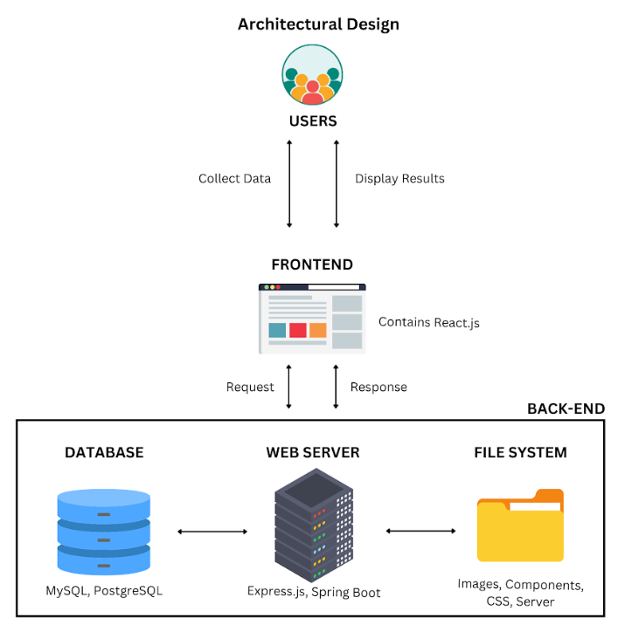

**Module Decomposition**

**Module 1: User Management**

* 1. Registration

1.1.1 UI

1.1.2 Class Diagram

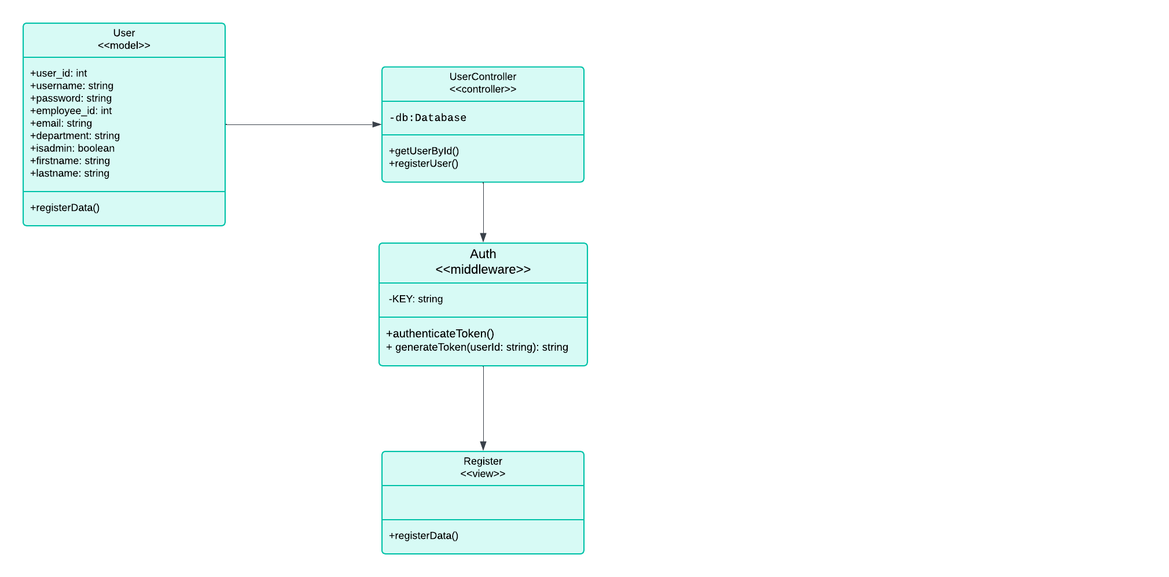

1.1.4 Database

