Software Design Description (SDD)
Veterinary Management Platform. Version 1.0, 2026-10-13, written at the B-04 merge.

1. Introduction
This document describes how the platform is built: its structure, request flow, data design and the patterns every new module follows. Requirements are in SRS.md; the reasoning behind each major decision is recorded once, in the ADRs of ARCHITECTURE.md section 11, and only referenced here. If this document and an ADR disagree, the ADR wins and this document must be fixed.
Sections 2–7 describe what exists (B-01 to B-04). Section 8 is the design to follow for planned modules.

2. System context
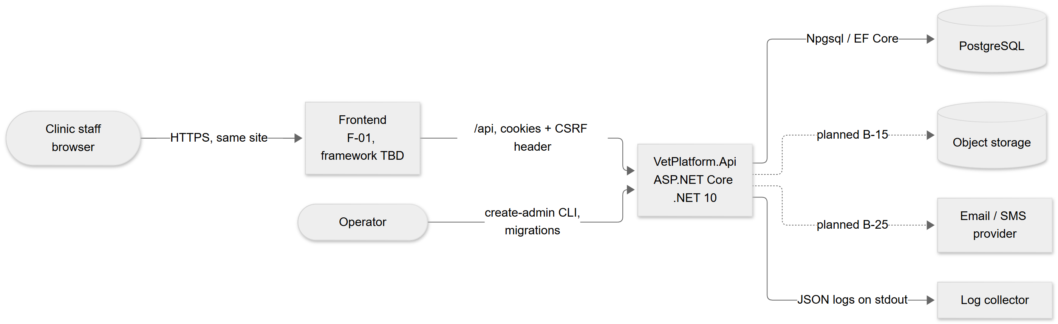
- The frontend and API share a site (SameSite=Strict cookies, no CORS). In development the frontend dev server proxies /api to https://localhost:7096.
- There is no public sign-up; an operator provisions each clinic with the CLI (ADR-004).

3. Architectural style (ADR-001)
A modular monolith: one deployable (backend/src/VetPlatform.Api), organised by feature.
src/VetPlatform.Api/
Program.cs composition root, middleware order, CLI dispatch
Common/ cross-cutting infrastructure, no business rules
Errors/ error envelope, ApiException, global exception handler, model-state mapping
Http/ request id, request logging, paging, strict enum parsing
Persistence/ AppDbContext, Entity base, timestamps interceptor, health check, Migrations/
Security/ CSRF filter
Authorization/ Role enum, permission catalogue, [RequirePermission], policy handler
Tenancy/ ITenantContext, ClinicScopeInterceptor
Auditing/ AuditLog entity, AuditTrail
Features/
Identity/ Clinic, User, UserRole, UserSession entities, password policy
Auth/ AuthController, AuthService, cookie session events, antiforgery binding
Users/ UsersController, UserService, contracts, create-admin command
Layering inside a feature: controller (HTTP mapping, attributes, no logic) → service (business rules, transactions, audit) → AppDbContext (EF Core; no repository layer, since the context already is one). Request and response types are records in <Feature>Contracts.cs; entities never cross the API boundary.
Rules that keep modules separable later: a feature reaches another feature's data only through that feature's service or its entities' navigation properties, never by duplicating its rules; Common/ never depends on Features/ except where entity types are required by infrastructure (identity entities for session validation).

4. Request pipeline
Order is set in Program.cs and matters:
# | Stage | Responsibility
1 | RequestIdMiddleware | Accept a safe X-Request-Id or generate one; echo it; open the CorrelationId log scope.
2 | RequestLoggingMiddleware | Log method, path, status, duration only (never query, headers, body).
3 | Exception handler + status code pages | Turn any exception or bare status into the error envelope (API.md section 2).
4 | HSTS | Outside Development only.
5 | Rate limiter | Login/password policy: fixed window per client IP (IPv6 /64). Runs before authentication so throttled attempts cost no database work.
6 | Authentication | Cookie handler; SessionCookieEvents.ValidatePrincipal re-validates the session on every request (6.1).
7 | Authorization | Endpoint default RequireAuthorization(); [RequirePermission] policies; [AllowAnonymous] exceptions.
8 | MVC filters | CsrfProtectionFilter on unsafe methods; model validation → 422/400 mapping.
9 | Controller → service → AppDbContext | Business logic, with the tenant filter and write guard (6.2) and audit (6.3).

Error precedence observed by clients (API.md section 3): 429 → 401 → 403 FORBIDDEN → 403 CSRF_TOKEN_INVALID → 400/422 → endpoint result.
Unsafe endpoints must be controller actions because CSRF protection is an MVC filter; a test enforces it.

5. Data design (ADR-002)
- PostgreSQL, EF Core 10 with Npgsql, one AppDbContext. Entity configuration lives next to the entity as IEntityTypeConfiguration<T> and is discovered automatically.
- Conventions: snake_case names; uuid keys from Guid.CreateVersion7(); timestamptz in UTC as DateTimeOffset; money numeric(19,4); enums stored as their names with CHECK constraints; created_at / updated_at set by TimestampsInterceptor from the injected TimeProvider.
- Clinic-owned tables have a non-null clinic_id FK and an index starting with clinic_id.

Current schema:
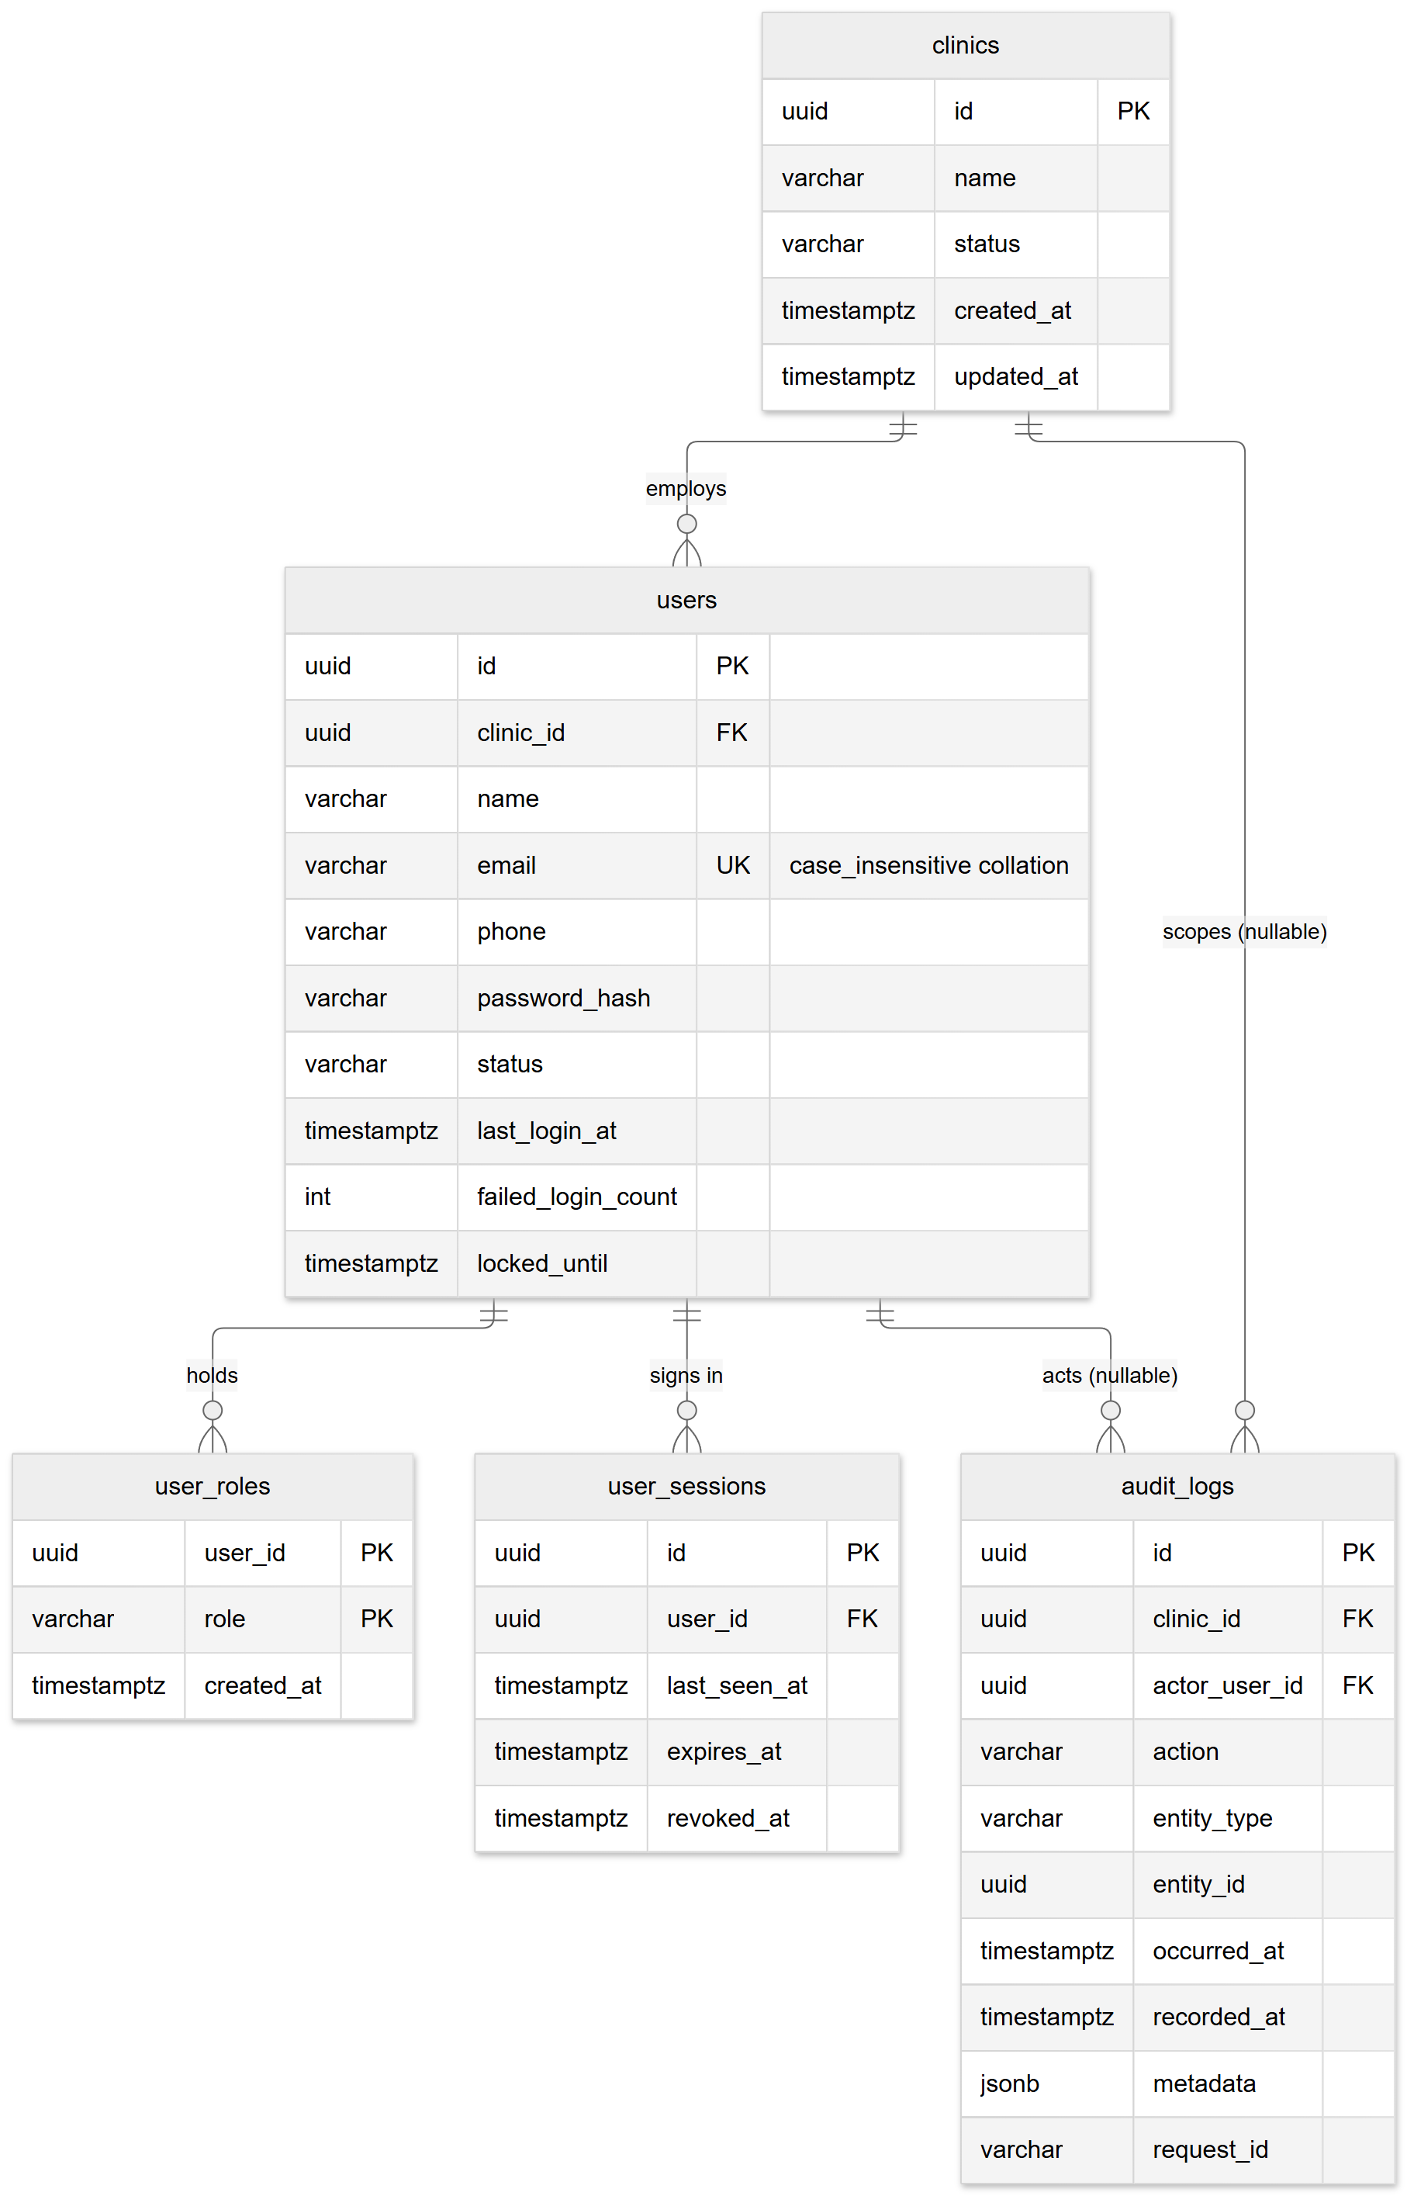
Migrations: Baseline (B-02), AddIdentityAndSessions (B-03), AddRolesAndAuditLog (B-04). The full planned model is in DATABASE.md.

6. Cross-cutting mechanisms

6.1 Authentication and sessions (ADR-003)
- Cookie __Host-vet_session (HttpOnly, Secure, SameSite=Strict, browser-session lifetime) carries user id, clinic id and session id, encrypted by ASP.NET Core Data Protection.
- On each request SessionCookieEvents loads the session row with its user, clinic and roles, and rejects the principal when the session is revoked, idle past 2 h, past its 12 h absolute end, the user is disabled, the clinic suspended, or the cookie's user/clinic claims do not match the row. It then adds role claims for this request only and refreshes last_seen_at at most once per minute.
- Sign-in (AuthService): clears the incoming identity, hashes the password even for unknown emails, counts failures with one atomic UPDATE that also sets locked_until, and serialises with password change through a row lock on the user. Success revokes the browser's previous session and creates a new one.

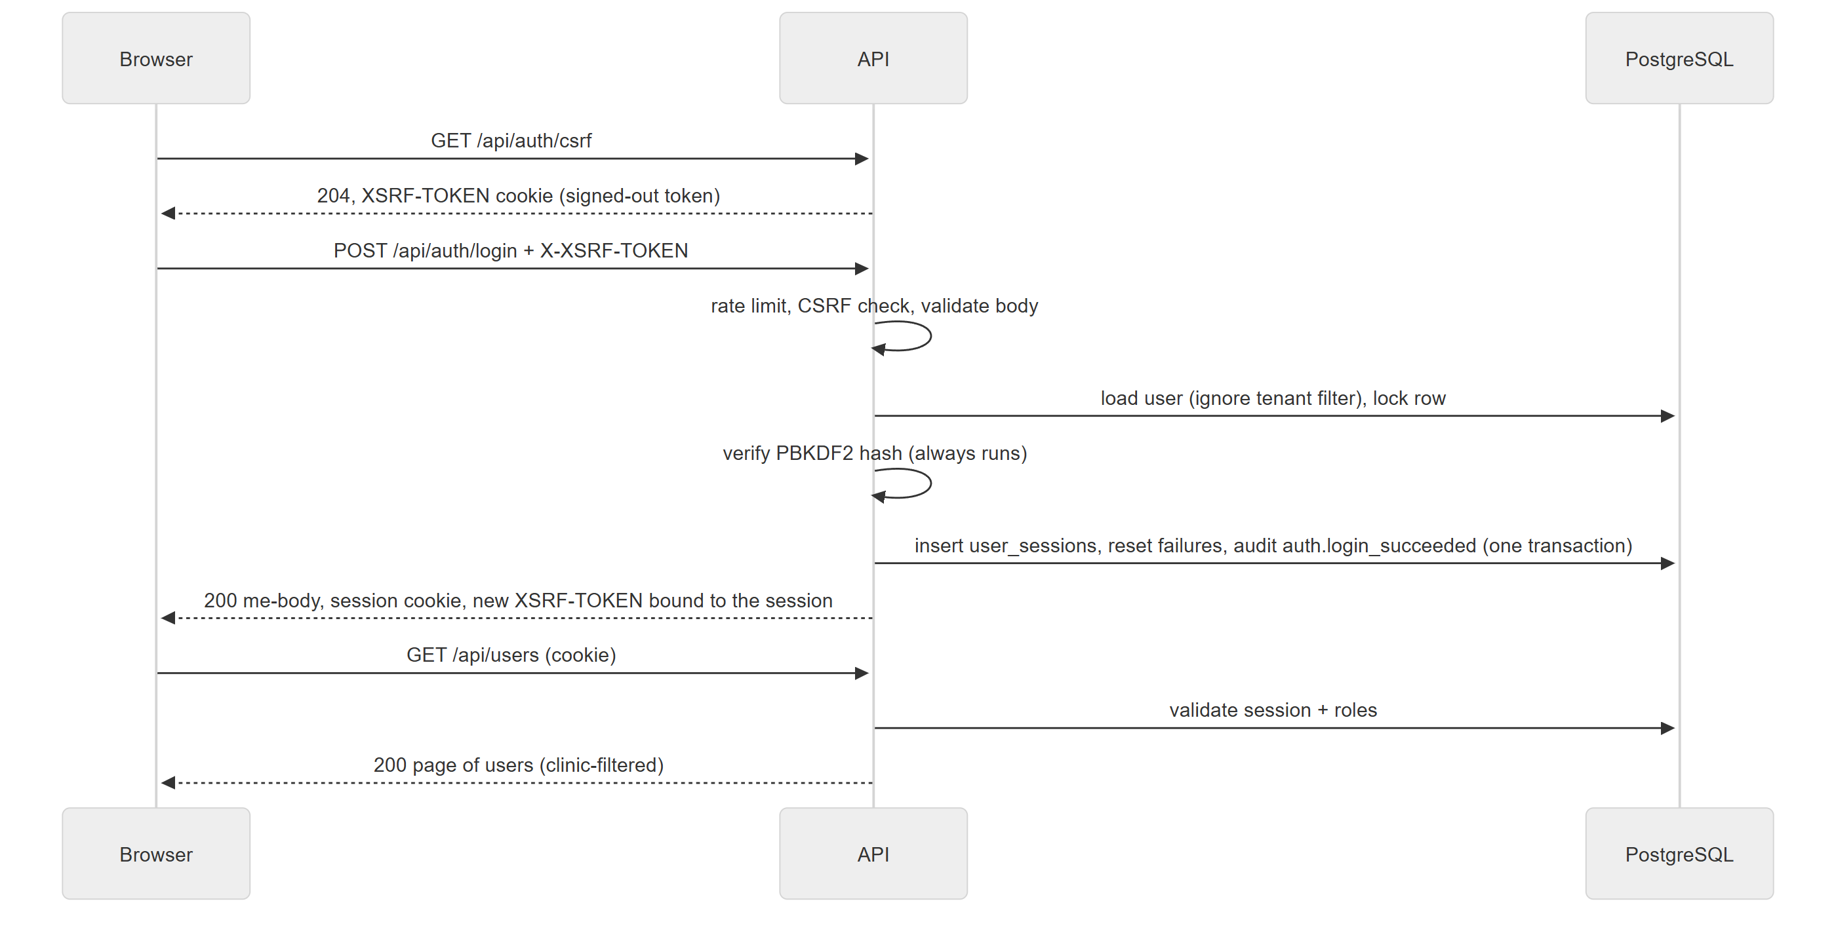

6.2 Authorization and tenant isolation (ADR-004)
- Roles and permissions are fixed in Common/Authorization/Permissions.cs. Endpoints declare [RequirePermission(Permissions.X)]; PermissionHandler checks the request's role claims.
- Current clinic comes only from the validated session through ITenantContext. Request bodies never carry a clinic id.
- Read guard: every IClinicOwned entity has the named global query filter AppDbContext.ClinicFilter. No current clinic → the filter matches nothing (fail closed).
- Write guard: ClinicScopeInterceptor stamps new rows with the current clinic and throws when a row of, or a move to, another clinic is saved.
- IgnoreQueryFilters() is allowed only for genuinely cross-clinic code (sign-in, session validation, platform-wide email uniqueness, CLI), each with a justifying comment.
- Other clinics' records are 404, never 403.
- Invariants needing cross-row consistency (the last active administrator) take a row lock on the clinic and re-check the caller's permission inside the lock.

6.3 Audit trail
AuditTrail.Record(...) adds an audit_logs row to the current unit of work, so it commits with the change. Actor and clinic come from the caller; RecordFor(...) sets them explicitly (sign-in, CLI). Triggers make the table append-only and stamp recorded_at from the database clock. Metadata never contains secrets, passwords or emails. Action names so far:
auth.login_succeeded, auth.login_failed, auth.account_locked, auth.logout, auth.password_changed, auth.password_change_failed, auth.sessions_revoked, user.created, user.updated, user.roles_changed.
New actions use <entity>.<past_tense_verb> and are listed here when added.

6.4 Errors, validation and serialisation
- ApiException(status, code, message, details) for expected failures; everything else becomes 500 INTERNAL_ERROR and is logged with the request id.
- DataAnnotations and IValidatableObject on contracts produce 422 VALIDATION_ERROR with camelCase field details; unparsable JSON is 400 BAD_REQUEST.
- Enums cross the boundary only as exact names (StrictEnumConverterFactory in bodies, StrictEnum in queries).
- Pagination: PageQuery (page, pageSize 1–100) and Paging produce the { data, pagination } envelope.

6.5 Time and configuration
- All code reads time from the DI TimeProvider; tests use a fake clock.
- Configuration: appsettings.json < appsettings.{Environment}.json < environment variables < command line. ConnectionStrings:Default is required at startup; Auth options are validated at startup.

6.6 Logging and health
- JSON console logs (Development: single-line text) with CorrelationId scope.
- GET /api/health runs DatabaseHealthCheck with a 5-second timeout and returns only the overall status.

7. Command-line interface
Program.cs dispatches create-admin before the web host starts. It validates arguments, reads the password from stdin (hidden when interactive), refuses a taken email, and creates the clinic, the user with Admin and an audit entry in one transaction. Exit codes: 0 success, 1 conflict, 2 usage/validation error.

8. Design for planned modules
Every module from B-05 onward follows this template; the milestone records any deviation as an ADR.
- Entities in Features/<Module>/, deriving from Entity, implementing IClinicOwned when clinic-owned. Child rows (invoice items, PO items) are not DbSets and are reached through their parent.
- Migration in the same change, reviewed for unintended drops.
- Permissions added to Permissions.cs and granted to roles. Proposed initial grants:

Permission | Admin | Veterinarian | Nurse | Receptionist | Inventory
clients.read / clients.manage | ✓/✓ | ✓/– | ✓/– | ✓/✓ | –/–
patients.read / patients.manage | ✓/✓ | ✓/✓ | ✓/✓ | ✓/✓ | –/–
appointments.read / appointments.manage | ✓/✓ | ✓/✓ | ✓/✓ | ✓/✓ | –/–
clinical.read / clinical.write | ✓/– | ✓/✓ | ✓/✓ (no prescribing) | –/– | –/–
prescriptions.issue | – | ✓ | – | – | –
billing.read / billing.manage | ✓/✓ | ✓/– | –/– | ✓/✓ | –/–
payments.record / payments.refund | ✓/✓ | –/– | –/– | ✓/– | –/–
inventory.read / inventory.manage | ✓/✓ | ✓/– | ✓/– | –/– | ✓/✓
reports.read | ✓ | – | – | – | –
settings.manage, audit.read | ✓ | – | – | – | –

This table is a proposal to be confirmed per milestone with the user; Permissions.cs is the source of truth.
- Service owns rules and transactions; it records audit entries before SaveChanges.
- Controller with [RequirePermission] on every action; unsafe actions only as controller actions.
- Contract documented in API.md and openapi.yaml in the same change.
- Tests per TEST_PLAN.md section 5.

Module-specific design notes:
Module | Design decision to make in its milestone
Scheduling (B-08–B-10) | Prevent overlaps in the database with a PostgreSQL exclusion constraint on (veterinarian_id, tstzrange(start_at, end_at)) for active statuses, plus availability checks in the service. Status transitions as an explicit state table in code. Times stored UTC, displayed in the clinic timezone.
Clinical (B-11–B-15) | Completed consultations become read-only; corrections are addenda rows. Attachments stored in private object storage under random keys, served through an authorised endpoint, never by public URL.
Billing (B-16–B-18) | Totals recomputed server-side on every change; invoice numbers from a per-clinic sequence row locked in the transaction; payments and invoice balance updated in one transaction; voids instead of deletes.
Inventory (B-19–B-22) | stock_lots.quantity changed only by the service that writes the matching stock_movements row in the same transaction, with a row lock on the lot; CHECK quantity >= 0 unless Q-5 decides otherwise.
Reports (B-23–B-24) | Read-only queries through the tenant filter; heavy reports may later use a read replica (X-04).
Audit query (B-27) | audit_logs is not IClinicOwned; use one shared, tested helper that filters clinic_id explicitly.

9. Deployment view
Target (decided in X-05): one stateless API container image behind a TLS-terminating reverse proxy, managed PostgreSQL, object storage. Requirements already known:
- Forwarded headers configured so the app sees HTTPS and the client address (rate limiting and CSRF depend on it).
- Data Protection key ring persisted and encrypted, shared by all instances.
- Separate database roles: schema owner for migrations, restricted role for the API.
- Migrations applied as a deployment step (idempotent script or migration bundle), never at startup.
- Frontend served from the same site as /api.

Operating procedures are in RUNBOOK.md.

10. Design risks and limits
Risk | Current handling
Lockout can be abused to deny service to a known email | Accepted in ADR-003; mitigations listed there.
Restarting without persisted Data Protection keys signs everyone out | Deferred to X-05.
Table owner can disable audit triggers | Separate DB roles in X-05.
One DB read per request for session validation | Acceptable at clinic scale; revisit in X-04.
Offset pagination slows on very large tables | Cursor pagination allowed per endpoint later (API.md section 13).

